CR-05 Goals and Outcomes

Progress the state has made in carrying out its strategic plan and its action plan. 91.520(a)

Idaho Department of Commerce

Of the six goals established in the consolidated plan:

$715,000 in CDBG funds were awarded to three projects meeting the Public Facilities / Infrastructure- Compliance Goal. 3,325 Idaho residents will benefit from these projects, as they will help bring their public facilities systems (infrastructure, community facilities, public utilities) into compliance with environmental laws, federal and state standards, industry standards, or best management practices. 1,870 of the residents are low-to-moderate income. The three projects consist of two parks and one community center.

From April 1, 2024 to March 30, 2025, six CDBG projects (projects that were funded in the last five years) were completed and closed out. These six projects account for 6,308 people benefiting from the public facility or infrastructure activity.

$1,730,450 in CDBG funds were awarded to five projects meeting the Public Facilities / Infrastructure – Rehabilitation Goal. 7,880 Idaho residents will benefit from the rehabilitation, replacement, or remodeling of a public facility system. 4,633 of the residents are low-to-moderate income. The five projects consist of two water systems, one wastewater system, and two parks.

From April 1, 2024 to March 30, 2025, seven CDBG projects (projects that were funded in the last five years) were completed and closed out. These seven projects account for 6,661 people benefiting from the public facility or infrastructure activity.

$4,057,660 in CDBG funds were awarded to twelve projects meeting the Public Facilities / Infrastructure – New Construction Goal. 56,908 Idaho residents will benefit from projects that will construct new systems or facilities in their community. 33,660 of the residents benefiting are low to moderate income. The twelve projects consist of three water systems, one wastewater, one fire engine, one senior center, and six parks.

From April 1, 2024 to March 30, 2025, four CDBG projects (projects that were funded in the last five years) were completed and closed out. These four projects account for 24,179 people benefiting from the public facility or infrastructure activity.

No CDBG funds were awarded to any projects meeting the Economic Development – Job Creation Goal. Therefore, the outcome of creating 50 jobs is not applicable.

From April 1, 2024 to March 30, 2025, one economic development – job creation project was closed out. Eighteen people benefited from the activity.

$1,555,000 in CDBG funds were awarded to three projects meeting the Economic Development - Downtown Revitalization Goal.

From April 1, 2024 to March 30, 2025, two downtown revitalization projects were closed out. These two projects account for 5,945 people benefitting from the activity.

In the 2024 program year $175,000 in CDBG CV CARES funds were awarded to one project meeting the Prepare, Prevent, and Respond and Build Resiliency to COVID-19 Infections. Ten Idaho residents will benefit from the job creation project. At least six of the residents to be hired are required to be low to moderate income prior to their hiring date.

From April 1, 2024 to March 30, 2025, four CDBG CV CARES projects (projects that were funded in the last three years) were completed and closed out. These four projects account for 9,326 people benefiting from the public facility / infrastructure or public service activity.

Note: Between the expenditure amounts established in the 2024 annual action plan for the six CDBG goals, recognize the expenditure are the amounts allocated to a CDBG project that meets the applicable goal. Whereas CDBG projects will take longer than one year to complete the CR-05 outcomes amounts will not align with the projects funded in the 2024 program year. The CR-05 outcomes are for previously funded projects that closed out in the 2024 program year.

Comparison of the proposed versus actual outcomes for each outcome measure submitted with the consolidated plan and explain, if applicable, why progress was not made toward meeting goals and objectives. 91.520(g)
Categories, priority levels, funding sources and amounts, outcomes/objectives, goal outcome indicators, units of measure, targets, actual outcomes/outputs, and percentage completed for each of the grantee's program year goals.
Assess how the jurisdiction’s use of funds, particularly CDBG, addresses the priorities and specific objectives identified in the plan, giving special attention to the highest priority activities identified.
- Public Infrastructure and Facilities – Compliance: CDBG obligated / expended $715,000 on activities. This did not meet the 25% goal of $1,828,079.
- Public Infrastructure and Facilities – Rehabilitation: CDBG obligated / expended $1,730,450 on activities. This did not meet the 30% goal of $2,193,695.
- Public Infrastructure and Facilities – New Construction: CDBG obligated / expended $4,057,660 on activities. This exceeded the 25% goal of $1,828,079.
- Economic Development – Job Creation: CDBG obligated / expended $0 on job creation activities. This did not meet the 10% goal of $731,231.
- Economic Development – Downtown Revitalization: CDBG obligated / expended $1,555,000 on downtown revitalization activities. This exceeded the 10% goal of $731,231.

Note: For the CDBG program, Program Year 2024 Table 1 identifies the goals and their corresponding objectives, some of which may have a low percentage of completion or even zero percent (0%) of completion. This is misleading because a goal with its applicable objective is not reported until a project is closed out. It is not uncommon for CDBG projects to take over a year to complete, therefore, a CDBG project may be trending towards meeting a specific goal and its objective, but the trending data is not captured in the table because the project is not closed out.

CR-15-Resources and Investments
CDBG
In the table below, the column identified as "Amount Expended during Program year (2024) as reported in PR-50.
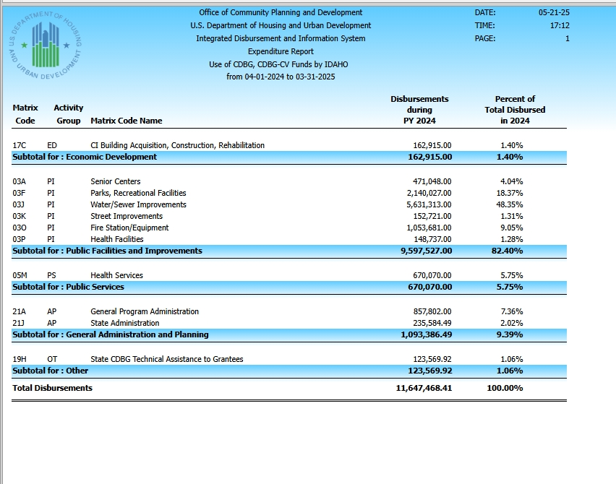

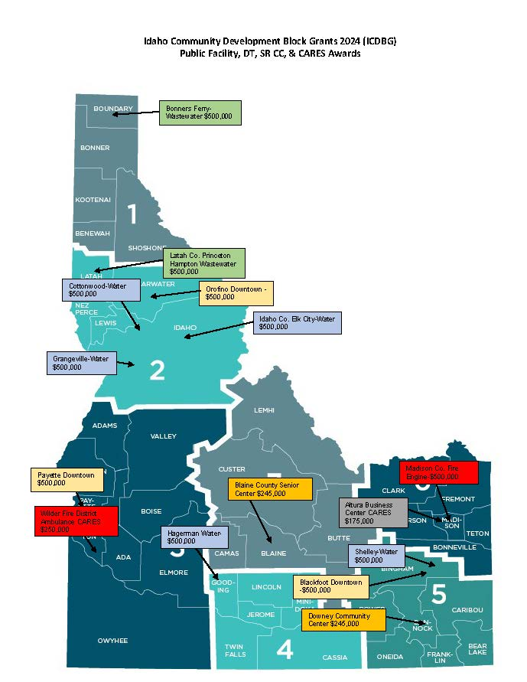

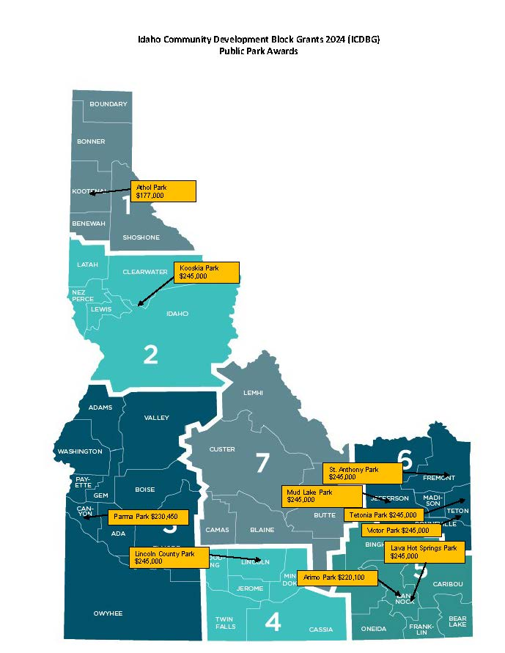

Leveraging
Explain how federal funds leveraged additional resources (private, state and local funds), including a description of how matching requirements were satisfied, as well as how any publicly owned land or property located within the jurisdiction that were used to address the needs identified in the plan.

Idaho Department of Commerce- CDBG Program

2024 CDBG LEVERAGE
Type/Source | Match Amount | Goals Addressed
Local: |  | ⋅ | Public Facilities Infrastructure-Rehabilitation
Cash, bonds, in-kind | $21,422,151 | ⋅  ⋅ | Public Facilities Infrastructure-Compliance Public Facilities Infrastructure-New Construction
 |  | ⋅ | Economic Development-Job Creation
 |  | ⋅ | Economic Development- Downtown Revitalization
State: |  | ⋅ | Public Facilities Infrastructure-Rehabilitation
Grants from Idaho Dept. of Environmental Quality | $1,361,500 | ⋅  ⋅  ⋅ | Public Facilities Infrastructure-Compliance Public Facilities Infrastructure-New Construction Economic Development-Job Creation
 |  | ⋅ | Economic Development- Downtown Revitalization
Federal: |  | ⋅ | Public Facilities Infrastructure-Rehabilitation
Grants from USDA- Rural Development and US Army Corp of Engineers | $125,000 | ⋅  ⋅  ⋅ | Public Facilities Infrastructure-Compliance  Public Facilities Infrastructure-New Construction Economic Development-Job Creation
 |  | ⋅ | Economic Development- Downtown Revitalization
Private: |  | ⋅  ⋅  ⋅  ⋅  ⋅ | Public Facilities Infrastructure-Rehabilitation Public Facilities Infrastructure-Compliance Public Facilities Infrastructure-New Construction Economic Development-Job Creation  Economic Development- Downtown Revitalization
 | $0 | ⋅  ⋅  ⋅  ⋅  ⋅
Business, |  | ⋅  ⋅  ⋅  ⋅  ⋅
Foundation Grants |  | ⋅  ⋅  ⋅  ⋅  ⋅
Total | $22,908,651

IDC received $8,236,180 in CDBG funds for PY 2024. The state and local communities leveraged $22,908,651 to match CDBG funds that were used to fund projects and state administration activities. For every CDBG dollar invested, IDC and local communities leveraged $2.78 to match the 2024 HUD CDBG grant award. In regard to IDC program administration, IDC has provided $164,724 in match to the CDBG program.
In regard to project match, the CDBG program does not require communities to provide any match in order to receive an ICDBG grant, but the state’s competitive grant process does award points to communities who do provide match. As a result, many of the projects that receive ICDBG funding do leverage matching funds. The
table above provides a summary of sources of match, the match that was leveraged, and the strategies that were addressed.

CDBG grantees (cities and counties) and many of their sub-recipients (government special districts) which are public entities do own the land or easements where CDBG funded projects are constructed to address the CDBG goals and objectives. Basically, almost all CDBG projects (water, wastewater, parks, downtown revitalization, senior center, community centers, health clinics, fire stations, etc.) are located on publicly owned land or property.

CR-35-Other Actions

Actions taken to address obstacles to meeting underserved needs. 91.220(k); 91.320(j)

IDC staff continues to offer training and technical assistance to cities and counties, grant administrators, and design professionals. To more effectively develop CDBG technical capacity for Grantees, IDC now provides certified grant administration training on-line. IDC has recorded presentations on eligibility, environmental reviews, labor, procurement, acquisition, and section 3. IDC provides ongoing one-on-one technical assistance to communities. IDC has available at its website [http://commerce.idaho.gov/] both the CDBG grant administration manual and application handbook.
To help build local government capacity to manage CDBG projects, IDC will train consultants to become CDBG grant administrators, instead of relying on resource-limited cities and counties to ensure requirements and rules are met.

Actions taken to reduce the number of poverty-level families. 91.220(k); 91.320(j)

IDC’s anti-poverty strategy consists of four methods. First, IDC will provide CDBG funds to cities and counties to construct public infrastructure or facilities that lead to a business’s ability to create or retain jobs. At a minimum, low-to-moderate income (LMI) individuals, including individuals at poverty level, must take 51% of these jobs. Jobs taken by LMI individuals should increase their income and help them develop more marketable skills as well as their confidence. IDC is creating opportunity for low income and poverty individuals.
Second, the implementation of HUD’s Section 3 Program. The program fosters local economic development and individual self-sufficiency for lower income persons in the solicitation of professional services and construction work needed to complete CDBG projects. The purpose of these requirements is to ensure that a greater share of
economic opportunities generated by HUD funding is targeted to lower income families who live in the grantee’s jurisdiction.
ICDBG funded grantees and their sub-recipient, contractors or businesses must make a good faith effort to award contracts to Section 3 business concerns and utilize Section 3 area residents as trainees and employees.
Third, IDC advertised CDBG funded projects through Idaho’s APEX Accelerator Bid Match program to ensure professional and construction services on CDBG funded projects were directly solicited to 508 businesses. These businesses comprise of Disadvantaged Businesses, Women Business Enterprises, HUD Zone Businesses, SBA Section 8(a) Businesses, Disabled Veteran owned Businesses, and Minority Owned Businesses.

Fourth, IDC provides additional points to job creation projects that are located or sited in the Small Business Administration’s HUB zones (HUB zones are historically underutilized business zones that typically have higher rates of unemployment or lower per capita income then national levels) and Opportunity Zones.

Actions taken to develop institutional structure. 91.220(k); 91.320(j)

IDC believes that the department does not have gaps in its institutional structure or in the delivery of the CDBG program. The CDBG program strengths include the administration of the CDBG program for over 35 years and maintains consistent rules, yet adapting to necessary program changes. IDC’s certified grant administration program has also established a network of experienced and knowledgeable consultants that help cities and
counties manage a CDBG project. In addition, IDC’s CDBG staff provides on-going technical assistance.
IDC did consult with over 40 cities and counties. Technical assistance activities can range from strategic planning and project development to on-site training.
IDC staff also continued to work to improve the amount and quality of data available on the IDC website. In addition, IDC posts the Consolidated Plan, Annual Action Plan, CAPER, and CDBG Application Handbook and Grant Administration Manual.
IDC continues to hold quarterly meetings with USDA-Rural Development, Army Corps of Engineers, and Idaho Department of Environmental Quality to discuss community needs and coordinate efforts to meet those needs.
IDC continues to provide grant administration training, application trainings and one-on-one technical assistance to local governments, non-profits, grant consultants, and design professionals in efforts to ensure the on-going and future effective use of CDBG funds.

Actions taken to enhance coordination between public and private housing and social service agencies. 91.220(k); 91.320(j)

- IHFA and IDC will continue to facilitate the coordination and participation between public and private housing and in stakeholder forums during PY2021 to enhance collaboration and coordination of public, private and faith-based service providers for housing, economic development, and other services:
  - Idaho’s Regional Housing Roundtable
  - Idaho Rural Partnership (www.irp.idaho.gov)
  - Association of Idaho Cities (https://idahocities.org)
  - Disability Action Center NW (http://dacnw.org)
  - Consortium for Idahoans with Disabilities (https://www.idahocid.com)
  - Idaho Commission on Hispanic Affairs (https://icha.idaho.gov)
  - Idaho Commission on Aging (https://aging.idaho.gov)
  - Idaho Association of Counties (http://idcounties.org)
  - Local Planning Districts
  - Idaho Center for Fiscal Policy (https://www.jannus.org/program/idaho-center-for-fiscal-policy)
  - USDA-RD
- Continuing in 2018 IHFA and the City of Boise worked together to develop a multifamily rental model that
follows Boise’s Housing First Initiative. The approved proposal is mixed-income, targeting low, very low, and extremely low-income households. Idaho's LIHTC and HOME programs and the City of Boise will provided the development financing. The City of Boise/Ada County Housing Authority has awarded 40 Project-based vouchers to the project, which will include 40 one-bedroom units.
- Both IHFA and IDC are participating members of the Fair Housing Forum, which works with various agencies

Actions taken to overcome the effects of any impediments identified in the jurisdictions analysis of impediments to fair housing choice.

While no housing issues in Idaho rose to the level of an impediment in the 2017 Fair Housing Assessment-Analysis of Impediments to Affirmatively Further Fair Housing, the report does identify several housing issues and potential contributing factors.

ISSUES AND CONTRIBUTING FACTORS ADDRESSED | GOAL | MILESTONES | RESPONSIBLE ENTITY | 2020 ACTIONS TAKEN
Higher housing needs of Hispanic, Native American, disabled and elderly households | A. Support residents with disproportionate housing needs living in non- entitlement areas:  - Continue preferences for deeply subsidized rental housing.  - Support tenant preferences that target priority housing needs populations as identified in the 5-Year Consolidated Plan.  - Support partner efforts to develop a recurring source of state funding for the Idaho Housing Trust Fund, emphasizing the unique needs of non- entitlement communities.  - Require affordable rental housing projects to be located in communities that are | - Complete 10 units of rental housing annually that target priority housing needs populations (Disabled, Elderly,  ≤30% AMI.  - Retain current preferences in LIHTC QAP for 2017 and 2018; evaluate effectiveness of income targeting during subsequent years based on applications received in 2017 and 2018.  - Encourage efforts to provide state support for housing trust fund.  - Three to five completed multifamily housing rental projects per year in communities that support affirmatively furthering fair housing. | IHFA | - Approved LIHTC/HOME &/or HTF multifamily rental projects: 48 rental units targeting the elderly (age 62+) in Eagle ID; 4 single-family units targeting ≤30 AMI- Owned by a non- profit organization that works with refugee populations in the Boise area; 30 multifamily units, 2 units @ 30% AMI- Owned by a non-profit that works with victims of domestic violence.  - The 2018 QAP retained a preference for project applications that target very low and extremely low-income households. QAP also provided scoring points for projects providing permanent supportive housing to homeless veterans.  - No committee action taken during the 2018 (January- March) legislative session.  - The 2018 QAP and Annual Administrative Plan continue to require proof communities in which
 | committed to Affirmatively Furthering Fair Housing Choice. |  |  | the HOME, HTF or LIHTC programs are involved be committed to Fair Housing. Evidenced by the submission of an adopted Fair Housing Resolution, and a Fair Housing Plan or Analysis of Impediments to Affirmatively Furthering Fair Housing (CDBG Entitlement Communities) at the time the application is submitted for funding. In 2018, development rental and /or homebuyer projects were completed Bonner, Kootenai,  Nez Perce, Canyon, Blaine, and Bannock counties.
Disproportionately lower homeownership rates among Hispanic, Native American and African American households | B. Help qualified renters attain homeownership: Support credit counseling and homeownership readiness though affirmative marketing. | 1. Continue Finally Home! Homebuyer Education classes in Moscow, Sandpoint, Coeur d Alene, Idaho Falls, Twin Falls, Nampa, and Boise, and online to reach 5,000 or more potential homebuyers. Continue bilingual outreach, training, and customer  service efforts. | IHFA | 1. In 2018, over 6,000 potential homebuyers participated in the Finally Home! Homebuyer Education classes. Bilingual outreach, training, and customer services efforts continue.
Landlord lack of fair housing awareness resulting in fair housing complaints and higher use of publicly subsidized housing by minority residents | C. Increase fair housing knowledge:  - Continue current fair housing capacity building and educational outreach activities, particularly among property owners and persons with disabilities.  - Continue to provide information about and | - With Idaho Fair Housing Forum partners, support 2 to 10 fair housing training events annually with landlord groups  - Support efforts to add familial status to state protections.  - During program years 2017- 2021, Commerce will continue to award preference points to CDBG applicants that include fair housing protections for familial | IHFA-1,2, & 4  Commerce -3 | 1. On 4/26/18, Idaho Fair Housing Forum partners sponsored a free  “Equal Access for All” workshop for housing providers and managers, realtors and lenders to coincide with the 50th Anniversary of the Fair Housing Act. The Fair Housing / Vision Conference preceded the event on 4/18/18. IHFA participated in multiple panels/presentations along with

 | support expansion of state fair housing protections to include familial status.  3. Continue to award preferences points to CDBG applicants with fair housing protections that include familial status. | status.  4. HOME and HTF written agreements specify Federal fair housing and nondiscrimination laws, including familial status as a protected class in accordance with Title VIII of the Civil Rights Act of 1968. |  | other Fair Housing Forum members.  2. As noted in 2018, IHFA researched substantial equivalency and adding familial status to Idaho Fair Housing law; during an 8/30/17 meeting with Joseph Pelletier, Director, Fair Housing Assistance Program, IHFA learned it is ineligible to pursue this  on behalf of the state of Idaho. We
 | 4. Require affordable  rental housing projects to be located in communities that are committed to Affirmatively Furthering Fair Housing Choice or have adopted a Fair Housing Plan (CDBG non- entitlement areas). |  |  | subsequently turned over all findings to the Idaho Department of Labor/Idaho Commission on Human Rights.  3. Commerce: For the 2024 grant applicants, Commerce reviewed 25 applicants to determine and award points to applicants who had adopted familial status
 |  |  |  | 4. HOME and HTF written agreements include language regarding ongoing compliance with the Federal Fair Housing and Nondiscrimination laws, and regulations, including familial status as a protected class in accordance with Title VIII of the Civil Rights Act of 1968.
Housing in rural areas developed without Visitable/Accessible features due to limited development in rural areas and when housing was | D. Increase accessible, affordable housing options:  - Continue with HOME, HTF, and LIHTC application preference points for rental housing that benefits elderly, ≤30% AMI | - Retain current preferences in QAP and Administrative Plan.  - Provide funding preferences for Visitable single-family rental housing.  - Encourage regional partners | IHFA 1,2,3,4,5  Commerce-6 | - Multifamily rental applications receive additional scoring points if the owner commits to serving households with annual incomes at or below 30% AMI, or disabled, or elderly (age 62+).  - In 2018: Single-family rental housing (new construction and

developed. Local policies that limit group homes | households, and persons with disabilities.  - Explore ways to incent Visitable housing.  - Explore peer states' efforts to create assisted living-like community supported environments in rural communities. 4. Continue educational efforts to inform local jurisdictions of best practices and legal risks associated with land use and zoning laws, including requiring conditional use permits for group homes.  - Encourage use and completion of Transition Plans and prioritize CDBG to making identified needed accessibility improvements.  - Explore creation of a more coordinated and comprehensive effort to address the access needs of persons with disabilities. | to use Avenues for Hope and other private funding options to create accessible home modification in rural communities.  - Coordinate annual training on best practices in land use and zoning, focusing on group homes.  - Five percent of all new multifamily rental housing will be wheelchair accessible; two percent will accommodate persons living with sensory impairments.  6 Continue to market ADA improvements as eligible activities for CDBG  - Complete 15 projects that improve ADA accessibility during 2017-2021 assuming national objectives are met.  - Ensure all CDBG grantees (cities and counties) have updated their ADA Transition Plans prior to project closeout.  - Increase CDBG application priority ranking points for projects that focus on the removal of architectural barriers or improve ADA accessibility. |  | rehabilitation) eleven visitable single- family units were created in 2018; Five new construction multifamily projects were completed, which required a minimum 5% of the units to be handicap accessible, with an additional 2% accessible for persons with hearing and visual disabilities.  - No funding available in 2018.  - IHFA requested FHIP funds to support a best practices training on land use, zoning and group homes to coincide with the October, 2018 Idaho American Planning Association conference, but the request was  turned down. ‘Essential Trends and Strategies’ in housing planning and development to support fair housing choice; 7/13/18 Presentation:  ‘Housing as a Second Language: Expanding the conversation’ - NW Community Development Institute.  - In 2018, multifamily rental housing project architects must certify design specifications as applicable to the type of project (new construction vs. rehabilitation): Fair Housing Accessibility Guidelines, Section 504 of the Rehabilitation Act and HUD's Fair Housing Design Criteria (if federal funding in the projects), Americans with Disabilities Act, and Uniform Accessibility Standards.  - Commerce: For 2024,

- Nine CDBG funded projects will help to improve ADA accessibility in their respective communities.
- With exception to a post disaster grant, all of the 2024 CDBG grantees are required to update their transition plans, as per the Commerce grant agreement.
- The Economic Advisory Council approved a scoring point increase for projects that improve ADA accessibility. The procedure change was enacted for 2020 and 2021-24 CDBG projects.
Gaps in educational achievement for students with disabilities; African American, Native American and Hispanic students; LEP students; and students in transition and at- risk and economically disadvantaged students | E. Help address education proficiency gaps:  - Consider Utah's best practice of adding preferences for LIHTC location in areas with high proficiency schools* | Explore effectiveness of Utah's LIHTC program in 2019 and 2020 (after it has been utilized for three years) | IHFA
Low wages in economically disadvantaged rural areas due to limited economic growth and growth in low wage industries (e.g., | F. Increase employment in economically disadvantaged communities:  - Continue to allocate CDBG to job creation activities in rural | 1. Use CDBG funds to leverage the creation of 30 moderate to high paying jobs created or retained annually, 2012 through 2026 | Commerce | For 2024, Commerce did not receive any job creation applications, therefore did not fund any job creation projects.

service jobs) | communities.
Inaccessible (pre-ADA) public buildings, commercial establishments, and infrastructure. Lack of funding for—and high cost of—accessibility improvements to streets, sidewalks, and other public infrastructure. | G. Dedicate additional federal support to increasing employment and accessibility in non- entitlement areas:  - Support federal efforts to expand infrastructure redevelopment in rural areas and ensure that these include creating environments that are more accessible. | - Activities to be determined in future action plans depending upon federal activities to improve infrastructure.  - Promote community accessibility practices such as Ramp Up Idaho to increase awareness of access and opportunity. | Commerce-1 IHFA-2 | - In 2024, Commerce attended four quarterly meetings with other infrastructure funding agencies, USDA-RD, DEQ, and USACE. Also Commerce participated with these funding agencies in a state-wide training of potential grantees.  Commerce helps provide support and guidance to these federal agencies in their efforts to improve infrastructure and facilities in rural communities.  - IHFA participated in or coordinated presentations during PY 2018 for the Association of Idaho Cities, the Idaho Chapter of the American Planning Association, the NW Community Development Institute, Regional Housing Roundtables, Idaho Rural Partnership and the Idaho Women’s Charitable Foundation. Each presentation featured information about the importance of residential and community access and housing choice. IHFA staff continued to promote Ramp Up Idaho, fair housing design and construction and ADA principles, and distributed/updated  copies of ‘Housing Diversity: Supporting Community and Economic Stability.’ Which features information on fair housing law, housing choice and access at conferences, meetings and trade shows.

Insufficient transportation services to support independent, integrated community living for seniors and persons with disabilities. Lack of public transportation in rural areas. | H. Dedicate additional federal support to increasing employment and accessibility in non- entitlement areas— contingent on participation of Idaho Transportation Department and Federal Highway Administration):  - Encourage local government grantee's ability to play a role in transportation planning at the state and regional levels.  - Through AAAs, roundtable discussions, public-private partnerships, explore the demand to expand and create formal rideshare programs in rural communities with need. | - Ensure CDBG grantees (cities and counties) located in resort communities or college towns have completed the transportation component of their comprehensive plan (as per Idaho's Local Land Use Planning Act). At a minimum, the transportation component should assess bicycle and pedestrian circulation and the existing (or feasibility of) public transportation - bus or van. Further, the city or county should address the transportation factors that are contributing to limiting opportunities for its residents in their fair housing assessment.  - Convey the importance of transportation alternatives in an integrated community living to the Idaho Transportation Department's Public Transportation Interagency Working Group. | Commerce-1 IHFA-2 | - Commerce: As of 2024, All CDBG applicants (Grantees) were required to identify if the transportation component of their plan did address public transportation options. Additional points were awarded to applicants who had addressed public transportation options. Commerce’s CDBG program does request Grantees to review the transportation options in their community under their Fair Housing Assessment.  - IHFA staff maintain contact with our partners through ITD’s Statewide Bicycle and Pedestrian Advisory Committee (BPAC) to promote diverse transportation and mobility options.
Challenges housing persons with criminal backgrounds who cannot qualify for publicly supported housing and for whom private sector may be reluctant to provide housing. | - Explore programs to provide housing options for persons with criminal backgrounds, particularly those who are disproportionately represented by certain protected classes:  - Explore best practices | Publish annual updates and information in Cornerstones and Rent Sense newsletters; include best practice information in correspondence to affordable housing providers. | IHFA | IHFA no longer publishes “Cornerstones” or “Rent Sense” newsletters; relevant outreach and updates on best practices are disseminated via stakeholder networks and conferences.  Fair Housing trainings provided by HUD and offered through Idaho AHMA (Idaho’s Affordable Housing

 | (e.g., Sponsors, Inc. in Oregon) to assist men and women in corrections re- integrating into communities.  2. Educate housing partners statewide on appropriate language on criminal backgrounds in  rental agreements. |  |  | Management Association) and Fair Housing Forum partners continue to include a section regarding VAWA, criminal background checks, and reasonable tenant selection policies regarding "criminal history." VAWA language is included in the HOME and HTF project regulatory agreements with owners.

CR-40 - Monitoring
91.220 and 91.230
Describe the standards and procedures that will be used to monitor activities carried out in furtherance of the plan and will be used to ensure long-term compliance with requirements of the programs involved, including minority business outreach and comprehensive planning requirements.

Idaho Department of Commerce

IDC monitors all CDBG funded projects to ensure compliance with applicable program rules and regulations. The IDC monitoring process starts before the actual funding of an application and continues until project closeout. This dynamic process helps to ensure projects meet program requirements and improves the chances that any violations or potential violations are identified and corrected.

-Pre-Development Monitoring-
Local governments who anticipate applying for CDBG funds are encouraged to contact their regional IDC specialist. IDC specialists provide recommendations and technical assistance to local governments to help them understand the CDBG program requirements. Pre-development reviews also provide IDC an understanding of the potential projects and an early assessment to determine if it will meet the CDBG national objective, eligibility, and goals.

-Application Monitoring-
During the review of the applications, IDC staff first determines if the application meets the required eight threshold factors, which includes national objectives and eligible activities. If the application meets the eight threshold factors, further review of the application continues to determine if the project will meet the program goals and strategies, procurement rules, acquisition and relocation requirements, citizen participation, and an assessment of the
environmental review requirements. Local governments’ accomplishments towards furthering fair housing and accessibility (504) standards are also reviewed.
Generally, IDC conducts a monitoring of the environmental review conducted by the local government prior to execution of the IDC contract.

-Project Monitoring-
IDC conducts a risk assessment of each project, utilizing the department’s Determination of On-site Monitoring criteria to establish if the project will require on-site monitoring or if the desk monitoring process will suffice. IDC monitors all CDBG funded projects and reviews the Grantee’s financial audits. During the course of a project IDC, specialists are continually monitoring the following applicable project components:

Financial Management | Procurement | Performance
Environmental | Labor Standards | Acquisition & Relocation
Civil Rights | LEP | Citizen Participation
504 Standards | Fair Housing

IDC continues to update its project-monitoring guide, which must be completed by a staff project specialist prior to closeout. IDC specialists approve every CDBG request for payment. Requests for payment are required to be supported by an invoice and executed contract. IDC has an established process of receiving and reviewing a local government’s independent financial audit for any open project or project closed out within one year. The audit is
reviewed by IDC to determine if there are any findings and if so do they affect the CDBG funds. IDC has also implemented an audit checklist to help ensure a grantee's compliance with 2 CFR Part 200.501 Audit Requirements.

-On-Site Monitoring-
IDC will try to visit all CDBG funded projects at least once during construction, to conduct site observation. IDC based on a risk analysis will conduct onsite fiscal monitoring of at least 20% of the CDBG funded projects for each program year.

-Women/Minority Business Enterprises Outreach-
ICDBG funded grantees and their sub-recipient, contractors or businesses must make a good faith effort to award contracts to Section 3 business concerns and utilize Section 3 area residents as trainees and employees.
IDC advertises ICDBG funded projects through the Idaho Small Business and Development Center, Idaho’s Procurement Technical Assistance Center and Disadvantage Business Enterprises to ensure professional and construction services on CDBG funded projects are directly solicited to Disadvantaged and Women Business Enterprises, HUB Zone businesses, SBA Section 8(a) businesses, disabled veteran owned businesses, veteran- owned businesses, and minority-owned businesses.

Insert PR 28 Report Commerce 2016-2024.

