CHAPTER VI - LABOR STANDARDS

Introduction

Idaho Community Development Block Grant construction activities are subject to federal prevailing (Davis-Bacon) wage requirements and related standards. The information presented in this chapter is to inform contracting agencies (cities, counties, subrecipients) what is required to meet federal Davis-Bacon prevailing wage and reporting requirements on a CDBG funded project.

It is the responsibility of the local grantee to administer and enforce the federal labor standards provisions on contracts covered by Davis-Bacon requirements. This can be done by a city or county employee or a consultant hired by the city or county. This person, referred to hereafter as the grant administrator, will ensure the applicable wage decision (wage determination or prevailing wage) and contract clauses are incorporated into the bid and contract documents. The grant administrator will also monitor labor standards compliance by the construction contractors. This will be done by conducting interviews with construction workers at the job site, collecting and reviewing payroll reports, and overseeing any corrective actions.

This chapter is broken up into nine (9) sections.
- Section One: Summary of Responsibilities
- Section Two: Applicable Law
- Section Three: Exemptions to DBRA
- Section Four: Labor Standards Administration: Pre-Bid Phase
- Section Five: Labor Standards Administration: Post-Bid Phase
- Section Six: Monitoring and Compliance Enforcement: Construction Phase
- Section Seven: Violation and Restitution
- Section Eight: Frequently Asked Questions
- Section Nine: Section 3

SECTION ONE: SUMMARY OF RESPONSIBILITIES

Labor Standards Compliance is an effort of all parties involved and prevention is the key to success with labor standards. Some basic objectives to protect worker’s rights are:

1. Proper application of Davis-Bacon requirements.

2. Support contractor compliance through education and information.

3. Monitor contractor performance.

4. Investigate probable violations and complaints of underpayment.

5. Pursue debarment and other available sanctions against repeat labor standards violators.

A. Responsibilities of Grant Administrator:

1. Make sure proper, current wage decision and labor standards provisions are contained in the bid documents.

2. Attend the pre-bid meeting/tour to notify contract bidders of Section 3 and federal labor standards provisions.

3. Conduct 10 day wage check.

4. Verify eligibility of Contractor.

5. Participate in preconstruction conference.

6. Ensure submission of all appropriate documentation, including payroll authorized signature form, payroll overview, signed checklists, requests for Additional Classifications, and documentation of fringe benefit plans.

7. Ensure wage decisions and/or additional classifications and USDOL poster are posted on site.

8. Conduct on-site interviews with laborers and mechanics.

9. Review Certified Payrolls and compare to the employee interviews and wage decisions.

10. Notify Prime Contractor and subcontractors (as applicable) of payroll discrepancies.

11. Notify IDC Specialist of wage restitution found due, including the preparation and submission of Labor Standards Enforcement Reports.

12. Investigate probable violations and complaints of underpayment and submit Labor Standards Enforcement Reports as necessary.

B. Responsibilities of Prime Contractor:

1. Attend pre-construction conference.

2. Review and identify any Additional Classifications needed by all contractors and subcontractors for the project.

3. Read, understand, and sign all appropriate forms from the grant administrator, including but not limited to: contractor certification, certificate of substantial completion, pre-construction checklist, and payroll authorized signature form.

4. Comply, in a timely manner, with requests from grant administrator. Including documentation of fringe benefits, correction CPRs, and wage restitution.

5. Comply with Section 3 requirements and reporting.

6. Include appropriate wage decisions and labor standards clauses in contracts with subcontractors.

7. Insertion of all applicable CDBG clauses in all contracts and subcontracts.

8. Ensure labor standards compliance from subcontractors.

9. Post wage decision, including additional wage classifications, at work site.

10. Collect certified payrolls from all subcontractors.

11. Submit all certified payrolls to Grant Administrator weekly.

12. Ensure availability of the prime contractor and subcontractor’s employees for interview at the job site with the grant administrator or agency representative.

SECTION TWO: APPLICABLE LAW

A. Davis-Bacon Act: The Davis-Bacon Act (DBA) requires the payment of prevailing wage rates (which are determined by the USDOL) to all workers. The law applies to construction, alterations or repair contracts in excess of $2,000. Construction includes alterations and/or repair, including painting and decorating, of public buildings or public works. Those Davis-Bacon provisions contained in HUD assisted construction programs are known as “Related Acts” and will be referred to as DBRA in this chapter.

B. Copeland “Anti-Kickback” Act: The Copeland Act requires employers to pay employees at least once a week, without any deductions or rebates except permissible deductions. The Copeland Act also requires every employer (contractor and subcontractor) maintain payroll records and to submit weekly payroll reports (CPRs). The Act applies to all contracts covered by Davis-Bacon. Violation of this Act is a criminal offense.

C. Contract Work Hours and Safety Standards Act (CWHSSA): CWHSSA applies to contracts over $100,000. CWHSSA requires workers to receive overtime (O/T) compensation at time and one-half pay for overtime hours (over 40 hours in any workweek) plus full fringe worked on the covered project [(1 and ½ x base pay) + fringe = O/T compensation]. CWHSSA violations render the contractor liable to the underpaid worker for wage restitution and the United States for liquidated damages penalty ($31/calendar day per violation). Intentional violations of CWHSSA standards are considered a federal criminal misdemeanor.

D. The Fair Labor Standards Act (FLSA): The FLSA pertains to federal minimum wage rates, overtime pay, recordkeeping and child labor requirements. These requirements generally apply to any labor performed and may be pre-empted by other federal standards such as the DBRA prevailing wage requirements and CWHSSA overtime provisions. Only the USDOL has the authority to administer and enforce FLSA. HUD will refer to the USDOL any possible FLSA violations that are found on HUD projects.

SECTION THREE: EXEMPTIONS TO DAVIS-BACON AND RELATED ACTS (DBRA)

- Non-Covered Job Classifications: Workers performing the normal duties of the following job classifications are not subject to prevailing wage requirements of DBRA:

- Project engineer
- Project foreman (supervisory only), as distinguished from a working foreman (one who devotes more than twenty (20) percent of his/her time during a work week to mechanic or laborer duties, and who must be paid the applicable rate for the hours so worked).
- Watchman
- Clerical workers

- Volunteer Labor: A volunteer is an individual who performs services for a public or private entity for civic, charitable or humanitarian reasons without promise, expectations or receipt of compensation for services rendered. Individuals are considered to be volunteers only when their services are offered freely and without pressure and coercion, direct or implied, from an employer. Prison or correctional institution inmates can be considered volunteer workers if the institution’s program meets certain parameters.

For a project that will have work done solely by volunteers alone or in which there is a mix of paid workers and volunteers, the grantee shall record the name and address of the project, the number of hours worked and the hourly rate for all work performed by volunteers.

Volunteer Liability Insurance: Volunteer participation on a project can include inherent risks and accidents may result in unforeseen injury. In order to protect the community and volunteers, volunteer liability insurance is a solution.

- Force Account: The U. S. Department of Labor has taken the position that prevailing wage requirements do not apply to employees of a state or political subdivision of a state. In some instances, rather than contracting or subcontracting out construction work, a grant recipient performs the construction in-house, with its own “force account” employees. Such force account work is not subject to the prevailing wage requirements of DBRA. Furthermore, the USDOL does not consider a state or local government to be a contractor, even if it enters into a contract to perform construction work (see 29 CFR Section 5.2(h)).

- Cleaning: Cleaning performed during construction is subject to prevailing wage provisions. In the absence of a specific wage rate for the cleaning classification, the cleaners must be paid the predetermined wage rate for laborers. Cleaning performed after the completion of construction to prepare the premises for occupancy that is not done under the construction contract is not subject to the prevailing wage requirements.

- Demolition: Demolition not related to construction is not subject to the prevailing wage requirements of DBRA. For example, the demolition of a building because the structure is no longer needed would not be a covered construction activity. However, where an existing building is being demolished as a phase of a construction project subject to the prevailing wage requirements of DBRA, the demolition would also be covered, as in the case of demolition performed to permit construction of a new building.

- Utility Employees: Public utilities that are regulated by the state have an exemption from DBRA. This exemption is available only where the public utility is using its own equipment and employees, the utility in in effect extending or upgrading its own utility system, and ownership of the equipment remains with the utility.

- Precutting of Parts and Prefabrication of Assemblies: The precutting of parts and/or the prefabrication of assemblies are not subject to the prevailing wage requirements of DBRA unless conducted in connection with and at the site of the project or in a temporary plant set up elsewhere to supply the needs of the project and dedicated exclusively or nearly so, to performance of the contract or project.

- Supply and Installation Contracts: The manufacturer or furnisher of materials, supplies or equipment is not subject to prevailing wages unless conducted in connection with and at the site of the project or set up elsewhere to meet the needs of the project. If a supply contract, not otherwise covered, requires the supplier to install the product, the installation portion of the contract is subject to prevailing wage requirements of DBRA. There is an exception if the installation involves an incidental amount of construction activity. It is not subject to prevailing wage requirements in this instance. Contracts for the supply and installation of window shades, venetian blinds, traverse rods, and draperies involve only an incidental amount of construction activity, and therefore are not subject to prevailing wage decisions. The installation of a lagoon liner or a pre-fabricated park bathroom is an example of work subject to prevailing wage rates. Questions concerning the coverage of installation activity should be referred to the IDC Specialist.

- Railroad Employees: Employees of railroads operating under collective bargaining agreements that are subject to the Railway Labor Act are not subject to DBRA. However, any workers performing construction work on the railroad under a contract are subject to DBRA.

SECTION FOUR: LABOR STANDARDS ADMINISTRATION: PRE-BID PHASE

A construction project covered by federal labor standards requires a series of specific actions by grant administrators prior to awarding a construction contract. Refer to the list of responsibilities in Section One.

Section 4.1 Bidding Documents

The contract for construction is the vehicle to ensure contractor compliance and Davis-Bacon wage enforcement. Therefore, the bidding documents for each project subject to Davis-Bacon wage rates must contain both a Davis-Bacon wage decision and federal labor standards clauses (see “Bid/Contract Requirements” pages 27-51). It is the responsibility of the grant administrator to obtain the most current Davis-Bacon wage decision and provide it and the labor standards clauses to the project architect or engineer to ensure that these documents are included in the bidding documents.

The grant administrator must review the bidding documents using the CDBG Construction Bid Document Review Certification form (Chapter V) and certify they contain the correct forms. The final bid documents and the Bid Review Certification must be sent to the IDC at least 7 days prior to bid opening.

- Davis-Bacon Wage Decision (Wage Determination): Each construction contract subject to federal Davis-Bacon labor standards requirements must contain a Davis-Bacon wage decision. The Davis-Bacon wage decision is a listing of wage rates and fringe benefits for each classification of laborers and mechanics determined to be prevailing in a given area (usually a county) for a particular type of construction.

The USDOL has distinguished four general types of construction: Heavy Construction, Highway Construction, Building Construction and Residential Construction. To assist in identifying the type of construction for the project, see All Agency Memo 130 and 131 which can be downloaded on the IDC website on the Grant Resources page.

The grant administrator is responsible for obtaining the proper wage decision. One can be obtained from the following web address: https://sam.gov/ or by contacting your IDC Specialist. CDBG projects require wage decisions to be updated to ensure that the most current and correct wage decision is being used. The grant administrator is responsible for obtaining and documenting that the wage decision is updated 10 days prior to bid opening.

Failure to include the required wage decision and appropriate labor standards provisions in bidding documents will not relieve the city or county from potential liabilities for enforcement actions. It is the prime contractor's responsibility to ensure inclusion of wage rates and labor standards provisions in all subcontracts. Any failure to include a wage decision must be rectified.

- Updating Wage Decisions: There are specified times that wage decisions must be updated for different procurements. In all cases, wage decisions must be updated to ensure that the proper and correct wage rate is used for the project. To document this, send the completed Wage Rate Update form (page 77) to the IDC Specialist assigned to your region.

1. Competitive Sealed Bidding

Most construction contracts fall under the competitive sealed bid procurement process. This procurement process includes wage decisions in the bid documents and has a bid opening date. These projects require a Wage Decisions check to be completed no more than ten (10) days prior to bid opening. If the 10 day check falls on a weekend, the wage rate must be checked the Monday following the 10 day check. If the 10 day check falls on a holiday, the wage rate must be checked the day after the 10 day timeline.

2. Sole Source

This procurement process for construction work is rare and should be used only after consultation with your IDC Specialist. The wage decision that is in effect on the date that the contract is signed is the correct wage decision.

- Multiple Wage Decisions: It is possible to have multiple wage decisions on one project (e.g. a project that has CDBG funds used in rehabilitating of an industrial park building as well as doing construction on the road and turn-lane in front of the building). If there is potential for a multiple wage decision, contact your IDC Specialist. To assist in identifying the type of construction for the project, see All Agency Memo 130 and 131 which can be downloaded on the IDC website on the Community Grant Resources page.

Section 4.2 Pre-Bid Meeting

During the pre-bid meeting, the federal labor requirements and wage decision should be reviewed with the contractors. This is the time to determine if all work classification(s) needed for the job are on the wage decision. If the work classification(s) needed do not appear on the wage decision, then an additional classification and wage will be needed. Additional classifications are typically approved after the construction contract is awarded but an IDC Specialist can provide the grant administrator an estimated wage rate that is anticipated for approval to provide to the interested parties.

SECTION FIVE: LABOR STANDARDS ADMINISTRATION: POST-BID PHASE

The post-bid requirements consist of evaluating and tabulating each of the bidder’s responses, verifying contractor eligibility, notifying contractor of award, holding a preconstruction conference (including additional classification requests), and obtaining all appropriate certifications.

Section 5.1 Evaluation and Tabulation of bidders

After opening all sealed competitive bids, the grantee evaluates, prepares bid tabulation form and identifies the successful bidder. A successful bidder is the lowest responsive and responsible bidder.

Section 5.2 Verification of Contractor Eligibility (Federal Debarred List)

All contractors must be eligible to work on federally assisted contracts. By the insertion of certification of eligibility clauses in all contracts and subcontracts, the prime contractor and all subcontractors state they are eligible for award of federally assisted or insured contracts. The grant administrator shall verify that all prime contractors are eligible before contract award by requesting verification from IDC (page 79).

Prime contractors shall be informed in preconstruction conferences that it is their responsibility to employ only eligible subcontractors. All subcontractors must certify eligibility in written contracts containing federal labor standards provisions (see Contractor and Subcontractor Certification Concerning Labor Standards and Prevailing Wage Requirements – pages 49-52).

Section 5.3 Notice of Award

The contract must be awarded within 90 days of bid opening. If the contract has not been awarded within ninety (90) days after bid opening, the Wage Decision must be updated. To document this, send the new completed Wage Rate Update form (page 77) to the IDC Specialist assigned to your region.

Section 5.4 Preconstruction Conference

The preconstruction conference should address all questions related to the labor standards provisions posed by contractors and subcontractors and also applicable federal labor standards provisions. The preconstruction conference is to make certain that the contractor understands its responsibility for all federal labor standards provisions and Davis-Bacon compliance. The grantee, grant administrator and design professional shall hold a conference with the prime contractor and all subcontractors before the start of construction. At this time the contractor will be advised of the overall management of the project including the labor standards provisions.

A CDBG Preconstruction Conference Checklist (page 55-60) has been prepared as a tool to review project management considerations. Give each contractor and subcontractor on the job a copy of the preconstruction conference packet. Submit the Preconstruction Conference Checklist to IDC no more than five (5) days following the date of the conference.

Section 5.5 Implementation of Federal Labor Standards:

- Apprentices: The only workers who can be paid less than the wage rate on the wage decision for their work classification are “apprentices” and “trainees” registered in approved apprenticeship or training programs, including Step-Up apprenticeship programs designed for Davis-Bacon construction work. Approved programs are those which have been registered with the U.S. Department of Labor (USDOL), Bureau of Apprenticeship and Training (BAT) or with a BAT-recognized State Apprenticeship Agency (SAC). Note: Apprentices registered in a state or local (Idaho) sponsored program must also be registered with the USDOL, Bureau of Apprenticeship and Training. The grant administrator is responsible for verifying whether the program is registered with USDOL. Any questions regarding apprenticeships can be directed to the Idaho Department of Labor – Apprenticeship Office.

Apprentices and trainees are paid wage rates in accordance with the wage schedule in the approved program plus the full fringe amount.

- The allowable ratio of apprentices and trainees to journeymen in any classification shall not be greater than the ratio permitted under the registered program. Apprentices or trainees employed at the job site in excess of the allowable ratio on a day-to-day basis shall be paid the wage rate contained in the wage decision for the classification of work actually performed.
- Any worker listed on a payroll at an apprentice or trainee wage rate, who is not registered with or in a program approved by USDOL/BAT, shall be paid the Davis-Bacon wage rate for the classification of work actually performed.
- The contractor or subcontractor will be required to furnish to the labor standards compliance person written evidence of the registration of his/her employees in a USDOL approved program.

- Truck Drivers: Truck drivers employed by a construction contractor or construction subcontractor are not covered by the prevailing wage requirements of the Davis-Bacon Act while engaged in transporting materials or supplies to or from the site work. Truck drivers whose time spent on the site of work that is considered de minimis, such as only a few minutes at a time to pick up or drop off materials or supplies, are also exempt from the Davis-Bacon Act. Davis-Bacon would apply to them only for their time employed “directly upon the site of the work.” Davis-Bacon Act coverage will apply to truck drivers while hauling between the project site and any special facilities established exclusively for the project.

- Working Subcontractors/Owner Operators: A working subcontractor/owner operator is a contractor who owns the business and performs the work himself or herself and has no employees. All working subcontractors/owner operators need to be reported on the certified payrolls of whoever hired them. If they are the prime contractor, the grantee is responsible for signing and submitting payrolls. Their name, employee identification number (if applicable), work classification, hours worked, contract amount and “self-employed” designation must all be included on the certified payroll.

Contractors working on the project with their employees shall be listed on the payroll. They must list their name, work classification including “owner” and the daily and total hours worked. They do not need to list their rate of pay or amount earned.

- Relatives: There are no exceptions made in the enforcement of DBRA on the basis of family relationship for relatives who are performing the work of laborers or mechanics. They must be paid the prevailing wage rate for the classification of work performed and be included on the certified payrolls.

- Certified Payroll Reports (CPRs): Each contractor, subcontractor, and lower-tier subcontractor, shall submit (through the prime contractor) to the grant administrator, Certified Payroll Reports (CPRs – see page 71) for each work week from the time work is started on the project until it is completed. Payrolls shall be numbered sequentially and the last payroll marked “final.” If work is not performed on the project during a given work week, a payroll does not need to be submitted if the contractor numbers his payrolls sequentially and notifies the grant administrator he will not be working on the project for a specified period of time. Otherwise, the contractor should submit “No Work” payrolls when there is a temporary break in work on the project. Contractors are required to pay workers every week. They cannot put two weeks of work on one payroll. Payrolls must be completed and submitted no later than seven (7) workdays following completion of the workweek.

The prime contractor is responsible for full compliance with regard to his own workforce and with regard to the compliance of every subcontractor. For this reason, all CPRs and any related records are submitted to the grant administrator through the prime contractor. Payrolls and related records shall be maintained during the course of the construction work and preserved by the contractor and the subcontractor for at least four (4) years.

- Certified Payroll Reports Format (Form WH-347): Certified Payroll Reports information may be submitted in any form, provided that one can reasonably interpret the information to monitor employer compliance with the labor standards and all required information is included on the form. Contractors are encouraged to use USDOL Payroll Form WH-347. The weekly payrolls are called certified because each payroll is signed and contains language certifying that the information reported on the payroll is true. The payroll certification language is on the reverse side of the WH-347. If the contractor uses another type of payroll format he may attach the certification from the back of the WH-347. Instructions for Completing the Weekly Certified Payroll Form and a pdf to form WH347 can be found here: https://www.dol.gov/agencies/whd/forms/wh347

- Inspection of Records and On-Site Interviews: Each contractor shall make the required records (CPRs and related documents) available for inspection, copying or transcription by authorized representatives of the grantee, IDC, HUD or USDOL. In addition, each employer shall permit authorized representatives to interview employees during working hours on the job site.

Failure by any contractor to submit the required records or to make them available, or to permit on-site employee interviews may, after written notice to the contractor, cause a suspension of any further payment, advance or guarantee of funds. In addition, failure to submit the records on request or to make them available may be grounds for debarment action.

- Proper Designation of Trade: The classification of each employee must be selected from the wage decision or an approved Additional Classification based on the actual type of work performed. Each worker must be paid no less than the wage rate on the wage decision for that classification regardless of his or her level of skill. In other words, if someone is performing carpentry work on the project, they must be paid no less than the wage rate on the wage decision for Carpenters, even if they are not considered by the contractor to be fully trained as a Carpenter.

- Additional Classifications: If it is found that a wage decision does not contain some of the classifications needed for the project, the IDC Specialist should be notified. If there is not a suitable classification on the existing wage decision, then an additional classification will be requested. The rate of pay for the additional classification cannot be below the unskilled labor wage rate on the wage decision. Rates for additional laborers, truck drivers and power equipment operators should be compared with other laborers, truck drivers and power equipment operators respectively. Requested rates should be comparable to similar occupations listed in similar classifications. The Additional Classification Request form (page 65) will need to be completed by the grant administrator and sent to IDC along with a copy of the project wage decision. IDC will forward the additional classification request to the USDOL for approval and forward their determination to the grant administrator.

SECTION SIX: COMPLIANCE MONITORING AND ENFORCEMENT

There are several important aspects of effective labor standards compliance. Monitoring identifies possible misunderstandings on the part of the employers, discrepancies in the record and potential violations. The two key aspects of routine monitoring include regular reviews of project CPRs and on-site interviews with laborers employed on the project. Contractors are permitted thirty (30) days to provide missing documentation, and correct any discrepancies or violations, including any underpayments of wages.

Section 6.1 Weekly Payroll Reviews

The grantee may need to withhold CDBG funds from the contractor if excessively delinquent in the submission of payrolls. The grantee or grant administrator shall insist upon prompt submission of all payrolls no later than seven (7) work days following completion of the workweek. The payrolls shall be examined upon receipt so any necessary corrective action may be initiated before the problem multiplies, and may be accomplished while the workers are still available.

Special attention should be given to each project by the grant administrator during the early stages of construction to determine whether the prime contractor is meeting his responsibilities regarding payrolls. If there are no significant problems, spot-checking of payrolls is permissible after an initial review of four to five weeks of payrolls from the prime contractor and any sub-contractors. Initial CPR review parameters and corrective actions required of the contractor shall include the following aspects (see Weekly Payroll Review Form – page 81):

- Payroll Format: Contractors are urged to use Payroll Form WH-347 which accounts for all required information and includes the “Statement of Compliance” (the certified part of the payroll) on its reverse side. Employers may utilize any other appropriate payroll form provided that it contains all of the required information and is accompanied by a statement of compliance containing the identical wording on the form WH-347.

- Foreman: If a foreman is listed on the payroll with no other classification, it must be determined if he is a working foreman on a project. A project foreman is distinguished from a working foreman.

1. Project Foreman: This job is supervisory in nature. He can spend up to twenty (20) percent of his time performing mechanic or laborer duties and will be exempt from Davis-Bacon wages. He does not need to be listed on the payroll.

2. Working Foreman: This job is one that devotes more than twenty (20) percent of the time during a workweek to mechanic or laborer duties. This foreman must be paid the Davis-Bacon rate for all the hours worked. The classification would be the one that he performs the mechanic or laborer duties in.

- Split classification(s): This term refers to employees performing work in more than one classification during the same workweek. The employee must be paid the Davis-Bacon rate for actual hours spent in each classification, provided the work performed is capable of separation into more than one classification, and provided time records are kept in accordance with actual hours spent in each classification.

- Hours Worked, Pay Rates, and Gross Wages Earned: The daily and total hours worked for the week per employee per classification must be shown. List the actual hourly rate paid to the employee for straight time worked plus any cash fringe paid to the employee. The basic hourly rate and fringe rate cannot be less than the applicable wage decision in the approved contract specifications. The payroll should only show the regular and overtime hours worked on the Davis-Bacon covered project. If an employee performs work at job sites other than the project for which the payroll is prepared, those “other job” hours should not be reported on the payroll. For employees with earnings on other projects, gross wages for the project for which the payroll is prepared can be shown over gross earnings for “all projects” (for example, $425.40/$764.85). Deductions and net pay are based on the “all projects” earnings.

Corrections: Contractors must submit a supplemental Certified Payroll Report or other written documentation reflecting daily and total hours worked for the week per employee as well as the fringe benefit contribution. If underpayments have occurred, the contractor shall be required to make restitution (See Correcting Violations and Making Restitution in Section Six).

- Overtime Hours Worked: Overtime hours shall be compensated at not less than one and one-half (1 and 1/2) times the regular rate of basic pay plus the straight-time rate of any required fringe benefits for anything over a 40 hour work week. Weekly hours shall be reviewed to determine whether overtime hours were worked and properly compensated. Be especially careful when reviewing split classifications because sometimes hours between classifications are not totaled and overtime can be missed.

Corrections: Where CWHSSA overtime violations occur (contracts over $100,000), the contractor shall be required to pay restitution to the affected employees and shall be notified of liability for liquidated damages. Only overtime hours worked on the covered project are subject to CWHSSA compensation. Where the project is not subject to CWHSSA, the employer will be notified of possible FLSA overtime violations.

- Fringe Benefits: Where fringe benefits are included on the wage decision or where the employer seeks credit for fringe benefit payments, the employer shall certify as to the payment of fringe benefits on the Statement of Compliance (reverse of WH-347). Fringe benefits do not include employer payments or contributions required by other federal, state or local laws, such as the employer’s contribution to Social Security or some disability insurance payments.

Corrections: Contractors shall be required to submit corrected CPRs where the CPR does not indicate how the employer met any fringe benefit obligation contained in the wage decision. If fringe benefits are contained in the wage decision and the contractor does not participate in a bona fide fringe benefit program, the employer shall pay the cash equivalent of the required fringe benefit directly to the employees with the basic rate of pay. (Note: Fringe is paid for overtime worked, but not computed in the time and one half for overtime pay.) Where underpayments have occurred, the contractor shall be required to make restitution to the affected employees.

- Deductions Made and Actual Net Wages Paid: All deductions shall be identified and reviewed for any non-permissible deductions. Permissible deductions that do not require written authorization from the employee include deductions made in compliance with requirements of federal, state or local law, (e.g. taxes, social security, deductions required by court processes – including Child Support withholdings, etc.). Any voluntary deduction (savings account, loan repayment, employee contribution to health insurance, wage advance, pensions, life or accident insurance, and retirement plans) must be authorized in writing by the employee (see Employee Voluntary Deduction Authorization Form – page 75). The Voluntary Deduction Authorization Form signed by the employee should accompany the first payroll on which the deduction appears. Deductions for tools are permissible only when the employee provides written authorization and it is a benefit to the employee. An excerpt from 29 CFR 3 on the form provides additional information of permissible deductions. Other deductions are not allowable without prior approval from the U.S. Department of Labor.

- Authorized Signature: The statement of compliance must be signed (original signature) by a principal of the firm (owner or officer such as the president or treasurer) or by an authorized agent (a person authorized by a principal in writing to sign the payroll reports). The signature authorization form (page 67) must be submitted with the first payroll.

Section 6.2 Fringe Benefits

If fringe benefits are paid into a plan, the following criteria applies and documentation should be submitted to the grant administrator for review at the preconstruction conference (prior to the first payroll):

- A contractor may credit contributions for bona fide fringe benefits. Bona fide benefits are those common to the construction industry and are paid into a fund, plan or program on the employee’s behalf. Contractors may take credit for contributions made under such conventional plans without requesting approval of the USDOL. These plans are funded plans. The form Fringe Benefit Determination will help in determining the cash equivalent credit for a fringe benefit paid into a plan and the documentation required to show it meets the Davis-Bacon requirements.

- Contributions to funded plans must be made irrevocably at least quarterly to a third-party trust.

- When the per hour contribution for benefits paid into a plan do not equal the total rate set forth in the wage decision, the difference must be paid to the employee in cash.

- Fringe benefits must be paid for straight time and overtime; however, fringe benefits are not included when computing the overtime rate.

- Employees excluded from funded plans must be paid fringe benefits in cash.

- Vacation and sick leave plans are generally unfunded, paid from the contractor’s own account, and require USDOL approval before a contractor takes credit toward meeting the fringe benefit obligation.

G. The fringe may be shown as $4.15 + 3 1/2%. The 3 1/2% is computed on the base rate, then added back to the fringe. For example, base rate is $35.68 and fringe rate is $4.15 + 3 1/2%. Multiply the base rate by the percent fringe ($35.68 x .035 =$1.23). Add the amount computed to the fringe ($4.15 + 1.23 = $5.38). Total fringe required is $5.38. For apprentices, the percentage base rate is used to calculate the fringe.

The following method is an example on how to determine if the amount contributed to the plan equals the amount required to be paid for fringe benefits per the appropriate Davis-Bacon Wage Decision.

METHOD: In determining the cash equivalent credit for fringe benefit payments, take the total amount that would be paid into the funded plan for a year and divide by 2080 hours.

EXAMPLE: Contractor pays $100/month to a funded health insurance plan. Davis-Bacon Wage Rates require $4/hour paid for fringe benefits.

FORMULA: ($100 x 12) divided by 2080 = 57 cents as the cash equivalent.

RESULT: The contractor must pay $3.43 to the employee in cash for fringe benefits and the remaining 57 cents to the funded plan. The contractor must note on the back of the payroll under how fringe benefits are paid and provide documentation for the funded plan.

Adequacy of fringe benefits will be determined by IDC based upon a review of the following information that you are requested to submit:

- Description of the coverage that you provide those employees and the name, address and phone number of the third-party trustee.

- Signed authorization of those employees to accept those specific employer-paid contribution amounts considered bona fide fringe benefits.

- The providers proof of payment into the plan, fund or program (i.e., monthly billing statement).

This adequacy is applicable for one (1) year from the date of review and applies to HUD funded projects.

Section 6.3 Falsification of Certified Payroll Reports

Contractors who willfully violate the labor standards provisions may falsify Certified Payroll Reports to conceal the violations. Willfully violating contractor’s Certified Payroll Reports often contain indicators that permit a grant administrator to determine whether they were falsified. Where falsification is suspected, it may be appropriate to send questionnaires to the employees to gather more information to determine the nature and extent of any violations. In order to resolve violations involving falsified Certified Payroll Reports, it is often necessary to conduct an investigation to determine the true work and wage payment activity and to “reconstruct” the payroll.

Common indicators of falsification and willful violations follow:

- Ratio of Laborers to Mechanics: Except for concrete, landscaping and similar contractors, the ratio of laborers to mechanics should not exceed 1 to 1. A higher ratio of laborers normally indicates misclassification. In other words, laborers are performing some or all of mechanic’s work. The false information may be limited to the classification of work.

- Too Few or Irregular Hours: Most workers are employed on a regular forty (40) hour per week basis. CPRs that consistently reflect less than forty (40) hours per week for all or certain groups of employees or that reflect erratic work schedules (e.g., the crew works only a few hours per day scattered throughout the work week), indicate that the hours may have been reduced to give the appearance of compliance. The falsification in these cases may be limited to the hours worked.

- Discrepancies in Wage Computations: CPRs that reflect frequent discrepancies in wage computations, e.g., even gross wage payments ($800/week) computed from an uneven hourly wage rate ($28.87/hour), indicate that the employees may be working on a piece rate basis or at an even ($20/hour) wage rate. Here, the falsification may involve the hours worked or the rate of pay, or both.

- Extraordinary Deductions: Unexplained or unusually high deductions may indicate that the employee is being required to kickback a portion of their earnings. While this would indicate willful violations, it does not necessarily indicate falsification. The information on the CPR may otherwise be accurate.

Section 6.4 On-site Inspection

Maintaining compliance during the course of construction will save time, trouble, and expense to the contractor and grantee involved. Grant Administrators are encouraged to time their initial on-site monitoring within the first three (3) weeks of construction to assure all postings are displayed and conduct on-site interviews to identify potential problems as early as possible. The following on-site activities are required:

- Posting: The grant administrator must ensure the wage decision, any additional classifications and other required materials are posted by the contractor at the work site in a prominent and accessible place where the workers can easily read them. The Federal Labor Poster (page 61) that informs employees of their rights must also be conspicuously displayed. The Grant Administrator’s contact information must also be displayed.

- Employee Interviews: Every attempt must be made to conduct on-site employee interviews with the workers on the job site. The purpose of the interviews is to capture observations of the work being performed and to get the workers’ views on the hours they work, the type of work they perform and the wages they receive. Information gathered during the interview is recorded on the Record of Employee Interview form (page 83). The Record of Employee Interview form is compared to the corresponding contractor and subcontractors certified payrolls to test and verify the accuracy of the payroll information. If on-site interviews cannot be conducted, then mail or email interviews should be conducted.

Grant Administrators should make every attempt to interview up to ten (10) percent of the workers in all trades. At a minimum, these interviews would include at least one (1) person in each trade and each classification for each contractor. However, grant administrators are encouraged to target interviews to projects and/or groups of workers where violations are suspected or alleged. The following instructions are for the on-site interview form (Record of Employee Interview – page 83. The written version of the interview form when mailing or emailing is included on page 87).

- Place of Interview: Employees currently employed may be interviewed during working hours on the job, provided the interview can be properly and privately conducted on the premises. In cases of possible falsification of records, fear of reprisals or intimidation, it may be more advisable to conduct the interview elsewhere.

- Initiating the Interview: The interviewer shall begin the interview by identifying themselves to the worker. They must confirm their identity by showing the worker credentials and explain the project is being constructed with assistance from the federal government, the payment of prevailing wages on construction projects with federal assistance is required by law, and the purpose of the interview is to obtain information for use in determining whether the required wages are being paid. Inform the employee that the information given during the interview is confidential and that their identity will only be disclosed with prior written consent of the employee (See Labor Standards Investigations in Section 7.3.).

- Interview Time: If the interview is conducted on the job site, it shall be arranged causing the least inconvenience to the employer and employee.

Note: Interviews with non-English speaking workers will be conducted by a bi-lingual interviewer or with the assistance of a third-party interpreter.

- Record of Employee Interview: A Record of Employee Interview (page 83) has been prepared as a convenient format for recording interviews. Once the corresponding certified payroll reports are received, the information on the Record of Employee Interview must be compared to the payroll reports. Any discrepancies noted between Record of Employee Interview information and that on the payroll report need to be noted in Remarks. If discrepancies are noted, follow-up actions to resolve the discrepancies must be taken.

SECTION SEVEN: CORRECTING VIOLATIONS AND MAKING RESTITUTION

When any violation of labor standards requirements results in an underpayment of wages to employees, the grant administrator shall notify the prime contractor (who is responsible for the correction of all violations) in writing to make the adjustments.

  - Wage restitution in amounts less than $50 per worker does not require Contractor Confirmation.

  - Amount is in excess of $50 per worker, the contractor shall be required to report the restitution on a correction Certified Payroll Report and the grant administrator must prepare a Labor Standards Enforcement Report for Idaho Department of Commerce.

Section 7.1 Correction CPR

Contractors are permitted thirty (30) days within which to correct any discrepancies or violations, and to submit appropriate correction Certified Payroll Reports. The correction Certified Payroll Report shall reflect the previous Certified Payroll Reports or period of time for which restitution is due (e.g., Payrolls #1 through #6; or a beginning date and ending date).

- The CPR must list each employee to whom restitution is due and their work classification.
- The total number of work hours involved.
- The adjusted wage rate (the difference between the required wage rate and the wage rate paid).
- The gross amount of restitution due; deductions and the net amount to be paid.

A properly executed Statement of Compliance shall accompany the corrected Certified Payroll Report. Each employee who has received restitution shall sign the correction as evidence of their receipt of the payment or provide other proof documentation. A sample Wage Restitution Form can be found on page 91.

Section 7.2 Failure to Correct Violations

If the violations are not corrected in thirty (30) calendar days after written notification, the grant administrator, upon written notice to the contractor, can withhold the amount necessary to ensure correct payment to laborers and mechanics and to cover any applicable liquidated damages under the Contract Work Hours and Safety Standards Act (CWHSSA). Only an amount necessary to ensure payment of back wages and/or liquidated damages can be withheld. If it is necessary to estimate the amount any excess amount will be returned to the contractor.

The following procedures should be followed in instances of violations of labor standards if there is wage restitution due.

  - Payment of Wage Restitution When Funds Have Been Withheld. See HUD Handbook 1344.1 Link
  - Procedure for Disbursement of Wages Due. See HUD Handbook 1344.1 Link

  - Unfound Workers: If workers cannot be located and restitution made either by the contractor directly or through the use of withheld funds, sufficient funds shall be reserved in an escrow account as determined by IDC under conditions stipulated by HUD. Efforts should continue to be made to locate workers.

  - Disputes Over Findings: Should the contractor dispute the findings, the situation shall be reported promptly to the HUD Regional Labor Relations Staff for its consideration and appropriate action. Should the HUD Regional Office be unable to resolve the situation, the contractor shall be advised of his/her right to appeal to the U.S. Department of Labor under 29 CFR Section 5.11(a).

  - Overtime Violations and Liquidated Damages:

  - The prime contractor is responsible, under the Contract Work Hours and Safety Standards Act (CWHSSA), for proper overtime payments to all laborers and mechanics (and watchmen and guards) employed on a covered project, including those employed by subcontractors and lower tier contractors. All subcontracts must contain clauses including the statutory overtime requirements.

  - CWHSSA requires covered contractors and subcontractors to pay laborers and mechanics not less than one and one-half (1 and 1/2) times the basic rate of pay (plus full fringe) for all hours worked in excess of forty (40) in a work week. Failure to do so subjects the contractor or subcontractor to liability for the unpaid wages as well as for liquidated damages in the sum of $31 for every calendar day each employee was required or permitted to work more than forty (40) hours in a work week. The day an employee works the forty-first (41st) hour in a workweek, and subsequent days in that week, liquidated damages are assessed at $31 per day. USDOL notes that as a matter of administrative policy, liquidated damages are not computed for employees whose CWHSSA back wages are less than $50.

  - When it is necessary to compute liquidated damages, the contractor shall be notified of the amount and the basis for the computations. Prior to the notice, the grantee must submit a report to IDC that contains a recommendation to assess or seek a waiver of damages.

The notice shall state the contractor has sixty (60) days to file a written request for waiver or reduction of liquidated damages. Where contract monies remain available, the notice shall state funds equal to the computed amount of liquidated damages are being withheld pending final determination, waiver or reduction of damages.

  - When a contractor requests a waiver or reduction of liquidated damages, IDC shall submit a report to the Regional Labor Relations staff. The report shall contain copies of the Notice of Determination of Liquidated Damages, the contractor’s request and supporting statement of reasons, and any other pertinent correspondence, documents or information, together with a recommendation to affirm, waive or reduce the amount of liquidated damages.

  - Reporting Restitution Made: The grant administrator shall prepare a Labor Standards Enforcement Report to be submitted to IDC staff indicating actions taken with respect to wage restitution and any other violations. See Section 7.5 and pages 93-96 for the Labor Standards Enforcement Report for violations under $1,000 and for violations of $1,000 or more.

  - Suspension or Withholding of Draws and Advances: Withholding of funds may be recommended by the grant administrator or IDC during the course of construction where there has been failure by the contractor to comply with labor standards provisions after a written request by the grant administrator to the contractor to comply has been made and the contractor has not complied within a thirty (30) day period.

  - Escrow Accounts for Labor Standards Violations: Monies sufficient to cover any underpayments to employees shall be placed in escrow, as determined by HUD.

Section 7.3 Labor Standards Investigations

Investigations are made when violations are not readily adjustable or of a serious nature. Labor standards investigations are the primary responsibility of HUD and/or U.S. Department of Labor.

There is a distinction between investigations that are concerned with a specific allegation of wrongdoing and inspections that are routinely performed checks upon procedures and practices. Investigations are designed to dispel the allegations made or to assemble concrete evidence upon which administrative action could be taken.

Section 7.4 Sanctions

Sanctions may include assessment of penalties/liquidated damages for Contract Work Hours and Safety Standards Act overtime violations, suspension of contract payment, withholding of federal assistance, contract termination, debarment from participation in federal programs, and for falsification, a conviction resulting in monetary fine, imprisonment, or both. Information for Federal Labor Standards Requirements in HUD programs regarding Sanctions can be found here Link

Section 7.5 Labor Standards Enforcement Reports

When there is wage restitution of amounts in excess of $50 per worker or willful violations of labor standards, the grant administrator must prepare a Labor Standards Enforcement Report for IDC. Labor Standards Enforcement Reports must be submitted to IDC with the confirmation of wage restitution or the enforcement action. It is possible that one project will have multiple Labor Standards Enforcement Reports.

  - Under $1,000 Report: Where underpayments total less than $1,000 and are not willful, the Grant Administrator shall complete and submit to IDC a Labor Standards Enforcement Report (Under $1,000, page 93). Violations for straight-time and overtime need to be computed separately. If overtime violations are subject to CWHSSA, complete a CWHSSA Liquidated Damages Report (page 103). Contact IDC Specialist for assistance in identifying the documentation needed.

  - Above $1,000 Report: Where underpayments total $1,000 or more or are willful, the Grant Administrator shall complete and submit to IDC a Labor Standards Enforcement Report ($1,000 and over, page 95). Violations for straight-time and overtime need to be computed separately. If overtime violations are subject to CWHSSA, complete a CWHSSA Liquidated Damages Report (page 97). Contact IDC Specialist for assistance in identifying the documentation needed.

SECTION EIGHT: LABOR STANDARDS FREQUENTLY ASKED QUESTIONS

  - What wage rate would a contractor pay their employee while traveling to and from a job site?

Contractors are not bound by any Davis-Bacon regulations concerning the compensation of their employees during their travel time. However, the Fair Labor Standards Act mandates the payment of at least minimum wage to employees during travel time.

  - Should a contractor pay an employee overtime for driving to and from work on top of their forty hour work week?

No, the employee clock starts at the job site, therefore, the hours traveled to and from work do not count against the forty-hour work week, but the employee must be compensated according to the Fair Labor Standards Act. See number one.

  - If a contractor pays an employee his/her hourly rate for their travel time to and from a job site, could this be considered a fringe benefit?

Yes. As long as it is a written statement included in the company policy.

  - If a contractor works on multiple projects, should they include all labor hours on the CDBG payroll?

For example, if a contractor is working on a CDBG project and is also working on a project for someone else in another location that is NOT a CDBG project, the contractor does not have to report any of the hours worked on the other project. He is only required to report the CDBG project hours. However, the contractor is required to report the gross wages earned on all projects followed by the gross wages earned on the CDBG project. The contractor can do this on the payroll itself. This is our way of finding out whether or not a contractor is paying overtime.

  - Are apprentices entitled to fringe benefits, or are they only entitled an hourly rate based on a journeyman’s hourly rate?

Apprentices that are registered with a USDOL Approved Apprenticeship Program are entitled to a percentage of the journeyman wage rate plus full fringe benefits.

  - Can a contractor require an employee to work during a week where there is a paid holiday? Would the holiday pay be considered in the regular forty-hour week or would the employee have to work the forty regular hours and get paid holiday hours as overtime?

Employees must work a forty-hour work week before they are entitled to overtime. In the case above, the contractor can ask his/her employees to work up to a forty hour work week before paying them overtime wages. However, the contractor must compensate employees for the holiday pay.

  - Do Davis-Bacon regulations have to be enforced if a “Surveyor and Surveyor Helper” classifications are working on a street improvement project?

Surveyors are “service” oriented and thus exempt from Davis-Bacon wages. If you see a Surveyor on any payrolls you are reviewing, don’t worry about the Davis-Bacon implication. However, if you find a “service” orientated classification on any payroll, review only, do not make the judgment yourself, call your IDC Specialist for clarification.

  - Does the televising of lines fall under Davis-Bacon?

No, the video recording of lines is exempt from Davis-Bacon as it is considered a service.

  - Is the use of a company truck for personal use considered a fringe benefit to an employee?

No. It is not considered a fringe benefit. The use of the truck is considered as payment for travel expenses and is incurred for the employer’s benefit.

  - If a contractor subs out to a subcontractor who has 4-5 contracted laborers how should the subcontractor account for the hours and wage rates?

Consider the contract laborers as subs, as long as they are being paid according to an agreement and, for this situation, it is OK for the subcontractor carrying the contract laborers on his payroll. Have each of the subcontractors listed on the payroll, just like an owner/operator does.

  - When are Davis-Bacon wage regulations triggered with regard to housing rehabilitation projects?

Davis-Bacon wage regulations are triggered when eight or more housing units owned by an owner, and the work is the work is being rehabilitated through a CDBG project.

  - Does an employee who worked 38 hours during a week and who took 8 hours of vacation earn overtime pay to the week?

No, the employee must have worked over 40 hours during a week in order to earn overtime pay regardless of the vacation time taken during the week.

  - Are per diem and lodging expense payments to employees working out of town considered fringe benefits?

No, these expenses are part of doing business for the employer. If the employee was not working out of town the payments would not be paid to the employee, therefore, they are not considered fringe benefits but are a cost of doing business.

SECTION NINE: SECTION 3 APPLICABILITY AND REPORTING

Section 3 of the Housing and Urban Development Act of 1968 is a policy established by Congress to ensure that the employment and other economic opportunities generated by Federal financial assistance (such as CDBG) for housing and community development programs shall, to the greatest extent feasible, be directed toward low-to-moderate income (LMI) persons, particularly those who are recipients of government assistance for housing.

Definition of a Section 3 Worker: A low-to-moderate income person residing in the County in which the ICDBG funds are expended. The person typically has an annual income of less than $45,000 or resides in public or Indian housing or is a recipient of housing voucher assistance.

Definition of a Section 3 Business: A business that has a majority (51%) ownership held by Section 3 Workers.

Section 9.1 Applicability

- Cities, Counties or Sub-recipients who receive $200,000 or less in CDBG funds are not required to comply with Section 3 regulations.

- Cities, Counties, or Sub-recipients who receive a CDBG in excess of $200,000 are required to comply with Section 3 for their project. This would be a Section 3 covered project. Thus, if a grantee and any of its contractors, including subcontractors, needs to fill any construction jobs as a result of project activities, the grantee must follow Section 3 regulations. Design professional services are excluded from Section 3.

Section 9.2 Reporting and Record Keeping

Contractors must make a good faith effort to award contracts to Section 3 business concerns and hire Section 3 workers. Good faith efforts will include evidence of recruiting through local advertising media or Idaho Department of Labor, or placing signs at the project, and identifying Section 3 hiring objective in invitations to bid, pre-bid meeting, and pre-construction conferences.

Contractors must keep records documenting good faith efforts and the results of these efforts. Additional information on Section 3 and all reporting forms can be found in the forms section of the chapter. Section 3 – “Steps to Comply” and B. “Section 3 – Summary Report” and on pages 99-100 of this Chapter.

FORMS

Page No.

Bid/Contract Requirements: Insert Pages 27-51 in the Bid/Contract Documents

Supplemental General Conditions 27

Steps to Comply with Section 3 33

Federal Labor Standards (HUD 4010) 35

(Insert Wage Decision here after Federal Labor Standards Form) 45

Project Sign Example (contact IDC Specialist) 47

Contractor’s Certification Concerning Labor Standards & 49
Prevailing Wage Requirements

Subcontractor’s Certification Concerning Labor Standards & Steps to Comply 51
With Section 3

Preconstruction Conference Packet: Distribute at Preconstruction Conference

Preconstruction Conference Checklist 55

Federal Labor Poster 61

Additional Classification Request 65

Payroll Signature Authorization Form 67

Payroll Overview 69

Payroll (WH-347) 71

Instructions for Completing Payroll Form WH-347 & Sample Payrolls 73

No Work Performed Form 73

29 CFR 3.5 Permissible Deductions & 75
Employee Voluntary Deduction Authorization Form

Page No.

Construction Compliance Requirements: For Compliance Monitoring

Wage Rate Update Form 77
Submit completed form to IDC ten days prior to bid opening

Contractor Eligibility Form (Debarred Check) 79
Submit to IDC for authorization to award bid.

Weekly Payroll Review Form 81

Record of Employee Interview 83

Mail Interview Format/Employee Interview 87

Wage Restitution Certification Form 99

Labor Standards Enforcement Report (less than $1,000) 91

Labor Standards Enforcement Report (Willful and/or $1,000 and above) 95

CWHSSA Liquidated Damages Report (Contracts over $100,000) 97

Section 3 Summary Report 99

CDBG Supplemental General Conditions

These Supplemental General Conditions are to be part of an Idaho Community Development Block Grant funded construction project.

Preconstruction Conference
After the contract(s) have been awarded but before the start of construction, a conference will be held for the purpose of discussing requirements on such matters as project supervision, progress schedule and reports, payrolls, payment to contractors, contract change order, insurance, safety and other items pertinent to the project. The contractor shall arrange to have all subcontractors and supervisory personnel connected with the project on hand to meet with representatives of the engineer and owner to discuss any problems anticipated

Reports and Information
The contractor, at such times and in such forms as the owner may require, shall furnish the owner such periodic reports as requested pertaining to the work or services undertaken pursuant to this contract, the costs and obligations incurred or to be incurred in connection therewith, and any other matters covered by this contract.

Conflict of Interest
No member, officer, or employees of the grantee, or its designees or agents, no members of the grantee’s governing body and no other public official of the grantee who exercises any functions or responsibilities with respect to this contract during his/her tenure or for one (1) year thereafter, shall have any interest, direct or indirect, in work to be performed in connection with this contract. All contractors shall incorporate, or cause to be incorporated, in all subcontracts, a provision prohibiting such interest.

Minority Business Enterprise
Affirmative steps will be taken to assure that small, minority and female businesses and firms located in labor surplus areas are used when possible as sources of supplies, equipment, construction and services. Affirmative steps shall include the following:

- Include any such qualified firms on solicitation lists.
2. Assure that such firms are solicited whenever they are potential sources.
3. When economically feasible, divide total requirements into small tasks or quantities so as to permit such firms maximum participation.
4. Where possible, establish delivery schedules which will encourage such participation.
5. Use the services and assistance of the Small Business Administration, Idaho Transportation Department’s Disadvantage Business Enterprise Program, and other sources when appropriate. (24 CFR Part 85.36(e)(vi))

HUD Section 3
The contractor will need to comply with 24 CFR Part 75 – Economic Opportunity for Lower Income Persons. Section 3 requires that to the greatest extent feasible the contractor will make available employment opportunities to Section 3 Workers (lower income persons) and subcontracting opportunities to Section 3 Businesses located in the project area. The contractor will need to complete the Steps to Comply with Section 3 form prior to issuance of the notice to proceed and the contractor will need to complete the Section 3 Summary Report at project completion. All subcontractors will also be required to comply with the Section 3 requirements for providing job opportunities and subcontracting.

CDBG Build America Buy America
The Contractor understands the goods and services under this Contract are being funded with monies made available by the Community Development Block Grant program and have a statutory requirement identified as CDBG BABA – Version 3.0. This requires:

all the iron and steel products permanently installed in the project are produced in the United States –this means all manufacturing processes, from the initial melting stage through the application of coating, occurred in the United States;

all construction materials
  - The listed items are:
    - Non-ferrous metals;
    - Plastic and polymer-based products (including polyvinylchloride, composite building materials, and polymers used in fiber optic cables);
    - Glass (including optic glass);
    - Fiber optic cable (including drop cable);
    - Optical fiber;
    - Lumber;
    - Engineered wood, and
    - Drywall.
permanently installed are manufactured in the United States – this means that all manufacturing processes for the construction material occurred in the United States; and

all manufactured products permanently installed in the project are produced in the United States—this means the manufactured product was manufactured in the United States; and the cost of the components of the manufactured product that are mined, produced, or manufactured in the United States is greater than 55 percent of the total cost of all components of the manufactured product, unless another standard for determining the minimum amount of the domestic content of the manufactured product has been established under applicable law or regulation.

The Contractor hereby represents and warrants that:

- the Contractor has reviewed and understands the CDBG BABA – Version 3.0 requirement,

- all of the iron and steel products, all construction materials, and all manufactured products used in the project will be and/or have been produced in the United States in a manner that complies with the CDBG BABA – Version 3.0 requirement, unless a waiver of the requirement is approved, and

(c) the Contractor will provide any further verified information, certification, or assurance of compliance with this paragraph, or information necessary to support a waiver of CDBG BABA – Version 3.0, as may be requested by the Owner or Idaho Department of Commerce (Commerce).

Bonding
All bids in excess of $150,000 shall be accompanied by a guarantee equal to at least five percent (5%) of the bid amount. This guarantee may be in the form of a bond, certified check or other negotiable instrument. Bid bonds will be accompanied by power of attorney bearing the same date as the bond.

If this contract is for an amount in excess of $150,000, the contractor shall furnish a performance bond in an amount not less than one hundred percent (100%) of the contract price as security for the faithful performance of this contract. The contractor shall also furnish a payment bond in an amount not less than one hundred percent (100%) of the contract price as security for the payment of all persons performing labor under this contract and furnishing materials in connection with this contract. Idaho Code shall govern if this contract is $150,000 or less.

Public Works Licensing of Contractors
Prior to the award of the contract, bidders shall possess or obtain a license issued in the state of Idaho by the Idaho Public Works Contractors License Board in the class and type specified for the value and scope of work to be done in accordance with the provision of Title 54, Chapter 19, Idaho Code, as amended. Subcontractors undertaking to perform any work covered by the contract must also possess or obtain a license prior to award of the contract. Any construction project with an estimated cost of less than one hundred thousand dollars ($100,000) is exempt from the licensing requirement.

Standard Environmental Mitigation Measures
- The construction contractors must comply with the Rules for the Control of Air Pollution in Idaho, IDAPA 58.01.01.651, by implementing precautions to prevent particulate matter from becoming airborne.
- If any items of suspected historical or archaeological value are uncovered during construction, the contractor will be required to stop work and contact the Idaho State Historic Preservation Office and the Idaho Department of Commerce.
- The collection and disposal of storm and surface water runoff from the project site must comply with the Idaho Department of Environmental Quality’s (DEQ) Catalog of Storm Water Best Management Practices for design of all storm water treatment and disposal systems.
- The contractor shall comply with the provisions of the Environmental Protection Agency’s Idaho Pollutant Discharge Elimination System (IPDES) General Permit for Storm Water Discharge from Construction Activities and the Construction Storm Water Pollution Prevention Plan (SWPPP).
- If during the construction of the project, an underground storage tank, buried drum, other container, contaminated soil, or debris not scheduled for removal under the contract are discovered, the Contractor shall immediately notify the Engineer and the Idaho Department of Commerce. No attempt shall be made to excavate, open, or remove such material without written approval.

Clean Air and Water Act
For all contracts and subcontracts exceeding $100,000, the contractor and all subcontractors shall comply with the requirements of the Clean Air Act, as amended, 42 USC 1857 et seq., the Federal Water Pollution Control Act, as amended, 33 USC 1368 et seq., and the regulations of the Environmental Protection Agency with respect thereto, at 40 CFR 15, as amended.

1. Any building, facility or site listed on the EPA List of Violating Facilities as of this contract may not be used in the performance of this contract.
2. The contractor will comply with all the requirements of Section 114 of the Air Act and Section 308 of the Water Act relating to inspection, monitoring, entry, reports and information, as well as other requirements specified in Sections 114 and 308 of the respective Acts, and all regulations and guidelines issued thereunder.
3. Prior to signing this contract, the contractor shall notify the grantee of any communication from EPA indicating that a facility to be used in the performance of this contract is under consideration to be listed on the EPA List of Violating Facilities.
4. The contractor shall include or cause to be included these four (4) provisions in every subcontract in excess of $100,000 and take such action as the government may direct as a means of enforcing such provisions.

Insurance During Construction
The contractor shall have in effect without interruption from the date of construction commencement until final payment is made and the Project is closed-out pursuant to the terms of this Contract, the following types of insurance Further, the contractor warrants such insurance coverage shall be written on an "occurrence" basis and will be obtained with the following minimum liability limits:

1. Workers’ Compensation Insurance and Employer's Liability Insurance:

(1) State: Statutory Limits
(2) Employer’s Liability: $100,000 per accident
$500,000 Disease, Policy Limit
$100,000 Disease, Each Employee

2. Comprehensive or Commercial General Liability Insurance which shall be endorsed to name the DEPARTMENT as an additional insured. It shall include premises operation, owners and contractors protective liability, products and completed operations liability, personal injury liability including employee acts, broad form property damage liability and blanket contractual liability, with no exclusion for explosion (X), collapse (C) and underground (U) hazards:

(1) $1,000,000 Each Occurrence
(2) $1,000,000 Personal Injury
(3) $2,000,000 Products/Completed Operations to be maintained for two (2) years following final payment
(4) $2,000,000 General Aggregate

3. Automobile Liability Insurance which shall be endorsed to name the DEPARTMENT as an additional insured. It shall include for bodily injury and property damage: $1,000,000 Combined Single Limit

Property or Builder's Risk Insurance
If required by the owner, the contractor shall have in effect Property or Builder’s Risk Insurance. The Property or Builder’s Risk Insurance shall include coverage for all direct physical loss, also known as “Special Causes of Loss” in an amount equal to one-hundred percent (100%) of the estimated maximum value of the Project upon completion with the broadest form of “all risk” coverage possible.

Certification of Nonsegregated Facilities
For contracts in excess of $10,000, the contractor certifies that he/she does not maintain or provide for his/her employees any segregated facility at any of his/her establishments, and that he/she does not permit employees to perform their services at any location, under his/her control, where segregated facilities are maintained. He/she certifies further that he/she will not maintain or provide for employees any segregated facilities at any of his/her establishments, and he/she will not permit employees to perform their services at any location under his/her control where segregated facilities are maintained.

The bidder, offeror, applicant or subcontractor agrees that a breach of this certification is a violation of the Equal Opportunity Clause of this contract. As used in this certification, the term “segregated facilities” means any waiting rooms, work areas, rest rooms and wash rooms, restaurants and other eating areas, time clocks, locker rooms, and other storage or dressing areas, *transportation and housing facilities provided for employees which are segregated by explicit directive or are in fact segregated on the basis of race, color, religion, or national origin, because of habit, local custom, or otherwise. She/he further agrees that (except where she/he has obtained identical certifications from proposed subcontractors for specific time periods) she/he will obtain identical certification from proposed subcontractors prior to the award of subcontracts exceeding $10,000 which are not exempt from the provisions of the Equal Opportunity Clause; that she/he will forward the following notice to such proposed subcontractors (except where proposed subcontractors have submitted identical certifications for specific time periods). *Parking lots, drinking fountains, recreation or entertainment areas.

Sign Requirements

The contractor shall supply, erect and maintain a project sign. The sign shall be located prominently at the project site as directed by the project owner. The sign shall be maintained in good condition and removed six (6) months after the project is completed. The sign should be similar to the one included in this bidding document in overall appearance and proportion.

Contract Pricing
The cost plus a percentage of cost and percentage of construction cost method of contracting shall not be used. This clause overrides all references to the cost-plus method of pricing.

Data, Patent, and Copyright

The contractor shall hold and save the owner and its officers, agents, servants and employees harmless from liability of any nature or kind, including cost and expenses for, or on account of, any patented or unpatented invention, process, article or appliance manufactured or used in the performance of the contract, including its use by the owner, unless otherwise specifically stipulated in the contract documents.

Access to Records
The grantee, the federal grantor agency, the Comptroller General of the United States, the Idaho Department of Commerce, or any of their duly authorized representatives, shall have access to any books, documents, papers, and records of the contractor which are directly pertinent to this specific contract, for the purpose of making audit, examination, excerpts, and transcriptions. All required records must be maintained by the contractor for three (3) years after grantee makes final payments and all other pending matters are closed. (24 CFR Part 85.36(i)(10))

Architectural Barrier Act
Any building designed, constructed or altered must be made accessible to persons with disabilities. Exceptions include (1) alterations where access cannot be provided, i.e. roofs, heating systems, water and sewer systems; (2) alterations are not structurally feasible; or (3) where Uniform Federal Accessibility Standards (UFAS) or Americans With Disabilities Act (ADA) requirements cannot be met according to undue hardship criteria. (42 USC 4151 et seq., 24 CFR Part 40 (UFAS), 24 CFR Part 8)

Lead Based Paint
For all residential new construction or rehabilitation, use of lead based paint on any interior surface, whether accessible or inaccessible, and exterior surfaces readily accessible to children under seven (7) years of age is prohibited. The surfaces of all existing structures must be inspected. If lead based paint is found on any interior surfaces or accessible surfaces, it must be treated and repainted with two (2) coats of nonlead paint; or completely removed; or covered with a suitable material such as gypsum wallboard, plywood or plaster. (42 USC 4801 et seq., 24 CFR Part 35)

Davis-Bacon and Related Acts
See Federal Labor Standards Provisions HUD Form 4010 within the bidding document.

Copeland “Anti-Kickback” Act
See Federal Labor Standards Provisions HUD Form 4010 within the bidding document.

Contract Work Hours and Safety Standards Act, Sections 103 and 107
See Federal Labor Standards Provisions HUD Form 4010 within the bidding document.

Executive Order 11246: Equal Employment Opportunity
During the performance of this contract, the contractor agrees as follows:

1. The contractor will not discriminate against any employee or applicant for employment because of race, color, religion, sex, or national origin. The contractor will take affirmative action to ensure that applicants are employed, and that employees are treated during their employment without regard to their race, color, religion, sex, or national origin. Such action shall include, but not be limited to the following: employment, upgrading, demotion, or transfer; recruitment or recruitment advertising; layoff or termination; rates of pay or other forms of compensation; and selection for training, including apprenticeship. The contractor agrees to post in conspicuous places, available to employees and applicants for employment, notices to be provided setting forth the provisions of this nondiscrimination clause.

2. The contractor will, in all solicitations or advertisements for employees placed by or on behalf of the contractor, state that all qualified applicants will receive considerations for employment without regard to race, color, religion, sex, or national origin.

3. The contractor will send to each labor union or representative of workers with which he has a collective bargaining agreement or other contract or understanding, a notice to be provided advising the said labor union or workers’ representatives of the contractor’s commitments under this section, and shall post copies of the notice in conspicuous places available to employees and applicants for employment.

4. The contractor will comply with all provisions of Executive Order 11246 of September 24, 1965, and of the rules, regulations, and relevant orders of the Secretary of Labor.

5. The contractor will furnish all information and reports required by Executive Order 11246 of September 24, 1965, and by rules, regulations, and orders of the Secretary of Labor, or pursuant thereto, and will permit access to his books, records, and accounts by the administering agency and the Secretary of Labor for purposes of investigation to ascertain compliance with such rules, regulations, and orders.

6. In the event of the contractor’s noncompliance with the nondiscrimination clauses of this contract or with any of the said rules, regulations, or orders, this contract may be canceled, terminated, or suspended in whole or part and the contractor may be declared ineligible for further government contracts or federally assisted construction contracts in accordance with procedures authorized in Executive Order 11246 of September 24, 1965, and such other sanctions may be imposed and remedies invoked as provided in Executive Order 11246 of September 24, 1965, or by rule, regulation, or order of the Secretary of Labor, or as otherwise provided by law.

7. The contractor will include the portion of the sentence immediately preceding paragraph (1) and the provisions of paragraphs (1) through (7) in every subcontract or purchase order unless exempted by rules, regulations, or orders of the Secretary of Labor issued pursuant to section 204 of Executive Order 11246 of September 24, 1965, so that such provisions will be binding upon each subcontractor or vendor. The contractor will take such action with respect to any subcontract or purchase order as the administering agency may direct as a means of enforcing such provisions, including sanctions for noncompliance: Provided, however, that in the event a contractor becomes involved in, or is threatened with, litigation with a subcontractor or vendor as a result of such direction by the administering agency the contractor may request the United States to enter into such litigation to protect the interests of the United States.

8 The applicant further agrees that it will be bound by the above equal opportunity clause with respect to its own employment practices when it participates in federally assisted construction work: Provided, That if the applicant so participating is a State or local government, the above equal opportunity clause is not applicable to any agency, instrumentality or subdivision of such government which does not participate in work on or under the contract.

9. The applicant agrees that it will assist and cooperate actively with the administering agency and the Secretary of Labor in obtaining the compliance of contractors and subcontractors with the equal opportunity clause and the rules, regulations, and relevant orders of the Secretary of Labor, that it will furnish the administering agency and the Secretary of Labor such information as they may require for the supervision of such compliance, and that it will otherwise assist the administering agency in the discharge of the agency's primary responsibility for securing compliance.

10. The applicant further agrees that it will refrain from entering into any contract or contract modification subject to Executive Order 11246 of September 24, 1965, with a contractor debarred from, or who has not demonstrated eligibility for, Government contracts and federally assisted construction contracts pursuant to the Executive order and will carry out such sanctions and penalties for violation of the equal opportunity clause as may be imposed upon contractors and subcontractors by the administering agency or the Secretary of Labor pursuant to Part II, Subpart D of the Executive order. In addition, the applicant agrees that if it fails or refuses to comply with these undertakings, the administering agency may take any or all of the following actions: Cancel, terminate, or suspend in whole or in part this grant (contract, loan, insurance, guarantee); refrain from extending any further assistance to the applicant under the program with respect to which the failure or refund occurred until satisfactory assurance of future compliance has been received from such applicant; and refer the case to the Department of Justice for appropriate legal proceedings.

Idaho Certifications
1. Certification Concerning Boycott of Israel. Pursuant to Idaho Code section 67-2346, if payments under the Grant exceed one hundred thousand dollars ($100,000) and Contractor employs ten or more persons, Contractor certifies that it is not currently engaged in, and will not for the duration of the Grant engage in, a boycott of goods or services from Israel or territories under its control.
2. Ownership or Operation by China. Pursuant to Idaho Code section 67-2359, Contractor certifies that it is not currently owned or operated by the government of China and will not for the duration of the Grant be owned or operated by the government of China.

Steps to Comply with Section 3

*This form must be completed by the awarded prime contractor and all of his/her subcontractors prior to issuing the notice to proceed.

From: For:
Name of Contractor Name of Project

What is Section 3?
Under Section 3 of the Housing and Urban Development Act of 1968, whenever HUD financial assistance is given for housing or community development, to the greatest extent feasible, economic opportunities will be given to low income residents and businesses in that area. The project being awarded has Idaho Community Development Block Grant funding which is subject to HUD requirements. *Covered prime contractors and subcontractors are required to show a good faith effort to:

- Provide employment and training opportunities for Section 3 Workers.
- Provide opportunities for Section 3 Businesses for construction contracts.

Definition of a Section 3 Worker: A low-to-moderate income person residing in the County in which the ICDBG funds are expended. The person typically has an annual income of less than $45,000 or resides in public or Indian housing or is a recipient of housing voucher assistance.

Definition of a Section 3 Business: A business that has a majority (51%) ownership held by Section 3 Workers.

Part I. Affirmative Action Plan for hiring and training Section 3 Workers:
- The total number of new hires I need for this project is _________.

- Activities planned to meet Section 3 hiring objectives (check those applicable):
( ) Recruit through local advertising and social media.
( ) Recruit by contacting the local housing authority.
( ) Utilize the recruiting services provided by the Idaho Department of Labor.
( ) Utilize the services of local apprenticeship or training programs.

- The total number of my current employees I intend to use on this project is _______. The number of these who would be considered Section 3 Workers is ______.

Part II. Affirmative Action Plan for contracting with Section 3 Businesses:

- Activities planned to recruit Section 3 Businesses:

( ) Recruit by submitting subcontracting bidding opportunities to the Idaho APEX Accelerator, the ITD Disadvantage Business Enterprise (DBE) program, and area TERO programs.

- I will award ______contracts in connection with these project activities.
- Of any of the subcontractors to be awarded are you aware if any are section 3 businesses?
Yes ____ No ____
- The total estimated dollar value of contracts awarded to Section 3 Businesses is $____________.

I certify to the greatest extent possible I will hire and train Section 3 Workers and will obtain subcontracts from Section 3 Businesses.

Signature (Prime Contractor or Subcontractor) Date

a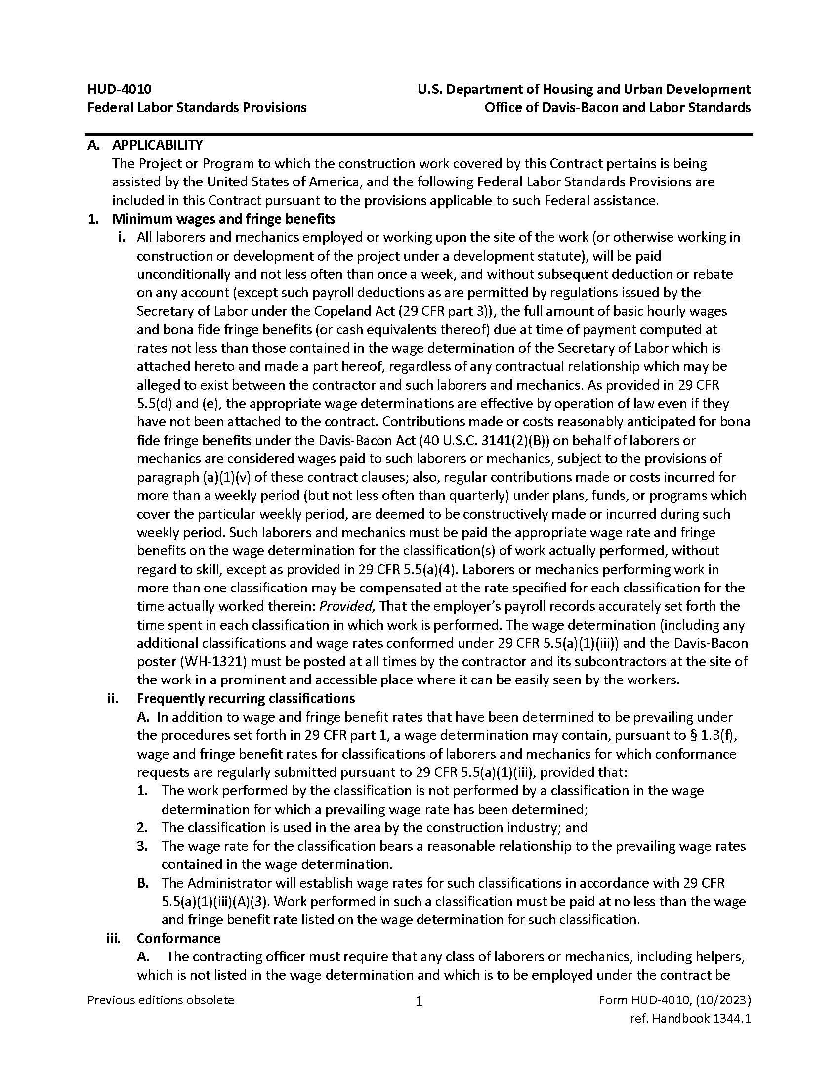

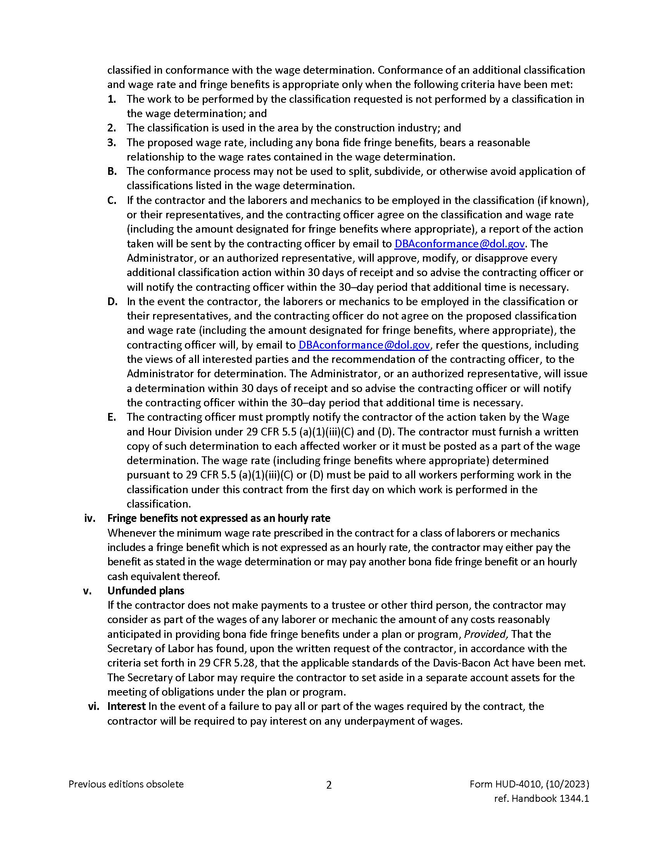

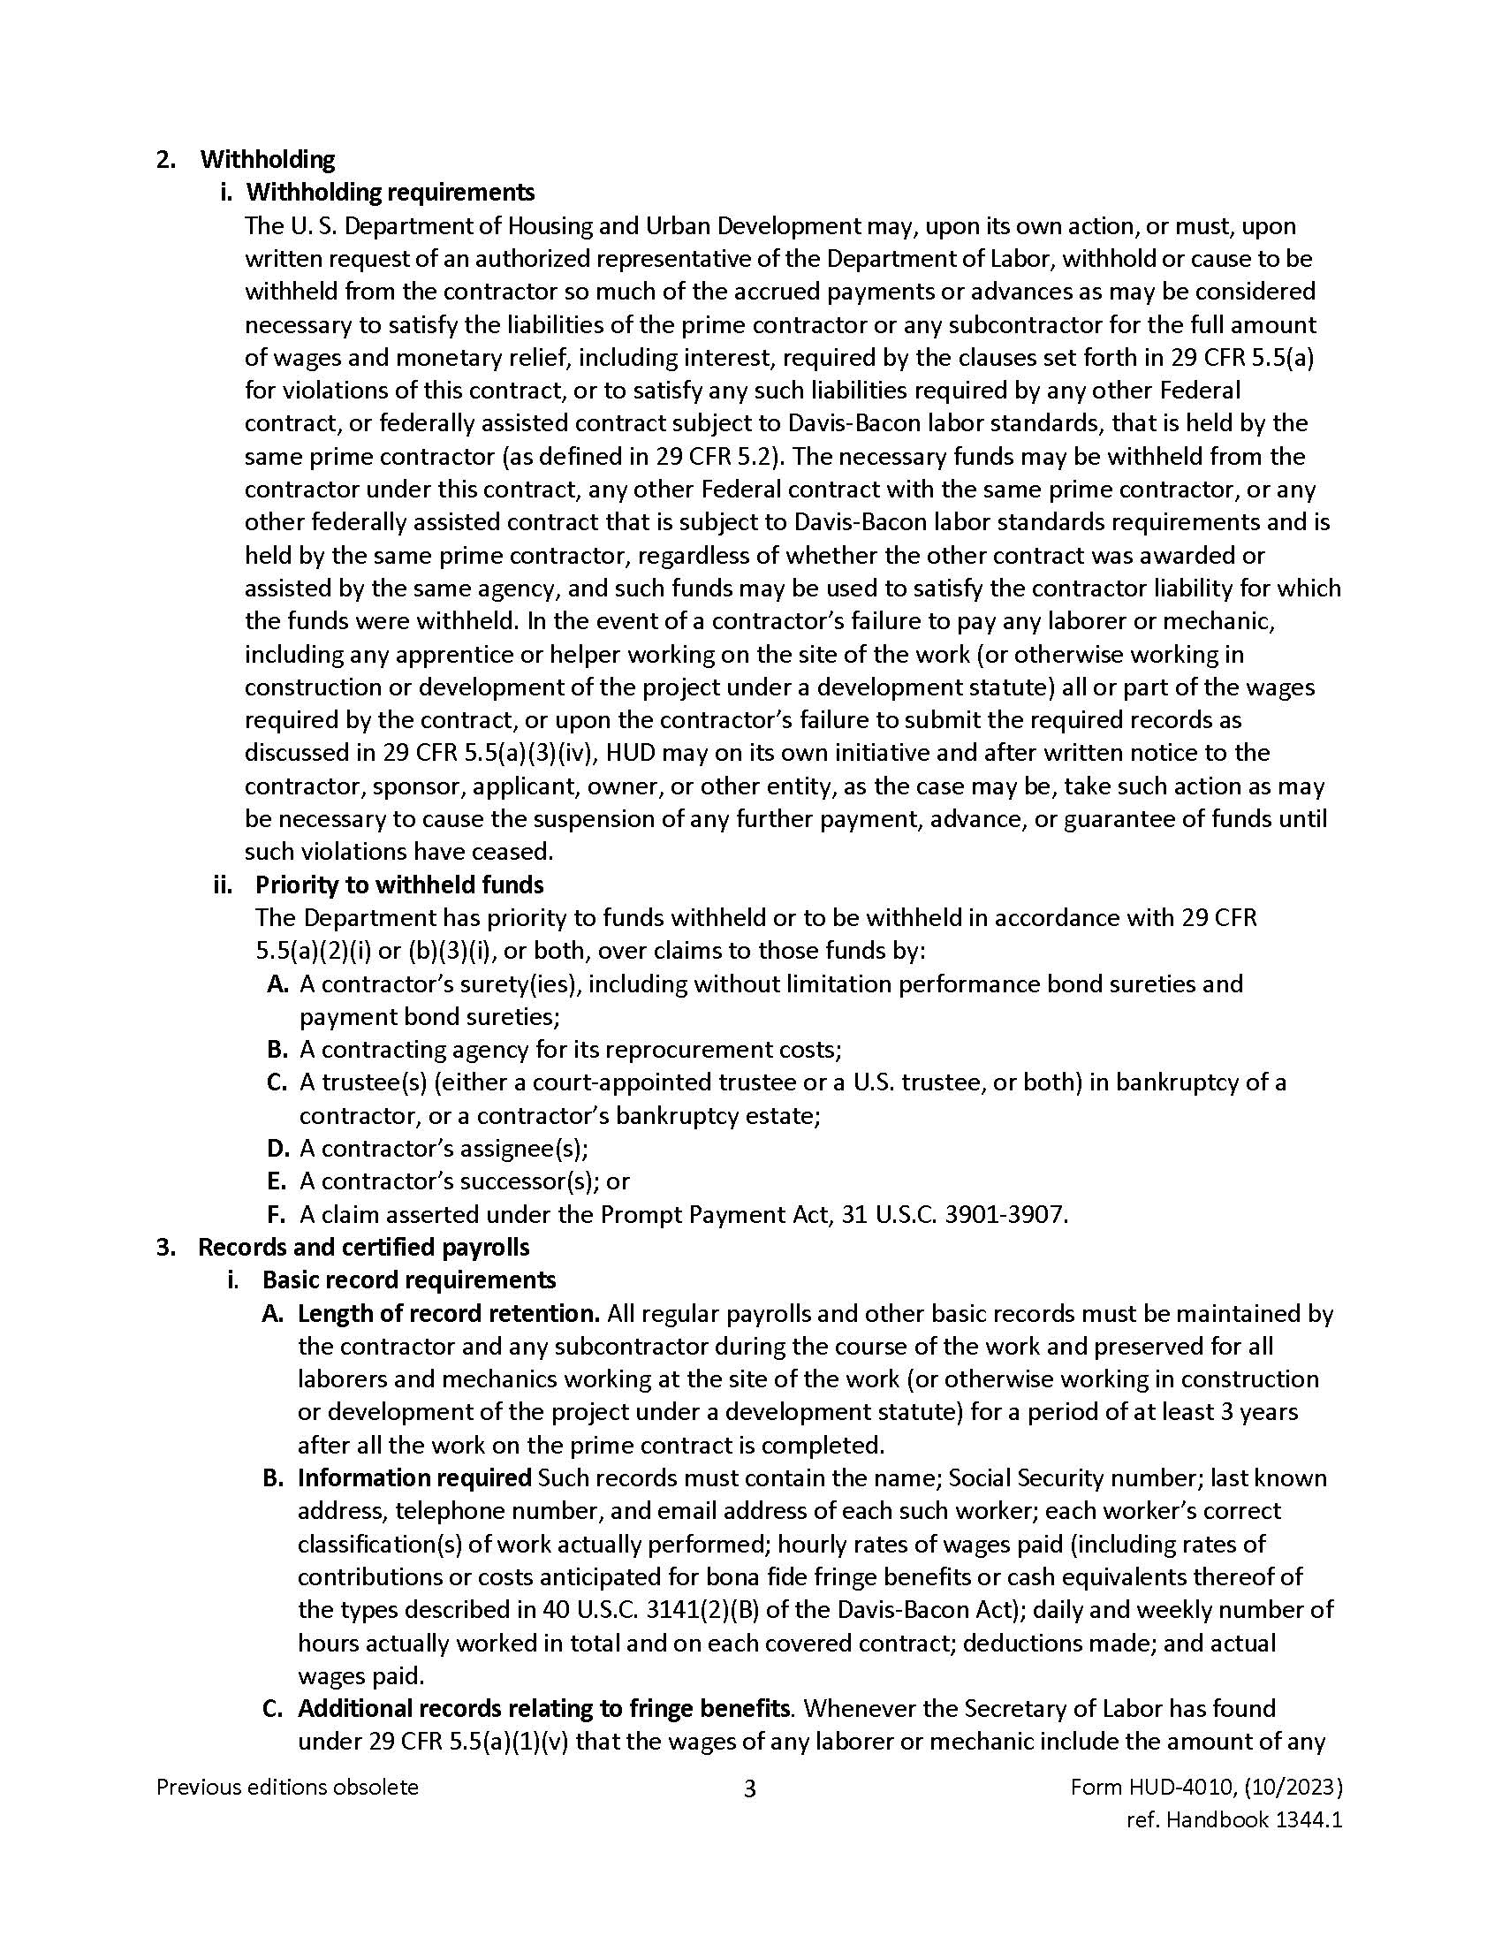

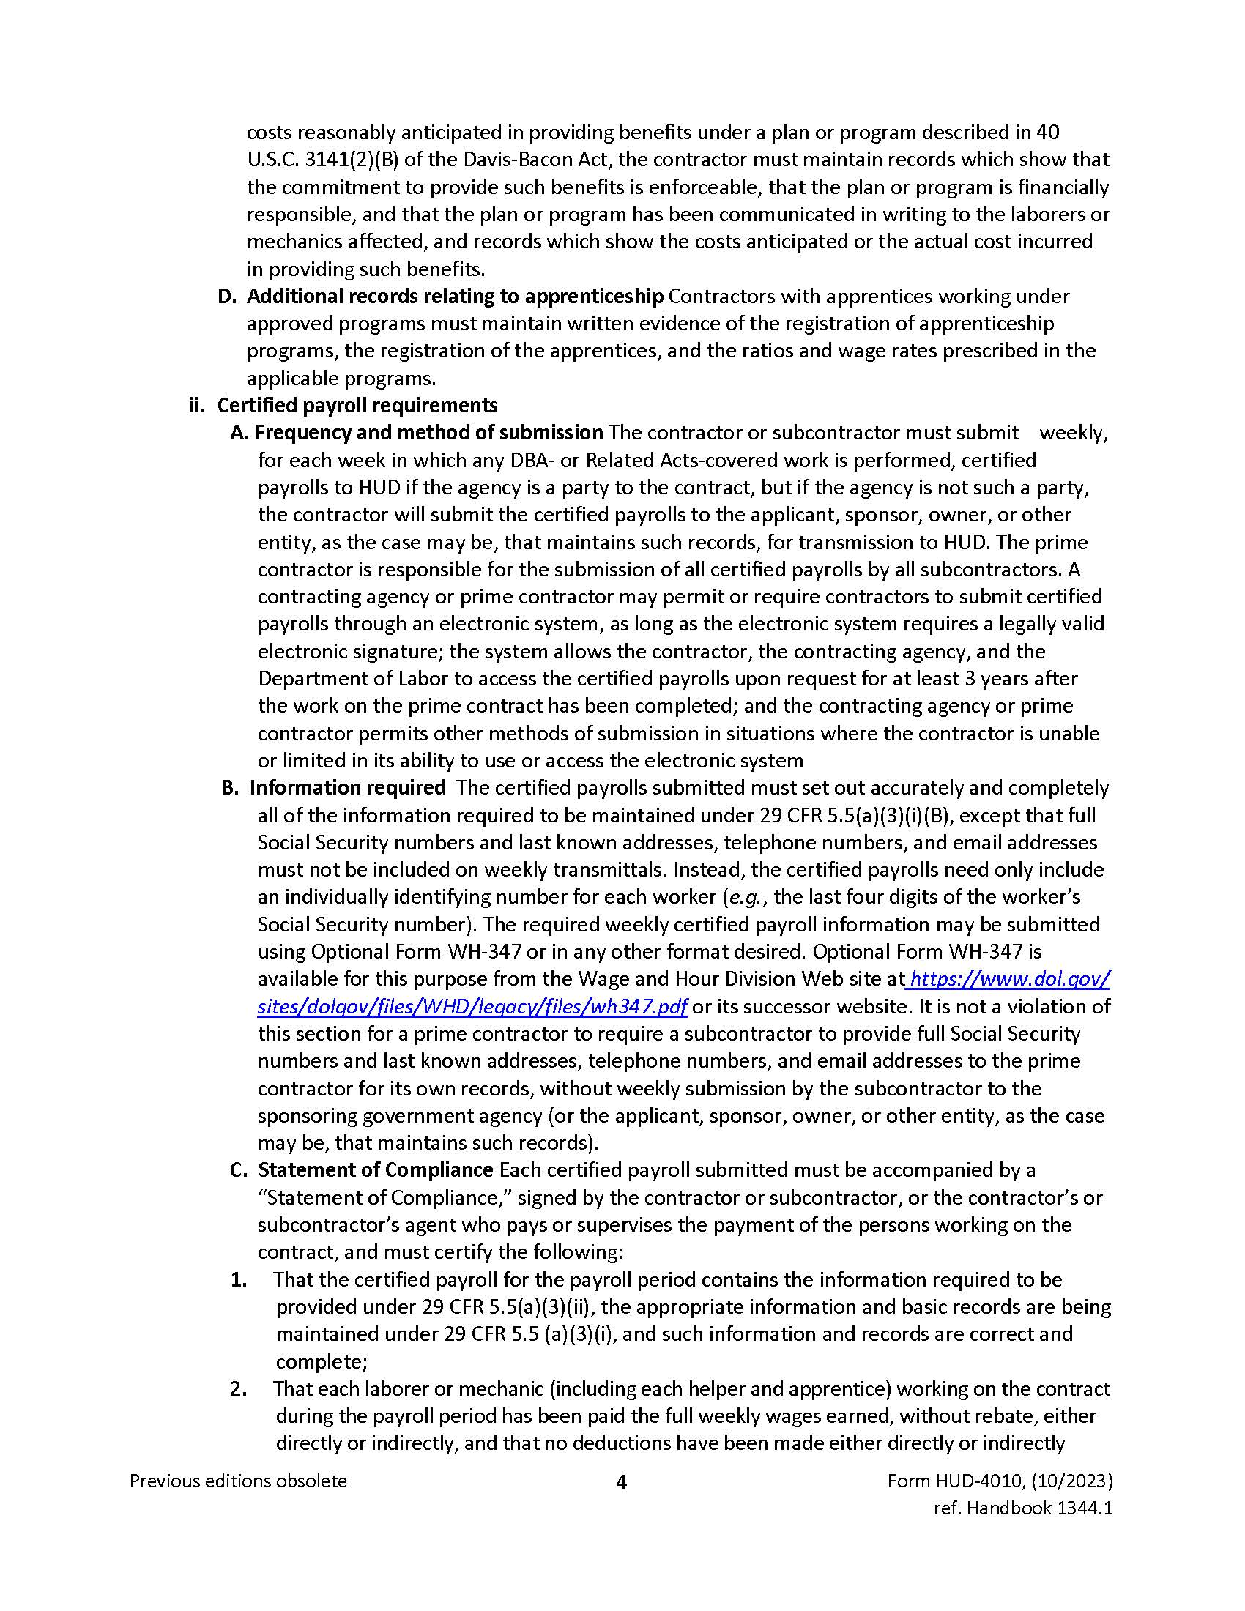

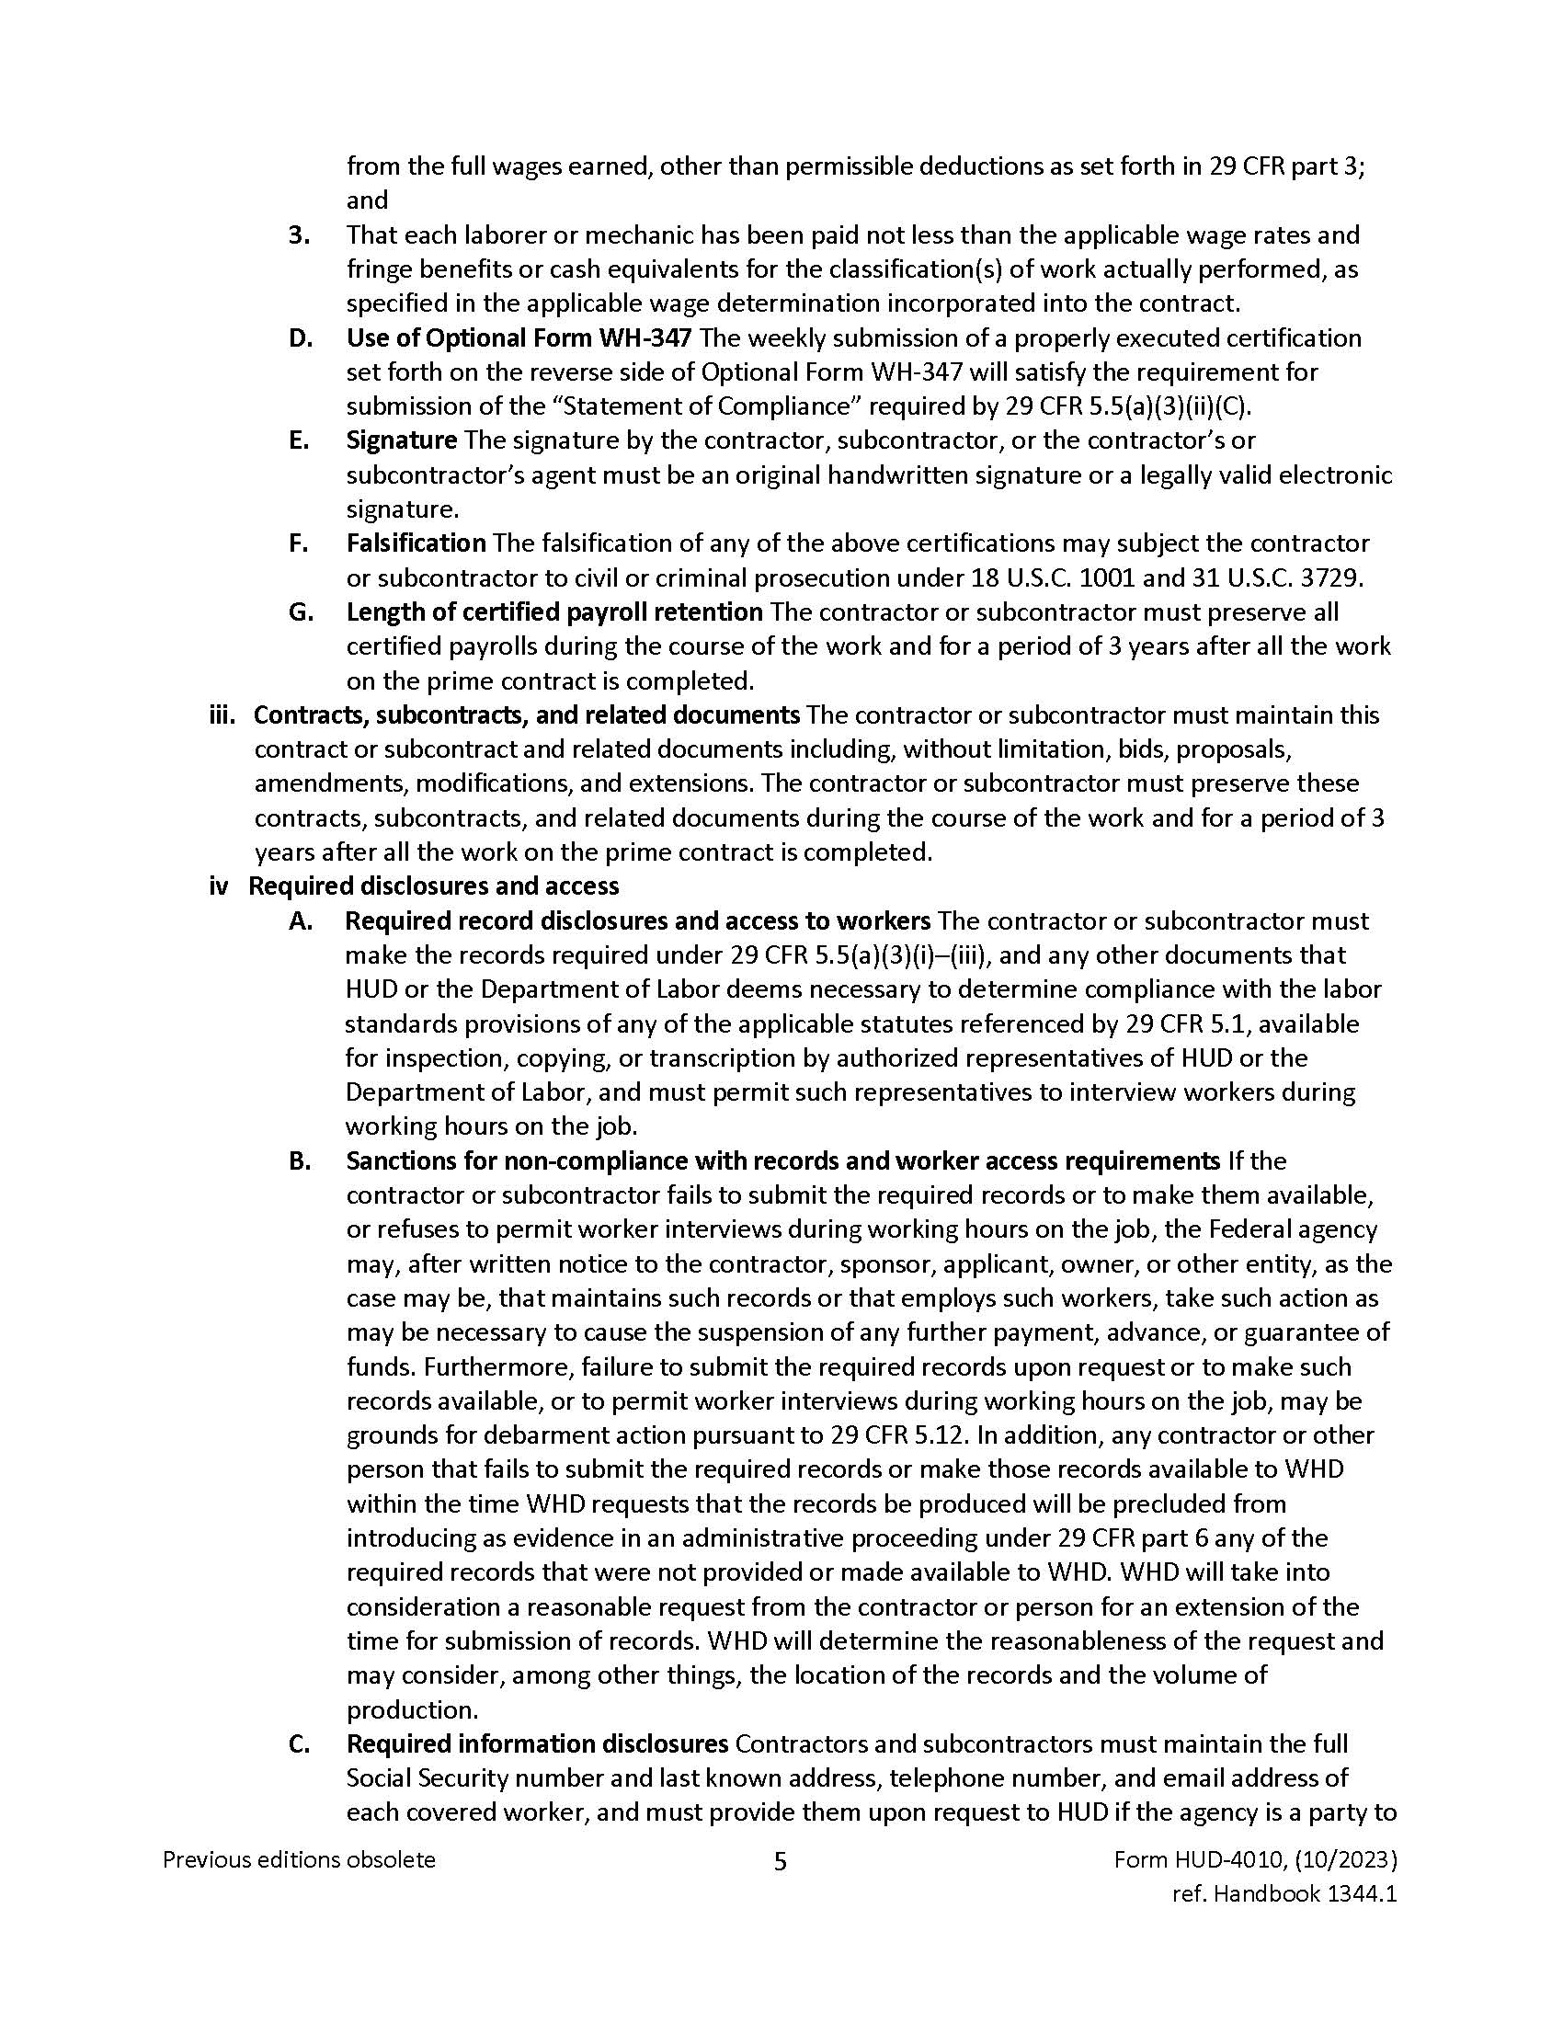

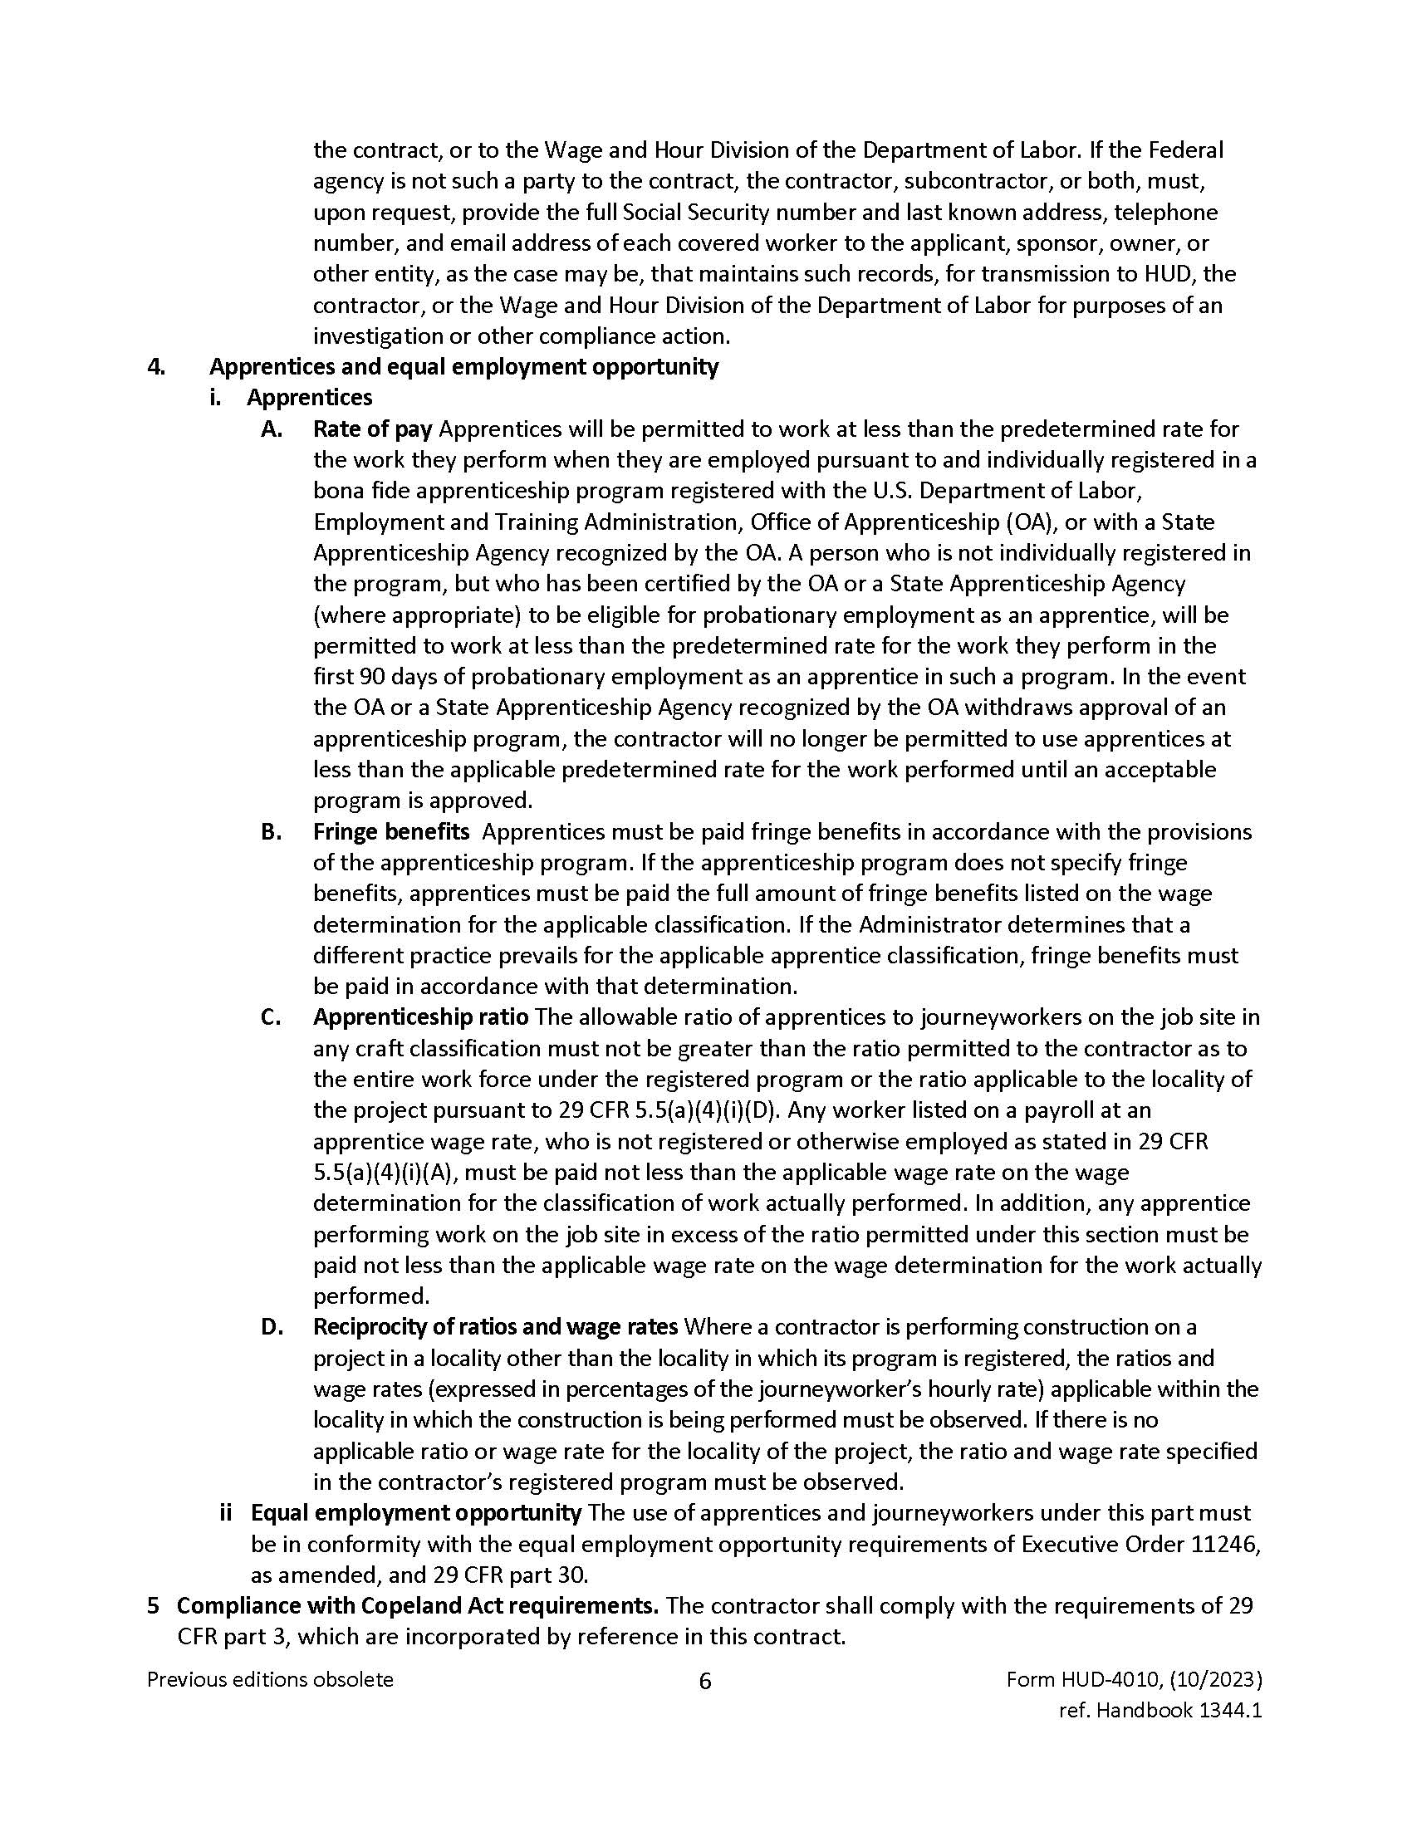

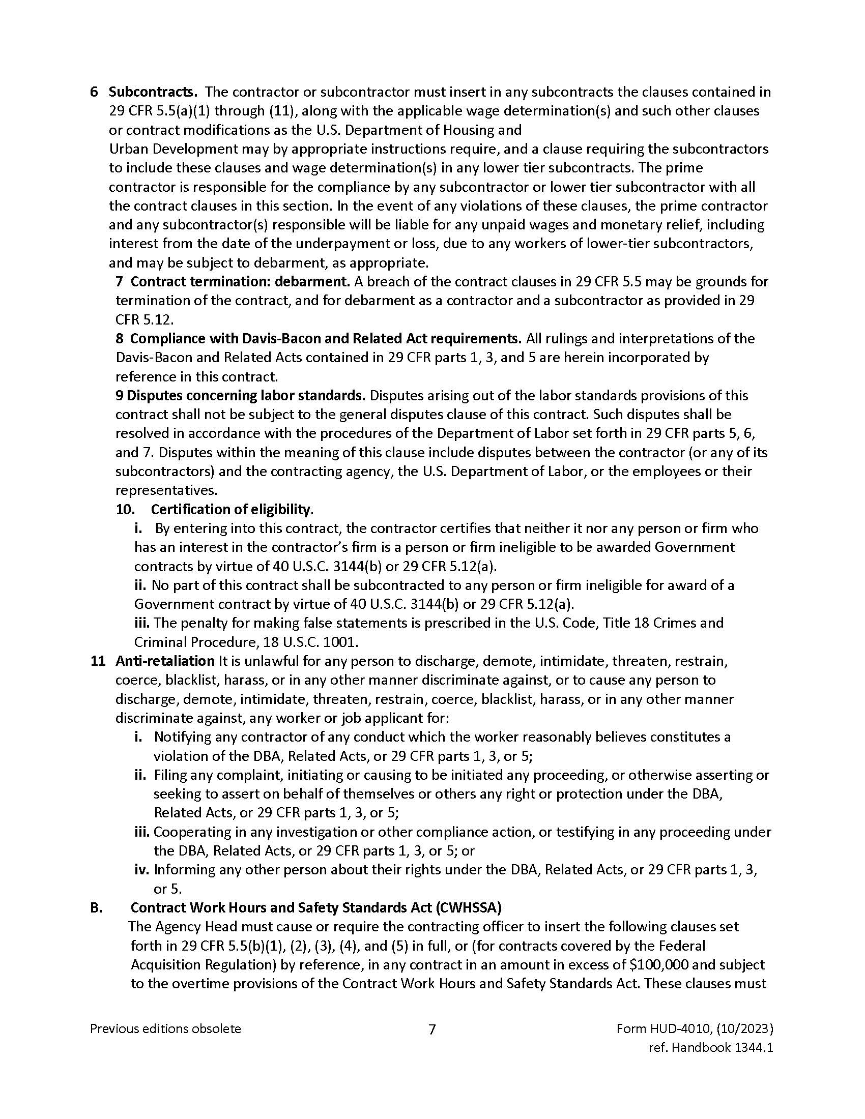

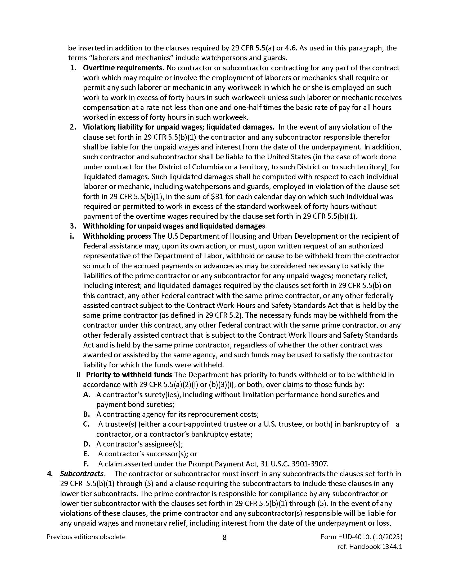

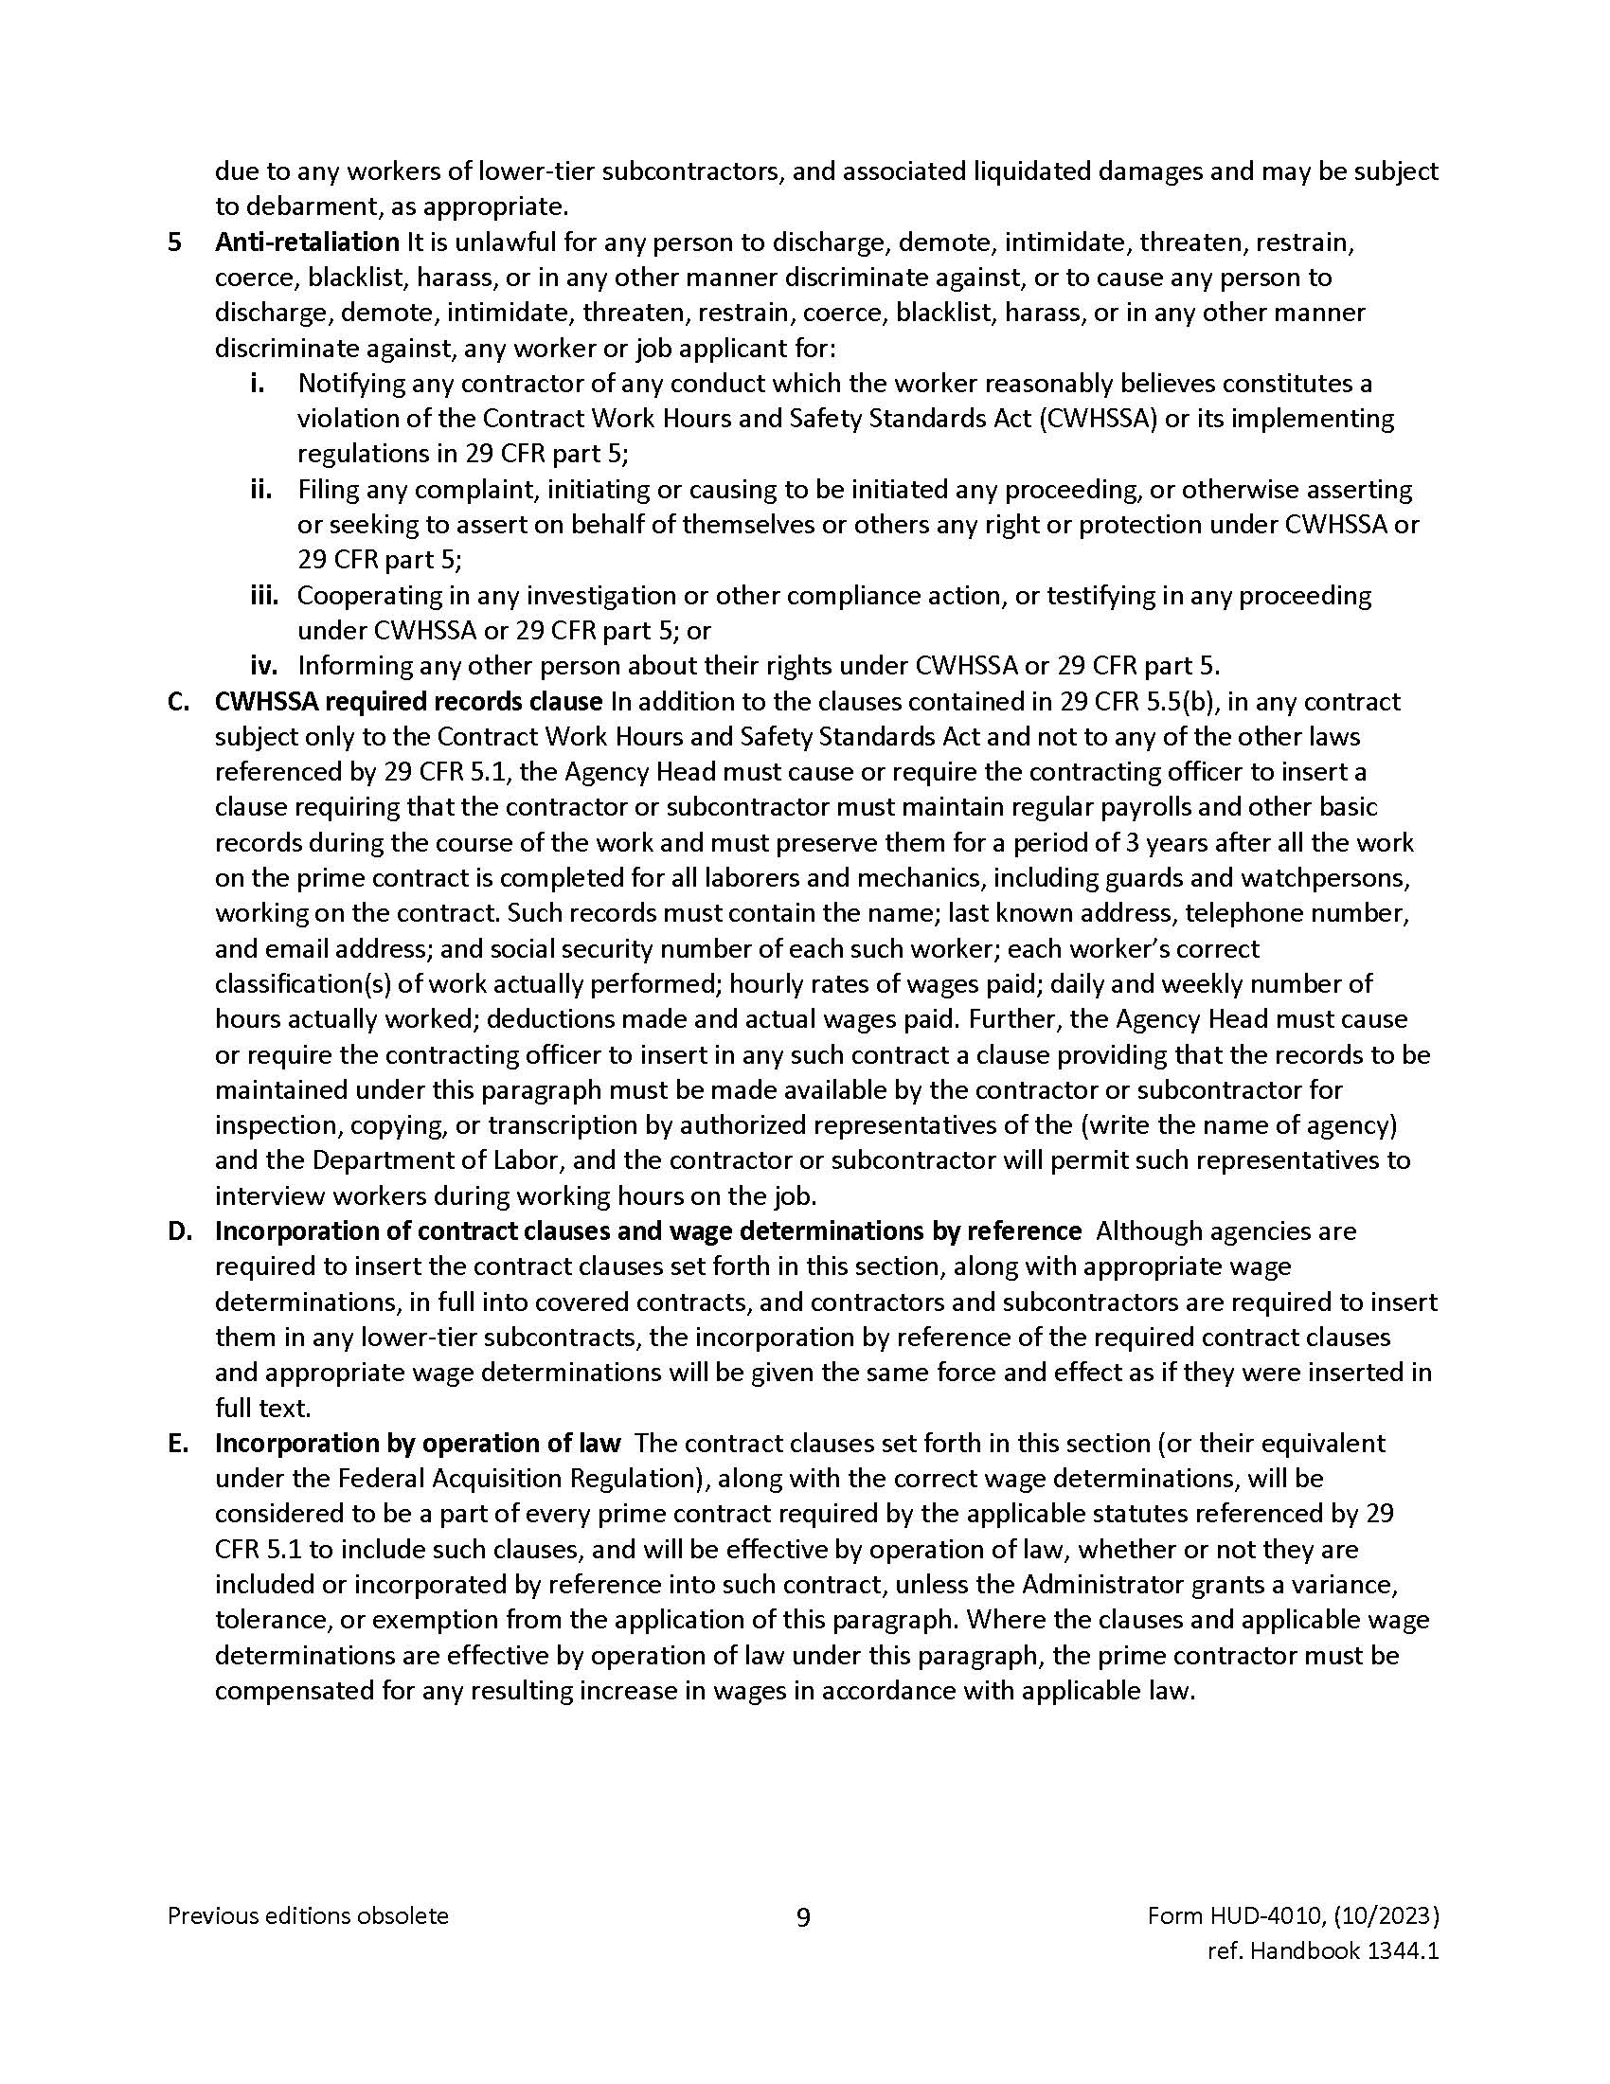

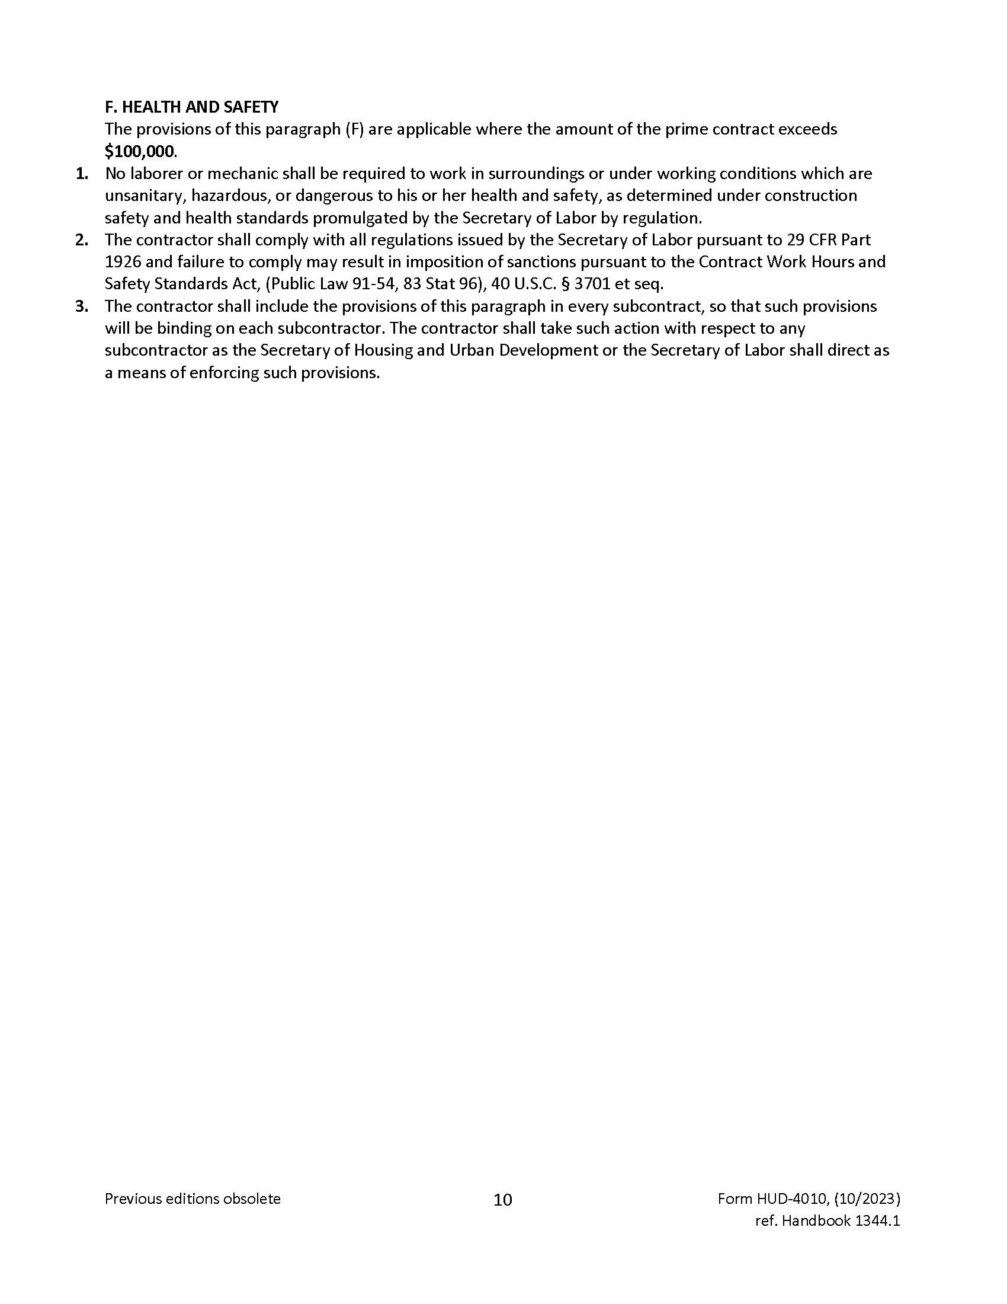

(Insert Davis Bacon Wage Decision Here)

https://sam.gov/wage-determinations

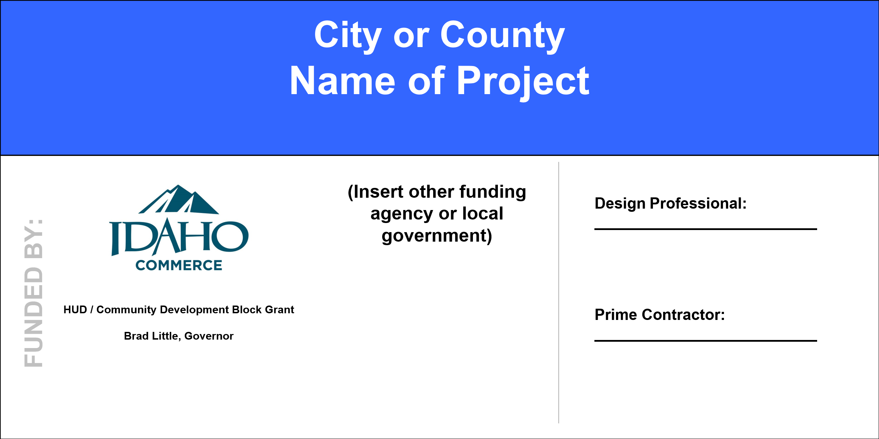


Prime Contractor’s Certification

Concerning Federal Labor Standards (Davis Bacon)

Local Government Name:__________________________________________________________________

Project Name:____________________________________________________________

The undersigned prime contractor, having executed a contract with
(Local Government)

in the amount of $____________ for the construction of the above-identified project, certifies that:

  - He/she will comply with the Federal Labor Standards Provisions (e.g. Davis-Bacon Act, Copeland Act, Contract Work Hours and Safety Standards Act) and Prevailing Wage Decision(s) are included in the project’s contract documents.

  - All laborers and mechanics employed on the project will be paid according to the appropriate Prevailing Wage Decision #_______________, MOD#__________________.

  - Corrections of any infractions of the Federal Labor Standards Provisions, including infractions by any subcontractors and any lower tier subcontractors, is this contractor’s responsibility.

  - Neither this contractor, any subcontractor, nor any affiliates, have been declared ineligible to participate in federally funded construction projects.

  - Contractor agrees to obtain and forward all Subcontractors’ Certification concerning Federal Labor Standards Provisions and Prevailing Wage requirements to the Local Government or Local Government’s representative within ten (10) days after execution of any subcontract.

Prime Contractor

Prime Contractor Signature

Date

Subcontractor’s Certification

Concerning Federal Labor Standards (Davis Bacon)

Local Government Name:____________________________________________________________________

Project Name:______________________________________________________________

The undersigned subcontractor, having executed a contract with for
(Prime Contractor)

(Nature of Work)

in the amount of $ _____________________ for the above-identified project, certifies that:

- He/she will comply with the Federal Labor Standards provisions (e.g. Davis-Bacon Act, Copeland Act, Contract Work Hours and Safety Standards Act) and Prevailing Wage Decision(s) as per the project’s contract documents.

- All laborers and mechanics employed on the project will be paid according to the appropriate Prevailing Wage Decision #_______________, MOD#__________________.

- Corrections of any infractions of the Federal Labor Standards Provisions, including infractions by any lower tier subcontractors, is this subcontractor’s responsibility.

- Neither this subcontractor, nor any affiliates, have been declared ineligible to participate in federally funded construction projects.

- This subcontractor agrees to forward a Subcontractor’s Certification concerning Federal Labor Standards provisions and Prevailing Wage requirements to the Prime Contractor within ten (10) days after execution of any subcontract.

Subcontractor

Subcontractor Signature

Date

Steps to Comply with Section 3

*This form must be completed by the subcontractor.

From: For:
Name of Subcontractor Name of Project

What is Section 3?
Under Section 3 of the Housing and Urban Development Act of 1968, whenever HUD financial assistance is given for housing or community development, to the greatest extent feasible, economic opportunities will be given to low income residents and businesses in that area. The project being awarded has Idaho Community Development Block Grant funding which is subject to HUD requirements. *Covered prime contractors and subcontractors are required to show a good faith effort to:

A. Provide employment and training opportunities for Section 3 Workers.
B Provide opportunities for Section 3 Businesses for supplies, services, and construction contracts.

Definition of a Section 3 Worker: A low-to-moderate income person residing in the County in which the ICDBG funds are expended. The person typically has an annual income of less than $45,000 or resides in public or Indian housing or is a recipient of housing voucher assistance.

Definition of a Section 3 Business: A business that has a majority (51%) ownership held by Section 3 Workers.

Part I. Affirmative Action Plan for hiring and training Section 3 Workers:
A. The total number of new hires I need for this project is _________.
B. Activities planned to meet Section 3 hiring objectives (check those applicable):
( ) Recruit through local advertising and social media.
( ) Recruit by contacting the local housing authority.
( ) Utilize the recruiting services provided by the Idaho Department of Labor.
( ) Utilize the services of local apprenticeship or training programs.
- The total number of my current employees I intend to use on this project is _______. The number of these who would be considered Section 3 Workers is ______.

Part II. Affirmative Action Plan for contracting (sub-subcontracts) with Section 3 Businesses:
A. Activities planned to recruit Section 3 Businesses:
( ) Recruit by submitting subcontracting bidding opportunities to the Idaho APEX Accelerator, the ITD Disadvantage Business Enterprise (DBE) program, and area TERO programs.
B. I will award ______contracts in connection with these project activities.
- Of any of the sub-subcontractors to be awarded are you aware if any are section 3 businesses?
Yes ____ No ____
- The total estimated dollar value of contracts awarded to Section 3 Businesses is $____________.

I certify to the greatest extent possible I will hire and train Section 3 Workers and will obtain construction subcontracts from Section 3 Businesses.

Signature (Subcontractor) Date

Preconstruction Conference Checklist
1. PROJECT NAME AND NUMBER | 2. LOCATION OF PROJECT (City, County)
3. BRIEF DESCRIPTION OF PROJECT | 4. CHARACTER OF CONSTRUCTION
3. BRIEF DESCRIPTION OF PROJECT | Building  Heavy  Highway |  | Residential  Other (specify)
5. WAGE DECISION NO. (include modification number, if any) |  | 6. CONTRACT AMOUNT:  $
7. PRIME CONTRACTOR | 8. DATE & PLACE OF CONFERENCE
9. GRANT ADMINISTRATOR | 10. ENGINEER/ARCHITECT
11. ATTENDEE LIST
Attached

Responsibilities of Consulting Engineer/Architect: (Does not “supervise” the contractor’s employees, equipment or operation.)

Assure owner obtains desired facility. Certifies payment estimates. Prepares any change orders. Requests any other funding as soon as allowed. General review of the work by a registered professional engineer/architect. Supervises resident inspector. Issues Statements of Substantial Completion. Provide as-built drawings. Approves shop drawings.

Responsibilities of Grantee/Governing Body: (Actual contracting Organization)

Monitors consultant, inspectors & contractor’s activities and provides funding agencies with a narrative explaining (1) any schedule slippage; (2) quantity overruns (analysis & explanation); (3) any significant problems, delays, or adverse conditions and the action taken or contemplated to resolve immediately; (4) any favorable developments. Approves change orders and payment estimates. Member of final inspection team. Works through engineer/architect.

Responsibilities of CDBG Grant Administrator (Must see that approval conditions are observed and represents the Grantee’s interests.) Works to ensure the project is in compliance with CDBG rules and regulations. Rules and regulation include, but are not limited, to project eligibility, acquisition, environmental, procurement, labor standards, citizen participation, and civil rights.

Responsibilities of Contractor: (Review contract terms.)

Furnished all materials, labor, equipment necessary to construct per plans & specifications. Notifies engineer/architect of any discrepancies. Completes job on schedule.

Responsibilities of Any Other Agency Contributing to the Project:

General Discussions of Contract:
    - Alternative Specifications: (Does everyone understand the alternatives applicable to the contract as awarded)?

    - Initiating Construction: (Notice to Proceed): __________

    - Completion Time of Contract: ___________days to substantial completion and ___________ days to final completion

    - Liquidated Damages: $_________ per day for delay of substantial completion and $__________ per day for delay of time between substantial completion and project completion.

    - Request of Extension of Contract Time: Must be made with a change order in writing to consultant or owner promptly.

    - Procedures for Making Partial Payments: Partial payment estimates prepared on the ________day of each month. Use form (USDA-RD) RD 1924-18, or EJCDC 1910-8-E, or AIA G702 & G703, or a similar form. The form should include, at a minimum, signature blocks and certification statements for the contractor, owner, and design professional to certify completion of work to date. Note: CDBG payments can take up to 30 days.

    - Guarantee on Completed Works: (Materials, Installed Equipment, Workmanship, Etc.): One year after substantial completion. Performance Bond is in effect one year after final acceptance.

    - Other Requirements of the Contract and Specifications which deserve special discussion by all parties:
        - Build America Buy America provision and certifications
      - Environmental/Cultural issues; mitigation measures.

    - Multiple Funding Agencies: Determine schedule of draws from each agency and discuss the timeline and timeliness of availability of funds.

Contractors Schedule and Other Personnel:

Manager/Supervisor: Cell Phone:

Other: Cell Phone:

A. Analyze Work Schedule in Sufficient Detail to Enable Consulting Engineer/Architect to Plan His Operations: (Considerations must be given to needs of Owner and the planned operations of other contractors.)

Contractor will provide work schedule to Engineer/Architect as soon as possible. Schedule showing monthly quantity completion for major items must be furnished before first payment estimates. Send copy to IDC.

B. Equipment to be used by Contractor:

C. Contractor’s Plans to Delivering Materials to Project Site: (Protection and storage of Materials.) as per contract documents.

Sub-Contracts: (Review and approval of proposed Sub-Contractors and their work schedules.)

Status of Materials Furnished by Owner:

A. Schedule for Future Deliveries:

B. Procedures to be adopted by contractor in accounting for and storing such materials:

C. Other: Storage Location

Change Orders: (Detailed explanation of procedure to be followed and clearance. Which must be obtained before changes are implemented). Required before additional work accomplished including quantity overruns. Estimate overruns, final cleanup change order. Use unit prices bid or if not applicable, negotiated unit or lump sum prices. Contractor warned may not be paid for changes if not covered by fully approved change order. Call for verbal approval if holding up work. Determine form to be used.

Staking of Work: (Clearly Define responsibilities of Architect/Engineer and Contractor. Engineer/Architect must furnish Line and Grade.)

Engineer/Architect to furnish baseline and bench marks per contract

Project Inspection:

A. Functions of Consulting Architect/Engineer. Including Records and Reports: All inspection must be recorded. Copy of page entries made available to CDBG Grant Administrator or IDC Representative, if requested.

B. Responsibilities of Owner: Monitor, pre-final, final inspection, 11-month inspection after substantial completion.

C. Safety and Sanitary Regulations: OSHA and AGC’s Manual.

Final Acceptance of Work: Final Acceptance of Work: (Include requirements for tests and cleanup of project site.)

When everything is 100% complete.

Right-of-Way and Easements:

A. Explain any Portion of Project Not Available to Contractor:

B. Contractors Responsibilities During Work Covered by Contract:

Protect adjacent property.

C. Coordination with Railroads, Highway Departments and Other Organizations:

Davis-Bacon and Related Acts (DBRA) requires the payment of prevailing wage rates to
all laborers and mechanics working on the construction site. The prevailing wages for this project are listed in the contract documents. Prevailing wages include a basic hourly rate of pay and in most cases a fringe benefit payment.

The Copeland Act makes it a crime for anyone to require any laborer or mechanic to kickback any part of their wages. Consequently, the only deductions that can be taken out of employee’s paychecks are those required by law or those authorized by the employee in writing. The Copeland Act also requires that every contractor pay their employees weekly and submit weekly certified payroll reports (CPRs).

The Contract Work Hours and Safety Standards Act (CWHSSA) requires time and one-half pay for hours worked over 40 in any workweek. The time and one-half is computed on the basic hourly wage and then the fringe amount is added to it. CWHSSA violations carry a liquidated damages penalty of ten dollars per day per violation. Intentional violations of CWHSSA standards are considered a Federal criminal misdemeanor.

Additional Classifications
If the work classification(s) needed do not appear on the wage decision, a request for an additional classification and wage rate will be needed. The grant administrator can assist you in this process. These additional classifications and rates must be approved by the USDOL.

Post on Job Site
The contractor is required to display in a conspicuous place the following:
The Wage Decision for this project.
All Additional Classifications for this project.
The Secretary of Labor’s Wage and Hour poster (See page 57)
Equal Employment Opportunity Poster

Payrolls
A. Original payrolls must be submitted weekly by all contractors and subcontractors.

B. Contractors are not required to use Payroll Form WH-347; but the payroll used must contain all of the information that is required on the WH-347 and the Statement of Compliance must be the exact wording as on the reverse of WH-347.

C. Payroll deductions must be made according to USDOL Regulations 29 CFR Part 3. These regulations prohibit the employer from requiring employees to “kick-back” any of their earnings.

D. If fringe benefits are paid to a plan instead of in cash, the hourly contribution must be determined. Documentation of the plan and the amount paid into the plan per employee must be submitted with the first payroll.

E. If payrolls are not numbered sequentially by the respective contractor or subcontractor, then submit a letter or the “No Work” form to the contract administrator for the period that work is not performed so that a continuous record is maintained. A form may be submitted for extended periods of inactivity on the job.

F. General and all subs submit Signature Authorization Form stating who is designated to sign payrolls if someone other than the owner signs them (see page 59).

G. Payrolls must be submitted to the Prime Contractor, within seven (7) days after the payroll period ends.

H. Prime Contractor must submit payrolls to the Grant Administrator.

Contractor/Subcontractor Certifications Concerning Labor Standards (See pages 43-46). Contractor/subcontractor certifications are to be submitted within ten (10) days of signing the contract.

Prime contractors are responsible for the payment of employees of subcontractors and lower tier subcontractors in compliance with Labor Standards Provisions.

Split Classification
If employees perform work in more than one classification during the workweek, the wage rates specified for each classification can be paid only if accurate time records are maintained showing the amount of time spent in each classification of work. If there is a dispute, the contractor will be asked to provide the employee time records. If accurate time records are not maintained, the employees must be paid the highest wage rate of all the classifications for work performed.

Proper Designation of Trade
The classification of each employee must be selected from the wage decision or an approved Additional Classification based on the actual type of work performed. Each worker must be paid no less than the wage rate on the wage decision for that classification regardless of their level of skill. In other words, if someone is performing carpentry work on the project, they must be paid no less than the wage rate on the wage decision for Carpenters, even if they aren’t considered by the contractor to be fully trained as a Carpenter. The only people who can be paid less than the rate for their craft are apprentices registered with the USDOL.

Foremen
Foremen or supervisors that regularly spend more than 20% of their time performing construction work are covered laborers and mechanics (workers, employees) for labor standards purposes and must be paid the designated wage for the classification in which they work.

Relatives
Relatives are not exempt from Davis-Bacon requirements and must be paid the prevailing wage rate for the classification of work performed.

Apprenticeship Provisions
Idaho does not have an approved (by the USDOL) apprenticeship or trainee program, so all apprentices must be registered with the USDOL, Bureau of Apprenticeship and Training, to be paid less than the Davis-Bacon rate for the work they perform.

1. Documentation of Apprentice registration must be submitted with the first payroll on which he appears. If the papers are not submitted, the employee must be paid the mechanic rate for the classification of work being performed. The apprentice must be registered prior to going to work on the job.
2. The Journeyman - Apprentice ratio must be observed. If more apprentices per journeyman are used than permitted, the extras must be paid at the journeyman’s rate.

The Idaho Department of Labor’s Apprenticeship Idaho program can help contractors register workers in an approved USDOL registered program. Apprenticeship Idaho acts as a liaison between Idaho contractors and the USDOL-Office of Apprenticeship. They will help contractors develop their Registered Apprenticeship Program (RAP), write standards, and get them registered.
Contact the Apprenticeship Idaho team at: apprenticeship@labor.idaho.gov

Wage Interviews
Every contractor must make their employees available for interviews at the job site with the grant administrator or other agency representative.

Working Subcontractors
In the event the general contractor or the subcontractor hires a self-employed proprietor (someone who has no employees so will perform all the work himself/herself), the Davis-Bacon rate must be paid.

The following procedure must be followed:
1. Report the self-employed proprietor on the certified payroll of whoever hired them.
2. “Owner-operators” of trucks who are independent contractors and working on site, must be reported on weekly payrolls. The payrolls do not need to show the hours worked or rates, only the notation Owner-operator.”

Truck Drivers
Truck drivers employed by a construction contractor or construction subcontractor are not covered by Davis-Bacon prevailing wage requirements while engaged in transporting materials or supplies to or from (BUT NOT DIRECTLY ON) the site of the work. These truck drivers must be paid Davis-Bacon rates for their time spent while employed “directly upon the site of the work.” They would also be covered while hauling between the project site and any special facilities established exclusively for the project (i.e., “dedicated facilities” under 29 CFR 5.2(1)(2)).

Violations can result in:
Withholding of funds, termination of the contract or contractor debarment.

Equal Employment Opportunity
The contractor will not discriminate against any employee or applicant for employment because of race, color, religion, sex, or national origin. The contractor will take affirmative action to ensure that applicants are employed, and that employees are treated during their employment without regard to their race, color, religion, sex, or national origin. Such action shall include, but not be limited to the following: employment, upgrading, demotion, or transfer; recruitment or recruitment advertising; layoff or termination; rates of pay or other forms of compensation; and selection for training, including apprenticeship. The contractor agrees to post in conspicuous places, available to employees and applicants for employment, notices to be provided setting forth the provisions of this nondiscrimination clause. For full explanation see Executive Order 11246.

Section 3
- What is Section 3?
Whenever HUD financial assistance is given for housing or community development, to the greatest extent feasible, economic opportunities will be given to low to moderate income residents and businesses in the area. This project being awarded has Idaho Community Development Block Grant funding which is subject to HUD’s Section 3 requirements.
Covered prime contractors and subcontractors are required to show a good faith effort to:

Provide employment and training opportunities for Section 3 Workers.
Definition of a Section 3 Workers: A low to moderate income person residing in the County in which the ICDBG funds are expended. A low to moderate income person typically has an annual income of less than $45,000 or resides in public or Indian housing or is a recipient of housing voucher assistance.
Provide opportunities for Section 3 Businesses for Individuals construction contracts.
Definition of a Section 3 Business: A business that has a majority (51%) ownership held by Section 3 Residents.

- Covered contractors must keep records documenting good faith efforts taken and results of these efforts.

- Contractors are required to complete a Steps to Comply with Section 3 and a Section 3 Summary Report. The Section 3 Summary Report must be submitted to the Idaho Department of Commerce prior to substantial completion.

Placement of Project Signs & Posters:

EEO Poster in office where hiring and on-job trailer. Provide contractor with information for project sign. Location of sign.

Handling Disputes: First try informally in conference with all parties.

Contractor Signature Date

Owner/Grantee Signature Date

Grant Administrator Date

Design Professional Date

Send copy to Department of Commerce. Attach signup sheet of subcontractors and other attendees

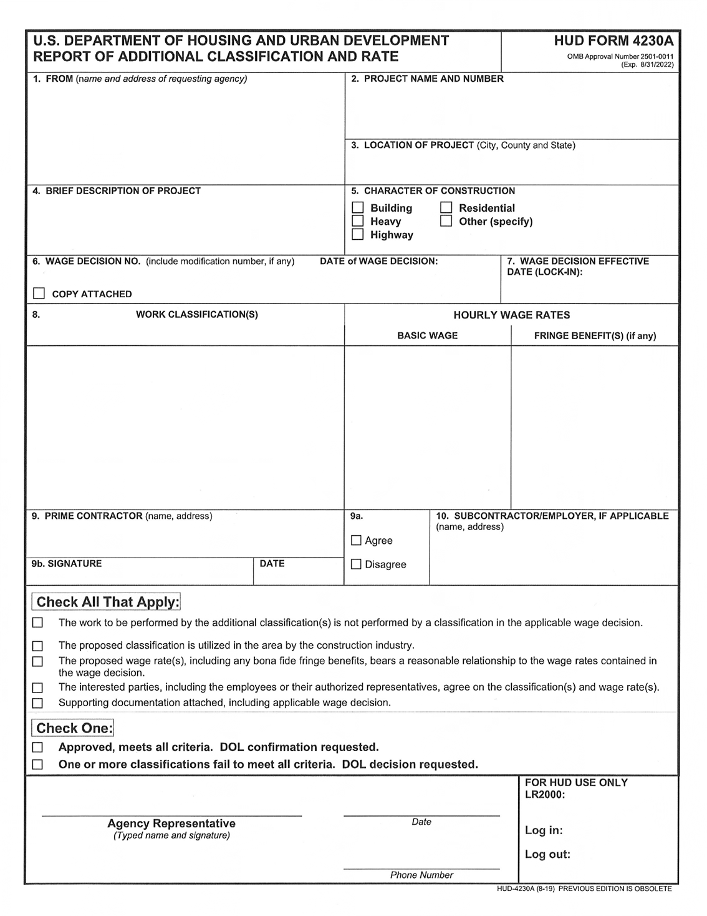
SUBJECT TO APPROVAL BY THE U.S. DEPARTMENT OF LABOR
Idaho Department of Commerce
Community Development Division
P.O. Box 83720
Boise, ID 83720-0093

Instructions for filling out the Additional Classification and Wage Rate Form 4230A

Submit a written, signed request to Commerce naming the work classifications and the wage rates, including any fringe benefits that are proposed.

Grant Administrator: Complete items 2 through 10 and all “check all that apply” fields. Submit a copy of this form to Commerce with a complete copy of the applicable Davis-Bacon wage decision.

- Enter the name and address of the submitting the report and to which the DOL reply should be sent.
- Enter the name and number of the project or contract involved.
- Enter the location of the project involved: city, county and state.
- Describe the construction involved, e.g., new construction or rehabilitation, number and type of buildings, number of stories, number of units (as applicable). For example, new construction: 3-4 story buildings; 120 units.
- Enter the character of construction as defined by DOL for Davis-Bacon prevailing wage rate purposes.
- Enter the number of the Davis-Bacon wage decision applicable to the construction work. Include the number of wage decision modifications (if any) applicable to the work.
- Enter the effective date of the wage decision for the project. (See DOL regulations at 29 CFR 1.6.)
- Enter the work classifications and corresponding hourly basic wage rates and fringe benefit rates (if any) requested.
- Self-explanatory.
- If the requesting employer is not the prime contractor, enter the name and address of the subcontractor/employer making the request.

Remainder of the form:

Evaluate the employer’s request against the criteria for approval (see DOL Regulations, 29 CFR Part 5, and related contract labor standards provisions). The criteria are reflected in the “Check All That Apply” section to ensure that each factor is considered and met. Check the box next to each criterion that is met; do not check the box next to any criterion that is not met.

Submit the completed form to Commerce with a copy of the applicable Davis-Bacon wage decision.

Commerce: If the request meets all criteria, Commerce will check the appropriate box, sign and date the form, enter agency contact information and submit a copy of the completed form to the DOL for approval.

Payroll Signature Authorization Form

Certificate from Contractor Appointing Officer
or Employee to Supervise Payment of Employees
(HUD -5282)

Grant Recipient CDBG No.

Project Name Date

Location

(I) (We) hereby certify that (I am) (we are) (the prime contractor) (a subcontractor) for
(Specify “General Construction,” i.e., plumbing, electrical, etc.) in connection with construction of the above mentioned CDBG¹ Project, and (I) (we) have appointed , whose signature appears below, to supervise the payment of (my) (our) employees beginning (Date: mm/dd/yyyy) ; That he/she is in a position to have knowledge of the facts set forth in the payroll documents and in the Statement of Compliance required by the so-called Kick-Back Statute that he is to execute with (my) (our) full authority and approval until such times as (I) (we) submit to the (Grant Recipient) a new certificate appointing some other person for the purposes hereinabove stated.

(Identifying Signature of Appointee) (Name of Firm or Corporation)

By:
(Signature) (Signature)

(Title) (Title)

(Date) (Date)

NOTE: This certificate must be executed by an authorized officer of a corporation or by a member of a partnership, and shall be executed prior to and submitted with the first payroll. Should the appointee be changed, a new certificate must accompany the first payroll for which the new appointee executes a statement of compliance required by the Kick-Back Statute.

Payroll Overview

Project Name:

Contractor/Subcontractor:

Wage Decision No. and Modification(s):

Name of Payroll Clerk

Contact Information for Payroll Clerk

List below the job classification, basic hourly rate, and fringe benefit rate for each job classification of employees you will utilize during the entire project. You must use the job classification from the approved wage decision listed above. If the approved wage decision does not include a job classification needed for the project, an additional job classification must be obtained. Contact the Grant Administrator for assistance.

JOB CLASS | BASIC HOURLY RATE* | FRINGE BENEFIT RATE | OVERTIME RATE
“Power Equipment Operator – Bulldozer”
*The basic hourly rate includes the zone rate where applicable

Check the applicable box:
- All Fringe benefits are paid in cash for all employees.
- All Fringe benefits are paid to a plan for all employees
- Fringe benefits are paid part in cash and part to a plan for all employees

If Fringe benefits are paid in whole or part to a plan, attach a copy of the:
- Letter from U.S. Department of Labor declaring plan acceptable (if available) or;
- Letter from the Idaho Department of Commerce – CDBG Program declaring plan acceptable (if available), include documentation of payment within last quarter and documentation of renewal of plan if plan expired since date of letter or;
- Plan(s) and documentation(s) of payment for all funded plans, including but not limited to the Health Insurance Plan, Retirement Plan, Liability Insurance, and Disability Insurance.

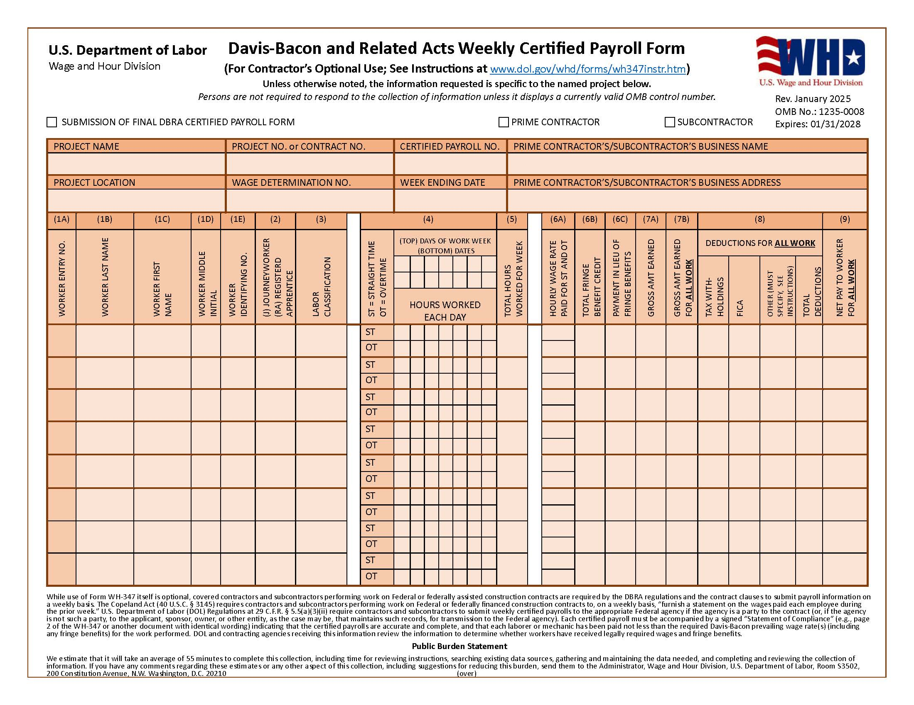
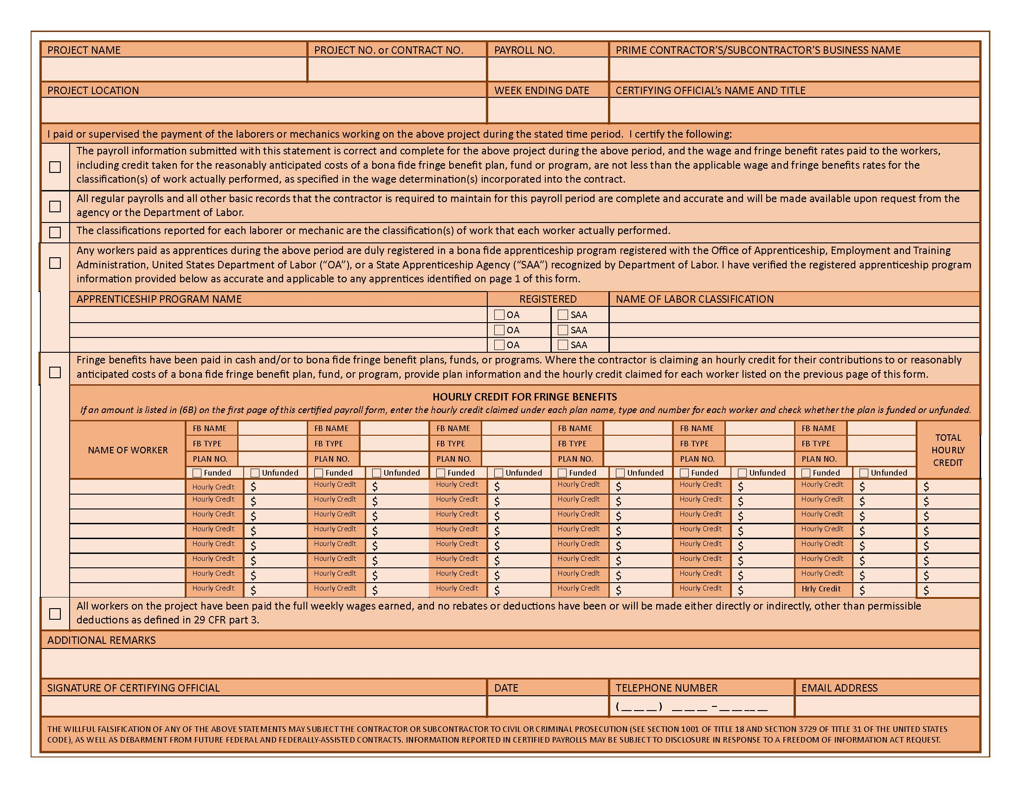

NO WORK PERFORMED

I hereby certify that no work was performed by the undersigned contractor and/or employees on the construction of:

Project No.:

Project Name:

During the period dating from 20

through 20 .

By:

Title:

Date:

Contractor:

Comments: _______________________________________________________________________________________________________________________________________________________________________________________________________________________________________________________________________________________________________________________________.

Employee Voluntary Deduction Authorization Form

Date:

Project Name:

CDBG Project Number:

I have chosen to enroll in the payroll deduction programs made available on a voluntary basis. I hereby authorize , my employer, to withhold from my compensation for the programs checked below for the corresponding, one time only deduction program or a continuous deduction program. The consent to participate in these programs is not a condition either for the obtaining of or for the continuation of employment.

One time Continuous

Only

Reconciliation of a wage advance – 29 CFR 3.5 § b

Health Insurance plan – 29 CFR 3.5 § d

Retirement Plan (IRA, 401K, or other pension plan) – 29 CFR 3.5 § d

Liability Insurance – 29 CFR 3.5 § d

Disability Insurance – 29 CFR 3.5 § d

Vacation Plan (funded program) – 29 CFR 3.5 § d

Loan Repayment to Credit Unions– 29 CFR 3.5 § f

Union Dues – 29 CFR 3.5 § i

Tool withholding, which is a direct benefit to me – 29 CFR 3.5 § j & k

Other:

Other:

(Type of Print Name of Employee) (Signature of Employee)

WAGE DETERMINATION UPDATE FORM

Project:

CDBG-

IDC Project Manager:

Date/Time:

Bid Opening Scheduled For (Date/Time):

Projected Contract Award Date:
Is Contract Award Date within 90 days of Bid Opening? (If No, a new Wage Rate Update will be required prior to Award)

Wage Decision Used in Bid Document:

Highway ID Modification # Publication Date:

Heavy ID Modification # Publication Date:

Building ID Modification # Publication Date:

Residential ID Modification # Publication Date:

Are these rates still current? Yes No

If no, the new Wage Decision that will apply to the project:

Highway ID Modification # Publication Date:

Heavy ID Modification # Publication Date:

Building ID Modification # Publication Date:

Residential ID Modification # Publication Date:

Comments:

Signed:

Certified Grant Administrator

CONTRACTOR ELIGIBILITY FORM

(Debarred Check)

Project:
CDBG-

IDC Project Manager:

Project Description:

Bid Opening Date/Time:

Projected Contract Award Date:
(If Contract Award date is more than 90 days after Bid Opening date, a new Wage Rate Update will be required prior to Award)

Wage Rates to be Used in Contract:

Highway ID Modification # Publication Date:

Heavy ID Modification # Publication Date:

Building ID Modification # Publication Date:

Residential ID Modification # Publication Date:

Name of Company:

DUNS Number:

Company Address:

President/CEO: ________________________________

Bid Amount:

Date of Clearance:

Signed:

Specialist

Idaho Department of Commerce

Contractor/Subcontractor Weekly Payroll Review Form

Contractor/Subcontractor Name:__________________________Project/Grant No.___________
Date Reviewed/Reviewed by: _______________________
Yes No N/A
- Did the Contractor attend the pre-construction conference?

- Did the Contractor complete the Contractor/ Subcontractor Certification concerning Labor Standards and Wage Requirements?

- Did the Contractor execute the Payroll Authorization Form?

- Did the Contractor request for an additional classification? If yes:
Has the classification been approved by the US DOL?

- Is the Contractor submitting its payrolls on a weekly basis?

- Is the Contractor utilizing the proper payroll form (WH-347) or electronic version of the form?

- Has the following information been provided on the payroll?
- Name of Contractor?
- Payroll Number and Week Ending?
- Project and Location
- Employee(s) Name and Identification Number?
- Work Classification
- Hours Worked Each Day?
- Total Hours?
- Rate of pay? _____ _____ _____
- Gross amount earned? _____ _____ _____
- Deductions and net wage? _____ _____ _____
Is the Contractor paying overtime if employee worked over 40 hours in the week? _____
Are the overtime hours correctly computed (1.5 times base plus fringe)?

- Has the Contractor’s authorized payroll agent completed the “Statement of Compliance”?

- Is the “Statement of Compliance” signed by the authorized agent?

- Is the agent the same individual as identified on the Payroll Authorization Form?

- Are fringe benefits paid to an approved plan or fund?

If yes:
Do you have documentation that the plan is acceptable? _____ _____ _____
Do you have a copy of the plan on file? _____ _____ _____
- Are fringe benefits paid in cash?

Yes No N/A
- Is the fringe paid to the plan less than the amount required to be paid in the wage decision?
_____ _____ _____
If yes, is the difference paid in cash? _____ _____ _____
- Is the Contractor utilizing apprentices? If yes:
Is the apprentice enrolled in an USDOL approved program? _____

- Is the Contractor utilizing a foreman? If yes:
Is it a project foreman (does not appear on payrolls)?
Is it a working foreman (does appear on payrolls)?

- Is the Contractor paying in piece work? If yes:
Are the employees being properly paid?

- Is the Contractor using a self-employed Subcontractor? If yes:
Is the Subcontractor identified on the Contractor’s payroll? _____ _____ _____

- Other considerations:
Is there a proper ratio of laborers to mechanics? _____ _____ _____
Are employees working to few or irregular hours? _____ _____ _____
Is there a discrepancy in wage computation? _____ _____ _____
Are there extraordinary deductions? _____ _____ _____

19. Number of employee interviews conducted on-site and/or by mail / email _ .

20. Were a representative number of Subontractors interviewed? ___________________________.

21. Have you compared interviews against the payrolls and remarked under Payroll Examination of the Record of Employee Interview? ______________________________________________.

22. Were there any wage restitutions required by any Contractors? If yes, refer to Section 7 of this Chapter. _________________________________________________________________.

23. Did any Contractor fail to pay their employees proper overtime wage rate? If yes, refer to Section 7 of this Chapter. __________________________________________________________.

Record of Employee Interview
Public reporting burden for this collection of information is estimated to average 15 minutes per response, including the time for reviewing instructions, searching existing data sources, gathering and maintaining the data needed, and completing and reviewing the collection of information. This agency may not collect this information, and you are not required to complete this form, unless it displays a currently valid OMB control number. The information is collected to ensure compliance with the Federal labor standards by recording interviews with construction workers. The information collected will assist HUD in the conduct of compliance monitoring; the information will be used to test the veracity of certified payroll reports submitted by the employer. Sensitive Information. The information collected on this form is considered sensitive and is protected by the Privacy Act. The Privacy Act requires that these records be maintained with appropriate administrative, technical, and physical safeguards to ensure their security and confidentiality. In addition, these records should be protected against any anticipated threats or hazards to their security or integrity that could result in substantial harm, embarrassment, inconvenience, or unfairness to any individual on whom the information is maintained. The information collected herein is voluntary, and any information provided shall be kept confidential.
1a. Project Name |  |  |  |  |  |  | 2a. Employee Name
1b. Project Number |  |  |  |  |  |  | 2b. Employee Phone Number (including area code)
1c. Contractor or Subcontractor (Employer) |  |  |  |  |  |  | 2c. Employee Home Address & Zip Code
2d. Verification of identification?
Yes No
3a. How long on this job? | 3b. Last date on this job before today? |  | 3c. No. of hours last day on this job? |  |  | 4a. Hourly rate of pay? |  | 4b. Fringe Benefits? |  |  |  | 4c. Pay stub?
 |  |  |  |  |  |  |  | Vacation | Yes |  | No | Yes |  | No
 |  |  |  |  |  |  |  | Medical | Yes |  | No
 |  |  |  |  |  |  |  | Pension | Yes |  | No
5. Your job classification(s) (list all) --- continue on a separate sheet if necessary

6. Your duties

7. Tools or equipment used

 |  | Y | N |  |  |  |  |  |  |  |  |  | Y |  | N
8. Are you an apprentice or trainee? |  |  |  | 10. Are you paid at least time and ½ for all hours worked in excess of 40 in a week?
9. Are you paid for all hours worked? |  |  |  | 11. Have you ever been threatened or coerced into giving up any part of your pay?
12a. Employee Signature |  |  |  |  |  |  | 12b. Date
13. Duties observed by the Interviewer (Please be specific.)

14. Remarks

15a. Interviewer name (please print) |  |  |  |  | 15b. Signature of Interviewer |  |  |  |  | 15c. Date of interview
Payroll Examination
16. Remarks

17a. Signature of Payroll Examiner | 17b. Date

Instructions for completing Record of Employee Interview form HUD-11:

This form is to be used by HUD and local agency staff for recording information gathered during on-site interviews with laborers and mechanics employed on projects subject to Federal prevailing wage requirements. Typically, the staff that will conduct on-site interviews and use this form are HUD staff and fee construction inspectors, HUD Labor Relations staff and local agency labor standards contract monitors.

Information recorded on the form HUD-11 is evaluated for general compliance and compared to certified payroll reports submitted by the respective employer. The comparison tests the veracity of the payroll reports and may be critical to the successful conclusion of enforcement actions in the event of labor standards violations. The thoroughness and accuracy of the information gathered during interviews is crucial.

Note that the interview itself and the information collected on the form HUD-11 are considered confidential. Interviews should be conducted individually and privately. All laborers and mechanics employed on the job site must be made available for interview at the interviewer’s request. The employee’s participation, however, is voluntary. Interviews must be conducted in a manner and place that are conducive to the purposes of the interview and that cause the least inconvenience to the employer(s) and the employee(s).

Items 1a-1c: Self-explanatory

Items 2a-2d: Enter the employee’s full name, a telephone number where the employee can be reached and the employees address. Many construction workers use a temporary address in the locality of the project and have a more permanent address elsewhere from which mail may be forwarded to them. Obtain a more permanent address, if available. Ask the employee for a form of identification (e.g., driver’s license) to verify their name.

Items 3a-4c: Enter the employee’s responses. Ask the employee whether they have a pay stub with them; if so, determine whether the pay stub is consistent with the information provided by the employee.

Items 5-7: Be certain that the employee’s responses are specific. For example, job classification (#5) must identify the trade involved (e.g. carpenter, electrician, plumber)- response such as “journeyman” or “mechanic” are not helpful for our purposes.

Items 8-12b: Self-explanatory

Items 13-15c: These items represent some of the most important that can be gathered while conducting on-site interviews. Please be specific about the duties you observed the employee performing. It may be easiest to make these observations before initiating the interview. Please record any comments or remarks that may be helpful. For example, if the employee interviewed was working with a crew, how many workers were in the crew? Was the employee evasive?

The level of specificity that is warranted is directly related to the extent to which interview(s) or other observations indicate that there may be violations present. If interviews indicate that there may be underpayments involving a particular trade(s), the interviewer is encouraged to interview as many workers in the trade(s) that are available.

Items 16-17b: The information on the form HUD-11 may be reviewed for general compliance, initially. For example, are the job classification and wage rate stated by the employee compatible with the classifications and wage rates on the applicable wage decision? Are the duties observed by the interviewer consistent with the job classification?

Historial de Entrevista del
Empleado
Se estima que la tarea de recolección de esta información pública es de aproximadamente 15 minutos por respuesta, incluso el tiempo para examinar instrucciones, buscar fuentes de datos existentes, recopilar y mantener datos necesarios, y completar y examinar la recopilación de la información. Esta agencia no puede recopilar esta información y no se requiere que usted llene este formulario, a menos que éste exhiba un número de control válido de la Oficina de Administración y Presupuesto (OMB, por sus siglas en inglés. La información que se recopila tiene la finalidad de garantizar la conformidad a las normas laborales Federales mediante entrevistas con obreros de construcción. La información recopilada asistirá a HUD a conducir el monitoreo de conformidad; la información se usará para examinar la veracidad de los informes de nómina certificados presentados por el patrón. Información confidencial. La información recopilada en este formulario es considerada confidencial y está protegida por la Ley de Privacidad. La Ley de Privacidad requiere que estos archivos se mantengan con salvaguardas administrativos, técnicos, y físicos apropiados para garantizar su seguridad y confidencialidad. Además, estos archivos deberán ser protegidos contra cualquier amenaza anticipada o riesgos a su seguridad o integridad, que podría causar daño sustancial, vergüenza, inconveniencias, o injusticias a cualquier individuo de quien se mantiene la información. La información recopilada aquí es voluntaria y cualquier información proporcionada será mantenida como confidencial.
1a. Nombre del proyecto |  |  |  |  |  |  | 2a. Nombre del empleado
1b. Número del proyecto |  |  |  |  |  |  | 2b. Número de teléfono del empleado (incluso prefijo local)
1c. Contratista o subcontratista (Patrón) |  |  |  |  |  |  | 2c. Dirección residencial del empleado y código postal
2d. ¿Verificación de identificación?
Sí No
3a. ¿Cuánto tiempo en este trabajo? | 3b. ¿Último día en este trabajo antes de hoy? |  | 3c. ¿No. de horas en su ultimo día en este trabajo? |  |  | 4a. ¿Salario por hora? |  | 4b. ¿Beneficios complementarios? |  |  |  | 4c. ¿Talonario de paga?
 |  |  |  |  |  |  |  | Vacaciones | Sí |  | No | Sí |  | No
 |  |  |  |  |  |  |  | Médicos | Sí |  | No
 |  |  |  |  |  |  |  | Pensión | Sí |  | No
5. Clasificación(es) de su trabajo(s) (enumere todas) --- continúe en una página separada si es necesario

6. Sus deberes

7. Herramientas o equipo usado

 |  | S | N |  |  |  |  |  |  |  |  |  | S |  | N
8. ¿Es aprendiz? |  |  |  | 10. ¿Le pagan al menos tiempo y medio por todas las horas trabajadas superior a 40 horas semanales?
9. ¿Le pagan todas las horas trabajadas? |  |  |  | 11. ¿Alguna vez ha sido amenazado o coercionado a entregar parte de su paga?
12a. Firma del empleado |  |  |  |  |  |  | 12b. Fecha
13. Deberes observados por el entrevistador (Por favor sea específico.)

14. Comentarios

15a. Nombre del entrevistador (use letra de imprenta) |  |  |  |  | 15b. Firma del entrevistador |  |  |  |  | 15c. Fecha de la entrevista

Examinación de Nómina
16. Comentarios

Instructions for completing Record of Employee Interview form HUD-11:

This form is to be used by HUD and local agency staff for recording information gathered during on-site interviews with laborers and mechanics employed on projects subject to Federal prevailing wage requirements. Typically, the staff that will conduct on-site interviews and use this form are HUD staff and fee construction inspectors, HUD Labor Relations staff and local agency labor standards contract monitors.

Information recorded on the form HUD-11 is evaluated for general compliance and compared to certified payroll reports submitted by the respective employer. The comparison tests the veracity of the payroll reports and may be critical to the successful conclusion of enforcement actions in the event of labor standards violations. The thoroughness and accuracy of the information gathered during interviews is crucial.

Note that the interview itself and the information collected on the form HUD-11 are considered confidential. Interviews should be conducted individually and privately. All laborers and mechanics employed on the job site must be made available for interview at the interviewer’s request. The employee’s participation, however, is voluntary. Interviews must be conducted in a manner and place that are conducive to the purposes of the interview and that cause the least inconvenience to the employer(s) and the employee(s).

Items 1a-1c: Self-explanatory

Items 2a-2d: Enter the employee’s full name, a telephone number where the employee can be reached and the employees address. Many construction workers use a temporary address in the locality of the project and have a more permanent address elsewhere from which mail may be forwarded to them. Obtain a more permanent address, if available. Ask the employee for a form of identification (e.g., driver’s license) to verify their name.

Items 3a-4c: Enter the employee’s responses. Ask the employee whether they have a pay stub with them; if so, determine whether the pay stub is consistent with the information provided by the employee.

Items 5-7: Be certain that the employee’s responses are specific. For example, job classification (#5) must identify the trade involved (e.g. carpenter, electrician, plumber)- response such as “journeyman” or “mechanic” are not helpful for our purposes.

Items 8-12b: Self-explanatory

Items 13-15c: These items represent some of the most important that can be gathered while conducting on-site interviews. Please be specific about the duties you observed the employee performing. It may be easiest to make these observations before initiating the interview. Please record any comments or remarks that may be helpful. For example, if the employee interviewed was working with a crew, how many workers were in the crew? Was the employee evasive?

The level of specificity that is warranted is directly related to the extent to which interview(s) or other observations indicate that there may be violations present. If interviews indicate that there may be underpayments involving a particular trade(s), the interviewer is encouraged to interview as many workers in the trade(s) that are available.

Items 16-17b: The information on the form HUD-11 may be reviewed for general compliance, initially. For example, are the job classification and wage rate stated by the employee compatible with the classifications and wage rates on the applicable wage decision? Are the duties observed by the interviewer consistent with the job classification?

Mail or Email Interview Format

Date

Mr. ________
Street or email Address
City, State, Zip

RE: Name of Grant Project
Grant Project Number

Dear Mr._______:

It is requested that you complete the attached form pertaining to your employment with ______, Inc. on the subject project. This project is being constructed under a program of the U.S. Department of Housing and Urban Development (HUD), and a minimum hourly wage rate has been established by the U.S. Secretary of Labor that is in effect during the construction of the project.

You were reported on the payroll submitted by your employer for the week ending September 15, 2025 as having worked as a roofer at the rate of $_____ per hour.

The interview form and a self-addressed envelope are included. Please be sure that your answers are accurate and complete, and that you report the hours worked on this project separately from hours worked on any other project during this period of time. Your answers will not be revealed to your employer without your written consent.

Your cooperation in completing the enclosed form and returning it to this office by _________, 2025 will be greatly appreciated. If you should need assistance or have any questions, please do not hesitate to contact me at (208) 999-9999.

Sincerely,

Mary Smith
Grant Administrator

Format for Mailed or Email Employee Interview

Date:

Name:
Home Address:
City, State, Zip

Location of Project:
Employer: Foreman/Supervisor:
Your job title:
Description of work you performed:

Your rate of pay: /hr. Average hours worked per week:
How was your wage determined? (hourly wage, salary, piece work, etc.)
When did you work on this project - from to:
Did you receive fringe benefits? If yes, which fringe benefits (vacation, medical, pension, other, etc.)

List tools or equipment you used

Did you work more than 40 hours per week?
Were you paid 1 ½ times for your regular rate of pay for overtime?
Did you keep a record of hours worked?

Are you presently working for this employer?

Additional information: ________________________________________________________

How may we contact you? (cell #, email,)?

Signature:

Español

Fecha

Sr. _______
Dirección o email
Ciudad, Estado, código postal

RE: Nombre del Proyecto
Número del Proyecto

Estimado Sr. __________

Se solicita que complete el formulario adjunto correspondiente con su empleo en_________, Inc. en el proyecto citado anteriormente. La construcción de este proyecto forma parte de un programa con el Departamento de Vivienda y Desarrollo Urbano de E.U (HUD, por sus siglas en inglés), y se ha establecido un salario mínimo por el Departamento de Labor de E.U que está en efecto durante la construcción de dicho proyecto.

Las horas trabajadas por usted han sido reportadas en la nómina de sueldos de su empleador durante la semana de _______, 2025 como fontanero, a la tarifa de pago de ______ por hora.

El formulario con las preguntas y un sobre están adjuntos. Por favor, preste atención a que sus respuestas sean precisas y solo reporte las horas que ha trabajado en este proyecto separadas de horas trabajadas en otros proyectos durante este periodo.

Le agradecemos por su cooperación en cumplir y devolver la forma adjunta a esta oficina el __________, 2025. Si necesita alguna asistencia o tiene preguntas, no dude en llamarme al 208.999.9999

Sinceramente,

Mary Smith

Fecha:

Nombre:
Dirección:
Ciudad, Estado, Código Postal

Ubicación del proyecto:
Empleador: Supervisor:
Título profesional:
Descripción del trabajo realizado:

Tasa de pago: /hora. Promedio de horas trabajadas cada semana:
¿Como se determinó su salario? (salario por hora, salario, por proyecto, etc.)
¿Cuándo trabajó en este proyecto? - de hasta:
¿Recibió benéficos adicionales? ¿Cuales? (vacaciones, medico, pensión, otros, etc.)

Lista de herramientas usadas

¿Trabajó más de 40 horas a la semana?
¿Le pagaron 1 ½ veces por su tasa de pago por horas extras?
¿Mantuvo un registro de las horas trabajadas?
¿Sigue trabajando para este empleador?

Información adicional: ________________________________________________________

¿Como podemos contactar con Ud. (celular, correo electrónico)?

Firma:

Wage Restitution Certification Form

CDBG Project Name:

CDBG Project Number:

Name of Contractor:

I, , certify that I received $
(Employee Name) (Dollar Amount)

for wage restitution on the project listed above.

Employee Signature Date

Labor Standards Enforcement Report
(Less than $1,000)

Date

Idaho Department of Commerce
700 W. State St.
P. O. Box 83720
Boise, ID 83720-0093

IDC Project Manager:

Project Name:

Project Number:

Prime Contractor:

This is a wage restitution report on the cited project. (See attached Schedule(s) of Wages Found Due.)

Straight-time wage restitution of: $ has been paid to employees.
Overtime wage restitution of: $ has been paid to employees.
Total wage restitution of: $ has been paid to employees.

employees of the General Contractor were underpaid.
employees of were underpaid.
(Subcontractor Name)

The wage underpayments were discovered through (i.e. routine payroll review, on-site investigations, employee complaint, etc.):

Were CWHSSA liquidated damages applicable? Yes No
(If yes, attach CWHSSA Liquidated Damages Report form.)

Check one:

The violation appeared to be: Willful Non-willful Explain:

Grant Administrator Signature of Chief Elected Official

Labor Standards Enforcement Report
($1,000 and above)

Date

Idaho Department of Commerce
700 W. State St.
P. O. Box 83720
Boise, ID 83720-0093

  - Coverage
Project Name:

Project Number:

Location:
(City, County, and State)
Wage Decision:

Prime Contractor:
(Name, City and State)
Subcontractor:
(Name, City and State)

II. Violations
This is a wage restitution report on the cited project. (See attached Schedule(s) of Wages Found Due.)

Straight-time wage restitution of: $ has been paid to employees.
Overtime wage restitution of: $ has been paid to employees.
Total wage restitution of: $ has been paid to employees.

Were any of the actions willful? Yes No
(If yes, see attached detailed report.)
Were CWHSSA liquidated damages computed? Yes No
(If yes, attach CWHSSA Liquidated Damages Report form.)
Are Administrative sanctions recommended? Yes No
(If yes, see attached detailed report.)
The wage underpayments were discovered through (i.e., routine payroll review, on-site investigations, employee complaint, etc.):

The types of violations were:

- Disposition
This section should detail the nature of the conference with the contractor, if any, and the action taken to resolve the violations. Recommendations where relevant as to reduction, waiver or assessment of liquidated damages as well as debarment or other ineligibility sanctions shall be made in this section and sufficiently justified (reference may be made to the description in II).
__________________________________________________________________________
__________________________________________________________________________
__________________________________________________________________________
__________________________________________________________________________

- Documentation

This section should include copies of pertinent certified weekly payrolls, on-site interviews where referred to elsewhere in the report, employee statements, preconstruction conference minutes/checklists, contract documents including the wage decision and labor standards clauses in the contracts for all contractors involved (prime, 1st tier, and 2nd tier subcontractors as appropriate), contractor and subcontractor certifications, schedule of wages due, communication documents, CWHSSA Liquidated Damage Report form, and related materials.

__________________________________________________________________________
__________________________________________________________________________
__________________________________________________________________________
__________________________________________________________________________

Grant Administrator Signature of Chief Elected Official

CWHSSA Liquidated Damages Report

(Attached to corresponding Labor Standards Enforcement Report)

(Applicable for individual Contracts of $100,000 or more)

Project Name:

Project Number:

CWHSSA Violations
This is a CWHSSA liquidated damages report for the cited project (See attached Schedule(s) of Wages Found Due & CWHSSA Liquidated Damages Report Computation Worksheet).
CWHSSA (overtime) wage restitution in the total amount of $ has been paid to employees. The CWHSSA (overtime) was computed for violations. The total amount of liquidated damages of $ was computed at a rate of $31 for every calendar day each employee was required or permitted to work more than forty hours in a week.

employees of the General Contractor for whom violations were computed.
employees of for whom violations were computed.
(Subcontractor Name)

Description of Violations

The violation appeared to be: Willful Non-willful Explain:

This section should detail the nature of the violations and name the specific statutes violated.

Grant Administrator Signature of Chief Elected Official

CWHSSA Liquidated Damages Report

Computation Worksheet

Employee Name | Payroll Ending Date | Total # of days worked | # of Days with O/T Violation | Liquidated Damages Computed
e.g. John Smith | 6/12/05 | 5 | 1 | $ 31
e.g. James Johnson | 6/12/05 | 4 | 2 | $ 62
 |  |  |  | $ -
 |  |  |  | $ -
 |  |  |  | $ -
 |  |  |  | $ -
 |  |  |  | $ -
 |  |  |  | $ -
Total |  | 9 | 3 | $ 93

Section 3 Summary Report – Community Development Block Grant Program
Section 3 as per 24 CFR Part 75 requires to the greatest extent feasible that for projects funded with CDBG funds that contractors shall ensure that new employment opportunities are made available to Section 3 Workers and contract opportunities are made available to Section 3 Businesses.
Definition of a Section 3 Worker: A low-to-moderate income person residing in the County in which the ICDBG funds are expended. The person typically has an annual income of less than $45,000 or resides in public or Indian housing or is a recipient of housing voucher assistance.

Definition of a Section 3 Business: A business that has a majority (51%) ownership held by Section 3 Workers.

1. Contractor Name & Address: | 2. ICDBG Grant #: | 3. Dollar Amount of Award:
1. Contractor Name & Address: | 4. Contact Person: | 5. Phone:
1. Contractor Name & Address: | 6. Date Report Submitted: | 7. Project Name:
Part I: Workers Hired
A  List of Contractors: | B  Number of New Hires | C  Number of New Hires that are Section 3 Workers | D  Estimated Number of Hours Section 3 Workers Worked on Project | E  Estimated Number of Total Labor Hours Worked on Project
Prime Contractor Name:

____________________
Subcontractor Name:

____________________
Subcontractor Name:

____________________
Subcontractor Name:

____________________
Subcontractor Name:

____________________
Subcontractor Name:

____________________
Subcontractor Name:

____________________
Subcontractor Name:

____________________
Subcontractor Name:

____________________
Total

Part II: Contracts Awarded
Construction Contracts:
A. Dollar amount of Prime Contract | $
B. Number of Section 3 businesses receiving subcontracts
C. Dollar amount of contracts awarded to Section 3 businesses | $
D. Percentage of the total dollar amount that was awarded to Section 3 businesses | %


Part III: Good Faith Effort
- Efforts made to hire a Section 3 worker ( check effort(s) implemented)

___ Utilize the services of local apprenticeship or training programs.

___ Utilize the recruiting services provided by the Idaho Department of Labor.

___ Recruited by contacting the local housing authority.

___ Recruited through local advertising social media.

___ Coordinated with Youth Build Programs.

___ Other; describe below.

_____________________________________________________________________________________________

- Efforts made to Sub-Contract a Section 3 business ( check effort(s) implemented)

___ Recruited by submitting subcontracting bidding opportunities to area TEROs.

___ Recruited by submitting subcontracting bidding opportunities to the Idaho APEX Accelerator and the ITD Disadvantage Business Enterprise (DBE) program.

___ Job opportunity signs displayed at project site.

___ Other; describe below.

_____________________________________________________________________________________________

Submit a copy of this report to the Idaho Department of Commerce.

