Contents
ES-05- Executive Summary- Summary of Objectives and Outcomes 3
Idaho Department of Commerce 3
CDBG 3
IHFA 4
HOME INVESTMENT PARTNERSHIPS PROGRAM 4
HOUSING TRUST FUND PROGRAM 4
ESG PROGRAM 5
PR-10 Citizen Participation 5
PR-15 Citizen Participation 16
NA-10 Housing Needs Assessment 17
NA-25 Disproportionately Greater Need: Housing Cost Burdens – 91.305 (b)(2) 26
NA-35 Public Housing – (Optional) 27
NA-45 Non-Homeless Special Needs Assessment – 91.305 27
NA-50 Non-Housing Community Development Needs - 91.315 (f) 29
Housing Market Analysis 32
MA-15 Housing Market Analysis: Cost of Housing – 91.310(a) 32
MA-20 Condition of Housing – 91.310(a) 43
MA-35 Special Needs Facilities and Services – 91.310(c) 46
MA-40 Barriers to Affordable Housing – 91.310(d) 47
MA-45 Infrastructure Needs in Idaho 48
2025 Action Plan 49
AP-25 Allocation Priorities 49
CDBG 49
HOME & Housing Trust Fund 49
Tenant Preference Populations 49
IHFA Visitability Design Components 49
Eligible Activities 49
Allocation Priorities 50
AP-30 Method of Distribution 50
State of Idaho HOME/HTF 50
State of Idaho CDBG 61
State of Idaho ESG 64
AP-50 – Geographic Distribution 67
AP-65 Homeless and Other Special Needs Activities – 91.320(h) 70
AP-75-Barriers to Affordable Housing 75
AP-85- Other Actions 82
AP-90- Program Specific Requirements 83
Emergency Solutions Grant 83
HOME & HTF Programs 83

ES-05- Executive Summary- Summary of Objectives and Outcomes
A chart summarizing the annual allocations for each program is below:
 | CDBG | HOME | ESG | HTF
2024 | $8,236,180 | $4,987,264 | $1,115,776 | $3,144,833
2023 | $7,944,686 | $6,067,311 | $1,117,066 | $3,066,413
2022 | $7,641,562 | $5,974,010 | $1,103,073 | $2,982,433
2021 | $8,008,952 | $5,249,159 | $1,099,467 | $3,101,884
2020 | $7,769,225 | $5,245,528 | $1,110,270 | $3,000,000
TOTAL | $39,600,605 | $27,523,272 | $5,545,652 | $15,295,563

Idaho Department of Commerce

CDBG
CDBG PROGRAM
Over the next five years, the goals and indicators for the CDBG program are as follows:
Public Facilities / Infrastructure - Compliance: Obligate/Expend 25% of the five-year allocation on activities that brings public facilities systems (infrastructure, community facilities, public utilities) into compliance with environmental laws, federal and state standards, industry standards, building codes, and best management practices. These activities over a five-year period should benefit approximately 60,000 individuals.

Public Facilities / Infrastructure - Rehabilitation: Obligate/Expend 30% of the five-year allocation on activities that include the rehabilitation, replacement, and/or remodeling of public facilities (infrastructure, community facilities, public utilities, and affordable housing) systems. These activities should benefit approximately 85,000 individuals.

Public Facilities / Infrastructure / Services – New Construction or Purchasing: Obligate/Expend 25% of the five-year allocation on the new construction of a public facility (infrastructure, community facilities, and public utilities) or extension of public facilities to an eligible service area. This includes new infrastructure to support affordable housing and housing related activities. These activities should benefit approximately 60,000 individuals. Activities could also include new public services, which would include the purchasing of meal delivery vehicles and possibly medical vehicles (ambulances).

Economic Development – Job Creation: Obligate/Expend 10% of the five-year allocation on public infrastructure improvements for business expansion and subsequent job creation for low-to-moderate income persons. These activities should create 250 jobs.

Economic Development – Downtown Revitalization: Obligate/Expand 10% of the five-year allocation on public infrastructure improvements to prevent blighted downtown areas. These activities should improve eight (8) downtowns.

Technical Assistance- These activities will include furthering fair housing education and outreach and CDBG technical assistance and training.

Over the last five years (2020-2024) Commerce received $39,600,605 in CDBG funding. Of this total amount, minus state administration and technical assistance, the following breakdown of the indicators for the five goals follows:
Public Facilities / Infrastructure – Compliance:
Total amount of CDBG obligated = $8,586,288
Number of projects = 24
Number of people who benefit = 67,167
Number of LMI individuals who benefit = 38,733

Public Facilities / Infrastructure – Rehabilitation:
Total amount of CDBG obligated = $10,512,925
Number of projects = 29
Number of people who benefit = 49,034
Number of LMI individuals who benefit = 28,860

Public Facilities / Infrastructure – New Construction:
Total amount of CDBG obligated = $15,034,890
Number of projects = 39
Number of people who benefit = 182,315
Number of LMI individuals who benefit = 109,773
Economic Development – Job Creation:
Total amount of CDBG obligated = $500,000
Number of projects = 1
Number of people who benefit = 20
Number of LMI individuals who benefit = 11

Economic Development – Downtown Revitalization
Total amount of CDBG obligated = $2,754,000
Number of projects = 6
Number of people who benefit = 37,753

IHFA

HOME INVESTMENT PARTNERSHIPS PROGRAM
Over the last five years (2020-2024) IHFA received $27,523,272 in HOME funding. Of this total amount, minus state administration, here is the breakdown of the five goals and indicators:

Rental Housing:
Total amount of HOME obligated = $24,784,771
Goal- 104 Units
Completed – 35

Homeowner Housing Added:
Total amount of HOME obligated = $15,868,295
Goal- 53 Units
Completed -17
Direct Financial Assistance to Homebuyers:
Total amount of HOME obligated = $4,438,537
Goal- 25 Units
Completed - 3

HOUSING TRUST FUND PROGRAM
Over the last five years (2020-2024) IHFA received $14,115,037.88 through the Housing Trust Fund. Of this total amount, minus state administration, here is the breakdown of the goals and indicators:

Rental Housing:
Total amount of HTF obligated = $5,057,240
Goal- 71 Units
Completed – 6 Units

ESG PROGRAM
Over the last four years the State received $3,857,218 in ESG funding. ESG program funds were to be used for the following eligible activities: shelter, homelessness prevention, and rapid re-housing. IHFA’s goal was to, through collaboration with and participation in the Balance of State and Boise City/Ada County CoC’s, continually impress a positive impact upon the homeless families and individuals in Idaho. As data collection evolved through HMIS and CoC innovations, ESG funds were to be used in a manner that best fits the needs of those seeking the refuge it can offer.

Tenant Based Rental Assistance/Rapid Rehousing Assisted
Total amount of ESG obligated = $961,215
Goal- 1500
Completed - 1469

Homeless Person Overnight Shelter Assisted
Total amount of ESG obligated = $2,027,678
Goal- 7500
Completed - 5864

Homelessness Prevention Assisted
Total amount of ESG obligated = $868,325
Goal- 3300
Completed - 1651

PR-10 Citizen Participation

Describe Agencies, groups, organizations and others who participated in the process and describe the jurisdictions consultations with housing, social service agencies and other entities.

The following agencies were invited to participate in consultation:

Agency/Group/Organization | Agency/Group/Organization Type | What section of the Plan was addressed by Consultation? | How was the Agency/Group/Organization consulted and what are the anticipated outcomes of the consultation or areas for improved coordination?
1. City of Jerome | Other govt - local | Housing Needs Assessment; Non-homeless special needs; non-housing community development strategy | Agency was invited to participate in the stakeholder survey and to attend community meetings to provide feedback around community needs, existing resources, and ways to address gaps for the State’s most vulnerable residents using HUD funds.
2.City of Post Falls | Other govt - local | Housing Needs Assessment; Non-homeless special needs; non-housing community development strategy | Agency was invited to participate in the stakeholder survey and to attend community meetings to provide feedback around community needs, existing resources, and ways to address gaps for the State’s most vulnerable residents using HUD funds.
3.Benewah County | Other govt - County | Housing Needs Assessment; Non-homeless special needs; non-housing community development strategy | Agency was invited to participate in the stakeholder survey and to attend community meetings to provide feedback around community needs, existing resources, and ways to address gaps for the State’s most vulnerable residents using HUD funds.
4.City of Greenleaf | Other govt - local | Housing Needs Assessment; Non-homeless special needs; non-housing community development strategy | Agency was invited to participate in the stakeholder survey and to attend community meetings to provide feedback around community needs, existing resources, and ways to address gaps for the State’s most vulnerable residents using HUD funds.
5.City of Hailey | Other govt - local | Housing Needs Assessment; Non-homeless special needs; non-housing community development strategy | Agency was invited to participate in the stakeholder survey and to attend community meetings to provide feedback around community needs, existing resources, and ways to address gaps for the State’s most vulnerable residents using HUD funds.
6.City of Malad | Other govt - local | Housing Needs Assessment; Non-homeless special needs; non-housing community development strategy | Agency was invited to participate in the stakeholder survey and to attend community meetings to provide feedback around community needs, existing resources, and ways to address gaps for the State’s most vulnerable residents using HUD funds.
7.City of Potlatch | Other govt - local | Housing Needs Assessment; Non-homeless special needs; non-housing community development strategy | Agency was invited to participate in the stakeholder survey and to attend community meetings to provide feedback around community needs, existing resources, and ways to address gaps for the State’s most vulnerable residents using HUD funds.
8.City of Rexburg | Other govt - local | Housing Needs Assessment; Non-homeless special needs; non-housing community development strategy | Agency was invited to participate in the stakeholder survey and to attend community meetings to provide feedback around community needs, existing resources, and ways to address gaps for the State’s most vulnerable residents using HUD funds.
9.City of Salmon | Other govt - local | Housing Needs Assessment; Non-homeless special needs; non-housing community development strategy | Agency was invited to participate in the stakeholder survey and to attend community meetings to provide feedback around community needs, existing resources, and ways to address gaps for the State’s most vulnerable residents using HUD funds.
10.City of Weiser | Other govt - local | Housing Needs Assessment; Non-homeless special needs; non-housing community development strategy | Agency was invited to participate in the stakeholder survey and to attend community meetings to provide feedback around community needs, existing resources, and ways to address gaps for the State’s most vulnerable residents using HUD funds.
11.Elmore County Rural Development | Services – Education;  Regional Organization  Business Leaders | Housing Needs Assessment; Non-homeless special needs; non-housing community development strategy | Agency was invited to participate in the stakeholder survey and to attend community meetings to provide feedback around community needs, existing resources, and ways to address gaps for the State’s most vulnerable residents using HUD funds.
12.Lincoln County | Other govt - county | Housing Needs Assessment; Non-homeless special needs; non-housing community development strategy | Agency was invited to participate in the stakeholder survey and to attend community meetings to provide feedback around community needs, existing resources, and ways to address gaps for the State’s most vulnerable residents using HUD funds.
13.TD&H Engineering | Housing | Housing Needs Assessment; Non-homeless special needs; non-housing community development strategy | Agency was invited to participate in the stakeholder survey and to attend community meetings to provide feedback around community needs, existing resources, and ways to address gaps for the State’s most vulnerable residents using HUD funds.
14.Bannock Youth Foundation | Services – children  Services – homeless  Services – health  Services - Education | Housing Needs Assessment; Non-homeless special needs; non-housing community development strategy | Agency was invited to participate in the stakeholder survey and to attend community meetings to provide feedback around community needs, existing resources, and ways to address gaps for the State’s most vulnerable residents using HUD funds.
15.Family Promise of North Idaho | Housing  Services – children, homeless, health | Housing Needs Assessment; Non-homeless special needs; non-housing community development strategy | Agency was invited to participate in the stakeholder survey and to attend community meetings to provide feedback around community needs, existing resources, and ways to address gaps for the State’s most vulnerable residents using HUD funds.
16.Family Services Alliance | Services – children; victims of domestic violence, health, education | Housing Needs Assessment; Non-homeless special needs; non-housing community development strategy | Agency was invited to participate in the stakeholder survey and to attend community meetings to provide feedback around community needs, existing resources, and ways to address gaps for the State’s most vulnerable residents using HUD funds.
17.LC Valley Youth Resource Center | Housing  Services – children, homeless | Housing Needs Assessment; Non-homeless special needs; non-housing community development strategy | Agency was invited to participate in the stakeholder survey and to attend community meetings to provide feedback around community needs, existing resources, and ways to address gaps for the State’s most vulnerable residents using HUD funds.
18.LCCI-Mahoney House | Services – victims of domestic violence, children, health | Housing Needs Assessment; Non-homeless special needs; non-housing community development strategy | Agency was invited to participate in the stakeholder survey and to attend community meetings to provide feedback around community needs, existing resources, and ways to address gaps for the State’s most vulnerable residents using HUD funds.
19.Oneida Crisis Center | Services – children, elderly persons, victims of domestic violence, health, education | Housing Needs Assessment; Non-homeless special needs; non-housing community development strategy | Agency was invited to participate in the stakeholder survey and to attend community meetings to provide feedback around community needs, existing resources, and ways to address gaps for the State’s most vulnerable residents using HUD funds.
20.Salvation Army Nampa/Boise | Services – children, elderly persons, persons with disabilities, homeless, health, education, employment | Housing Needs Assessment; Non-homeless special needs; non-housing community development strategy | Agency was invited to participate in the stakeholder survey and to attend community meetings to provide feedback around community needs, existing resources, and ways to address gaps for the State’s most vulnerable residents using HUD funds.
21.Salvation Army Nampa/Caldwell | Services – children, elderly persons, persons with disabilities, homeless, health, education, employment | Housing Needs Assessment; Non-homeless special needs; non-housing community development strategy | Agency was invited to participate in the stakeholder survey and to attend community meetings to provide feedback around community needs, existing resources, and ways to address gaps for the State’s most vulnerable residents using HUD funds.
22.SCCAP | Housing  Services – youth, homeless, education  Regional Organization | Housing Needs Assessment; Non-homeless special needs; non-housing community development strategy | Agency was invited to participate in the stakeholder survey and to attend community meetings to provide feedback around community needs, existing resources, and ways to address gaps for the State’s most vulnerable residents using HUD funds.
23.Autumn Gold | Housing;  Services – elderly persons | Housing Needs Assessment; Non-homeless special needs; non-housing community development strategy | Agency was invited to participate in the stakeholder survey and to attend community meetings to provide feedback around community needs, existing resources, and ways to address gaps for the State’s most vulnerable residents using HUD funds.
24.Bonner County Housing Authority | PHA | Housing Needs Assessment; Non-homeless special needs; non-housing community development strategy | Agency was invited to participate in the stakeholder survey and to attend community meetings to provide feedback around community needs, existing resources, and ways to address gaps for the State’s most vulnerable residents using HUD funds.
25.CHA Idaho | PHA | Housing Needs Assessment; Non-homeless special needs; non-housing community development strategy | Agency was invited to participate in the stakeholder survey and to attend community meetings to provide feedback around community needs, existing resources, and ways to address gaps for the State’s most vulnerable residents using HUD funds.
26.Community Council of Idaho | Housing  Services – homeless, health, education, employment | Housing Needs Assessment; Non-homeless special needs; non-housing community development strategy | Agency was invited to participate in the stakeholder survey and to attend community meetings to provide feedback around community needs, existing resources, and ways to address gaps for the State’s most vulnerable residents using HUD funds.
27.LEAP | Housing | Housing Needs Assessment; Non-homeless special needs; non-housing community development strategy | Agency was invited to participate in the stakeholder survey and to attend community meetings to provide feedback around community needs, existing resources, and ways to address gaps for the State’s most vulnerable residents using HUD funds.
28.NB Housing | Housing | Housing Needs Assessment; Non-homeless special needs; non-housing community development strategy | Agency was invited to participate in a targeted stakeholder interview, the stakeholder survey and to attend community meetings to provide feedback around community needs, existing resources, and ways to address gaps for the State’s most vulnerable residents using HUD funds.
29.NWB | Housing;  Services - Education | Housing Needs Assessment; Non-homeless special needs; non-housing community development strategy | Agency was invited to participate in the stakeholder survey and to attend community meetings to provide feedback around community needs, existing resources, and ways to address gaps for the State’s most vulnerable residents using HUD funds.
30.NW Pocatello | Housing  Services - Education | Housing Needs Assessment; Non-homeless special needs; non-housing community development strategy | Agency was invited to participate in the stakeholder survey and to attend community meetings to provide feedback around community needs, existing resources, and ways to address gaps for the State’s most vulnerable residents using HUD funds.
31.PAHA | Housing | Housing Needs Assessment; Non-homeless special needs; non-housing community development strategy | Agency was invited to participate in the stakeholder survey and to attend community meetings to provide feedback around community needs, existing resources, and ways to address gaps for the State’s most vulnerable residents using HUD funds.
32.Rennison Co. | Housing | Housing Needs Assessment; Non-homeless special needs; non-housing community development strategy | Agency was invited to participate in the stakeholder survey and to attend community meetings to provide feedback around community needs, existing resources, and ways to address gaps for the State’s most vulnerable residents using HUD funds.
33.Roundhouse | Housing | Housing Needs Assessment, Public Housing Needs; non-homeless special needs; non-housing community development strategy; market analysis | Agency was invited to participate in a targeted stakeholder interview. Agency also participated in community meetings to provide feedback around community needs, existing resources, and ways to address gaps for the State’s most vulnerable residents using HUD funds.
34.SEICAA | Housing  Services – elderly persons, education, health | Housing Needs Assessment; Non-homeless special needs; non-housing community development strategy | Agency was invited to participate in the stakeholder survey and to attend community meetings to provide feedback around community needs, existing resources, and ways to address gaps for the State’s most vulnerable residents using HUD funds.
35.Syringa | Other – Sustainable energy | Housing Needs Assessment; Non-homeless special needs; non-housing community development strategy | Agency was invited to participate in the stakeholder survey and to attend community meetings to provide feedback around community needs, existing resources, and ways to address gaps for the State’s most vulnerable residents using HUD funds.
36.Tail Water | Housing | Housing Needs Assessment; Non-homeless special needs; non-housing community development strategy | Agency was invited to participate in a targeted stakeholder interview, the stakeholder survey and to attend community meetings to provide feedback around community needs, existing resources, and ways to address gaps for the State’s most vulnerable residents using HUD funds.
37.Thomas Development | Housing | Housing Needs Assessment; Non-homeless special needs; non-housing community development strategy | Agency was invited to participate in the stakeholder survey and to attend community meetings to provide feedback around community needs, existing resources, and ways to address gaps for the State’s most vulnerable residents using HUD funds.
38.Tomlinson | Housing | Housing Needs Assessment; Non-homeless special needs; non-housing community development strategy | Agency was invited to participate in the stakeholder survey and to attend community meetings to provide feedback around community needs, existing resources, and ways to address gaps for the State’s most vulnerable residents using HUD funds.
39.TPC | Housing | Housing Needs Assessment; Non-homeless special needs; non-housing community development strategy | Agency was invited to participate in the stakeholder survey and to attend community meetings to provide feedback around community needs, existing resources, and ways to address gaps for the State’s most vulnerable residents using HUD funds.
40.Department of Veterans Services | Other govt - local | Housing Needs Assessment; Non-homeless special needs; non-housing community development strategy | Agency was invited to participate in the stakeholder survey and to attend community meetings to provide feedback around community needs, existing resources, and ways to address gaps for the State’s most vulnerable residents using HUD funds.
41.Northwest Real Estate Corp, NWRECC | Housing | Housing Needs Assessment; Non-homeless special needs; non-housing community development strategy | Agency was invited to participate in the stakeholder survey and to attend community meetings to provide feedback around community needs, existing resources, and ways to address gaps for the State’s most vulnerable residents using HUD funds.
42.GMD Development LLC | Housing | Housing Needs Assessment; Non-homeless special needs; non-housing community development strategy | Agency was invited to participate in the stakeholder survey and to attend community meetings to provide feedback around community needs, existing resources, and ways to address gaps for the State’s most vulnerable residents using HUD funds.
43.Twin Falls Housing Authority | PHA | Housing Needs Assessment; Non-homeless special needs; non-housing community development strategy | Agency was invited to participate in the stakeholder survey and to attend community meetings to provide feedback around community needs, existing resources, and ways to address gaps for the State’s most vulnerable residents using HUD funds.
44.Nampa Housing Authority | PHA | Housing Needs Assessment; Non-homeless special needs; non-housing community development strategy | Agency was invited to participate in the stakeholder survey and to attend community meetings to provide feedback around community needs, existing resources, and ways to address gaps for the State’s most vulnerable residents using HUD funds.
45.Housing Authority of the City of Pocatello | PHA | Housing Needs Assessment; Non-homeless special needs; non-housing community development strategy | Agency was invited to participate in the stakeholder survey and to attend community meetings to provide feedback around community needs, existing resources, and ways to address gaps for the State’s most vulnerable residents using HUD funds.
46.Housing Authority of Buhl | PHA | Housing Needs Assessment; Non-homeless special needs; non-housing community development strategy | Agency was invited to participate in the stakeholder survey and to attend community meetings to provide feedback around community needs, existing resources, and ways to address gaps for the State’s most vulnerable residents using HUD funds.
47.Housing Authority of Jerome | PHA | Housing Needs Assessment; Non-homeless special needs; non-housing community development strategy | Agency was invited to participate in the stakeholder survey and to attend community meetings to provide feedback around community needs, existing resources, and ways to address gaps for the State’s most vulnerable residents using HUD funds.
48.Housing Authority of American Falls | PHA | Housing Needs Assessment; Non-homeless special needs; non-housing community development strategy | Agency was invited to participate in the stakeholder survey and to attend community meetings to provide feedback around community needs, existing resources, and ways to address gaps for the State’s most vulnerable residents using HUD funds.
49.Boise City Housing Authority | PHA | Housing Needs Assessment; Non-homeless special needs; non-housing community development strategy | Agency was invited to participate in the stakeholder survey and to attend community meetings to provide feedback around community needs, existing resources, and ways to address gaps for the State’s most vulnerable residents using HUD funds.
50.SW Idaho Cooperative Housing Authority | PHA | Housing Needs Assessment; Non-homeless special needs; non-housing community development strategy | Agency was invited to participate in the stakeholder survey and to attend community meetings to provide feedback around community needs, existing resources, and ways to address gaps for the State’s most vulnerable residents using HUD funds.
51.Ada County Housing Authority | PHA | Housing Needs Assessment; Non-homeless special needs; non-housing community development strategy | Agency was invited to participate in the stakeholder survey and to attend community meetings to provide feedback around community needs, existing resources, and ways to address gaps for the State’s most vulnerable residents using HUD funds.
52.Department of Commerce | Other govt - local | Housing Needs Assessment; Non-homeless special needs; non-housing community development strategy | Agency was invited to participate in the stakeholder survey and to attend community meetings to provide feedback around community needs, existing resources, and ways to address gaps for the State’s most vulnerable residents using HUD funds.
53.Department of Corrections | Other govt - local | Housing Needs Assessment; non-homeless special needs | Participated in community meetings to provide feedback around community needs, existing resources, and ways to address gaps for the State’s most vulnerable residents using HUD funds.
54.Department of Education | Other govt - local | Housing Needs Assessment; Non-homeless special needs; non-housing community development strategy | Agency was invited to participate in the stakeholder survey and to attend community meetings to provide feedback around community needs, existing resources, and ways to address gaps for the State’s most vulnerable residents using HUD funds.
55.Department of Health & Wellness | Other govt - local | Housing Needs Assessment; Non-homeless special needs; non-housing community development strategy | Agency was invited to participate in the stakeholder survey and to attend community meetings to provide feedback around community needs, existing resources, and ways to address gaps for the State’s most vulnerable residents using HUD funds.
56.Department of Labor | Other govt - local | Housing Needs Assessment; Non-homeless special needs; non-housing community development strategy | Agency was invited to participate in the stakeholder survey and to attend community meetings to provide feedback around community needs, existing resources, and ways to address gaps for the State’s most vulnerable residents using HUD funds.

PR-15 Citizen Participation
Summary of survey results are included in the Community Participation Appendix.

NA-05 Overview
Definitions
Because CHAS data is derived from ACS data, Census definitions dictate the definitions of the variables discussed in these tables

Small Family Household: A household with two-four members
Large Family Household: A household with five or more members
Elderly: Ages 62-74
Frail Elderly or Extra Elderly: Ages 75+
Household: All people living in a housing unit. Members of a household can be related or unrelated.
Family: Related individuals living in the same household
Nonfamily: Unrelated individuals living in the same household
The term Area Median Income (AMI) and HUD Area Median Family Income (HAMFI) are interchangeable when the terms are being used to explain CHAS data derived from ACS data. For consistency throughout this document, only the term AMI will be used. It is important to note that within this document, AMI refers to the entire state of Idaho. Throughout this document data tables compare populations based on income ranges. These income ranges are categorized based on AMI and are used by HUD to determine eligibility to certain programs.
HUD defines the following income brackets as low-moderate income.
Extremely Low Income = >30% AMI
Low Income = 30-50% AMI
Moderate Income 50-80% AMI

NA-10 Housing Needs Assessment
Summary of Housing Needs
Based on Census data, the State of Idaho grew by 11.9% between 2009 and 2020 and held 1,754,367 residents in 2020. According to 2018-2022 ACS data, the population has continued increasing and was at 1,854,109 residents by 2022.
Chart III.1 shows the change in population between 2000 and 2022. Map III.1 shows that between 2017 and 2022, only four counties had a population decline: Butte (-0.31%), Lincoln (-1.76%), Lewis (-5.07%), and Clark (-28.34%). All other counties saw a population growth during this period, with Madison County experiencing that highest growth (37.25%)
Chart III.1
Population Change
State of Idaho
2000 Census; 2018-2012 ACS; 2013-2017 ACS; 2018-2022 ACS

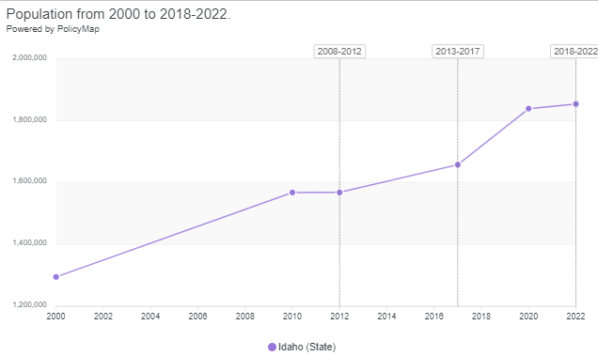

Map III.1
Population Percent Change between 2013-2017 and 2018-2022
State of Idaho
2013-2017 ACS; 2018-2022 ACS

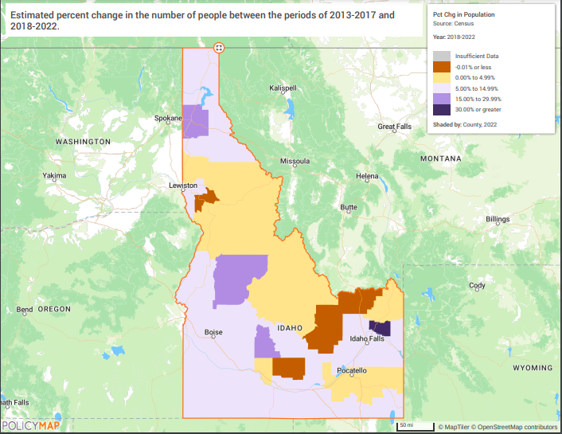
Consistent with the increase in population, the number of households in Idaho increased by 3% between 2009 and 2020 and there were 609,124 households by 2020. Census data suggest that between 2017 and 2022, there was a 10.9% increase in the number of households in the State. Table 6 shows that about under 43% of these households have incomes at or below 80% AMI in the following groupings – there were 67,790 households between 0-30% AMI (11.1%), 70,225 households between >30-50% AMI (11.5%), and 113,540 households between 50-80% AMI (18.6%). As the number of low-moderate income households continues to increase the need for affordable housing options will also need to increase to keep pace with demand.
The median income in the state also increased by 37.7% between 2017 and 2022 and was at $70,214 by 2022. However, with the significant increase in rent and living costs, this increase has likely not kept up with these demands. Map III.2 shows the distribution of median household income in the State. The counties of Lemhi, Butte, Shoshone, and Lewis have the lowest median incomes in the State, and all are below $49,376. 2018-2022 data suggests that 11% of people were living in poverty in the State. Map III.3 highlights the areas of poverty concentration. Unsurprisingly, the areas with higher rates of poverty are the same counties that have lower median household incomes. When income is concentrated in certain areas it can lead to concentrated areas of poverty, which become of particular concern if income and geography are closely related to race or ethnicity in the community. This data may suggest that there are not enough affordable housing options to allow LMI individuals to live in Idaho.
MAP III.2
Median Household Income
State of Idaho
2018-2022 ACS

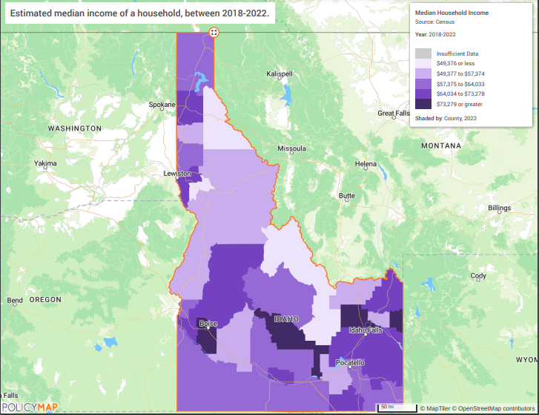
MAP III.3
Percent of People in Poverty
State of Idaho
2018-2022 ACS

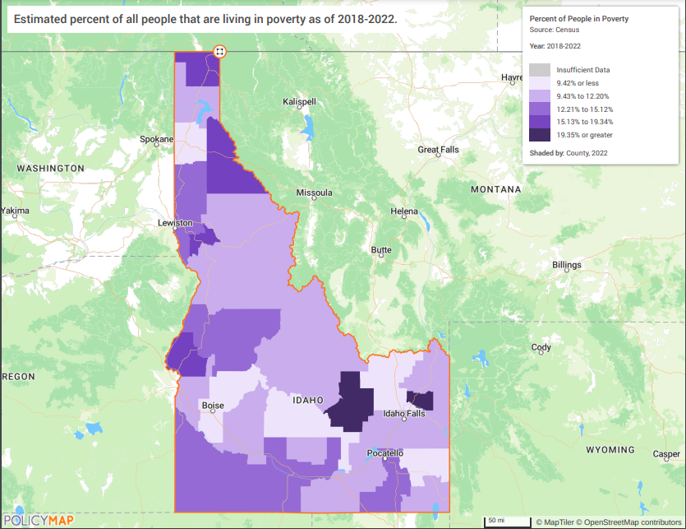

Describe the number and type of single person households in need of housing assistance.
Estimate percent of households that are 1-person households
2022 ACS
County | Percent
Lewis | 33.52%
Clearwater | 34.49%
Shoshone | 36.84%
Butte | 37.11%
Clark | 41.09%
Lemhi | 41.62%

Estimate the number and type of families in need of housing assistance who are disabled or victims of domestic violence, dating violence, sexual assault and stalking.
Persons with Disabilities
2018-2022 ACS data suggests that 251,201 residents, or 13.74% of the population of the State of Idaho is living with a disability. Although the overall disability rate has only gone up by about 0.4% since 2017, there are some areas of the state that saw large increases of over 36%, especially in the central and southeastern areas (shown in Map III.4). 34.95% of residents aged 65 or older are living with a disability. 21.6% of residents in the state are living below the poverty level with a disability (a 3.35% increase from 2017) - Map III.5 shows that those living with disabilities who are also living in poverty have a higher density in northern tracts. 2023 ACS data shows that 24.8% of the city’s population aged 65-74 years and 45.9% of those aged 75 years or older are living with a disability. Ambulatory disabilities are the highest disability type for those 65 years or older and affect 18.4% of the population. Independent living difficulties (because of a physical, mental, or emotional problem, having difficulty doing errands alone such as visiting a doctor’s office or shopping) are also noted as a high disability type and affect 10.4% of the population of those aged 65 years or older. There is a need for more housing assistance for those living with disabilities, especially the elderly population.

MAP III.4
Disability Percent Change
State of Idaho
2018-2022 ACS

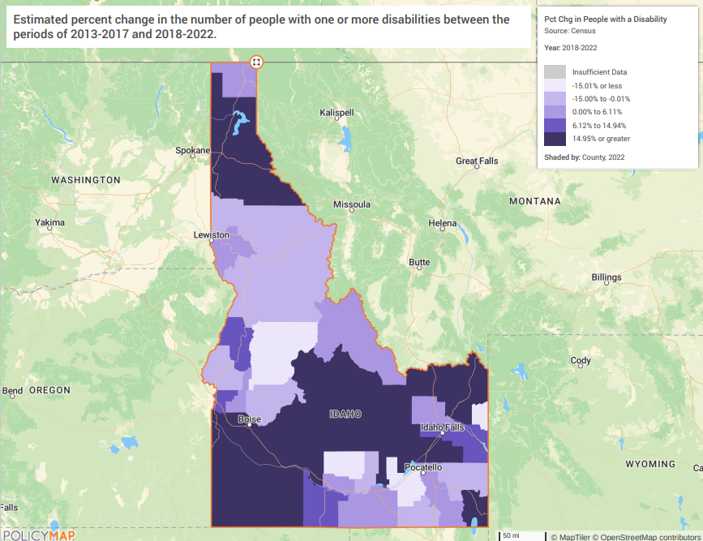

MAP III.5
Percent of People in Poverty with a Disability
State of Idaho
2018-2022 ACS

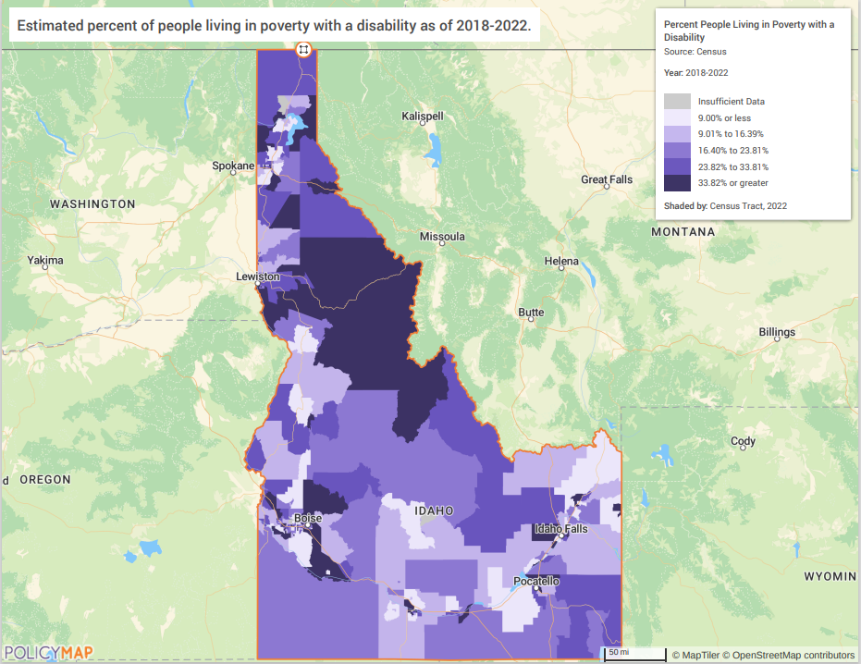
Victims of Domestic Violence, Dating Violence, Sexual Assault, and Stalking
Gathering accurate and current data on topics of domestic violence, dating violence, sexual assault, and stalking can be a challenge due to substantial underreporting. The Idaho Council on Domestic Violence and Victim Assistance funds a project that includes papers and reports about victimization in Idaho. The report “Emerging Issues in Victimization: Domestic Violence and Housing in Idaho” was conducted to better understand the housing resources available for domestic violence survivors in Idaho. They concluded that over the past several years, domestic violence has been the leading cause of homelessness in Idaho. They note that victims of domestic violence experience increased threats of housing insecurity, including “financial instability, substance use and abuse, mental health concerns, barriers due to culture or minority status, and housing regulations.” The report also found that between 2019 and 2022, there have been an increasing number of individuals receiving housing services from domestic violence focused programs (see chart below).
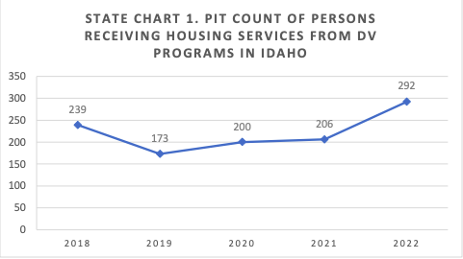
In 2022, funded domestic violence provider organizations reported 26,407 domestic violence victimizations. The chart below shows the amount of domestic violence victimizations from 2018 to 2022, along with the number of these clients being provided with housing services.

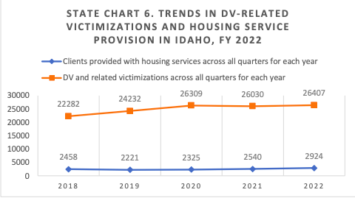
Additionally, the National Network to End Domestic Violence (NNEDV) conducted their 18th annual domestic violence counts report on September 6, 2023 and 95% of identified domestic violence programs participated. During this 24 hour period, the participating programs reported the following:
- 650 victims were served
- 220 hotline contacts were received
- 29 people were provided with educational resources
- There were 565 unmet service requests – this was due to a lack of resources that created barriers to the programs assisting the clients.

NA-25 Disproportionately Greater Need: Housing Cost Burdens – 91.305 (b)(2)
Assess the need of any racial or ethnic group that has disproportionately greater need in comparison to the needs of that category of need as a whole.
Introduction
According to HUD, disproportionate need refers to any need for a certain race/ethnicity that is more than ten (10) percentage points above the need demonstrated for the total households within the jurisdiction at a specific income level. The tables and analyses below identify the share of households by race/ethnicity and income level experiencing housing cost burdens as outlined by HUD guidelines. When the ten-percentage point threshold is reached, that number is highlighted in yellow. The table below indicates the share of households by race/ethnicity experiencing cost burden (paying 30%-50% of household income towards housing costs) and severe cost burden (paying more than 50% of household income towards housing costs).
Disproportionate need for each race/ethnicity is determined by calculating the share of the total number of cost burdened and severely cost burdened households from each race/ethnicity and comparing that figure to the share of all Idaho households. (Share of Race/Ethnicity = # of households for that race/ethnicity with cost burden / total # of households for that race/ethnicity.)

NA-35 Public Housing – (Optional)

What are the number and type of families on the waiting lists for public housing and section 8 tenant-based rental assistance? Based on the information above, and any other information available to the jurisdiction, what are the most immediate needs of residents of public housing and Housing Choice voucher holders?
IHFA branch offices, as of December 2024, have 6,339 applicants on the waiting list. Of those, 2,212 (33%) have a disability; 1,484 (23%) are homeless; and 889 are elderly (14%).
The most immediate needs of public housing and Housing Choice Voucher (HCV) residents often revolve around ensuring stable and sustainable living conditions. These include:
- Affordable and stable housing: It is important to ensure that rent does not exceed 30% of household income. Having access to safe and quality housing in areas with schools, employment opportunities, and public services and amenities.
- Access to utilities and services: Consistent access to electricity, water, heating, and cooling systems. To ensure safety, it is important that maintenance issues are responded to.
- Support for financial stability: This can include employment assistance and job training, and financial literacy resources (ie. Budgeting, credit repair, etc.).
- Access to health and safety resources: This includes access to healthcare, mental health services, substance abuse treatment, and safe housing free from environmental hazards.
- Transportation: This includes access to nearby reliable and affordable public transit.
- Accessibility: This includes having a sufficient number of units that accommodate various disabilities. It also includes the ability to make reasonable accommodations to housing units.
- Education and Childcare: This includes access to schools and access to affordable childcare.
- Community resources and support: This includes access to social services like case management and counseling, along with resources to help with food security.
- Tenant rights and advocacy: This includes education on tenant rights to prevent discrimination or unfair treatment, along with access to legal aid.

NA-45 Non-Homeless Special Needs Assessment – 91.305
Discuss the size and characteristics of the population with HIV/AIDS and their families within the Eligible Metropolitan Statistical Area:
AIDSVu is an interactive mapping tool that visualizes the impact of the HIV epidemic on communities across the U.S. It estimates that in 2022, there were 1,365 people living with HIV in Idaho.

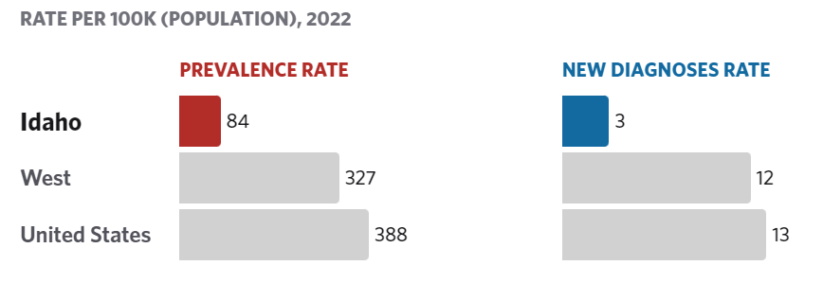
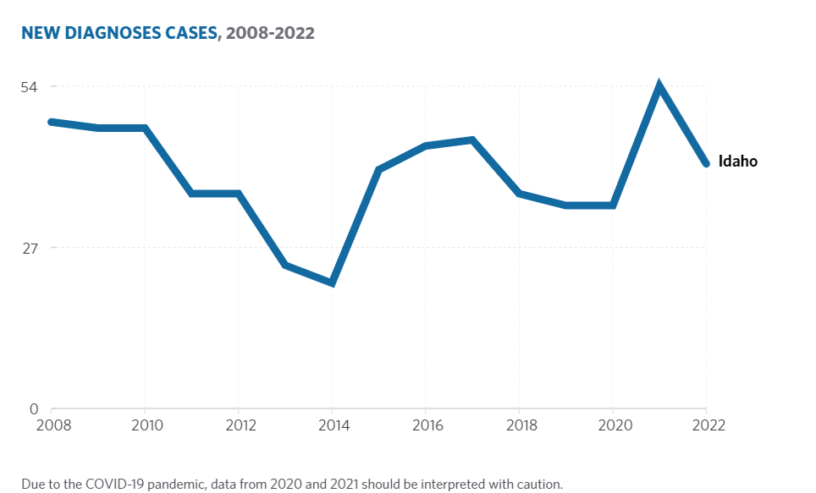
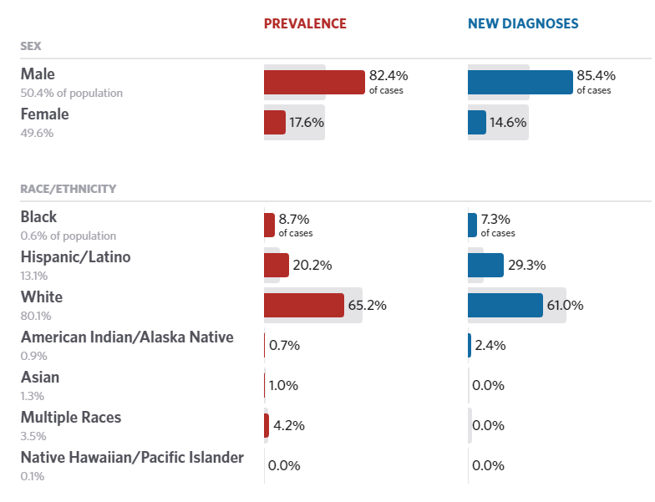
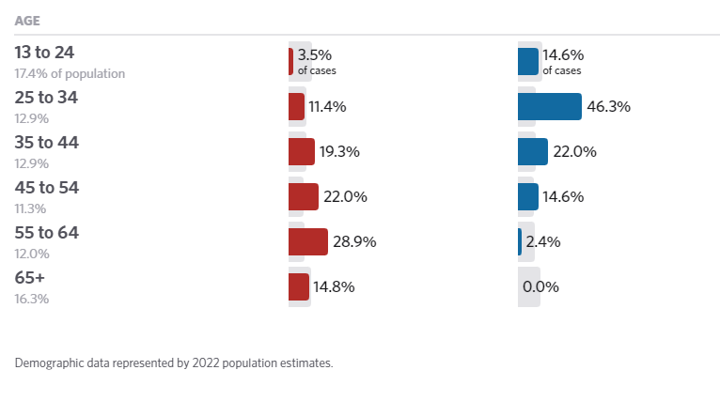

NA-50 Non-Housing Community Development Needs - 91.315 (f)
In June of 2024, the Idaho Department of Commerce mailed out a CDBG survey to approximately 180 cities and 44 counties throughout the State to better understand the non-housing community development needs of Idaho’s cities and counties (or CDBG grantees). Idaho’s nine entitlement cities were not included in this survey. 92 survey responses were received.
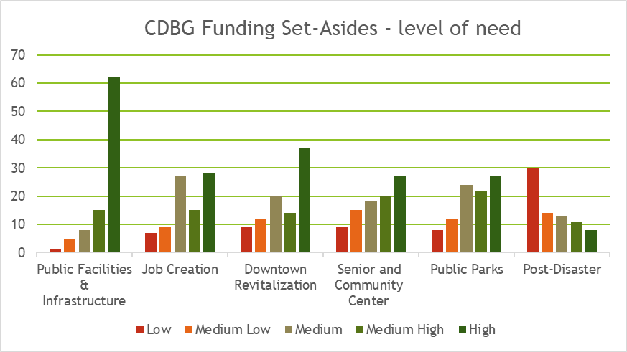
Describe the jurisdiction’s need for Public Improvements:
Based on the local government needs survey, the top needs are water, sewer, streets, and sidewalk systems. These results were supported by feedback at community meetings.
How were these needs determined?
The needs of the state CDBG jurisdictions (cities and counties) for public facilities, public improvements (infrastructure), services, and economic development activities is based on a number of variables. These variables include geographic locations, local economy, population, governance philosophies, and the existing services provided by the city or county. In an attempt to understand Idaho cities and counties non-housing community development needs, IDC conducted a local government needs survey. The survey was sent out to 180 cities and 44 counties in July 2024. Of the 224 surveys, sent out a total of 92 responded. Of the 92 respondents – 78 were cities and 14 were counties.
Further, the American Society of Civil Engineers 2021 Report Card for Idaho’s infrastructure was used to further assess non-housing community development needs. Specific to public infrastructure the following systems were graded as such. (The 2021 reports is the most recent information as of the date of this plan. A new report card is expected in March 2025, and information will be updated prior to completion of the plan.)
Drinking Water – (Grade C) – Idaho’s approximately 1,960 public water systems consists of pipes, plants, and pumps that work together to deliver clean water to the state’s homes and businesses. The costs to maintain and improve this infrastructure are paid by users and rates can vary. Recent population growth has helped spur investment in new drinking water systems in some parts of the state. The Environmental Protection Agency estimates Idaho will need $961.8 million over 20 years to maintain, repair and replace its existing drinking water infrastructure and accommodate a larger population.
Wastewater- (Grade B-) Idaho’s 1.68 million residents rely on a variety of wastewater collection and treatment systems, including municipal wastewater treatment plants and septic systems. The state’s population is growing rapidly, and Idahoans are benefiting from some new wastewater collection and treatment facilities built to accommodate the increased demand. However, Idaho’s challenge will be to maintain and increase funding for ongoing maintenance requirements. The U.S. Environmental Protection Agency reports that over the next 20 years, Idaho will need $1.38 billion in funding for wastewater infrastructure.
Roads – (Grade C-) - Highways provide a critical transportation link between the places we live, work, and play. Over 75,891 lane miles of roads in the state transport 650,000 residents to work each day and 150 million tons of freight, worth $80.5 billion, each year. Of these 75,891 miles, approximately 12,000 lane miles are state highways (interstate, US, and Idaho roads), and 63,607 lane miles are local roads and streets (owned by city, county, or highway district). While the Idaho legislature has made strides in identifying additional funding for the state’s highways and roads, available funding is insufficient to meet current and future demands. It’s estimated that 18% of roads are in need of improvement. Over the next 20 years, the state will experience a $3.6 billion shortfall if funding remains stagnant.
Responses to the ASCE survey on infrastructure demonstrate that the ability of Idaho’s systems to meet various recent levels of population growth is a cause for concern.

Housing Market Analysis

MA-15 Housing Market Analysis: Cost of Housing – 91.310(a)

Introduction
The median home value in Idaho according to ACS data saw a 5.8% increase between 2012 and 2017 and was $176,800 by 2017. This number has increased exponentially between 2018 and 2023 with a 96% increase in median home values in 5 years.
According to Zillow, in June of 2022 the average home value reached a high of $485,281 before home values decrease slightly moving into 2023 and increasing again in June of 2023. The average home value as of October 2024 was $451,520. See Zillow graph for home value trending in recent years.
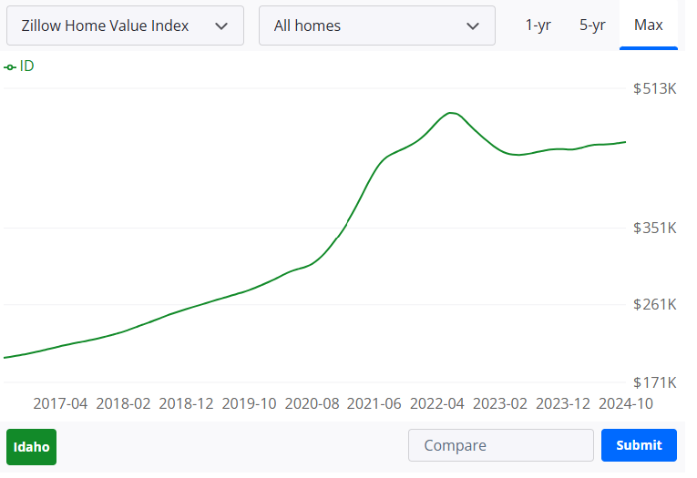
Source: Zillow, November 2024

Map IV.1 shows the change in home values between 2017 and 2022. There were very few areas of the state that saw an increase in home values less than 21%. The darker shaded areas indicate a greater increase in the median home value, with the darkest color indicating a growth of 62.86% or greater. This increase in home values reflects the cost burden experienced by Idaho residents. Map IV.2 shows the percentage of cost burdened homeowners in Idaho – while all areas of the state see at least a 15% homeowner cost burden rate, there are some tracts that are between 25%-30%. %. Map IV.3 highlights the change in cost burdened homeowners between 2017-2022 by county. The darker orange areas indicate where the cost burden has actually decreased, while the light yellow and darker blue areas indicate cost burden increase.
Table 32 of this Plan shows the median contract rent also increased by 10%, or from $720 to $792, between 2012 and 2017. This number has only continued to increase – in 2022 the median rent was $1,061, which was about a 34% increase from 2020. Rent Prices have continued to increase, however, with top median gross rents since 2022 reaching $1,901 in January 2023, according to, Zillow. Rents then fell throughout 2023, but have risen again through 2024 with top median gross rents reaching $1825 in November. See Zillow’s rent tracking graphic below.
Map IV.4 shows the percentage of cost burdened renters in the state. The renter cost burden was 46.7% and was spread fairly evenly throughout the state, with no areas seeing less than 19%. Map IV.5 highlights the change in cost burdened renters between 2017-2022 by county. The darker orange areas indicate where the cost burden has actually decreased, while the light yellow and darker blue areas indicate cost burden increase.

MAP IV.1
Median Value of Owner-Occupied Home Percent Change
State of Idaho
2018-2022 ACS

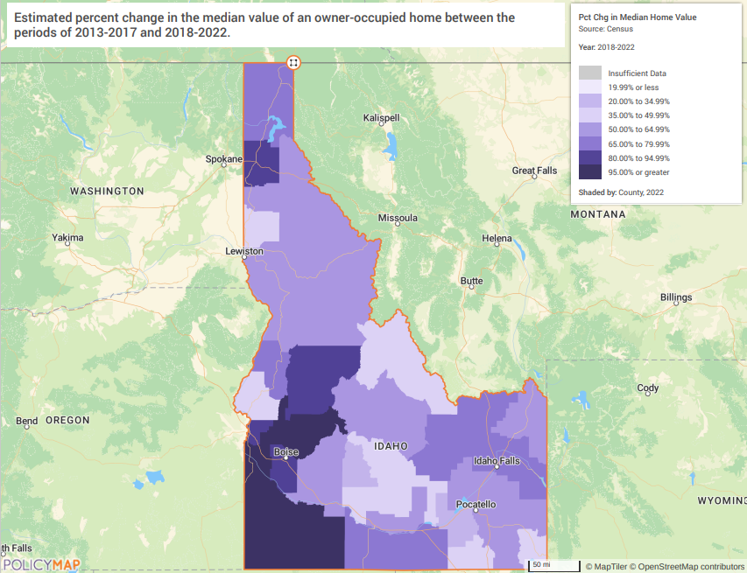

MAP IV.2
Cost Burdened Homeowners Percent Change
State of Idaho
2018-2022 ACS

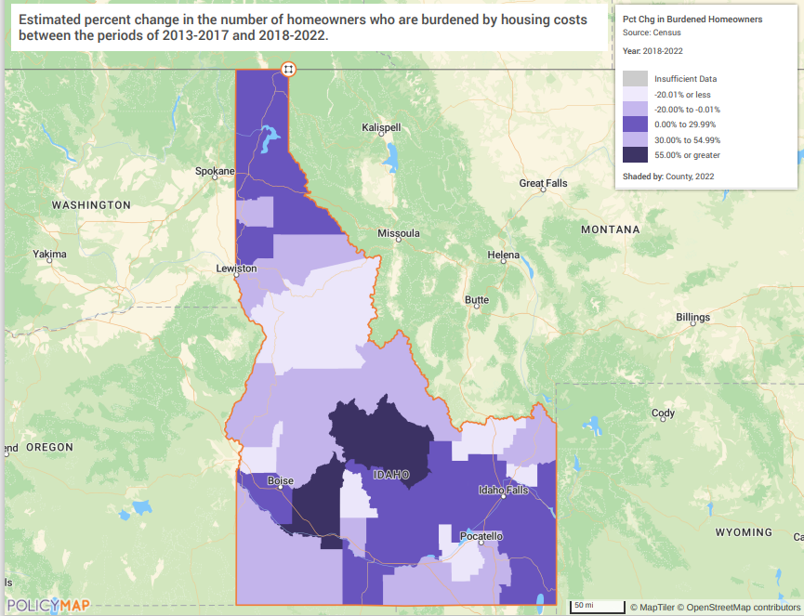

MAP IV.3
Homeowner Cost Burden
State of Idaho
2019-2023 ACS
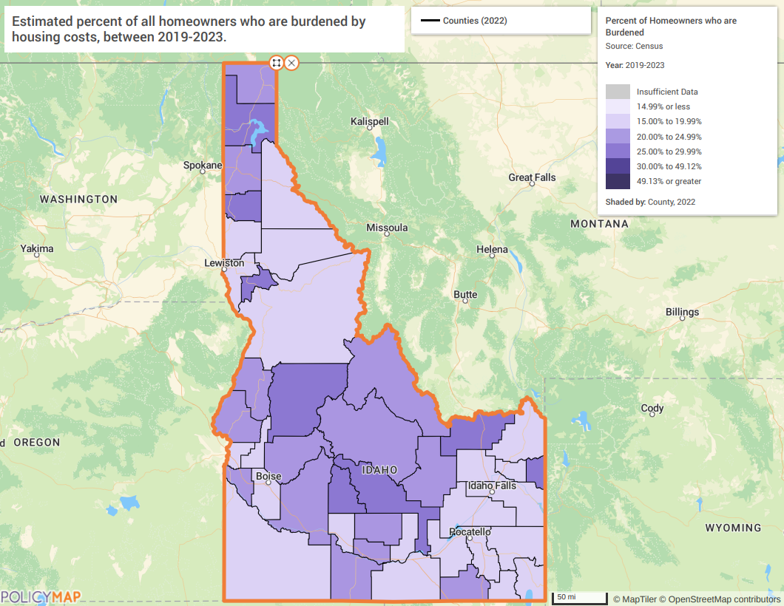

MAP IV.4
Renter Cost Burden
State of Idaho
2019-2023 ACS

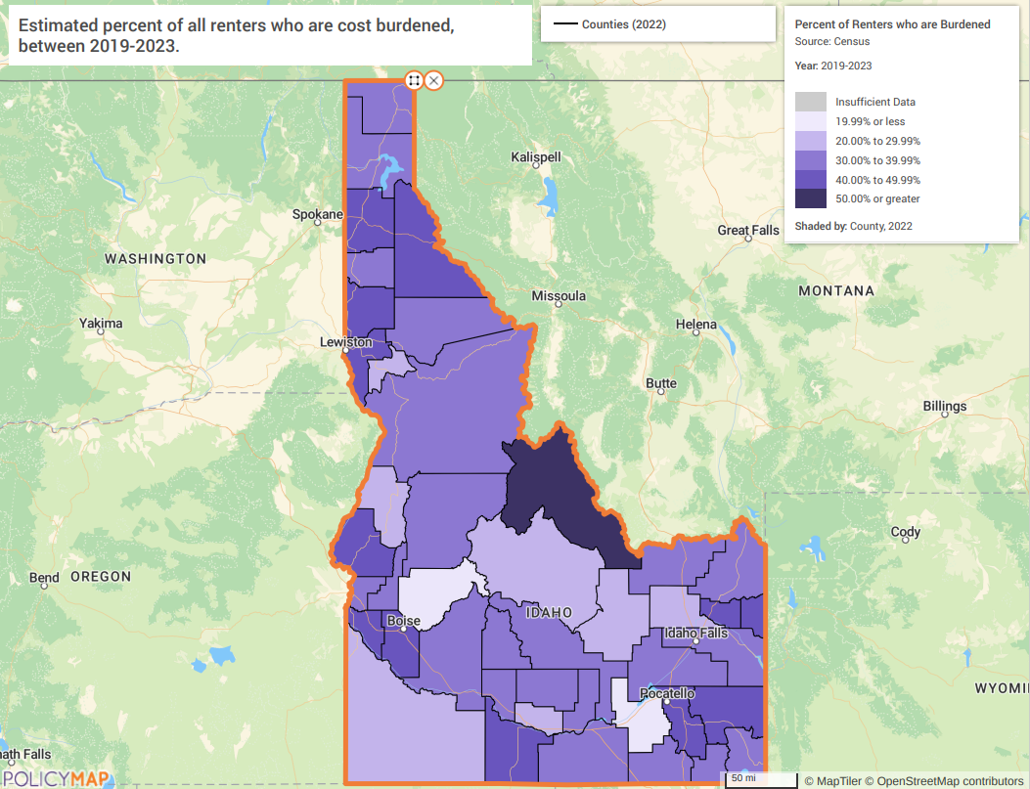

MAP IV.5
Renter Cost Burden Percent Change
State of Idaho
2018-2022 ACS

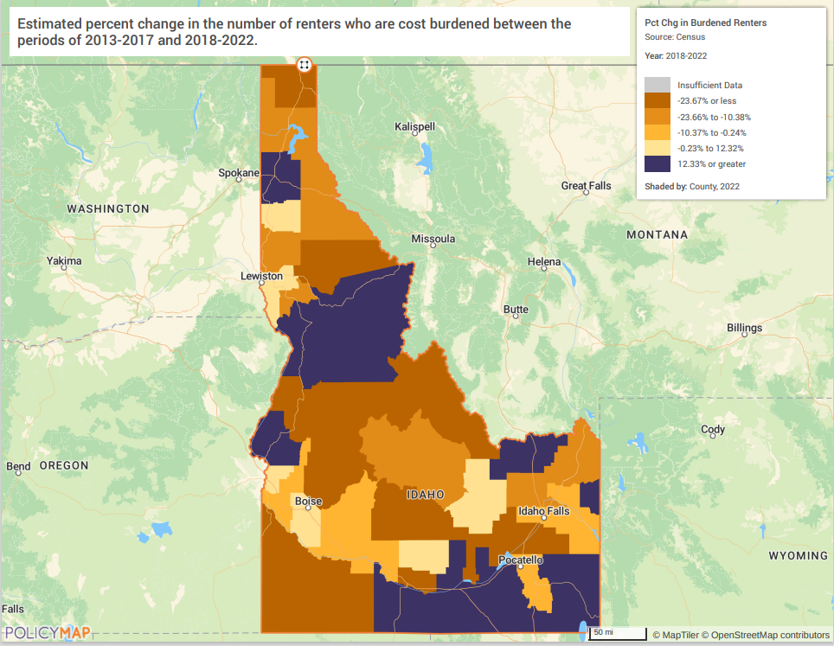

Table 32 shows the median contract rent also increased by 10%, or from $720 to $792, between 2012 and 2017. This number has only continued to increase – in 2022 the median rent was $1,061, which was about a 34% increase from 2020. Rent Prices have continued to increase, however, with top median gross rents since 2022 reaching $1,901 in January 2023, according to, Zillow. Rents then fell throughout 2023, but have risen again through 2024 with top median gross rents reaching $1825 in November. See Zillow’s rent tracking graphic below.
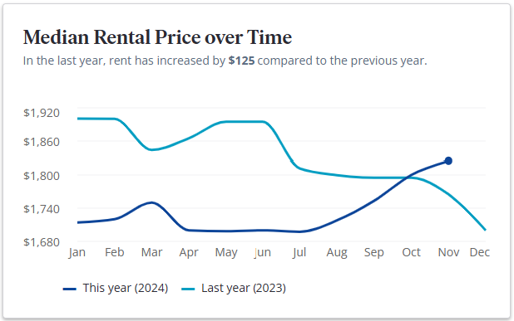
Source: Zillow, November 2024

MAP IV.7
Median Rent Percent Change
State of Idaho
2017-2022 ACS

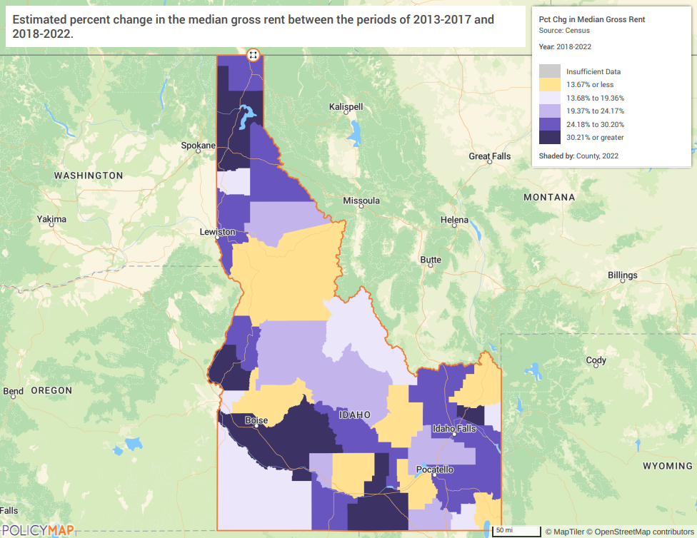

Source: Zillow, November 2024
According to Table 34, there are over 9 and a half times as many rental units that are affordable to someone making 80% HAMFI when compared to a household with 30% HAMFI and over 2.5 times as many rentals affordable to 80% HAMFI compared to 50% HAMFI. Owner occupied units have a similar pattern with significantly fewer units that are affordable to very low-income households. Map II.6 shows the percentage change of median gross rent prices by county. All counties have seen an increase of at least 13.67%, with the darkest purple shaded areas having an increase of 30.21% or higher. The county with the largest increase in median gross rent between 2017-2022 was Camas County with a 65.79% increase in 5 years.
Table: Percent Change in Median Gross Rent by County
County | Percent Change 2017-2022
Ada | 45.1%
Adams | 26.3%
Bannock | 24.9%
Bear Lake | 9.1%
Benewah | 17.2%
Bingham | 20.7%
Blaine | 25.9%
Boise | 11.6%
Bonner | 32.3%
Bonneville | 27.9%
Boundary | 24.9%
Butte | -3.9%
Camas | 65.8%
Canyon | 40.2%
Caribou | 25.9%
Cassia | 39.2%
Clark | 26.4%
Clearwater | 20.1%
Custer | 23.6%
Elmore | 32.6%
Franklin | 16%
Fremont | 1.6%
Gem | 11.8%
Gooding | 22.1%
Idaho | 13%
Jefferson | 24.8%
Jerome | 13.5%
Kootenai | 34.8%
Latah | 28.7%
Lemhi | 17.7%
Lewis | 11.1%
Lincoln | 1.9%
Madison | 36.1%
Minidoka | 40%
Nez Perce | 28.1%
Oneida | 21.1%
Owyhee | 17.6%
Payette | 15.3%
Power | 2.6%
Shoshone | 24.5%
Teton | 18.2%
Twin Falls | 26.1%
Valley | 19.8%
Washington | 33.9%
Source: 2013-2017 ACS, 2018-2022 ACS

How do HOME rents / Fair Market Rent compare to Area Median Rent? How might this impact your strategy to produce or preserve affordable housing?
See Unique Appendices for a list of median rents in each county compared to HOME rents/Fair Market Rents.

MA-20 Condition of Housing – 91.310(a)
Describe the need for owner and rental rehabilitation based on the condition of the jurisdiction’s housing.
Table 36 details the number of owner and renter households by number of housing problems identified in the 2016-2020 ACS estimates. Overall, renters are almost twice as likely to have a housing problem than homeowners – 43% of renter households experience one or more housing conditions and only 23% of homeowner households experience one or more housing conditions. According to 2022 ACS data, the rate rose to 48.41% for renter households and declined to 21.35% for homeowner households. Relatively few units have more than one selected condition but there are still over 210,256 households with multiple housing problems. Map IV.8 shows the rates of renter households experiencing at least one housing condition – the areas with the highest rate are in the eastern and western areas of the state. Deteriorating housing can depress neighboring property values, discourage reinvestment and eventually impact the quality of life in a neighborhood.
The year a house is built is heavily correlated with whether it is in substandard condition. Older homes are more likely to need regular maintenance in order to provide a safe and secure living environment for residents. When looking at the age of a home an important factor is whether it was built before 1978. Prior to 1978 lead-based paint was used in many homes and the presence of that paint can cause significant health problems for residents, particularly for children, the elderly, and those with compromised immune systems. Table 37 illustrates that about 47% of the City’s renter-occupied housing stock was constructed prior to 1980 and 42% of owner-occupied housing stock was built before 1980. Map IV.9 shows that the distribution of housing units built before 1980, with the darker shaded areas indicating a larger percentage. There are three counties which have over 68.22% of their housing stock built before 1980- Butte (71.36%), Lewis (74.38%), and Shoshone (79.21%).
Seniors or those on a fixed or limited income oftentimes cannot afford to maintain their home or to make necessary safety accommodations. As costs of materials for new builds continue to rise, rehabilitation assistance for low-income families and those on fixed incomes such as seniors and those with disabilities will be an important tool in allowing them to maintain their housing and lessen the risks of homelessness.

Vacant Units –
Table: Vacancy Rates by County
County | 2018 | 2023 | Percent Change
Ada | 4.5% | 4.1% | -0.4%
Adams | 37.6% | 34.3% | -3.3%
Bannock | 9.4% | 6.6% | -2.8%
Bear Lake | 42.3% | 41.5% | -0.8%
Benewah | 28.9% | 15.5% | -13.4%
Bingham | 11.1% | 7.3% | -3.8%
Blaine | 46.7% | 37.7% | -10.0%
Boise | 43.3% | 37.0% | -6.3%
Bonner | 29.8% | 26.4% | -3.4%
Bonneville | 7.7% | 6.6% | -1.1%
Boundary | 15.0% | 12.7% | -2.3%
Butte | 24.5% | 20.2% | -4.3%
Camas | 54.1% | 51.2% | -2.9%
Canyon | 5.1% | 3.2% | -1.9%
Caribou | 20.3% | 22.5% | 2.3%
Cassia | 9.0% | 8.4% | -0.6%
Clark | 45.1% | 43.0% | -2.1%
Clearwater | 19.3% | 22.6% | 3.3%
Custer | 44.7% | 38.9% | -5.8%
Elmore | 17.3% | 10.9% | -6.4%
Franklin | 9.9% | 4.9% | -5.0%
Fremont | 51.6% | 48.0% | -3.6%
Gem | 9.6% | 4.9% | -4.7%
Gooding | 12.3% | 9.6% | -2.7%
Idaho | 26.2% | 26.1% | -0.1%
Jefferson | 6.3% | 5.7% | -0.6%
Jerome | 7.4% | 6.0% | -1.4%
Kootenai | 12.7% | 11.4% | -1.3%
Latah | 7.5% | 7.9% | 0.4%
Lemhi | 26.8% | 27.7% | 0.9%
Lewis | 14.9% | 15.2% | 0.3%
Lincoln | 15.5% | 6.9% | -8.6%
Madison | 22.9% | 13.5% | -9.4%
Minidoka | 10.0% | 7.8% | -2.2%
Nez Perce | 8.1% | 6.7% | -1.4%
Oneida | 20.3% | 6.3% | -14.0%
Owyhee | 12.9% | 11.6% | -1.3%
Payette | 6.2% | 4.7% | -1.5%
Power | 14.1% | 8.5% | -5.6%
Shoshone | 22.2% | 19.3% | -2.9%
Teton | 34.5% | 26.2% | -8.3%
Twin Falls | 6.6% | 5.1% | -1.5%
Valley | 71.7% | 70.0% | -1.7%
Washington | 13.3% | 10.8% | -2.5%
Total (State) | 13.1% | 10.7% | -2.4%
Source: 2014-2018 ACS, 2019-2023 ACS, PolicyMap

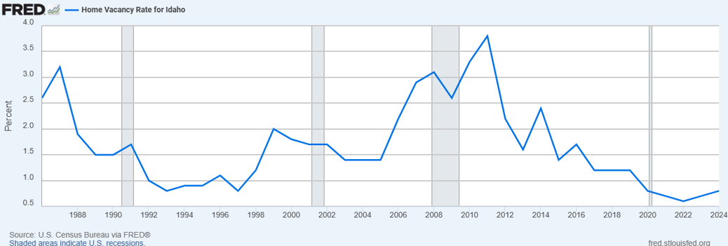

MAP IV.8
Percent Renter-Occupied Units with Housing Problems
State of Idaho
2018-2022 ACS

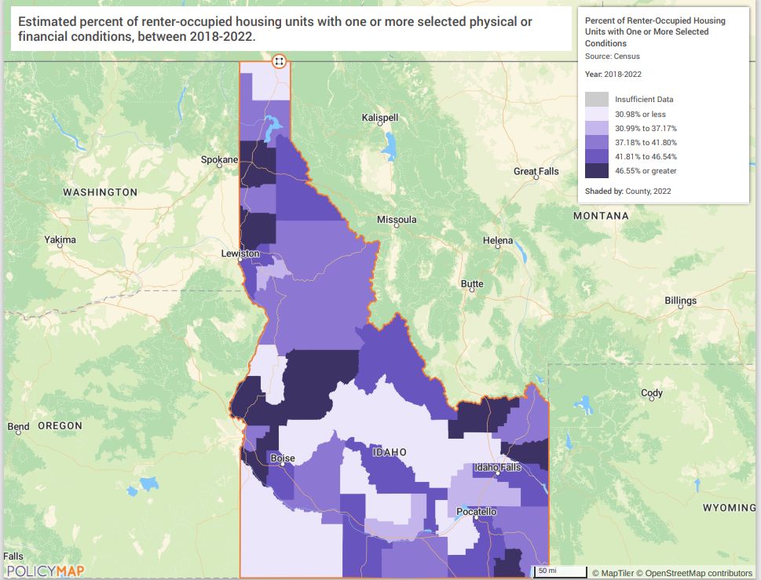

MAP IV.9
Housing Units Built Pre-1980
State of Idaho
2018-2022 ACS

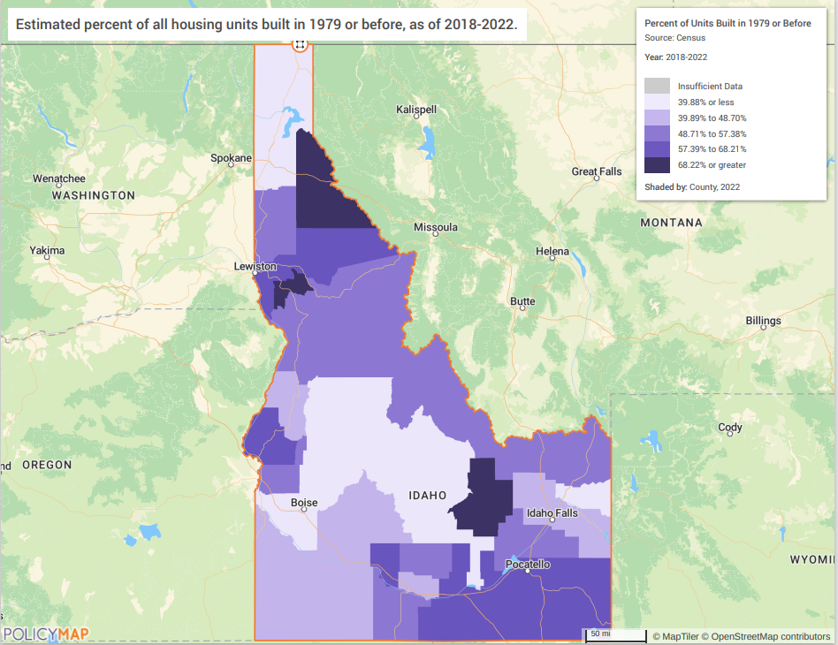

MA-35 Special Needs Facilities and Services – 91.310(c)
To the extent information is available, describe the facilities and services that assist persons who are not homeless but who require supportive housing, and programs for ensuring that persons returning from mental and physical health institutions receive appropriate supportive housing
In addition to HOME, HTF and CDBG funding used for affordable supportive housing, HUD also funds Section 202 and Section 811 housing, reserved entirely for elderly individuals and persons with a disability. HUD-funded Public Housing and Project-Based Section 8 also can be used to fund supportive housing units, though the funding sources are not reserved exclusively for this purpose.
The Section 202 program funds affordable housing development for elderly households, while Section 811 funds non-profit housing development for very- and extremely low-income persons with disabilities. Both programs provide vital supportive housing to those that cannot otherwise afford market-rate housing or supportive services. Most Section 202/811 residents have income below 30 percent of the area median income and are considered “extremely low-income”.
Unfortunately, compared to other HUD-funded subsidized housing, including Housing Choice Vouchers, Section 202/811 supportive housing units are in short supply. Though exact 202/822 waitlist waiting times are not tracked, Public Housing and Housing Choice Vouchers, of which there are ten times as many units, have waitlist waiting times of one and nearly-two years, respectively.
HOME- The HOME Program has previously funded (1) HUD-811 projects with a total of 12 units assisting renters with special needs. (9) HUD Supportive Housing program projects with a total of 56 units serving low income tenants with special needs.
ESG- Supportive housing is made available in two forms; scattered- or single-site. Services associated with supportive housing projects are case management, transportation, life skills training, counseling, and educational and career building, among others. Access to public assistance through programs such as SSI/SSDI Outreach, Access, and Recovery (SOAR) greatly improve one’s ability to experience a stable living environment. These housing and service options assist not only those coming directly into housing from the streets, but those exiting institutions as well. The housing provided offers stability, and safe, decent, and sanitary environments. The services offered aid individuals in working towards being employable, gainfully employed, receiving linkages to resources, and removing barriers to attaining stable housing.
Finally, IHFA will be using its HOME ARP to provide financial resources for Permanent Supportive Housing (PSH) in communities who do not have or have limited PSH units. The approach is to ensure developers start building the supportive services’ partnerships in the beginning to wholistically take care of the households. Learning from past PSH projects, IHFA will also make available from HOME ARP direct supportive services funds to help with the initial hiring of case managers within these projects. It is the hope in providing seed money for supportive services, communities will understand the value and find longer term financing sources for these vulnerable households.

MA-40 Barriers to Affordable Housing – 91.310(d)
Negative Effects of Public Policies on Affordable Housing and Residential Investment
Public policies are meant to address the overall needs of citizens in the State. Yet, there are times where they may have a negative effect on certain aspects of the community, specifically affordable housing and residential investment. Affordable housing and public and private residential investments are key components in furthering fair housing in any community. The primary tool communities have for identifying contributing factors for these barriers to housing is an assessment of fair housing and fair housing choice. In the 2022-2027 Analysis of Impediments to Fair Housing, the following regulatory findings were noted:
Idaho statutes continue to be silent in the many areas that affect residential development. Regulations governing land use, zoning, housing type and placement (including group living facilities) are primarily adopted and applied at the local level. The effects of a passive approach are mixed: the state does not directly adversely affect residential development, but it does not encourage practices that can mitigate fair housing risks (e.g., defining disability and reasonable accommodation) or encourage residential housing supply (e.g., specifying that localities must allow for density bonuses in exchange for affordable housing when economically feasible). The state statutes that do address housing generally promote more varied and affordable housing and were adopted to prevent unfair and discriminatory practices in the local regulation of group homes, housing for persons with mental or physical disabilities, manufactured housing, or rental housing.
State statutes are neutral on incentives for building ‘zero-step’ single family subdivisions. Given the demand for ‘visitable’ housing (approximately 6% of Idahoans live with a mobility limitation, but only 1% of residential units are wheelchair accessible), the lack of accessible housing choice leads to increased costs for accessibility modifications, independent living and Idaho’s Medicaid budget.
Idaho places restrictions on local jurisdiction authority to impose local taxes, which has been interpreted by Idaho courts as including programs that would require affordable housing (“inclusionary housing”). Idaho also prohibits rent control except on land or in properties in which a local government has an interest. These laws limit the powers of local jurisdictions to promote more affordable housing that could benefit those protected by the FHA. The direct effect of these limitations depends on how local ordinances would be structured and who would benefit from such programs if allowed by state law. The State of Colorado, which also has a rent control prohibition, recently amended its constitution to allow inclusionary zoning when jurisdictions offer an offset to the cost of developing affordable housing, including density bonuses. Density bonus programs are generally well-received by residential developers and are becoming a popular mechanism to make better use of land and facilitate affordable housing development.

MA-45 Infrastructure Needs in Idaho

Table: Employment by Industry
Employment by Industry | People Employed | Percent Employed in this Industry
Accomodation and Food Services Industry | 62,167 | 7.1%
Administrative and Support and Waste Management Services Industries | 31,428 | 3.6%
Agriculture, Forestry, Fishing anf Hunting Industry | 34,133 | 3.9%
Arts, Entertainment, and Recreation Industries | 15,617 | 1.8%
Educational Service Industry | 77,271 | 8.9%
Finance, Insurance, Real Estate, and Rental and Leasing Industries | 50,186 | 5.8%
Health Care and Social Assistance Industry | 116,763 | 13.4%
Information Industry | 13,982 | 1.6%
Manufacturing Industry | 83,456 | 9.6%
Management of Companies and Enterprises Industry | 468 | 0.1%
Other Services Industry | 39,440 | 4.5%
Professional, Scientific, and Technical Services Industry | 54,481 | 6.2%
Public Administration Industry | 42,976 | 4.9%
Retail Trade Industry | 103,370 | 11.8%
Construction Industry | 79,176 | 9.1%
Transportation and Warehousing, and Utilities Industries | 43,160 | 4.9%
Wholesale Trade Industry | 22,155 | 2.5%
All Other Industries | 3,234 | 0.4%
Source: 2018-2022 Census

2025 Action Plan

AP-25 Allocation Priorities

CDBG
See AP-20- Goals 1,2,3,4, and 5 goal descriptions.

HOME & Housing Trust Fund

Tenant Preference Populations
Idaho's Five-Year Consolidated Plan identifies three "Priority Housing Needs" populations: Elderly (age 62+), Disabled, and Extremely-Low Income. A project owner can choose to provide a preference for one or more of these priority housing needs populations if the preference(s) is identified in the HOME/HTF written agreement and the owner does not otherwise violate Federal, State, and local fair housing laws, executive orders, or program regulations. The HOME, NSP & HTF Annual Administrative Plan and the Qualified Allocation Plan identify these populations as "Special Housing Needs Populations".
HOME/HTF multifamily rental housing applications receive additional points if the owner commits to a tenant preference of two of the three Special Housing Needs Populations.

IHFA Visitability Design Components
HOME and HTF single-family rental units will include at least one wider doorway to one main floor bathroom, other interior doorways, and one means of ingress/egress if feasible as part of a construction or rehabilitation activity.

Eligible Activities
- IHFA will award HOME and HTF funds to eligible recipients (owner, owner-developer) to acquire and construct/rehabilitate permanent single-family and multifamily rental housing.
- IHFA will award HOME funds to qualified nonprofits and units of local government to acquire and/or construct/rehabilitate single-family homebuyer properties then sold to HOME-eligible & IHFA qualified low-income homebuyers.
- Down payment/closing cost assistance to the HOME-eligible and IHFA qualified low-income homebuyers throughout Idaho to purchase a Standard condition single-family unit.
- IHFA may award HOME-funded Operating Assistance Grants to IHFA-certified Community Housing Development Organizations (CHDOs).
- IHFA may award up to 33% of each HTF allocation as operating/reserve assistance to HTF-funded permanent rental housing, if the owner is able to show it is needed.
- IHFA may use up to 10% of each HOME and HTF allocation and eligible program income for HOME/HTF planning and administrative costs.

Allocation Priorities
- HTF- 100% to owners and developers to acquire and/or construct and rehabilitate permanent rental housing activities targeting households with annual incomes ≤ 30% AMI.
- HOME- Approximately 50% to nonprofit developers and units of local government to acquire and/or rehabilitate or construct single-family structures then sell to HOME-eligible, IHFA- qualified homebuyers. Includes down payment/closing cost assistance activity for HOME-eligible and IHFA qualified low-income homebuyers throughout Idaho to purchase a Standard condition single-family unit.
- HOME- Approximately 50% to private and nonprofit owners/developers to acquire and construct multifamily permanent rental housing activities.

AP-30 Method of Distribution

State of Idaho HOME/HTF
Homebuyer Properties Program
General Requirements
Funding proposals are accepted from qualified units of local government and community-based non-profit developers following a published Request for Proposals. Eligible activities under this program include acquisition and/or rehabilitation of Substandard (condition) single-family units, and acquisition and/or new construction of single-family units. When development phase is complete, the units are sold to qualified HOME-eligible, IHFA-qualified homebuyers within 9 months. If the unit is not sold within 9 months, it must be converted to a permanent HOME rental unit or the owner-developer must repay the entire amount (including IHFA project costs) of HOME funds expended on the activity.
The sales price to a low-income homebuyer cannot exceed the annual HOME Homeownership Value Limits for the area, published by HUD-CPD. The homebuyer(s) must provide evidence they have completed a homebuyer-counseling course that meets the HOME program's homebuyer education requirements, and submit a monthly budget that identifies recurring expenses, as part of an application for funding. This is in addition to the other IHFA requirements such as homebuyer household asset limitation, credit score, and minimum homebuyer investment. These and other requirements, including maximum subsidy amounts are identified in the Annual Administrative Plan @ Chapter 2. IHFA reviews and updates its Administrative Plan annually to address the market and program changes.
HOME-eligible homebuyers must have an annual household income ≤ 80% AMI, as defined by 24 CFR 5.609 (Annual Gross Income). HOME assistance is provided to the homebuyer as a 0% interest, due-on-sale or default loan. The homebuyer must reside in assisted unit as a primary residence during the HOME period of affordability. IHFA does allow two exceptions to the primary residency rule: Military transfer or deployment and full-time student status at a post-secondary education institution located more than 50 miles from the assisted unit. The homebuyer must have a plan in place to return to the unit at a specified time to be considered for an exception. The residency requirements and loan terms are provided to the homebuyer at the time of application for funding, and again prior to loan closing in the homebuyer's Deed of Trust Note.

Eligible Homebuyer Activities
Home Activity- Single-Family Housing | Regulatory Provision
- Acquisition and new construction/ rehabilitation | Recapture
- New construction/rehabilitation of single-family housing on land owned by a land trust | Resale

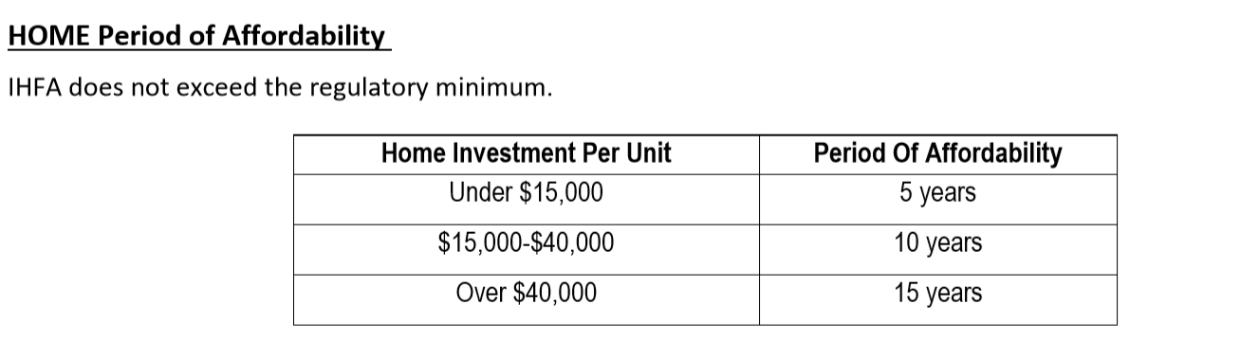
Methods used to Recapture HOME Funds
Resale and Recapture Policies
Introduction
IHFA is a participating jurisdiction in HUD's HOME Investment Partnerships Program. When undertaking HOME-assisted homebuyer activities, which IHFA does, federal regulations must establish written resale and recapture policies that comply with HOME statutory and regulatory requirements. These policies are to be set forth in the Annual Administrative Plan (Admin Plan) and clearly describe the terms of the resale and recapture provisions, the specific circumstances under which these provisions will be used, and how IHFA will enforce the provisions for HOME-funded ownership projects. HUD reviews and approves the provisions as part of the Annual Action Plan process. The purpose of this section is to provide the Resale and Recapture policies for IHFA's HOME Investment Partnerships Program. As stated above, HOME requires jurisdictions to utilize resale and/or recapture policies to ensure continued affordability for low to moderate-income homeowners and as a benefit to the public through the wise stewardship of federal funds. IHFA has used HOME funds for different types of programs to assist with single-family housing units:
- Down Payment Assistance provided to new homebuyers;
- Acquisition and Development provided to developers of new single-family housing for ownership;
- Acquisition and Development provided to developers of new single-family housing for rent;
- Community Land Trust acquisition of a parcel of land under an existing single-family home to provide affordable ownership;
- Community Land Trust development of homes on an existing parcel of land placed in a trust to provide affordable ownership;
Not all of these programs are always available; program providers are able to apply for funding on an annual basis based on RFP notifications and may or may not receive an award.

General HOME Property Restrictions
For a homebuyer or homeowner to be eligible for HOME assistance, they must have a low to moderate income, at or below 80% of area median income, as provided by HUD. The household must be purchasing a home to maintain as their primary residence. Depending on the amount of HOME assistance provided to the residence, the property must remain affordable for the number of years indicated according to HOME’s Period of Affordability outlined in the Annual Administrative Plan and the executed loan documents between IHFA and the household. If the property is sold during this time, or if it is no longer the primary residence of the household, either resale or recapture restrictions will be enforced.

Resale Policy
IHFA's Resale policies ensure HOME-assisted units remain affordable throughout the entire affordability period. The Resale method is used in cases where HOME funding is invested directly into a property, through a developer or nonprofit, to reduce development or acquisition costs, thereby, making the price of the home affordable to an eligible buyer.
Specific examples where IHFA would use the resale method for homeowner assistance include:
- Providing HOME funds to acquire property to be developed or to acquire affordable owner units;
- Providing HOME funds for site preparation or improvement, including demolition; and
- Providing HOME funds for construction materials and/or labor; and
- Providing HOME funds for direct buyer loans for assistance with financing down payments and closing costs.

Resale Policy Notification to Prospective Buyers
The resale policy is explained to prospective homebuyers (Owner) prior to signing a contract to purchase a HOME-assisted unit. The prospective homebuyers sign an acknowledgement that they understand the terms and conditions applicable to the resale policy as they have been explained. This document is included with the executed sales contract. (See attached Acknowledgement of HOME CLT Program Requirements and Terms.)

Enforcement of Resale Restrictions
The resale restrictions are enforced by restrictive covenants between the nonprofit land owner, IHFA, and the owner by executing an IHFA approved ground lease containing required provisions. Additionally, requirements are enforced between IHFA and the Owner by executing a Note and Deed of Trust. . The ground lease and loan documents are signed by the homebuyer at closing and recorded with the County. This document will specify:
- The length of the affordability period (based on the dollar amount of HOME funds invested in the unit; either 5, 10, or 15 years);
- The home remains the Owner’s principal residence throughout the affordability period; and
- The conditions and obligations of the should the Owner wish to sell before the end of the affordability period, including:
- The Owner must contact IHFA in writing if intending to sell the home prior to the end of the affordability period;
- The subsequent purchaser must be low-income as defined by HOME and occupy the home as their primary residence for the remaining years of the affordability period. (However, if the new purchaser requires any additional HOME assistance, the affordability period will be reset according to the amount of assistance provided); and
- Whether or not a Community Land Trust has adopted a targeted population policy which can prioritize eligible buyers within the marketplace.

Fair Return on Investment
IHFA will administer the resale restrictions to ensure the Owner receives a fair return on investment and the home will continue to be affordable to a specific range of incomes.
The resale formula used by IHFA provides a fair return to the homeowner at resale, based on an objective standard that is publicly accessible and can be easily measured, both at the time of initial purchase and at resale.
IHFA uses an appraisal based resale formula to achieve its dual goals of providing a fair return to the original homeowner/seller at resale and ensuring an affordable price to the incoming, low-income homebuyer.
The resale formula stipulates the homeowner, should they choose to sell, will be able to sell the home for the value of the original price paid plus 25% of any increase in value since initial purchase, as determined by an appraisal at the time of purchase and a new appraisal at the time of sale. Capital improvements are included in the home value determined by the resale appraisal; therefore, no additional credit for capital improvements is calculated or allowable.
Fair Return at Resale Example
Here is an example of how the resale formula is designed to work, using hypothetical market conditions:
Equity earned by Owner by amortization of mortgage after 5years ¹
Total increase in value between original and resale appraisal divided by 25% to determine Owner’s eligible portion

At initial purchase:
$ 230,000.00 | Market value of land and improvements, as determined by appraisal at initial purchase.
$ (65,000.00) | HOME investment or land value removed according to initial appraisal of CLT.
$ 165,000.00 | Purchase price of home paid by homebuyer
At Resale 5 years later:
$ 380,000.00 | Market value of land and improvements, as determined by appraisal at time of resale
$150,000.00 | Total increase in value
$ 37,500.00 | Owner's 25% of increase in value
$ 20,728.67 | Equity earned by Owner by amortization of mortgage after 5 years
$ 58,228.67 | Total Fair Return on Investment based on 25% if increase in value plus owner’s equity (principal paid down from  original Sales price – captures down payment (owners initial investment)
Sale to next buyer:

$ 223,228.67 | Original sales price of Current owner, plus Fair Return on Investment

In this example, the home is sold to an eligible low-income household - a property now has an appraised market value of $380,000 - for an affordable price of $223,228.67, without requiring investment of additional affordability subsidies. After the departing Owner has been paid all that is owed, as per the resale formula, the incoming, low-income homebuyer pays 100% of the HOME-assisted property's new $223,228.67purchase price.
1 Assuming 3.99%, fixed-rate, 30-year mortgage loan of $165,000 to original Owner.

By using a market rate (fee simple) appraisal conducted by an independent, state-licensed appraiser to establish the initial value of the property prior to the original purchase of the home, IHFA follows the standard practice for all real estate purchase transactions. By calculating the resale value using a resale appraisal upon notice of intent to sell by the Owner, IHFA ensures that market volatility for determining property values throughout the real estate industry are minimized. In this way, resale values are easily measured, professionally determined, and publicly accessible. No subjective judgments are made by IHFA or the Owner as to what constitutes value and how value is determined.
The HUD publication CPD 12-003 of 24 CFR 92.254 entitled “Guidance on Resale and Recapture Provision Requirements under the HOME Program.” published January 2012, addresses this issue of what a "fair return" might be. In this calculation, the owner receives 25% of the increase in value (includes capital improvements) as determined by an initial and resale appraisal and mortgage equity and initial investment. This constitutes the Fair Return on Investment, while keeping sales price affordable to the next buyer. This calculation is based on a clearly defined standard that is publicly accessible in our administrative plan, action plan, and will be included on all resale loan documents and agreements, or by request from IHFA or the Community Land Trust.
https://www.hudexchange.info/resources/documents/Notice-CPD-12-003-Guidance-Resale-Recapture-HOME.pdf

Affordability to a Range of Buyers
Using the resale method, IHFA will ensure continued affordability to a range of buyers, particularly those whose total household incomes is between 60% and 80% of area median income. Sales prices shall be set such that the amount of Principal, Interest, Taxes, and Insurance does not exceed 35% of a household's income who earns 80% of the area median income.
Recapture Policy
IHFA will use recapture provisions for down payment assistance programs, where HOME funds are provided to an eligible household for the purchase of a single-family unit that will be their primary residence.
The amount recaptured is limited to the net proceeds available, if any, from the sale of the residence. If the net proceeds (sale price minus non-HOME mortgage repayment and standard closing costs) are sufficient, the full amount of the HOME assistance shall be recaptured.
If the net proceeds are not sufficient to recapture the full HOME investment, the participating jurisdiction may accept only the net proceeds available from the sale and forgive any remaining balance. The net proceeds are the sales price minus senior loan repayment (other than HOME funds) and standard closing costs. If there are other approved junior loans (partner financing or approved secondary financing) in addition to HOME, the participating jurisdiction may choose to share net proceeds on a proportionate basis.
If the housing purchased with HOME assistance is sold, refinanced without IHFA’s authorization, or no longer the principal residence prior to the end of the affordability period, IHFA expects to recapture the full HOME investment.

ACKNOWLEDGMENT OF HOME CLT PROGRAM REQUIREMENTS AND TERMS

Date: ______________
Borrower(s): _____________________________________________________________
Property: _____________________________________________

Please carefully read the following terms and requirements of Idaho Housing and Finance Association’s (“IHFA”) HOME Program Community Land Trust (“CLT”) activity. The CLT units are funded by the HOME Investment Partnership Program (“HOME”), which is administered by the Office of Housing and Urban Development (“HUD”). HUD requires all buyers of HOME funded units to meet specific requirements to be eligible to purchase. Your initials and your signature serve as your acknowledgment, understanding, and acceptance of all of the terms and requirements of the program. If there are multiple borrowers, all borrowers must sign and initial.

- Any unit with HOME funds invested must be occupied by buyers whose household income is at or below 80% of the area median income at the time of purchase, as determined by IHFA. There are no allowable exceptions to income qualification requirements. Initials _______

- When a CLT home is sold, the “Fair Return on Investment” calculation approved by IHFA and HUD determines the amount of proceeds, if any, the homeowner may receive from the sale of the home. This calculation formula allows the homeowner to receive up to 25% of the increase in value (as determined by initial and resale appraisals) and their equity (difference between initial sales price and current principal balance on the first mortgage) when the current market value is sufficient to support the return. The increase in value is calculated by taking the appraised market value at the time of sale, and subtracting the appraised value from the initial purchase. The difference is the increase in value that is multiplied by .25. This determines the amount that may be available for return to the homeowner in addition to equity funds. The Fair Return on Investment may be reduced or there may be no return available if there has been no increase in the unit’s value, or the value has decreased since purchase. More detailed explanation of the Fair Return on Investment calculation and example calculations are provided in the Ground Lease, in IHFA’s Administrative Plan, and by request from the nonprofit/land trust or IHFA. Initials _______

- The HOME Program requires the home to be owner occupied during the entirety of the Period of Affordability (“POA”). The POA is the length of time HUD requires the unit to be the primary residence of the owner based on the amount of funds invested into the unit and/or the activity type. New construction requires owner occupancy for a minimum of 20 years, starting on the date of sale to the first buyer. You are required to live in the home as your primary residence during the entirety of the 20 year POA. After the end of the POA, the nonprofit/land trust may continue to enforce occupancy requirements as a condition of owning a land trust unit. Initials _______

- You may NOT rent the unit, use it as an investment home, vacation home, recreational home or any other type of secondary home during the POA. The only allowable exceptions are military deployment/assignment, full time post-secondary education relocation of borrower or spouse, or other employment related exceptions as approved by the nonprofit/land trust and/or IHFA. All exceptions require documentation, including an expected return date, and must be reviewed and approved in writing by the nonprofit/land trust and/or IHFA prior to any extended absence from the unit. The nonprofit/land trust may continue to enforce use restrictions on the unit after the POA as a condition of owning a land trust unit. Initials ______________

- You may refinance the first mortgage on the unit provided the transaction meets all refinance terms stated below. Cash out is generally not allowed, except in the specific circumstances stated below. You must contact the nonprofit/land trust and/or IHFA prior to any refinance for authorization to proceed. The nonprofit/land trust may choose to allow fewer exceptions, or no exceptions for cash out, based on their own policies. Initials _______

- The IHFA HOME Programs Department will send an Occupancy Certification Letter every year during the Period of Affordability to verify your ownership and occupancy of the unit. You are required to sign and return this document certifying you still own and reside in the home as your primary residence. Initials _______

- When you are ready to sell the unit, under the HUD approved resale provisions, the unit must be sold to another qualified household whose income is at or below 80% of the area median income. You must notify the nonprofit/land trust of your intent to sell BEFORE making any attempt to sell the unit. The nonprofit/land trust is responsible for ensuring HOME requirements are met upon resale, and they will assist you to find a qualified buyer, and complete the sale of the unit per the approved resale provisions. Initials ______

- The HOME Program is a federally funded program administered by HUD; therefore, these terms are non-negotiable and cannot be waived for any reason. The only allowable exceptions are those specifically stated in this document above. Initials ______

Refinance Terms for HOME Units:

If you are considering refinancing your first mortgage, the nonprofit/land trust shall be contacted prior to proceeding with any refinance. The nonprofit/land trust and/or IHFA must review the terms of the refinance and provide written approval to proceed. The refinance request must meet the following criteria:

- Refinancing your first mortgage loan may be considered only when utilizing an IHFA approved loan and lender.
- Allowed only if the refinance is to reduce the borrower’s current interest rate, principal, taxes & insurance (PITI) payment, or to remove PMI.
- Second mortgages, home equity products, or cash-out refinances are not allowed, except in select circumstances as stated below. Revolving equity products or HELOC’s of any kind are not permitted.

Cash Out/Equity Withdrawals for HOME Units:

Cash directly to the homeowner or debt consolidation is not be permitted. Home Equity loans or cash-out refinance of the primary mortgage may only be considered if one of the following applies and written approval has been provided by the nonprofit/land trust and/or the IHFA HOME Programs Department:

- Medical hardship and/or death of homebuyer or immediate family
- Emergency repairs of primary residence
- Capital Improvements of primary residence (roof, HVAC, windows, siding, Etc.)

If an equity withdrawal is approved, all disbursements are required to be completed through a title company. An owner may never receive equity funds directly to do their own disbursements or DIY improvements.

Buyer Certification:

I certify I have thoroughly read and understand the above terms of the HOME Community Land Trust activity. I agree to abide by the terms set forth above, in the legal loan documents, and in the Ground Lease. I understand I can contact the nonprofit/land trust or IHFA if I have questions about any of these requirements or terms.

Borrower Borrower

HOME & HTF Rental Housing Production
Describe threshold factors and grant size limits
At application, submission of the following is required in order for the application to receive additional review and scoring:
- CPA audited financial statements for prior year-end is not required if the entity is newly formed. The HOME Department will use the financial statement to help determine if the recipient has adequate financial management systems and practices in place, and sufficient financial resources to carry out the project to completion, including positive net income for the most recent year end.
- Capital Needs Assessment for all acquisition and/or rehabilitation activities (See Chapter 2 for details)
https://www.idahohousing.com/federal-programs/home-program/
- Exhibit S- Site Selection and Environmental Checklist. Previously, submission of this form was recommended, but is now required as part of the application. See Exhibit S of this Administrative Plan.
Phase 1 Environmental Site Assessment- Assisted properties shall be free of hazardous materials, contamination, toxic chemicals and gases, and radioactive substances where a hazard could affect the health and safety of occupants or conflict with the intended utilization of the property. A Phase 1 ESA report is valid for 180 days, and may require an update based on the timing of the environmental review process. See Chapter 6 for Phase 1 ESA requirements
- Language Access Plan for Limited English Proficient (LEP) Persons. See chapter 6 for LEP requirements.
- Section 3 and MBE/WBE Developer Plan (see Chapter 11)
- Independent third Party Capital Needs Assessment- Required for all projects- Must be in sufficient detail to determine amount of funds needed for intermediate and long-term needs and costs as represented in the proposed replacement reserve account. At minimum must match the term of HOME/HTF Loan. For Rehab projects a remaining useful life of current items typically included in a CAN should be determined. See chapter 2 for CNA requirements.
- Operating Costs – Minimum operating costs per unit per year benchmarks are as follows; these numbers will be published annually
 | Family | Senior/Elderly
Operating Expense | $4,700 per unit | $4,350 per unit

- Market Study (see Exhibit M for requirements)
- Fair Housing Requirements
See Chapter 6 for documentation Applicant must also submit one of the following items:
- If the proposed activity will be located in a CDBG Non-Entitlement area, then submit the local jurisdiction's most recent Fair Housing Assessment Plan reviewed by the State of Idaho's CDBG Program (Idaho Department of Commerce); or

- If the proposed activity will be located in a CDBG Entitlement Area (Boise, Nampa, Meridian, Lewiston, Coeur d'Alene, Idaho Falls, Caldwell, and Pocatello, and Twin Falls), submit that city's most recent Analysis of Impediments To Affirmatively Further Fair Housing. If the city's Analysis of Impediments or Affirmative Housing Assessment document is available online, then applicant need only provide IHFA with the link to the online document (hard copy would not be required to submit).
- Evidence the recipient has the experience and capacity to begin construction within 12 months and complete the project within a reasonable time period. A narrative should be included in the application detailing the experience and not just a list of past projects and resumé. (see Exhibit W).
- Evidence of site control that complies with the Uniform Relocation Assistance and Real Property Acquisition Policies Act of 1970 and Environmental Review Procedure 24 CFR §58.22 (See Chapters 6 and 10, and Exhibit O of this Plan)
- Must meet one of four Green Building Design Standards or certifications: Energy Star, LEED, Enterprise Green Communities, and/or IHFA Green Building Standards. Once the standard is selected the proposed project may not change the standard.
- For Energy Star design requirements, applicant must document Energy Star Reference Design in all Checklists. IHFA Green Building Standards, the application must contain evidence the project will meet a minimum of 10 IHFA Green Building Standard items (see Exhibit V).
- Request for Release of Information. To all/any outside agencies the recipient has an active project(s) (See Exhibit X)
- Pro forma- All operating costs and revenues must be in sufficient detail to compare line items against properties that are similar in physical type and size, so that the HOME Department may determine whether the planned expenditures are sufficient and reasonable. The operating budget should include general management expenses, maintenance and operating costs, any project paid utilities, taxes, insurance premiums, and adequate deposits to replacement reserves. In most cases, evaluation of total operating costs should be summarized in “per unit per year” amounts along with the operating expense ratio. A narrative shall be provided as to why the project will be able to sustain the projected operating costs and revenues if the operating expense ratio is ˂50%. If the proposed project includes leased land and there is an in-kind portion of the lease then an estimated value of a market rate lease should be included in the Pro Forma. Applicant should also provide a debt service schedule with details of proposed loan. (i.e., interest rate, term, payment schedule)
- Pro forma that incorporates the following assumptions:
    - 7% vacancy factor (5% allowable with prior approval, and if documented in Market Study)
    - 2% annual increase in income
    - 3% annual increase in expenses including replacement reserves
- Minimum Match Requirement of 10% requested loan amount-HOME Only (see chapter 4)
- Subsidy Layering sheet (See Exhibit P)
- Funding Commitments:
  - To receive the points, the application must include a written commitment from all proposed funding sources (excluding HOME, HTF, and LIHTC). An application that does not include evidence of commitments will not be underwritten and be deemed incomplete.
  - A funding commitment must be on letter head from the issuing entity, which includes the financing and commitment terms, including the minimum debt service for primary and subordinate debts, the type of funding (construction/interim/permanent), the amount, and source of funding (HUD 202/811, USDA, etc.)
- Project Narrative Description

State of Idaho CDBG
Describe the state program addressed by the Method of Distribution
Commerce distributes CDBG funds on a competitive statewide basis where applications are ranked against each other within their applicable set-aside for funding. The six set-aside are public facilities, infrastructure to jobs, downtown revitalization, senior / community centers, public parks, and planning / studies grants. Post-disaster applications are not reviewed and funded under a competitive basis.
Describe all the criteria that will be used to select applications and the relative importance of these criteria.
There are five variables that define how Idaho prioritizes its projects and activities that will be eligible to receive CDBG funds.
First variable to prioritizing CDBG funds is to ensure the project will meet at least one required national objective.
- Activities benefiting low to moderate-income (LMI) persons.
- Prevention/Elimination of Slums and Blight
- Urgent Needs (Imminent Threat)
Second variable to prioritizing CDBG funds is ensuring the proposed project meets Idaho CDBG threshold factors. Applications must meet the following:
- Submission of an application
- Eligible applicant
- Eligible activities
- Executed citizen participation plan and hold public hearing
- Applicant has the administrative capacity to properly administer a CDBG
- Adopted fair housing resolution
- Grantee’s execution of the ICDBG certifications
Third variable to prioritizing CDBG funds is to score, rank, and fund projects that meet the following conditions:
- Have a need for CDBG funds
- A measurable and positive impact for lower income households
- Project is well planned and feasible
- Local commitment and match
- Project has a high degree of readiness to proceed
- Grantee’s or sub-recipient’s ability to maintain and operate the system or facility
Fourth variable: Idaho’s Economic Advisory Council review, evaluation, and recommendation of the project. Determining if the project can demonstrate:
- local ability to finance,
- local effort and commitment, and
- local and regional economic impact.
- The Governor of Idaho decides to fund or not to fund.
Fifth variable:
- 70% of Idaho’s CDBG funds, aggregated over a three-year or two-year period, will fund projects that will principally benefit low to-moderate income persons.
- 100% of annual CDBG awarded will be obligated within 15 months of funding agreement date.
These five variables cover public facilities, infrastructure for jobs, downtown revitalization, senior / community centers, public parks and post-disaster applications.
If only summary criteria were described, how can potential applicants access application manuals or other state publications describing the application criteria? (CDBG only)
Idaho CDBG application handbook with specific scoring criteria is located on website www.commerce.idaho.gov
Describe how resources will be allocated among funding categories.
Commerce distributes CDBG funds on a competitive statewide basis where applications are ranked against each other for funding. The ICDBG Application Handbook details the application review procedures and is available online at www.community.idaho.gov . Commerce does set-aside the CDBG funds as follows:
- Two percent (2%) plus $100,000 of the total allocation is reserved for the department's administrative costs;
- One percent (1%) of the total is reserved for technical assistance;
- $300,000 is set aside for post-disaster grants with a maximum grant amount of $150,000. Applications are received quarterly.
- Applications are received annually.
- Twenty five percent (25%) of the remaining allocation is set aside for senior citizen center, community center, and public park grants with a maximum grant amount of $245,000. Applications are received annually.
- Sixty percent (60%) of the remaining allocation, plus 100% of the program income, recaptured funds, and carryover funds from previous program year is reserved for public facility grants. Maximum grant amount available is $650,000. Applications are received annually.
- Forty percent (40%) of the remaining allocation, for both job creation and downtown revitalization projects. Maximum grant amount available is $650,000. Job creation applications are received quarterly, and downtown revitalization applications are received annually.
Commerce CDBG procedures allow for flexibility between these funding set-asides based upon public need in the various categories (i.e. if Commerce receives fewer requests for job creation and a larger than normal number of public facilities funding requests, we may choose to increase the public facilities funding above the projected set-aside). Historically, Commerce has moved more funds due to demand into the Public Facilities set aside.

Describe threshold factors and grant size limits
Commerce distributes CDBG funds on a competitive statewide basis where applications are ranked against each other for funding. The ICDBG Application Handbook details the application review procedures and is available online at www.community.idaho.gov . Commerce does set-aside the CDBG funds as follows:
- Two percent (2%) plus $100,000 of the total allocation is reserved for the department's administrative costs;
- One percent (1%) of the total is reserved for technical assistance;
- $300,000 is set aside for post-disaster grants with a maximum grant amount of $150,000. Applications are received quarterly.
- Applications are received annually.
- Twenty five percent (25%) of the remaining allocation is set aside for senior citizen center, community center, and public park grants with a maximum grant amount of $245,000. Applications are received annually.
- Sixty percent (60%) of the remaining allocation, plus 100% of the program income, recaptured funds, and carryover funds from previous program year is reserved for public facility grants. Maximum grant amount available is $650,000. Applications are received annually.
- Forty percent (40%) of the remaining allocation, for both job creation and downtown revitalization projects. Maximum grant amount available is $650,000. Job creation applications are received quarterly, and downtown revitalization applications are received annually.

What are the outcome measures expected as a result of the method of distribution?
Create Suitable Living Environments and Expand Economic Development Opportunities in the following:
- Public Facilities Infrastructure – Compliance - Availability: Activities that bring public facilities systems (infrastructure, community facilities, public utilities) into compliance with environmental laws, federal and state standards, and best management practices.
- Public Facilities Infrastructure – Rehabilitation - Affordability: Activities that include rehabilitation, replacement, or remodeling of a public facility (infrastructure, community facilities, public utilities, and housing) systems.
- Public Facilities/Infrastructure/Services - New Construction or Purchasing - Sustainability: Activities that construct new public facilities (infrastructure, community facilities, and public utilities) system or extending a system to a new service area. This includes infrastructure to support affordable housing and related activities.
- Economic Development - Job Creation - Availability: Activities that expand or construct new public infrastructure to support businesses creating new low to moderate-income jobs.
- Economic Development - Downtown Revitalization - Affordability: Activities that improve public infrastructure and remove slum and blight in redevelopment areas.

State of Idaho ESG
Describe the state program addressed by the Method of Distribution.

Through the state recipient, ESG funding is available to units of local government or private nonprofit organizations across the state of Idaho. These funds are awarded on a competitive basis through an application and award process. Funding supports programs focused on homelessness prevention, rapid rehousing, outreach, and emergency shelters.

With the support of the HIC and its subcommittees, the recipient is responsible for administering HMIS and Coordinated Entry. As the grant administrator, the recipient also oversees the following:
  - CoC consultation
  - Establishment and maintenance of Written Standards
  - Grant competition and award distribution
  - Payments to subrecipients and financial management
  - Training and technical assistance to subrecipients
  - Policy and procedure review
  - Recordkeeping
  - Monitoring and compliance
  - Consolidated Annual Performance and Evaluation Report
  - Communication with HUD

Describe all of the criteria that will be used to select applications and the relative importance of these criteria.

In order to be considered for funding, applicants must agree to the following conditions:
  - Comply with HUD’s Code of Federal Regulations
  - Abide by the Written Standards developed by IHCC
  - Participate in Coordinated Entry
  - Utilize HMIS or a comparable database
  - Implement Housing First principles
  - Match 100% of grant funds
  - Participate in Regional Coalition meetings
  - Participate in annual Point-In-Time count
  - Submit performance reports and comply with annual monitoring
  - Maintain an individual with lived experience on the board of directors or in another policy-making capacity

For new grants, the relative importance of application criteria is as follows:
Agency narrative: 30%
Project narrative: 30%
Regional allocation: 20%
Financial stability and match ability: 20%

Criteria for renewal grants also includes narratives, regional allocation, financial stability, and match ability. A score for previous grant performance is incorporated, and accounts for 23% of the total score. Outcome scoring criteria includes:
- Ability to meet project goals
- Percentage of award expended at grant year-end, relative to the initial award amount
- Number of monitoring findings (scaled to program size)
- HMIS/CMIS or DVIMS data quality
- Regional Coalition participation
- Fulfillment of matching funds requirement
Describe the process for awarding funds to state recipients and how the state will make its allocation available to units of general local government, and non-profit organizations, including community and faith-based organizations. (ESG only)

Annual ESG competition process:

Approximately two months prior to the grant application deadline, the ESG NOFA is advertised to the public through email communication, the IHFA website, and announcements in Regional Housing Coalition meetings. Units of general local government and non-profit organizations are required to submit a notice of intent to apply, at which time, the applicant is provided access to the submission program. The submission program is a secure portal used to upload the grant application and supporting documentation.

Along with the grant application, applicants are required to submit the following documentation:
- Conditions for funding, signed by authorized representative
- Current organizational chart
- Current list of Board of Directors
- IRS 501(c) (3) determination letter
- Most current financial audit
- Balance sheet
- Profit & loss statements
- Federally approved cost allocation plan and indirect cost rate, if applicable

Policies and procedures relating to:
- Confidentiality
- Recordkeeping
- Conflicts of interest
- Affirmative outreach
- Agency intake procedures
- Nondiscrimination and equal opportunity
- Involuntary family separation
- Homeless child and family educational support, if applicable

The grant application includes 12 narrative questions, which accounts for 60% of the total score. Narrative questions are scored by an Independent Review Panel (IRP), which consists of a minimum of three, unbiased and vetted volunteers.

20% of the application score is based on regional need, which takes the following data into account:
- Population
- Average rent
- Median income
- Percentage of population at or below poverty level
- Number of homeless individuals

20% of the application score is based on the applicant’s financial stability and ability to match grant funds.

The total application score, as well as past grant administration performance and outcomes, is used to rank projects. Members of the recipient’s Homelessness Programs department review the proposed grant funding allocation to ensure each grant component will be adequately implemented throughout the state.

During the 2023 ESG competition, 24 agencies submitted 38 grant applications for emergency shelter, homelessness prevention, and rapid rehousing. In total, 38 projects were funded.

Describe how resources will be allocated among funding categories.

During the 2023 ESG competition, 38 programs were funded. Funding is allocated to subrecipients among funding categories, as follows:
Emergency shelter: 41%
Homelessness prevention: 20%
Rapid rehousing: 31%
IHFA Data collection: 5%
IHFA Administration: 3%

Describe threshold factors and grant size limits.

Through the ESG grant application, applicants describe their organization and explain their experience effectively utilizing grant funds. A budget request, as well as project goals, are submitted. The data gleaned from this information is the basis for determining grant award amounts. Although the ESG program does not set grant size limits, the final allocation will reflect the regional need and other factors described in the Action Plan.

AP-50 – Geographic Distribution
HOME & HTF
Rental Activities- Because HOME/HTF funds are awarded as gap financing; IHFA does not follow a geographic distribution model. For development activities, IHFA follows a published NOFA/RFP application process. Activities are selected following an application review and scoring process. This process allows IHFA to fund activities that best demonstrate long-term feasibility, owner, developer and management capacity, as well as market need, among other IHFA criteria.
- Multifamily Rental activity applications are submitted once each year. The application must meet minimum threshold requirements prior to scoring. Threshold requirement include: Market analysis including the current number and type of affordable and market rate housing units, age of current housing stock, rental vacancy rates, employment opportunity, percentage of low-income households to overall population, and proximity of the project to essential services (schools, medical, food), prior to scoring. Other threshold requirements include an alternative site analysis, a pro forma that includes the industry standard vacancy rates and an annual increase in expenses and income, site control that adheres to Uniform Relocation Act, Voluntary Sales Disclosure, and Environmental Review requirements. Owner must also submit evidence the local community in which the project will be located, is committed to affirmatively furthering fair housing choice.
  - Additional multifamily scoring categories: Geographic diversity, applicant/developer capacity, leverage, tenant preference for a priority housing needs population, IHFA green building design components, and site/unit amenities, match, and site suitability.
- Single-Family Activities- Non-profit owner-developers apply for funds to acquire and/or construct or rehabilitate single-family homebuyer housing units once each year. Homebuyer properties must be sold to HOME-eligible homebuyers within 9 months of development completion. The nonprofit’s proposal must include an analysis of the local market, evidence of developer experience and capacity, including previously funded activities, the local community’s commitment to fair housing choice, and the number, type, and scope of the proposed activity, and if a homebuyer activity, a sales plan, etc.
Housing Trust Fund Program-Specific
The Federal Housing Enterprises Financial Safety and Soundness Act of 1992 (The Act) as revised by HERA, provides for the distribution of funds to states based on four (4) Need factors [24 CFR 93.51(a)-(d) and a local construction cost adjustment factor [§93.51(e)]. Need factors include:
- Relative shortage of rental housing available to Extremely low-income individuals and families
- Relative shortage of rental housing available to very low-income individuals and families
- Relative number of extremely low-income (ELI) renters living in substandard, overcrowded and/or unaffordable housing in Idaho
- Relative number of very low-income renters living in substandard, overcrowded, and/or unaffordable housing.
See AP-90 for a detailed response regarding geographic diversity
Emergency Solutions Grant

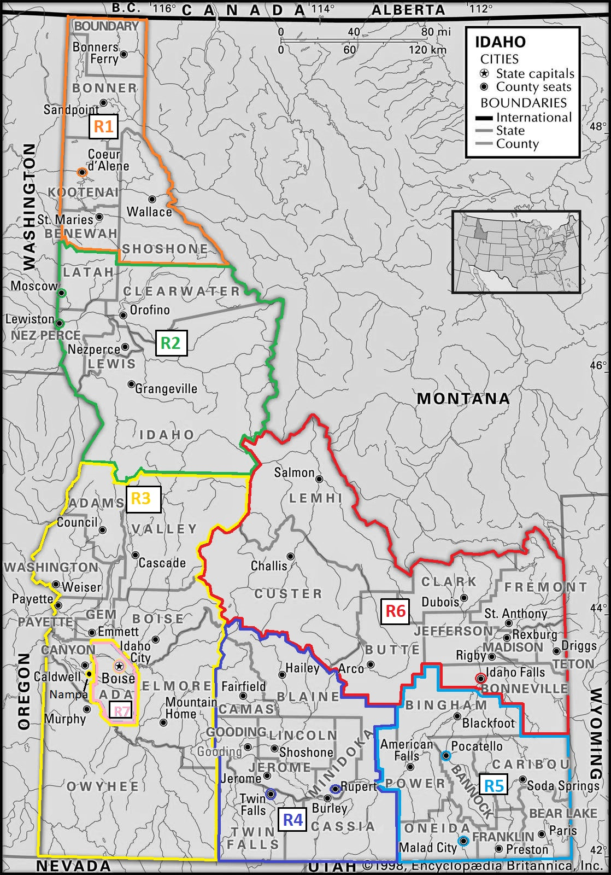

AP-65 Homeless and Other Special Needs Activities – 91.320(h)
Reaching out to homeless persons (especially unsheltered persons) and assessing their individual needs
Due to the geographic diversity of being a balance of state continuum of care, and the rural nature and uniqueness of the many communities within the Idaho BoS CoC, a “one size fits all” approach to conducting outreach to those experiencing homelessness to assess their individual needs is not efficient, practical or effective. Because of these considerations, the Idaho BoS CoC is divided into six regions, with each region having an active Regional Coalition and a Coordinated Entry Access Point.
      - IHFA works with the six Regional Coalitions to help identify effective tools, methods and strategies to effectively conduct outreach to those experiencing homelessness. Additionally, each region works together with their own community partners to help identify the most effective outreach strategies for their unique location and to identify and address barriers within their geographic region. This approach allows flexibility within each geographic region to ensure the outreach is effective given the unique circumstances of each region, while also having the Idaho BoS CoC provide comprehensive coordination and oversight.

      - To help with outreach, the Idaho BoS CoC produces informational brochures, cards and posters which are displayed in Access Point locations and delivered to community stakeholders who may come in contact with those experiencing a housing crisis. Additionally, IHFA, in coordination with the Idaho BoS CoC, maintains and updates a dedicated landing page on its website to make information about housing programs and resources for those who may be experiencing a housing crisis, readily available.

      - The Idaho BoC CoC ensures a broad representation of community stakeholders are participating on the IHCC Board and in Regional Coalitions. This enables the CoC to share up to date information about COC, ESG and HOPWA programs which can then be disseminated throughout the state through a wide variety of resource providers. The IHCC board includes representatives from the Idaho Departments of Education, Labor, Commerce, Corrections, Health and Welfare, as well as representation from DV agencies and HIV/AIDs organizations. Regional Coalitions include representatives from local law enforcement, early childhood education, elected officials, food banks, social workers, and other non-profit organizations who serve those who are or who may become at risk of homelessness.

      - IHFA, in coordination with the Idaho BoS CoC, produces an annual Report to the Community on the state of homelessness in Idaho. This professionally designed booklet provides statistics and shows trends and needs throughout the state. The booklet is widely disseminated to hundreds of stakeholders, including state and local elected officials, news media, and representatives from hospitals, education, justice, law enforcement, nonprofits and others to increase awareness of the programs available and the needs throughout the state. This helps educate those working with marginalized Idahoans, and increases the distribution of information to them about out programs through this wide array of stakeholders.
Addressing the emergency shelter and transitional housing needs of homeless persons
The Coordinated Entry system went into effect in the BOS COC on January 22, 2018. Coordinated Entry streamlines and facilitates access to appropriate housing and services. The process centers on streamlining access to housing assistance and screens applicants for eligibility for these and other programs using a consistent and well-coordinated approach, and assessing their needs to determine which interventions are most appropriate. This has proved to be an invaluable tool in l assessing the vulnerability, needs, and extent of barriers of those experiencing homelessness.
      - We will continue to collect data, which allows homeless provider networks, such as the BoS CoC, understand the homeless population’s needs better. Using an objective assessment of each individual or family, allows IHFA to assess which housing component and service types that Idaho is in most need of. “Right sizing,” or re-aligning resources with the population need, can then occur. This process will ensure homeless persons are directed towards the resources that have the highest likelihood of reducing their extent of homelessness, or removing them from homelessness altogether. As this shift in resource priority is made, emergency shelters, and rapid rehousing can be utilized as intended; to reduce length of homelessness and re-introduce households to stable living environments.

      - We will continue to support the need for Emergency Shelters throughout the state of Idaho through funding allocations and in all decision-making processes, including outreach to shelters for target populations of domestic violence survivors and youth.

      - IHFA, in coordination with the Idaho BoS CoC, is spearheading the renovation of a former city owned building to repurpose it for a much needed shelter in Pocatello Idaho. Aid for Friends is the only shelter for men, women and families in the area. For the past 30 years, the non-profit operated out of a single family three story home built in the 1930’s, making it very difficult to serve those struggling in their community. Many times, the shelter has operated at 114% capacity. Thanks to a community wide fundraising effort, Aid for Friends has started the renovation process on a new and much larger homeless shelter. The new shelter will provide appropriate living quarters for men, women and families. It will include a dining area, laundry facilities and space for education and workforce development opportunities. Aid for Friends anticipates the new shelter will serve almost 1,000 Southeast Idaho residents each year who may be facing or experiencing homelessness. This is an example that IHFA is looking to replicate in other communities in Idaho.

      - The Idaho BoS CoC provides grant funding and support to many agencies who are helping survivors of domestic violence. By providing the survivors with transitional housing, it enables them to find a safe refuge to be able to rebuild their lives and move on to more permanent housing opportunities. Through education, support, and counseling, these agencies help many families heal and become stably housed.

Helping homeless persons (especially chronically homeless individuals and families, families with children, veterans and their families, and unaccompanied youth) make the transition to permanent housing and independent living, including shortening the period of time that individuals and families experience homelessness, facilitating access for homeless individuals and families to affordable housing units, and preventing individuals and families who were recently homeless from becoming homeless again
In the absence of appropriate and effective intervention efforts and resources, many families and individuals will become homeless as life changes such as loss of employment, lack of affordable housing, loss of support networks, exit from an institution or facility, and other severe circumstances present themselves. For those that experience these misfortunes, recovery can be extremely difficult when disability, controlled substance or alcohol dependency, or other extreme conditions exist. In some cases long-term and ongoing permanent housing is the most appropriate housing solution. However, IHFA, the BOS CoC, and regional housing coalitions identify the need for services that focus on reducing shelter stays and diverting individuals and families away from homelessness altogether.
IHFA and the BoS CoC acknowledges and supports the commitment to preventing and ending homelessness displayed by HUD through Home Together and Opening Doors. Whether a participant receives housing and service support through transitional or permanent housing, each agency strives to provide individualized goal-based service planning to increase the likelihood for long-term success and self-sufficiency; ensure access to more stable housing situations; and establish support networks and habits that reduce the likelihood of recidivism.
The Idaho BoS CoC provides grants and support to many Permanent Supportive Housing programs throughout the state of Idaho. Additionally, IHFA, who is also the tax credit recipient for the state of Idaho, has added in its QAP, incentive points for developers to add dedicated PSH units in their tax credit properties. Developers are required to partner with agencies who work with those experiencing homelessness to provide supportive services and enter data into HMIS. These additional PSH units are in great need and IHFA is proud of the success this has had in adding PSH units to current and future tax credit projects throughout Idaho.
IHFA has also been instrumental in the development of New Path, which has 40 PSH units serving chronically homeless individuals, providing housing and partnering with health care and service providers to meet the needs of its residents. IHFA also celebrated the opening of Valor Point, a project with 27 PSH units, providing housing and services to housing veterans experiencing homelessness. IHFA is looking for other opportunities to develop similar properties that will provide more PSH units to vulnerable populations throughout Idaho.
Helping low-income individuals and families avoid becoming homeless, especially extremely low-income individuals and families and those who are: being discharged from publicly funded institutions and systems of care (such as health care facilities, mental health facilities, foster care and other youth facilities, and corrections programs and institutions); or, receiving assistance from public or private agencies that address housing, health, social services, employment, education, or youth needs
Over the next year, the Balance of State CoC will continue to work to help low-income individuals and families avoid becoming homeless, especially extremely low-income individuals and families and (1) those who are being discharged from publicly funded institutions and systems of care (such as health care facilities, mental health facilities, foster care and other youth facilities, and corrections programs and institutions); and (2) those who are receiving assistance from public or private agencies that address housing, health, social services, employment, education, or youth needs. The following goals and strategies will guide this work:
- We will, over the next year, leverage the work IHFA does in administering the HUD Housing Choice Voucher (HCV) rental assistance program in 34 of the 44 counties in Idaho. The program helps low-income families, the elderly, and disabled individuals obtain decent, safe, and affordable rental housing. IHFA was recently awarded Mainstream Vouchers which target non-elderly disabled individuals who are either chronically homeless or are exiting institutions. Mainstream vouchers have been allocated throughout the CoC’s six regions, with clients identified and prioritized in collaboration with the CoC’s Coordinated Entry system. This ensures all housing options are made available to clients within this population and facilitates the goal of filling all the mainstream voucher slots to house as many clients as possible within this population.
- We will continue, over the coming year, to strengthen our relationships with the school systems and the foster care system in Idaho to prevent homelessness among youth aging out of foster care.
- We will continue, over the coming year, to include key stakeholders at the table to provide input regarding these vulnerable populations. For example, we have representatives from the Idaho Department of Education and the Department of Corrections on our IHCC Board and have many representatives from key stakeholders serving these populations participating in our Regional Coalitions who provide input and direction to our CoC.
- Over the next year, we will ensure that all agencies receiving ESG funds in Idaho offer services that educate and counsel individuals and families to develop skills that promote self-sufficiency, including connecting to SOAR resources when appropriate.
- Approximately 40% of the ESG funding not associated with shelter activities is used to fund Homelessness Prevention efforts. This funding allocation will remain consistent over the coming year. These funds are leveraged with services to assist families or individuals in evaluating their primary cause(s) of becoming or being at risk of homelessness.
- Over the coming year, we will continue to work with public and private agencies that address housing, health, social services, employment, education, or youth needs in making them aware of the Coordinated Entry system so that those needing housing assistance can be referred and assessed and have access appropriate programs as they are available.
Putting these goals and strategies into action will increase the probability that those needing assistance will improve their housing stability and reduce their risk of experiencing future episodes of homelessness.
IHFA also supplements the homelessness prevention dollars provided through the ESG program with private funds raised though the Home Partnership Foundation, providing another resource to help prevent individuals and families from entering the homelessness services system.

AP-75-Barriers to Affordable Housing
Goals and milestones- 2020 Program Year

ISSUES AND CONTRIBUTING FACTORS | GOAL | MILESTONES | RESPONSIBLE ENTITY
Higher housing needs of disabled, elderly and extremely low income households and limits on local revenue generation | A. Support residents with disproportionate housing needs living in non- entitlement areas:  - Continue preferences for deeply subsidized rental housing.  - Support tenant preferences that target priority housing needs populations as identified in the 5-Year Consolidated Plan.  - Support partner efforts to develop a recurring source of state funding for the Idaho Housing Trust Fund, emphasizing the unique needs of non- entitlement communities.  - Require affordable rental housing projects to be located in communities that are committed to Affirmatively Furthering Fair Housing Choice. | - Complete 10 units of rental housing annually that target priority housing needs populations (Disabled, Elderly,  ≤30% AMI).  - Retain current preferences in LIHTC QAP; evaluate effectiveness of income targeting during subsequent years based on applications received in 2018 and 2019.  - Encourage efforts to provide state support for housing trust fund.  - The Annual Administrative Plan to require proof that communities in which the HOME, HTF projects are located are committed to Affirmatively Furthering Fair Housing. Evidenced by the submission of an adopted Fair Housing Resolution, a Fair Housing Plan, or a current Analysis of Impediments to Affirmatively Furthering Fair Housing (CDBG Entitlement Communities) at the time the application is submitted for funding. | IHFA
Disproportionately lower homeownership rates among Hispanic, Native American and African American households | B. Help qualified renters attain homeownership: Support credit counseling and homeownership readiness though affirmative marketing. | 1. Continue Finally Home! Homebuyer Education classes in Moscow, Sandpoint, Coeur d Alene, Idaho Falls, Twin Falls, Nampa, and Boise, and online to reach 5,000 or more potential homebuyers. Continue bilingual outreach, training, and customer  service efforts. | IHFA
Landlord lack of fair housing awareness resulting in fair housing complaints and higher use of publicly subsidized housing by minority residents | C. Increase fair housing knowledge:  - Continue current fair housing capacity building and educational outreach activities, particularly among property owners and persons with disabilities.  2. Continue to provide information about and support expansion of state fair housing protections to include familial status.  3. Continue to award preferences points to CDBG applicants with fair housing protections that include familial status.  4. Require affordable  rental housing projects to be located in communities that are committed to Affirmatively Furthering Fair Housing Choice or have adopted a Fair Housing Plan (CDBG non- entitlement areas). | - With Idaho Fair Housing Forum partners, support 2 to 10 fair housing training events annually with landlord groups  - Support efforts to add familial status to state protections.  - During program years 2017- 2020, Commerce will continue to award preference points to CDBG applicants that include fair housing protections for familial status.  4. HOME and HTF written agreements specify Federal fair housing and nondiscrimination laws, including familial status as a protected class in accordance with Title VIII of the Civil Rights Act of 1968. | IHFA-1,2, & 4  Commerce -3

Housing developed with limited Visitable or Accessible features; Access or proximity to public infrastructure; Local policies associated with land use and zoning, including those that limit group homes. | D. Increase accessible, affordable housing options:  - Continue with HOME, HTF application preference points for rental housing that benefits elderly, disabled, ≤30% AMI.  - Explore ways to incent Visitable housing.  3. Continue to support educational efforts to inform local jurisdictions of best practices and legal risks associated with land use and zoning laws, including requiring conditional use permits for group homes.  - Provide funding preference for needed accessibility improvements.  - Explore creation of a more coordinated and comprehensive effort to address the access needs of persons with disabilities. | - Retain current preferences in Administrative Plan.  - Provide funding preferences for Visitable single-family rental housing.  - Coordinate annual training on best practices in land use and zoning, focusing on group homes.  - Five percent of all new multifamily rental housing will be wheelchair accessible; two percent will accommodate persons living with sensory impairments.  5. Continue to market ADA improvements as eligible activities for CDBG  - Complete 15 projects that improve ADA accessibility during 2017-2021 assuming national objectives are met.  b. Ensure all CDBG grantees (cities and counties) have updated their ADA Transition Plans prior to project closeout.  c. Increase CDBG application priority ranking points for projects that focus on the removal of architectural barriers or improve ADA accessibility. | IHFA 1,2,3,4  Commerce-5

Gaps in educational achievement for students with disabilities; African American, Native American and Hispanic students; LEP students; and students in transition and at- risk and economically disadvantaged students | E. Help address education proficiency gaps:  - Consider Utah's best practice of adding preferences for LIHTC location in areas with high proficiency schools* | Explore effectiveness of Utah's LIHTC program in 2019 and 2020 (after it has been utilized for three years) | IHFA
Low wages in economically disadvantaged rural areas due to limited economic growth and growth in low wage industries (e.g., service jobs) | F. Increase employment in economically disadvantaged communities:  - Continue to allocate CDBG to job creation activities in rural communities. | 1. Use CDBG funds to leverage the creation of 30 moderate to high paying jobs created or retained annually, 2017 through 2020 | Commerce
Inaccessible (pre-ADA) public buildings, commercial establishments, and infrastructure. Lack of funding for—and high cost of—accessibility improvements to streets, sidewalks, and other public infrastructure. | G. Dedicate additional federal support to increasing employment and accessibility in non- entitlement areas:  - Support federal efforts to expand infrastructure redevelopment in rural areas and ensure that these include creating environments that are more accessible. | - Activities to be determined in future action plans depending upon federal activities to improve infrastructure.  - Promote community accessibility practices to increase awareness of access and opportunity. | Commerce-1 IHFA-2

Insufficient transportation services to support independent, integrated community living for seniors and persons with disabilities. Lack of public transportation in rural areas. | H. Dedicate additional federal support to increasing employment and accessibility in non- entitlement areas— contingent on participation of Idaho Transportation Department and Federal Highway Administration):  - Encourage local government grantee's ability to play a role in transportation planning at the state and regional levels.  - Through roundtable discussions, public-private partnerships, explore the demand to expand and create formal rideshare programs in rural communities with need. | - Ensure CDBG grantees (cities and counties) located in resort communities or college towns have completed the transportation component of their comprehensive plan (as per Idaho's Local Land Use Planning Act). At a minimum, the transportation component should assess bicycle and pedestrian circulation and the existing (or feasibility of) public transportation - bus or van. Further, the city or county should address the transportation factors that are contributing to limiting opportunities for its residents in their fair housing assessment.  - Convey the importance of transportation alternatives in an integrated community living to the Idaho Transportation Department's Public Transportation Interagency Working Group. | Commerce-1 IHFA-2
Challenges to housing for persons with criminal backgrounds who cannot qualify for publicly supported housing and for whom private sector may be reluctant to provide housing. | - Explore programs to provide housing options for persons with criminal backgrounds, particularly those who are disproportionately represented by certain protected classes:  1. Explore best practices (e.g., Sponsors, Inc. in Oregon) to assist men and women in corrections re- integrating into communities.  2. Educate housing partners statewide on appropriate language on criminal backgrounds in rental agreements. | Annual outreach via stakeholder networks and conferences; include best practice information in correspondence to affordable housing providers. | IHFA

AP-85- Other Actions
Actions planned to foster and maintain affordable housing
Idaho Housing and Finance Association
- As the State of Idaho’s legislated housing agency, IHFA maintains a highly visible presence in Idaho. This is accomplished through ongoing public affairs and media events, including the annual Regional Housing Roundtable (Lewiston, Coeur d’ Alene, Boise/Nampa, Twin Falls and Pocatello) bi-annual Conference on Housing and Economic Development.

- IHFA is the HUD grantee for the State of Idaho’s federal affordable housing programs, including the Section 8 Housing Choice Voucher Program, the HOME Investment Partnerships Program, the National Housing Trust Program, the Neighborhood Stabilization Program, and the Low-Income Housing Tax Credit Program.

- During the period of affordability, IHFA’s Compliance Department conducts compliance monitoring on all rental housing projects as required at §92.504 (HOME) and §93.404 (HTF). Monitoring includes the following: Tenant files, annual owner certifications, unit mix (fixed/floating units), household income prior to occupancy and at recertification, rent and utility allowance calculations, tenant disclosure notices (lead-based paint and Section 504), tenant rights and protections are included in the lease agreement, marketing and outreach. At least once every 3 years, there is a physical inspection of the units, based on the appropriate unit sample, to ensure property standards at §92.251 (HOME) and §93.301 (HTF) are maintained.

- Households who participate in the Section 8 Housing Choice Voucher program are eligible to be part of Idaho Housing's Family Self-Sufficiency (FSS) Program, a voluntary program that helps families become economically independent. The goals include assisting families to become free of all forms of state and federal welfare through employment. Participants may receive an interest-bearing escrow (savings) account that accrues as their household's portion of the rent increases because of an increase in earned-income. A tax-free account is provided to the family when they complete their FSS Contract of Participation and are free of welfare for 12 consecutive months. The program matches an individual's savings, up to $2,000, dollar-for-dollar towards the down payment on a home. 5) When HUD funds create or preserve affordable housing, HUD's Section 3, and Minority and Women Owned Business Entities (MBE/WBE) requirements help local economic development opportunities for low-income residents, business entities, Minority, and Women-Owned Business Entities (MBE/WBE). Section 3 outreach requirements are determined by the project's aggregate federal funding. Some examples of Section 3 and MBE/WBE outreach includes advertising potential employment in the area in which the project is located, and submitting the project information to Idaho's Section 3 Business Entity Registration. Section 3 and MBE/WBE requirements are included in the written agreement. 6) Financial Risk Assessment- To help ensure multifamily projects remain financially viable during their period of affordability, IHFA conducts an annual financial risk assessment on HOME/HTF properties with 10 or more assisted units. Additional financial oversight and corrective actions can be implemented, as required by the program regulation and included in the written agreement.

- LIHTC Program- Twenty percent of the annual per capita tax credit will be set-aside for the rehabilitation of existing federally assisted rent-restricted developments and/or for the new construction of developments financed or guaranteed by USDA-Rural Development. For rehabilitation developments, the scope of the rehabilitation must meet the per unit hard cost requirements identified in Section 4.17 of IHFA’s annual LIHTC Qualified Action Plan. The set-aside is available on a statewide basis during the August Application Round if sufficient applications are received. Otherwise, it will be available for all other qualified non-targeted applications.

- ESG- The Idaho Balance of State Continuum of Care has utilized a non-renewable planning grant to help expand current activities and establish governing structures and systems, which ensure proper oversight and coordination of HUD-funded homeless programs. The activities identified by the BoS CoC are coordination activities, project evaluation, participation in the consolidated plan, CoC application activities, and developing a CoC system. Several of these activities include efforts that enhance coordination between public and private housing and service agencies. The CoC has made itself more visible in regional planning and advocacy bodies to ensure all agencies and individuals connected to homelessness issues are familiar with resources available. This promotes and fosters relationships between housing and service providers. ESG and HOPWA providers are included in the CoC’s efforts.

AP-90- Program Specific Requirements

Emergency Solutions Grant
House Idaho Collaborative (HIC) Written Standards is found on IHFA’s website under the initiatives subheading https://www.idahohousing.com/homelessness-services-programs/house-idaho-collaborative/

HOME & HTF Programs
IHFA may consider refinancing of existing debt if the debt was not made or insured by any Federal Program (CDBG, USDA-RD, VA, HUD-202 or 811 or 221(d(4), PHA Capitol Fund, FHA), and substantial rehabilitation will be the primary activity. Activity is eligible within Idaho, except the City of Boise.
Requirements:
- Refinancing is necessary to permit the continued affordability of the project. For HTF, this must result in the housing being more affordable and proportional to the number of HTF-assisted units in the rental project; additionally, the proportional rehabilitation cost must be greater than the proportional amount of debt that is refinanced.
- Affordability period is no less than 15 Years;
- A review of the owner’s financial and property management practices clearly demonstrates there was no disinvestment in the property;
- Feasibility of serving the current target population over an extended period is demonstrated by pro forma;
- Substantial Rehabilitation of all units and tenant common areas is necessary as demonstrated by a Physical Needs Assessment.
- “Substantial Rehabilitation” defined as ≥$25,000 per unit in hard rehabilitation costs. “Hard” rehabilitation costs for this activity is defined as site work, physical improvements, and construction contingency.
- Capital Needs Assessment must meet the following requirements:
- Assessment must be conducted or updated within the previous 6 months;
- At minimum CNA must match term of HOME/HTF Loan
- Assess the physical condition of all major systems, structures, units, and tenant common areas; Identify any major system with a useful remaining life. Any system with less than a 15-year useful remaining life must be replaced as part of the rehabilitation project.
- Prepared by an independent architect/engineer who is licensed and certified by the State of Idaho;
- Architect or Engineer must certify the CNA is an accurate assessment of the entire property and includes an assessment of the items needed to comply with the Property Standards:
- Property Standards- State of Idaho's building codes, applicable local property standards and ordinances, Uniform Physical Condition Standards (UPCS) or updated standard found at 92.251 and/or 93.301, applicable federal crosscutting regulations (Fair Housing Act, Section 504, ADA, UFAS, HUD Lead Safe Housing Rule) and ASHRAE 90.1 for Multifamily buildings.
Discussion- Sales Price Limits

Pursuant to 92.254(a)(2)(iii), IHFA has utilized local data to determine the median area purchase price for twelve (12) counties. Most areas used a full year of data (March 1, 2024 to February 28, 2025). For the Ada County metro area, three months of data was used (November 2024- January 2025). These three months were selected as the point in time at which the Annual Action Plan was started. The median data was then multiplied by .95.

To ensure households have access to the same inventory, this analysis is necessary.

Phase 1 is not needed at time of application, but must be completed if the project is selected.

