# **Needs Assessment**

## NA-05 Overview

**Needs Assessment Overview**

The Needs Assessment provides an overview of the impacts of this growth on housing availability, affordability, and quality. It includes the following sections:

* **Housing Needs Assessment:** data on population, income level, number and type of households, and housing problems. For the purpose of this section, housing problems are defined as:
* Lack of complete kitchen facilities.
* Lack of complete plumbing facilities.
* Cost burden: the allocation of more than 30% of gross household income toward housing costs. For renters, housing costs include rent paid by the tenant plus utilities; for owners, housing costs include mortgage payment, taxes, insurance, and utilities. This section includes data on severe cost burden, as well, which is paying more than 50% of gross household income on housing costs.
* Overcrowding: more than one person per room, not including bathrooms, porches, foyers, halls, or half-room.

HUD default data for this section are from the 2000 Census (Base Year); 2016-2020 American Community Survey (ACS); and the 2016-2020 CHAS (Comprehensive Housing Affordability Strategy).

* **Disproportionately Greater Need:** when the members of a racial or ethnic group at a given income level experiences housing problems (as defined above) at a greater rate (10% or more) than the income level for the County as a whole.
* **Public Housing:** information on the number and type of public housing units and the characteristics of residents is presented. For the purpose of this section, “public housing” includes traditional public housing units subsidized by annual contribution contracts (ACC) and former public housing units that have been converted to “affordable housing” under the Rental Assistance Demonstration (RAD) program. Data on voucher programs is provided, as well.
* **Homeless Needs Assessment:** the nature and extent of homelessness in Perris using data from the Homeless Management Information System (HMIS) and
* **Non-Homeless Special Needs Assessment:** housing needs for persons who are not homeless but require supportive services are presented. These populations include the elderly, frail elderly, persons with disabilities, and persons with alcohol or other drug addictions. HUD default data is not provided; data used to assess these needs is appropriately cited. HOPWA data is based on CDC HIV Surveillance Data and the HOPWA CAPER and HOPWA Beneficiary Verification Worksheet.
* **Non-Housing Community Development Needs:** non-housing community development needs (i.e., public facilities, public improvements, and public services) is based on input from consultations/community input and local plans and reports as HUD default data is not provided.

***Maps Used in the Needs Assessment***

To provide the most current representation of needs in Idaho, where available, GIS Maps are used to support the data tables. All maps are based on 2018-2022 ACS data.

Where possible and useful to understanding current challenges, additional narrative has been added with alternative data sources to provide a more current snapshot of certain data points.

Because CHAS data is derived from ACS data, Census definitions dictate the definitions of the variables discussed in these tables

Small Family Household: A household with two-four members

Large Family Household: A household with five or more members

Elderly: Ages 62-74

Frail Elderly or Extra Elderly: Ages 75+

Household: All people living in a housing unit. Members of a household can be related or unrelated.

Family: Related individuals living in the same household

Nonfamily: Unrelated individuals living in the same household

The term Area Median Income (AMI) and HUD Area Median Family Income (HAMFI) are interchangeable when the terms are being used to explain CHAS data derived from ACS data. For consistency throughout this document, only the term AMI will be used. It is important to note that within this document, AMI refers to the entire state of Idaho. Throughout this document data tables compare populations based on income ranges. These income ranges are categorized based on AMI and are used by HUD to determine eligibility to certain programs.

HUD defines the following income brackets as low-moderate income.

Extremely Low Income = >30% AMI

Low Income = 30-50% AMI

Moderate Income 50-80% AMI

## NA-10 Housing Needs Assessment - 24 CFR 91.305 (a,b,c)

**Summary of Housing Needs**

Based on Census data, the State of Idaho grew by 3% between 2009 and 2020 and held 1,657,375 residents in 2020. According to 2018-2022 ACS data, the population has continued increasing and was at 1,854,109 residents by 2022.

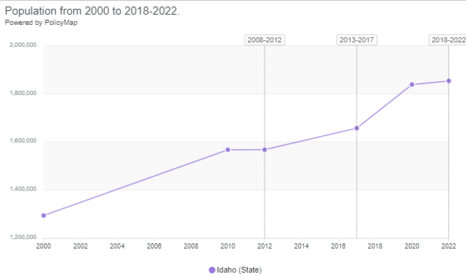

| **Demographics** | **Base Year: 2009** | **Most Recent Year: 2020** | **% Change** |
| --- | --- | --- | --- |
| Population | 1,616,572 | 1,657,375 | 3% |
| Households | 589,364 | 609,124 | 3% |
| Median Income | $0.00 | $50,985.00 |  |

Table 5 - Housing Needs Assessment Demographics

|  |  |
| --- | --- |
| **Data Source:** | 2000 Census (Base Year), 2016-2020 ACS (Most Recent Year) |

**Number of Households Table**

|  | **0-30% HAMFI** | **>30-50% HAMFI** | **>50-80% HAMFI** | **>80-100% HAMFI** | **>100% HAMFI** |
| --- | --- | --- | --- | --- | --- |
| Total Households | 67,790 | 70,225 | 113,540 | 67,520 | 290,045 |
| Small Family Households | 17,500 | 21,700 | 38,455 | 27,410 | 144,090 |
| Large Family Households | 3,980 | 6,660 | 13,885 | 8,230 | 32,265 |
| Household contains at least one person 62-74 years of age | 12,955 | 15,310 | 24,740 | 14,660 | 68,915 |
| Household contains at least one person age 75 or older | 8,845 | 12,070 | 16,645 | 7,540 | 20,845 |
| Households with one or more children 6 years old or younger | 9,925 | 13,170 | 22,810 | 13,535 | 34,595 |

Table 6 - Total Households Table

|  |  |
| --- | --- |
| **Data Source:** | 2016-2020 CHAS |

**Housing Needs Summary Tables**

1. Housing Problems (Households with one of the listed needs)

|  | **Renter** | | | | | **Owner** | | | | |
| --- | --- | --- | --- | --- | --- | --- | --- | --- | --- | --- |
| **0-30% AMI** | **>30-50% AMI** | **>50-80% AMI** | **>80-100% AMI** | **Total** | **0-30% AMI** | **>30-50% AMI** | **>50-80% AMI** | **>80-100% AMI** | **Total** |
| NUMBER OF HOUSEHOLDS | | | | | | | | | | |
| Substandard Housing - Lacking complete plumbing or kitchen facilities | 1,940 | 1,075 | 1,120 | 410 | 4,545 | 550 | 520 | 410 | 240 | 1,720 |
| Severely Overcrowded - With >1.51 people per room (and complete kitchen and plumbing) | 550 | 415 | 450 | 145 | 1,560 | 120 | 270 | 205 | 215 | 810 |
| Overcrowded - With 1.01-1.5 people per room (and none of the above problems) | 1,220 | 1,840 | 1,870 | 675 | 5,605 | 300 | 930 | 1,735 | 630 | 3,595 |
| Housing cost burden greater than 50% of income (and none of the above problems) | 23,705 | 8,165 | 1,295 | 105 | 33,270 | 13,135 | 9,240 | 6,205 | 1,225 | 29,805 |
| Housing cost burden greater than 30% of income (and none of the above problems) | 4,220 | 15,610 | 13,880 | 1,515 | 35,225 | 4,200 | 8,760 | 18,470 | 7,765 | 39,195 |
| Zero/negative Income (and none of the above problems) | 4,940 | 0 | 0 | 0 | 4,940 | 4,385 | 0 | 0 | 0 | 4,385 |

Table 7 – Housing Problems Table

|  |  |
| --- | --- |
| **Data Source:** | 2016-2020 CHAS |

2. Housing Problems 2 (Households with one or more Severe Housing Problems: Lacks kitchen or complete plumbing, severe overcrowding, severe cost burden)

|  | **Renter** | | | | | **Owner** | | | | |
| --- | --- | --- | --- | --- | --- | --- | --- | --- | --- | --- |
| **0-30% AMI** | **>30-50% AMI** | **>50-80% AMI** | **>80-100% AMI** | **Total** | **0-30% AMI** | **>30-50% AMI** | **>50-80% AMI** | **>80-100% AMI** | **Total** |
| NUMBER OF HOUSEHOLDS | | | | | | | | | | |
| Having 1 or more of four housing problems | 27,415 | 11,495 | 4,740 | 1,335 | 44,985 | 14,105 | 10,955 | 8,560 | 2,310 | 35,930 |
| Having none of four housing problems | 8,745 | 23,180 | 39,265 | 19,645 | 90,835 | 8,200 | 24,595 | 60,980 | 44,235 | 138,010 |
| Household has negative income, but none of the other housing problems | 4,940 | 0 | 0 | 0 | 4,940 | 4,385 | 0 | 0 | 0 | 4,385 |

Table 8 – Housing Problems 2

|  |  |
| --- | --- |
| **Data Source:** | 2016-2020 CHAS |

3. Cost Burden > 30%

|  | **Renter** | | | | **Owner** | | | |
| --- | --- | --- | --- | --- | --- | --- | --- | --- |
| **0-30% AMI** | **>30-50% AMI** | **>50-80% AMI** | **Total** | **0-30% AMI** | **>30-50% AMI** | **>50-80% AMI** | **Total** |
| NUMBER OF HOUSEHOLDS | | | | | | | | |
| Small Related | 10,500 | 10,415 | 6,355 | 27,270 | 3,965 | 5,310 | 8,645 | 17,920 |
| Large Related | 2,060 | 2,340 | 1,725 | 6,125 | 1,115 | 1,950 | 3,010 | 6,075 |
| Elderly | 5,380 | 4,810 | 2,805 | 12,995 | 8,840 | 8,185 | 8,315 | 25,340 |
| Other | 12,750 | 8,610 | 5,455 | 26,815 | 3,920 | 3,215 | 5,245 | 12,380 |
| Total need by income | 30,690 | 26,175 | 16,340 | 73,205 | 17,840 | 18,660 | 25,215 | 61,715 |

Table 9 – Cost Burden > 30%

|  |  |
| --- | --- |
| **Data Source:** | 2016-2020 CHAS |

4. Cost Burden > 50%

|  | **Renter** | | | | **Owner** | | | |
| --- | --- | --- | --- | --- | --- | --- | --- | --- |
| **0-30% AMI** | **>30-50% AMI** | **>50-80% AMI** | **Total** | **0-30% AMI** | **>30-50% AMI** | **>50-80% AMI** | **Total** |
| NUMBER OF HOUSEHOLDS | | | | | | | | |
| Small Related | 9,110 | 3,075 | 320 | 12,505 | 3,335 | 2,745 | 1,755 | 7,835 |
| Large Related | 1,615 | 535 | 35 | 2,185 | 870 | 665 | 410 | 1,945 |
| Elderly | 4,045 | 1,960 | 745 | 6,750 | 6,225 | 4,060 | 2,650 | 12,935 |
| Other | 10,955 | 3,480 | 610 | 15,045 | 3,055 | 1,970 | 1,410 | 6,435 |
| Total need by income | 25,725 | 9,050 | 1,710 | 36,485 | 13,485 | 9,440 | 6,225 | 29,150 |

Table 10 – Cost Burden > 50%

|  |  |
| --- | --- |
| **Data Source:** | 2016-2020 CHAS |

5. Crowding (More than one person per room)

|  | **Renter** | | | | | **Owner** | | | | |
| --- | --- | --- | --- | --- | --- | --- | --- | --- | --- | --- |
| **0-30% AMI** | **>30-50% AMI** | **>50-80% AMI** | **>80-100% AMI** | **Total** | **0-30% AMI** | **>30-50% AMI** | **>50-80% AMI** | **>80-100% AMI** | **Total** |
| NUMBER OF HOUSEHOLDS | | | | | | | | | | |
| Single family households | 1,895 | 1,960 | 1,955 | 685 | 6,495 | 385 | 1,030 | 1,580 | 685 | 3,680 |
| Multiple, unrelated family households | 40 | 95 | 225 | 150 | 510 | 74 | 215 | 370 | 135 | 794 |
| Other, non-family households | 160 | 240 | 205 | 40 | 645 | 0 | 0 | 20 | 35 | 55 |
| Total need by income | 2,095 | 2,295 | 2,385 | 875 | 7,650 | 459 | 1,245 | 1,970 | 855 | 4,529 |

Table 11 – Crowding Information – 1/2

|  |  |
| --- | --- |
| **Data Source:** | 2016-2020 CHAS |

|  | **Renter** | | | | **Owner** | | | |
| --- | --- | --- | --- | --- | --- | --- | --- | --- |
| **0-30% AMI** | **>30-50% AMI** | **>50-80% AMI** | **Total** | **0-30% AMI** | **>30-50% AMI** | **>50-80% AMI** | **Total** |
| Households with Children Present |  |  |  |  |  |  |  |  |

Table 12 – Crowding Information – 2/2

**Describe the number and type of single person households in need of housing assistance.**

According to HUD 2018-2022 Census data, 24.74% of all households in the State of Idaho were single-person households, or 167,052 households. This is a -1.4% decline from 2017 in which 26.13% of households were single-person households. Renters are more likely than homeowners to live in single-person households and renter households are more likely to be cost burdened. The chart below shows the counties that have the highest densities of single-person households. Elderly residents living in single-person households and on fixed incomes may need housing assistance.

|  |  |
| --- | --- |
| Estimate percent of households that are 1-person households  2022 ACS | |
| County | Percent |
| Lewis | 33.52% |
| Clearwater | 34.49% |
| Shoshone | 36.84% |
| Butte | 37.11% |
| Clark | 41.09% |
| Lemhi | 41.62% |

**Estimate the number and type of families in need of housing assistance who are disabled or victims of domestic violence, dating violence, sexual assault and stalking.**

Persons with Disabilities

2018-2022 ACS data suggests that 251,201 residents, or 13.74% of the population of the State of Idaho is living with a disability. Although the overall disability rate has only gone up by about 0.4% since 2017, there are some areas of the state that saw large increases of over 36%, especially in the central and southeastern areas (shown in Map I.1). 34.95% of residents aged 65 or older are living with a disability. 21.6% of residents in the state are living below the poverty level with a disability (a 3.35% increase from 2017) - Map I.2 shows that those living with disabilities who are also living in poverty have a higher density in northern tracts. 2023 ACS data shows that 24.8% of the city’s population aged 65-74 years and 45.9% of those aged 75 years or older are living with a disability. Ambulatory disabilities are the highest disability type for those 65 years or older and affect 18.4% of the population. Independent living difficulties (because of a physical, mental, or emotional problem, having difficulty doing errands alone such as visiting a doctor’s office or shopping) are also noted as a high disability type and affect 10.4% of the population of those aged 65 years or older. There is a need for more housing assistance for those living with disabilities, especially the elderly population.

**MAP I.1**

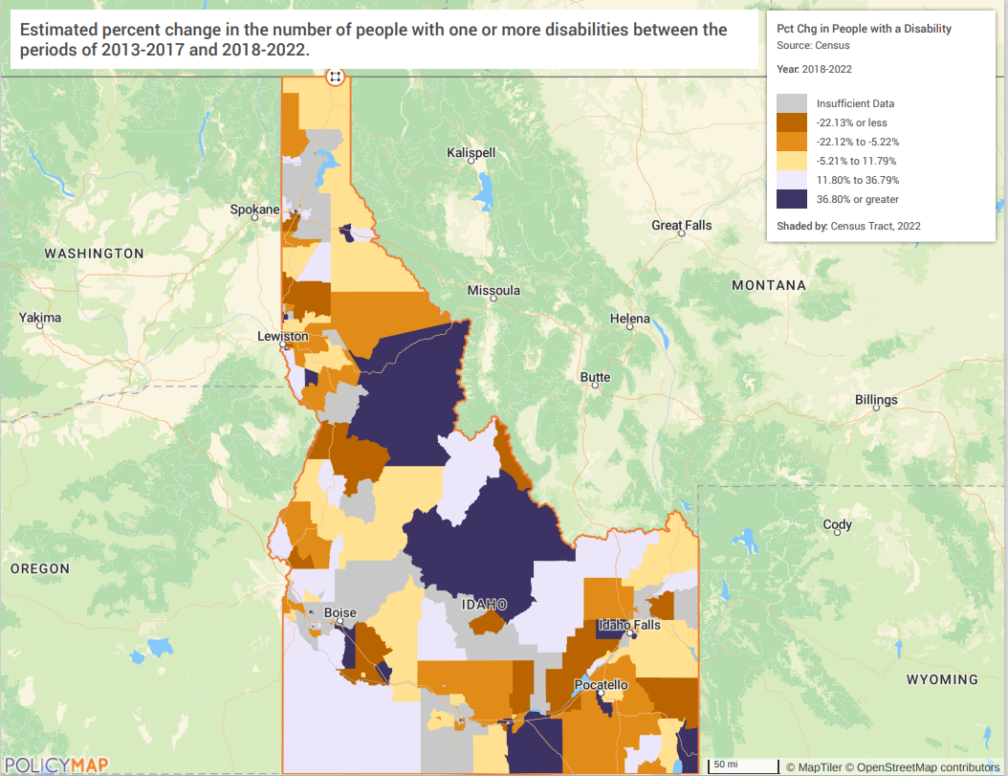

**MAP I.2**

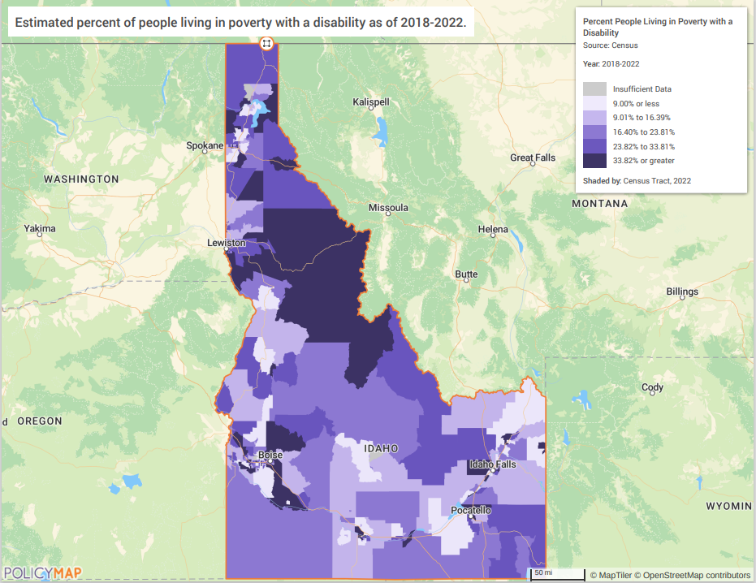

Victims of Domestic Violence, Dating Violence, Sexual Assault, and Stalking

[Microsoft Word - DV & Housing Report.docx](https://icdv.idaho.gov/wp-content/uploads/2023/07/DV-Housing-Report.pdf)

[All Research Reports | Idaho Victimization Clearinghouse](https://idvch.com/all-research-reports/)

[Statistics – WCA](https://wcaboise.org/about-us/statistics/)

[FFT-2023-24-ICDVVA-Only.pdf](https://icdv.idaho.gov/wp-content/uploads/2024/02/FFT-2023-24-ICDVVA-Only.pdf)

[18th-Annual-DV-Counts-Report-ID-Summary.pdf](https://nnedv.org/wp-content/uploads/2024/03/18th-Annual-DV-Counts-Report-ID-Summary.pdf)

Gathering accurate and current data on topics of domestic violence, dating violence, sexual assault, and stalking can be a challenge due to substantial underreporting. The Idaho Council on Domestic Violence and Victim Assistance funds a project that includes papers and reports about victimization in Idaho. The report “Emerging Issues in Victimization: Domestic Violence and Housing in Idaho” was conducted to better understand the housing resources available for domestic violence survivors in Idaho.

**What are the most common housing problems?**

Housing cost burden is the most common housing problem in the State of Idaho. Resources spent on housing become unavailable for transportation, health care, childcare, and education. All these factors reinforce each other creating an economic situation that is difficult to exit. High housing costs reduce the availability of reliable transportation which prevents access to new economic opportunities which then makes it difficult to earn enough money to cover housing expenses.

A housing unit is considered cost-burdened when between 30 and 50 percent of its income goes toward housing costs, and severely cost-burdened when housing costs consume more than 50 percent of a household’s income as shown in Tables 8 and 9 above.  Table 7 shows that 74,420 households are cost-burdened, and 63,075 households are severely cost burdened. Out of all households that experience a housing problem, 45.2% experience cost burden and 38.2% experience extreme cost burden.

**Are any populations/household types more affected than others by these problems?**

Renter and owner households between 0-50% AMI are most affected by cost-burdening. Table 9 shows that out of the 134,920 combined owner and renter households that were cost-burdened, 93,365 were in income categories between 0-50% AMI (69.2%). Renter households experience cost burden at a higher rate than homeowner households – 42% of renter households and 19.94% of homeowner households experience housing cost burden, while 17.95% of renter households and 7.7% of homeowner households experience severe housing cost burden.

Small, related renter households are most likely to be cost burdened and extremely cost burdened. For owner occupied households, the elderly population is most likely to be affected by cost burdened and severe cost burden.

**Describe the characteristics and needs of Low-income individuals and families with children (especially extremely low-income) who are currently housed but are at imminent risk of either residing in shelters or becoming unsheltered 91.205(c)/91.305(c)). Also discuss the needs of formerly homeless families and individuals who are receiving rapid re-housing assistance and are nearing the termination of that assistance**

Low-income, cost-burdened residents are most at risk of becoming unsheltered. HUD defines extremely low-income households as those earning 0-30% of the Area Median Income (AMI) and considers households spending over 50% of their income on housing to be severely cost burdened. According to 2016-2020 CHAS data from the Housing Needs Summary Tables, the most pressing issue for extremely low-income households and families with children in Idaho is the limited availability of affordable housing. In Idaho, approximately 13,485 extremely low-income homeowner households and 30,690 extremely low-income renter households are severely cost burdened, meaning they contribute over half of their income to housing costs. Together, these nearly 50,000 households are at high risk of housing instability and potential homelessness.

The data also shows that Idaho had 9,925 extremely low-income households with children and 8,845 extremely low-income households with at least one person aged 75 or older. These families are vulnerable residents facing significant housing challenges. underscoring the need for targeted interventions to support and stabilize housing for the city’s most vulnerable residents. Addressing these affordability issues is essential to prevent housing instability and promote long-term security for low-income families and households in Idaho.

Families and individuals receiving rapid re-housing assistance and nearing the termination of that assistance indicated a need for affordable rental housing and stable employment to effectively continue beyond the re-housing assistance. Those nearing termination of assistance are connected with resources to identify affordable housing options available to them. Because rapid rehousing projects may determine their own desired maximum timeframes, there is no data estimating the number of individuals nearing the termination of rapid rehousing assistance.

**If a jurisdiction provides estimates of the at-risk population(s), it should also include a description of the operational definition of the at-risk group and the methodology used to generate the estimates:**

The State of Idaho does not provide estimates of its at-risk populations.

**Specify particular housing characteristics that have been linked with instability and an increased risk of homelessness**

Extremely low-income households with a severe housing cost burden are more likely to lose their homes in the event of loss of employment, health issues, or other unexpected expenses.   Unemployment and underemployment have been among the primary reasons for families losing their homes.  Cost burden is by far the most common housing problem and threatens housing stability.

To assist in homelessness prevention in rural areas, investment in job training and effective transportation infrastructure will be important as Idaho’s primary population growth continues in the urban areas of the state.

**Discussion**

The data demonstrates value in exploring owner-occupied rehabilitation with federal resources. Rehabilitation is often cheaper and preserves naturally occurring affordable housing. In rural areas, there may not be access to programs in assisting with the preservation of an owner’s existing property.

## NA-15 Disproportionately Greater Need: Housing Problems - 91.305 (b)(2)

**Assess the need of any racial or ethnic group that has disproportionately greater need in comparison to the needs of that category of need as a whole.**

**Introduction**

A disproportionately greater housing need exists when the members of racial or ethnic group at a given income level experience housing problems at a greater rate (10% points or more) than the income level as a whole.  The following tables analyze housing problems experienced by different racial and ethnic groups across income ranges in the State of Idaho.

**0%-30% of Area Median Income**

| **Housing Problems** | **Has one or more of four housing problems** | **Has none of the four housing problems** | **Household has no/negative income, but none of the other housing problems** |
| --- | --- | --- | --- |
| Jurisdiction as a whole | 49,968 | 8,590 | 9,381 |
| White | 41,486 | 7,245 | 7,507 |
| Black / African American | 449 | 100 | 60 |
| Asian | 426 | 134 | 527 |
| American Indian, Alaska Native | 932 | 222 | 98 |
| Pacific Islander | 34 | 30 | 0 |
| Hispanic | 5,297 | 679 | 1,012 |

Table 13 - Disproportionally Greater Need 0 - 30% AMI

|  |  |
| --- | --- |
| **Data Source:** | 2016-2020 CHAS |

*The four housing problems are:

1. Lacks complete kitchen facilities, 2. Lacks complete plumbing facilities, 3. More than one person per room, 4.Cost Burden greater than 30%

**30%-50% of Area Median Income**

| **Housing Problems** | **Has one or more of four housing problems** | **Has none of the four housing problems** | **Household has no/negative income, but none of the other housing problems** |
| --- | --- | --- | --- |
| Jurisdiction as a whole | 46,812 | 23,424 | 0 |
| White | 38,914 | 19,971 | 0 |
| Black / African American | 182 | 115 | 0 |
| Asian | 442 | 186 | 0 |
| American Indian, Alaska Native | 600 | 397 | 0 |
| Pacific Islander | 14 | 10 | 0 |
| Hispanic | 5,686 | 2,370 | 0 |

Table 14 - Disproportionally Greater Need 30 - 50% AMI

|  |  |
| --- | --- |
| **Data Source:** | 2016-2020 CHAS |

*The four housing problems are:

1. Lacks complete kitchen facilities, 2. Lacks complete plumbing facilities, 3. More than one person per room, 4.Cost Burden greater than 30%

**50%-80% of Area Median Income**

| **Housing Problems** | **Has one or more of four housing problems** | **Has none of the four housing problems** | **Household has no/negative income, but none of the other housing problems** |
| --- | --- | --- | --- |
| Jurisdiction as a whole | 45,671 | 68,018 | 0 |
| White | 38,259 | 57,646 | 0 |
| Black / African American | 491 | 238 | 0 |
| Asian | 500 | 620 | 0 |
| American Indian, Alaska Native | 559 | 820 | 0 |
| Pacific Islander | 83 | 75 | 0 |
| Hispanic | 5,112 | 7,774 | 0 |

Table 15 - Disproportionally Greater Need 50 - 80% AMI

|  |  |
| --- | --- |
| **Data Source:** | 2016-2020 CHAS |

*The four housing problems are:

1. Lacks complete kitchen facilities, 2. Lacks complete plumbing facilities, 3. More than one person per room, 4.Cost Burden greater than 30%

**80%-100% of Area Median Income**

| **Housing Problems** | **Has one or more of four housing problems** | **Has none of the four housing problems** | **Household has no/negative income, but none of the other housing problems** |
| --- | --- | --- | --- |
| Jurisdiction as a whole | 12,975 | 54,591 | 0 |
| White | 11,373 | 47,552 | 0 |
| Black / African American | 4 | 185 | 0 |
| Asian | 233 | 438 | 0 |
| American Indian, Alaska Native | 129 | 463 | 0 |
| Pacific Islander | 0 | 14 | 0 |
| Hispanic | 1,080 | 5,261 | 0 |

Table 16 - Disproportionally Greater Need 80 - 100% AMI

|  |  |
| --- | --- |
| **Data Source:** | 2016-2020 CHAS |

*The four housing problems are:

1. Lacks complete kitchen facilities, 2. Lacks complete plumbing facilities, 3. More than one person per room, 4.Cost Burden greater than 30%

**Discussion**

0-30% AMI

None of the racial or ethnic groups have a disproportionately greater need (10% or more than the than the income level as a whole) in the 0-30% AMI category. All groups experience housing problems at rates within or below the jurisdiction as a whole’s rate of 76.3%.

30-50% AMI

66.6% of households in this income category experience housing problems. None of the racial or ethnic categories experience disproportionate need at 10% or higher than the jurisdiction as a whole. 70.4% of Asian households and 70.6% of Hispanic households experience housing problems – although these do not meet the criteria for disproportionately greater need, they are the groups that have the highest rate of housing problems.

50-80% AMI

40.17% of households in this income category experience housing problems. Two racial groups have a disproportionately greater housing need compared to the overall jurisdiction. 67.35 of Black/African American households with 50-80% AMI experience housing problems, which is about 27% more than the jurisdiction as a whole. 52.53% of Pacific Islander households in this income category experience housing problems, which is about 12% more than the jurisdiction as a whole.

80-100% AMI

19.2% of households in this income category experience housing problems. Asian households in this income group have a disproportionately greater housing need – 34.72% of Asian households with 80-100% AMI experience housing problems.

## NA-20 Disproportionately Greater Need: Severe Housing Problems – 91.305(b)(2)

**Assess the need of any racial or ethnic group that has disproportionately greater need in comparison to the needs of that category of need as a whole.**

**Introduction**

This section compares the existence of housing problems amongst racial groups against that of the jurisdiction as a whole in an effort to determine if any group(s) share a disproportionate burden of the area’s housing problems. For this purpose, HUD guidelines deem a disproportionately greater need exists when persons of a particular racial or ethnic group experiences housing problems at a rate of at least 10 percentage points higher than the jurisdiction as a whole.

**0%-30% of Area Median Income**

| **Severe Housing Problems\*** | **Has one or more of four housing problems** | **Has none of the four housing problems** | **Household has no/negative income, but none of the other housing problems** |
| --- | --- | --- | --- |
| Jurisdiction as a whole | 41,578 | 16,966 | 9,381 |
| White | 34,616 | 14,143 | 7,507 |
| Black / African American | 349 | 195 | 60 |
| Asian | 283 | 282 | 527 |
| American Indian, Alaska Native | 736 | 422 | 98 |
| Pacific Islander | 34 | 30 | 0 |
| Hispanic | 4,440 | 1,515 | 1,012 |

Table 17 – Severe Housing Problems 0 - 30% AMI

|  |  |
| --- | --- |
| **Data Source:** | 2016-2020 CHAS |

*The four severe housing problems are:

1. Lacks complete kitchen facilities, 2. Lacks complete plumbing facilities, 3. More than 1.5 persons per room, 4.Cost Burden over 50%

**30%-50% of Area Median Income**

| **Severe Housing Problems\*** | **Has one or more of four housing problems** | **Has none of the four housing problems** | **Household has no/negative income, but none of the other housing problems** |
| --- | --- | --- | --- |
| Jurisdiction as a whole | 22,452 | 47,769 | 0 |
| White | 18,394 | 40,425 | 0 |
| Black / African American | 133 | 169 | 0 |
| Asian | 308 | 320 | 0 |
| American Indian, Alaska Native | 264 | 731 | 0 |
| Pacific Islander | 14 | 10 | 0 |
| Hispanic | 2,975 | 5,089 | 0 |

Table 18 – Severe Housing Problems 30 - 50% AMI

|  |  |
| --- | --- |
| **Data Source:** | 2016-2020 CHAS |

*The four severe housing problems are:

1. Lacks complete kitchen facilities, 2. Lacks complete plumbing facilities, 3. More than 1.5 persons per room, 4.Cost Burden over 50%

**50%-80% of Area Median Income**

| **Severe Housing Problems\*** | **Has one or more of four housing problems** | **Has none of the four housing problems** | **Household has no/negative income, but none of the other housing problems** |
| --- | --- | --- | --- |
| Jurisdiction as a whole | 13,310 | 100,299 | 0 |
| White | 10,687 | 85,114 | 0 |
| Black / African American | 90 | 645 | 0 |
| Asian | 187 | 923 | 0 |
| American Indian, Alaska Native | 191 | 1,191 | 0 |
| Pacific Islander | 8 | 150 | 0 |
| Hispanic | 1,961 | 10,945 | 0 |

Table 19 – Severe Housing Problems 50 - 80% AMI

|  |  |
| --- | --- |
| **Data Source:** | 2016-2020 CHAS |

*The four severe housing problems are:

1. Lacks complete kitchen facilities, 2. Lacks complete plumbing facilities, 3. More than 1.5 persons per room, 4.Cost Burden over 50%

**80%-100% of Area Median Income**

| **Severe Housing Problems\*** | **Has one or more of four housing problems** | **Has none of the four housing problems** | **Household has no/negative income, but none of the other housing problems** |
| --- | --- | --- | --- |
| Jurisdiction as a whole | 3,648 | 63,835 | 0 |
| White | 2,941 | 55,908 | 0 |
| Black / African American | 0 | 189 | 0 |
| Asian | 94 | 578 | 0 |
| American Indian, Alaska Native | 69 | 519 | 0 |
| Pacific Islander | 0 | 14 | 0 |
| Hispanic | 484 | 5,867 | 0 |

Table 20 – Severe Housing Problems 80 - 100% AMI

|  |  |
| --- | --- |
| **Data Source:** | 2016-2020 CHAS |

*The four severe housing problems are:

1. Lacks complete kitchen facilities, 2. Lacks complete plumbing facilities, 3. More than 1.5 persons per room, 4.Cost Burden over 50%

**Discussion**

0-30% AMI

71.02% of households in the State of Idaho with 0-30% AMI experience severe housing problems. No racial or ethnic group has a disproportionately greater need.

30-50% AMI

31.97% of households with 30-50% AMI experience severe housing problems. There are three racial groups disproportionately affected by severe housing problems in this category: (1) 44.04% of Black/African American households, (2) 49.04% of Asian households, and (3) 58.33% of Pacific Islander households experience severe housing problems.

50-80% AMI

11.72% of households in this income range experience severe housing problems. No racial or ethnic group with 50-80% AMI are disproportionately affected.

80-100% AMI

5.41% of households in this income range experience severe housing problems. No racial or ethnic group are disproportionately affected.

## NA-25 Disproportionately Greater Need: Housing Cost Burdens – 91.305 (b)(2)

**Assess the need of any racial or ethnic group that has disproportionately greater need in comparison to the needs of that category of need as a whole.**

**Introduction**

According to HUD, disproportionate need refers to any need for a certain race/ethnicity that is more than ten (10) percentage points above the need demonstrated for the total households within the jurisdiction at a specific income level. The tables and analyses below identify the share of households by race/ethnicity and income level experiencing housing cost burdens as outlined by HUD guidelines.

Disproportionate need for each race/ethnicity is determined by calculating the share of the total number of cost burdened and severely cost burdened households from each race/ethnicity and comparing that figure to the share of all Idaho households.

**Housing Cost Burden**

| **Housing Cost Burden** | **<=30%** | **30-50%** | **>50%** | **No / negative income (not computed)** |
| --- | --- | --- | --- | --- |
| Jurisdiction as a whole | 439,671 | 90,957 | 68,502 | 10,045 |
| White | 387,889 | 77,438 | 58,764 | 8,040 |
| Black / African American | 1,785 | 714 | 413 | 60 |
| Asian | 4,703 | 1,014 | 733 | 527 |
| American Indian, Alaska Native | 4,193 | 1,045 | 970 | 123 |
| Pacific Islander | 446 | 75 | 52 | 0 |
| Hispanic | 34,886 | 8,884 | 6,104 | 1,131 |

Table 21 – Greater Need: Housing Cost Burdens AMI

|  |  |
| --- | --- |
| **Data Source:** | 2016-2020 CHAS |

**Discussion**

The only disproportionate housing cost burden is experienced by Black/African American households in the 30-50% AMI income category. About 14% of all households in this income category experience housing cost burden, while about 24% of Black/African American households experience housing cost burden.

## NA-30 Disproportionately Greater Need: Discussion – 91.305 (b)(2)

**Are there any Income categories in which a racial or ethnic group has disproportionately greater need than the needs of that income category as a whole?**

30-50% AMI

* **Severe Housing Problems**: Black/African American households, Asian households, and Pacific Islander households are disproportionately affected by severe housing problems.

50-80% AMI

* **Housing cost burden**: Black/African American households in this income group disproportionately experience housing cost burden.
* **Housing Problems**: Black/African American households and Pacific Islander households in this income category disproportionately experience housing problems.

80-100% AMI

* **Housing Problems:** Asian households disproportionately experience housing cost burden.

**If they have needs not identified above, what are those needs?**

There is an overall need for more affordable housing for all income categories.

**Are any of those racial or ethnic groups located in specific areas or neighborhoods in your community?**

The racial groups that have identified disproportionate needs (discussed above) are Black/African Americans, Pacific Islanders, and Asians. However, these groups are very small percentages of the population of Idaho (according 2020 Census data).

Black/African Americans: 0.86% of Idaho’s population

Pacific Islanders: 0.2% of Idaho’s population

Asians: 1.46% of Idaho’s population

## 

## NA-35 Public Housing – (Optional)

**Introduction**

The Totals in Use numbers provided below by HUD below illustrate the Vouchers and Public Housing administered by Idaho Housing and Finance Association (IHFA).

IHFA administers the Section 8 Housing Choice Voucher program in 34 of 44 counties and encourages public housing programs statewide. IHFA is only one in a statewide network of public housing providers. IHFA does not oversee any citywide or countywide Participating Jurisdictions (PJs) for public housing. These jurisdictions have local official governing boards responsible to appoint the board of a PHA and direct PHA activities. The State of Idaho does not own or administer any public housing.

**Totals in Use**

| **Program Type** | | | | | | | | | |
| --- | --- | --- | --- | --- | --- | --- | --- | --- | --- |
|  | **Certificate** | **Mod-Rehab** | **Public Housing** | **Vouchers** | | | | | |
| **Total** | **Project -based** | **Tenant -based** | **Special Purpose Voucher** | | |
| **Veterans Affairs Supportive Housing** | **Family Unification Program** | **Disabled**  **\*** |
| # of units vouchers in use | 0 | 0 | 75 | 3,241 | 0 | 2,984 | 19 | 9 | 196 |

Table 22 - Public Housing by Program Type

**\*includes Non-Elderly Disabled, Mainstream One-Year, Mainstream Five-year, and Nursing Home Transition**

|  |  |
| --- | --- |
| **Data Source:** | PIC (PIH Information Center) |

**Characteristics of Residents**

| **Program Type** | | | | | | | | |
| --- | --- | --- | --- | --- | --- | --- | --- | --- |
|  | **Certificate** | **Mod-Rehab** | **Public Housing** | **Vouchers** | | | | |
| **Total** | **Project -based** | **Tenant -based** | **Special Purpose Voucher** | |
| **Veterans Affairs Supportive Housing** | **Family Unification Program** |
| # Homeless at admission | 0 | 0 | 0 | 31 | 0 | 31 | 0 | 0 |
| # of Elderly Program Participants (>62) | 0 | 0 | 16 | 563 | 0 | 546 | 2 | 0 |
| # of Disabled Families | 0 | 0 | 36 | 1,540 | 0 | 1,324 | 10 | 4 |
| # of Families requesting accessibility features | 0 | 0 | 75 | 3,241 | 0 | 2,984 | 19 | 9 |
| # of HIV/AIDS program participants | 0 | 0 | 0 | 0 | 0 | 0 | 0 | 0 |
| # of DV victims | 0 | 0 | 0 | 0 | 0 | 0 | 0 | 0 |

Table 23 – Characteristics of Public Housing Residents by Program Type

|  |  |
| --- | --- |
| **Data Source:** | PIC (PIH Information Center) |

**Race of Residents**

| **Program Type** | | | | | | | | | |
| --- | --- | --- | --- | --- | --- | --- | --- | --- | --- |
| **Race** | **Certificate** | **Mod-Rehab** | **Public Housing** | **Vouchers** | | | | | |
| **Total** | **Project -based** | **Tenant -based** | **Special Purpose Voucher** | | |
| **Veterans Affairs Supportive Housing** | **Family Unification Program** | **Disabled**  **\*** |
| White | 0 | 0 | 73 | 3,129 | 0 | 2,876 | 19 | 9 | 192 |
| Black/African American | 0 | 0 | 1 | 28 | 0 | 27 | 0 | 0 | 1 |
| Asian | 0 | 0 | 1 | 3 | 0 | 3 | 0 | 0 | 0 |
| American Indian/Alaska Native | 0 | 0 | 0 | 74 | 0 | 72 | 0 | 0 | 2 |
| Pacific Islander | 0 | 0 | 0 | 7 | 0 | 6 | 0 | 0 | 1 |
| Other | 0 | 0 | 0 | 0 | 0 | 0 | 0 | 0 | 0 |

|  |
| --- |
| **\*includes Non-Elderly Disabled, Mainstream One-Year, Mainstream Five-year, and Nursing Home Transition** |

Table 24 – Race of Public Housing Residents by Program Type

|  |  |
| --- | --- |
| **Data Source:** | PIC (PIH Information Center) |

**Ethnicity of Residents**

| **Program Type** | | | | | | | | | |
| --- | --- | --- | --- | --- | --- | --- | --- | --- | --- |
| **Ethnicity** | **Certificate** | **Mod-Rehab** | **Public Housing** | **Vouchers** | | | | | |
| **Total** | **Project -based** | **Tenant -based** | **Special Purpose Voucher** | | |
| **Veterans Affairs Supportive Housing** | **Family Unification Program** | **Disabled**  **\*** |
| Hispanic | 0 | 0 | 6 | 214 | 0 | 197 | 1 | 1 | 12 |
| Not Hispanic | 0 | 0 | 69 | 3,027 | 0 | 2,787 | 18 | 8 | 184 |

|  |
| --- |
| **\*includes Non-Elderly Disabled, Mainstream One-Year, Mainstream Five-year, and Nursing Home Transition** |

Table 25 – Ethnicity of Public Housing Residents by Program Type

|  |  |
| --- | --- |
| **Data Source:** | PIC (PIH Information Center) |

**Section 504 Needs Assessment:**

**Describe the needs of public housing tenants and applicants on the waiting list for accessible units:**

The State of Idaho does not own or manage any public housing units

**What are the number and type of families on the waiting lists for public housing and section 8 tenant-based rental assistance? Based on the information above, and any other information available to the jurisdiction, what are the most immediate needs of residents of public housing and Housing Choice voucher holders?**

Idaho Housing and Finance Association (IHFA) branch offices maintain data on waitlists by family type, race, ethnicity and disability.

IHFA branch offices, as of December 2024, have 6339 applicants on the waiting list. Of those, 2212 (33%) have a disability; 1484 (23%) are homeless; and 889 are elderly (14%).

The most immediate needs of public housing and Housing Choice Voucher (HCV) residents often revolve around ensuring stable and sustainable living conditions. These include:

1. Affordable and stable housing: It is important to ensure that rent does not exceed 30% of household income. Having access to safe and quality housing in areas with schools, employment opportunities, and public services and amenities.
2. Access to utilities and services: Consistent access to electricity, water, heating, and cooling systems. To ensure safety, it is important that maintenance issues are responded to.
3. Support for financial stability: This can include employment assistance and job training, and financial literacy resources (ie. Budgeting, credit repair, etc.).
4. Access to health and safety resources: This includes access to healthcare, mental health services, substance abuse treatment, and safe housing free from environmental hazards.
5. Transportation: This includes access to nearby reliable and affordable public transit.
6. Accessibility: This includes having a sufficient number of units that accommodate various disabilities. It also includes the ability to make reasonable accommodations to housing units.
7. Education and Childcare: This includes access to schools and access to affordable childcare.
8. Community resources and support: This includes access to social services like case management and counseling, along with resources to help with food security.
9. Tenant rights and advocacy: This includes education on tenant rights to prevent discrimination or unfair treatment, along with access to legal aid.

**How do these needs compare to the housing needs of the population at large**

People with disabilities and homeless are over-represented in the waitlists for Housing Choice Vouchers. Idaho’s general population for those with disabilities is 14.1% and 13/10,000 for homeless. Those who are elderly, are slightly under-represented by about 3%, based on ACS data. However, in rural areas, elderly represent 21.4% of the population.

The needs of public housing residents and HCV holders are more specialized and immediate due to their lower income levels, reliance on subsidies, and systemic barriers. While the general population shares some similar concerns, they typically experience less severe and critical pressures and may have more options to address housing challenges. Addressing housing needs for both groups requires tailored policies, including expanding affordable housing, reducing discrimination, and increasing housing supply across all income levels.

**Discussion:**

With limited affordable housing options, waitlist data demonstrates the importance of housing stability with a voucher. While vouchers are limited, a concerning trend is landlords charging a higher rent for voucher holders over non-voucher holders. This is a double edge sword, while the landlord is collecting rents in alignment with the market, it reduces the ability to serve other households, as the funding for vouchers is set for each PHA. To mitigate this, IHFAs Compliance department has implemented some maximum rent increases , which has been helping.

## NA-40 Homeless Needs Assessment – 91.305(c)

**Introduction:**

The following tables contain information derived from Idaho’s Balance of State CoC 2023 Point-In-Time count and Homeless Management Information System (HMIS).  The Balance of State CoC covers 43 of Idaho’s 44 counties.  Ada County is not included in the Balance of State data. Idaho’s homelessness issues are exacerbated by the rural nature of the state and the severe funding limitations.

One of the primary measures of homelessness in Idaho is the Point-In-Time Count, which occurs during the last 10 days of January each year. The count is executed during a time when the weather is typically very cold and individuals and families experiencing homelessness are utilizing all resources that are available to them, such as sleeping on a friend’s couch. Thus, the effort provides a minimum count of those that are homeless who are presumed to have exhausted resources previously available through support networks. Of those counted, more than fifty-eight percent (58%) were unsheltered, an increase from forty nine percent (49%) in the 2018 Point-In-Time Count.

|  |  |  |  |  |  |  |
| --- | --- | --- | --- | --- | --- | --- |
|  | | | | | | |
| **Population** | **Estimate the # of persons experiencing homelessness on a given night** | | **Estimate the # experiencing homelessness each year** | **Estimate the # becoming homeless each year** | **Estimate the # exiting homelessness each year** | **Estimate the # of days persons experience homelessness** |
|  | **Sheltered** | **Unsheltered** | 6,057 | 4,503 | 4,207 | 75 |
| Persons in Households with Adult(s) and Child(ren) | 386 | 348 | 3,377 | 2,742 | 2,539 | 77 |
| Persons in Households with Only Children | 1 | 0 | 63 | 61 | 62 | 19 |
| Persons in Households with Only Adults | 281 | 595 | 2,560 | 1,753 | 1,656 | 68.5 |
| Chronically Homeless Individuals | 33 | 142 | 385 | 156 | 152 | 118 |
| Chronically Homeless Families | 15 | 23 |  | 81 | 67 | 149 |
| Veterans | 22 | 51 | 166 | 90 | 84 | 74 |
| Unaccompanied Child | 1 | 0 | 63 | 61 | 62 | 19 |
| Persons with HIV | 1 | 1 | 6 | 6 | 5 | 28 |

Table 26 - Homeless Needs Assessment

**If data is not available for the categories "number of persons becoming and exiting homelessness each year," and "number of days that persons experience homelessness," describe these categories for each homeless population type (including chronically homeless individuals and families, families with children, veterans and their families, and unaccompanied youth):**

Indicate if the homeless population is: Partially Rural Homeless

A large majority of Idaho consists of rural communities with small metropolitan areas widely spread throughout the state.  While the Homeless Needs Table consists of a statewide portrayal of homelessness, including both urban and rural statistics, the data is more reflective of rural homelessness than not.

**Rural Homeless Needs Assessment**

|  |  |  |  |  |  |  |
| --- | --- | --- | --- | --- | --- | --- |
|  | | | | | | |
| **Population** | **Estimate the # of persons experiencing homelessness on a given night** | | **Estimate the # experiencing homelessness each year** | **Estimate the # becoming homeless each year** | **Estimate the # exiting homelessness each year** | **Estimate the # of days persons experience homelessness** |
|  | **Sheltered** | **Unsheltered** | 6,057 | 4,503 | 4,207 | 75 |
| Persons in Households with Adult(s) and Child(ren) | 386 | 348 | 3,377 | 2,742 | 2,539 | 77 |
| Persons in Households with Only Children | 1 | 0 | 63 | 61 | 62 | 19 |
| Persons in Households with Only Adults | 281 | 595 | 2,560 | 1,753 | 1,656 | 68.5 |
| Chronically Homeless Individuals | 33 | 142 | 385 | 156 | 152 | 118 |
| Chronically Homeless Families | 15 | 23 |  | 81 | 67 | 149 |
| Veterans | 22 | 51 | 166 | 90 | 84 | 74 |
| Unaccompanied Child | 1 | 0 | 63 | 61 | 62 | 19 |
| Persons with HIV | 1 | 1 | 6 | 6 | 5 | 28 |

Table 27 - Homeless Needs Assessment

**Nature and Extent of Homelessness: (Optional)**

|  |  |  |
| --- | --- | --- |
| **Race:** | **Sheltered:** | **Unsheltered (optional)** |
| White | 518 | 777 |
| Black or African American | 16 | 5 |
| Asian | 2 | 1 |
| American Indian or Alaska Native | 28 | 111 |
| Native Hawaiian or Other Pacific Islander | 16 | 1 |
| Multiple Races | 88 | 48 |
| **Ethnicity:** | **Sheltered:** | **Unsheltered (optional)** |
| Hispanic | 202 | 211 |
| Not Hispanic | 466 | 732 |

**Estimate the number and type of families in need of housing assistance for families with children and the families of veterans.**

Of the fifteen (15) chronically homeless families with children, more than half (55%) were unsheltered. Of *all* homeless households with children, 51% were unsheltered. Those families that are not chronically homeless are more likely to be sheltered. Of the 734 persons in households with adults and children, 47% were unsheltered. Of the 38 persons in chronically homeless households with adults and children, nearly 61% were unsheltered.

There were approximately 73 veterans experiencing homelessness on a single night. Most veterans, nearly 70%, were unsheltered.

There were approximately 73 veterans experiencing homelessness on a single night. Most veterans, nearly 70%, were unsheltered.

**Describe the Nature and Extent of Homelessness by Racial and Ethnic Group.**

The majority of individuals and families experiencing homelessness are White (~80%), which is reflective of Idaho’s demographic makeup. The American Indian or Alaskan Native population experience homelessness at the second highest rate (9%). The American Indian or Alaskan Native population experiences unsheltered homelessness at a higher rate than other populations.

**Describe the Nature and Extent of Unsheltered and Sheltered Homelessness.**

The Point in Time count summary for January 25, 2023, indicated that 58.5% of all persons experiencing homelessness are unsheltered, while 80% of all American Indian or Alaska Native persons experiencing homelessness are in an unsheltered situation. Of the 943 individuals that were unsheltered, 191 (20%) were children under the age of 18.

**Discussion:**

Based on the Point In Time Count data, homelessness in the Idaho Balance of State CoC has shown an increase of 28% over the past 5 years (2018- 2023) including an increase in unsheltered homelessness by nearly 57%. This is happening despite the increased number of individuals utilizing emergency shelters, which rose by more than 22% in the same period. Affordable housing is the biggest barrier to achieving stability.

## NA-45 Non-Homeless Special Needs Assessment – 91.305 (b,d)

**Introduction**

The non-homeless special needs assessment includes the elderly, developmentally disabled, persons with disabilities, persons with HIV/AIDS, and persons with drug and alcohol addictions. Services for these populations are critical in the prevention of homelessness. Common special needs populations identified in the State’s community meetings and targeted stakeholder interviews included accessible housing for those living with disabilities, services to help seniors or those on fixed incomes, services and housing for those exiting incarceration, and affordable and accessible childcare for those working non-traditional hours.

**Describe the characteristics of special needs populations in your community:**

Many persons with such special needs also have very low incomes. Therefore, their needs may have already been considered in estimating the housing needs of persons with very low incomes. However, for some people, supportive housing – housing with supportive services – is needed as they are unable to undertake the activities of daily living (ADL) without assistance.

Seniors: According to 2018-2022 Census Data, a little over 16% percent of the State’s population was aged 65 or older. Seniors are considered a special needs group because of their typically limited incomes, mobility limitations, and need for health care and other supportive services. Many seniors live on fixed incomes and/or have disabilities, creating financial pressures that can reduce independence, especially as costs rise.

Persons with disabilities: According to the 2018-2022 Census data, nearly 17% of the State’s population was living with one or more disabilities. Nearly 35% of those aged 65 or older in Idaho were living with a disability. Ambulatory disabilities are the highest disability types for those aged 65 or older, followed by independent living difficulties (because of a physical, mental, or emotional problem, having difficulty doing errands alone such as visiting a doctor’s office or shopping). There is a need for more housing assistance for those living with disabilities, especially the elderly population.

Persons with drug/alcohol addictions: People with substance use disorders typically have unique needs, including mental health support, housing stability, and long-term recovery programs.

HIV/AIDS: Please see discussion below.

**What are the housing and supportive service needs of these populations and how are these needs determined?**

Seniors: Housing options for the elderly range from independent living to assisted living, nursing homes, and support facilities like adult day care. Key considerations include location, affordability, proximity to healthcare and essential services, and ease of upkeep. As health issues become more common with age, elderly individuals benefit from access to healthcare and assistance with daily activities such as shopping and housekeeping. Proximity to essential services and reliable transportation is critical as mobility decreases, and safety becomes a growing concern for those living alone. The 2018-2022 ACS estimates that over 9% of seniors over 65 years old in Idaho lived below the poverty level. These seniors may need housing assistance, ranging from repairs on homes they own to subsidized rental assistance.

Persons with disabilities: According to the Center for Disease Control, current estimates of disability prevalence in the United States from different data sources range from 8% to over 30% of the population, depending on how disability is defined.  In the 2018-2022 ACS data, 12.9% of adults in the U.S. have some type of disability, compared to 13.7% in Idaho.  ACS data also shows that people who are physically disabled are more likely to be living in poverty and therefore more in need of both housing and supportive service needs. Of those over 16 with a physical disability, 15.9% of people live in poverty as compared to 8.4% of those who do not have a disability. Many individuals with disabilities rely on a fixed income, limiting their housing options. There is a need for more affordable, accessible housing units for those living with disabilities.

Persons with drug/alcohol addiction: Based on data maintained by the Substance Abuse and Mental Health Services Administration (SAMHSA), an estimated 2,560 residents in Idaho were served by the Idaho SMHA system and are unemployed. These residents may have limited access to health care to address their needs and are very likely to need both housing and social service supports.

An estimated 108,000 Idahoans struggle with substance abuse. Of these, 97,000 need but are not receiving treatment. SAMHSA estimates that 57.8% of those in Idaho with a mental illness are unemployed, and 9.1% are homeless. The supportive services needs of this population are significant.

**Discuss the size and characteristics of the population with HIV/AIDS and their families within the Eligible Metropolitan Statistical Area:**

AIDSVu is an interactive mapping tool that visualizes the impact of the HIV epidemic on communities across the U.S. It estimates that in 2022, there were 1,365 people living with HIV in Idaho.

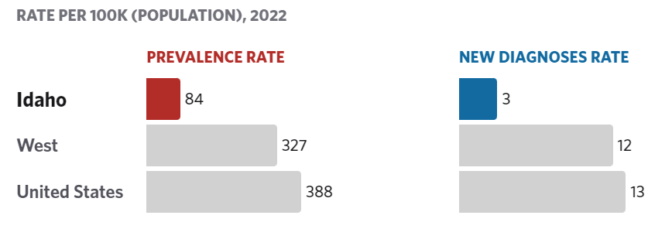

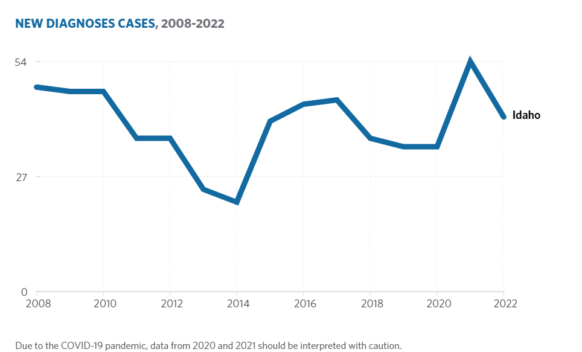

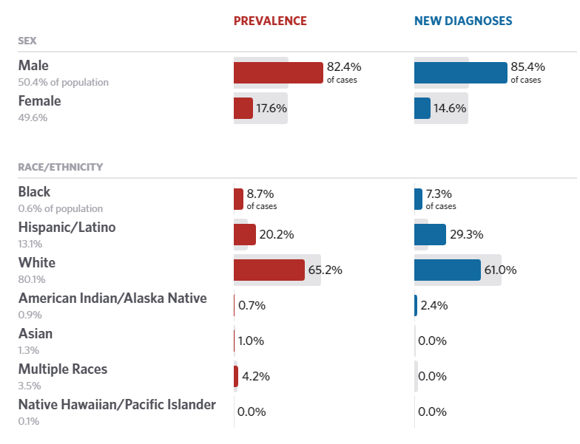

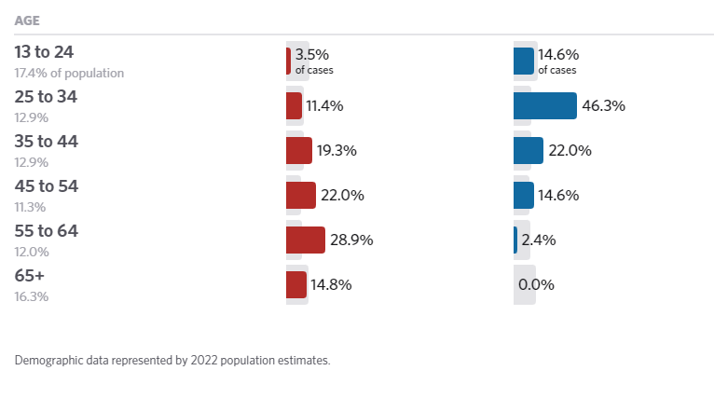

**If the PJ will establish a preference for a HOME TBRA activity for persons with a specific category of disabilities (e.g., persons with HIV/AIDS or chronic mental illness), describe their unmet need for housing and services needed to narrow the gap in benefits and services received by such persons. (See 24 CFR 92.209(c)(2) (ii))**

N/A

**Discussion:**

## NA-50 Non-Housing Community Development Needs - 91.315 (f)

In June of 2024, the Idaho Department of Commerce mailed out a CDBG survey to approximately 180 cities and 44 counties throughout the State to better understand the non-housing community development needs of Idaho’s cities and counties (or CDBG grantees). Idaho’s nine entitlement cities were not included in this survey. 92 survey responses were received.

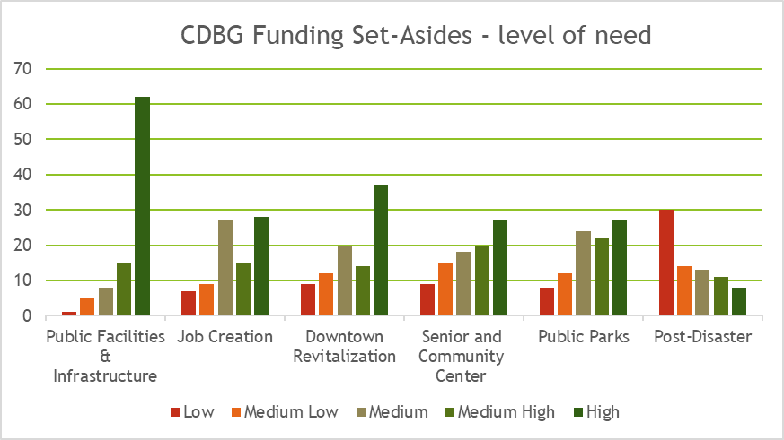

**Describe the jurisdiction’s need for Public Facilities:**

68.1% of the CDBG non-housing community development needs survey responses indicated a high need for public facilities and infrastructure funding set-asides.

Based on the local government needs survey conducted by Commerce in July of 2024 (survey results attached) the top three public facility needs are for improvements of parks and recreation facilities, fire/EMT stations, and senior centers.

**How were these needs determined?**

The needs of the state CDBGs’ jurisdictions (cities and counties) for public facilities, public improvements (infrastructure), services, and economic development activities is based on a number of variables. These variables include geographic locations, economic variables, population, governance philosophies, and the existing services provided by the city or county. In an attempt to understand Idaho cities and counties non-housing community development needs, IDC conducted a local government needs survey. The survey was sent out to 200 cities and 44 counties in July 2019. Of the 244 surveys, sent out a total of 123 responded.

**Describe the jurisdiction’s need for Public Improvements:**

Based on the local government needs survey, the top needs are water, sewer, streets, and sidewalk systems.

**How were these needs determined?**

The needs of the state CDBG jurisdictions (cities and counties) for public facilities, public improvements (infrastructure), services, and economic development activities is based on a number of variables. These variables include geographic locations, local economy, population, governance philosophies, and the existing services provided by the city or county. In an attempt to understand Idaho cities and counties non-housing community development needs, IDC conducted a local government needs survey. The survey was sent out to 180 cities and 44 counties in July 2024. Of the 224 surveys, sent out a total of 92 responded. Of the 92 respondents – 78 were cities and 14 were counties.

The American Society of Civil Engineers, 2021 Report Card for Idaho’s infrastructure was used to further assess non-housing community development needs. Specific to public infrastructure the following systems were graded as such.

Drinking Water – (Grade C) – Idaho’s approximately 1,960 public water systems consists of pipes, plants, and pumps that work together to deliver clean water to the state’s homes and businesses. The costs to maintain and improve this infrastructure are paid by users and rates can vary. Recent population growth has helped spur investment in new drinking water systems in some parts of the state. The Environmental Protection Agency estimates Idaho will need $961.8 million over 20 years to maintain, repair and replace its existing drinking water infrastructure and accommodate a larger population.

Wastewater- (Grade B-) Idaho’s 1.68 million residents rely on a variety of wastewater collection and treatment systems, including municipal wastewater treatment plants and septic systems. The state’s population is growing rapidly, and Idahoans are benefiting from some new wastewater collection and treatment facilities built to accommodate the increased demand. However, Idaho’s challenge will be to maintain and increase funding for ongoing maintenance requirements. The U.S. Environmental Protection Agency reports that over the next 20 years, Idaho will need $1.38 billion in funding for wastewater infrastructure.

Bridges- (Grade D) - There are 4,492 bridges in Idaho. Of these, 1,848 bridges are on the state highway system, and 2,375 are local bridges; the remainder are owned and maintained by federal agencies. Most twentieth century bridges were designed for a 50-year life span. 45% of the existing bridges (837) on the state highway system are 50 years or older and nearly 30% of the local bridges are 50 years or older. Based on currently planned bridge replacements, in just three years the number of bridges 50 years and older will rise to 911, or over 49% of the bridges on just the State Highway System. While rehabilitation of older bridges can extend the lifespan of that structure beyond the 50-year design life, the aging of Idaho bridges is of concern. In total, Idaho has identified needed repairs on 1,520 bridges, and the state estimates the cost of repair to these bridges will total $2.2 billion.

Roads – (Grade C-) - Highways provide a critical transportation link between the places we live, work, and play. Over 75,891 lane miles of roads in the state transport 650,000 residents to work each day and 150 million tons of freight, worth $80.5 billion, each year. Of these 75,891 miles, approximately 12,000 lane miles are state highways (interstate, US, and Idaho roads), and 63,607 lane miles are local roads and streets (owned by city, county, or highway district). While the Idaho legislature has made strides in identifying additional funding for the state’s highways and roads, available funding is insufficient to meet current and future demands. It’s estimated that 18% of roads are in need of improvement. Over the next 20 years, the state will experience a $3.6 billion shortfall if funding remains stagnant.

Responses to the ASCE survey on infrastructure demonstrate that the ability of Idaho’s systems to meet various recent levels of population growth is a cause for concern.

**Describe the jurisdiction’s need for Public Services:**

Based on the Commerce’s needs survey of local governments, the top needs for public improvements (public infrastructure) were needs survey, the top needs are streets, sewer, sidewalks, and water systems.

**How were these needs determined?**

Commerce conducted a local government needs survey. The survey was sent out to 180 cities and 44 counties in July 2024. Of the 224 surveys sent out a total of 92 responded.

# Housing Market Analysis

## MA-05 Overview

**Housing Market Analysis Overview**

## MA-10 Number of Housing Units – 91.310(a)

**Introduction**

2016-2020 ACS data estimated that the State of Idaho had 701,196 housing units, of which 77% are single-family homes. 15% of housing units are duplexes, quadruplexes, or smaller multifamily buildings (less than 20 units), 3% are larger multifamily buildings (20+ units), and 8% are mobile homes, boats, RV’s, vans, or other (as shown in Table 30).

Among occupied households, 421,439 are homeowners and approximately 187,685 are renters. 82% of homeowner households have 3 or more bedrooms, while only 43% of renter units have 3 or more bedrooms. 38% of renter households have 2 bedrooms, 15% have 1 bedroom, and 4% have no bedrooms (as shown in Table 31).

**All residential properties by number of units**

| **Property Type** | **Number** | **%** |
| --- | --- | --- |
| 1-unit detached structure | 515,886 | 74% |
| 1-unit, attached structure | 20,420 | 3% |
| 2-4 units | 46,829 | 7% |
| 5-19 units | 34,328 | 5% |
| 20 or more units | 24,316 | 3% |
| Mobile Home, boat, RV, van, etc | 59,417 | 8% |
| ***Total*** | ***701,196*** | ***100%*** |

Table 30 – Residential Properties by Unit Number

|  |  |
| --- | --- |
| **Data Source:** | 2016-2020 ACS |

**Unit Size by Tenure**

|  | **Owners** | | **Renters** | |
| --- | --- | --- | --- | --- |
| **Number** | **%** | **Number** | **%** |
| No bedroom | 1,530 | 0% | 7,669 | 4% |
| 1 bedroom | 8,915 | 2% | 28,652 | 15% |
| 2 bedrooms | 64,006 | 15% | 71,340 | 38% |
| 3 or more bedrooms | 346,988 | 82% | 80,024 | 43% |
| ***Total*** | ***421,439*** | ***99%*** | ***187,685*** | ***100%*** |

Table 31 – Unit Size by Tenure

|  |  |
| --- | --- |
| **Data Source:** | 2016-2020 ACS |

**Describe the number and targeting (income level/type of family served) of units assisted with federal, state, and local programs.**

See uploaded image  as a JPEG for number of units by program and target population.

Within the State of Idaho, Housing Choice Vouchers represent the majority of units and households assisted by federal, state, and local programs.  The majority of households, 85%, are White households.  The majority of those families, about 57%, fall within the 0-80% AMI range, while about 15% fall within the 0-30% AMI range.

Besides White Households, Hispanic households are the second most represented demographic group in assisted housing.  Hispanic families make up nearly 16% of public housing units in the state, which is slightly higher than the community’s representation in the state of about 12%.

**Provide an assessment of units expected to be lost from the affordable housing inventory for any reason, such as expiration of Section 8 contracts.**

While the changes in the national tax code pose some challenges in the future, LIHTC will remain a popular program and should not see any major reductions in units built in Idaho over the next 5 years.

The 2025 LIHTC application cycle yielded 17 applications totaling over $13 million in requests for an available $6.355 million in available resources. The approved projects will add and add approximately 260 new affordable rental units to the state of Idaho.

**Does the availability of housing units meet the needs of the population?**

According to the Federal Reserve Bank, the vacancy rate for owner-occupied units has been generally trending downward since 2012. From 2020 – 2023, the home vacancy rate was .8%, .6%, and .7% respectively.

Based on *Idaho County-by County Housing, Demographic Assessment* of 2024, 50.4% of the housing units in the state are affordable to renters earning the Area’s Median Income.  Meanwhile, about 79.4% of housing units are affordable to owners earning the Area’s Median Income.  Moreover, the gap of affordability is particularly large for families earning less than 50% of the Area Median Income.

**Describe the need for specific types of housing:**

Larger units to accommodate families are still in short supply in the state.  Moreover, properties that are accessible for people with ambulatory disabilities and the elderly are also needed.  Lastly, as national trends have shown, greater diversity in the housing typology to accommodate not only larger families, but also multi-generational and an array of other family unit structures should also be considered for the long-term viability of the affordable housing stock of the state.  Local efforts are being made to address housing concerns through changes in policy. For example, Kootenai Count has been identifying collaborative solutions. Some of those include: HomeSharing, Resident-Owned Communities, and Accessory Dwelling Units.

In addition to the need to address particular types of housing, the location and sizes of adequate parcels for housing development continued to be an issue. Such elements are particularly important in addressing the need for better access to housing for workers in urbanized areas of the state and the elderly disabled population still residing in rural areas. See Unique Appendices for additional images.

**Discussion**

Idaho's overall rural character, with varied geographic areas, and small and sometimes isolated communities, creates the backdrop to Idaho's cost-burdened homeowners and renters in all 44 counties.

Stakeholders were asked their opinions about the top needs of specific housing types (and for specific population types) in the survey conducted for this Consolidated Plan. The top housing needs by type, according to stakeholders is included in the 2019 State of Idaho Housing Needs Assessment.

## MA-15 Cost of Housing – 91.310(a)

**Introduction**

The median home value in Idaho saw a 5.8% increase between 2012 and 2017 and was $176,800 by 2017. This number has increased exponentially between 2017 and 2022 – in 2022 the median home value was $331,600, which is an 87.6% increase in 5 years. According to Zillow, in June of 2022 the average home value reached a high of $485,281 before home values decrease slightly moving into 2023 and increasing again in June of 2023. The average home value as of October 2024 was $451,520. See Zillow graph for home value trending in recent years.

*Source: Zillow, November 2024*

Map II.1 shows the change in home values between 2017 and 2022. There were very few areas of the state that saw an increase in home values less than 21%. The darker shaded areas indicate a greater increase in the median home value, with the darkest color indicating a growth of 62.86% or greater. This increase in home values reflects the cost burden experienced by Idaho residents. Map II.2 shows the percentage of cost burdened homeowners in Idaho – while all areas of the state see at least a 14% homeowner cost burden rate, there is a large area in the central area and some census tracts in the north that are higher than 30%. Map II.3 highlights the change in cost burdened homeowners between 2017-2022 by county. The darker orange areas indicate where the cost burden has actually decreased, while the light yellow and darker blue areas indicate cost burden increase.

Table 32 of this Plan shows the median contract rent also increased by 10%, or from $720 to $792, between 2012 and 2017. This number has only continued to increase – in 2022 the median rent was $1,061, which was about a 34% increase from 2020. Rent Prices have continued to increase, however, with top median gross rents since 2022 reaching $1,901 in January 2023, according to, Zillow. Rents then fell throughout 2023, but have risen again through 2024 with top median gross rents reaching $1825 in November. See Zillow’s rent tracking graphic below.

Table II.4 shows the percentage of cost burdened renters in the state. The renter cost burden was 42% and was spread fairly evenly throughout the state, with no areas seeing less than 27%. Table II.5 highlights the change in cost burdened renters between 2017-2022 by county. The darker orange areas indicate where the cost burden has actually decreased, while the light yellow and darker blue areas indicate cost burden increase.

**Map II.1**

**Map II.2**

**Map II.3**

**Map II.4**

**Map II.5**

Table 32 shows the median contract rent also increased by 10%, or from $720 to $792, between 2012 and 2017. This number has only continued to increase – in 2022 the median rent was $1,061, which was about a 34% increase from 2020. Rent Prices have continued to increase, however, with top median gross rents since 2022 reaching $1,901 in January 2023, according to, Zillow. Rents then fell throughout 2023, but have risen again through 2024 with top median gross rents reaching $1825 in November. See Zillow’s rent tracking graphic below.

*Source: Zillow, November 2024*

According to Table 34, there are over 9 and a half times as many rental units that are affordable to someone making 80% HAMFI when compared to a household with 30% HAMFI and over 2.5 times as many rentals affordable to 80% HAMFI compared to 50% HAMFI. Owner occupied units have a similar pattern with significantly fewer units that are affordable to very low-income households.  Map II.6 shows the percentage change of median gross rent prices by county. All counties have seen an increase of at least 13.67%, with the darkest purple shaded areas having an increase of 30.21% or higher. The county with the largest increase in median gross rent between 2017-2022 was Camas County with a 65.79% increase in 5 years.

**Map II.6**

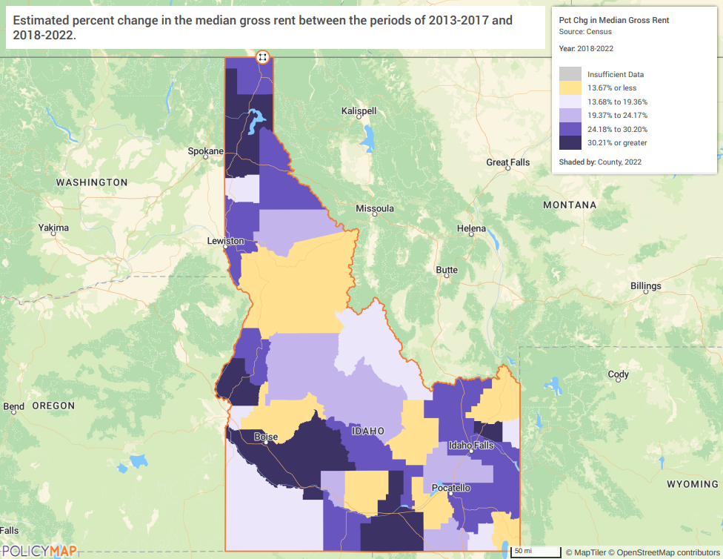

**Cost of Housing**

**ALTERNATE DATA SOURCE: POLICY MAPS 2018-2022 CENSUS**

|  | **Base Year: 2012** | **Year: 2017** | **Most Recent Year: 2022** | **% Change 2017-2022** |
| --- | --- | --- | --- | --- |
| Median Home Value | 167,100 | 176,800 | 331,600 |  |
| Median Contract Rent | 720 | 792 | 1,061 | 74.7% |

Table 32 – Cost of Housing

|  |  |
| --- | --- |
| **Data Source:** | 2000 Census (Base Year), 2016-2020 ACS (Most Recent Year), 2018-2022 ACS |

| **Rent Paid** | **Number** | **%** |
| --- | --- | --- |
| Less than $500 | 53,762 | 28.6% |
| $500-999 | 109,191 | 58.2% |
| $1,000-1,499 | 19,162 | 10.2% |
| $1,500-1,999 | 3,277 | 1.8% |
| $2,000 or more | 2,293 | 1.2% |
| ***Total*** | ***187,685*** | ***100.0%*** |

Table 33 - Rent Paid

|  |  |
| --- | --- |
| **Data Source:** | 2016-2020 ACS |

**Housing Affordability**

| **Number of Units affordable to Households earning** | **Renter** | **Owner** |
| --- | --- | --- |
| 30% HAMFI | 12,105 | No Data |
| 50% HAMFI | 46,845 | 25,935 |
| 80% HAMFI | 118,085 | 93,305 |
| 100% HAMFI | No Data | 145,885 |
| ***Total*** | ***177,035*** | ***265,125*** |

Table 34 – Housing Affordability

|  |  |
| --- | --- |
| **Data Source:** | 2016-2020 CHAS |

**Monthly Rent**

See HUD’s website for 2024 Fair Market Rents and HOME Rents Statewide.

<https://www.huduser.gov/portal/datasets/home-datasets/files/HOME_RentLimits_State_ID_2024.pdf>

| **Monthly Rent ($)** | **Efficiency (no bedroom)** | **1 Bedroom** | **2 Bedroom** | **3 Bedroom** | **4 Bedroom** |
| --- | --- | --- | --- | --- | --- |
| Fair Market Rent |  |  |  |  |  |
| High HOME Rent |  |  |  |  |  |
| Low HOME Rent |  |  |  |  |  |

Table 35 – Monthly Rent

|  |  |
| --- | --- |
| **Data Source:** | HUD FMR and HOME Rents; |

**Is there sufficient housing for households at all income levels?**

Table 6 shows that there were 67,790 total households earning less than 30% AMI in the state and Table 34 shows that there were only 12,105 affordable housing units available for those at that income level. This means that there are only affordable housing units available for 17.8% of households earning less than 30% AMI. Most households at that income level were small family households, followed by households with at least one person aged 62-74. There were 70,225 total households earning 31- 50% AMI in the city and 72,780 affordable units available (for combined renter and owner households). The availability of affordable housing units, especially for those with incomes between 0-30% AMI, does not meet the demand.

**How is affordability of housing likely to change considering changes to home values and/or rents?**

It is unlikely that the housing market will shift to increase the number of affordable owner-occupied or renter-occupied units to meet current demand. Further, rental units do not typically see prices decrease even when the housing market crashes.

Housing cost in general has been on a steady upward climb in recent years with incomes not keeping pace. As a result. Increasingly fewer units are “affordable” to low- and moderate-income households and units with deeper subsidies are not added in large quantities or in time to meet the increasing demands.

**How do HOME rents / Fair Market Rent compare to Area Median Rent? How might this impact your strategy to produce or preserve affordable housing?**

Currently the only public resources available at the State level to create and preserve affordable housing is the Low-Income Housing Tax Credit Program, the HOME program, and the Housing Trust Fund. Further, a main factor in housing affordability concerns is the gap between wages and housing costs. The State of Idaho’s minimum wage has not been updated since 2009 while housing costs have grown exponentially. A broader issue remains of a gap in what households can afford and the available units at their price point.

**Discussion**

## MA-20 Condition of Housing – 91.310(a)

**Introduction:**

The tables and maps in this section provide details on the condition of housing units throughout the state by looking at factors such as age, vacancy, and the prevalence of housing problems.

As defined by HUD, the 4 housing problems are:

1) a home which lacks complete or adequate kitchen facilities  
 2) a home which lacks complete or adequate plumbing facilities  
 3) a home which is overcrowded (having more than one person per room)  
 4) a household that is cost burdened (paying 30% or more of their income towards housing costs)

Renter-occupied units are much more likely to have at least one housing problem than owner-occupied units. This is primarily due to cost burden.

**Describe the jurisdiction's definition of "standard condition" and "substandard condition but suitable for rehabilitation":**

*Language from Chapter 2A:*

*Standard Condition* **-** Prior to acquisition, a residential property meets applicable state and/or local code (for existing structures), local property/housing quality standard, and the program's property standards found in 92.251 and/or 93.301.

*Substandard Condition* **-** Prior to acquisition, a residential property does not meet one of the following: Applicable state and/or local code/property/housing quality standard, **or** Idaho State or local building code (for existing structures), **or** the program's applicable property standards found in 92.251 and/or 93.301.

*Substandard Condition but Suitable for Rehabilitation* **-**  Prior to acquisition, a residential property is defined as Substandard but can be brought up to the applicable existing state and local (applicable) code for existing structures and property/housing quality standards, and the applicable property standard, at a total project cost that is less than <75% of the property's replacement cost**.**

**Condition of Units**

| **Condition of Units** | **Owner-Occupied** | | **Renter-Occupied** | |
| --- | --- | --- | --- | --- |
| **Number** | **%** | **Number** | **%** |
| With one selected Condition | 88,138 | 21% | 75,952 | 40% |
| With two selected Conditions | 2,817 | 1% | 6,414 | 3% |
| With three selected Conditions | 192 | 0% | 792 | 0% |
| With four selected Conditions | 1 | 0% | 40 | 0% |
| No selected Conditions | 330,291 | 78% | 104,487 | 56% |
| ***Total*** | ***421,439*** | ***100%*** | ***187,685*** | ***99%*** |

Table 36 - Condition of Units

|  |  |
| --- | --- |
| **Data Source:** | 2016-2020 ACS |

**Year Unit Built**

| **Year Unit Built** | **Owner-Occupied** | | **Renter-Occupied** | |
| --- | --- | --- | --- | --- |
| **Number** | **%** | **Number** | **%** |
| 2000 or later | 122,769 | 29% | 41,401 | 22% |
| 1980-1999 | 119,784 | 28% | 58,177 | 31% |
| 1950-1979 | 127,994 | 30% | 63,406 | 34% |
| Before 1950 | 50,892 | 12% | 24,701 | 13% |
| ***Total*** | ***421,439*** | ***99%*** | ***187,685*** | ***100%*** |

Table 37 – Year Unit Built

|  |  |
| --- | --- |
| **Data Source:** | 2016-2020 CHAS |

**Risk of Lead-Based Paint Hazard**

| **Risk of Lead-Based Paint Hazard** | **Owner-Occupied** | | **Renter-Occupied** | |
| --- | --- | --- | --- | --- |
| **Number** | **%** | **Number** | **%** |
| Total Number of Units Built Before 1980 | 178,886 | 42% | 88,107 | 47% |

|  |  |  |  |  |
| --- | --- | --- | --- | --- |
|  |  |  |  |  |
| Housing Units build before 1980 with children present | 61,090 | 14% | 38,735 | 21% |

Table 38 – Risk of Lead-Based Paint

|  |  |
| --- | --- |
| **Data Source:** | 2016-2020 ACS (Total Units) 2016-2020 CHAS (Units with Children present) |

**Vacant Units**

|  | **Suitable for Rehabilitation** | **Not Suitable for Rehabilitation** | **Total** |
| --- | --- | --- | --- |
| Vacant Units |  |  |  |
| Abandoned Vacant Units |  |  |  |
| REO Properties |  |  |  |
| Abandoned REO Properties |  |  |  |

Table 39 - Vacant Units

**Need for Owner and Rental Rehabilitation**

Table 36 details the number of owner and renter households by number of housing problems identified in the 2016-2020 ACS estimates. Overall, renters are almost twice as likely to have a housing problem than homeowners – 43% of renter households experience one or more housing conditions and only 23% of homeowner households experience one or more housing conditions. According to 2022 ACS data, the rate rose to 48.41% for renter households and declined to 21.35% for homeowner households. Relatively few units have more than one selected condition but there are still over 210,256 households with multiple housing problems. Map II.7 shows the rates of renter households experiencing at least one housing condition – the areas with the highest rate are in the eastern and western areas of the state. Deteriorating housing can depress neighboring property values, discourage reinvestment and eventually impact the quality of life in a neighborhood.

The year a house is built is heavily correlated with whether it is in substandard condition. Older homes are more likely to need regular maintenance in order to provide a safe and secure living environment for residents. When looking at the age of a home an important factor is whether it was built before 1978. Prior to 1978 lead-based paint was used in many homes and the presence of that paint can cause significant health problems for residents, particularly for children, the elderly, and those with compromised immune systems. Table 37 illustrates that about 47% of the City’s renter-occupied housing stock was constructed prior to 1980 and 42% of owner-occupied housing stock was built before 1980. Map II.8shows that the distribution of housing units built before 1980, with the darker shaded areas indicating a larger percentage. There are three counties which have over 68.22% of their housing stock built before 1980- Butte (71.36%), Lewis (74.38%), and Shoshone (79.21%).

Seniors or those on a fixed or limited income oftentimes cannot afford to maintain their home or to make necessary safety accommodations. As costs of materials for new builds continue to rise, rehabilitation assistance for low-income families and those on fixed incomes such as seniors and those with disabilities will be an important tool in allowing them to maintain their housing and lessen the risks of homelessness.

**Map II.7**

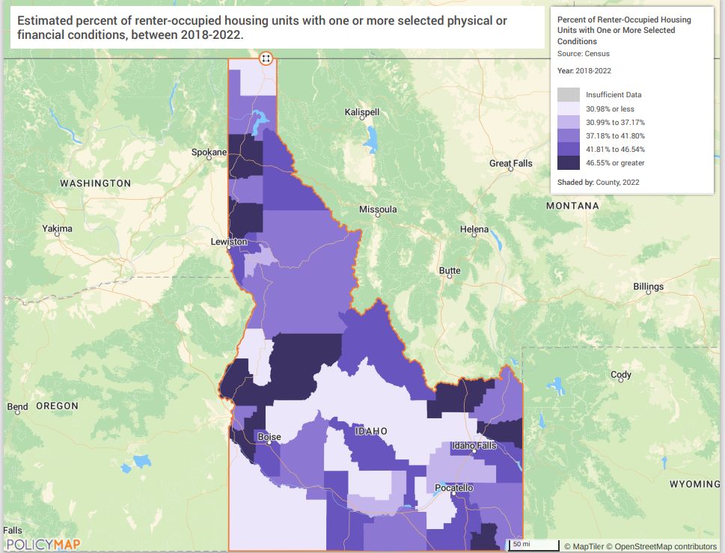

**Map II.8**

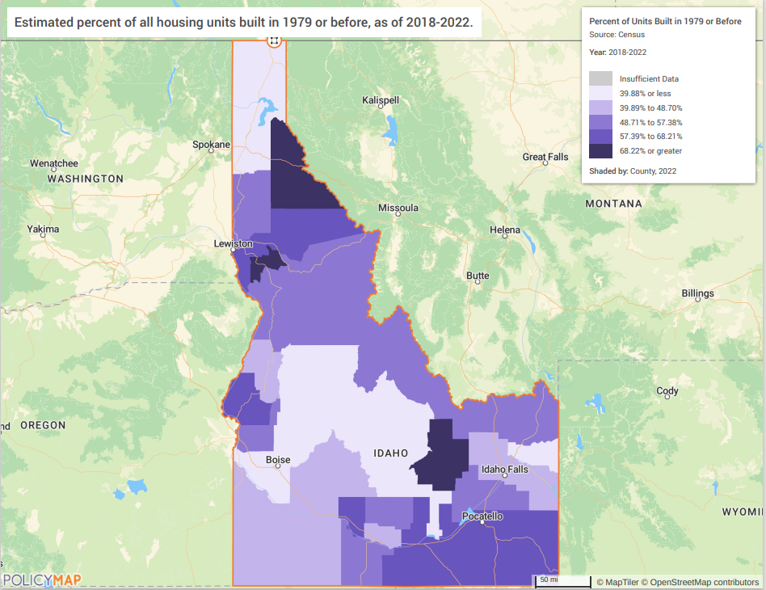

**Estimated Number of Housing Units Occupied by Low or Moderate Income Families with LBP Hazards**

Housing units built prior to 1980 may contain lead-based paint in portions of the home (window and door frames, walls, ceilings, etc.) or throughout the entire home. Housing units built before 1980 have a risk of lead-based paint hazards and should be tested in accordance with HUD standards. Map II.7 (above) shows the prevalence of homes built before 1980 in the State of Idaho. According to Table 39, there were 266,993 housing units in the State of Idaho that were built prior to 1980 and are therefore at-risk of lead-based paint hazards. 42% of all owner-occupied units and 47% of all renter-occupied units fall into this category. There were 99,825 housing units built before 1980 with children present. These risks increase as the housing units age and if the rehabilitation needs are not met. Testing for lead-based paint and the repair, if needed, is another added cost for home rehabilitation.

**Discussion:**

The counties of Butte, Lewis, and Shoshone all have over 70% of their housing units being built prior to 1980 which increases the risk of lead-based paint hazards and the possibility of substandard conditions. As of 2022, nearly one half of renter households experience one or more housing conditions. The vacancy rate in Idaho is low at 1.31% - 0.96% of residential units and 4.34% of business units were vacant as of the 2nd quarter of 2024 (according to Valassis Lists).

For single-family homebuyer Down Payment Assistance, IHFA will require a Lead-Based Paint Assessment on all units prior to 1978 and 1980 in Butte, Lewis, and Shoshone county if an eligible household chooses to purchase a property in one of these counties.

## MA-25 Public and Assisted Housing – (Optional)

**Introduction:**

Idaho Housing and Finance Association administers HUD's Section 8 Housing Choice Voucher program in 34 of 44 counties in Idaho through four (4) branch offices in Coeur d’Alene, Lewiston, Idaho Falls, and Twin Falls. Through the HCV program, IHFA also administers the Veterans Affairs Supportive Housing (VASH) voucher, the Mainstream Non-Elderly and Disabilities voucher, and other targeted programs. The HCV waiting lists can vary from 12 months to over 2 years. IHFA is one of a statewide network of public housing providers. IHFA does not oversee any city or county public housing authorities. These local jurisdictions each have a local official governing board, which is responsible for the Public Housing Authority and all its activities.

Idaho Housing and Finance Association (IHFA) administers the Section 8 Housing Choice Voucher program in 34 of 44 Idaho counties and encourages housing programs statewide, as IHFA is only one in a statewide network of housing providers. IHFA does not oversee any citywide or countywide Participating Jurisdictions (PJs) for public housing. These jurisdictions have local official governing boards responsible to appoint the board of a Public Housing Authority (PHA) and direct PHA activities.

The Housing Authorities in the State of Idaho are:

* Boise City/Ada County Housing Authority
* Southwestern Idaho Cooperative Housing Authority
* Nampa Housing Authority
* Twin Falls Housing Authority
* Housing Authority of the City of Pocatello

**Totals Number of Units**

| **Program Type** | | | | | | | | | |
| --- | --- | --- | --- | --- | --- | --- | --- | --- | --- |
|  | **Certificate** | **Mod-Rehab** | **Public Housing** | **Vouchers** | | | | | |
| **Total** | **Project -based** | **Tenant -based** | **Special Purpose Voucher** | | |
| **Veterans Affairs Supportive Housing** | **Family Unification Program** | **Disabled**  * |
| # of units vouchers available |  |  | 76 | 3,419 |  |  | 34 | 0 | 945 |
| # of accessible units |  |  |  |  |  |  |  |  |  |

|  |
| --- |
| **\*includes Non-Elderly Disabled, Mainstream One-Year, Mainstream Five-year, and Nursing Home Transition** |

Table 40 – Total Number of Units by Program Type

|  |  |
| --- | --- |
| **Data Source:** | PIC (PIH Information Center) |

**Describe the supply of public housing developments:**

State response not required

**Describe the number and physical condition of public housing units in the jurisdiction, including those that are participating in an approved Public Housing Agency Plan:**

State response not required

**Describe the Restoration and Revitalization Needs of public housing units in the jurisdiction:**

State response not required

**Describe the public housing agency's strategy for improving the living environment of low- and moderate-income families residing in public housing:**

State response not required

**Discussion:**

## 

## MA-30 Homeless Facilities – 91.310(b)

**Introduction**

**Facilities Targeted to Homeless Persons**

|  | **Emergency Shelter Beds** | | **Transitional Housing Beds** | **Permanent Supportive Housing Beds** | |
| --- | --- | --- | --- | --- | --- |
| **Year Round Beds (Current & New)** | **Voucher / Seasonal / Overflow Beds** | **Current & New** | **Current & New** | **Under Development** |
| Households with Adult(s) and Child(ren) | 546 | 2 | 127 | 164 | 0 |
| Households with Only Adults | 279 | 76 | 64 | 262 | 0 |
| Chronically Homeless Households | 0 | 0 | 0 | 156 | 0 |
| Veterans | 8 | 0 | 0 | 237 | 0 |
| Unaccompanied Youth | 22 | 0 | 0 | 0 | 0 |

Table 41 - Facilities Targeted to Homeless Persons

**Describe mainstream services, such as health, mental health, and employment services to the extent those services are use to complement services targeted to homeless persons**

In addition to receiving housing assistance, homeless individuals and families have the opportunity to receive services, whether via the COC, ESG, or HOPWA programs, or partnering agencies.  Services may include case management, child care assistance, education and career counseling, employment assistance, job training, health care, mental health services, substance or alcohol abuse treatment, transportation, and utility assistance, among other supportive services.  The level of services and length of care or participation varies greatly.  To the extent that program regulations allow, service providers attempt to offer as much support as possible for as long as needed.  Apart from projects and agencies operating COC, ESG, and HOPWA programs, the Department of Health and Welfare’s Behavioral Health Division, the Substance Abuse and Mental Health Services Administration, and faith-based welfare programs, along with other federal and/or state agencies, are the primary agencies offering services which target homeless individuals and families.

**List and describe services and facilities that meet the needs of homeless persons, particularly chronically homeless individuals and families, families with children, veterans and their families, and unaccompanied youth. If the services and facilities are listed on screen SP-40 Institutional Delivery Structure or screen MA-35 Special Needs Facilities and Services, describe how these facilities and services specifically address the needs of these populations.**

According to homeless individual declarations from past Point In Time count surveys and the expertise of highly involved service providers, the most commonly reported causes homelessness are identified as: 1) unemployment; 2) inability to find affordable housing; 3) divorce/family separation; 4) eviction; 5) substance abuse; and 6) lack of education or job skills.  One prevalent commonality among those experiencing homelessness is the existence of a disabling condition.  With this understanding, the BOS COC and staff administering COC, ESG and HOPWA programs attempt to seek out services and resources linked to the causes of homelessness listed above, as these most certainly become barriers to later locating and securing housing.  To that end, services must also include resources that aid those experiencing homelessness in extinguishing barriers that may have arisen as a result of becoming homeless, such as poor credit, criminal history, poor finances, etc.

Additional efforts will be made to link healthcare and housing providers and promote affordable housing projects which encourage access to supportive services for homeless families and individuals.  IHFA’s efforts in researching homelessness solutions, the receipt of HUD technical assistance to form partnerships between housing and healthcare providers, and proactively seeking systems that successfully pair vulnerable populations to appropriate services will all generate a positive impact on Idaho’s homeless population.

## MA-35 Special Needs Facilities and Services – 91.310(c)

**Introduction**

Many Idaho residents face homelessness, or the risk of becoming homeless, each year. As the main recipient of homelessness assistance funding, Idaho Housing and Finance Association is the recipient of the majority of homelessness assistance funds. IHFA administers the COC, ESG, and HOPWA programs to meet the special needs and services for communities in the state. While also maintaining Idaho’s Homeless Management Information System, HOME/HTF, Low Income Housing Tax Credit allocations, and a large portion of the total Section 8 Housing Choice Vouchers available in the state, IHFA is unique position to pair resources and form partnerships with others to promote a positive impact upon the living situation of homeless persons in Idaho and meet the needs of different communities in the state.

**To the extent information is available, describe the facilities and services that assist persons who are not homeless but who require supportive housing, and programs for ensuring that persons returning from mental and physical health institutions receive appropriate supportive housing**

In addition to HOME, HTF and CDBG funding used for affordable supportive housing, HUD also funds Section 202 and Section 811 housing, reserved entirely for elderly individuals and persons with a disability. HUD-funded Public Housing and Project-Based Section 8 also can be used to fund supportive housing units, though the funding sources are not reserved exclusively for this purpose.

The Section 202 program funds affordable housing development for elderly households, while Section 811 funds non-profit housing development for very- and extremely low-income persons with disabilities. Both programs provide vital supportive housing to those that cannot otherwise afford market-rate housing or supportive services. Most Section 202/811 residents have income below 30 percent of the area median income and are considered “extremely low-income”.

Unfortunately, compared to other HUD-funded subsidized housing, including Housing Choice Vouchers, Section 202/811 supportive housing units are in short supply. Though exact 202/822 waitlist waiting times are not tracked, Public Housing and Housing Choice Vouchers, of which there are ten times as many units, have waitlist waiting times of one and nearly-two years, respectively.

HOME- The HOME Program has previously funded 4 projects that are still in their affordability period. (3) HUD-811 projects with a total of 27 units assisting renters with special needs. (1) HUD-202 project with a total of 13 units assisting Elderly households with special needs. (4) HUD Supportive Housing program projects with a total of 34 units serving low income tenants with special needs. There is a total of 114 units in 8 Projects throughout the state of Idaho serving low income tenants with special needs: Eagle Pointe, CORE Lodge, SEICAA Manor, Cathy Reed House, Lynn Peterson House, John O Brien House, Trestle Creek and New Path.

ESG- Supportive housing is made available in two forms; scattered- or single-site. Services associated with supportive housing projects are case management, transportation, life skills training, counseling, and educational and career building, among others. Access to public assistance through programs such as SSI/SSDI Outreach, Access, and Recovery (SOAR) greatly improve one’s ability to experience a stable living environment. These housing and service options assist not only those coming directly into housing from the streets, but those exiting institutions as well. The housing provided offers stability, and safe, decent, and sanitary environments. The services offered aid individuals in working towards being employable, gainfully employed, receiving linkages to resources, and removing barriers to attaining stable housing.

Finally, IHFA will be using its HOME ARP to provide financial resources for Permanent Supportive Housing (PSH) in communities who do not have or have limited PSH units. The approach is to ensure developers start building the supportive services’ partnerships in the beginning to wholistically take care of the households. Learning from past PSH projects, IHFA will also make available from HOME ARP direct supportive services funds to help with the initial hiring of case managers within these projects. It is the hope in providing seed money for supportive services, communities will understand the value and find longer term financing sources for these vulnerable households.

**Describe programs for ensuring that persons returning from mental and physical health institutions receive appropriate supportive housing**

One definition of homelessness includes those individuals that are exiting a facility or institution who were homeless prior to entry, and when exiting, do so without services made available through their placement into society. Resources to house these individuals, and potentially their families, are used to house them rapidly to minimize their potential to become, or time experiencing, homelessness. Services necessary to eliminate barriers to permanent housing and gainful employment are made available. Encouraging housing providers to adopt low-barrier eligibility screening, and promoting this system-wide within the COC, will help to avoid homelessness or minimize the length of time individuals and families spend in homelessness. The Facilities and Services For Non-Homeless Persons table includes resources that those exiting mental or physical health institutions can access supportive housing or appropriate services.

**Specify the activities that the jurisdiction plans to undertake during the next year to address the housing and supportive services needs identified in accordance with 91.215(e) with respect to persons who are not homeless but have other special needs. Link to one-year goals. 91.315(e)**

The special needs housing programs administered by IHFA predominately serve homeless persons. In many cases, these HUD program requirements do not allow funds to be used for non-homeless individuals. However, ESG funds can be used for homelessness prevention and rapid re-housing activities. Although an applicant must meet one of several HUD homeless definitions, one of those is being imminently at risk of homelessness (Category 2 of HUD’s homeless definition) which means they would still be housed when assistance is provided. Those accessing ESG homelessness prevention and rapid re-housing assistance may receive short to medium term tenant-based rental assistance and/or housing relocation and stabilization services, including financial counseling, housing locator assistance, and housing stability case management.

**For entitlement/consortia grantees: Specify the activities that the jurisdiction plans to undertake during the next year to address the housing and supportive services needs identified in accordance with 91.215(e) with respect to persons who are not homeless but have other special needs. Link to one-year goals. (91.220(2))**

N/A

## MA-40 Barriers to Affordable Housing – 91.310(d)

**Negative Effects of Public Policies on Affordable Housing and Residential Investment**

Public policies are meant to address the overall needs of citizens in the State. Yet, there are times where they may have a negative effect on certain aspects of the community, specifically affordable housing and residential investment. Affordable housing and public and private residential investments are key components in furthering fair housing in any community. The primary tool communities have for identifying contributing factors for these barriers to housing is an assessment of fair housing and fair housing choice. In the 2022 Analysis of Impediments to Fair Housing, the following regulatory findings were noted:

* Idaho statutes continue to be silent in the many areas that affect residential development. Regulations governing land use, zoning, housing type and placement (including group living facilities) are primarily adopted and applied at the local level. The effects of a passive approach are mixed: the state does not directly adversely affect residential development, but it does not encourage practices that can mitigate fair housing risks (e.g., defining disability and reasonable accommodation) or encourage residential housing supply (e.g., specifying that localities must allow for density bonuses in exchange for affordable housing when economically feasible). The state statutes that do address housing generally promote more varied and affordable housing and were adopted to prevent unfair and discriminatory practices in the local regulation of group homes, housing for persons with mental or physical disabilities, manufactured housing, or rental housing.
* State statutes are neutral on incentives for building ‘zero-step’ single family subdivisions. Given the demand for ‘visitable’ housing (approximately 6% of Idahoans live s a mobility limitation, but only 1% of residential units are wheelchair accessible), the lack of accessible housing choice leads to increased costs for accessibility modifications, independent living and Idaho’s Medicaid budget.
* Idaho places restrictions on local jurisdiction authority to impose local taxes, which has been interpreted by Idaho courts as including programs that would require affordable housing (“inclusionary housing”). Idaho also prohibits rent control except on land or in properties in which a local government has an interest. These laws limit the powers of local jurisdictions to promote more affordable housing that could benefit those protected by the FHA. The direct effect of these limitations depends on how local ordinances would be structured and who would benefit from such programs if allowed by state law. The State of Colorado, which also has a rent control prohibition, recently amended its constitution to allow inclusionary zoning when jurisdictions offer an offset to the cost of developing affordable housing, including density bonuses. Density bonus programs are generally well-received by residential developers and are becoming a popular mechanism to make better use of land and facilitate affordable housing development.

## MA-45 Non-Housing Community Development Assets -91.315(f)

**Introduction**

There are many factors within a community that can impact housing supply and demand. The economic development of the community can play a major role in what type of home a household needs and what they can afford. The presence, or lack thereof, of specific industries can also decrease or increase the number of residents in a community. Throughout this section a variety of economic indicators will be described and analyzed. This will include business activity, labor force participation, travel time, education, and veterans.

**Economic Development Market Analysis**

**Business Activity**

| **Business by Sector** | **Number of Workers** | **Number of Jobs** | **Share of Workers**  **%** | **Share of Jobs**  **%** | **Jobs less workers**  **%** |
| --- | --- | --- | --- | --- | --- |
| Agriculture, Mining, Oil & Gas Extraction |  |  |  |  |  |
| Arts, Entertainment, Accommodations |  |  |  |  |  |
| Construction |  |  |  |  |  |
| Education and Health Care Services |  |  |  |  |  |
| Finance, Insurance, and Real Estate |  |  |  |  |  |
| Information |  |  |  |  |  |
| Manufacturing |  |  |  |  |  |
| Other Services |  |  |  |  |  |
| Professional, Scientific, Management Services |  |  |  |  |  |
| Public Administration |  |  |  |  |  |
| Retail Trade |  |  |  |  |  |
| Transportation & Warehousing |  |  |  |  |  |
| Wholesale Trade |  |  |  |  |  |
| Grand Total |  |  |  |  |  |

Table 43- Business Activity

|  |  |
| --- | --- |
| **Data Source:** | 2016-2020 ACS (Workers), 2020 Longitudinal Employer-Household Dynamics (Jobs) |

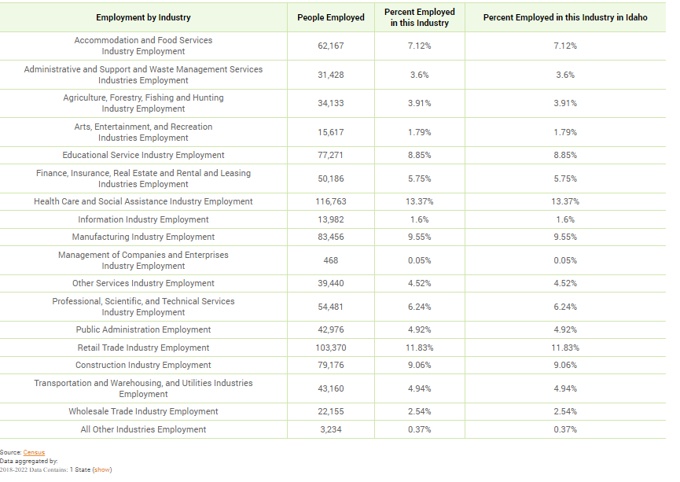

**Labor Force**

|  |  |
| --- | --- |
|  |  |
| Total Population in the Civilian Labor Force | 471,661 |
| Civilian Employed Population 16 years and over | 451,640 |
| Unemployment Rate | 4.10 |
| Unemployment Rate for Ages 16-24 | 13.48 |
| Unemployment Rate for Ages 25-65 | 2.16 |

Table 44 - Labor Force

|  |  |
| --- | --- |
| **Data Source:** | 2016-2020 ACS |

| **Occupations by Sector** | **Number of PeopleMedian Income** |
| --- | --- |
| Management, business and financial |  |
| Farming, fisheries and forestry occupations |  |
| Service |  |
| Sales and office |  |
| Construction, extraction, maintenance and repair |  |
| Production, transportation and material moving |  |

Table 45 – Occupations by Sector

|  |  |
| --- | --- |
| **Data Source:** | 2016-2020 ACS |

**Travel Time**

| **Travel Time** | **Number** | **Percentage** |
| --- | --- | --- |
| < 30 Minutes | 294,975 | 72% |
| 30-59 Minutes | 90,836 | 22% |
| 60 or More Minutes | 24,359 | 6% |
| ***Total*** | ***410,170*** | ***100%*** |

Table 46 - Travel Time

|  |  |
| --- | --- |
| **Data Source:** | 2016-2020 ACS |

**Education:**

Educational Attainment by Employment Status (Population 16 and Older)

| **Educational Attainment** | **In Labor Force** | |  |
| --- | --- | --- | --- |
| **Civilian Employed** | **Unemployed** | **Not in Labor Force** |
| Less than high school graduate |  |  |  |
| High school graduate (includes equivalency) |  |  |  |
| Some college or Associate’s degree |  |  |  |
| Bachelor’s degree or higher |  |  |  |

Table 47 - Educational Attainment by Employment Status

|  |  |
| --- | --- |
| **Data Source:** | 2016-2020 ACS |

Educational Attainment by Age

|  | **Age** | | | | |
| --- | --- | --- | --- | --- | --- |
| **18–24 yrs** | **25–34 yrs** | **35–44 yrs** | **45–65 yrs** | **65+ yrs** |
| Less than 9th grade |  |  |  |  |  |
| 9th to 12th grade, no diploma |  |  |  |  |  |
| High school graduate, GED, or alternative |  |  |  |  |  |
| Some college, no degree |  |  |  |  |  |
| Associate’s degree |  |  |  |  |  |
| Bachelor’s degree |  |  |  |  |  |
| Graduate or professional degree |  |  |  |  |  |

Table 48 - Educational Attainment by Age

|  |  |
| --- | --- |
| **Data Source:** | 2016-2020 ACS |

Educational Attainment – Median Earnings in the Past 12 Months

| **Educational Attainment** | **Median Earnings in the Past 12 Months** |
| --- | --- |
| Less than high school graduate |  |
| High school graduate (includes equivalency) |  |
| Some college or Associate’s degree |  |
| Bachelor’s degree |  |
| Graduate or professional degree |  |

Table 49 – Median Earnings in the Past 12 Months

|  |  |
| --- | --- |
| **Data Source:** | 2016-2020 ACS |

**Based on the Business Activity table above, what are the major employment sectors within the state?**

The major employment sectors in Idaho for the period 2018-2022 based on the number of people employed and their percentage of total employment are:

1. **Health Care and Social Assistance** – 116,763 people employed (13.37%)
2. **Retail Trade** - 103,370 people employed (11.83%)
3. **Educational Services** - 77,271 people employed (8.85%)
4. **Manufacturing** - 83,456 people employed (9.55%)
5. **Construction** - 79,176 people employed (9.06%)

**Describe the workforce and infrastructure needs of business in the state.**

According to BLS data, the unemployment rate in Idaho as of July 2024 was 3.7%, however, stakeholders indicated that while jobs are available wages are not sufficient to meet the cost of living, especially in relation to housing costs.

**Describe any major changes that may have an economic impact, such as planned public or private sector investments or initiatives that have affected or may affect job and business growth opportunities during the planning period. Describe any needs for workforce development, business support or infrastructure these changes may create.**

**How do the skills and education of the current workforce correspond to employment opportunities in the state?**

With the geographical size and somewhat three distinct regions within Idaho (north, central, eastern) there is no one private sector investment(s) that is likely to have a significant effect on job and business growth opportunities statewide. However, one public / private sector investment that could have a major impact would be the development and manufacturing of small modular nuclear reactors at the Idaho National Lab, especially in the eastern part of the state. The development and manufacturing of small modular reactors would greatly increase the need for skilled manufacturing and nuclear technicians.

Idaho state government's reluctant to expand or develop public financing tools, (such as local option tax, expand impact fees allowance, fund a state housing trust, increase fuel taxes) especially during a time of high economic and population growth, will start to hamper quality growth in the future, as infrastructure, educational systems, and public services won't have the funding to adequately serve the future needs. Although local government will collect more in terms of fees and taxes, due to the rapid pace of the growth, they will struggle with the price of growth.

**Describe current workforce training initiatives supported by the state. Describe how these efforts will support the state's Consolidated Plan.**

**Describe any other state efforts to support economic growth.**

**Discussion**

## MA-50 Needs and Market Analysis Discussion

**Are there areas where households with multiple housing problems are concentrated? (include a definition of "concentration")**

**Are there any areas in the jurisdiction where racial or ethnic minorities or low-income families are concentrated? (include a definition of "concentration")**

State Grantees response not required

**What are the characteristics of the market in these areas/neighborhoods?**

State Grantees response not required

**Are there any community assets in these areas/neighborhoods?**

State Grantees response not required

**Are there other strategic opportunities in any of these areas?**

State Grantees response not required

## MA-60 Broadband Needs of Housing occupied by Low- and Moderate-Income Households - 91.210(a)(4), 91.310(a)(2)

**Describe the need for broadband wiring and connections for households, including low- and moderate-income households and neighborhoods.**

Internet is an essential communications and information platform that allows users to take advantage of the increased interconnectedness of business, education, commerce, and day to day utility. Reliable access to the internet is becoming a necessity to thrive in the modern economic environment. Communities that lack broadband access struggle to keep pace with the country. According to the Idaho Broadband Strategic Plan (2022-2027), determining the number of unserved households in Idaho varies widely depending on the source cited. The FCC estimates that nearly 18,000 households lack access to fixed terrestrial broadband service at 25/3Mbps. Conversely, Broadband Now and the US Census estimate the number of unserved households is closer to 100,000. Connecting Idahoans who are underserved, or lack access to 100/20Mbps, to high-speed broadband, is an even larger task, estimated by the FCC to be 150,000 households.

Locations without broadband access impedes its population’s ability to take advantage of the educational and entrepreneurial opportunities available online. This is particularly problematic for LMI areas where economic opportunities are often already lacking. Studies suggest a strong correlation between increased high-speed internet access and increased education and employment opportunities, especially in small cities and rural areas.

In 2020, the state created the Office of Broadband within the Department of Commerce to help communities improve broadband infrastructure in support of improving distance learning, remote work, access to telehealth, and ensuring communities have reliable internet. In 2021, the Idaho Broadband Advisory Board was created by the Idaho Legislature in 2021, via the passage of  [**House Bill 127.**](https://legislature.idaho.gov/sessioninfo/2021/legislation/H0127/) The board established the Idaho Broadband Strategic Plan, which supports the board’s vision that Idahoans have access to affordable and reliable broadband infrastructure. The board is responsible for structuring, prioritizing and dispersing state and federal grants, which will enhance connectivity across the state and address equal access to economic development, telework, public safety, telehealth and education. Pursuant to the Broadband Strategic Plan, by 2027 Idaho will strive to serve 100% of Idaho’s businesses and homes with access to high-speed broadband that provides minimum download speeds of at least 100 megabits per second and minimum upload speeds of at least 20 megabits per second. Part of this strategy includes implementing grant programs that focus on unserved and underserved communities.

**Describe the need for increased competition by having more than one broadband Internet service provider serve the jurisdiction.**

Once broadband access has been obtained, it is important to ensure there is competition among service providers. According to the Federal Communications Commission (FCC), the State of Idaho is home to 67 terrestrial broadband providers, however, connectivity is uneven for the residents of Idaho. Any resource that has a de facto monopoly on an area may not be incentivized to provide standard and consistent services so it will be important to ensure there is competition among providers as broadband services reaches all communities across the state.

## MA-65 Hazard Mitigation - 91.210(a)(5), 91.310(a)(3)

**Describe the jurisdiction’s increased natural hazard risks associated with climate change.**

The Idaho State Hazard Mitigation Plan (SHMP) (2023) focuses on hazards and risks that affect local jurisdictions, including impacts from risks on the built environment; community lifelines; future conditions; population; land use; and socially vulnerable communities. The SHMP also assesses the effects of climate change on hazards, their potential impacts, and strategies for addressing them.

The SHMP assessed that Idaho has experienced thousands of hazard events, resulting in casualties, millions of dollars in losses, 32 federal major disaster (DR) declarations, three federal emergency (EM) declarations, and 19 federal fire management assistance (FM) declarations. Federal disaster declarations in Idaho since 1956 can be categorized as follows:

• Floods and wildfires were components of 22 declarations each (44 percent)

• Severe storms were a component of 10 declarations (21 percent)

• Landslides and mudslides were a component of four declarations (8 percent)

• Severe weather was a component of 2 declarations (4 percent)

• Earthquake, drought, dam collapse, and evaluation were components of one declaration each (2 percent)

Many of the declarations were classified as a combination of incident types; therefore, these percentages may include the same event in multiple declaration types.

Climate change will continue to exacerbate the frequency, scale, and intensity of hazards across Idaho. Many communities have experienced substantial damage from climate-related hazards. Climate patterns are shifting, resulting in more extreme and variable weather conditions across the state, with more extreme precipitation events, declining snowpack, more frequent and severe heat waves, and drought conditions. Climate change has impacted Idaho’s natural areas and forests, increasing the frequency of wildfires.

**Describe the vulnerability to these risks of housing occupied by low- and moderate-income households based on an analysis of data, findings, and methods.**

Low and moderate-income residents are at particular risk due to having less available resources to combat the impacts of natural disasters. Adapting to the changing climate will require an approach to hazard mitigation that prioritizes long-term community resilience practices. Such practices aim to reduce harm for those who experience greater risk and burden of harm due to historical and current marginalization and under-investment, thus resulting in greater resilience across the whole community. The hazard mitigation actions necessary to achieve this goal constantly evolve as conditions change, and the participation of all levels of government, non-profit organizations, the private sector, and the public enhances all actions. It is important to ensure that hazard mitigation actions do not contribute to greenhouse gas emissions, which exacerbate climate change impacts.

Looking at the top three hazards, wildfires, floods, and severe storms, which historically have cause the most disasters in the state, the vulnerability to these risks of housing occupied by low- and moderate-income households as described in the SHMP follows:

* Wildfires: Low-income communities, migrant populations, populations whose primary language is not English, indigenous populations, communities of older adults, and those with respiratory and other health concerns are all especially vulnerable to wildfires. Members of immigrant communities may be concerned about impacts to their immigration status and do not seek help. When a wildfire impacts an area with high rents where multiple families live in one structure, it may be difficult for those not listed on the lease to prove that they were affected by the fire; this could result in a lack of access to services. Additionally, fires quickly increase housing prices and rent prices, further displacing people already affected by the fire. Homelessness can increase.
* Floods: Socially vulnerable populations are most susceptible based on many factors, including their physical and financial ability to react or respond during a hazard and the location and construction quality of their housing. Economically disadvantaged populations are likely to evaluate their risk and make decisions based on the major economic impact on their family and may not have funds to evacuate. The aftermath of flooding events presents numerous threats to public health and safety, including unsafe food, contaminated drinking and washing water and poor sanitation, mosquitoes and animals, mold and mildew, carbon monoxide poisoning, and mental stress and fatigue.
* Severe Storms: Power outages from severe weather can be life-threatening to those dependent on electricity for life support and are a significant concern. These populations face isolation and exposure during severe weather events and could suffer more secondary effects of the hazard. Vulnerable populations, such as the elderly, low-income and linguistically isolated populations, are most susceptible to severe weather. This vulnerability is based on several factors, including their physical and financial ability to react or respond during a hazard and the location and construction quality of their housing. Other risk factors include that power outages can be life-threatening to people dependent on electricity for life support. Because these vulnerable populations face various forms of isolation, they are more at risk for secondary effects from severe weather hazards.