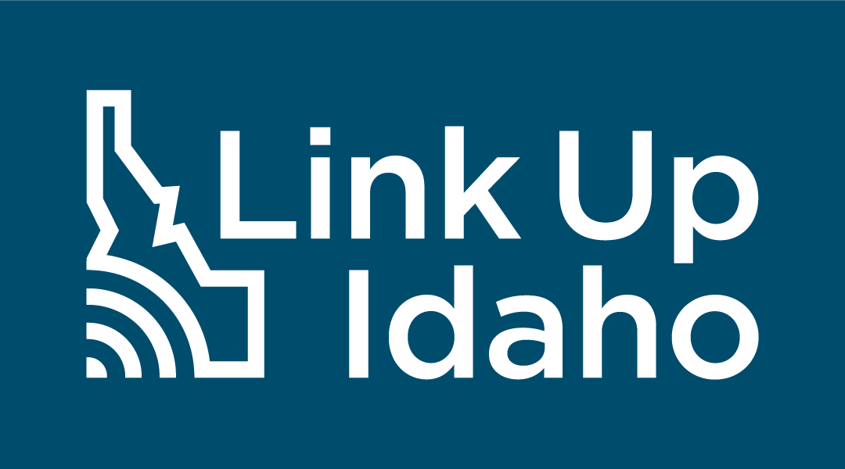

Communications Toolkit

Idaho Internet Access Survey and Speed Test

  - Target Audience: All Idaho citizens and small business owners
  - Goal: Statewide participation in the survey and Ookla speed test through
  - https://linkup.idaho.gov

About Link Up Idaho
The Link Up Idaho initiative is led by the Idaho Broadband Advisory Board (IBAB) and the Idaho Department of Commerce, in coordination with the Idaho Office of Information Technology Services. This multifaceted initiative aims to gather information about connectivity challenges in Idaho communities to provide insight into broadband availability across the state, provide outreach across Idaho to inform communities of the availability of broadband funds, and through the work of the Idaho Broadband Advisory Board, disperse funds to communities to improve broadband access. Link Up Idaho’s mission is to provide all Idahoans with access to affordable and reliable broadband infrastructure.

The Idaho Office of Broadband through the Idaho Department of Commerce has launched the Link Up Idaho initiative to better understand who has access to high-speed, affordable internet in the state and what areas are struggling to connect. The public survey element is critical to accessing new funding for broadband expansion in the state and ensuring as many Idahoan voices are heard as possible. Working together with statewide and regional agencies, local governments, stakeholders, ISPs, development partners, and more, the survey will aid the state in better understanding coverage gaps to ensure both urban and rural communities are connected.
To learn more about broadband expansion in Idaho, visit https://linkup.idaho.gov/ https://linkup.idaho.gov.

Logos

Standard
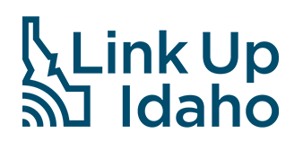
Reverse
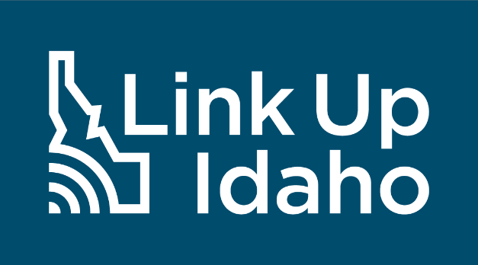

Social Media
This toolkit aims to provide helpful resources and materials to assist in raising awareness about the public survey and other resources available at https://linkup.idaho.gov/.

How to use Social Media
The prepared text and graphics are ready to be used in social media posts to promote participation in the Idaho Internet Access Survey and accompanying speed test. Please follow these step-by-step instructions on how to post to your social media channels.
- Download the image by right-clicking the image and save it to your desktop. Or find high-quality versions of these graphics here. Find the Spanish toolkit here.
- Log in to the appropriate social media site with your organization’s credentials.
- Copy and paste the corresponding text copy into the post and include the social campaign hashtags as noted below.
- Upload the saved image from your desktop to the post.
- Post the status update.
- Repeat as needed for multiple posts on different social media sites.
- Pin the social media post to the top of your profile page for increased visibility.
If you are unsure how to post to different social media sites, please follow the links below for instructions directly from the social media site.
- Facebook
- Twitter
- Instagram
- LinkedIn

Social Campaign - Hashtags
In all posts, please include the hashtag #LinkUpIdaho. The appropriate secondary hashtag is #IdahoBroadband.

Idaho Department of Commerce’s Facebook, Twitter and LinkedIn accounts will also be posting about the Idaho Internet Access Survey and Speed Test throughout the life of the project. We encourage you to tag, re-post, and interact with Link Up Idaho’s posts. Follow us on Facebook, Twitter and LinkedIn: @IdahoCommerce.
Facebook
Twitter
LinkedIn

Social Media Posts

Target: Resident/Community
POST TEXT:
Slow Internet? No Internet? Let us know. Take the Idaho Internet Access Survey and Speed Test at https://linkup.idaho.gov/ #LinkUpIdaho #IdahoBroadband
Facebook/ Twitter/LinkedIn  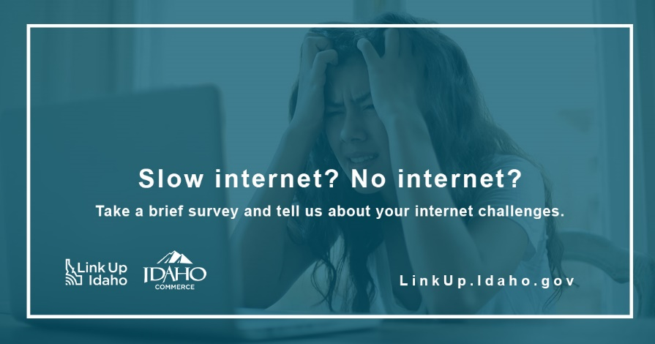 | Instagram  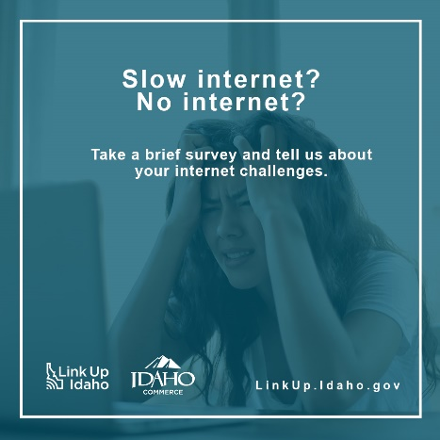

Target: Resident/Community
POST TEXT:
Slow connection? No connection? Take the Idaho Internet Access Survey and Speed Test from your home or business Wi-Fi and let us at: https://linkup.idaho.gov/ #LinkUpIdaho #IdahoBroadband

Facebook/Twitter/LinkedIn  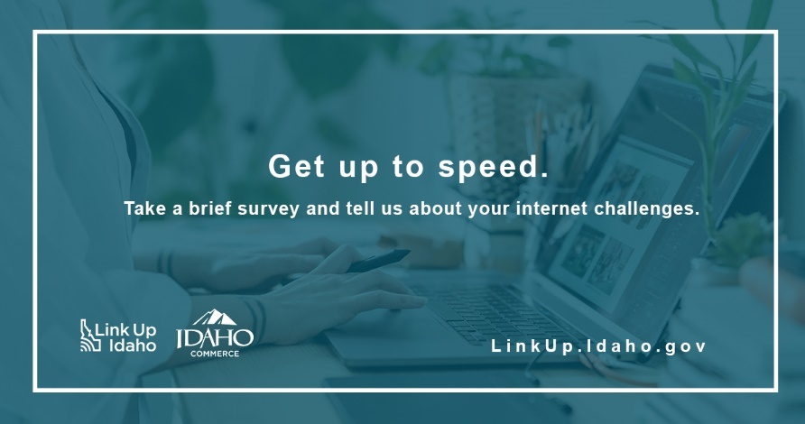 | Instagram  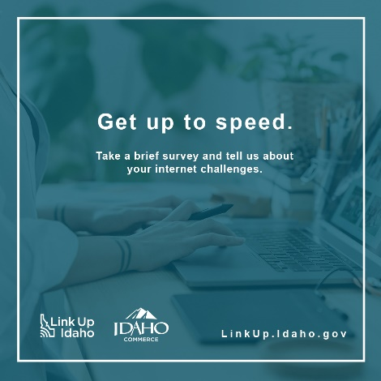

Target: Resident/Community: Students/Parents/Educators
POST TEXT:

Help every student get connected to high-speed internet. Take the Idaho Access Survey and Speed Test at https://linkup.idaho.gov. #LinkUpIdaho #IdahoBroadband

Facebook/ Twitter/LinkedIn  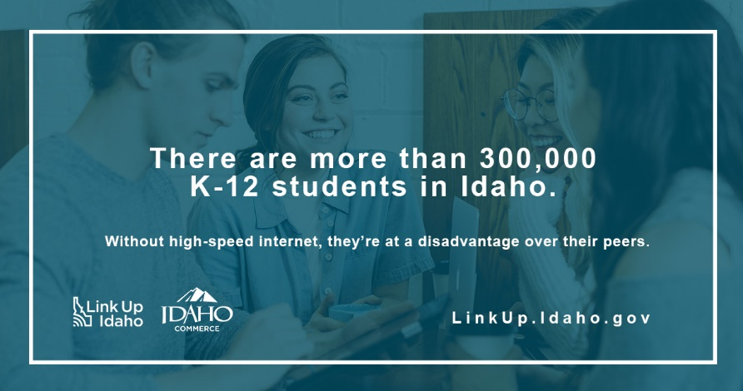 | Instagram  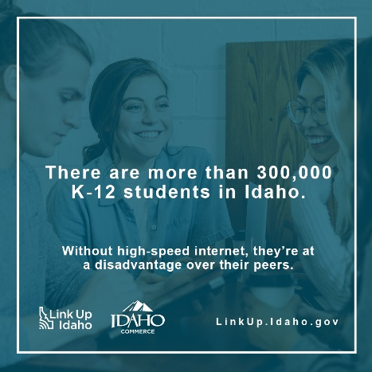

Target: Business Owner
POST TEXT:
More than 99% of Idaho businesses are small businesses. Take the Idaho Internet Access Survey and Speed Test so we can get your business connected and open you up to a world of new customers. https://linkup.idaho.gov #LinkUpIdaho #IdahoBroadband

Facebook/Twitter/LinkedIn  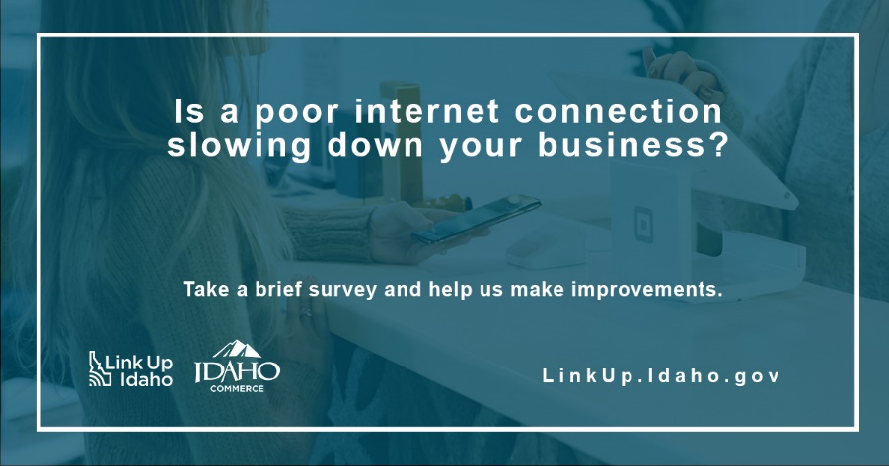 | Instagram  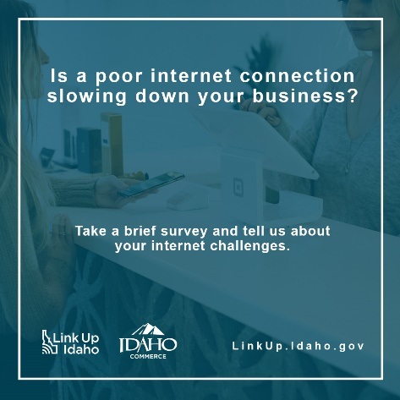

Target: Healthcare
POST TEXT:
A faster internet connection is just what the doctor ordered. Take the Idaho Internet Access Survey and Speed Test at https://linkup.idaho.gov . #LinkUpIdaho #IdahoBroadband
Facebook/Twitter/LinkedIn  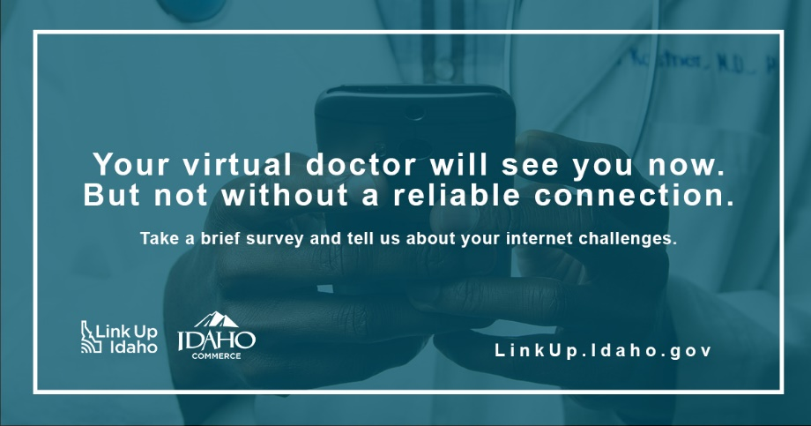 | Instagram  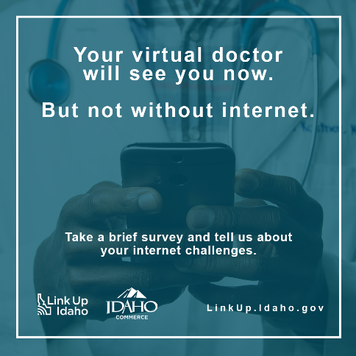

Target: Agriculture
POST TEXT:
Broadband is the key to the future of farming. Take the Idaho Internet Access Survey and Speed Test at https://linkup.idaho.gov. #LinkUpIdaho #IdahoBroadband
Facebook/Twitter/LinkedIn  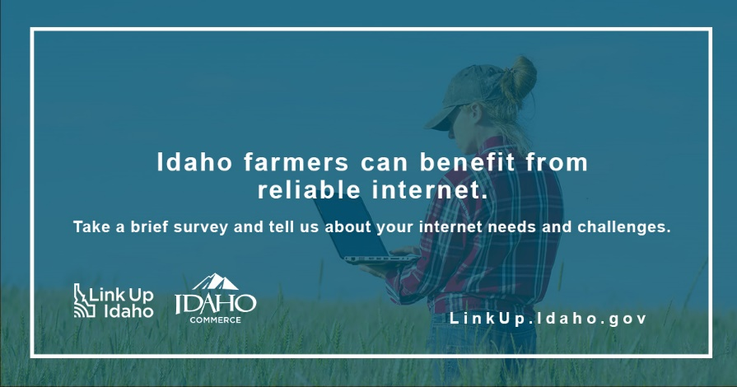 | Instagram  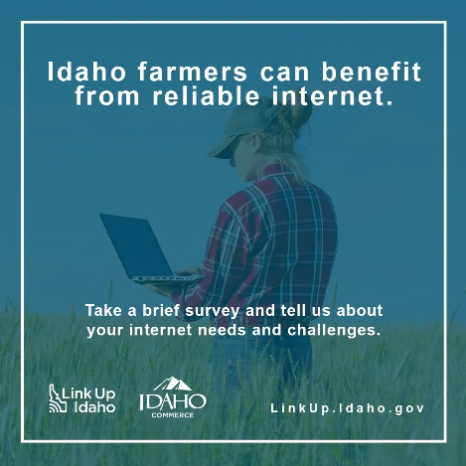

Eblast for Champions
Email Header Graphic:
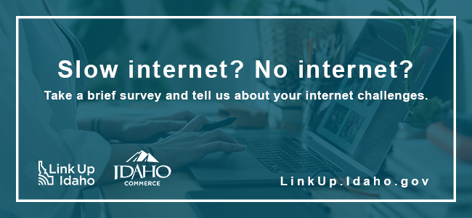

Email Subject: Do You Need High-Speed, Affordable Internet? Let the Idaho Office of Broadband Know!
Idaho Department of Commerce through the Idaho Office of Broadband has launched Link Up Idaho, an initiative aimed at assessing internet availability, reliability, and affordability throughout the State – and they want to hear from you!
Residents and business owners statewide are encouraged to take a brief five-minute survey from their home or business Wi-Fi connection. The results will enable the Idaho Office of Broadband to better understand service needs and identify project opportunities.
No internet? No problem. Take the survey from your local library! Find the library nearest you.

Here are two ways you can help expand high-speed internet across Idaho:
- Visit LinkUp.Idaho.gov – In just a few minutes, you can help contribute to the future of broadband availability in your community.
- Share the survey – Tell your family, friends, and neighbors about the website and survey. More responses will provide the state with a more complete view of internet affordability and service gaps.

To learn more about broadband expansion in Idaho or to sign-up for email updates on the initiative, visit https://linkup.idaho.gov .

Newsletter/Article
Idahoans’ Participation in Internet Access Survey and Speed Test Critical for State’s Broadband Expansion

Access to high-speed internet is no longer a luxury. It’s a necessity for Idahoans to compete in the job market, to participate equally in educational opportunities, to receive world class healthcare, and to stay connected to friends and family. With the accelerated advancement of the digital economy, broadband internet has become critical infrastructure required for our residents to thrive economically and socially.
Our lives depend on internet connection yet fast, affordable, and reliable service remains out of reach for many Idahoans. That’s why your participation in the statewide Idaho Internet Access Survey and Speed Test is critical.
The survey is part of a larger statewide outreach effort that aims to assess the needs of residents across the state. Data collected will help inform the distribution of the Broadband Equity, Access & Deployment (BEAD) Program funding for internet expansion projects.
To ensure accurate speed test data, residents and business owners are encouraged to take the survey from their Wi-Fi connection. If a resident has no current connection but would like to participate, the survey and speed test can be completed from the nearest public library.
The survey is part of the Idaho Department of Commerce’s Link Up Idaho initiative through the Idaho Office of Broadband and the Idaho Broadband Advisory Board.
Take the Idaho Internet Access Survey and Speed Test to help close the digital divide and ensure your voice is heard as Idaho embarks on plans for distributing this historic funding. For more information on the Link Up Idaho initiative or to participate, visit https://linkup.idaho.gov.

Block Ad
A block ad can be provided to stakeholders and other partners for use in their newsletters. This is a 4 x 6 size.

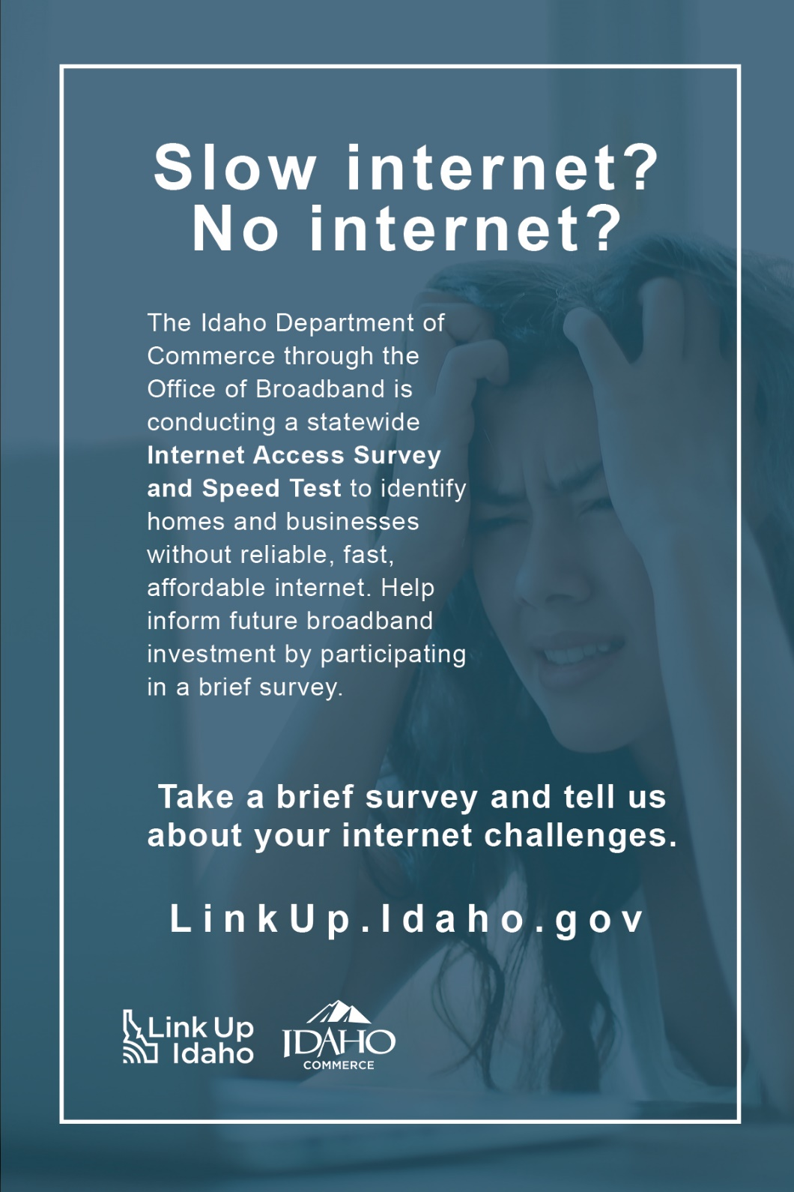

Flyer

Letter – 8 ½ x 11
Half Page (double sided) – 8 ½ x5 ½
