Chapter 1: Overview

Introduction

The Idaho Community Development Block Grant (ICDBG) program is a competitive grant program administered by the Idaho Department of Commerce. Each year the U.S. Department of Housing and Urban Development allocates Idaho’s share of the State Community Development Block Program as determined by the funding formula contained in the Housing and Community Development Act of 1974 as amended. The formula is based on Idaho’s population, poverty, and age of housing.

Commerce distributes the federal CDBG funding to counties and (non-entitlement) cities through a competitive grant process. Therefore, cities and counties may submit an application to Commerce for ICDBG funding for a qualifying project. Qualifying projects must meet an ICDBG national objective and ICDBG funding is typically used for the design and construction of public infrastructure or facilities. The most competitive application factors are matching funds, need, and readiness to proceed.

The information contained within this handbook is critical to your efforts in developing a competitive application. This handbook, forms, and the grant administration manual can be found on our Web site at https://commerce.idaho.gov or you can call our office to receive a copy. Use this handbook to assist your community with the application process.

Funding Categories & Thresholds:

I. There are five funding categories or set-asides. Each funding category has a maximum amount that can be requested. These categories and their corresponding request limits are:

  - Public Facility (public infrastructure, facilities and utilities) – Maximum Award = $500,000

  - Economic Development
    - Infrastructure for Jobs – Maximum Award = $30,000 per job, up to $500,000
    - Downtown Revitalization – Maximum Award = $500,000

  - Community / Senior Centers – Maximum Award = $245,000

  - Post-Disaster – Maximum Award = $150,000

  - Public Parks – Maximum Award = $245,000

Examples of recently funded ICDBG projects:

City of Moscow ICDBG award = $289,000
Procurement of new fire engine Project total cost = $572,900

City of Blackfoot ICDBG award = $150,000
Installation of new restrooms at city park and ADA Project total cost = $193,400
sidewalk improvements.

Power County / subrecipient – Health West ICDBG award = $250,000
Health clinic renovations Project total cost = $580,449

City of Rupert ICDBG award = $500,000
Downtown Revitalization Project total cost = $1,008,500

City of Priest River ICDBG award = $500,000
Sewer line replacement project Project total cost = $2,051,750

City of Kooskia ICDBG award = $100,000
Post-Disaster – Lagoon cell wall repairs Project total cost = $137,000

- ICDBG can be the primary funding source, and, on other projects, secondary. However, other federal programs allow ICDBG to be counted as local match (unique).
- Project sizes range from $55,000 to $15,000,000
- Community population sizes range from 90 to 49,000
- Eligible ICDBG project activities include: new construction or rehab, land acquisition, design professional, and grant administration.

Statewide Goals and Strategies:

Idaho Community Development Block Grant program Statewide Goals are listed below.

I. Preserve and Enhance Suitable Living Environments
  - Public Facilities – Infrastructure Compliance - Availability:
Activities under this strategy include bringing water and sewer systems into compliance with environmental standards, improving medical and fire safety facilities and eliminating slum and blight from downtowns or neighborhoods and other public facility projects.
  - Public Facilities – Infrastructure New Construction - Sustainability:
Activities include installing a water or sewer system where none exists, building new fire safety and medical facilities, rehabilitation or construction of senior and community centers, improving or constructing assisted living facilities and other public facility projects.
  - Public Facilities - Infrastructure Rehabilitation – Affordability:
Activities include construction or rehabilitation of water, sewer, fire, medical and assisted living facilities, streets and other public facilities for the purpose of making them more affordable and sustainable.

II. Expanding Economic Opportunities
  - Economic Development, Job Creation - Availability:
Activities include installation, upgrade, construction and acquisition of public facilities such as water, sewer, power, gas, streets, and buildings to assist in the public cost to promote expansion of an existing business or location of a new business.
  - Economic Development, Downtown Revitalization - Affordability:
Activities include elimination of slum and blight in downtowns through infrastructure improvements, acquisition and demolition of dilapidated properties.

If you have any questions regarding the application process or the rules that guide this process, please contact the Commerce project specialist assigned to your project.

Region Map

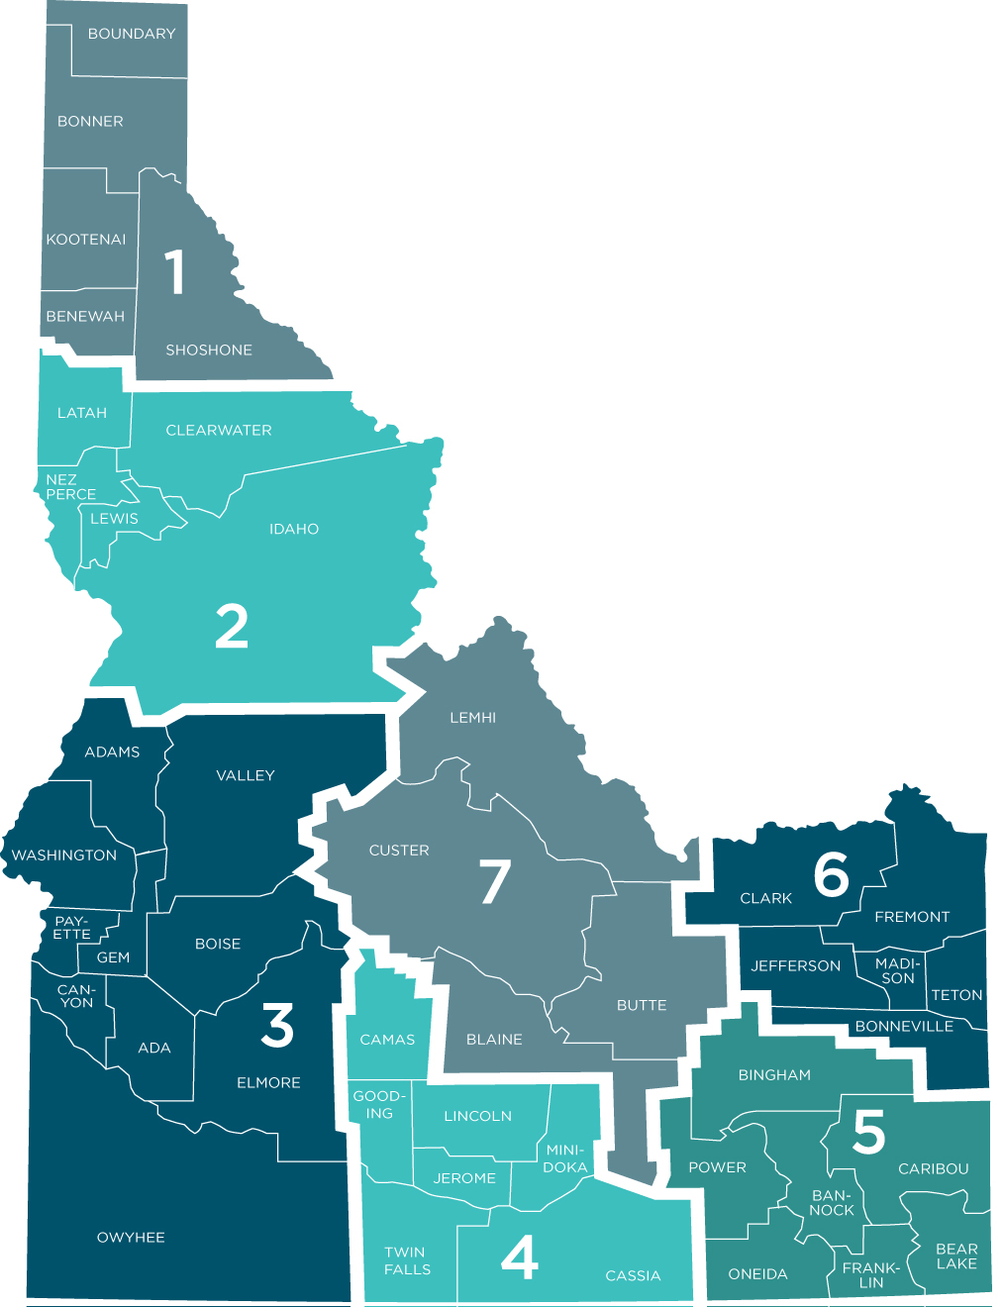

Typical Program Year Funding Allocations & Set-asides

$7,500,000
$250,000 | State Administration
$75,000 | Technical Assistance
$300,000 Reserved | Post-Disaster (*$150,000)
$1,875,000 Reserved (25%) | Community / Senior Center / Public Parks (*$245,000)
$3,000,000 Reserved (60%) of remaining) | Public Facilities (*$500,000)
$2,000,000 Reserved (40%) of remaining) | Economic Development - Job Creation and Downtown Revitalization Grant (*$500,000)

*Maximum Grant Amount

Note:

ICDBG set-aside amounts may be changed by the Economic Advisory Council based on the demands and needs of the applicants.

Any remaining and/or unobligated ICDBG funds for a specific program year will be rolled over into the next program year.

ICDBG funding for grant administration for a project cannot exceed 10% of the total ICDBG project award.

Application Schedule

Public Facilities and Downtown Revitalization applications due. | November, the Friday before Thanksgiving
Job Creation applications due. | December, Third Monday
Economic Advisory Council meeting.  - Review of PF & DT applications; invite for addenda. | January
Senior Citizen/Community Center grant applications due. | March, First Friday
Public Facilities and Downtown Revitalization addenda due. | March, Second Friday
Job Creation applications due. | March, Third Monday
Economic Advisory Council meeting. | April
Job Creation applications due. | June, Third Monday
Economic Advisory Council meeting. | July
Job Creation and Public Parks applications due. | September, Third Monday
Economic Advisory Council meeting. | October

