USCS Services Guidelines and Application Instructions

- Introduction

The U.S. Small Business Administration’s (SBA) Office of International Trade (OIT) has awarded a State Trade Expansion Program (STEP) grant to the Idaho Department of Commerce (IDC). The STEP program provides competitive Idaho Online Global Program Awards (OGPs) to Idaho small businesses for the purposes of international export marketing initiatives. These initiatives are aimed at achieving three primary goals:
1) increase the number of small businesses that export
2) increase the value of exports
3) increase the number of small businesses exploring significant new trade opportunities.
Awards can offset a portion of eligible expenses for services provided by the U.S. Commercial Service. They are a valuable trade tool available to qualifying companies seeking support with various services through the matching program. 10% match required for the RAISE program and/or 25% match for any other services.

Project Period
All project activities must be completed and all funds must be expended on or before September 29, 2022.

Note: If an applicant has limited English proficiency and needs access to resources for assistance, the IDC/ISDA maintains service standards to help.

- Eligible Activities

The program was designed with flexibility to meet the specific international marketing needs of Idaho companies. All Commercial Service offerings and fees can be found here: https://legacy.trade.gov/fees/

Approved project options include, but are not limited to the following:
- International Partner Search+ (IPS+)
  - Provides U.S. companies with a list of up to five partners/distributors that have expressed an interest in the client’s goods/services. The service includes identification and outreach to potential matching firms, sending client’s information to identified matching firms, preparing a profile of interested firms, and providing a report with the profile and contact information for interested firms.
- Rural America's Intelligence Service for Exporters (RAISE)
  - Provides rural U.S. companies with one-on-one market intelligence from a team who identifies customized industry-specific insights and contacts.

- Eligible Applicants

The Trade Facilitation and Trade Enforcement Act of 2015, which authorized the State Trade Expansion Program, limits provision of services to ‘eligible small business concerns’. For purposes of implementing the STEP Program, the SBA operationally defines the term ‘eligible small business concern’ as an entity that meets the specifications below and completes the subsequent certification.

- Is organized or incorporated in the United States;
- Is operating in the United States;
- Meets
  - The applicable industry-based small business size standard established under section 3 of the Small Business Act; or
  - The alternate size standard applicable to the program under section 7(a) of the Small Business Act and the loan programs under title V of the Small Business Investment Act of 1958 (15 U.S.C. 695 et seq.);
  - The U.S. Small Business Administration (SBA) size standards are found at 13 C.F.R. Part 121. Use the following sba.gov link for information on size standards for your business (https://www.sba.gov/size-standards). Click HERE to link directly to the complete list of SBA size standards used to define small business concerns based on NAICS codes
      - Affiliates: You must include the employees or receipts of all affiliates when determining the size of a business. Affiliation with another business is based on the power to control, whether exercised or not. The power to control exists when an external party has 50 percent or more ownership. It may also exist with considerably less than 50 percent ownership by contractual arrangement or when one or more parties own a large share compared to other parties. Check the SBA’s compliance guide for size and affiliation for more detailed information.
      - Annual receipts: This is the “total income” (or “gross income”) plus the “cost of goods sold.” These numbers can normally be found on the business’s IRS tax return forms. Receipts are averaged over a business’s latest three complete fiscal years or (except in the Business Loan and Disaster Loan Programs) five complete fiscal years to determine the average annual receipts. If a business hasn’t been in business for five years, multiply its average weekly revenue by 52 to determine its average annual receipts. The SBA calculates annual receipts in accordance with 13 CFR 121.104.
      - Employee calculation: This is the average number of people employed for each pay period over the business’s latest 12 calendar months. Any person on the payroll must be included as one employee regardless of hours worked or temporary status. The number of employees of a concern in business less than 12 months is the average for each pay period that it has been in business. The SBA calculates number of employees in accordance with 13 CFR 121.106.
- Has been in business for not less than 1 year, as of the date on which assistance using a grant under this subsection commences; and
- Has access to sufficient resources to bear the costs associated with trade, including the costs of packing, shipping, freight forwarding, and customs brokers
- Is an export ready U.S. company seeking to export goods or services of U.S. origin or have at least 51% content, click HERE for information.

Eligible small business must meet the following additional criteria to be considered for this program:
- Operates a business in Idaho to process, assemble, and/or distribute a product or provide an exportable service. The company does not need to be headquartered in Idaho, but must have operations located within the state to qualify.
- Must not be debarred, suspended, proposed for disbarment, declared ineligible, or voluntarily excluded from participation in this transaction by any Federal department or agency
- Company is for-profit
- Recipients must adhere to the Civil Rights Act of 1964, click HERE for information
- A company producing products derived from legal hemp, to include CBD when it meets the definition in section 297A of the Agricultural Marketing Act of 1946 and state of Idaho legislation under House Bill 126. Must comply with FDA Regulations for Dietary Supplement & Conventional Food Products, review here.

The following small businesses are not eligible for STEP funding:
- Consulting agencies
- Companies, organizations or individuals recruiting foreign direct investment
- Companies engaged in any activity that is illegal under Federal or state law
- Companies that develop and produce products from marijuana
- Companies that sell products or services to a marijuana business may not be eligible. Consult Project Director to verify.
- Derives more than one-third of its gross annual revenue from legal gambling activities
- Distributors representing clients
- Educational institutions or for-profit schools recruiting students
- Foreign based companies or more than 49% foreign owned
- Hospitality or tourism operators
- Law Firms
- Multi-level marketing (MLM), direct sales or network marketing companies
- Non-Profit organizations, unless a significant portion of activities are to assist entrepreneurs
- Presents live performances of a sexual nature or derives more than a minor amount of revenue from the sale of products or services of a sexual nature
- Real estate developers
- Retail businesses
- The IDC/ISDA reserves the right to limit or exclude previous recipients of STEP funds that have been assessed risk rating

- Eligible Expenses

Approved project expenses include, but are not limited to the following:
- International Partner Search+ = $900
- Rural America's Intelligence Service for Exporters – RAISE = $3,750

- Ineligible Expenses

Expense categories ineligible for reimbursement include, but are not limited to:
- Printing of brochures, flyers and business cards
- Capital goods, product samples and supplies (except for trade show and/or sales trip demonstration supplies)
- Expenses incurred outside of the STEP grant period
- Federal regulations set by the U.S. Department of the Treasury prohibit funding of activities in/with sanctioned and/or embargoed countries. Click HERE for the current list.
- New product development or alteration of existing products
- Television and radio production
- Expenses for the purpose of attracting foreign direct investment
- Efforts to create or augment marketing and advertising campaigns to draw international visitors to a State
- Costs for enhancement and/or development of an existing company’s product

- Matching Funds

Applicants are required to provide 10% match for the RAISE program and/or 25% cash match for all other services. For example: for every authorized $100 you spend you will be reimbursed $75, up to the maximum amount awarded.
- AWARD FOR IPS+ = $675
Allowable expenditures of $900, you will be reimbursed $675 ($900 x 75% = $675)
- AWARD FOR RAISE = $3,375
Allowable expenditures of $3,750, you will be reimbursed $3,375 ($3,750 x 10% = $3,375)

- Application Process

Submission Procedures
All applications are accepted online at Idaho Commerce’s Grant Portal. To register for a portal account and apply for a STEP Idaho Online Global Program Award, contact Tina Salisbury at 208-287-3164 or by email: tina.salisbury@commerce.idaho.gov. Once registered you will receive instructions via email for using the portal. Only one login is given per company.

Selection and Scoring Criteria
Applications will be scored by a team of subject matter experts and will be considered in the final funding determination. Applications for funding will be evaluated on applicant’s export capabilities, product/service potential, commitment and resources, proposal completeness, and potential impact on the Idaho company and the greater state economy.

Subject to the demand for program funds the IDC/ISDA will determine a competitive range for applications and set a threshold score. Application that fall below the threshold may not be funded.
Socially and Economically Disadvantaged Applicants
Up to 14 points will be given to companies that are socially and economically disadvantaged per the SBA guidelines: Woman Owned; Veteran or Service-Disabled Veteran Owned; Rural Classification; Located in an Opportunity Zone and/or New to STEP. See chart below for definitions of eligibility.

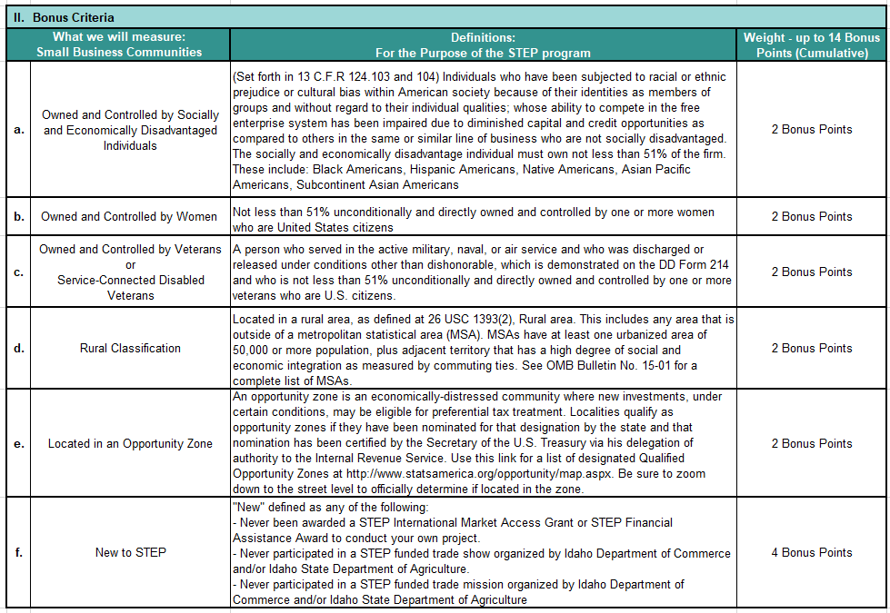

Risk Assessment
A Risk Assessment Rating of up to negative fifteen (-15) points may apply to previous award recipients that have not performed adequately per the award guidelines.

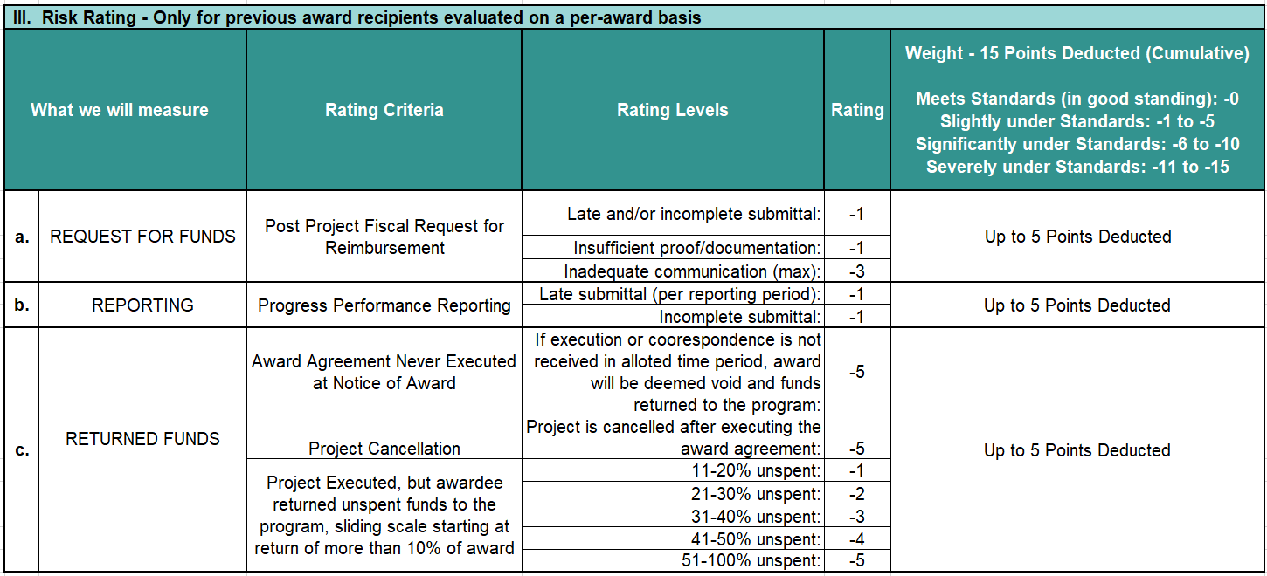
H. Financial Reporting

The STEP program is a cost reimbursable program. Recipients of funds will be reimbursed for eligible costs after the approved activity has been started and all documentation has been received. Requests for reimbursements are submitted online via Idaho Commerce’s Grants Portal along with a .pdf of all eligible receipts. Requests must be completed and submitted within 30 days of the project end date listed on the award agreement.

Upon final approval from IDC, payment will be disbursed to the grant recipient. Subject to the availably of federal funds it may take up to 8 weeks to be received.

I. Reporting Requirements

Companies will be required to complete Progress Performance Reports (PPR) indicating projected and actual sales, activities performed, including success stories and/or trade barriers. A reminder email will be sent to recipients with instructions and reporting template as deadlines approach. As a participant in the STEP Grant program, you may be required to report up to 5 times post event, dependent upon when the project occurred.

Additional reporting beyond the required schedule is encouraged and appreciated, especially if your project occurs late in the grant period. It helps to continue providing the results to the SBA and Congress so that the program may continue to receive Federal funding.

Quarterly Reporting Schedule:
  - January 2022
  - April 2022
  - July 2022
  - October 2022
  - December 2022

J. Contacts

Tina Salisbury, Idaho Department of Commerce
Phone: (208) 287-3164
Email: Tina.Salisbury@commerce.idaho.gov

Sharon Adams, Idaho Department of Commerce
Phone: (208) 287-3152
Email: Sharon.Adams@commerce.idaho.gov

