Industrial
Revenue Bond

Guide

January 2020

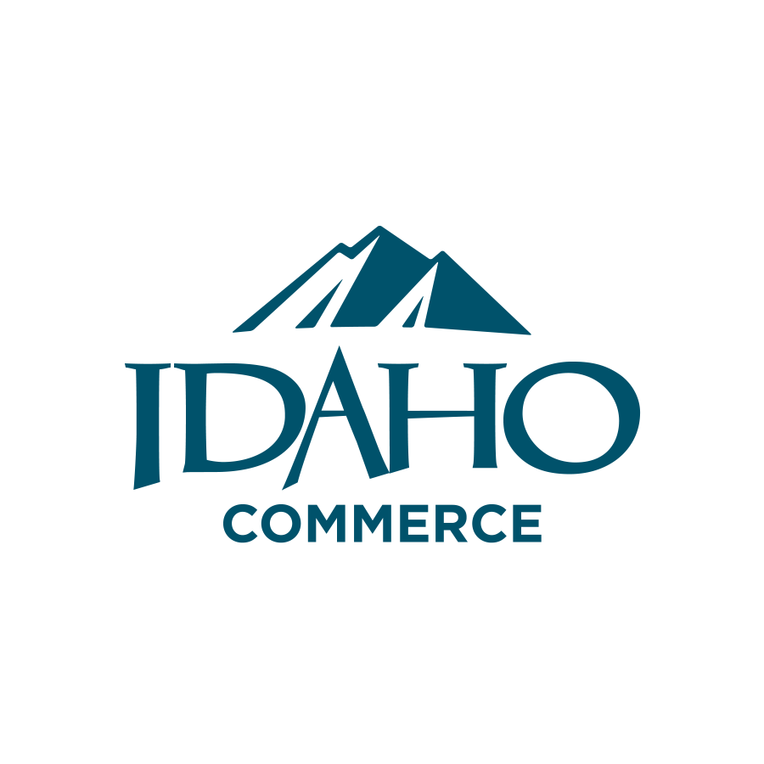

January 2020
Overview

Industrial revenue bonds (IRBs) are a means of primarily financing the construction, enlargement, or equipping of manufacturing plants, and a limited number of non-manufacturing facilities. These bonds are intended to serve as an incentive to businesses to undertake capital investment projects that will provide new jobs and an expanded tax base, both of which will enhance the economic well-being of the community and the state.

IRBs are issued by local industrial development corporations and, hence, are a form of municipal bonds. Idaho Housing and Finance Association is also a qualified issuer. The proceeds of the bond issue are loaned to businesses to finance capital investment projects. Even though they are municipal bonds, IRBs are not general obligations of the local government; tax money is not required to pay the interest on these bonds or to retire them when they mature. The company or organization that uses the facility provides the interest and principal payments on the loan. The local government is simply in partnership with industry, lending its name but not its credit.

Even though they are financed by IRBs, the land and buildings are not exempt from local property taxes. The business must pay the property taxes the same as on comparable property, so there is no loss of tax revenue to the municipality.

Similar to other municipal bonds, the interest earned on IRBs is exempt from federal income taxes. Persons or institutions that buy the bonds, therefore, will be satisfied with a lower rate of interest than they otherwise might obtain. The interest is also exempt from Idaho income taxes.

The lower interest rate is an attractive feature for the borrower as it reduces the cost of financing an industrial project. In addition, the terms of financing can be structured to meet the needs of the business. IRBs offer businesses a convenient, long-term, and, often fixed-rate financing package unlike most conventional loans. The communities that issue IRBs benefit too. As a result of new or expanded industrial facilities, municipalities realize growth in their economic base, additions to real taxable property and new jobs.

The investor, business, and community can all benefit from IRB-financed projects.

Basic Concepts of IRB Financing

IRB financing remains a popular economic development incentive in Idaho. Evidence of this interest comes from the many requests for information and questions about IRB financing the Department of Commerce continues to receive from businesses, municipal officials, developers, and individuals. Most often these inquiries focus on topics such as: the advantages and disadvantages of IRBs; the type of projects that qualify for IRB financing; the principal parties and their role in the IRB process; the use of bond proceeds; size limitations on bond issues; marketability of the bond; and, most importantly, how to obtain a bond issue. The following pages provide both general, and where necessary, more detailed information that address the frequently asked questions about IRB financing in Idaho.

Advantages/Disadvantages of IRB Financing for Business

The main advantage IRBs provide is low interest rates and often longer term financing. These rates are realized because the bonds are sold under the name of the industrial development corporation; therefore, the interest earned from municipal bonds is exempt from federal taxes and from state of Idaho income tax. The bond buyer is willing to accept a lower rate of interest in exchange for tax-free income. Typically, interest rates on IRBs may be from 1.5 to 2.5 percentage points lower than on comparably rated corporate bonds. The savings in interest cost can be substantial to a business over the term of the bond issue.

A second advantage is that IRBs provide a complete financing package. That is, a single bond issue can be used to finance the cost of the entire project--purchase of land, construction of buildings, and acquisition of equipment. A bond issue may also be used to buy equipment only. In addition, bond proceeds can be used to cover the cost of issuing the bond, including attorney fees, underwriter fees, etc., up to 2 percent of the bond issue. This is an attractive feature because these costs, which can be sizable, are spread out over the term of the bond issue.

A third advantage is that the general terms of the revenue agreement between the business and the bond buyer, or underwriter, can be negotiated to conform to the needs of the business. Key components such as the rate of interest, maturity date, and repayment schedules can be arranged, within the limits of federal tax laws, for the convenience of the business. In addition, IRBs, in most instances, allow borrowers to have fixed interest rates for longer terms than conventional financing, which many businesses believe is as important as low interest rates. This is also advantageous to the bondholders, because convenient terms will better enable the business to repay the debt.

A fourth advantage is, by working with the local government, the business can develop a positive relationship with municipal officials. This relationship can be useful in building a cooperative environment for future business-municipal dealings.

Among the disadvantages of IRBs, the high cost of issuing an IRB is the primary one. Typical cost components include: bond counsel fees; underwriter fees; trustee fees; municipal charges (if any); and other ancillary costs. These costs vary depending upon the size and complexity of the bond issue, and whether the bond sale is a private or a public sale. The latter is more costly. The business bears all of these costs. Generally though, the costs are included in the bond issue and paid from bond proceeds. Most businesses will want to perform their own evaluation as it regards using this form of financing versus conventional financing.

Another disadvantage is that the process of issuing an IRB takes time. The business must receive approval of the local government; public hearings must be held; and all federal, state, and local government procedures must be followed. In addition, a business may have to wait for an allocation of the state’s Volume Cap, if the set-a-side for IRBs is temporarily used up. The duration of the issuing process varies. On a stepped-schedule, and if all procedural steps can be accomplished without delay, a bond deal can be completed within six to eight weeks. However, a period of two to three months is generally more realistic.

A third disadvantage is the large volume of paperwork that an IRB issue involves. The documentation of meetings, resolutions, legal opinions, and revenue agreements generate sizable amounts of paperwork for all of the parties involved. This, in turn, contributes to the cost of issuing IRBs.

A fourth disadvantage is that borrowers cannot use the Accelerated Cost Recovery System (ACRS) for computing depreciation (except with residential housing projects). Rather, they must use straight-line depreciation.

Many businesses in Idaho have successfully financed their capital investment projects with IRBs. Even so, IRBs may not always be the best method of financing for some types of projects. The business should weigh the advantages and disadvantages carefully when considering IRB financing. The company should also seek the advice of bond counsel and financial experts to assist in making its determination.

Qualified Projects

In order to derive the primary benefit from revenue bond financing (i.e., the exemption of interest on revenue bonds from federal income taxation), one must comply with federal restrictions on the types of projects which can be financed. Generally, for-profit companies can only use federally tax exempt revenue bonds to finance:

* Manufacturing facilities * Processing
* Production * Assembly
* Solid waste disposal
* Local housing authorities

The term “manufacturing facilities” includes any facility which is used in the manufacturing or production of tangible personal property (to include processing which results in a change to the condition of such property).

If a project qualifies for revenue bond financing, the proceeds from the bonds may be used to finance land, construct buildings, purchase equipment or machinery, or finance capitalized interest related to the project, provided that the costs for such items were incurred by the company after the date the issuing governmental body adopts a resolution indicating its intent to issue revenue bonds. In addition, bond proceeds may be used to finance legal fees and other issuance costs (but not in excess of 2 percent of the face amount of the bonds). Also, in the case of a 501(c)(3) entity, under certain circumstances, bond proceeds may be used to refinance outstanding taxable indebtedness or reimburse the entity for certain capital costs paid or incurred prior to the inducement resolution.

Often a company will combine tax increment financing with revenue bond financing from a local urban renewal agency. The company will use tax increment financing to finance the public improvement portion of its project (sewer connections, water, parking, etc.) as well as the cost of clearing the land, while using revenue bond financing for the brick and mortar portions of the project.

Participants in the Process

A typical bond transaction will have the following parties:

1. Bond Counsel--A law firm with expertise in the field of municipal bonds. Bond counsel will typically draft the documentation related to the bonds. Bond counsel will certify that an IRB issue complies with all state and federal legal requirements and deliver an opinion regarding the tax-exempt status of the bonds. Bond counsel can also help to form a public corporation when required, and place the borrower in contact with local officials and lenders. See the list of Experienced Idaho Bond Counsel on page 7.

2. Underwriter/Purchaser/Lender--An investment banking firm, bank, or other financial institution. The underwriter is involved only if the bonds are to be marketed to the public rather than privately placed by the company. The underwriter helps structure the financing and ultimately purchases the bonds for resale to the public. A lender is usually found through bond counsel, or a bond placement service (see page 7).

3. Governmental Issuer/Public Corporation--A governmental industrial development corporation (public corporation) authorized by law to issue revenue bonds. The local governmental body must formally approve each IRB by issuing an Inducement Resolution. The public corporation also coordinates the activities of all the participants in the process. The responsibility of repayment of the bond is that of the borrower. The local government incurs no liability for repayment. See page 8 for a list of existing chartered public corporations.

4. The Borrowing Company--The eligible participant which is to benefit from the financing. There may be more than one eligible participant and the eligible participant does not need to be directly or indirectly the user of the project. For most bond issues, though, the eligible participant is also the principal user of the facility to be financed.

When the public corporation has passed an inducement resolution, it must apply to the Idaho Department of Commerce for an allocation of the state private activity bond ceiling. Allocations are valid for a period of up to 180 days during which the final sale of the bond must be concluded. Applications for allocation are made using the form on page 9.

The Process

The following is a sample step-by-step guide to the IRB process:

1. Preliminary Discussions
A borrower discusses the preliminary project proposal with bond counsel and the public corporation (where in existence) or with city or county officials where a public corporation does not exist (see page 8).

2. Application Submittal
If the project is feasible, appears to be eligible, and meets the objectives of the public corporation, the company submits an application provided by the public corporation, and may be requested to submit financial statements or other information.

3. Preliminary Project Evaluation
The public corporation reviews the application with assistance from staff, financial institutions and bond counsel. Project evaluation often includes a credit review conducted by an investment banker or lender.

4. Substantive Negotiations Begin
If the project is eligible, negotiations begin between the company, public corporation, bond counsel and the bond purchaser to obtain a project acceptable to all parties.

5. “Inducement Resolution”
If initial agreement, on basic terms and conditions is achieved, bond counsel assists the public corporation in preparing an “inducement resolution” stating the corporations conditional intent to issue revenue bonds in a certain amount for a specified company and use. The date that this inducement resolution is approved by the public corporation is important to the borrowing company because only the project expenditures made within 60 days of that date are recoverable from the bond proceeds. As such, it is best to work toward an inducement resolution early in the process so that costs of initiating and planning the project can be financed by bond proceeds.

6. Planning Jurisdiction Approval
Project approval of the planning jurisdiction, if different from the creating municipality, must be secured.

7. Final “Bond Issuing Resolution”
Negotiations may continue until the final bond issuing resolution is approved. This final resolution approves the documents setting forth the terms and conditions of the bond sale, and it is approved by the creating municipality using a resolution or ordinance.

8. Request IRB Allocation from the Department of Commerce
Federal law restricts the amount of private activity bonds that can be issued in Idaho each year. The Idaho Department of Commerce allocates the amount of each bond issued to ensure the ceiling is not exceeded. The public corporation requests an allocation from the established ceiling when a buyer for the bond has committed to the purchase. A request for allocation is made with the form on page 9, and an attached inducement resolution.

9. Bond Counsel Opinion and Issuance of Bonds
The opinion of bond counsel regarding tax-exempt status of the project is rendered, the sale is closed, and the bonds are purchased. Post-closing reports are made to the Internal Revenue Service and Idaho Department of Finance. The process for bond payment may then vary depending upon whether it is to be a public or private bond placement.

10. Other Documentation and Procedures Involved
Bond counsel involvement.

STATE OF IDAHO
EXPERIENCED BOND COUNSEL

Moore, Smith, Buxton
Mr. Michael C. Moore
225 N. 9th, Suite 420
Boise, Idaho 83702
208-331-1800

Skinner, Fawcett
Mr. Richard A. Skinner
515 South Sixth Street
Boise, Idaho 83701
208-345-2663

Hawley, Troxell, Ennis, & Hawley
Mr. Nicholas G. Miller
Wells Fargo Center, Suite 1000
877 West Main Street
Post Office Box 1617
Boise, Idaho 83701
208-344-6000

BOND PLACEMENT SERVICES

Mr. Eric Heringer
Investment Banker
Seattle Northwest Securities
802 West Bannock
Boise, Idaho 83702
208-344-8577

Chris Karlin
US Bank
Government Banking Center
Post Office Box 8247
Boise, Idaho 83733
503-275-5506

Mr. Jim C. Wrigley
Wedbush Morgan Securities
950 W. Bannock Street, Ste. 600
Boise, ID 83702
208-331-1559

Ms. Linda DelBianco
KeyBank Capital Markets
601 108th Avenue NE Floor 3
Bellevue, WA 98004
425-709-4351
Fax: 425-709-4354

Scott Bramhall
GE Capital
6510 Millrock Drive, Ste. 200
Holladay, UT 84121
801-733-3058
Cell: 801-891-0870
Fax: 888-867-0031

Christian Anderson, V.P.
Zion’s Bank
800 West Main Street
Boise, ID 83702
208-501-7533
Cell: 208-761-3960
Fax: 208-855-9702

IRB ALLOCATION REQUESTS
Idaho Department of Commerce
700 West State Street
Post Office Box 83720
Boise, Idaho 83720-0093
(208) 334-2470
* Idaho Department of Commerce does not intend the names given above as an endorsement.

STATE OF IDAHO

CHARTERED PUBLIC CORPORATIONS

The cities and counties listed below have formed chartered public corporations for the purpose of issuing industrial revenue bonds. Projects financed by IRBs can be completed more quickly in these cities and counties because they have done the necessary groundwork of forming a public corporation. Each of these corporations may issue any number of bonds as long as they do not exceed $20 million ($10 million tax-exempt/$10 million taxable) per project each and $40 million per beneficiary per year.

Legislation passed in 2007 permits the financing of economic development projects through the issuance of revenue bonds by the Idaho Housing and Finance Association.

Potential IRB users should not avoid doing IRB projects in places without public corporations. In those cases, the Idaho Department of Commerce will be glad to assist city or county officials in forming a public corporation to expedite the IRB financing process. Businesses attempting to use IRB financing in cities or counties without public corporations should contact local elected officials and inform them of the Idaho Department of Commerce’s offer to help them charter a public corporation.

Because public corporations are not centrally registered, the list below may be incomplete. Check with the city and/or county government office to confirm the existence or absence of a public corporation.

CITIES COUNTIES

Boise Ada Kootenai
Caldwell Bannock Lincoln
Eagle Benewah Madison
Fruitland Bingham Minidoka
Garden City Bonneville Nez Perce
Idaho Falls Bonner Oneida
Lewiston (Port of Lewiston) Camas Payette
Meridian Canyon Power
Nampa Cassia Shoshone
Shelley Custer Twin Falls
Twin Falls Gooding Washington
Mountain Home Jerome

IDAHO DEPARTMENT OF COMMERCE
Request for Allocation of Private Activity Bond Authority

Date:

To: Idaho Department of Commerce
700 West State Street
Post Office Box 83720
Boise, Idaho 83720-0093

In accordance with Executive Order No. 2018-05 of the Governor of the State of Idaho, dated
May 23, 2018, the Issuing Authority indicated below hereby requests an allocation from the state ceiling of Private Activity Bonds and as evidence of compliance with said Executive Order, hereby files with the Idaho Department of Commerce the attached Bond Inducement Resolution (or similar binding commitment), and the following information:

Issuing Authority Name:
Identification number _______ Phone:
Executive Officer Title:
Address:
City, State, Zip:
Bond Counsel Name:
Name of firm:
Address:
City, State, Zip:
Phone number:
Name of project:
Location:
Description of use:
Name of project owner/user:
Par amount of obligations (allocation requested):
Date of purchase agreement:
Purchaser(s):
Name of bond issue:
Anticipated closing date:
Anticipated date for issuing certificates:
Applicable Provision of Internal Revenue Code:
Request allocation be carried forward to:
Evidence of need, economic impact and distribution
of resources throughout the State:
(please attach a separate sheet of paper if needed)

Signed:
Name:
Title:

NOTES

