**Idaho's Federal Community Development and Affordable Housing Programs**

**2015-2019 Five-Year Consolidated Plan & 2015 Action Plan**



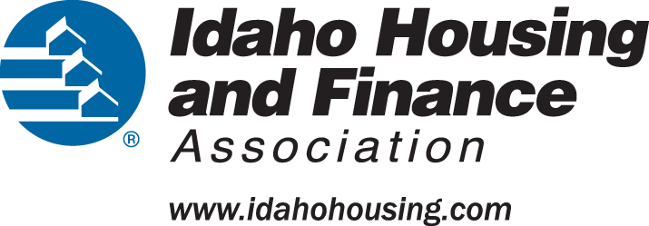

***Upon request, this document will be provided in a format accessible to persons with disabilities and/or limited English proficiency. The Idaho Department of Commerce and Idaho Housing and Finance Association prohibit discrimination based on race, color, nation origin, religion, sex, familial status, sexual orientation/identity, disability, and age in the HUD program covered herein.***

[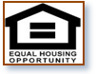](http://www.wearefla.com/equal_housing_opportunity.jpg)  

Contents

Executive Summary 7

ES-05 Executive Summary - 91.300(c), 91.320(b) 7

The Process 9

PR-05 Lead & Responsible Agencies 24 CFR 91.300(b) 9

PR-10 Consultation - 91.110, 91.300(b); 91.315(l) 9

PR-15 Citizen Participation - 91.115, 91.300(c) 16

Needs Assessment 21

NA-05 Overview 21

NA-10 Housing Needs Assessment - 24 CFR 91.305 (a,b,c) 21

NA-15 Disproportionately Greater Need: Housing Problems - 91.305 (b)(2) 29

NA-20 Disproportionately Greater Need: Severe Housing Problems –91.305(b)(2) 31

Greater Need: Housing Cost Burdens – 91.305 (b)(2) 34

NA-30 Disproportionately Greater Need: Discussion – 91.305 (b)(2) 35

NA-35 Public Housing – (Optional) 36

NA-40 Homeless Needs Assessment – 91.305(c) 40

NA-45 Non-Homeless Special Needs Assessment – 91.305 (b,d) 44

NA-50 Non-Housing Community Development Needs - 91.315 (f) 45

Housing Market Analysis 50

MA-05 Overview 50

MA-10 Number of Housing Units – 91.310(a) 51

MA-15 Cost of Housing – 91.310(a) 57

MA-20 Condition of Housing – 91.310(a) 61

Definitions 61

Standard Condition- 61

Substandard Condition- 61

MA-25 Public and Assisted Housing – (Optional) 65

MA-30 Homeless Facilities – 91.310(b) 67

MA-35 Special Needs Facilities and Services – 91.310(c) 70

MA-40 Barriers to Affordable Housing – 91.310(d) 72

MA-45 Non-Housing Community Development Assets -91.315(f) 72

MA-50 Needs and Market Analysis Discussion 78

STRATEGIC PLAN 80

SP-05 Overview 80

SP-10 Geographic Priorities – 91.315(a)(1) 82

SP-25 Priority Needs – 91.315(a)(2) 84

SP-30 Influence of Market Conditions – 91.315(b) 94

Influence of Market Conditions 94

SP-35 Anticipated Resources - 91.315(a)(4), 91.320(c)(1,2) 96

SP-40 Institutional Delivery Structure – 91.315(k) 102

SP-45 Goals Summary – 91.315(a)(4) 106

Goal Descriptions 110

SP-50 Public Housing Accessibility and Involvement – 91.315(c) 117

SP-55 Barriers to affordable housing – 91.315(h) 118

SP-60 Homelessness Strategy – 91.315(d) 118

SP-65 Lead based paint Hazards – 91.315(i) 121

SP-70 Anti-Poverty Strategy – 91.315(j) 123

SP-80 Monitoring – 91.330 125

2015 ACTION PLAN 126

AP-15 Expected Resources – 91.320(c)(1,2) 126

Annual Goals and Objectives 132

AP-25 Allocation Priorities – 91.320(d) 140

Funding Allocation Priorities 140

Reason for Allocation Priorities 140

AP-30 Methods of Distribution – 91.320(d)&(k) 143

AP-35 Projects – (Optional) 157

AP-38 Project Summary 159

AP-40 Section 108 Loan Guarantee – 91.320(k)(1)(ii) 167

AP-45 Community Revitalization Strategies – 91.320(k)(1)(ii) 167

AP-50 Geographic Distribution – 91.320(f) 167

Affordable Housing 169

AP-55 Affordable Housing – 24 CFR 91.320(g) 169

AP-60 Public Housing - 24 CFR 91.320(j) 170

AP-65 Homeless and Other Special Needs Activities – 91.320(h) 171

AP-75 Barriers to affordable housing – 91.320(i) 176

AP-85 Other Actions – 91.320(j) 177

Actions planned to reduce lead-based paint hazards 178

Certifications of Consistency 180

Program Specific Requirements 181

AP-90 Program Specific Requirements – 91.320(k)(1,2,3) 181

Emergency Solutions Grant (ESG) 183

UNIQUE APPENDICES 202

ES-05- Executive Summary- Summary of Objectives and Outcomes 202

Idaho Department of Commerce 202

CDBG Program 202

Idaho Housing and Finance Association 202

Affordable Housing Trust Fund 202

HOME Program 203

ESG Program 204

PR-15 Citizen Participation 206

Pre-Draft 206

Post Draft 30- Day Comment Period 207

MA-35-Idaho Facilities And Services For Non-Homeless Persons Requiring Supportive Housing 208

MA-40 Barriers to Affordable Housing 91.310(d) 211

Affirmatively Furthering Fair Housing 212

MA- 50- Non-Housing Community Development Assets 213

NA-10 Housing Needs Assessment 215

Projected Rental and Homeowner Occupied Units 217

Number of Households Table 217

Housing Needs Summary Tables 218

NA-35 Public Housing 222

NA-50 Non-Housing Community Development Needs 223

SP 40 – Institutional Delivery Structure 226

Assess of Strengths and Gaps in the Institutional Delivery System 226

State Of Idaho-CDBG Program 226

IHFA- HOME Program 226

ESG Program 228

SP-55 Barriers to Affordable Housing 229

SP-80 Monitoring 230

Idaho Housing and Finance Association 232

AP-30 Method of Distribution 237

State of Idaho CDBG 237

AP-65 Homeless and Other Special Needs Activities – 91.320(h) 240

AP-75-Barriers to Affordable Housing 244

Affirmatively Furthering Fair Housing 247

Impediments 247

AP-90- Program Specific Requirements 251

Written standards for providing ESG assistance 253

Housing First! Sample Letter 254

Grantee SF-424s and Certification(s)- 2015 Action Plan 256

Appendix - Alternate/Local Data Sources 274

# Executive Summary

## ES-05 Executive Summary - 91.300(c), 91.320(b)

**1. Introduction**

The State of Idaho receives approximately $13 million in block grant funds annually from the U.S. Department of Housing and Urban Development (HUD) for affordable housing and community development programs. They are the Community Development Block Grant (CDBG), the Emergency Solutions Grant (ESG), and the HOME Investment Partnerships Program (HOME).

As State Grantees of these HUD-CPD programs, Idaho Housing and Finance Association(HOME and ESG) can award funds anywhere in the state, while the Idaho Department of Commerce (IDC) can award CDBG funds anywhere in the state except for local CDBG entitlement areas.  Although IHFA is not a State Agency, it does administer the State's housing programs. HUD refers to IHFA and IDC collectively as the "State".

State Grantees are required to submit a long-term plan to HUD summarizing the state's housing and community development needs, priorities, goals, and strategies for the next five (5) years. This document is the *Five-Year Consolidated Plan.*

Each year in the Consolidated Plan is based on a Program Year that begins April 1st and ends March 31st of the subsequent year.  Beginning with the first Program Year the Consolidated Plan, IHFA and IDC submit an *Annual Action Plan* that identifies each program's anticipated allocation, annual goals, strategies, and outcomes.  An annual plan is submitted to HUD within 60 days of notification from HUD of that year's allocation amount.  Within 90 days following each program year, the State Grantees are required to submit the Consolidated Annual Performance Evolution Report (CAPER) to HUD.  

**2. Summary of the objectives and outcomes identified in the Plan Needs Assessment Overview**

Response exceeds maximum number of characters, please refer to Unique Appendices

**3. Evaluation of past performance**

Response exceeds maximum number of characters allowed, please refer to Unique Appendices.

**4. Summary of citizen participation process and consultation process**

Although not required, IDC and IHFA held a pre-drafting 30-day comment period for the public and stakeholders to provide the opportunity for input prior to drafting the Plan. Following the drafting of the Plan, a second 30-day public comment period is required to receive comments on the Draft Plan. Comments received during the pre-draft comment period are not included herein.

The Legal Notices for both comment periods was published on major Idaho newspapers including Idaho’s El Hispanõ. A copy of the notice was emailed to local, regional, state level stakeholders, including continuum of care within the state, public housing authorities, state agencies, entitlement cities, major public libraries, IHFA branch offices.  English and Spanish versions of the notices were posted on the IDC and IHFA websites.

**5. Summary of public comments**

The Summary of public comments exceeds maximum allowable characters. See Citizen Participation Attachment.

**6. Summary of comments or views not accepted and the reasons for not accepting them**

All Comments were accepted

**7. Summary**

No Response required.

# The Process

## PR-05 Lead & Responsible Agencies 24 CFR 91.300(b)

1. Describe agency/entity responsible for preparing the Consolidated Plan and those responsible for administration of each grant program and funding source

The following are the agencies/entities responsible for preparing the Consolidated Plan and those responsible for administration of each grant program and funding source.

| Agency Role | Name | Department/Agency |
| --- | --- | --- |
| Lead Agency | IDAHO |  |

|  |  |  |
| --- | --- | --- |
| CDBG Administrator | IDAHO | Commerce |
| HOPWA Administrator | IDAHO |  |
| HOME Administrator | IDAHO | Grants Department |
| ESG Administrator | IDAHO | Homeless Programs |

Table 1 – Responsible Agencies

Consolidated Plan Public Contact Information

CDBG Program- State of Idaho Department of Commerce-Dennis J Porter, Manager 208-287-0782 Email: dennis.porter@commerce.idaho.gov

HOME Program- Idaho Housing and Finance Association- James M. Gruber jamesg@ihfa.org 208-331-4670

ESG Program- Idaho Housing and Finance Association- Brady B. Ellis bradye@ihfa.org 208-331-4839

## PR-10 Consultation - 91.110, 91.300(b); 91.315(l)

1. Introduction

In preparation for the consolidated planning process, IDC and IHFA conducted a statewide housing needs survey and a community development needs survey. Published notices invited the public to go online and participate in the anonymous housing needs survey. The notice was mass emailed to public, assisted, and special needs housing providers, special needs and homeless service providers, disability centers and advocates, fair housing advocates, affordable housing owners, developers and management, mortgage lenders, public and private agencies, CHDOs, Section 8 landlords and PHAs. The survey results and the commissioned report were posted online on IHFA's and IDC's websites prior to the pre-drafting citizen participation process. In addition, Federal housing administrators, Idaho Department of Health and Welfare, local units of government, and stakeholders were consulted during the pre-drafting and drafting process as applicable

Provide a concise summary of the state’s activities to enhance coordination between public and assisted housing providers and private and governmental health, mental health and service agencies (91.215(l))

IHFA hosts a housing coordination round table event twice each year. The event provides a regional forum to discuss current housing issues, promote effective partnerships and enhance ongoing coordination between public and assisted housing providers and local/regional/state service agencies. It brings local, regional, state housing advocates, public and private service providers, developers, city/county/state/federal officials, state agencies, elected officials/representatives, lenders, and program administrators together to discuss housing, homeless, and services regionally. Attendees were asked to participate in the Statewide Housing Survey and provide comment regarding this year's Consolidated Plan. In addition IHFA used email distribution lists to request input regarding the consolidated planning process from Idaho's Public Housing Authorities, Section 8/USDA-RD/LIHTC/HOME property owners and developers, residential lenders, real estate brokers, homeless service providers, CHDOs, CDBG entitlement cities, CDBG non-entitlement jurisdictions, Idaho Homelessness Coordinating Committee (IHCC), Idaho Fair Housing Forum, Idaho's disability advocates and centers, Idaho Health &Welfare-Environmental Heath, IDHW-TANF & Employment and Training Program.  Additionally, IHFA hosts a housing conference every third year with the intent of encouraging these parties to convene together and have impactful and beneficial learning session and discussions on potential strategies used to increase affordable housing opportunities.  Increased collaboration between the Balance of State Continuum of Care and the Boise City Ada County Continuum of Care has also emerged.  This will encourages greater awareness to the statewide issue of homelessness and for the sharing of best practices and successful models throughout Idaho.  The IHCC has and continues to invite state agencies to participate in homelessness resolution discussions and IHCC board planning sessions and activities.  This body creates strategic plans designed to assist the Continuum in meeting the challenges posed by Opening Doors.  Resources targeting and leveraging are also discussed to ensure access priorities mirror HUD’s goals for special populations.  For example, one of the IHCC’s regional coalitions is actively involved in participating in their region’s efforts in extinguishing veteran homelessness.  Further, newly established projects have focused on chronic homelessness and homeless families by implementing Housing First and Rapid Re-Housing endeavors.  Additionally, the IHCC will now have a greater awareness of runaway and homeless youth now that programs statewide are required to enter project data into Idaho’s HMIS.

Describe coordination with the Continuum of Care and efforts to address the needs of homeless persons (particularly chronically homeless individuals and families, families with children, veterans, and unaccompanied youth) and persons at risk of homelessness

IHFA is both the Balance Of State (BOS) COC Collaborative Applicant and HMIS Lead, which ensures effective and constant collaboration between the Continuum and data collection, reporting, and evaluation activities.  The HMIS Lead participates in IHCC sub-committee meetings to contribute pertinent program data and demographics to ensure policy decisions and funding allocations are done with a clear understanding of populations and geographical areas in the highest need of assistance and attention.

The IHCC has made efforts towards not just simply addressing the needs of homeless persons, but to address the needs of persons at risk of homelessness and specific sub-populations therein, which may be more prevalent in various regions of the state.  The BOS COC currently utilizes a Coordinated Assessment system in the form of an Assessment of Barriers to Housing form used by subrecipients.  Based on the evaluation performed, homeless persons can be referred to the type of housing that best aligns with their needs and circumstances.  IHFA and the BOS COC will focus on transitioning to a Coordinated Entry concept which will increase the ability to serve the most vulnerable  homeless individuals and families first, and more accurately define the State’s and each regions’ homeless population.  Furthermore, the collection of assessments results will allow the Continuum to conduct ‘right-sizing’ evaluations to ensure resources allocations are proportionate to those served by each program type.  Imbalances between outcomes and resource allocation can signify inefficiencies within a particular housing component type.  Data collection and evaluation efforts will continue to grow as parties not currently collaborating with the BOS COC are willing to attend planning sessions, pair resources, and compare data and program outcomes.  This renewed desire for collaboration will be demonstrated at a HUD-approved technical assistance planning session to be held in May, 2015, and will include housing, homeless, service, and health care providers with the goal of identifying system gaps and increasing linkages between health care and housing.

Describe consultation with the Continuum(s) of Care that serves the state in determining how to allocate ESG funds, develop performance standards and evaluate outcomes, and develop funding, policies and procedures for the administration of HMIS

IHFA is the HUD grantee for all ESG funding in Idaho.  This ensures constant COC and HMIS integration and collaboration.  IHFA, and therefore COC policy makers, is heavily and actively involved in contributing to the creation of Emergency Solutions Grant allocation planning.   ESG subrecipients are involved in the planning process through their participation in the BOS COC regional housing coalitions.  Additionally, COC subrecipients are able to provide input based on their knowledge and experience in serving families and individuals that are homeless or at risk of homelessness.  COC participation, along with IHFA’s contributions, lead to the development and implementation of performance standards and outcome evaluations.  IHFA will research performance outcomes and fund allocation methods used by other ESG grantees to assess whether there are more equitable or effective performance evaluations available.  Furthermore, HMIS funding levels and policies and procedures are determined and employed to ensure ESG subrecipients participate in HMIS data collection and reporting.  This ensures HMIS contribution and participation in the development of the competitive application process.

ESG Homelessness Prevention and Rapid Re-Housing fund allocation is currently based on a formula that considers population, area median income (AMI), unemployment rate, Point In Time Count results, bed utilization, and competitive project application scoring.  The performance measures and outcome evaluations used in the competitive application process are created by IHFA staff and approved by COC and regional coalition representatives, and are used with the intent of utilizing an objective evaluation and allocation model. The BOS COC aids in contributing to the competitive application standards and scoring criteria.  The HMIS Lead is essential in contributing data to each projects application.  An unbiased evaluation process is implemented by recruiting individuals not connected with ESG projects to score applications.

IHFA staff regularly review ESG spending reports to evaluate variances between projected and actual budgets to ensure subrecipients are spending grant funds according to the priorities, allocations, and goals set prior to the grant term.

**Describe Agencies, groups, organizations and others who participated in the process and describe the jurisdictions consultations with housing, social service agencies and other entities**

Table 2 – Agencies, groups, organizations who participated

|  |  |  |
| --- | --- | --- |
| 1 | Agency/Group/Organization | State of Idaho Dept of Commerce |
| Agency/Group/Organization Type | Other government - State Other government - County Other government - Local Regional organization Planning organization Business Leaders |
| What section of the Plan was addressed by Consultation? | Economic Development non housing community development needs |
| How was the Agency/Group/Organization consulted and what are the anticipated outcomes of the consultation or areas for improved coordination? | To better understand Idaho cities and counties non-housing community development needs, the IDC conducted a local government survey. The survey was sent out to 193 cities and 44 counties in August 2014. The survey did have specific questions related to CDBG current method of distribution. Of the 237 surveys sent out a total of 98 were received. In an effort to enhance economic development coordination statewide University of Idaho, with IDC's support, implemented the Idaho Pathways Project, which was developing-Idaho's Comprehensive Economic Development Strategy - 2015-20 (CEDS). This activity was unique in that it brought together Idaho's six economic development districts (EDD) to develop their regional CEDS plans based on unifying themes as projected in the statewide CEDS. This effort, which was completed in March 2015 helped to ensure a consistent overall vision and template from around the state that aligns with state's economic development goals. However, the effort more importantly allowed each region to maintain its economic strategies based on its unique characteristics and assets. The CEDS process does require engagement of private industry to better understand their needs, specifically workforce skill gaps. Now moving forward the U of I will transfer ownership of the statewide CEDS to Commerce to be responsible to ensure the EDDs continually work towards their CEDS objectives. Overall this process is galvanizing the coordination of IDC with Idaho's economic development stakeholders. As the Consolidated Plan was being developed, IDC assessed data and objectives identified in the EDDs CEDS report to compare and contract if the goals and method of distribution of the CDBG program were in alignment. IDC also utilizes and Economic Advisory Council to review IDC and CDBG policies as well as review of CDBG applications. The EAC is comprised of individuals who represent private industry and regularly provide feedback and advice on public/private partnership and business perspectives. |
| 2 | Agency/Group/Organization | IDAHO HOUSING AND FINANCE ASSOCIATION |
| Agency/Group/Organization Type | Housing PHA Services - Housing Service-Fair Housing Other government - County Other government - Local Public Private Sector Banking / Financing |
| What section of the Plan was addressed by Consultation? | Housing Need Assessment Homelessness Strategy Homeless Needs - Chronically homeless Homeless Needs - Families with children Homelessness Needs - Veterans Homelessness Needs - Unaccompanied youth Market Analysis |
| How was the Agency/Group/Organization consulted and what are the anticipated outcomes of the consultation or areas for improved coordination? | The above groups and organizations were asked to provide input through participation in an anonymous statewide housing needs survey prior to the pre-drafting process, and providing input during the drafting process. They were also asked to review the draft plan prior to submission to HUD. PHA's who require a Certification of Consistency from IHFA were asked provide input regarding their affordable housing needs, issues, and concerns, during the drafting process and after the plan was drafted. |
| 3 | Agency/Group/Organization | Idaho Balance of State Continuum of Care |
| Agency/Group/Organization Type | Services - Housing Services-Children Services-Elderly Persons Services-Persons with Disabilities Services-Persons with HIV/AIDS Services-Victims of Domestic Violence Services-homeless Services-Health Services-Education Services - Victims Health Agency Child Welfare Agency Publicly Funded Institution/System of Care Other government - State Other government - Local |
| What section of the Plan was addressed by Consultation? | Housing Need Assessment Homelessness Strategy Homeless Needs - Chronically homeless Homeless Needs - Families with children Homelessness Needs - Veterans Homelessness Needs - Unaccompanied youth Non-Homeless Special Needs HOPWA Strategy |
| How was the Agency/Group/Organization consulted and what are the anticipated outcomes of the consultation or areas for improved coordination? | Through meetings and emails requesting comments regarding funding priority recommendations. Entitlement communities were contacted with a request for comment. |
| 7 | Agency/Group/Organization | Idaho Department of Health and Welfare |
| Agency/Group/Organization Type | Health Agency Child Welfare Agency Other government - State |
| What section of the Plan was addressed by Consultation? | Housing Need Assessment Lead-based Paint Strategy Homeless Needs - Chronically homeless Homeless Needs - Families with children Homelessness Needs - Veterans Anti-poverty Strategy |
| How was the Agency/Group/Organization consulted and what are the anticipated outcomes of the consultation or areas for improved coordination? | Idaho Department of Health and Welfare was consulted regarding the State's program to reduce the number of poverty-level families in Idaho and Lead-based Paint hazard reduction activities, and the State's Anti-Poverty strategies. |

Identify any Agency Types not consulted and provide rationale for not consulting

For purposes of receiving input on homelessness strategies, business leaders were not consulted through direct contact.  In our professional experience and interaction as program administrators of multiple federally-funded homeless housing programs and the Collaborative Applicant for the BOS COC, we have not encountered community business leaders with a heightened awareness of homelessness issues or knowledge of homelessness interventions.  However, for those who desire to provide input on the strategies and methodology used to address homelessness issues, the public hearing platform was offered to the public as a whole on two separate occasions.

| Other local/regional/state/federal planning efforts considered when preparing the Plan Name of Plan | Lead Organization | How do the goals of your Strategic Plan overlap with the goals of each plan? |
| --- | --- | --- |
| Continuum of Care |  |  |

Table 3 – Other local / regional / federal planning efforts

Describe cooperation and coordination among the State and any units of general local government, in the implementation of the Consolidated Plan (91.315(l))

Idaho’s Balance of State COC governing board includes representation from multiple state departments, including the Department of Health and Welfare, the Department of Mental Health, the Department of Commerce, the Department of Labor, the Department of Education, the Department of Corrections, and the Department of Veteran Affairs.  IHFA distributed solicitations for funding priority recommendations to the Balance of State COC, which includes these departments.  Additionally, entitlement communities were contacted with a request for comment.

## PR-15 Citizen Participation - 91.115, 91.300(c)

**See PR-15 Unique Appendices** **Citizen Participation Outreach**

| Sort  Order | Mode of Outreach | Target of  Outreach | Summary of  response/  attendance | Summary of  comments received |
| --- | --- | --- | --- | --- |
| 1 | Pre-Draft Public Hearing | Minorities   Non-English Speaking - Specify other language: Spanish   Persons with disabilities   Non-targeted/broad community   Residents of Public and Assisted Housing   Stakeholders | See PR-15 Attachment | Summary of comments exceeds the allowable characters. See Citizen Participation Attachment @ Pre-Draft Public Hearing Summary of Comments |
| 2 | Newspaper Ad | Non-English Speaking - Specify other language: Spanish   Non-targeted/broad community | Legal Notices in Idaho's major newspapers regarding two separate 30-day (PRE-DRAFT and POST-DRAFT) comment periods and two public hearings. | See PR-15 Citizen Participation Attachment for proof of publication for both public comment periods and both public hearing. |
| 3 | Pre-Draft Public Hearing | Persons with disabilities   Disability Action Centers, Fair Housing Advocates, CoC members | email asking for input regarding affordable housing needs for clients. Email included both Spanish and English version of the first (Pre-draft) legal notice. | See PR-15 Citizen Participation Attachment |
| 4 | Pre-Draft Public Hearing | Minorities   Non-English Speaking - Specify other language: Spanish   Residents of Public and Assisted Housing   Affordable housing property management, owners, developers | Mass email sent to Section 8, IHFA Branch Offices (Section 8 Tenant-Based Vouchers), PHAs, HOME, & LIHTC property management/owners. Email included the legal notices in English and Spanish. | See PR-15 Citizen Participation Attachment |
| 5 | Pre-Draft Public Hearing | Units of local Government | Pre-draft and Post-draft 30-day comment periods. Outreach included the legal notices in English and Spanish version. The public comment notice was also posted on the Commerce website. | See PR-15 Attachment |
| 6 | Pre-Draft Public Hearing | State, Regional, Local affordable housing stakeholders | Consolidated Planning consultation and outreach included as an agenda Item- IHFA discussed the upcoming Five-Year Consolidated Plan and its planning process. Stressed the importance of providing input regarding each community's housing and community development needs into the drafting process. | No comments |
| 7 | Pre-Draft Public Hearing | Idaho Department of Health and Welfare | Individual outreach to IDHW personnel regarding their Lead-based Paint hazard reduction program(s). Individual outreach to IDHW personnel regarding the State's Anti-Poverty strategies. Responses are included in the Consolidated Plan. | Input from IDHW is included in the Lead-based Paint and Anti-Poverty Strategies sections of the Consolidated plan. |
| 8 | Pre-Draft Public Hearing | Homeless Service providers, and statewide stakeholders | Agenda item for the annual in-person meeting. The Consolidated Plan and planning process was discussed. Included an invitation and importance of providing input into the process. | See PR-15 Citizen Participation Attachment |
| 9 | Pre-Draft Public Hearing | Idaho Homelessness Coordination Members | To all members of the coalition throughout the state regarding the pre-drafting comment period, specifically asking for their input and that the public comment notice be posted in areas available to clients/residents/public | See PR-15 Citizen Participation Attachment |
| 10 | Pre-Draft Public Hearing | Minorities   Non-English Speaking - Specify other language: Spanish   Residents of Public and Assisted Housing   Affordable housing owners, developers, including CHDOs | All public comments are found in the PR-15 Attachment | No comments |
| 11 | Pre-Draft Public Hearing | Minorities   Non-English Speaking - Specify other language: Spanish   Residents of Public and Assisted Housing | The legal notice was sent by email to the Executive Director of the Community Council of Idaho, with a request to make the notice available to residents and clients. The Council is specifically mentioned because they are Idaho's largest non-profit serving Idaho's Latino population, including healthcare, education and training, workforce preparation, early childhood education, and affordable and homeless housing. | No comment or input was received. |
| 12 | Public Meeting | Minorities   Non-English Speaking - Specify other language: Spanish Speaking   Persons with disabilities   Non-targeted/broad community   Residents of Public and Assisted Housing | See PR-15 Attachment | See PR-15 Attachment |
| 13 | Newspaper Ad | Non-targeted/broad community | See PR-15 Attachment | See PR-15 Attachment |

Table 4 – Citizen Participation Outreach

# Needs Assessment

## NA-05 Overview

## NA-10 Housing Needs Assessment - 24 CFR 91.305 (a,b,c)

Summary of Housing Needs

Response exceeds maximum allowable characters. See Unique Appendices.

| Demographics | Base Year: 2000 | Most Recent Year: 2011 | % Change |
| --- | --- | --- | --- |
| Population | 1,293,953 | 1,549,987 | 20% |
| Households | 470,133 | 575,497 | 22% |
| Median Income | $37,572.00 | $46,890.00 | 25% |

Table 5 - Housing Needs Assessment Demographics

|  |  |
| --- | --- |
| Data Source: | 2000 Census (Base Year), 2007-2011 ACS (Most Recent Year) |

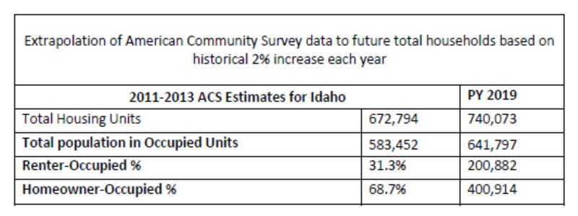

**Projected Rental and Homeowner Occupied Units**

Number of Households Table

|  | 0-30% HAMFI | >30-50% HAMFI | >50-80% HAMFI | >80-100% HAMFI | >100% HAMFI | |
| --- | --- | --- | --- | --- | --- | --- |
| Total Households * | 52,545 | 64,795 | 100,665 | 62,410 | 295,080 | |
| Small Family Households * | 17,265 | 19,340 | 37,305 | 25,565 | 158,345 | |
| Large Family Households * | 4,265 | 6,325 | 12,095 | 8,555 | 32,235 | |
| Household contains at least one person 62-74 years of age | 7,000 | 11,555 | 18,425 | 11,330 | 54,570 | |
| Household contains at least one person age 75 or older | 6,060 | 12,955 | 13,855 | 6,505 | 18,895 | |
| Households with one or more children 6 years old or younger * | 11,150 | 13,395 | 23,325 | 13,900 | 38,895 | |
| * the highest income category for family type is >80% HAMFI | | | | | |

Table 6 - Total Households Table

|  |  |
| --- | --- |
| Data Source: | 2007-2011 CHAS |

| Housing Needs Summary Tables1. Housing Problems (Households with one of the listed needs) | Renter | | | | | Owner | | | | |
| --- | --- | --- | --- | --- | --- | --- | --- | --- | --- | --- |
| 0-30% AMI | >30-50% AMI | >50-80% AMI | >80-100% AMI | Total | 0-30% AMI | >30-50% AMI | >50-80% AMI | >80-100% AMI | Total |
| NUMBER OF HOUSEHOLDS | | | | | | | | | | |
| Substandard Housing - Lacking complete plumbing or kitchen facilities | 930 | 860 | 565 | 350 | 2,705 | 610 | 420 | 465 | 310 | 1,805 |
| Severely Overcrowded - With >1.51 people per room (and complete kitchen and plumbing) | 375 | 490 | 680 | 125 | 1,670 | 195 | 185 | 190 | 105 | 675 |
| Overcrowded - With 1.01-1.5 people per room (and none of the above problems) | 1,515 | 1,285 | 1,860 | 840 | 5,500 | 575 | 560 | 1,690 | 1,170 | 3,995 |
| Housing cost burden greater than 50% of income (and none of the above problems) | 19,895 | 9,070 | 1,530 | 110 | 30,605 | 11,375 | 10,025 | 10,550 | 3,215 | 35,165 |
| Housing cost burden greater than 30% of income (and none of the above problems) | 3,085 | 13,320 | 15,045 | 2,525 | 33,975 | 2,645 | 6,995 | 16,725 | 12,035 | 38,400 |
| Zero/negative Income (and none of the above problems) | 2,190 | 0 | 0 | 0 | 2,190 | 2,370 | 0 | 0 | 0 | 2,370 |

Table 7 – Housing Problems Table

|  |  |
| --- | --- |
| Data Source: | 2007-2011 CHAS |

| 2. Housing Problems 2 (Households with one or more Severe Housing Problems: Lacks kitchen or complete plumbing, severe overcrowding, severe cost burden) | Renter | | | | | Owner | | | | |
| --- | --- | --- | --- | --- | --- | --- | --- | --- | --- | --- |
| 0-30% AMI | >30-50% AMI | >50-80% AMI | >80-100% AMI | Total | 0-30% AMI | >30-50% AMI | >50-80% AMI | >80-100% AMI | Total |
| NUMBER OF HOUSEHOLDS | | | | | | | | | | |
| Having 1 or more of four housing problems | 45,430 | 23,400 | 9,270 | 2,850 | 80,950 | 25,520 | 22,380 | 25,790 | 9,600 | 83,290 |
| Having none of four housing problems | 14,630 | 41,820 | 70,470 | 34,170 | 161,090 | 10,400 | 41,990 | 95,800 | 78,210 | 226,400 |
| Household has negative income, but none of the other housing problems | 4,380 | 0 | 0 | 0 | 4,380 | 4,740 | 0 | 0 | 0 | 4,740 |

Table 8 – Housing Problems 2

|  |
| --- |
| Alternate Data Source Name: |
| Renter and homeowner data past, present and future | |

**3. Cost Burden > 30%**

|  | **Renter** | | | | **Owner** | | | |
| --- | --- | --- | --- | --- | --- | --- | --- | --- |
| 0-30% AMI | >30-50% AMI | >50-80% AMI | Total | 0-30% AMI | >30-50% AMI | >50-80% AMI | Total |
| NUMBER OF HOUSEHOLDS | | | | | | | | |
| Small Related | 9,670 | 9,020 | 7,265 | 25,955 | 4,105 | 5,655 | 12,030 | 21,790 |
| Large Related | 2,095 | 2,355 | 1,675 | 6,125 | 1,590 | 2,035 | 4,215 | 7,840 |
| Elderly | 2,920 | 4,140 | 2,585 | 9,645 | 5,340 | 6,715 | 6,760 | 18,815 |
| Other | 10,495 | 8,515 | 5,850 | 24,860 | 3,910 | 3,050 | 5,045 | 12,005 |
| Total need by income | 25,180 | 24,030 | 17,375 | 66,585 | 14,945 | 17,455 | 28,050 | 60,450 |

Table 9 – Cost Burden > 30%

|  |  |
| --- | --- |
| Data Source: | 2007-2011 CHAS |

**4. Cost Burden > 50%**

|  | Renter | | | | Owner | | | |
| --- | --- | --- | --- | --- | --- | --- | --- | --- |
| 0-30% AMI | >30-50% AMI | >50-80% AMI | Total | 0-30% AMI | >30-50% AMI | >50-80% AMI | Total |
| NUMBER OF HOUSEHOLDS | | | | | | | | |
| Small Related | 8,505 | 3,505 | 660 | 12,670 | 3,755 | 3,540 | 4,460 | 11,755 |
| Large Related | 1,880 | 620 | 40 | 2,540 | 1,460 | 1,125 | 1,165 | 3,750 |
| Elderly | 2,170 | 1,880 | 670 | 4,720 | 3,750 | 3,385 | 2,815 | 9,950 |
| Other | 9,135 | 3,585 | 475 | 13,195 | 3,160 | 2,150 | 2,270 | 7,580 |
| Total need by income | 21,690 | 9,590 | 1,845 | 33,125 | 12,125 | 10,200 | 10,710 | 33,035 |

Table 10 – Cost Burden > 50%

|  |  |
| --- | --- |
| Data Source: | 2007-2011 CHAS |

**5. Crowding (More than one person per room)**

|  | Renter | | | | | Owner | | | | |
| --- | --- | --- | --- | --- | --- | --- | --- | --- | --- | --- |
| 0-30% AMI | >30-50% AMI | >50-80% AMI | >80-100% AMI | Total | 0-30% AMI | >30-50% AMI | >50-80% AMI | >80-100% AMI | Total |
| NUMBER OF HOUSEHOLDS | | | | | | | | | | |
| Single family households | 1,715 | 1,485 | 1,895 | 775 | 5,870 | 635 | 665 | 1,630 | 1,020 | 3,950 |
| Multiple, unrelated family households | 119 | 165 | 225 | 160 | 669 | 135 | 80 | 250 | 270 | 735 |
| Other, non-family households | 135 | 210 | 440 | 130 | 915 | 15 | 0 | 20 | 10 | 45 |
| Total need by income | 1,969 | 1,860 | 2,560 | 1,065 | 7,454 | 785 | 745 | 1,900 | 1,300 | 4,730 |

Table 11 – Crowding Information – 1/2

|  |  |
| --- | --- |
| Data Source: | 2007-2011 CHAS |

|  | Renter | | | | Owner | | | |
| --- | --- | --- | --- | --- | --- | --- | --- | --- |
| 0-30% AMI | >30-50% AMI | >50-80% AMI | Total | 0-30% AMI | >30-50% AMI | >50-80% AMI | Total |
| Households with Children Present | 0 | 0 | 0 | 0 | 0 | 0 | 0 | 0 |

Table 12 – Crowding Information – 2/2

**Describe the number and type of single person households in need of housing assistance.**

According to the 2009-2013 five-year American Community Survey (ACS), 23.9 percent of Idaho households are made up of people living alone. This equates to 138,600 single person households. Of these, about 9 percent are elderly residents living alone.

Data on the proportion of these residents with housing needs is not directly available from the Census or HUD. However, poverty can be used as a proxy for housing need.  Applying the poverty rates of elderly residents and non-elderly residents to the number of single households by age produces an estimated 17,500 single person households with housing needs.

During the next five years, if single people in Idaho grow at the same as the state’s population overall has grown in the past 10 years, an estimated 19,000 single person households will have needs in 2020.

For elderly households, twice as many owners are cost burdened than renters. In contrast, “other” households are more likely to  be rent burdened.

The stakeholders interviewed for this study were asked about the extent of unmet housing needs by household type. Elderly—but not specifically single person households—was among the household categories in the 'unmet need' question.  18% of stakeholders identified 'elderly' as having some of the greatest unmet housing needs in Idaho. Stakeholders also tended to identify families, and not single person households, as the housing type with the greatest housing needs.

**Estimate the number and type of families in need of housing assistance who are disabled or victims of domestic violence, dating violence, sexual assault and stalking.**

An estimated 3,000 residents in Idaho are developmentally disabled, are 18 years and older.

Approximately 21,000 Idahoans are physically disabled, older than 18 and live in poverty. As many as 43,000 have ambulatory, self-care and/or independent living needs and live in poverty, suggesting that they have both housing and supportive service needs.

The Center for Disease Control (CDC) collects national data on lifetime prevalence of intimate partner violence (IPV) through the National Intimate Partner and Sexual Violence Survey (NISVS).[1][1] This ongoing, nationally representative survey collects information about the IPV experiences of English- or Spanish-speaking men and women age 18 years and older. The most recent survey data are as of 2010 and include state prevalence rates.

For Idaho women, the lifetime prevalence of rape, physical violence, and/or stalking by an intimate partner is 29 percent; for men, it is 33 percent. The CDC estimates there are as many as 166,000 women and 187,000 men in Idaho who have experienced some time of intimate partner related violence. The most common type of assault is physical.

The CDC also estimates that 3.6 percent of women and one percent of men who have experienced IPV have some type of housing need. This would put the number of women and men in Idaho who have experienced IPV at some point in their lives and had housing needs related to the event at nearly 6,000 women and 2,000 men.

Although the CDC has recently quantified the public costs of IPV, the studies have mostly focused on health care costs (e.g., medical visits, counseling, long term mental health support). The housing needs of Idahoans who have experienced IPV are unknown. In 2011, HUD released a memorandum discussing the housing challenges of IPV victims, which can include discrimination and immediate need for housing when threatened and/or living in an abusive situation.

The housing needs of special needs populations, including persons with disabilities and IPV victims, are discussed in the Needs Assessment Overview above.

**What are the most common housing problems?**

According to the housing problems tables above, the most common housing problem in Idaho is cost-burden (homeowners and renters paying more than  30% of gross household income in housing costs).  Of the more than 575,000 households in Idaho, 127,000 face cost burden and 65,000 are severely cost burdened (paying more than 50% of income in housing costs).

About 67,000 renters in the State of Idaho pay more than 30 percent of their household income in housing costs (“cost burden”). Nearly 33,000 pay more than 50 percent of their household incomes in housing costs (“severely cost burdened”). Severe cost burden mostly affects renters who earn less than 30 percent of the median family income (MFI)generally equivalent to poverty level. General cost burden is most prevalent among renters earning between 30 and 80 percent of MFI. Although these renters are paying more than what is affordable to them in housing costs, these costs are not as crippling as for poverty-level renters.

**Are any populations/household types more affected than others by these problems?**

Of those renters who are cost burdened and severely cost burdened, most live in small households (about 26, face cost burden and 13,000 face severe cost burden) or “other” arrangements (25,000 face cost burden and 13,000 face severe cost burden. These households are made up of roommates, non-family members, etc).

Owners most affected by housing cost burden are those living in small households, elderly households and, to a lesser extent, “other” households.

**Describe the characteristics and needs of Low-income individuals and families with children (especially extremely low-income) who are currently housed but are at imminent risk of either residing in shelters or becoming unsheltered 91.205(c)/91.305(c)). Also discuss the needs of formerly homeless families and individuals who are receiving rapid re-housing assistance and are nearing the termination of that assistance**

The most common characteristics of precariously housed individuals and families reported in Idaho’s 2012, 2013, and 2014 Point-in-time counts were unemployment, inability to find affordable housing, and divorce/family breakup as the most prevalent causes of housing instability.  These households were primarily headed by white females age 25-61.  The most common disabling condition reported was substance abuse, and the most common sub-population was victims of domestic violence.  Most reported they are currently living in housing that they owned or rented, and have been at that location for one year or longer.

Families and individuals receiving rapid re-housing assistance and nearing the termination of that assistance indicated a need for affordable rental housing and stable employment to effectively continue beyond the re-housing assistance.  Those nearing termination of assistance are connected with resources to identify affordable housing.  Data estimating the number of individuals nearing graduation from the program is not available as all projects may determine their own desired maximum timeframes.

Once learning of the successfulness of rapid re-housing, and the improved efficiencies offered under the employ of this housing type, IHFA re-allocated funds to four rapid re-housing projects across Idaho.  This shift in strategy will greatly impact families who are in need of placement out of shelter environments and have the ability to rebound into a stable financial and living environment.

**If a jurisdiction provides estimates of the at-risk population(s), it should also include a description of the operational definition of the at-risk group and the methodology used to generate the estimates:** **N/A**

**Specify particular housing characteristics that have been linked with instability and an increased risk of homelessness**

Idaho’s 2012, 2013, and 2014 Point-in-Time Count report the top six causes identified by survey respondents for their precarious housing situations as: 1) unemployment, 2) inability to find affordable housing, 3) divorce/family separation, 4) eviction, 5) substance abuse, and 6) lack of education/job skills.  These declarations assist ESG, COC, and HOPWA program administrators in educating and encouraging housing and service providers to focus efforts on reducing these barriers.

The causes of homelessness identified point towards a need for discussion around strategic shifts in funding and program focus.  Innovative, and now proven, models such as Rapid Re-Housing and Housing First demonstrate an increased ability to successfully improve an individual or family’s chance of stabilizing life circumstances and becoming permanently and stably housed.  IHFA has committed time and resources towards evaluating successful projects throughout the United States during the 2015 calendar year.  The intent being, the BOS COC and IHFA will have the knowledge and information necessary to consider promoting and developing such models throughout Idaho.  This effort is already coming to fruition in the three small Housing First projects and four new Rapid Re-housing projects recently added within the BOS COC.

Increased collaboration and partnering opportunities, which may arise from the Housing and Healthcare Planning Session scheduled for May, 2015, will be of extreme importance and focus for IHFA and the BOS COC through 2015 and 2016.  Resource pairing and leverage associated with newly developed or currently existing permanent supportive housing is a crucial tool in preventing and reducing homelessness.

## NA-15 Disproportionately Greater Need: Housing Problems - 91.305 (b)(2)

**Assess the need of any racial or ethnic group that has disproportionately greater need in comparison to the needs of that category of need as a whole.**

**Introduction**

A disproportionately greater need exists when the percentage of persons in a category  of need who are members of a particular racial or ethnic group is 10 percentage points  or higher than the percentage of persons in category as a whole.

**0%-30% of Area Median Income**

| Housing Problems | Has one or more of four housing problems | Has none of the four housing problems | Household has no/negative income, but none of the other housing problems |
| --- | --- | --- | --- |
| Jurisdiction as a whole | 43,608 | 8,582 | 4,042 |
| White | 35,609 | 7,259 | 3,109 |
| Black / African American | 332 | 4 | 75 |
| Asian | 552 | 40 | 117 |
| American Indian, Alaska Native | 845 | 161 | 59 |
| Pacific Islander | 14 | 55 | 4 |
| Hispanic | 5,064 | 946 | 617 |

Table 13 - Disproportionally Greater Need 0 - 30% AMI

|  |  |
| --- | --- |
| Data Source: | 2007-2011 CHAS |

*The four housing problems are:

1. Lacks complete kitchen facilities, 2. Lacks complete plumbing facilities, 3. More than one person per room, 4. Cost Burden greater than 30%

**30%-50% of Area Median Income**

| Housing Problems | Has one or more of four housing problems | Has none of the four housing problems | Household has no/negative income, but none of the other housing problems |
| --- | --- | --- | --- |
| Jurisdiction as a whole | 41,722 | 23,613 | 0 |
| White | 35,883 | 20,715 | 0 |
| Black / African American | 274 | 30 | 0 |
| Asian | 227 | 173 | 0 |
| American Indian, Alaska Native | 466 | 214 | 0 |
| Pacific Islander | 10 | 15 | 0 |
| Hispanic | 4,171 | 2,244 | 0 |

Table 14 - Disproportionally Greater Need 30 - 50% AMI

*The four housing problems are:

1. Lacks complete kitchen facilities, 2. Lacks complete plumbing facilities, 3. More than one person per room, 4. Cost Burden greater than 30%

**50%-80% of Area Median Income**

| Housing Problems | Has one or more of four housing problems | Has none of the four housing problems | Household has no/negative income, but none of the other housing problems |
| --- | --- | --- | --- |
| Jurisdiction as a whole | 44,541 | 60,011 | 0 |
| White | 38,449 | 51,510 | 0 |
| Black / African American | 239 | 135 | 0 |
| Asian | 561 | 411 | 0 |
| American Indian, Alaska Native | 348 | 618 | 0 |
| Pacific Islander | 30 | 0 | 0 |
| Hispanic | 4,425 | 6,280 | 0 |

Table 15 - Disproportionally Greater Need 50 - 80% AMI

|  |  |
| --- | --- |
| Data Source: | 2007-2011 CHAS |

*The four housing problems are:

1. Lacks complete kitchen facilities, 2. Lacks complete plumbing facilities, 3. More than one person per room, 4. Cost Burden greater than 30%

**80%-100% of Area Median Income**

| Housing Problems | Has one or more of four housing problems | Has none of the four housing problems | Household has no/negative income, but none of the other housing problems |
| --- | --- | --- | --- |
| Jurisdiction as a whole | 17,111 | 46,647 | 0 |
| White | 15,356 | 41,837 | 0 |
| Black / African American | 45 | 118 | 0 |
| Asian | 289 | 267 | 0 |
| American Indian, Alaska Native | 59 | 464 | 0 |
| Pacific Islander | 50 | 14 | 0 |
| Hispanic | 1,081 | 3,257 | 0 |

Table 16 - Disproportionally Greater Need 80 - 100% AMI

|  |  |
| --- | --- |
| Data Source: | 2007-2011 CHAS |

*The four housing problems are:

1. Lacks complete kitchen facilities, 2. Lacks complete plumbing facilities, 3. More than one person per room, 4. Cost Burden greater than 30%

Discussion

0%-30% AMI *Hispanic* is identified as a category with a disproportionately greater percentage of housing problems than the percentage of persons in this category as a whole.

## NA-20 Disproportionately Greater Need: Severe Housing Problems –91.305(b)(2)

Assess the need of any racial or ethnic group that has disproportionately greater need in comparison to the needs of that category of need as a whole.

Introduction

While the number of households with severe housing problems decreases as household income rises, the percentage of households with a severe housing problem remains fairly constant across all HUD income categories. The *2013 U.S. Census Estimates*indicates the race category "*White alone, not Hispanic or Latino*" makes up 83.1% of Idaho's total population, while "Hispanic (or Latino)" makes up 11.8% of Idaho's total population. These percentages are provided for comparison purposes when reviewing the race/ethnicity populations who have a severe housing  problem.

0%-30% of Area Median Income

| Severe Housing Problems* | Has one or more of four housing problems | Has none of the four housing problems | Household has no/negative income, but none of the other housing problems |
| --- | --- | --- | --- |
| Jurisdiction as a whole | 35,719 | 16,405 | 4,042 |
| White | 28,972 | 13,860 | 3,109 |
| Black / African American | 262 | 74 | 75 |
| Asian | 518 | 73 | 117 |
| American Indian, Alaska Native | 669 | 330 | 59 |
| Pacific Islander | 14 | 55 | 4 |
| Hispanic | 4,241 | 1,762 | 617 |

Table 17 – Severe Housing Problems 0 - 30% AMI

|  |  |
| --- | --- |
| Data Source: | 2007-2011 CHAS |

*The four severe housing problems are:

1. Lacks complete kitchen facilities, 2. Lacks complete plumbing facilities, 3. More than 1.5 persons per room, 4. Cost Burden over 50%

American Fact Finder 2013 Estimates

Idaho 588,490 occupied housing units: 0.6% lack plumbing facilities, 1.5% lack kitchen facilities, and 2.9% have no telephone service available. 50.3% are heated with utility gas, 33.4% with electricity, 7.9% with wood, and 1.7% with fuel oil, and kerosene. Remaining units are heating with solar, coal or coke, other fuel, and no fuel used.  97% of Idaho's housing units have 1 occupant or less per room.

30%-50% of Area Median Income

| Severe Housing Problems* | Has one or more of four housing problems | Has none of the four housing problems | Household has no/negative income, but none of the other housing problems |
| --- | --- | --- | --- |
| Jurisdiction as a whole | 19,030 | 46,298 | 0 |
| White | 16,127 | 40,447 | 0 |
| Black / African American | 155 | 149 | 0 |
| Asian | 94 | 311 | 0 |
| American Indian, Alaska Native | 320 | 357 | 0 |
| Pacific Islander | 0 | 25 | 0 |
| Hispanic | 2,012 | 4,443 | 0 |

Table 18 – Severe Housing Problems 30 - 50% AMI

|  |  |
| --- | --- |
| Data Source: | 2007-2011 CHAS |

*The four severe housing problems are:

1. Lacks complete kitchen facilities, 2. Lacks complete plumbing facilities, 3. More than 1.5 persons per room, 4. Cost Burden over 50%

50%-80% of Area Median Income

| Severe Housing Problems* | Has one or more of four housing problems | Has none of the four housing problems | Household has no/negative income, but none of the other housing problems |
| --- | --- | --- | --- |
| Jurisdiction as a whole | 13,540 | 90,961 | 0 |
| White | 10,872 | 79,057 | 0 |
| Black / African American | 130 | 244 | 0 |
| Asian | 209 | 774 | 0 |
| American Indian, Alaska Native | 120 | 848 | 0 |
| Pacific Islander | 18 | 12 | 0 |
| Hispanic | 2,062 | 8,652 | 0 |

Table 19 – Severe Housing Problems 50 - 80% AMI

|  |  |
| --- | --- |
| Data Source: | 2007-2011 CHAS |

*The four severe housing problems are:

1. Lacks complete kitchen facilities, 2. Lacks complete plumbing facilities, 3. More than 1.5 persons per room, 4. Cost Burden over 50%

80%-100% of Area Median Income

| Severe Housing Problems* | Has one or more of four housing problems | Has none of the four housing problems | Household has no/negative income, but none of the other housing problems |
| --- | --- | --- | --- |
| Jurisdiction as a whole | 4,526 | 59,242 | 0 |
| White | 3,738 | 53,485 | 0 |
| Black / African American | 25 | 138 | 0 |
| Asian | 94 | 463 | 0 |
| American Indian, Alaska Native | 23 | 500 | 0 |
| Pacific Islander | 50 | 14 | 0 |
| Hispanic | 510 | 3,830 | 0 |

Table 20 – Severe Housing Problems 80 - 100% AMI

|  |  |
| --- | --- |
| Data Source: | 2007-2011 CHAS |

*The four severe housing problems are:

1. Lacks complete kitchen facilities, 2. Lacks complete plumbing facilities, 3. More than 1.5 persons per room, 4. Cost Burden over 50%

Discussion

Idaho's Hispanic(or Latino) population has a disproportionately higher percentage of households with housing problems than other race/ethnicity income categories in all AMI groups 0%-30%(11%), 30-50% AMI(Hispanic 11%) and the 50-80% AMI(Hispanic 15%) and 80%-100% AMI(it is noted that the HOME program cannot serve this households with income ≥80% AMI). NA-25 Disproportionately

## Greater Need: Housing Cost Burdens – 91.305 (b)(2)

Assess the need of any racial or ethnic group that has disproportionately greater need in comparison to the needs of that category of need as a whole.

Introduction

Cost-burdened is defined as a household whose mortgage or rent is 30% or more of the household income. In 2013, the US Census indicates 28% of homeowners and 49% of renters in Idaho are defined as Cost-burdened. This translates to 111,360 homeowners, and 77,552 renters.

Housing Cost Burden

| Housing Cost Burden | <=30% | 30-50% | >50% | No / negative income (not computed) |
| --- | --- | --- | --- | --- |
| Jurisdiction as a whole | 387,273 | 96,797 | 64,406 | 4,296 |
| White | 349,613 | 85,887 | 55,372 | 3,318 |
| Black / African American | 1,108 | 358 | 537 | 75 |
| Asian | 3,205 | 962 | 757 | 127 |
| American Indian, Alaska Native | 3,163 | 718 | 964 | 84 |
| Pacific Islander | 416 | 42 | 14 | 4 |
| Hispanic | 25,355 | 7,575 | 5,225 | 617 |

Table 21 – Greater Need: Housing Cost Burdens AMI

|  |  |
| --- | --- |
| Data Source: | 2007-2011 CHAS |

Discussion

Based on the HUD definition of "disproportionately greater need", no non-white race/ethnic categories meet the definition of disproportionately greater need in these income categories. "Hispanic" was the closest, with percentages of 8%, 7%, and 8%.

## NA-30 Disproportionately Greater Need: Discussion – 91.305 (b)(2)

Are there any Income categories in which a racial or ethnic group has disproportionately greater need than the needs of that income category as a whole?

This section describes the population categories with disproportionate needs, based on the tables above. Disproportionate need occurs when a population category has a rate of housing problems that is at least 10 percentage points higher than the jurisdiction overall or predominant population category.

Disproportionate need in *housing problems* occurs for:

* African Americans at all income categories less than 80 percent of AMI
* Asians and Pacific Islanders at 50-80 percent and 80-100 percent of AMI.

Disproportionate need in severe housing problems occurs for:

* Asians earning less than 30 percent AMI,
* African Americans and American Indians earning 30 to 50 percent AMI,
* African Americans and Pacific Islanders earning 50 to 80 percent AMI, and
* Pacific Islanders at 80-100 percent of AMI.
* Disproportionate need in *cost burden* occurs for:
* Pacific Islanders earning less than 30 percent AMI, and
* African Americans earning more than 50 percent AMI.

If they have needs not identified above, what are those needs?

Persons of Hispanic descent—who tend to have larger families and have lower incomes than Non-Hispanic residents—need larger rental units and homes that are also affordable. These can be very difficult to find in markets where housing supply is limited and housing is expensive.

Are any of those racial or ethnic groups located in specific areas or neighborhoods in your community?

Not applicable to a state jurisdiction.

## 

## NA-35 Public Housing – (Optional)

Introduction

The Totals in Use numbers provided below by HUD below illustrate the Vouchers and Public Housing administered by IHFA. According to HUD reports on Public Housing Authorities (PHAs), there are 825 Public Housing units administered by PHAs statewide. Idaho currently has 6,493 households that receive a Section 8 Tenant Based Rental Assistance Voucher(Housing Choice).

Idaho Housing and Finance Association administers the Section 8 Housing Choice Voucher program in 34 of 44 counties and encourages public housing programs statewide. IHFA is only one in a statewide network of public housing providers. IHFA does not oversee any citywide or countywide Participating Jurisdictions (PJs) for public housing. These jurisdictions have local official governing boards responsible to appoint the board of a Public Housing Authority (PHA) and direct PHA activities. The State of Idaho does not own any public housing.

**Totals in Use**

| Program Type | | | | | | | | | |
| --- | --- | --- | --- | --- | --- | --- | --- | --- | --- |
|  | Certificate | Mod-Rehab | Public Housing | Vouchers | | | | | |
| Total | Project -based | Tenant -based | Special Purpose Voucher | | |
| Veterans Affairs Supportive Housing | Family Unification Program | Disabled  * |
| # of units vouchers in use | 0 | 0 | 75 | 3,241 | 0 | 2,984 | 19 | 9 | 196 |

Table 22 - Public Housing by Program Type*includes Non-Elderly Disabled, Mainstream One-Year, Mainstream Five-year, and Nursing Home Transition

|  |  |
| --- | --- |
| Data Source: | PIC (PIH Information Center) |

**Characteristics of Residents**

| Program Type | | | | | | | | |
| --- | --- | --- | --- | --- | --- | --- | --- | --- |
|  | Certificate | Mod-Rehab | Public Housing | Vouchers | | | | |
| Total | Project -based | Tenant -based | Special Purpose Voucher | |
| Veterans Affairs Supportive Housing | Family Unification Program |
| # Homeless at admission | 0 | 0 | 0 | 31 | 0 | 31 | 0 | 0 |
| # of Elderly Program Participants (>62) | 0 | 0 | 16 | 563 | 0 | 546 | 2 | 0 |
| # of Disabled Families | 0 | 0 | 36 | 1,540 | 0 | 1,324 | 10 | 4 |
| # of Families requesting accessibility features | 0 | 0 | 75 | 3,241 | 0 | 2,984 | 19 | 9 |
| # of HIV/AIDS program participants | 0 | 0 | 0 | 0 | 0 | 0 | 0 | 0 |
| # of DV victims | 0 | 0 | 0 | 0 | 0 | 0 | 0 | 0 |

Table 23 – Characteristics of Public Housing Residents by Program Type

|  |  |
| --- | --- |
| Data Source: | PIC (PIH Information Center) |

**Race of Residents**

| Program Type | | | | | | | | | | |
| --- | --- | --- | --- | --- | --- | --- | --- | --- | --- | --- |
| Race | Certificate | Mod-Rehab | Public Housing | Vouchers | | | | | | |
| Total | Project -based | Tenant -based | Special Purpose Voucher | | | |
| Veterans Affairs Supportive Housing | Family Unification Program | Disabled  * | |
| White | 0 | 0 | 73 | 3,129 | 0 | 2,876 | 19 | 9 | 192 | |
| Black/African American | 0 | 0 | 1 | 28 | 0 | 27 | 0 | 0 | 1 | |
| Asian | 0 | 0 | 1 | 3 | 0 | 3 | 0 | 0 | 0 | |
| American Indian/Alaska Native | 0 | 0 | 0 | 74 | 0 | 72 | 0 | 0 | 2 | |
| Pacific Islander | 0 | 0 | 0 | 7 | 0 | 6 | 0 | 0 | 1 | |
| Other | 0 | 0 | 0 | 0 | 0 | 0 | 0 | 0 | 0 | |
| *includes Non-Elderly Disabled, Mainstream One-Year, Mainstream Five-year, and Nursing Home Transition | | | | | | | | | |

Table 24 – Race of Public Housing Residents by Program Type

|  |  |
| --- | --- |
| Data Source: | PIC (PIH Information Center) |

**Ethnicity of Residents**

| Program Type | | | | | | | | | | |
| --- | --- | --- | --- | --- | --- | --- | --- | --- | --- | --- |
| Ethnicity | Certificate | Mod-Rehab | Public Housing | Vouchers | | | | | | |
| Total | Project -based | Tenant -based | Special Purpose Voucher | | | |
| Veterans Affairs Supportive Housing | Family Unification Program | Disabled  * | |
| Hispanic | 0 | 0 | 6 | 214 | 0 | 197 | 1 | 1 | 12 | |
| Not Hispanic | 0 | 0 | 69 | 3,027 | 0 | 2,787 | 18 | 8 | 184 | |
| *includes Non-Elderly Disabled, Mainstream One-Year, Mainstream Five-year, and Nursing Home Transition | | | | | | | | | |

Table 25 – Ethnicity of Public Housing Residents by Program Type

|  |  |
| --- | --- |
| Data Source: | PIC (PIH Information Center) |

**Section 504 Needs Assessment: Describe the needs of public housing tenants and applicants on the waiting list for accessible units:**

The State of Idaho does not own or manage any public housing units

**What are the number and type of families on the waiting lists for public housing and section 8 tenant-based rental assistance? Based on the information above, and any other information available to the jurisdiction, what are the most immediate needs of residents of public housing and Housing Choice voucher holders?**

IHFA branch offices maintain data on waitlists by family type, race, ethnicity and disability.  The table located in the Unique Appendices shows the numbers and types of families on the waitlists for tenant based rental assistance.

See Unique Appendices

PHA Plans for local units of government with their own PHAs were consulted for additional waitlist information.  These Plans were dedicated in large part to capital improvement needs and did not contain data on wait lists.

**How do these needs compare to the housing needs of the population at large**

People with disabilities are over-represented in the waitlists for Housing Choice Vouchers. These individuals are often single seniors living on very low fixed incomes who cannot afford market rate housing, particularly in Idaho’s smaller communities and rural areas, where housing is limited.

## NA-40 Homeless Needs Assessment – 91.305(c)

**Introduction:**

The following tables contain information derived from Idaho’s annual Point In Time count and Homeless Management Information System (HMIS).  Idaho’s homelessness issues are exacerbated by the rural make up of the state and the severe funding limitations experienced by any low population state.

**Homeless Needs Assessment**

|  | | | | | | |
| --- | --- | --- | --- | --- | --- | --- |
| Population | Estimate the # of persons experiencing homelessness on a given night | | Estimate the # experiencing homelessness each year | Estimate the # becoming homeless each year | Estimate the # exiting homelessness each year | Estimate the # of days persons experience homelessness |
|  | Sheltered | Unsheltered |  |  |  |  |
| Persons in Households with Adult(s) and Child(ren) | 247 | 446 | 1,251 | 453 | 578 | 107 |
| Persons in Households with Only Children | 0 | 1 | 0 | 0 | 0 | 0 |
| Persons in Households with Only Adults | 343 | 314 | 1,664 | 535 | 855 | 54 |
| Chronically Homeless Individuals | 79 | 30 | 300 | 68 | 156 | 53 |
| Chronically Homeless Families | 49 | 4 | 263 | 48 | 125 | 99 |
| Veterans | 73 | 51 | 271 | 84 | 117 | 108 |
| Unaccompanied Child | 0 | 0 | 200 | 187 | 237 | 0 |
| Persons with HIV | 0 | 0 | 0 | 0 | 0 | 0 |

Table 26 - Homeless Needs Assessment

|  |  |  |
| --- | --- | --- |
| Data Source Comments: | The data contained in the Homeless Needs Table is limited to the information collected and stored within Idaho's HMIS. This data includes both emergency shelter and transitional housing projects, but excludes permanent housing, including rapid re-housing and victim service providers. | |
| Indicate if the homeless population is: | | Partially Rural Homeless |

### 

**Rural Homeless Needs Assessment**

|  | | | | | | |
| --- | --- | --- | --- | --- | --- | --- |
| Population | Estimate the # of persons experiencing homelessness on a given night | | Estimate the # experiencing homelessness each year | Estimate the # becoming homeless each year | Estimate the # exiting homelessness each year | Estimate the # of days persons experience homelessness |
|  | Sheltered | Unsheltered |  |  |  |  |
| Persons in Households with Adult(s) and Child(ren) | 0 | 0 | 0 | 0 | 0 | 0 |
| Persons in Households with Only Children | 0 | 0 | 0 | 0 | 0 | 0 |
| Persons in Households with Only Adults | 0 | 0 | 0 | 0 | 0 | 0 |
| Chronically Homeless Individuals | 0 | 0 | 0 | 0 | 0 | 0 |
| Chronically Homeless Families | 0 | 0 | 0 | 0 | 0 | 0 |
| Veterans | 0 | 0 | 0 | 0 | 0 | 0 |
| Unaccompanied Youth | 0 | 0 | 0 | 0 | 0 | 0 |
| Persons with HIV | 0 | 0 | 0 | 0 | 0 | 0 |

Table 27 - Homeless Needs Assessment

|  |  |
| --- | --- |
| Data Source Comments: | The data contained in the Homeless Needs Table is limited to the information collected and stored within Idaho's HMIS. This data includes both emergency shelter and transitional housing projects, but excludes permanent housing, including rapid re-housing and victim service providers. |

**Domestic Violence by Race and Ethnicity**

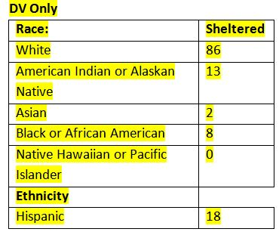

For persons in rural areas who are homeless or at risk of homelessness, describe the nature and extent of unsheltered and sheltered homelessness with the jurisdiction:

|  |
| --- |
| One measure of homelessness comes from Idaho’s annual Point In Time count, which is conducted on the last Wednesday of January each year.  The count is executed during a time when all individuals and families who are facing homelessness are utilizing any and all resources that may be available to them.  Thus, the statewide effort provides a minimum count of those that are homeless who are presumed to have exhausted resources previously available through support networks.  Of those counted, approximately thirty percent (30%) are unsheltered.  However, the average shelter bed-nights provided- of those agencies contributing data to HMIS- experienced an average bed utilization rate of fifty eight percent (58%) for the previous ESG reporting year.  This may demonstrate either a lack of awareness of, or access to, resources, or a desire to not utilize mainstream resources. |

**If data is not available for the categories "number of persons becoming and exiting homelessness each year," and "number of days that persons experience homelessness," describe these categories for each homeless population type (including chronically homeless individuals and families, families with children, veterans and their families, and unaccompanied youth):**

A large majority of Idaho consists of rural communities with small metropolitan areas widely spread throughout the state.  While the Homeless Needs Table consists of a statewide portrayal of homelessness, including both urban and rural statistics, the data is more reflective of rural homelessness than not.  Individual adults represent the largest group within the categories of becoming homeless and exiting homelessness, with households with adult and children coming in as a close second.  Both chronically homeless individuals and chronically homeless families are far behind the leading categories but comprise of similar representation in the becoming homeless and exiting homelessness categories.  Households with only youths are not represented in either category.

**Nature and Extent of Homelessness: (Optional)**

| Race: | Sheltered: | Unsheltered (optional) |
| --- | --- | --- |
| White | 1,162 | 759 |
| Black or African American | 72 | 50 |
| Asian | 10 | 6 |
| American Indian or Alaska Native | 75 | 12 |
| Pacific Islander | 4 | 5 |
| Ethnicity: | Sheltered: | Unsheltered (optional) |
| Hispanic | 114 | 71 |
| Not Hispanic | 0 | 0 |

**Estimate the number and type of families in need of housing assistance for families with children and the families of veterans.**

The data suggests that chronically homeless families are much more likely to be unsheltered than sheltered.  While non-chronically homeless families are more likely to be sheltered than not, Idaho still sees a proportionally high number of unsheltered families.  Of those veterans which are confirmed as being homeless, the majority are unsheltered, some of which may have children.

**Describe the Nature and Extent of Homelessness by Racial and Ethnic Group.**

The vast majority of homeless individuals, both sheltered and unsheltered, domestic violence victims and non-victims, are white/Caucasian.  Both American Indian or Alaskan Native and Black or African American have similar representation to each other; however, experienced counts far below the most predominant race.  While a minimum number of individuals declaring their ethnicity as being Hispanic is collected, Non-Hispanic is not a required response.  Due to unanswered responses, IHFA is unable to determine the exact ratio of Non-Hispanic to Hispanic that are either sheltered or unsheltered.  Furthermore, domestic violence information is collected separately and cannot report on the comparison of sheltered versus unsheltered or Hispanic versus Non-Hispanic.  The data reported are a minimum number of self-reporting individuals.

**Describe the Nature and Extent of Unsheltered and Sheltered Homelessness.**

All races and ethnicities report more sheltered individuals than unsheltered except in one race classification- Black or African American.  Yet, the difference in this one category is not heavily weighted on either side.  In most cases the number of sheltered individuals is at least one third higher than those that are unsheltered.  Overall, there are 37% more individuals sheltered than the alternative option of being unsheltered.

**Discussion:**

Some reporting limitations are present, which result from the elements of data collected and reported by homeless service providers.  Blacked out cells in the *Nature and Extent of Homeless Table* are an indication that the information has not been collected or cannot be verified as accurate, or if collected, carries severe limitations in its use or completeness.

## NA-45 Non-Homeless Special Needs Assessment – 91.305 (b,d)

**Describe the characteristics of special needs populations in your community:**

The housing and supportive service needs of residents in Idaho with special needs are estimated based on demographic information from the Census, including poverty rates, and national studies on housing and service needs.

As discussed in NA-10, an estimated 3,000 residents in Idaho are developmentally disabled, 18 years and older, and live in poverty. Approximately 21,000 Idahoans are physically disabled, older than 18 and live in poverty. As many as 43,000 have ambulatory, self-care and/or independent living needs and live in poverty. The 2012 Census’ American Community Survey estimates that 10,700 persons age 65 to 74 in Idaho lived below the poverty level in 2012. Idaho 2011 Profile of State OAA Programs indicates it has 19,736 registered clients, 22% live below the poverty line.

Based on data maintained by the Substance Abuse and Mental Health Services Administration (SAMHSA), an estimated 5,400 residents in Idaho have severe and persistent mental illnesses and are unemployed. 17,000 residents with mental illness live below the poverty line.

An estimated 25,000 Idahoans have substance abuse challenges and are unemployed; these individuals may need housing assistance. The supportive service needs of this population are large: More than 108,000 have substance abuse challenges and are not being treated.

An estimated 500 Idahoans could need housing and supportive services, based on data on the statewide prevalence of HIV/AIDS and the proportion of residents with HIV/AIDS needing housing assistance. Based on program participation, at least 215 households experiencing HIV/AIDS or mental illnesses require access to permanent supportive housing.

**What are the housing and supportive service needs of these populations and how are these needs determined?**

Approximately 21,000 Idahoans are physically disabled, older than 18 and live in poverty. As many as 43,000 have ambulatory, self-care and/or independent living needs and live in poverty, suggesting that they have both housing and supportive service needs.

The 2012 Census’ American Community Survey estimates that 10,700 seniors aged 65 to 74 in Idaho lived below the poverty level in 2012. These seniors may need housing assistance, ranging from repairs on homes they own to subsidized rental assistance. Another 9,300 seniors aged 75 and older lived in poverty and likely have both housing and supportive service needs.

Based on data maintained by the Substance Abuse and Mental Health Services Administration (SAMHSA), an estimated 5,400 residents in Idaho have severe and persistent mental illnesses and are unemployed. 17,000 residents with mental illness live below the poverty line. These residents may have limited access to health care to address their needs and are very likely to need both housing and social service supports.

An estimated 25,000 Idahoans have substance abuse challenges and are unemployed; these individuals may need housing assistance. The supportive service needs of this population are large: More than 108,000 have substance abuse challenges and are not being treated.

Discuss the size and characteristics of the population with HIV/AIDS and their families within the Eligible Metropolitan Statistical Area:

HOPWA program statistical data is the most accessible to the Idaho Housing and Finance Association, and therefore, for program administration purposes, the fairest representation of the population of those living with HIV/AIDS in Idaho.  In the most recently completely program year, there were over 200 participating households.  Of those, the age of the HOPWA eligible individual was:

1% were younger than 18

14% were 18-30

59% were 31-50

26% were 51 or older

The gender declared by the HOPWA eligible individual was:

77% identified as male,

23% as female,

0% as transgender. 

An overwhelming majority (84%) of HOPWA eligible individuals identified their race as white/Caucasian, and 90% as non-Hispanic/non-Latino HOPWA program, whether dispensed in the form of rental assistance, STMRU, or supportive services, exists in each region of the state.  Currently, the rental assistance waiting list holds approximately 65 applicant households.  The program also currently serves approximately 65 participating households.  Both the waiting list and program participant list contains an overwhelming majority of single individuals.  Of the current 65 participating households, only 4 are families.

IHFA has recently engaged in efforts designed to expand HOPWA service area coverage to ensure that services are accessible in all regions within the state, which has not been the case historically.

## NA-50 Non-Housing Community Development Needs - 91.315 (f)

Describe the jurisdiction’s need for Public Facilities:

Based on the local government needs survey, sequence 1, the top three public facility needs are parks and recreation facilities, community centers and youth centers.

How were these needs determined?

The needs of the state CDBGs’ jurisdictions (cities and counties) for public facilities, public improvements (infrastructure), services, and economic development activities is based on a number of variables. These variables include geographic locations, economic variables, population, governance philosophies, and the existing services provided by the city or county. In an attempt to understand Idaho cities and counties non-housing community development needs, IDC conducted a local government needs survey. The survey was sent out to 193 cities and 44 counties in August 2014. Of the 237 surveys sent out a total of 98 responded.

See below the survey results for the CDBG eligible activity groups.  Sequence No. 1.

Public participation was another method to determine need. A number of pre-draft written and hearing comments, appendix, identified that housing of homeless families and individuals was a very important need as well as ensuring the development of affordable housing. A high majority of comments received, favor the implementation of a “housing first” type program to assist the homeless population.

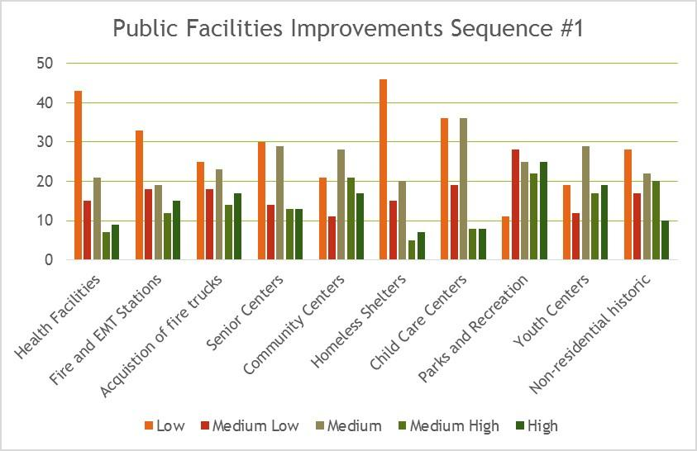  
Public Facilities

**Describe the jurisdiction’s need for Public Improvements:**

Based on the local government needs survey, See Sequence 2, the top three needs are street, water and sewer systems.

**How were these needs determined?**

IDC conducted a local government needs survey. The survey was sent out to 193 cities and 44 counties in August 2014. Of the 237 surveys sent out a total of 98 responded.

As side from the local government needs survey, another source, the American Society of Civil Engineers, 2012 Report Card for Idaho’s infrastructure was used to further assess non-housing community development needs. Specific to public infrastructure the following systems were graded as such.

Drinking water systems – grade = (C+) - repair and replacement of distribution lines is well below ideal rates.

Transit – grade = (D) – Transit in Idaho is safe and relatively efficient, but lacks the accessibility and funding to meet the needs.

Wastewater – grade = (B-) - Replacement and repair of collection pipelines is not keeping pace with the ageing infrastructure. Many wastewater system have not been video inspected in the last 10 years.

See below survey results for the CDBG eligible activity groups.  Sequence 2 through 6.  
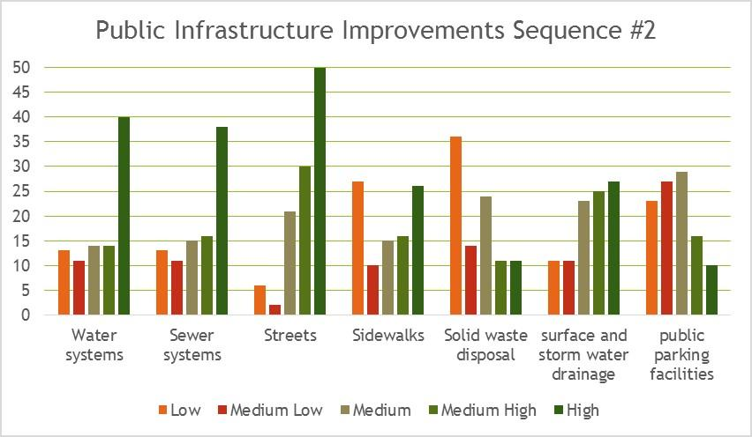  
Public Infrastructure

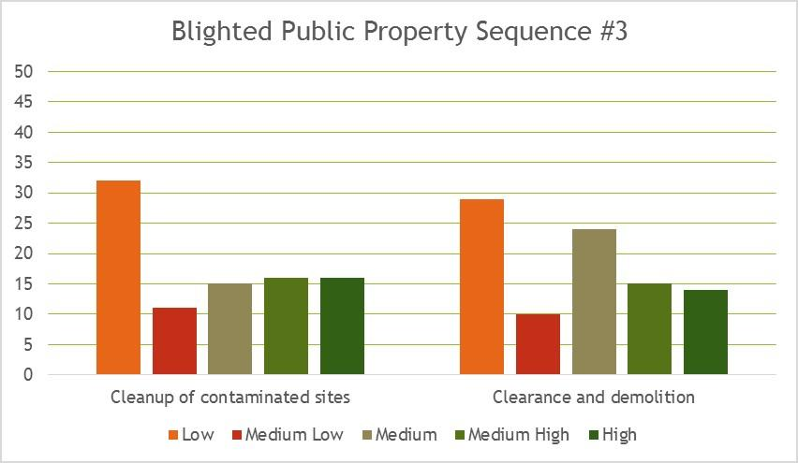  
Blighted Properties

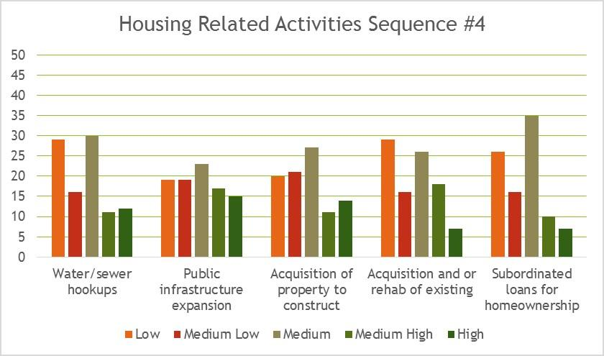  
Housing Related

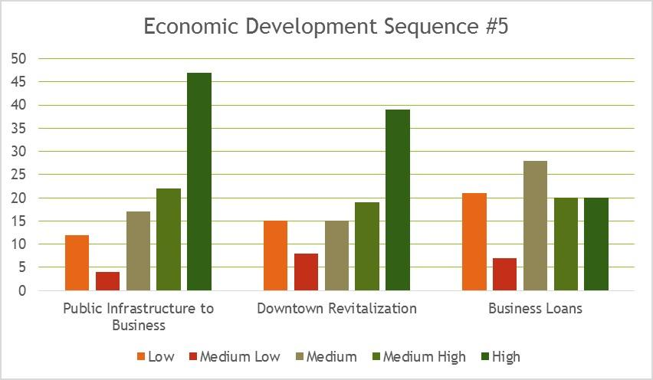  
Economic Development

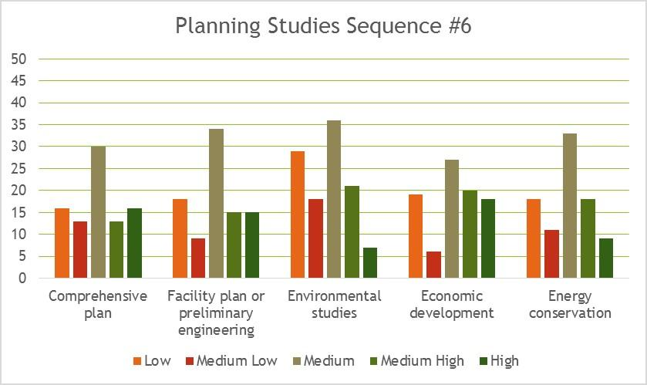  
Planning Studies

**Describe the jurisdiction’s need for Public Services:**

Based on the local government needs survey the top three public services, sequence 7, are for youth services, senior services and transportation services.

**How were these needs determined?**

IDC conducted a local government needs survey.  The survey was sent out to 193 cities and 44 counties in August 2014.  Of the 237 surveys sent out a total of 98 were received.

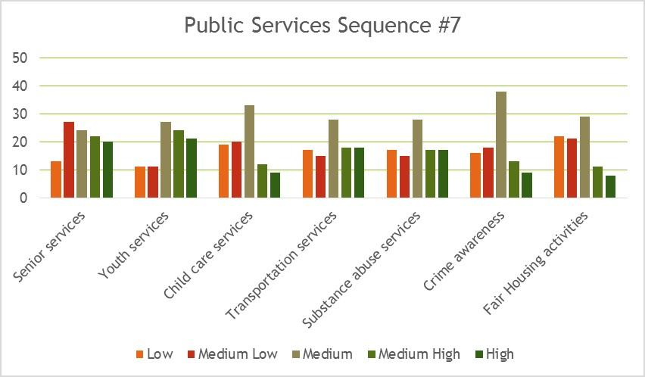  
Public Services

# Housing Market Analysis

## MA-05 Overview

**Housing Market Analysis Overview:**

This section summarizes key aspects of the State of Idaho’s housing market. The tables below are based on data provided by HUD for this eCon Plan; some are updated with newer Census data. Supplemental information on the state’s housing market by county is located in the Grantee Unique Appendices attached to this eCon Plan. This appendix shows key demographic and housing market characteristics for every county in the State of Idaho.

Overall, about three-quarters of the state’s housing units are single-family detached. Ten percent are mobile homes and the remainder are apartments, condos and duplexes. Counties with the lowest proportions of single family detached housing are generally those with expensive housing (e.g., Blaine County) or rural areas with high proportions of mobile homes (e.g., Power County, Lincoln County).

The Census estimates that 111,000 owners, or 28 percent of all homeowners in Idaho, pay more than 30 percent of their household income in housing costs and, as such, are “cost burdened.”  Nearly 78,000 renters, or 49 percent of all renters, are cost burdened.

Cost burdened owners and renters may need to cut back on other household goods to afford to pay their mortgage or rent. This can mean that they aren’t investing in the local economy (e.g., buying consumer goods, going to restaurants), investing in quality education (preschool, job training) and, for renters, saving for a home. Owner cost burden is highest in Blaine County (46%) and lowest in Clark County (just 4%). Renter cost burden is highest in Madison County (65%) and lowest in Clark County (4%).

A comparison between the average wage earned by workers in the state and new hires with median home prices and rental costs found that, in the state overall, the average worker would need to stretch to afford the median-priced home. The average worker—making about $3,100 per month—could afford a home priced at $164,000, a bit lower than the statewide median price of $167,000. This worker could afford to rent the median priced rental unit ($720/month).

The average new hire, however, could not afford to buy the median-priced home. With monthly earnings of just $2,000 per month, the average new hire would need a home priced at $105,000 or less.  This worker would even find renting the median-priced rental unit difficult on their wages: the median rent in the state is $720 per month compared to an affordable rent of $603 for the average new hire. It is likely that in most parts of the state, this worker would be rent burdened.

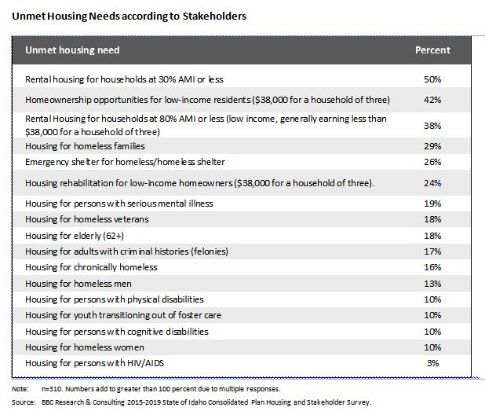

## MA-10 Number of Housing Units – 91.310(a)

Introduction

Single unit detached structures make up the majority of housing in Idaho's market. Larger multi-family rental units can be found in Idaho's relatively urban economic centers around the state, with fewer rental housing available in Idaho's more rural areas. Manufactured housing is the second largest type of housing in Idaho, especially in the rural areas. Unfortunately, these units depreciate in several areas fairly quickly, and are situated on leased/rented ground.

**All residential properties by number of units**

| Property Type | Number | % |
| --- | --- | --- |
| 1-unit detached structure | 328,573 | 75% |
| 1-unit, attached structure | 9,842 | 2% |
| 2-4 units | 24,990 | 6% |
| 5-19 units | 18,065 | 4% |
| 20 or more units | 7,631 | 2% |
| Mobile Home, boat, RV, van, etc | 50,028 | 11% |
| Total | 439,129 | 100% |

Table 28 – Residential Properties by Unit Number

**Unit Size by Tenure**

|  | Owners | | Renters | |
| --- | --- | --- | --- | --- |
| Number | % | Number | % |
| No bedroom | 2,038 | 0% | 7,320 | 5% |
| 1 bedroom | 15,569 | 4% | 42,905 | 29% |
| 2 bedrooms | 114,296 | 34% | 105,188 | 70% |
| 3 or more bedrooms | 540,200 | 161% | 113,651 | 96% |
| Total | 672,103 | 199% | 269,064 | 200% |

Table 29 – Unit Size by Tenure

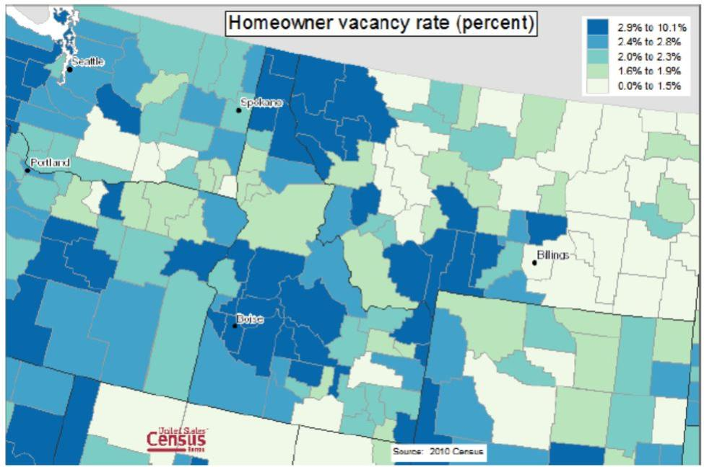  
Idaho Counties Homeowner Vacancy Rate

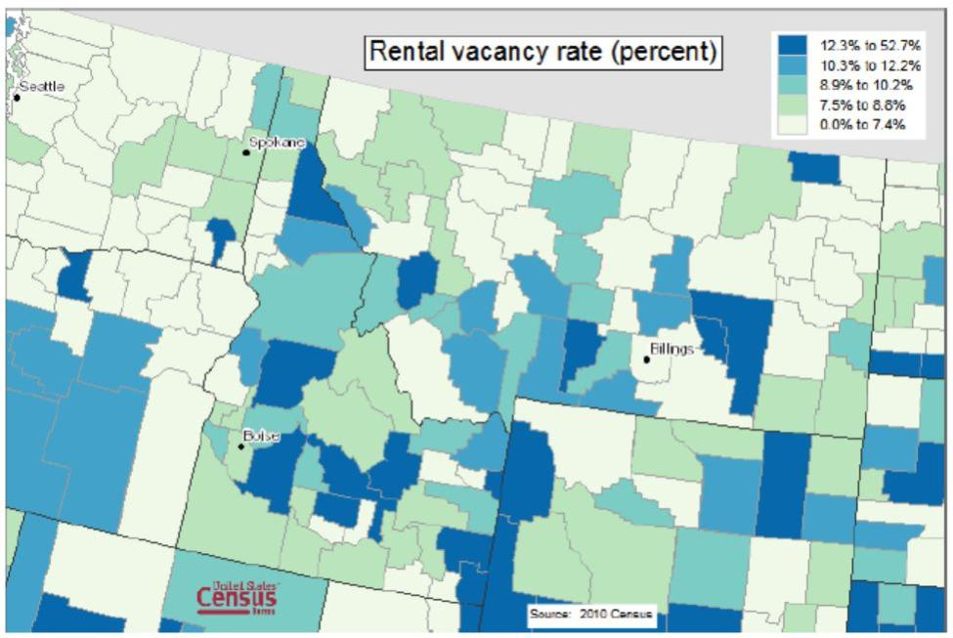  
Idaho Counties Rental Vacancy Rate

### 

**Units by Federal/State/Local- assisted Units**

**Describe the number and targeting (income level/type of family served) of units assisted with federal, state, and local programs.**

See uploaded image  as a JPEG for number of units by program and target population  
The HUD Multifamily Assistance and Section 8 Contracts Database shows the number of subsidized rental units in Section 8 project-based developments. The database was developed by HUD to provide a way of measuring the potential impact of expiring project-based subsidy contracts in cities and states (see below). According to HUD, the database represents one the most comprehensive picture of project-based subsidies available.

Forty-five percent of the units rent for more than 120 percent of the HUD Fair Market Rent (FMR). Another 30 percent rent between 100 and 120 percent. Twenty-three percent rent for less than 100 percent of the FMR.

Twenty-three percent of the units provide housing to low-income elderly, less than 3 percent are targeted to persons with disabilities. About 9 percent of the units are part of affordable rentals in rural areas.

Section 8 Housing Choice Voucher Program- IHFA is only one of a statewide network of public housing providers, and as such, does not oversee any city or countywide jurisdiction for public housing.

Most Low-Income Housing Tax Credit (LIHTC) rental units in Idaho are still in their LIHTC Period of Affordability or the LIHTC Extended Use Period. All units are ≤ 60% AMI. Approximately 50% of these units have a deeper skew, serving 30-50% AMI households.

USDA-RD- See table

The State of Idaho does not provide state fund for any type of housing.

**Provide an assessment of units expected to be lost from the affordable housing inventory for any reason, such as expiration of Section 8 contracts.**

The Multifamily Assistance and Section 8 Contracts Database identifies 1,297 units that have contracts expiring between 2014 and 2018. Of these units, 386 are affordable senior rentals and 103 provide affordable rentals to persons with disabilities. About one-quarter provide deep affordability, at less than 80 percent of the HUD defined FMR.   IHFA  does not anticipate losing any Section 8 HAP contract units over the next 5 years.

LIHTC does not anticipate the loss of any LIHTC units over the next 5 years.

IHFA's HOME program anticipates it could lose approximately 50 HOME-assisted units in the next 5 years because they have satisfied the HOME Period of Affordability requirements.

**Does the availability of housing units meet the needs of the population**?

Homeowner Vacancy- According to the 2010 U.S. Census 42 of Idaho's 44 counties had homeowner vacancy rates that ranged between 1.6 to 10.1%; two counties in southeast Idaho had homeowner vacancy rates that ranged from 0.0-1.5%.  Idaho's most northern counties had a higher homeowner vacancy rate, ranging from 2.9-10.1%. See attached Idaho Counties Homeowner Vacancy Rate.

Rental Vacancy rate- The 2010 U.S. Census indicates there is a wide range of vacancy rates in Idaho's 44 counties.  At the lowest end of the vacancy rate, nine counties have a 0-7.4% rental vacancy rate, at the highest, 8 counties have a vacancy rate % range of 12.3-52.7%. See attached Idaho Counties Rental Vacancy Rate.

Overall in the state, there is a shortage of affordable rental units or subsidies for renters earning less than $20,000 per year. The rental gaps are largest in the state’s most urban counties, where the numbers of low-income renters are the largest and housing costs are generally higher. Yet there are also very high proportions of low income renters in some rural counties. For example, 50 percent of renters in Butte County earn less than $20,000 per year; 69 percent earn less than $25,000. Similarly, 56 percent of renters in Oneida County (59% earn less than $25,000) and 50 percent of renters in Washington County earn less than $20,000 (56% earn less than $25,000).

Describe the need for specific types of housing:

The 2014 Idaho Statewide Housing Needs Survey indicates Idaho's highest unmet housing need affordable rental housing for households with incomes ≤30% AMI.  The survey also indicates there is an unmet housing need for affordable homeownership opportunities for low-income households ≤80% AMI, affordable rental housing for households ≤80% AMI, emergency shelter for the homeless, including homeless families with children.

The *2014 Idaho County-by-County Demographic, Housing, and Transportation Report* indicates 28% of Idaho's homeowners are defined as Cost-burdened, with 49% of Idaho's renters (a household that spends 30% of household income on a mortgage or rent). HUD's data indicates households ≤30% AMI are severely Cost-burdened (a household that spends 50% of household income on a mortgage or rent). 

The 2014 County-by County Housing, Demographic, and Transportation Report indicates that when transportation costs are added to monthly rent or a mortgage, Idaho's low-income households are expending >100% of their monthly household income. On average, Idaho's low-income homeowners expend 20% more of their household income on housing and transportation costs than low-income renters.

In 2013, the average home value an Idaho worker could afford, based on their average monthly earnings, was $164,230, however, the average home value an Idaho's "new hire" could afford was $104,676; Idaho's median home value in 2013 was $167,100.

Based on a  overall net positive growth of 2% in the number of households in Idaho each year, the current low vacancy rates for both rental and homebuyer housing,  it can be estimated the need for affordable rental housing and homebuyer housing will also increase by 2% each year.

**Discussion**

Idaho's overall rural character, with varied geographic areas, and small and sometimes isolated communities, creates the backdrop to Idaho's cost-burdened homeowners and renters in all 44 counties.

Stakeholders were asked their opinions about the top needs of specific housing types (and for specific population types) in the survey conducted for this Consolidated Plan. The top housing needs by type, according to stakeholders is included in the 2014 State of Idaho Housing Needs Assessment

## MA-15 Cost of Housing – 91.310(a)

**Introduction**

According to the *2014 Idaho County-by County Housing, Demographic, and Transportation Report*, Idaho has a total of 676,192 housing units:  73% of these units are defined as single-family detached, 3% single-family attached, 15% multifamily attached, and 9% mobile homes/other. The median value of a owner-occupied unit in 2013 was $159,000, which is a 4% increase from 2012.  The median gross rent in 2013 was $720, which is a 2% increase from the previous year.

HUD's self populated table below uses the term "Contract Rent". This term is defined as Section 8 Project-Based Rents and Section 8 Tenant-Based 8 Rents. In a discussion about Idaho's Cost of Housing, "Contract Rents" should be included in that discussion, but should be recognized as only one component.

**Cost of Housing**

|  | Base Year: 2000 | Most Recent Year: 2012 | % Change |
| --- | --- | --- | --- |
| Median Home Value | 106,300 | 154,500 | 45% |
| Median Contract Rent | 413 | 602 | 46% |

Table 30 – Cost of Housing

| Rent Paid | Number | % |
| --- | --- | --- |
| Less than $500 | 63,968 | 37.9% |
| $500-999 | 91,797 | 54.3% |
| $1,000-1,499 | 10,097 | 6.0% |
| $1,500-1,999 | 1,719 | 1.0% |
| $2,000 or more | 1,403 | 0.8% |
| Total | 168,984 | 100.0% |

Table 31 - Rent Paid

**Housing Affordability**

| % Units affordable to Households earning | Renter | Owner |
| --- | --- | --- |
| 30% HAMFI | 9,635 | No Data |
| 50% HAMFI | 39,530 | 19,245 |
| 80% HAMFI | 105,710 | 68,615 |
| 100% HAMFI | No Data | 116,465 |
| Total | 154,875 | 204,325 |

Table 32 – Housing Affordability

|  |  |
| --- | --- |
| Data Source: | 2007-2011 CHAS |

**Monthly Rent**

| Monthly Rent ($) | Efficiency (no bedroom) | 1 Bedroom | 2 Bedroom | 3 Bedroom | 4 Bedroom |
| --- | --- | --- | --- | --- | --- |
| Fair Market Rent | 0 | 0 | 0 | 0 | 0 |
| High HOME Rent | 0 | 0 | 0 | 0 | 0 |
| Low HOME Rent | 0 | 0 | 0 | 0 | 0 |

Table 33 – Monthly Rent

**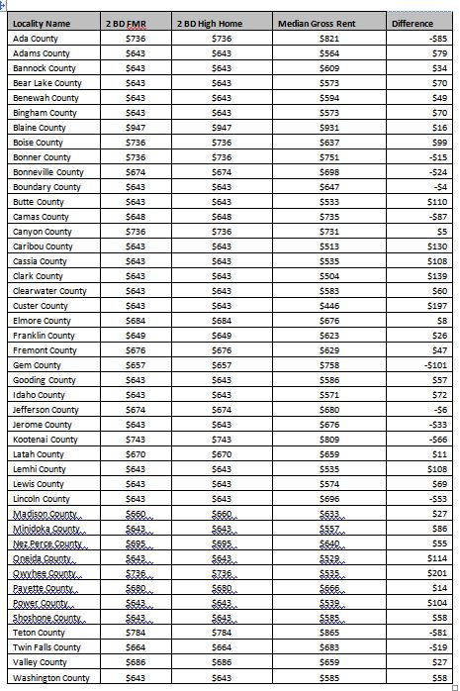****Is there sufficient housing for households at all income levels?**

To determine the sufficient provision of housing across income levels, the state conducted a “gaps analysis,” which compares the supply of rental and ownership housing with demand. For the gaps analysis, housing demand is defined as what renters at various income levels can afford to rent or buy. Supply is the actual distribution of rental and ownership housing. The source of data for the gaps analysis was the 2008-2012 Census American Community Survey (ACS), which was available for every county in the state.

For the State of Idaho overall, 34 percent of renters, or 59,000 renters, earned less than $20,000 per year. To avoid being cost burdened, these renters needed units that rented for less than $500 per month, including utilities costs.

Approximately 34,000 rental units were affordable for these renters, leaving a gap of about 25,000 rental units. This gap is similar to the number of renters who are severely cost burden and who are below the poverty level.

Renters earning more than $20,000 per year have an adequate supply of affordable rentals. However, many of the units affordable to these renters are being occupied by lower income renters who cannot find affordable units.

Gaps analyses were also conducted for every county in the state. The counties with the largest rental gaps for households earning less than $20,000 per year included:

Ada (gap of 9,700 units priced less than $500 per month, including utilities),

Canyon (3,200 unit rental gap), and

Kootenai (3,000 unit rental gap).

Other counties with relatively large rental gaps included:

Bannock, with a rental gap of 1,500 units affordable to renters earning less than $15,000 per year (units priced less than $375 per month, including utilities),

Bonneville (also 1,500 for renter earning less than $15,000 per year), and

Madison (1,500 units for renters earning less than $25,000 per year).

In addition to the rental gaps analysis, the proportion of affordable homes to buy was examined for the state overall and for each county. Home value data from the Census was used as a proxy for the price distribution of homes for sale.

This analysis found approximately 40 percent of homes to be affordable to renters earning $35,000. Yet 60 percent of renters earn less than $35,000.

Renters earning $50,000 will have an easier time finding an affordable home to buy: of these 76 percent of renters, 67 percent of units are affordable to them.

**How is affordability of housing likely to change considering changes to home values and/or rents?**

Since 2000, median homes values in the State of Idaho overall have risen 45 percent—from $106,300 in 2000 to $154,500 as of the 2012 ACS. On average, home prices in Idaho’s counties rose by 65 percent, according to the 2008-2012 ACS, which provides the latest data for small counties. The counties in the state that experienced the smallest home value increases were also those with some of the highest poverty and unemployment rates.

Counties experiencing the strongest price increases were rural, and some, rural resort counties. Shoshone County experienced a 111 percent increase in home prices; Lemhi, 100 percent; Bonner, 97 percent; and Bear Lake, 94 percent. The highest priced counties in the state contain resort areas and include Blaine, Valley, Bonner, Teton and Kootenai.

Rental price increases in the state overall paralleled home price growth, rising by 46 percent. At the county level, rents grew the most in Madison (112%), Lewis (68%) and Bear Lake (66%) Counties. Rent growth was lowest for Oneida and Custer Counties.

No counties experienced declines in median home values or median gross rent between 2000 and 2008-2012, according to the Census.

It is difficult to tell how housing prices will change during the next five to 10 years, given the unpredictable trends in housing prices during the past 10 years. It is likely that price increases will continue and be strongest in the state’s resort areas. If aging residents in the state’s rural areas migrant to larger cities to be close to family, housing prices in these areas may flatten. It is most likely that price changes will be more modest than in the past decade except in areas with strong economic growth.

**How do HOME rents / Fair Market Rent compare to Area Median Rent? How might this impact your strategy to produce or preserve affordable housing?**

IHFA has included a county by county table that compares High HOME rents for a 2 bedroom rental unit to the 2 bedroom FMR to the county median gross rent. The comparison indicates High HOME rent for a 2 bedroom rental unit is equal the county FMR. However, the median gross rents are higher than the FMR/High HOME rent in 13 counties: Ada, Bonner, Bonneville, Boundary, Camas, Gem, Jefferson, Jerome, Kootenai, Lincoln, Teton, and Twin Falls, while 31 counties have lower median gross rents.  Owyhee County is noted as having the greatest difference with a median gross rent that is $201 less than High HOME and FMR rent levels.

The comparison data is somewhat useful from a general statewide perspective, however, it will not be used to develop a statewide housing strategy. IHFA will continue rely on current professional local information and data for each proposed rental activity. The professionally prepared market study includes an extensive evaluation of the market conditions, including the area's market and affordable housing, current economic conditions and long-term forecast, and demographic (including total population vs. low-income population) information and need.  In addition, the proposed project is reviewed for overall feasibility, cost reasonableness, and long-term viability.

As IHFA explores the possibility of a tenant-based rental assistance program for extremely low-income households and individuals, the data may be more useful as one component of the research.

## MA-20 Condition of Housing – 91.310(a)

**Introduction:**

Many of Idaho's counties and smaller local jurisdictions do not have a local housing code or local property/housing quality standards. The State of Idaho has adopted a building, residential, other applicable codes.

## Definitions

### Standard Condition-

A property that meets all of the following: Local housing code, local property standard, local ordinances, Idaho building code as applicable to the type of housing, and the HOME program's property standard.

### Substandard Condition-

A property that does not meet one or more of the following: Local housing code, local property standard, local ordinance(s), Idaho building code as applicable to the type of housing, or the HOME program's property standard.

**Substandard Condition but Suitable for Rehabilitation-**

A property that can be brought up to local housing code, local property standard and ordinances, Idaho building code as applicable to the type of housing, and the HOME program's property standard, with total rehabilitation costs that are less than 75% of the property's total cost of replacement after the rehabilitation.

**Condition of Units**

| Condition of Units | Owner-Occupied | | Renter-Occupied | |
| --- | --- | --- | --- | --- |
| Number | % | Number | % |
| With one selected Condition | 108,204 | 27% | 71,723 | 42% |
| With two selected Conditions | 3,361 | 1% | 5,060 | 3% |
| With three selected Conditions | 455 | 0% | 497 | 0% |
| With four selected Conditions | 35 | 0% | 11 | 0% |
| No selected Conditions | 294,458 | 72% | 91,693 | 54% |
| Total | 406,513 | 100% | 168,984 | 99% |

Table 34 - Condition of Units

|  |  |
| --- | --- |
| Data Source: | 2007-2011 ACS |

**Year Unit Built**

| Year Unit Built | Owner-Occupied | | Renter-Occupied | |
| --- | --- | --- | --- | --- |
| Number | % | Number | % |
| 2000 or later | 88,992 | 22% | 32,804 | 19% |
| 1980-1999 | 125,591 | 31% | 48,166 | 29% |
| 1950-1979 | 138,991 | 34% | 63,818 | 38% |
| Before 1950 | 52,939 | 13% | 24,196 | 14% |
| Total | 406,513 | 100% | 168,984 | 100% |

Table 35 – Year Unit Built

|  |  |
| --- | --- |
| Data Source: | 2007-2011 CHAS |

**Risk of Lead-Based Paint Hazard**

| Risk of Lead-Based Paint Hazard | Owner-Occupied | | Renter-Occupied | |
| --- | --- | --- | --- | --- |
| Number | % | Number | % |
| Total Number of Units Built Before 1980 | 191,930 | 47% | 88,014 | 52% |
|  |  |  |  |  |
| Housing Units build before 1980 with children present | 42,985 | 11% | 22,100 | 13% |

Table 36 – Risk of Lead-Based Paint

|  |  |
| --- | --- |
| Data Source: | 2007-2011 ACS (Total Units) 2007-2011 CHAS (Units with Children present) |

Risk of Lead-Based Paint Hazards in housing constructed prior to January 1, 1978

While HUD's pre-populated table indicates all housing built prior 1980 has the risk of lead-based paint, the 2012 HUD Lead Safe Housing Rule Update indicates this number is most likely much lower, i.e. 11% of the housing built between 1966 and 1977 is estimated to have "significant" lead-based paint hazards as compared to 39% for housing built in the period 1940-1959 and 67 % for units built before 1940. Federally-assisted housing in Idaho is required to have an EPA Risk Assessment/Paint Testing to determine the presence of Lead-based Paint prior to rehabilitation activities.

**Vacant Units**

|  | Suitable for Rehabilitation | Not Suitable for Rehabilitation | Total |
| --- | --- | --- | --- |
| Vacant Units | 0 | 0 | 0 |
| Abandoned Vacant Units | 0 | 0 | 0 |
| REO Properties | 0 | 0 | 0 |
| Abandoned REO Properties | 0 | 0 | 0 |

Table 37 - Vacant Units

|  |  |
| --- | --- |
| Data Source: | 2005-2009 CHAS |

**Need for Owner and Rental Rehabilitation**

Selected Conditions- (1) lacks complete plumbing facilities, (2) lacks kitchen facilities, (3) more than one person per room, (4) cost burden greater than 30%.

46% of owner-occupied housing in Idaho was built before 1979. The largest percentage of this housing was actually built 1950-1979. However, 72% of owner-occupied housing has been identified by HUD as having "No Selected Conditions", and 25% having "One Selected Condition", which is most likely Cost-burdened because 29% of Idaho homeowners are defined as Cost-burdened. Homeowner rehabilitation was not identified as a priority housing need in Idaho. IHFA does not use HOME funds to rehabilitate owner-occupied housing.

52% of Idaho's rental housing stock was built prior to 1979, with 38% being built 1950-1979. 54% of this housing stock has been identified by HUD as having no "Selected Conditions" and 42% having one "Selected Condition". Although this specific Condition is not defined, it is noted that 50% of Idaho's renters are identified as being Cost-burdened.

Data on the extent of the state’s housing units that need rehabilitation are scarce. As shown in Table 34 above,  the majority of the state’s owner occupied and rental units were built before 2000, with 50 percent of owner-occupied and 55 percent of rentals built before 1980. Thus, a significant portion of the state’s housing units are older and likely in need of some rehabilitation.

Twenty-four percent of stakeholders responding to the survey conducted for this eCon Plan identified a need for owner rehabilitation, particularly units targeted to low income homeowners (earning less than $38,000 per year). However, local stakeholders and other survey participants indicate there is a much higher need for the creation of affordable units vs. the rehabilitation of existing units.

**Estimated Number of Housing Units Occupied by Low or Moderate Income Families with LBP Hazards**

The U.S. Census estimates 47% of Idaho's housing stock was built prior to 1980. Based on the age of this housing,  one could make the assumption that some of these units will have Lead-based paint (LBP).  While not all pre-78 housing has Lead-based paint, housing constructed prior to 1959 (77,207 units) has a higher risk for having LBP. While it is unknown how many units in Idaho have undergone LBP remediation activity, including abatement, it is realistic to assume a lower income family would not be able to afford this type of activity. 12% of Idaho residents live at or below the poverty line, with an additional 4% of Idaho families with children at or below the poverty line.  Based on a total of Idaho families with children living in poverty(257,941 persons) one could assume that 16% of Idaho families live in housing that was built pre-78 (279,944 units).  Based on this information, it could also be extrapolated that 44,791 persons who live in poverty, also live in housing built prior to January 1, 1978, with 13%  or approximately 5, 823 persons live in housing built before 1950, which has an even higher incidence of LBP.

## MA-25 Public and Assisted Housing – (Optional)

**Introduction**:

IHFA administers the Section 8 Housing Choice Voucher program in 34 of 44 counties in Idaho and encourages public housing programs statewide. IHFA is only one in a statewide network of public housing providers.  IHFA does not oversee any citywide or countywide Participating Jurisdictions (PJs) for public housing. These jurisdictions have a local official governing board responsible to appoint the board of a Public Housing Authority (PHA) and direct PHA activities. With this consideration, a description of efforts to foster public housing resident initiatives during the 2014 program year are as follows:

IHFA will continue to make available a Housing Choice Voucher Homeownership program, currently available only to disabled households and those voucher households currently participating in the voucher Family Self Sufficiency program. Presently, 41 participants have been successful in purchasing homes using Section 8 Housing Choice Vouchers to provide mortgage payment subsidy on a long-term basis. IHFA will hold regional PHA Plan hearings and perform outreach in each area that IHFA has a branch office administering Section 8 vouchers and Low Rent Public Housing to encourage participation in a Resident Advisory Board.

IHFA implemented a Homeownership program for the 29 scattered-site Low Rent Public Housing units in Idaho Falls offering the homes first to public housing residents.  To date five homes have been purchased, and numerous public housing and family self-sufficiency clients are working toward homeownership.  IHFA submitted an application for the HUD Rental Assistance Demonstration program for its 47-unit complex in Kellogg.  Once approved this would provide for long-term affordability by converting the property to the Section 8 project-based program.  Until such time as these efforts are finalized the remaining residents will be asked to serve on Resident Advisory Boards.

No Public Housing Program within IHFA's jurisdiction is designated as "troubled.

**Totals Number of Units**

| Program Type | | | | | | | | | |
| --- | --- | --- | --- | --- | --- | --- | --- | --- | --- |
|  | Certificate | Mod-Rehab | Public Housing | Vouchers | | | | | |
| Total | Project -based | Tenant -based | Special Purpose Voucher | | |
| Veterans Affairs Supportive Housing | Family Unification Program | Disabled  * |
| # of units vouchers available |  |  | 76 | 3,419 |  |  | 34 | 0 | 945 |
| # of accessible units |  |  |  |  |  |  |  |  |  |
| *includes Non-Elderly Disabled, Mainstream One-Year, Mainstream Five-year, and Nursing Home Transition | | | | | | | | | |

Table 38 – Total Number of Units by Program Type

|  |  |
| --- | --- |
| Data Source: | PIC (PIH Information Center) |

Describe the number and physical condition of public housing units in the jurisdiction, including those that are participating in an approved Public Housing Agency Plan:

State response not required

Describe the Restoration and Revitalization Needs of public housing units in the jurisdiction:

State response not required

Describe the public housing agency's strategy for improving the living environment of low- and moderate-income families residing in public housing:

State response not required

Discussion:

State response not required

## 

## MA-30 Homeless Facilities – 91.310(b)

Introduction

See Unique Appendices- Exceeds number of allowable characters.

**Facilities Targeted to Homeless Persons**

|  | Emergency Shelter Beds | | Transitional Housing Beds | Permanent Supportive Housing Beds | |
| --- | --- | --- | --- | --- | --- |
| Year Round Beds (Current & New) | Voucher / Seasonal / Overflow Beds | Current & New | Current & New | Under Development |
| Households with Adult(s) and Child(ren) | 182 | 11 | 470 | 415 | 0 |
| Households with Only Adults | 436 | 42 | 395 | 411 | 0 |
| Chronically Homeless Households | 0 | 0 | 0 | 305 | 0 |
| Veterans | 4 | 0 | 136 | 297 | 0 |
| Unaccompanied Youth | 14 | 0 | 3 | 0 | 0 |

Table 39 - Facilities Targeted to Homeless Persons

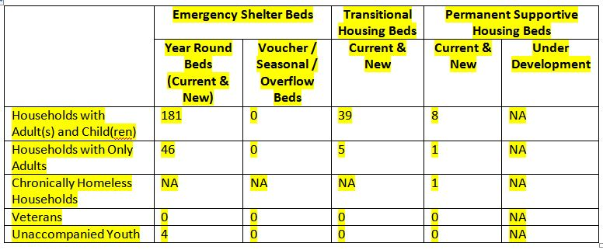Facilities targeting DV only

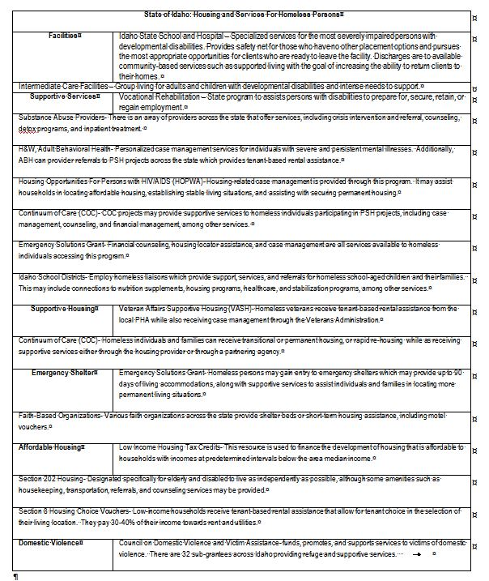

Describe mainstream services, such as health, mental health, and employment services to the extent those services are use to complement services targeted to homeless persons

In addition to receiving housing assistance, homeless individuals and families have the opportunity to receive services, whether via the COC, ESG, or HOPWA programs, or partnering agencies.  Services may include case management, child care assistance, education and career counseling, employment assistance, job training, health care, mental health services, substance or alcohol abuse treatment, transportation, and utility assistance, among other supportive services.  The level of services and length of care or participation varies greatly.  To the extent that program regulations allow, service providers attempt to offer as much support as possible for as long as is needed.  Apart from projects and agencies operating COC, ESG, and HOPWA programs, the Department of Health and Welfare’s Behavioral Health Division, the Substance Abuse and Mental Health Services Administration, and faith-based welfare programs, along with other federal and/or state agencies, are the primary agencies offering services which target homeless individuals and families.

List and describe services and facilities that meet the needs of homeless persons, particularly chronically homeless individuals and families, families with children, veterans and their families, and unaccompanied youth. If the services and facilities are listed on screen SP-40 Institutional Delivery Structure or screen MA-35 Special Needs Facilities and Services, describe how these facilities and services specifically address the needs of these populations.

According to homeless individual declarations from past Point In Time count surveys and the expertise of highly involved service providers, the most commonly reported causes homelessness are identified as: 1) unemployment; 2) inability to find affordable housing; 3) divorce/family separation; 4) eviction; 5) substance abuse; and 6) lack of education or job skills.  One prevalent commonality among those experiencing homelessness is the existence of a disabling condition.  With this understanding, the BOS COC and staff administering COC, ESG and HOPWA programs attempt to seek out services and resources linked to the causes of homelessness listed above, as these most certainly become barriers to later locating and securing housing.  To that end, services must also include resources that aid those experiencing homelessness in extinguishing barriers that may have arisen as a result of become homeless, such as poor credit, criminal history, poor finances, etc.

Additional efforts will be made to link healthcare and housing providers and promote affordable housing projects which encourage access to supportive services for homeless families and individuals.  IHFA’s efforts in researching homelessness solutions, the receipt of HUD technical assistance to form partnerships between housing and healthcare providers, and proactively seeking systems that successfully pair vulnerable populations to appropriate services will all generate a positive impact on Idaho’s homeless population.  See attached JPEG Housing and Services for Homeless

## MA-35 Special Needs Facilities and Services – 91.310(c)

**Introduction**

Supportive housing is made available in two forms; scattered- or single-site.  Services associated with supportive housing projects are case management, transportation, life skills training, counseling, and educational and career building, among others.  Access to public assistance through programs such as SSI/SSDI Outreach, Access, and Recovery (SOAR) greatly improve one’s ability to experience a stable living environment.  These housing and service options assist not only those coming directly into housing from the streets, but those exiting institutions as well.  The housing provided offers stability, and safe, decent, and sanitary environments.  The services offered aid individuals in working towards being employable, gainfully employed, receiving linkages to resources, and removing barriers to attaining stable housing.

See Unique Appendices  for Idaho's Facilities and Services for Special Needs Populations"

Describe programs for ensuring that persons returning from mental and physical health institutions receive appropriate supportive housing

One definition of homelessness includes those individuals that are exiting a facility or institution who were homeless prior to entry, and when exiting, do so without services made available through their placement into society.  Resources to house these individuals, and potentially their families, are used to house them rapidly to minimize their potential to become, or time experiencing, homelessness.  Services necessary to eliminate barriers to permanent housing and gainful employment are made available.  Encouraging housing providers to adopt low-barrier eligibility screening, and promoting this system-wide within the COC, will help to avoid homelessness or minimize the length of time individuals and families spend in homelessness.  The Facilities and Services For Non-Homeless Persons table includes resources that those exiting mental or physical health institutions can access supportive housing or appropriate services.

Specify the activities that the jurisdiction plans to undertake during the next year to address the housing and supportive services needs identified in accordance with 91.215(e) with respect to persons who are not homeless but have other special needs. Link to one-year goals. 91.315(e)

The special needs housing programs administered by IHFA predominately serve homeless persons.  In many cases, these HUD program requirements do not allow funds to be used for non-homeless individuals.  However, ESG funds can be used for homelessness prevention and rapid re-housing activities.  Although an applicant must meet one of several HUD homeless definitions, one of those is being imminently at risk of homelessness (Category 2 of HUD’s homeless definition) which means they would still be housed when assistance is provided.  Those accessing ESG homelessness prevention and rapid re-housing assistance may receive short to medium term tenant-based rental assistance and/or housing relocation and stabilization services, including financial counseling, housing locator assistance, and housing stability case management.  IHFA also provides housing and/or supportive services to households participating in the Housing Opportunities For Persons With HIV/AIDS (HOPWA) program.  Homelessness is not a required program admittance requirement.  HOPWA participants may receive permanent rental subsidies, along with individualized case management.  While the COC, ESG, and HOPWA programs may serve vulnerable populations (elderly, frail elderly, persons with disabilities, etc.), the only specifically targeted subpopulations are HIV/AIDS and disabled.

For entitlement/consortia grantees: Specify the activities that the jurisdiction plans to undertake during the next year to address the housing and supportive services needs identified in accordance with 91.215(e) with respect to persons who are not homeless but have other special needs. Link to one-year goals. (91.220(2))

Not applicable to State Grantees.

## MA-40 Barriers to Affordable Housing – 91.310(d)

Negative Effects of Public Policies on Affordable Housing and Residential Investment

Response exceeds maximum allowable characters- See Unique Appendices.

## MA-45 Non-Housing Community Development Assets -91.315(f)

**Introduction**

Economic Development Market Analysis

**Business Activity**

| Business by Sector | Number of Workers | Number of Jobs | Share of Workers  % | Share of Jobs  % | Jobs less workers  % |
| --- | --- | --- | --- | --- | --- |
| Agriculture, Mining, Oil & Gas Extraction | 19,371 | 21,167 | 7 | 10 | 3 |
| Arts, Entertainment, Accommodations | 35,817 | 25,841 | 12 | 12 | 0 |
| Construction | 19,275 | 17,147 | 7 | 8 | 1 |
| Education and Health Care Services | 50,384 | 30,682 | 17 | 14 | -3 |
| Finance, Insurance, and Real Estate | 15,651 | 9,258 | 5 | 4 | -1 |
| Information | 5,473 | 3,042 | 2 | 1 | -1 |
| Manufacturing | 38,571 | 29,987 | 13 | 14 | 1 |
| Other Services | 9,759 | 7,550 | 3 | 4 | 1 |
| Professional, Scientific, Management Services | 21,761 | 12,231 | 7 | 6 | -1 |
| Public Administration | 0 | 0 | 0 | 0 | 0 |
| Retail Trade | 49,087 | 35,279 | 17 | 16 | -1 |
| Transportation and Warehousing | 11,999 | 10,269 | 4 | 5 | 1 |
| Wholesale Trade | 17,313 | 13,080 | 6 | 6 | 0 |
| Total | 294,461 | 215,533 | -- | -- | -- |

Table 40- Business Activity

|  |  |
| --- | --- |
| Data Source: | 2007-2011 ACS (Workers), 2011 Longitudinal Employer-Household Dynamics (Jobs) |

**Labor Force**

|  |  |
| --- | --- |
|  |  |
| Total Population in the Civilian Labor Force | 474,998 |
| Civilian Employed Population 16 years and over | 437,991 |
| Unemployment Rate | 7.79 |
| Unemployment Rate for Ages 16-24 | 20.39 |
| Unemployment Rate for Ages 25-65 | 4.61 |

Table 41 - Labor Force

|  |  |
| --- | --- |
| Data Source: | 2007-2011 ACS |

| Occupations by Sector | Number of People |
| --- | --- |
| Management, business and financial | 90,993 |
| Farming, fisheries and forestry occupations | 16,281 |
| Service | 45,804 |
| Sales and office | 104,779 |
| Construction, extraction, maintenance and repair | 64,064 |
| Production, transportation and material moving | 30,445 |

Table 42 – Occupations by Sector

|  |  |
| --- | --- |
| Data Source: | 2007-2011 ACS |

**Travel Time**

| Travel Time | Number | Percentage |
| --- | --- | --- |
| < 30 Minutes | 300,073 | 74% |
| 30-59 Minutes | 81,832 | 20% |
| 60 or More Minutes | 22,107 | 5% |
| Total | 404,012 | 100% |

Table 43 - Travel Time

|  |  |
| --- | --- |
| Data Source: | 2007-2011 ACS |

**Education**:

Educational Attainment by Employment Status (Population 16 and Older)

| Educational Attainment | In Labor Force | |  |
| --- | --- | --- | --- |
| Civilian Employed | Unemployed | Not in Labor Force |
| Less than high school graduate | 35,329 | 3,952 | 19,572 |
| High school graduate (includes equivalency) | 98,893 | 8,287 | 36,832 |
| Some college or Associate's degree | 132,993 | 8,005 | 42,204 |
| Bachelor's degree or higher | 88,513 | 2,812 | 20,054 |

Table 44 - Educational Attainment by Employment Status

|  |  |
| --- | --- |
| Data Source: | 2007-2011 ACS |

**Educational Attainment by Age**

|  | Age | | | | |
| --- | --- | --- | --- | --- | --- |
| 18–24 yrs | 25–34 yrs | 35–44 yrs | 45–65 yrs | 65+ yrs |
| Less than 9th grade | 2,015 | 5,887 | 6,902 | 11,075 | 9,045 |
| 9th to 12th grade, no diploma | 14,734 | 9,684 | 8,577 | 16,728 | 14,522 |
| High school graduate, GED, or alternative | 32,126 | 36,638 | 32,907 | 74,670 | 43,876 |
| Some college, no degree | 38,446 | 34,240 | 31,070 | 70,971 | 31,305 |
| Associate's degree | 4,731 | 11,859 | 12,667 | 23,803 | 6,007 |
| Bachelor's degree | 4,367 | 19,648 | 20,806 | 39,094 | 14,970 |
| Graduate or professional degree | 184 | 4,859 | 8,497 | 19,035 | 8,815 |

Table 45 - Educational Attainment by Age

|  |  |
| --- | --- |
| Data Source: | 2007-2011 ACS |

**Educational Attainment – Median Earnings in the Past 12 Months**

| Educational Attainment | Median Earnings in the Past 12 Months |
| --- | --- |
| Less than high school graduate | 0 |
| High school graduate (includes equivalency) | 0 |
| Some college or Associate's degree | 0 |
| Bachelor's degree | 0 |
| Graduate or professional degree | 0 |

Table 46 – Median Earnings in the Past 12 Months

|  |  |
| --- | --- |
| Data Source: | 2007-2011 ACS |

**Based on the Business Activity table above, what are the major employment sectors within the state?**

1.  Education and Health Care Service

2.  Retail Trade

3.  Manufacturing

4. Construction

**Describe the workforce and infrastructure needs of business in the state.**

See Unique Appendices.

**Describe any major changes that may have an economic impact, such as planned public or private sector investments or initiatives that have affected or may affect job and business growth opportunities during the planning period. Describe any needs for workforce development, business support or infrastructure these changes may create.**

See Unique Appendices

**How do the skills and education of the current workforce correspond to employment opportunities in the state?**

Idaho is large geographically but sparsely populated.  It is experiencing net in-migration, but stakeholders and policy makers must remember the significant rural population when developing strategies.

Idaho’s population continues to grow and age, yet connecting youth to employment and long-term workforce retention must be emphasized.

Idaho private sector, nonfarm employment is 82 percent in the service sector, not typically offering sustainable wages or career opportunities.  But there are opportunities for growth in a variety of other professional/ business service subsectors.

Technical skills required of today’s workers are evolving as technology rapidly progresses, making collaboration among education, workforce and economic development systems critical to address skill needs of growth industries.

While strong technical skills are necessary for job function, the demand for interpersonal, or soft, skills remain a concern for employers

Describe current workforce training initiatives supported by the state. Describe how these efforts will support the state's Consolidated Plan.

Workforce Development Training Fund Program – This program administered by the Idaho Department of Labor can reimburse employee training costs to eligible companies that are bringing jobs to Idaho, adding jobs through expansion or upgrading skills of current workers who are at risk of being permanently laid off.  The fund is financed by employers through an offset to the unemployment insurance tax.

**Business Solutions Initiative** –

This effort includes training One-Stop management staff and selected workforce consultants to reach out and consult with businesses in targeted industries to better understand their workforce needs and help provide solutions by coordinating education and workforce resources.  The initiatives will better serve both employer and workers by meeting the skill, recruitment and retention needs of employers and the training, employment and career advancement needs of workers. Sector initiatives:

The business solutions approach will:

Focus intensively on the workforce needs to a specific industry sector over a sustained period, often concentrating on a specific occupation or set of critical occupations;

Create formal career paths to good jobs, reducing barriers to employment and sustaining or increasing middle-class jobs; Bolster economic competitiveness by creatively engaging economic development experts in workforce issues and align education and workforce development planning; Engage a broader array of key stakeholders through partnerships; and Promote systemic flexibility and change that achieve ongoing benefits for the industry and workers. On-the Job Training Program. This program administered by the Idaho Department of Labor can will allow qualifying businesses to receive a reimbursement for partial training cost when they agree to hire and train an eligible worker. These efforts support the Consolidated Plan in that they are providing job training to individuals for skilled and semi-skilled positions in growing industries. This will improve an individual’s ability to qualify for and retain a good paying job. Having a good job skill set should reduce the number of low income and poverty level families in the state.

**Describe any other state efforts to support economic growth.**

Idaho Tax Reimbursement Incentive (TRI) - TRI is a performance based incentive that provides tax credit up to 30% for up to 15 years on new corporate income tax, sales tax, and payroll taxes paid as a result of a new qualifying project.  To qualify, a new project must meet certain requirements for creating high-paying jobs in Idaho.  The credit is refundable and is available to both existing and new companies.  The tax credit percentage and project term is negotiated based upon the quality of jobs created, regional economic impact and return on investment for Idaho.

Business Advantage Program – If your business invests at least $500,000 in new facilities and creates 10 or more jobs with salaries averaging $40,000 a year with benefits, you may qualify for an incentive package which could include a variety of tax credits, sales tax rebates, and property tax exemptions.

3% Investment Tax Credit – If a business makes qualifying new investments in personal property, they may earn a 3% income tax credit to offset up to 50% of their tax liability.

Property Tax Exemption – If a business invests $3 million in a new manufacturing facility, they may receive a full or partial property tax exemption on the building facilities and personal property for up to five years.

Idaho Opportunity Fund – Grants can be awarded to local governments to support the expansion or extension of infrastructure to support a qualifying businesses.  A qualifying business must be creating jobs.

Idaho Collateral Loan program - The Program is a collaborative partnership between the U.S. Department of Treasury, Idaho Department of Commerce, Idaho Housing and Finance Association, and the Idaho Bankers Association that launched in November 2011. In summary, the Program places pledged cash deposits with lending institutions to enhance the collateral of qualified small business borrowers who would not otherwise be able to obtain financing. The deposits are available to cover loan losses, in the event of a default, or are returned to be recycled for the benefit of another qualified borrower.

Comprehensive Economic Development Strategies (CEDS) - The State of Idaho participated in helping Idaho’s six Economic Development Districts develop their CEDS goals and objectives. The state is committed, where it can, to help the districts implement action items as identified in their CEDS.

## MA-50 Needs and Market Analysis Discussion

**Are there areas where households with multiple housing problems are concentrated? (include a definition of "concentration")**

The State of Idaho’s last Analysis of Impediments to Fair Housing Choice (AI) examined concentrations of households by protected class. At the time the study was conducted, “concentration” was defined using HUD’s disproportionate need (10 percentage points) definition. This is a broader definition of concentration than more recent definitions used by HUD, including a 50 percent minority threshold and a 20 percentage points threshold.

The state has only a handful of Census Tracts where the proportion of non-White residents is 10 percentage points greater than the state proportion overall. Two tracts are located in northern Idaho along the state’s western border, one in is southeast Idaho and one in southwest Idaho. Two of these Census Tracts have high concentrations, 58 and 73 percent, of non-White populations. Overall, the minorities in these Census tracts represent less than 3 percent of the state’s total non-White populations.  There are fewer than 25 Census Tracts where the proportion of Hispanic residents exceeds 21 percent(the threshold for “Hispanic concentration”). Three Census Tracts in the entire state have Hispanic proportions exceeding 50 percent. However, in these Census Tracts where the Hispanic population is proportionately the highest, the Census Tract represents less than 2 percent of the state’s entire Hispanic population.

A comparison of Hispanic residents to all residents by county found that Canyon County is the only county that has disproportionately more persons of Hispanic descent than its overall share of the state’s population.  Only one Census Tract in the state showed a concentration of persons with disabilities

**Are there any areas in the jurisdiction where racial or ethnic minorities or low-income families are concentrated? (include a definition of "concentration")**

There are fewer than 25 Census Tracts where the proportion of Hispanic residents exceeds 21 percent (the threshold for “Hispanic concentration”). Three Census Tracts in the entire state have Hispanic proportions exceeding 50 percent. However, in these Census Tracts where the Hispanic population is proportionately the highest, the Census Tract represents less than 2 percent of the state’s entire Hispanic population.

A comparison of Hispanic residents to all residents by county found that Canyon County is the only county that has disproportionately more persons of Hispanic descent than its overall share of the state’s population. Only one Census Tract in the state showed a concentration of persons with disabilities.

**What are the characteristics of the market in these areas/neighborhoods?**

All Census tracts high non-White concentrations are adjacent to Native American reservations.

Many census tracts with Hispanic concentration are located in Canyon County or counties with similar agricultural influences.

Are there any community assets in these areas/neighborhoods?

State Grantees response not required

Are there other strategic opportunities in any of these areas?

State Grantee response not required

# STRATEGIC PLAN

## SP-05 Overview

**Strategic Plan Overview**

The Strategic Plan identifies Idaho's affordable housing goals and community development needs, as well as the strategies and resources used to help address the priority needs as identified herein. IHFA and IDC conducted a statewide affordable housing and community development survey, commissioned a *2014 Housing, Demographic, and Transportation Report*, solicited input from the public and other entities prior to drafting the 2015-2019 Five-Year Consolidated Plan and the 2015 Action Plan.

The State of Idaho consists of small towns and cities with six Metropolitan Statistical areas: Boise City-Nampa, Idaho Falls, Coeur d'Alene, Pocatello, Lewiston, ID-WA, Logan UT-ID. The geographical makeup within Idaho's borders, including two major mountain ranges, five major river systems, and 44 individual counties, create a unique set of barriers that can create barriers to the delivery of services.  This creates a challenge when prioritizing affordable housing and homeless needs.

**CDBG Program**

Commerce will not target CDBG funds geographically, but will ensure at least 70 % of the CDBG funds will benefit low-to-moderate income persons in whatever eligible geographic area they reside.

The needs for the CDBG program were established by a local government survey, public hearing, and review of prior demand.   The top needs indicated are broad.   They range from streets to public parks to housing for homeless to public infrastructure support for job growth.   Based on these needs, Commerce has increased the CDBG funding percentage objective under the public facilities / infrastructure goal from the 2010 consolidated plan.

The CDBG delivery structure consisting of threshold factors; application format, submission dates, scoring criteria, and the five funding set-asides may have some slight changes made to them but they will not be significant.   This constant, keeps the process familiar and recognizable for local governments.   This is helpful since almost all local governments do not regularly submit for CDBG funds and may not have the resources to learn of a new process or procedures.  Consistency of delivery structure has kept the CDBG funds accessible.

Commerce does recognize a need to make some changes to the CDBG state agency rules (administrative code).  Changes that Commerce will look to incorporate include:

slightly decreasing match points available,

increasing points for project readiness and preparedness,

Combining the health and safety, housing, and social services categories and their separate pointing into one category instead of the three separate.

Adding public parks to the senior / community center set-aside.

These change should level the playing field for all applications under the public facilities set-aside.  Whereas, Idaho local governments lack the tools necessary to generate revenue (such as a local option tax,  limits on tax increases, and debt limitations)  for improvements to public infrastructure and facilities they do look to CDBG to help fill the financial gap in meeting the needs of their citizens.

## SP-10 Geographic Priorities – 91.315(a)(1)

**General Allocation Priorities**

**Describe the basis for allocating investments geographically within the jurisdiction (or within the EMSA for HOPWA)**

HOME- Idaho's HOME program does not award funds based on a geographic distribution method.  IHFA uses its very limited resources to help fund housing activities that serve low, very-low and extremely-low income households throughout Idaho. Each proposed activity must meet HOME’s regulatory requirements and IHFA’s policies and procedures. This method provides the flexibility for a community to address its own individual housing needs. The HOME Program supports the creation of special community-based non-profit housing development organizations around the state.  These “CHDOs” are responsible to their community to identify and help address its affordable housing needs.

CDBG-Idaho CDBG program does not award funds based on geographic distribution.  The State CDBG program benefits low to moderate income areas throughout the State of Idaho as required to meet HUD's national objective.

SG fund allocation is not determined by geographic distribution.  Each year IHFA solicits requests for proposals throughout the state of Idaho.  Agencies from all regions of the state are eligible to participate in a competitive application and selection process.  Therefore, communities and regions are given the ability to lobby for the level of funding they deem appropriate as opposed to limiting the impact the ESG program may have on any particular region of the state.

Idaho by Region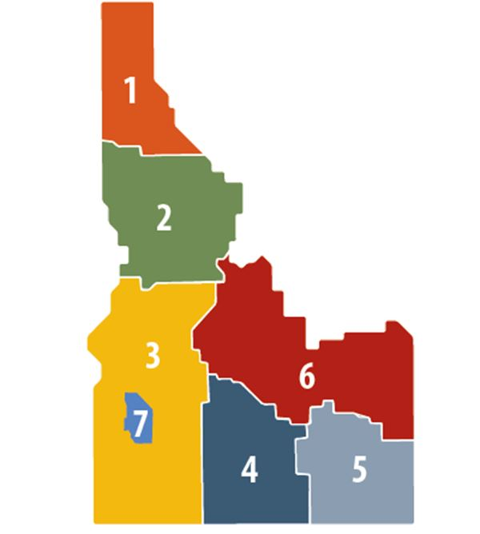

## SP-25 Priority Needs – 91.315(a)(2)

**Priority Needs**

|  |  |  |
| --- | --- | --- |
| 1 | Priority Need Name | Create and Preserve Affordable Rental Housing |
| Priority Level | High |
| Population | Extremely Low Low Elderly Persons with Mental Disabilities Persons with Physical Disabilities Persons with Developmental Disabilities |
| Geographic Areas Affected |  |
| Associated Goals | Provide Decent Affordable Housing |
| Description | The HOME program includes the Program Funds Rule as well as a Project Rule, which places constraints on the income levels of tenants occupying HOME-assisted units at initial occupancy and throughout the HOME Period of Affordability. These constraints require 90% of occupants in HOME-assisted rental and TBRA units have incomes ≤60% AMI, and 20% be rented to households with incomes at or below 50% AMI.  When HTF funds are used to construct or rehabilitation housing units, requirement indicate the units must target households ≤30% AMI. Because HTF will be able to provide operation support for HTF units, IHFA anticipates it may be able to provide an additional 16 HTF units of rental housing.  It is anticipated the HTF funds will be an additional funding source in some HOME/LIHTC housing activities, throughout the state.  New Construction  Acquisition and Rehabilitation of Substandard Housing  Acquisition of Standard Housing  Rehabilitation of Substandard Housing |
| Basis for Relative Priority | The 2014 Idaho Housing Needs Assessment, 2014 Idaho County-by-County Demographic, Housing, and Transportation Report and the public input helped inform and identify Idaho's priority housing needs. |
| 2 | Priority Need Name | Create Decent Affordable Homeownership |
| Priority Level | High |
| Population | Low |
| Geographic Areas Affected |  |
| Associated Goals | Provide Decent Affordable Housing |
| Description | Down-Payment/Closing Cost Assistance  Homebuyer Properties Activities  Acquisition and Rehabilitation/ New Construction  The HOME program serves households with income not to exceed 80% AMI.  Homeownership opportunities are often available to low-income households because HOME provides the gap financing for households not able to qualify for the entire amount needed to purchase a home through a primary mortgage of the sales price. The HOME Down Payment/ Closing Cost assistance program provides the gap between the sales price and the primary loan up to a maximum amount established on an annual basis depending on funds available and market conditions. IHFA's HOME program requires the household to qualify and accept the maximum primary loan available before the amount of HOME funds is determined. Other conditions apply. Acceptable primary loan products are Conventional, VA, USDA-RD and FHA. |
| Basis for Relative Priority | The 2014 Housing Needs Survey, input from the public (including units of local government, local regional and state level stakeholders), American Community Survey 5-Year Estimates(2008-2012 & 2013, and the 2014 Idaho County-by-County Housing, Demographic, and Transportation Report. |
| 3 | Priority Need Name | Tenant-Based Rental Assistance |
| Priority Level | High |
| Population | Extremely Low |
| Geographic Areas Affected |  |
| Associated Goals | Provide Decent Affordable Housing Provide Suitable Living Environment |
| Description | The 2014 Idaho Housing Needs Survey, the 2014 Idaho County by County Demographic, Housing and Transportation report, and public input identified permanent rental housing for extremely low-income(1st) and homeless individuals and families (4th) as unmet housing needs in Idaho. This income categories would certainly include the non-homeless in need of supportive services, such as persons with mental, physical, and cognitive disabilities. IHFA believes in some areas of Idaho, a HOME TBRA program may be beneficial if there is rental housing available. IHFA will explore the possibility of a HOME TBRA program in PY2015.  The 2015-2019 Five-Year Consolidated Plan submitted to HUD on or before April 1, 2015 will not contain a HOME TBRA program except to identify it as a priority housing need. IHFA will develop the TBRA program during PY2015. Once developed, IHFA will follow its Public Participation Plan and amend the Consolidated Plan. Once the amendment has been approved by HUD-CPD, IHFA will implement a HUD approved HOME TBRA program.  The most recent Public Participation Plan for Idaho's Federal Affordable Housing and Community Development Programs can be found at   http://www.idahohousing.com/Portals/0/Media/grant%20programs/2014%20Adopted%20Citizen%20Participation%20Plan-021715.pdf |
| Basis for Relative Priority | The 2014 Idaho Housing Needs Survey, and public comments identified housing for extremely-low income includes homeless families as two priority unmet housing needs. |
| 4 | Priority Need Name | Public Facilities |
| Priority Level | High |
| Population | Extremely Low Low Moderate Large Families Families with Children Elderly Rural Chronic Homelessness Individuals Families with Children Victims of Domestic Violence Elderly Frail Elderly Persons with Developmental Disabilities Victims of Domestic Violence Non-housing Community Development |
| Geographic Areas Affected |  |
| Associated Goals | Public Facilities/Infrastructure-Compliance Public Facilities/Infrastructure-Rehabilitation Public Facilities/Infrastructure-New Construction |
| Description | Public Facilities - health facilities, fire and EMT stations, fire trucks, senior centers, community centers, homeless shelters, child care centers, parks, youth centers, domestic shelters and non-residential historic. |
| Basis for Relative Priority | The basis has been determined by four sources:  The local government needs survey that was conducted by IDC August 2014  The American Society of Civil Engineers, 2012 Report Card for Idaho’s infrastructure was used to further assess non-housing community development needs.  Public participation was another method to determine need.   A number of pre-draft written and hearing comments, see attached, identified that housing of homeless families and individuals was a very important need as well as ensuring the development of affordable housing.  A high majority of comments received, favor the implementation of a “housing first” type program to assist the homeless population.  Prior five years of CDBG application submissions |
| 5 | Priority Need Name | Public Infrastructure |
| Priority Level | High |
| Population | Extremely Low Low Moderate Middle Non-housing Community Development |
| Geographic Areas Affected |  |
| Associated Goals | Public Facilities/Infrastructure-Compliance Public Facilities/Infrastructure-Rehabilitation Public Facilities/Infrastructure-New Construction |
| Description | Public Infrastructure - water systems, sewer systems, streets, sidewalks, solid waste disposal, surface and storm water drainage, public parking facilities. |
| Basis for Relative Priority | The basis has been determined by four sources:  The local government needs survey that was conducted by IDC August 2014  The American Society of Civil Engineers, 2012 Report Card for Idaho’s infrastructure was used to further assess non-housing community development needs.  Public participation was another method to determine need.   A number of pre-draft written and hearing comments, see attached, identified that housing of homeless families and individuals was a very important need as well as ensuring the development of affordable housing.  A high majority of comments received, favor the implementation of a “housing first” type program to assist the homeless population.  Prior five years of CDBG application submissions |
| 6 | Priority Need Name | Housing related activities |
| Priority Level | High |
| Population | Extremely Low Low Moderate Middle Large Families Families with Children Elderly Rural Chronic Homelessness |
| Geographic Areas Affected |  |
| Associated Goals | Public Facilities/Infrastructure-Compliance Public Facilities/Infrastructure-New Construction Provide Suitable Living Environment |
| Description | Housing related activities - water/sewer hookups to low to moderate income persons, public infrastructure expansion to affordable housing, acquisition of property to construct affordable housing, acquisition or rehabilitation of existing affordable housing, subordinated loans for homeownership. |
| Basis for Relative Priority | The basis has been determined by four sources:  The local government needs survey that was conducted by IDC in August 2014.  The American Society of Civil Engineers, 2012 Report Card for Idaho’s infrastructure was used to further assess non-housing community development needs.  Public participation was another method to determine need.   A number of pre-draft written and hearing comments, see appendix, identified that housing of homeless families and individuals was a very important need as well as ensuring the development of affordable housing.  A high majority of comments received, favor the implementation of a “housing first” type program to assist the homeless population.  Prior five years of CDBG application submissions |
| 7 | Priority Need Name | Economic Development |
| Priority Level | High |
| Population | Extremely Low Low Moderate Rural Non-housing Community Development |
| Geographic Areas Affected |  |
| Associated Goals | Economic Development-Job Creation Economic Development-Downtown Revitalization |
| Description | Economic Development - job creation and downtown revitalization (expansion or extension of public infrastructure that serves a business that will create new jobs).  Providing business loans. |
| Basis for Relative Priority | The basis has been determined by four sources:  The local government needs survey that was conducted by IDC in August 2014.  The American Society of Civil Engineers, 2012 Report Card for Idaho’s infrastructure was used to further assess non-housing community development needs.  Public participation was another method to determine need.   A number of pre-draft written and hearing comments, see appendix, identified that housing of homeless families and individuals was a very important need as well as ensuring the development of affordable housing.  A high majority of comments received, favor the implementation of a “housing first” type program to assist the homeless population.  Prior five years of CDBG application submissions |
| 8 | Priority Need Name | Cleanup of blighted properties |
| Priority Level | Low |
| Population | Non-housing Community Development |
| Geographic Areas Affected |  |
| Associated Goals | Public Facilities/Infrastructure-Rehabilitation Economic Development-Downtown Revitalization |
| Description | Clean-up of contaminated public property and sites; and clearance and demolition of blighted properties |
| Basis for Relative Priority | The basis has been determined by four sources:  The local government needs survey that was conducted by IDC in August 2014.  The American Society of Civil Engineers, 2012 Report Card for Idaho’s infrastructure was used to further assess non-housing community development needs.  Public participation was another method to determine need.   A number of pre-draft written and hearing comments, see appendix, identified that housing of homeless families and individuals was a very important need as well as ensuring the development of affordable housing.  A high majority of comments received, favor the implementation of a “housing first” type program to assist the homeless population.  Prior five years of CDBG application submissions |
| 9 | Priority Need Name | Planning Studies |
| Priority Level | Low |
| Population | Non-housing Community Development |
| Geographic Areas Affected |  |
| Associated Goals | Public Facilities/Infrastructure-Compliance Public Facilities/Infrastructure-Rehabilitation Public Facilities/Infrastructure-New Construction Economic Development-Job Creation Economic Development-Downtown Revitalization |
| Description | Comprehensive plan, facility plan or preliminary engineering, environmental studies, economic development and energy conservation. |
| Basis for Relative Priority | The basis has been determined by the local government needs survey that was conducted by IDC in August 2014. |
| 10 | Priority Need Name | Homeless Shelter Operations & Prevention |
| Priority Level | High |
| Population | Extremely Low Rural Chronic Homelessness Individuals Families with Children Mentally Ill Chronic Substance Abuse veterans Persons with HIV/AIDS Victims of Domestic Violence Unaccompanied Youth |
| Geographic Areas Affected |  |
| Associated Goals | Provide Suitable Living Environment |
| Description | Shelter operations and supportive services offered through shelters in all seven regions in Idaho. Rapid Re-housing and Homelessness Prevention made available through homeless services providers in all seven regions in Idaho. |
| Basis for Relative Priority | 2014 Statewide Housing Needs Homeless Needs Assessment demonstrates a need to direct resources towards efforts which offer opportunities that assist homeless individuals and families in avoiding homelessness, reducing time spent homeless, and reprieve from living in environments not meant for human habitation. |

**Narrative (Optional)**

According to the 2014 Idaho Housing Needs Assessment, the most urgent housing needs are(highest to lowest):

Rental housing for households at 30 percent AMI or less;

Homeownership opportunities for low income residents;

Rental housing for households at 80 percent AMI or less;

Emergency shelter for homeless/homeless shelter; and

Housing for homeless families.

IHFA is a non-profit housing corporation created by the State of Idaho to receive and administer federal programs and resources. The State of Idaho does not own or provide housing or housing resources.

IHFA HOME program provides funds only for permanent rental and homebuyer housing activities, see Priority Needs #1 and #2.  HOME funds cannot be used for any type of services, including supportive services. However, in an attempt to address the supportive services needs of HOME and LIHTC rental housing tenants, an applicant (owner/developer) receive additional points if the project application includes the provision of supportive services to their tenant population though the HOME period of affordability. The HOME program also has the flexibility to partner with many other types of supportive housing and special needs housing programs by providing the funds for the creation of the affordable housing units.

The special needs housing programs administered by IHFA predominately serve homeless persons.  In many cases, these HUD program requirements do not allow funds to be used for non-homeless individuals.  However, ESG funds can be used for homelessness prevention and rapid re-housing activities.  Although an applicant must meet one of several HUD homeless definitions, one of those is being imminently at risk of homelessness (Category 2 of HUD’s homeless definition) which means they would still be housed when assistance is provided.  Those accessing ESG homelessness prevention and rapid re-housing assistance may receive short to medium term tenant-based rental assistance and/or housing relocation and stabilization services, including financial counseling, housing locator assistance, and housing stability case management.  IHFA also provides housing and/or supportive services to households participating in the Housing Opportunities For Persons With HIV/AIDS (HOPWA) program.  Homelessness is not a required program admittance requirement.  HOPWA participants may receive permanent rental subsidies, along with individualized case management.  While the COC, ESG, and HOPWA programs may serve vulnerable populations (elderly, frail elderly, persons with disabilities, etc.), the only specifically targeted subpopulations are HIV/AIDS and disabled.  Limited resources and service providers, the lack of local financial support, and the rural make-up of Idaho make providing services and housing to non-homeless persons an extreme challenge.  Further, the limited federal resources awarded to Idaho are to be targeted towards special needs and specific populations, such as the chronically homeless and veterans, which can make meeting the needs of non-homeless persons with COC and ESG programs difficult.

## SP-30 Influence of Market Conditions – 91.315(b)

### Influence of Market Conditions

| Affordable Housing Type | Market Characteristics that will influence  the use of funds available for housing type |
| --- | --- |
| Tenant Based Rental Assistance (TBRA) | IHFA will explore the need for a TBRA program in certain areas in Idaho.  When IHFA determines the parameters of a proposed TBRA program, it will prepare to substantially amend the Con Plan to include the program, including any target populations and areas. |
| TBRA for Non-Homeless Special Needs |  |
| New Unit Production | Individual market studies that are submitted with proposed rental activities, the 2014 Idaho Housing, Demographics, and Transportation Report, and the 2014 Idaho Housing Needs Survey indicates adding new affordable rental housing remains a unmet housing need in many areas of Idaho. Data indicates Idaho's aging population, net in-migration, and the percentage of Cost-burdened renters and owners (49% of all wage earners in Idaho who live in rental housing are defined as Cost-burdened(rent alone is 30% or more of the total household income), combine together to create the need for additional affordable rental and homebuyer units. |
| Rehabilitation | Fifty-seven percent (57%) of Idaho's housing stock was built prior to 1990, with 47% being built prior to 1979.  Older rental housing may require rehabilitation to meet or continue to meet HOME and LIHTC property standards, This includes existing Section 8 and USDA-RD properties in many of Idaho's smaller towns.  There are several areas in Idaho that have a steady market of modest single-family homes for sale. When purchased and rehabilitated, they provide safe decent housing these community's low-income households that want to own their own home and not live in rental housing. In these communities, rehabilitating existing single-family units to be sold to low-income households helps to create a continuum of housing choices in these communities. |
| Acquisition including preservation | There is a continued demand for HOME down payment/closing cost assistance to help qualified low-income homebuyers acquire a standard condition single-family property in Idaho. The HOME DP/CC program requires a single-family property to meet IHFA-HOME program definition of Standard Condition housing, i.e. meets state and local housing quality/property standards and code, at acquisition; if no such standards exist then property must meet the HOME program's current property standard.  As Idaho's affordable housing rental properties age, there is a demand for HOME-assistance to help acquire the property. Under this program, when a rental property meet IHFA-HOME's definition of Standard Condition, which is defined as meeting Idaho's building code, local code/property standards/zoning /ordinances and the HOME Program's property standards prior to acquisition, HOME funds are used to help acquire the property.  If a homebuyer or a rental property does not meet the definition of Standard Condition at acquisition, it must be rehabilitated prior to completion. |

Table 47 – Influence of Market Conditions

**Projected Rental and Homeowner Occupied Units**

## SP-35 Anticipated Resources - 91.315(a)(4), 91.320(c)(1,2)

**Introduction**

Idaho Housing and Finance Association is the Allocating Agency for Idaho's Low-Income Housing Tax Credit program(LIHTC), the designated Administrator for Idaho's HOME Investment Partnership Program, HERA Housing Trust Fund, the Neighborhood Stabilization Program, and the Emergency Solutions Grant Program. The Idaho Department of Commerce is the designated Administrator of Idaho's CDBG Program.

**Anticipated Resources**

| **Program** | **Source of Funds** | **Uses of Funds** | **Expected Amount Available Year 1** | | | | **Expected Amount Available Reminder of ConPlan $** | **Narrative Description** |
| --- | --- | --- | --- | --- | --- | --- | --- | --- |
| Annual Allocation: $ | Program Income: $ | Prior Year Resources: $ | Total $ |
| CDBG | public - federal | Acquisition Admin and Planning Economic Development Housing Public Improvements Public Services | 7,822,995 | 0 | 0 | 7,822,995 | 30,000,000 | Over the next year it is expected CDBG funding will be used to construct or improve eligible public facilities, public infrastructure, housing related activities, and economic development activities specific to job creation or downtown improvements. These high priority activities will typically benefit populations including low-to-moderate income, families, rural, special needs, and non-housing community development |
| HOME | public - federal | Acquisition Homebuyer assistance Homeowner rehab Multifamily rental new construction Multifamily rental rehab New construction for ownership TBRA | 3,252,306 | 5,000,000 | 0 | 8,252,306 | 12,000,000 | Homeowner rehabilitation not an approved program under IHFA HOME Program |
| ESG | public - federal | Conversion and rehab for transitional housing Financial Assistance Overnight shelter Rapid re-housing (rental assistance) Rental Assistance Services Transitional housing | 1,013,565 | 0 | 0 | 1,013,565 | 4,052,260 | Shelter Operations and services, homelessness prevention and rapid re-housing. Conversion and rehab of transitional housing is not an approved activity under IHFA's ESG Program. |
| Continuum of Care | public federal | Admin and Planning Housing Rental Assistance Services Other | 3,111,636 | 0 | 0 | 3,111,636 | 12,446,544 |  |
| Federal  Housing Trust Fund | public federal | Acquisition Admin and Planning Conversion and rehab for transitional housing Financial Assistance Homebuyer assistance Multifamily rental new construction Multifamily rental rehab New construction for ownership Rental Assistance TBRA | 0 | 0 | 0 | 0 | 12,000,000 | This is added only as a potential resource. |
| LIHTC | private | Multifamily rental new construction Multifamily rental rehab | 3,700,000 | 0 | 0 | 3,700,000 | 14,800,000 | Low-Income Housing Tax Credits |
| Other | private | Overnight shelter Rapid re-housing (rental assistance) Rental Assistance Services | 813,000 | 0 | 0 | 813,000 | 3,252,000 | Match may be Federal and State, but is primarily private funding |
| Other | public federal | Admin and Planning Services TBRA Other | 463,423 | 0 | 0 | 463,423 | 1,853,692 | Match is not currently a HOPWA program requirement; therefore, all contributions are considered leverage. Sources of HOPWA donations of time, expertise, and funds include public, private, grants, and Ryan White programs. Contributions to the HOPWA program offer HIV/AIDS prevention, medical care, HIV/AIDS treatment, HIV/AIDS medication assistance, case management, utility assistance, transportation, food assistance, among other activities. |

Table 48 - Anticipated Resources

**Explain how federal funds will leverage those additional resources (private, state and local funds), including a description of how matching requirements will be satisfied**

The CDBG program does not require match except for administration at the State level, but CDBG does award points to projects based partially on the percentage of match they provide to the project. The local, State, and Federal match categories leverage the CDBG funds by completing the funding package necessary to construct public facilities and infrastructure and housing related projects. The private match leverage is from businesses expanding or building new facilities as a result of the CDBG infrastructure improvements.

With the projected $37.5 million over 5 year period the Idaho Department of Commerce expects to receive in CDBG funding it is estimated a total of $30 million annually from other local, State, Federal, and private sources will be partnered with the CDBG funded project.

Idaho's HOME program provides the gap financing to IHFA-approved rental and homebuyer activities. The HOME funds are leveraged with private loans and other Federal housing program funds.  IHFA incurs a 25% match liability for every HOME entitlement expended on housing activities.  IHFA meets this match liability by identifying eligible forms match as defined at HOME CPD Notice 97-03.

The HUD table above appears to indicate  HOME funds identified appear to be the total amount available for HOME-assisted activities. However, what the table does not identify is the estimated amounts that will be used for administrative and planning costs and CHDO Operating Assistance(and not HOME housing activities). Each annual HOME allocation and program income receipted is subject to a maximum 10% Administrative/planning fee (to help cover the costs of administering the program) and up to 5% for Community Housing Development Organizations(CHDOs) operating assistance grants.

ESG contribution sources include other non-ESG HUD funds, other federal funds, state government, local government, private funds, and other.  ESG imposes a 100% match requirement which may be fulfilled by cash or in-kind services.  Donations to the ESG encouraged and supported numerous activities, including encouraging homeownership, increasing access to facilities and services, case management, life skills guidance, counseling, among other support and service efforts.

**If appropriate, describe publically owned land or property located within the state that may be used to address the needs identified in the plan**

The State of Idaho does not designate publically-owned land or property to address the needs identified in this plan.

## SP-40 Institutional Delivery Structure – 91.315(k)

**Explain the institutional structure through which the jurisdiction will carry out its consolidated plan including private industry, non-profit organizations, and public institutions.**

| Responsible Entity | Responsible Entity Type | Role | Geographic Area Served |
| --- | --- | --- | --- |
| IDAHO HOUSING AND FINANCE ASSOCIATION | Other | Homelessness Non-homeless special needs Ownership Rental | Jurisdiction |
| State of Idaho Dept of Commerce | Government | Economic Development neighborhood improvements public facilities | State |

Table 49 - Institutional Delivery Structure

**Assess of Strengths and Gaps in the Institutional Delivery System**

See *Grantees Unique Appendices* for individual program responses

**Availability of services targeted to homeless persons and persons with HIV and mainstream services**

| Homelessness Prevention Services | Available in the Community | Targeted to Homeless | Targeted to People with HIV |
| --- | --- | --- | --- |
| Homelessness Prevention Services | | | |
|  |  |  |  |
| Counseling/Advocacy | X | X |  |
| Legal Assistance | X |  |  |
| Mortgage Assistance | X | X |  |
| Rental Assistance |  | X | X |
| Utilities Assistance | X | X | X |
| Street Outreach Services | | | |
| Law Enforcement | X |  |  |
| Mobile Clinics | X |  |  |
| Other Street Outreach Services | X |  |  |

| Supportive Services | | | |
| --- | --- | --- | --- |
| Alcohol & Drug Abuse | X | X |  |
| Child Care | X |  |  |
| Education | X |  |  |
| Employment and Employment Training | X |  |  |
| Healthcare | X |  |  |
| HIV/AIDS | X | X |  |
| Life Skills | X |  | X |
| Mental Health Counseling | X | X | X |
| Transportation | X | X | X |
| Other | | | |
|  | X | X | X |

Table 50 - Homeless Prevention Services Summary

**Describe the extent to which services targeted to homeless person and persons with HIV and mainstream services, such as health, mental health and employment services are made available to and used by homeless persons (particularly chronically homeless individuals and families, families with children, veterans and their families and unaccompanied youth) and persons with HIV within the jurisdiction**

**Describe the strengths and gaps of the service delivery system for special needs population and persons experiencing homelessness, including, but not limited to, the services listed above**

Due to the lack of a high concentration of individuals living with HIV/AIDS, funding, support, and awareness can limit the services and resources dedicated to this population.  This is further exacerbated by Idaho’s rural character.  Small towns are not well equipped, if at all, to appropriately serve HIV/AIDS patients.  This is evident in Table 49's demonstration of a lack of services targeting individuals with HIV/AIDS.

The second largest gap in service delivery is the absence of services which promote education and career growth.  These services include child care, education, employment services, and legal assistance.  While these services may be available in Idaho communities or regions, they oftentimes do not offer preference to homeless individuals or families.

When it comes to housing services, acceptance to rental assistance programs may be possible; however, landlord screening and backgrounds checks may restrict homeless households from attaining housing.  Poor credit/rental history or a criminal record can prohibit someone from being selected from a pool of prospective tenants.  This issue is currently exacerbated in some regions within Idaho due to very low vacancy rates.

The Continuum of Care network and structure which has been established is a huge contributor to Idaho's success in addressing homelessness issues.  Although the BOS COC covers a large geographical area, activities, efforts, service delivery, and fund allocation have been regionalized.  This ensures that issues are addressed locally by those with hands on experience and exposure.  This promotes local support, awareness, and advocacy.  As each region experiences issues and setbacks, or is exposed to new situations, updates are presented to the BOS COC governing body.  The BOS COC, in turn, distributes suggestions, guidance, and feedback to all regions across the state.  As guidance from HUD is received regarding any particular situation, direction is offered to all.  This improves the program knowledge and administrative competency of all agencies participating in the BOS COC.  Due to the scarce resources which may sometimes plaque certain regions or cities, most service providers are intimately aware of the resources available, how to access them, and what the eligibility criteria and process is which can, at times, make services more accessible than they may originally seem to an inquiring individual or family.

**Provide a summary of the strategy for overcoming gaps in the institutional structure and service delivery system for carrying out a strategy to address priority needs**

IHFA has sought several types of technical assistance from HUD in an effort to promote homelessness awareness, cross-agency collaboration, and mission support.  Approval of the technical assistance requests have been granted and will provide IHFA and the BOS COC with guidance on initiating the next steps towards an improved and more involved coordinated assessment system.  This effort will educate State Departments on the need to better target homeless individuals and families, as well as improve IHFA’s ability to prioritize limited program funds.  A robust coordinated entry system, with a thorough and documented assessment process, will also increase the BOS COC understanding and usefulness of homelessness data collection.  The additional statistics will benefit developers and organizations seeking to add affordable housing to Idaho communities by providing accurate and irrefutable data on which areas are in the most need of homelessness preferences and the level and extent of supportive housing needed.  IHFA, as representatives of the BOS COC governing body, will increase participation in regional housing coalitions with a focus on educating participating agencies on the importance of cultivating local effort to address the homeless issue in each region.  The BOS COC plans to develop an agenda to successfully seek out state and local support in combating and preventing homelessness, and increasing service-area coverage for individuals with HIV/AIDS.

IHFA is committing resources towards investigating successful Housing First models and projects currently operating in the western United States.  This endeavor will consist of a planning and development team of IHFA department managers with knowledge and understanding of resources that have been found to be associated with Housing First implementations.  IHFA will visit three to four agencies and multiple projects to study project development, access to and delivery of services, successful partnerships, reducing housing access barriers, financial structure, and the prioritization of homeless households.  These visits, and potentially future visits, will also focus on effective coordinated entry systems and vulnerability assessments intended to identify those who will receive first priority.

IHFA will also take the above opportunity to further investigate incentivizing developers to address the need for affordable housing for the homeless, or households with incomes at or below 30% of the area median income.  Initiatives, such as instituting bonus points for permanent supportive housing projects or communities that offer housing for the homeless will be located and reviewed.  Additional efforts to promote development of housing that meets the needs of Idaho’s homeless will be actively sought after.

## SP-45 Goals Summary – 91.315(a)(4)

Goals Summary Information

| **Sort Order** | **Goal Name** | **Start Year** | **End Year** | **Category** | **Geographic Area** | **Needs Addressed** | **Funding** | **Goal Outcome Indicator** |
| --- | --- | --- | --- | --- | --- | --- | --- | --- |
| 1 | Public Facilities/Infrastructure-Compliance | 2015 | 2019 | Affordable Housing Homeless Non-Homeless Special Needs Non-Housing Community Development |  | Public Facilities Public Infrastructure Housing related activities Planning Studies | CDBG: $9,000,000 | Public Facility or Infrastructure Activities other than Low/Moderate Income Housing Benefit: 108000 Persons Assisted   Public Facility or Infrastructure Activities for Low/Moderate Income Housing Benefit: 100 Households Assisted   Homeless Person Overnight Shelter: 40 Persons Assisted   Overnight/Emergency Shelter/Transitional Housing Beds added: 40 Beds |
| 2 | Public Facilities/Infrastructure-Rehabilitation | 2015 | 2019 | Affordable Housing Homeless Non-Homeless Special Needs Non-Housing Community Development |  | Public Facilities Public Infrastructure Cleanup of blighted properties Planning Studies | CDBG: $10,800,000 | Public Facility or Infrastructure Activities other than Low/Moderate Income Housing Benefit: 108000 Persons Assisted   Public Facility or Infrastructure Activities for Low/Moderate Income Housing Benefit: 120 Households Assisted   Rental units rehabilitated: 25 Household Housing Unit   Homeless Person Overnight Shelter: 40 Persons Assisted   Overnight/Emergency Shelter/Transitional Housing Beds added: 40 Beds |
| 3 | Public Facilities/Infrastructure-New Construction | 2015 | 2019 | Affordable Housing Non-Homeless Special Needs Non-Housing Community Development |  | Public Facilities Public Infrastructure Housing related activities Planning Studies | CDBG: $9,000,000 | Public Facility or Infrastructure Activities other than Low/Moderate Income Housing Benefit: 108000 Persons Assisted   Public Facility or Infrastructure Activities for Low/Moderate Income Housing Benefit: 100 Households Assisted |
| 4 | Economic Development-Job Creation | 2015 | 2019 | Non-Housing Community Development |  | Economic Development Planning Studies | CDBG: $3,600,000 | Jobs created/retained: 300 Jobs   Other: 8 Other |
| 5 | Economic Development-Downtown Revitalization | 2015 | 2019 | Non-Housing Community Development |  | Economic Development Cleanup of blighted properties Planning Studies | CDBG: $3,600,000 | Other: 8 Other |
| 6 | Provide Suitable Living Environment | 2015 | 2019 | Homeless |  | Tenant-Based Rental Assistance Housing related activities Homeless Shelter Operations & Prevention | ESG: $5,065,825 Continuum of Care: $15,558,180 ESG Match: $4,065,000 HOPWA Competitive Grant: $2,317,115 | Tenant-based rental assistance / Rapid Rehousing: 375 Households Assisted   Homeless Person Overnight Shelter: 3113 Persons Assisted   Homelessness Prevention: 223 Persons Assisted   Other: 335 Other |
| 7 | Provide Decent Affordable Housing | 2015 | 2019 | Affordable Housing |  | Create and Preserve Affordable Rental Housing Create Decent Affordable Homeownership Tenant-Based Rental Assistance | HOME: $20,252,306 Housing Trust Fund: $12,000,000 LIHTC: $18,500,000 | Rental units constructed: 1042 Household Housing Unit   Rental units rehabilitated: 400 Household Housing Unit   Homeowner Housing Added: 225 Household Housing Unit   Direct Financial Assistance to Homebuyers: 175 Households Assisted   Tenant-based rental assistance / Rapid Rehousing: 80 Households Assisted |

Table 51 – Goals Summary

## Goal Descriptions

|  |  |
| --- | --- |
| Goal Name  **Public Facilities/Infrastructure-Compliance**  Goal Description  Activities include bringing public facilities systems (infrastructure, community facilities, public utilities) into compliance with environmental laws, federal and state standards, industry standards or best management practices.  25%  Why 25%?  First, for the state CDBG program, the Public Facilities/ Infrastructure- Compliance goal consists of a large diverse number of activities, therefore, by going with 25% it gives local governments a fair amount of flexibility to submit an application based on their Public Facilities/Infrastructure-Compliance needs.  The original intent of the CDBG program was meant to not be a top down driven model.  Second, over the last four years the CDBG percentage expended on public facilities/infrastructure-compliance was 19%.  This continues to meet the 2010-14 Consolidated Plan’s five year goal of expending 15% to 20% on the public facilities / infrastructure – compliance.  Backed by Idaho Department of Commerce's local government needs survey, 87% of responders were satisfied with the existing allocation percentages.  Further rationale for 25%, includes an increasing interest to assist with housing for the homeless population, see attached public comment section.  Homeless and domestic violence shelters could fall within this goal.   A housing first approach to mitigating homelessness type projects will be considered a public facility, but could also be identified under homelessness prevention or public facilities housing benefit, depending on lease agreement.  Another reason for the 25% is that the survey indicated a higher than average need for park and recreational facilities, which could fall within the public facilities/infrastructure compliance goal.  Third, projects funding from this allocation priority will help to ensure Idaho Department of Commerce meets its 70% of funding to benefit low-to-moderate income requirement. | |
| 2  Goal Name  Public Facilities/Infrastructure-Rehabilitation  Goal Description  Activities include rehabilitation, replacement or remodeling of a public facilities (infrastructure, community facilities, public utilities and affordable housing) systems.  30% - Public Facility / Infrastructure – Rehab  Why 30?  First, for the state CDBG program, the Public Facilities/Infrastructure- Rehab. Consists of a large diverse number of activities, therefore, by going with 30% it gives local governments a fair amount of flexibility to submit an application based on their Public Facility/Infrastructure- Rehab needs.  The original intent of the CDBG program, was not meant to be a top down driven model.  Second, over the last four years the CDBG percentage expended on Public Facilities/Infrastructure-Rehab was 17%.  This meets the 2010-14 Consolidated Plan’s five year goal of expending 15% to 20% on the Public Facilities /Infrastructure – Rehab.  Backed by Idaho Department of Commerce’s local government needs survey 87% of responders were satisfied with the existing allocation percentages.  Further rationale for 30%, includes an increasing interest to assist with housing for the homeless population, see attached public comment section.  Homeless and domestic violence shelters could fall within this goal.  A housing first approach to mitigating homelessness type project will at this time be considered a public facility, but could also be identified under homelessness prevention or public facilities housing benefit, depending on lease agreement.  Another reason for the 30% is that the survey indicated a higher than average need for park and recreational facilities, which could fall within the Public Facilities/Infrastructure-Rehab goal.  Third, projects funding from this allocation priority will help to ensure Idaho Department of Commerce meets its 70% of funding to benefit low-to-moderate income requirement. |
| 3  Goal Name  Public Facilities/Infrastructure-New Construction  Goal Description  Activities include installing new public facilities systems (infrastructure, community facilities, and public utilities) or extending a system to an eligible service area.  This includes new infrastructure to support housing related activities and affordable housing.  25% - Public Facility / Infrastructure – New Construction  Why 25%?  First, for the state CDBG program, the Public Facilities/Infrastructure-New Construction goal consists of a large diverse number of activities, therefore, by going with 25% it gives local governments a fair amount of flexibility to submit an application based on their Public Facility/Infrastructure-New Construction needs.  The original intent of the CDBG program was not meant to be a top down driven model.  Second, over the last four years the CDBG percentage expended on Public Facilities/Infrastructure-New Construction goal was 14%.  This is slightly under the five year goal the 2010-14 Consolidated Plan’s five year goal of expending 15% to 20% on the Public Facilities /Infrastructure – New Construction.  Backed by Idaho Department of Commerce's local government needs survey 87% of responders were satisfied with the existing allocation percentages.  Third, projects funding from this allocation priority will help to ensure Idaho Department of Commerce meets its 70% of funding to benefit low-to-moderate income requirement. | |

|  |
| --- |
| 4  Goal Name  Economic Development-Job Creation  Goal Description  Public infrastructure improvements for business expansion and subsequent job creation for low to moderate income persons.  10% - Job Creation  Why 10%?  No question job creation, especially higher paying jobs, is a need in Idaho.  However, utilizing CDBG for job creation is not always user friendly for local governments and their partnering business due to environment review timelines, property acquisition standards, and job creation/retention requirements.  Therefore, only a limited number of eligible job creation projects that are not in a fast tracking mode nor obligating a large percentage of private funds to the public infrastructure expansion, are an effective and efficient use of CDBG.  Second, over the last five years the CDBG percentage expended on job creation was 16.6%.  This met the 2010-14 five year goal of expending 10% to 20% on the job creation priority.  Third, the local government survey indicated job creation as the 2nd highest priority with the “public infrastructure to business” as the highest need activity.  Fourth, projects funding from this allocation priority will help to ensure IDC meets its 70% of funding to benefit low-to-moderate income requirement. |
| 5  Goal Name  Economic Development-Downtown Revitalization  Goal Description  Public improvements to downtown blighted areas.  10% - Downtown Revitalization  Why 10%?  Many smaller cities that are served by the CDBG program have seen retail box type businesses establish outside their downtown area which have pulled business and jobs out of their downtown core or have experienced a general lack of sustainable investment in the existing private buildings.   In an effort to mitigate these elements some cities are looking to reinvest back into their downtowns.  In part because it’s a significant part of their sense of place, but also the infrastructure is in-place.  Therefore, a demand exists to improve their downtown infrastructure, which typically includes ADA improvements.  Over the last four years the CDBG percentage expended on downtown revitalization was 9%   This did not met the 2010-14 Consolidated Plan’s five year goal of expending 10% to 20% on the downtown revitalization priority, however, Idaho Department of Commerce is expecting to see a renewed interest in some cities pursuing CDBG funding for downtown revitalization.  Third, Idaho Department of Commerce's local government needs survey indicated the existing downtown revitalization goal as the 3rd highest need priority. |

|  |  |
| --- | --- |
| 6  Goal Name  Provide Suitable Living Environment  Goal Description  ESG program funds will be used for the following eligible activities: shelter, homelessness prevention, and rapid re-housing.  IHFA’s goal will be to, through collaboration with and participation in the Balance of State and Boise City/Ada County COC’s, continually impress a positive impact upon the homeless families and individuals in Idaho.  As data collection evolves through HMIS and COC innovations, ESG funds will be used in a manner that best fits the needs of those seeking the refuge it can offer. | |
| 7  Goal Name  Provide Decent Affordable Housing  Goal Description  The total number of units constructed and rehabilitated shown in the Goal Outcome Indicator below includes 5 years of rental units constructed and rehabilitated using HOME funds. However, the same Goal Outcome Indicator reflects 4 years of rental units using Federal Housing Trust funds because the funds are not expected to be expended during the 2015 Program Year. The number of beneficiaries (units) shown in the Goal Outcome Indicator "TBRA/rapid rehousing" includes only 4 years of and anticipated TBRA program because the program most likely will not be  adopted during PY2015. Accordingly, the 2015 Action Plan Goal Outcome Indicators for these same categories will be adjusted accordingly.  The Goal Outcome Indicators include rental housing units produced in partnership with Idaho's Low-Income Housing Tax Credit program.  These rental housing activities may include rental housing for non-homeless special needs populations |

**Estimate the number of extremely low-income, low-income, and moderate-income families to whom the jurisdiction will provide affordable housing as defined by HOME 91.315(b)(2)**

Beginning PY2015-2019 estimates are based on recent HOME allocation amounts and the number of HOME-assisted units produced, IHFA estimates it should be able to provide the following HOME-assisted units: Extremely-Low Income households(0-30% AMI)-12, Very-Low Income households(31-60% AMI)-235, and Low-Income(61-80%)-270.  However, it should be noted that the actual number of total rental units provided because of HOME's gap financing will be a larger.  This is because HOME funds will help Idaho's Low-Income Housing Tax Credit Program create an additional 376 LIHTC units and all LIHTC units are restricted to households with incomes ≤60% AMI.

Special needs program estimates are based on recent program allocation amounts and may fluctuate based on the number of special needs assisted units and future program funding.  IHFA estimates providing ESG assistance to over 3,200 individuals per PY, COC assistance to over 1,100 individuals per PY, and HOPWA assistance to over 200 individuals per PY.  All participants of COC, HOPWA, and ESG shelter and rapid re-housing (approximately 3,700 individuals) have income of anywhere from 0 to 50% AMI (very-low income).  ESG homelessness prevention participants (approximately 291 individuals) have income of less than 30% AMI (extremely-low income).

## SP-50 Public Housing Accessibility and Involvement – 91.315(c)

Need to Increase the Number of Accessible Units (if Required by a Section 504 Voluntary Compliance Agreement)

IHFA administers the Section 8 Housing Choice Voucher program in 34 of 44 counties and encourages public housing programs statewide. IHFA is only one in a statewide network of public housing providers.  IHFA does not oversee any citywide or countywide Participating Jurisdictions (PJs) for public housing. These jurisdictions have local official governing boards responsible to appoint the board of a Public Housing Authority (PHA) and direct PHA activities.

Activities to Increase Resident Involvements

With this consideration a description of efforts to foster public housing resident initiatives during the 2014 program year are as follows:

IHFA will continue to make available a Housing Choice Voucher Homeownership program, currently available only to disabled households and those voucher households currently participating in the voucher Family Self Sufficiency program. Presently, 41 participants have been successful in purchasing homes using Section 8 Housing Choice Vouchers to provide mortgage payment subsidy on a long-term basis. IHFA will hold regional PHA Plan hearings and perform outreach in each area that IHFA has a branch office administering Section 8 vouchers and Low Rent Public Housing to encourage participation in a Resident Advisory Board.

IHFA implemented a Homeownership program for the 29 scattered-site Low Rent Public Housing units in Idaho Falls offering the homes first to public housing residents.  To date five homes have been purchased, and numerous public housing and family self-sufficiency clients are working toward homeownership.  IHFA submitted an application for the HUD Rental Assistance Demonstration program for its 47-unit complex in Kellogg.  Once approved this would provide for long-term affordability by converting the property to the Section 8 project-based program.  Until such time as these efforts are finalized the remaining residents will be asked to serve on Resident Advisory Boards.

**Is the public housing agency designated as troubled under 24 CFR part 902?**

No

## SP-55 Barriers to affordable housing – 91.315(h)

Response exceeds maximum allowable characters- See Unique Appendices.

**Strategy to Remove or Ameliorate the Barriers to Affordable Housing**

Response exceeds 4000 Characters- See Unique Appendices

## SP-60 Homelessness Strategy – 91.315(d)

**Reaching out to homeless persons (especially unsheltered persons) and assessing their individual needs**

Traditionally, sixty percent (60%) of ESG funds have been directed towards emergency shelter activities.  This provides financial support for operational costs and services within the sixteen (16) facilities statewide receiving ESG shelter funds.  The remaining forty percent (40%) of ESG funds are distributed to nine (9) agencies statewide for homelessness prevention and rapid re-housing activities.  To determine homelessness prevention and rapid re-housing awards, a proportionate fund allocation is determined using a formula that incorporates five regional factors, including population, percentage of households at or below 30% of the area median income, unemployment rate, Point In Time count results, and bed utilization.  All ESG awards take competitive application scoring into consideration when making final awards to subrecipients.

Additionally, Continuum of Care bodies include representation from a currently or previously homeless individual.  The inclusion of individuals with firsthand experience of the issue is extremely valuable in adding insight regarding the needs of those misfortuned with homelessness into policy decision making.  Although the BOS COC spans across 43 of Idaho’s 44 counties and ESG serves all of Idaho, the organizational structure successfully pools the knowledge, experience, and encounters of all those participating.  This collection of individuals closely connected to the issue of homelessness provides invaluable insight into the housing needs and services of the homeless individuals they serve.

Each shelter and homelessness provider implements their own marketing strategies to ensure that their services are known to those in need of the services offered, and are easily accessible.  All program subrecipients and sponsors are encouraged to perform outreach within their community to increase project awareness and access.  Outreach may include attending local service provider meetings, partnering with local agencies to pair resources, attending homeless stand down events, locating offices in accessible and visible locations, ensuring community provider lists include current agency information, locating and engaging with homeless individuals, among other efforts.

IHFA is also researching assessment models and coordinated entry systems across the United States to determine which tools would have the highest impact on Idaho’s ability to assess the needs of homeless households.  A proper and effective assessment and coordinated entry system will aid the BOS COC in ensuring resources strategically target specific homeless sub-populations and to identify successful models and projects and any system gaps that may exist.  The BOS COC is forming a Coordinated Entry Committee to oversee the continuum’s strategic plan for coordinated entry.  Preliminary research and meetings have been coordinated with the Boise City Ada County COC.

**Addressing the emergency and transitional housing needs of homeless persons**

The need for emergency shelter services is high in Idaho.  For this reason, sixty percent (60%) of ESG funds are committed to shelter activities.  The distribution of these funds is determined based on the agencies that respond to the funding availability notice and the scoring of each project’s application.  This allows agencies to demonstrate their capacity to administer grant funds and experience in serving the homeless population.  The BOS COC is also addresses the needs of homeless persons by recognizing the benefit and success of rapid re-housing programs.  Although this is a form of permanent housing, it is time restricted and can be used as a more efficient alternative to transitional housing.  Higher efficiencies computes to more people being served.

The BOS COC currently funds 30 COC projects specifically targeting homeless individuals and/or families, 13 of which operate transitional housing programs.  Of the BOS COC funding that is used for housing activities, 34% is reserved for transitional housing purposes.  Services are oftentimes associated with these housing projects to ensure individuals and families receive the resources needed to obtain permanent housing, if necessary, and achieve self-sufficiency, if possible.

Helping homeless persons (especially chronically homeless individuals and families, families with children, veterans and their families, and unaccompanied youth) make the transition to permanent housing and independent living, including shortening the period of time that individuals and families experience homelessness, facilitating access for homeless individuals and families to affordable housing units, and preventing individuals and families who were recently homeless from becoming homeless again.

In the absence of appropriate and effective intervention efforts and resources, many families and individuals will become homeless as life changes such as loss of employment, lack of affordable housing, loss of support networks, exit from an institution or facility, and other severe circumstances present themselves.  For those that experience these misfortunes, recovery can be extremely difficult when disability, controlled substance or alcohol dependency, or other extreme circumstances exist.  Certain individuals may require more permanent support and services, traditionally associated with permanent housing.  The BOS COC has made permanent housing a priority while serving Idaho’s homeless population.  Of the 30 BOS COC housing projects currently operating, 17 are offering permanent housing options to homeless families and individuals.  However, the emphasis on permanent housing is not so heavily weighted as to discount the benefits of transitional housing, which can be used as an effective and useful method to divert individuals into life and housing stability.

IHFA and the BOS COC acknowledges and supports the commitment preventing and ending homelessness displayed by HUD through *Opening Doors.*  Whether a participant receives housing and service support through transitional or permanent housing, each agency strives to individualized goal-based service planning to increase the likelihood for success long-term success, including self-sufficiency; ensure access to situations that offer a permanent housing plan; and establish support networks and habits that reduce the likelihood of recidivism.  These efforts are especially crucial in transitional and rapid re-housing programs to increase the chance of individuals with an opportunity for self-sufficiency to succeed in the goals for independence.  The BOS COC placed an emphasis on rapid re-housing during the 2014 Continuum of Care Competition.  Funds from other housing projects became available for reallocation and all funds were dedicated to rapid re-housing.  This emphasis is designed to shorten the length of time homeless individuals and families experience homelessness.

**Help low-income individuals and families avoid becoming homeless, especially extremely low-income individuals and families who are likely to become homeless after being discharged from a publicly funded institution or system of care, or who are receiving assistance from public and private agencies that address housing, health, social services, employment, education or youth needs**

Of the ESG funding not associated with shelter activities, approximately 40% is used towards homelessness prevention efforts.  These funds can be leveraged with services which assist families or individuals in evaluating their primary causes for being at risk of homelessness.  Doing so increases the probability that those receiving assistance will not allow similar habits or situations to occur in the future.  Education on budget, finances, and credit can oftentimes assist a family or individual in making changes necessary to avoid a reoccurrence of the contributing factor(s).

The BOS COC is working with a HUD contractor to identify points of entry which may increase the Continuum’s ability to redirect individuals and families away from becoming homeless.  The effort will include a collaboration of state agencies, homeless network providers, both continuums of care in Idaho, and all others who may meet, treat, serve, or interact with the homeless on a regular basis.

## SP-65 Lead based paint Hazards – 91.315(i)

**Actions to address LBP hazards and increase access to housing without LBP hazards**

The Lead-Based Paint Poisoning Prevention Act prohibits the use of Lead-Based paint in all residential structures constructed on or after January 1, 1978(exemptions apply).  HUD estimates 11% of U.S. housing built between 1960 and 1977 has significant lead-based paint hazards, with 39% of housing built between 1940-1959, and 67% of housing built prior to 1939 (Guidelines for Evaluation of Control of LBP hazards in HUD Housing, 2012 Update: Chapter 5, pg. 12)]. Idaho has a total of 676,192 housing units; 46% of these units were built before 1970. Using HUD's estimates, a total of 93,583 housing units in Idaho could have significant LPB hazards. It is noted that these estimates do not account for the number of housing units that have had lead hazard reduction or elimination activities.  Accordingly,  the number of residential units in Idaho with significant LBP hazards is likely to be significantly lower.  Additional information available below.

**How are the actions listed above integrated into housing policies and procedures?**

The State of Idaho does not have its own Lead-based paint/hazard reduction program.  Because of this, Idaho is required to adhere to the Federal EPA Lead-Based Paint Renovation, Repair, and Paint Rule (RRP).  This rule applies to all permanent residential housing built before January 1, 1978. Because there is no state level program, EPA must approve and certify all Idaho's LBP trainers, risk assessors/paint testers and renovation firms/workers in Idaho; it does not recognize other state level programs or certifications, i.e. Oregon.

When HOME funds are used for acquisition and/or rehabilitation activities, HUD's Lead-Safe Housing Rule(LSHR) also applies to the activity. When one Federal rule(RRP and LSHR) is more restrictive than the other, the most restrictive rule applies. In many cases this is the HUD LSHR.

There are certain LBP rule exemptions under EPA's RRP rule, however to be defined as an acceptable exemption under the HOME Program, the HUD LSHR must also identify it as an exemption. The most restrictive rule will apply.

HOME LBP policies and procedures are identified in the HOME Administrative Plan and enforced through written agreement with the owner. LBP tenant disclosure requirements and LBP hazard identification and reduction activities requirements are monitored for compliance during the HOME period of affordability.

IHFA supports the position that education and training will reduce lead-based paint hazards in Idaho's residential housing. While IHFA is not a State agency, HUD defines it as such, and is therefore ineligible to apply for HUD Lead-based Paint training program funds. Local units of government are eligible to apply for these same training funds, as available.

|  |  |  |  |
| --- | --- | --- | --- |
| Housing Units in Idaho | | | |
| Total Housing Units in Idaho  676,192 | Housing built 1960-1977  11% | Housing built 1940-1959  39% | Housing built prior to 1930  67% |
| HUD Estimate of Idaho Housing units significant Lead-based Paint Hazards | 19,373 | 30,026 | 44,184 |

## SP-70 Anti-Poverty Strategy – 91.315(j)

**Jurisdiction Goals, Programs and Policies for reducing the number of Poverty-Level Families**

While IHFA is not a state agency, the populations it serves in affordable housing are often the same population that the Idaho Department of Health and Welfare(IDHW) serves. Although not necessarily a coordinated effort, IDHW goals and anti-poverty strategies are consistent with some of IHFA's affordable housing strategies.

IDHW goals: Addressing processes and procedures that challenge clients’ ability to enroll in and retain key work supports, improve childcare eligibility policies along with Idaho Child Care Program (ICCP) business processes and technology by building on successes in SNAP, Medicaid, and cash assistance programs.

Better integrate Idaho’s work support programs (including SNAP, Medicaid, and ICCP) to streamline benefit renewal for eligible families and, thus, to support improved outcomes for these families.

Increase the productivity of the department’s eligibility workforce by further implementing a universal workforce service delivery model.

IHFA- Small Business Loan Program-Funding for this Program is provided by the U.S. Department of Treasury under the State Small Business Credit Initiative (SSBCI), authorized under the Small Business Jobs Act of 2010. IHFA was approved as administrator for Idaho’s $13.2 million allocation on August 15, 2011. The Program is a collaborative partnership between the U.S. Department of Treasury, Idaho Department of Commerce, Idaho Housing and Finance Association, and the Idaho Bankers Association. Idaho small businesses who are interested in this Program work through their local lending institutions to qualify. In summary, the Program places pledged cash deposits with lending institutions to enhance the collateral of qualified small business borrowers who would not otherwise be able to obtain financing. In September of 2013, Treasury granted IHFA permission to add non-federal funds into the Collateral Support Program.

**How are the Jurisdiction poverty reducing goals, programs, and policies coordinated with this affordable housing plan**

IHFA- Households who participate in the federal Section 8 Housing Choice Voucher program are eligible to be part of Idaho Housing's Family Self-Sufficiency (FSS) Program, a voluntary program that helps families become economically independent. The goals include assisting families to become free of all forms of state and federal welfare through employment. Participants may receive an interest-bearing escrow (savings) account that accrues as their household's portion of the rent increases because of an increase in earned-income. This tax-free account is given to the family when they complete their FSS Contract of Participation and are free of welfare for 12 consecutive months. The program matches an individual's savings, up to $2,000, dollar-for-dollar towards the down payment on a home.

When HUD funds are used to created multifamily affordable housing, HUD' s Section 3 and Minority and Women-Owned Business Entities (MBE/WBE) requirements help target local economic development to low-income residents and business entities, as well as MBE/WBE. Section 3 outreach requirements are determined on the basis of the entire project's aggregate federal funding. Examples of local outreach can include an advertising potential employment in area the project will be located, and submitting the project information Idaho's and HUD's Section 3 Business Entity Registration.  Section 3 and MBE/WBE requirements are identified in the HOME Administrative Plan and are included in HOME written agreements, as they apply to the project.

**CDBG**

The Idaho Department of Commerce’s anti-poverty strategy is to assist cities and counties who construct infrastructure that aids in a businesses’ development that leads to job creation and retention.  At a minimum, 51% of these jobs must be taken by low-to-moderate income (LMI) individuals, including individuals at poverty level.  Jobs taken by LMI individuals should increase their income and help them develop more marketable skills as well as their confidence.  Commerce is creating opportunity for poverty individuals.

Second, is the implementation of HUD’s Section 3 regulations, which fosters local economic development and individual self-sufficiency for low income persons in the solicitation of professional services and construction work needed to complete ICDBG projects. The purpose of these requirements is to ensure that a greater share of economic opportunities generated by ICDBG funding is targeted to low income individuals and families who live in the grantee’s jurisdiction.  ICDBG funded grantees and contractors must make a good faith effort to award contracts to Section 3 business concerns and utilize Section 3 area residents as trainees and employees.  Section 3 requirements are applicable when projects receive $200,000 or more in federal funds.

Third, IDC advertizes ICDBG funded projects through Idaho’s Procurement Technical Assistance Center to ensure professional and construction services on CDBG funded projects are directly solicited to Disadvantaged and Women Business Enterprises.

Fourth, IDC provides additional points to job creation projects that are located or sited in the Small Business Administration’s HUB zones.  HUB zones are historically underutilized business zones that typically have higher rates of unemployment or lower per capita income then national levels.

## SP-80 Monitoring – 91.330

**Describe the standards and procedures that the state will use to monitor activities carried out in furtherance of the plan and will use to ensure long-term compliance with requirements of the programs involved, including minority business outreach and the comprehensive planning requirements**

The standards and procedures that the state will use to monitor activities are described in the *Unique Appendices.*

# 2015 ACTION PLAN

### AP-15 Expected Resources – 91.320(c)(1,2)

**Introduction**

Idaho Housing and Finance Association is the Allocating Agency for Idaho's Low-Income Housing Tax Credit program(LIHTC), the designated Administrator for Idaho's HOME Investment Partnership Program, HERA Housing Trust Fund, the Neighborhood Stabilization Program, and the Emergency Solutions Grant Program. The Idaho Department of Commerce is the designated Administrator of Idaho's CDBG Program.

**Anticipated Resources**

| **Program** | **Source of Funds** | **Uses of**  **Funds** | **Expected Amount Available Year 1** | | | | **Expected Amount Available Reminder of ConPlan $** | **Narrative Description** |
| --- | --- | --- | --- | --- | --- | --- | --- | --- |
| Annual Allocation: $ | Program Income: $ | Prior Year Resources:$ | Total:$ |
| CDBG | public - federal | Acquisition Admin and Planning Economic Development Housing Public Improvements Public Services | 7,822,995 | 0 | 0 | 7,822,995 | 30,000,00 | Over the next year it is expected CDBG funding will be used to construct or improve eligible public facilities, public infrastructure, housing related activities, and economic development activities specific to job creation or downtown improvements. These high priority activities will typically benefit populations including low-to-moderate income, families, rural, special needs, and non-housing community development |
| HOME | public - federal | Acquisition Homebuyer assistance Homeowner rehab Multifamily rental new construction Multifamily rental rehab New construction for ownership TBRA | 3,252,306 | 5,000,000 | 0 | 8,252,306 | 12,000,000 | Homeowner rehabilitation is not an approved program under IHFA's HOME Program |
| ESG | public - federal | Conversion and rehab for transitional housing Financial Assistance Overnight shelter Rapid re-housing (rental assistance) Rental Assistance Services Transitional housing | 1,013,565 | 0 | 0 | 1,013,565 | 4,052,260 | Shelter Operations and services, homelessness prevention and rapid re-housing. Conversion and rehab of transitional housing is not an approved activity under IHFA's ESG Program. |
| Continuum of Care | public - federal | Admin and Planning Housing Rental Assistance Services Other | 3,111,636 | 0 | 0 | 3,111,636 | 12,446,544 |  |
| Housing Trust Fund | public - federal | Acquisition Admin and Planning Conversion and rehab for transitional housing Financial Assistance Homebuyer assistance Multifamily rental new construction Multifamily rental rehab New construction for ownership Rental Assistance TBRA | 0 | 0 | 0 | 0 | 12,000,000 | This is added as a potential resource. |
| LIHTC | private | Multifamily rental new construction Multifamily rental rehab | 3,700,000 | 0 | 0 | 3,700,000 | 14,800,000 | Low-Income Housing Tax Credits |
| Other | private | Overnight shelter Rapid re-housing (rental assistance) Rental Assistance Services | 813,000 | 0 | 0 | 813,000 | 3,252,000 | Match may be Federal and State, but is primarily private funding |

Table 52 - Expected Resources – Priority Table

**Explain how federal funds will leverage those additional resources (private, state and local funds), including a description of how matching requirements will be satisfied**

The CDBG program does not require match except for administration at the State level, but CDBG does award points to projects based partially on the percentage of match they provide to the project. The local, State, and Federal match categories leverage the CDBG funds by completing the funding package necessary to construct public facilities and infrastructure and housing related projects. The private match leverage is from businesses expanding or building new facilities as a result of the CDBG infrastructure improvements.

With the projected $37.5 million over 5 year period the Idaho Department of Commerce expects to receive in CDBG funding it is estimated a total of $30 million annually from other local, State, Federal, and private sources will be partnered with the CDBG funded project.

Idaho's HOME program provides the gap financing to IHFA-approved rental and homebuyer activities. The HOME funds are leveraged with private loans and other Federal housing program funds.  IHFA incurs a 25% match liability for every HOME entitlement expended on housing activities.  IHFA meets this match liability by identifying eligible forms match as defined at HOME CPD Notice 97-03.

The HUD table above appears to indicate  HOME funds identified appear to be the total amount available for HOME-assisted activities. However, what the table does not identify is the estimated amounts that will be used for administrative and planning costs and CHDO Operating Assistance(and not HOME housing activities). Each annual HOME allocation and program income receipted is subject to a maximum 10% Administrative/planning fee (to help cover the costs of administering the program) and up to 5% for Community Housing Development Organizations(CHDOs) operating assistance grants.

ESG contribution sources include other non-ESG HUD funds, other federal funds, state government, local government, private funds, and other.  ESG imposes a 100% match requirement which may be fulfilled by cash or in-kind services.  Donations to the ESG encouraged and supported numerous activities, including encouraging homeownership, increasing access to facilities and services, case management, life skills guidance, counseling, among other support and service efforts.

**If appropriate, describe publically owned land or property located within the jurisdiction that may be used to address the needs identified in the plan**

The State of Idaho does not designate publically-owned land or property to address the needs identified in this plan.

## Annual Goals and Objectives

AP-20 Annual Goals and Objectives – 91.320(c)(3)&(e)

**Goals Summary Information**

| **Sort Order** | **Goal Name** | **Start Year** | **End Year** | **Category** | **Geographic Area** | **Needs Addressed** | **Funding** | **Goal Outcome Indicator** |
| --- | --- | --- | --- | --- | --- | --- | --- | --- |
| 1 | Public Facilities/Infrastructure-Compliance | 2015 | 2019 | Affordable Housing Homeless Non-Homeless Special Needs Non-Housing Community Development |  | Public Facilities Public Infrastructure Housing related activities | CDBG: $1,800,000 | Public Facility or Infrastructure Activities other than Low/Moderate Income Housing Benefit: 21622 Persons Assisted Public Facility or Infrastructure Activities for Low/Moderate Income Housing Benefit: 20 Households Assisted Homeless Person Overnight Shelter: 8 Persons Assisted Overnight/Emergency Shelter/Transitional Housing Beds added: 8 Beds |
| 2 | Public Facilities/Infrastructure-Rehabilitation | 2015 | 2019 | Affordable Housing Homeless Non-Homeless Special Needs Non-Housing Community Development |  | Public Facilities Public Infrastructure Housing related activities | CDBG: $2,160,000 | Public Facility or Infrastructure Activities other than Low/Moderate Income Housing Benefit: 21622 Persons Assisted Public Facility or Infrastructure Activities for Low/Moderate Income Housing Benefit: 24 Households Assisted Homeless Person Overnight Shelter: 8 Persons Assisted Overnight/Emergency Shelter/Transitional Housing Beds added: 8 Beds Housing for Homeless added: 5 Household Housing Unit |
| 3 | Public Facilities/Infrastructure-New Construction | 2015 | 2019 | Affordable Housing Non-Homeless Special Needs Non-Housing Community Development |  | Public Facilities Public Infrastructure | CDBG: $1,800,000 | Public Facility or Infrastructure Activities other than Low/Moderate Income Housing Benefit: 21622 Persons Assisted Public Facility or Infrastructure Activities for Low/Moderate Income Housing Benefit: 20 Households Assisted |
| 4 | Economic Development-Job Creation | 2015 | 2019 | Non-Housing Community Development |  | Economic Development | CDBG: $720,000 | Jobs created/retained: 60 Jobs |
| 5 | Economic Development-Downtown Revitalization | 2015 | 2019 | Non-Housing Community Development |  | Economic Development Cleanup of blighted properties | CDBG: $720,000 | Other: 2 Other |
| 6 | Provide Suitable Living Environment | 2015 | 2019 | Homeless |  | Housing related activities Homeless Shelter Operations & Prevention | ESG: $1,013,565 Continuum of Care: $3,111,636 ESG Match: $813,000 | Tenant-based rental assistance / Rapid Rehousing: 375 Households Assisted Homeless Person Overnight Shelter: 3113 Persons Assisted Homelessness Prevention: 223 Persons Assisted |
| 7 | Provide Decent Affordable Housing | 2015 | 2019 | Affordable Housing |  | Create and Preserve Affordable Rental Housing Create Decent Affordable Homeownership | HOME: $8,252,306 | Rental units constructed: 208 Household Housing Unit Rental units rehabilitated: 80 Household Housing Unit Homeowner Housing Added: 45 Household Housing Unit Direct Financial Assistance to Homebuyers: 35 Households Assisted |

Table 53 – Goals Summary

|  |  |  |
| --- | --- | --- |
| 1 | Goal Name | Public Facilities/Infrastructure-Compliance |
| Goal Description | Activities will include projects that bring public facilities systems (infrastructure, community facilities, public utilities) into compliance with environmental laws, federal and state standards, industry standards or best management practices.  25% - Public Facility / Infrastructure – Compliance  Why 25%?  First, for the state CDBG program, the Public Facilities/ Infrastructure- Compliance goal consists of a large diverse number of activities, therefore, by going with 25% it gives local governments a fair amount of flexibility to submit an application based on their Public Facilities/Infrastructure-Compliance needs.  The original intent of the CDBG program was meant to not be a top down driven model.  Second, over the last four years the CDBG percentage expended on public facilities/infrastructure-compliance was 19%.  This continues to meet the 2010-14 Consolidated Plan’s five year goal of expending 15% to 20% on the public facilities / infrastructure – compliance.  Backed by Idaho Department of Commerce's local government needs survey, 87% of responders were satisfied with the existing allocation percentages.  Further rationale for 25%, includes an increasing interest to assist with housing for the homeless population, see attached public comment section.  Homeless and domestic violence shelters could fall within this goal.   A housing first approach to mitigating homelessness type projects will be considered a public facility, but could also be identified under homelessness prevention or public facilities housing benefit, depending on lease agreement.  Another reason for the 25% is that the survey indicated a higher than average need for park and recreational facilities, which could fall within the public facilities/infrastructure compliance goal.  Third, projects funding from this allocation priority will help to ensure Idaho Department of Commerce meets its 70% of funding to benefit low-to-moderate income requirement. |

|  |  |  |
| --- | --- | --- |
| 2 | Goal Name | Public Facilities/Infrastructure-Rehabilitation |
| Goal Description | Activities will include rehabilitation, replacement, or remodeling of a public facility (infrastructure, community facilities, public utilities and affordable housing) system.  30% - Public Facility / Infrastructure – Rehab  Why 30?  First, for the state CDBG program, the Public Facilities/Infrastructure- Rehab. Consists of a large diverse number of activities, therefore, by going with 30% it gives local governments a fair amount of flexibility to submit an application based on their Public Facility/Infrastructure- Rehab needs.  The original intent of the CDBG program, was not meant to be a top down driven model.  Second, over the last four years the CDBG percentage expended on Public Facilities/Infrastructure-Rehab was 17%.  This meets the 2010-14 Consolidated Plan’s five year goal of expending 15% to 20% on the Public Facilities /Infrastructure – Rehab.  Backed by Idaho Department of Commerce’s local government needs survey 87% of responders were satisfied with the existing allocation percentages.  Further rationale for 30%, includes an increasing interest to assist with housing for the homeless population, see attached public comment section.  Homeless and domestic violence shelters could fall within this goal.  A housing first approach to mitigating homelessness type project will at this time be considered a public facility, but could also be identified under homelessness prevention or public facilities housing benefit, depending on lease agreement.  Another reason for the 30% is that the survey indicated a higher than average need for park and recreational facilities, which could fall within the Public Facilities/Infrastructure-Rehab goal.  Third, projects funding from this allocation priority will help to ensure Idaho Department of Commerce meets its 70% of funding to benefit low-to-moderate income requirement. |

|  |  |  |
| --- | --- | --- |
| 3 | Goal Name | Public Facilities/Infrastructure-New Construction |
| Goal Description | Activities will include projects that install a new public facility (infrastructure, community facilities and public utilities) system or extend a system to a new service area.  25% - Public Facility / Infrastructure – New Construction  Why 25%?  First, for the state CDBG program, the Public Facilities/Infrastructure-New Construction goal consists of a large diverse number of activities, therefore, by going with 25% it gives local governments a fair amount of flexibility to submit an application based on their Public Facility/Infrastructure-New Construction needs.  The original intent of the CDBG program was not meant to be a top down driven model.  Second, over the last four years the CDBG percentage expended on Public Facilities/Infrastructure-New Construction goal was 14%.  This is slightly under the five year goal the 2010-14 Consolidated Plan’s five year goal of expending 15% to 20% on the Public Facilities /Infrastructure – New Construction.  Backed by Idaho Department of Commerce's local government needs survey 87% of responders were satisfied with the existing allocation percentages.  Third, projects funding from this allocation priority will help to ensure Idaho Department of Commerce meets its 70% of funding to benefit low-to-moderate income requirement. |

|  |  |  |
| --- | --- | --- |
| 4 | Goal Name | Economic Development-Job Creation |
| Goal Description | Public infrastructure improvements for business expansion and subsequent job creation for low to moderate income persons    10% - Job Creation  Why 10%?  No question job creation, especially higher paying jobs, is a need in Idaho.  However, utilizing CDBG for job creation is not always user friendly for local governments and their partnering business due to environment review timelines, property acquisition standards, and job creation/retention requirements.  Therefore, only a limited number of eligible job creation projects that are not in a fast tracking mode nor obligating a large percentage of private funds to the public infrastructure expansion, are an effective and efficient use of CDBG.  Second, over the last four years the CDBG percentage expended on job creation was 16.6%.  This exceeded the 2010-14 five year goal of expending 10% to 20% on the job creation priority.  However four were very large job creation projects which is not typical.  Third, the local government needs survey indicated job creation as the 2nd highest priority with the “public infrastructure to business” as the highest need activity.  Fourth, projects funding from this allocation priority will help to ensure Idaho Department of Commerce meets its 70% of funding to benefit low-to-moderate income requirement. |

|  |  |  |
| --- | --- | --- |
| 5 | Goal Name | Economic Development-Downtown Revitalization |
| Goal Description | Public Improvements to downtown blighted areas that bring two substandard infrastructure systems into compliance or code  10% - Downtown Revitalization  Why 10%?  Many smaller cities that are served by the CDBG program have seen retail box type businesses establish outside their downtown area which have pulled business and jobs out of their downtown core or have experienced a general lack of sustainable investment in the existing private buildings.   In an effort to mitigate these elements some cities are looking to reinvest back into their downtowns.  In part because it’s a significant part of their sense of place, but also the infrastructure is in-place.  Therefore, a demand exists to improve their downtown infrastructure, which typically includes ADA improvements.  Over the last four years the CDBG percentage expended on downtown revitalization was 9%   This did not met the 2010-14 Consolidated Plan’s five year goal of expending 10% to 20% on the downtown revitalization priority, however, Idaho Department of Commerce is expecting to see a renewed interest in some cities pursuing CDBG funding for downtown revitalization.  Third, Idaho Department of Commerce's local government needs survey indicated the existing downtown revitalization goal as the 3rd highest need priority. |
| 6 | Goal Name | Provide Suitable Living Environment |
| Goal Description | The ESG program will serve a minimum of 3,000 households with shelter, homeless prevention and rapid re-housing funds. |
| 7 | Goal Name | Provide Decent Affordable Housing |
| Goal Description | The HOME program will award funds to approved eligible affordable rental housing and homebuyer activities during the 2015 Program Year. The total number of rental units constructed and rehabilitated below indicates the number of units produced in partnership with LIHTC |

## 

## AP-25 Allocation Priorities – 91.320(d)

**Introduction**

During PY 2015 IHFA will award HOME funds to eligible applicants to construct, acquire and/or rehabilitate permanent rental housing to help meet Idaho's rental housing needs. IHFA will award HOME funds to eligible nonprofits and qualified units of local government to construct, acquire and rehabilitate single-family units to be sold to HOME-eligible and IHFA qualified low-income homebuyers, based on market need. IHFA will also award Downpayment/closing cost assistance directly to HOME-eligible and IHFA-qualified homebuyers to acquire a standard condition single-family housing unit.

### Funding Allocation Priorities

|  |  |  |  |  |  |  |  |  |
| --- | --- | --- | --- | --- | --- | --- | --- | --- |
|  | Public Facilities/Infrastructure-Compliance (%) | Public Facilities/Infrastructure-Rehabilitation (%) | Public Facilities/Infrastructure-New Construction (%) | Economic Development-Job Creation (%) | Economic Development-Downtown Revitalization (%) | Provide Suitable Living Environment (%) | Provide Decent Affordable Housing (%) | Total (%) |
| CDBG | 25 | 30 | 25 | 10 | 10 | 0 | 0 | 100 |
| HOME | 0 | 0 | 0 | 0 | 0 | 0 | 100 | 100 |
| ESG | 0 | 0 | 0 | 0 | 0 | 100 | 0 | 100 |
| Continuum of Care | 0 | 0 | 0 | 0 | 0 | 100 | 0 | 100 |
| Housing Trust Fund | 0 | 0 | 0 | 0 | 0 | 0 | 100 | 100 |
| LIHTC | 0 | 0 | 0 | 0 | 0 | 0 | 100 | 100 |
| Other ESG Match | 0 | 0 | 0 | 0 | 0 | 100 | 0 | 100 |

Table 54 – Funding Allocation Priorities

### Reason for Allocation Priorities

**CDBG- See AP20 Goals 2,3,4,5 and 6 goal descriptions**

**HOME**

The *2014 Idaho Housing Needs Survey*, the 2014 Idaho County by County Demographic, Housing, and Transportation Report, and input received from the public clearly indicate rental housing assistance is needed for Idaho's lowest income families including the homeless, is a priority housing need.

During PY 2015, IHFA will develop a HOME TBRA program, then seek to amend the 2015-2019 Five-Year Consolidated Plan.  Following HUD's approval of the amended Consolidated Plan, IHFA will then be able to implement the program. IHFA anticipates implementation could take place during PY 2016.

Homeownership opportunities for Idaho's low-income families and individuals has also been identified as a priority housing need. IHFA acknowledges these families/individuals will need Downpayment/closing costs assistance as well as other types of financial/assistance to make homeownership a viable option.

**ESG**

Other than funding from faith-based organizations and Federal programs, Idaho’s homeless housing and service programs receive very little financial support.  In the absence of much needed emergency shelter funding, many individuals and families are unable to receive temporary assistance and reprieve from homelessness, and access to services to assist in being rapidly re-housed.  For this reason, Idaho has directed the maximum amount of ESG funds allowed by HUD regulations (60%) towards emergency shelter activities.  The remaining forty percent (40%) is used for homelessness prevention and rapid re-housing activities, with an emphasis placed on rapid re-housing.  The additional emphasis is imposed due to IHFA’s desire, and HUD precedence within the Homelessness Prevention and Rapid Re-Housing Program (HPRP) program which was born out of the American Recovery and Reinvestment Act of 2009, to divert individuals out of homelessness and shorten shelter stays.

**How will the proposed distribution of funds will address the priority needs and specific objectives described in the Consolidated Plan?**

CDBG- See AP20 Goals 2,3,4,5 and 6 goal descriptions.

HOME- Following a published NOFA process, IHFA will accept applications for rental housing project activities throughout Idaho.  Each application will be reviewed for compliance with regulatory requirements and IHFA preferences. Approved HOME activities must have documented market need and long-term feasibility for the type of housing proposed and the proposed population.  IHFA estimates it will award approximately 40% of the 2015 HOME allocation and HOME program income to the creation and preservation of permanent affordable rental housing in Idaho.

IHFA will accept single-family homebuyer activity proposals from qualified nonprofits and units of local government, following a published RFP(Request For Proposal) process for the new construction or acquire and rehabilitation single-family units, to be sold to IHFA qualified, HOME-eligible low and very-low income homebuyers throughout Idaho. At the sale of the unit, homebuyers assume a portion of the developer's loan as Downpayment/closing cost assistance. IHFA estimates it will award approximately 36% of the 2015 HOME allocation and program income to this activity. In addition to homebuyer properties activities, IHFA estimates it will also award approximately 9% of the 2015 HOME allocation and program income directly to HOME-eligible and IHFA qualified low-income homebuyers throughout Idaho, who want to purchase a standard condition single-family unit, in the form of down payment/closing cost assistance.

Prior to the Hearth Act, Idaho allocated the majority of ESG funds to homeless shelter activities.  While IHFA still places on emphasis on the importance of supporting shelter activities, which currently receives sixty percent (60%) of the annual award, this decreased upon Hearth Act implementation due to limitations imposed.  The remaining forty percent (40%) has been reserved for homelessness prevention and rapid re-housing activities, with majority support directed towards rapid re-housing.  Due to the changes in program regulations and need to prioritize resources in a new manner, IHFA felt it appropriate to impose a goal of ensuring that the changes in policy and regulations does not decrease the number of homeless households served.  For that reason, IHFA would like to see at least consistent impact on Idahoans served.  If a decrease in households served occurs while no waiting lists exist in emergency shelters, this would indicate a decreased need for emergency shelter beds which could allow for funds to be redirected towards homelessness prevention and rapid re-housing.  This could be an appropriate and positive scenario of not meeting the goal set.

## AP-30 Methods of Distribution – 91.320(d)&(k)

Introduction:

Idaho Department of Commerce- Idaho CDBG Program

Idaho Housing and Finance- Idaho HOME Program

Idaho Housing and Finance- Idaho Emergency Solutions Grant

**Distribution Methods**

Table 55 - Distribution Methods by State Program

|  |  |  |
| --- | --- | --- |
| **1** | **State Program Name:** | **HOME Down Payment/Closing Cost Assistance** |
| Funding Sources: | HOME |
| Describe the state program addressed by the Method of Distribution. | Funding proposals are accepted from qualified units of local government and/or non-profit development organizations, following a published Request for Proposal(RFP).  Eligible activities can include the acquisition and rehabilitation of substandard condition single-family units and/or new construction of single-family units to be sold to a qualified HOME-eligible, IHFA-qualified, low-income homebuyer, upon completion. The sales price to the low-income homebuyer cannot exceed the HOME Homeownership value limits for the area in which the unit is located.  Homebuyers under this program are evaluated in the same manner as the HOME Down Payment/Closing Cost Assistance Program(see above).  The sales price to the homebuyer cannot exceed the applicable HOME Homeownership Value Limits for the area.  The homebuyer must reside in the HOME-assisted unit as a principal residence, as defined in the HOME Administrative Plan during the HOME period of affordability, or repay the HOME loan in full. The HOME period of affordability is determined by the amount of direct HOME assistance the homebuyer receives.  The homebuyer is able to sell the HOME-assisted unit at any time, to any willing buyer, for whatever price the market will bear.  At transfer of title, IHFA will attempt to recapture the full amount of the HOME loan from the net proceeds of the sale as defined under the HOME Program's Recapture Option §92.254 (a)(ii)(A)(4 and 5).The maximum amount of DPCC available is determined on an annual basis and published in the HOME Administrative Plan.  An eligible homebuyer(s) must document household income ≤80% AMI as defined by 24 CFR 5.609 (Annual Income), have US citizenship or other eligibility status, have limited liquid assets as defined in the HOME Administrative Plan.  If the unit was constructed prior to January 1, 1978, the rehab activity must comply with EPA and HUD Lead-Based paint disclosures, inspections, assessments, and lead hazard reduction requirements. |
| Describe all of the criteria that will be used to select applications and the relative importance of these criteria. | At initial acquisition and final sale to the homebuyer, each transaction must include a purchase offer agreement that complies with HUD-ER requirements, URA and Voluntary Sales Disclosure requirements, as well as other applicable federal and state cross-cutting regulations.  HOME Match is considered eligible under this activity only when the amount of the match contribution reduces the sales price to the homebuyer, or enables the house to be sold for less than the development costs, by and amount equal to the match contribution.  At application the homebuyer's housing debt and overall debt is reviewed to help determine the appropriateness of HOME assistance requested. Household monthly expenses and assets are also evaluated.  The homebuyer(s) must be able to document the total household income is ≤80% AMI as defined by 24 CFR 5.609 (annual income), evidence of U.S. citizenship or other eligible status. The underwriting policies are outlined in the annual HOME Administrative Plan.  The HOME Program requires the homebuyer who received the HOME-assistance to reside in the HOME-assisted unit as their *principal residence* during the HOME period-of-affordability, as defined at §92.254 (a)(4) or repay the HOME funds in full. This homebuyer may sell their HOME-assisted unit at any time, to any willing buyer, for whatever price the market will bear. At transfer of title, IHFA will attempt to recapture the full amount of the HOME loan from the *net proceeds* of the sale, as defined under the HOME Program's *Recapture Option* [§92.254 (a)(ii)(A)(4 and 5)].  When the homebuyer receives HOME-assistance to purchase a home, the sales price of that unit cannot exceed the HOME Program's Homeownership Value Limits for the area in which the unit is located. The unit must be modest in character and meet Idaho's residential building code and local code, local property and housing standards and ordinances, as well as the HOME Program's property standard, at the time of sale. HOME Homeownership Value Limits and property standards are identified in the annual HOME Administrative Plan. |
| If only summary criteria were described, how can potential applicants access application manuals or other state publications describing the application criteria? (CDBG only) | N/A |
| Describe the process for awarding funds to state recipients and how the state will make its allocation available  to units of general local government, and non-profit organizations, including community and faith-based  organizations. (ESG only) | N/A |
| Identify the method of selecting project sponsors (including providing full access to grassroots faith-based and other  community-based organizations). (HOPWA only) |  |
| Describe how resources will be allocated among funding categories. | N/A |
| Describe threshold factors and grant size limits. | The current maximum amount of DPCC available to a HOME-eligible and IHFA qualified homebuyer is identified in the annual HOME Administrative Plan.  The HOME Administrative Plan is reviewed and revised annually. The effective dates of each year's plan is January 1st -December 31st of each year.  The HOME program's 2015 Program Year begins April 1, 2015 and ends March 31, 2016. The 2015 program year includes the threshold factors and grant size limits as identified in the 2015 HOME Administrative Plan as well as the upcoming 2016 plan. The current (2015 HOME Administrative Plan) maximum award level for HOME DPCC is 3.5% of the purchase price, not to exceed $8000.  This award level is subject to change each year based on market conditions and other factors as determined by IHFA. |
| What are the outcome measures expected as a result of the method of distribution? | 35 Homebuyers will be assisted with Downpayment/closing cost assistance |
| **2** | **State Program Name:** | **HOME Homebuyer Properties Activities** |
| Funding Sources: | HOME |
| Describe the state program addressed by the Method of Distribution. | Funding proposal are submitted by qualified units of local government and/or non-profit organizations following a published Request for Proposal(RFP). Eligible activities under this program include the acquisition and rehabilitation of substandard condition single-family units and the new construction of single-family units to be sold to a qualified HOME-eligible, IHFA-qualified, low-income homebuyer, when completed. The sales price to the low-income homebuyer cannot exceed the HOME Homeownership value limits for the area in which the unit is located.  The homebuyers are evaluated in the same manner as identified under the HOME Down Payment/Closing Cost Assistance Program(see above).  The sales price to the homebuyer cannot exceed the applicable HOME Homeownership Value Limits for the area.  The homebuyer must reside in the HOME-assisted unit as a principal residence, as defined in the HOME Administrative Plan, during the HOME period of affordability or repay the HOME loan in full. The HOME period of affordability is determined by the amount of direct assistance the homebuyer receives.  The homebuyer is able to sell the HOME-assisted unit at any time, to any willing buyer, for whatever price the market will bear. At transfer of title, IHFA will attempt to recapture the full amount of the HOME loan from the net proceeds of the sale as defined under the HOME Program's Recapture Option §92.254 (a)(ii)(A)(4 and 5).The maximum amount of DPCC available to a homebuyer will be determined on an annual basis and published in the annual HOME Administrative Plan.  An eligible homebuyer(s) must document household income ≤80% AMI as defined by 24 CFR 5.609 (Annual Income), have US citizenship or other eligibility status, have limited liquid assets as defined in the HOME Administrative Plan.  The single-family unit must be an eligible property type. If the unit was constructed prior to January 1, 1978, the rehab activity must comply with EPA and HUD Lead-Based paint disclosures, inspections, assessments, and lead hazard reduction requirements.  The initial acquisition and the final sale to the homebuyer, both transactions must document a purchase offer agreement that complies with HUD-ER requirements, Uniform Relocation Act and Voluntary Sales Disclosure, as well as other applicable federal and state cross-cutting regulations.  HOME Match is only considered eligible under this activity, if the amount of the match contribution reduces the sales price to the homebuyer or enables the house to be sold for less than the development costs by and amount equal to the match contribution. |
| Describe all of the criteria that will be used to select applications and the relative importance of these criteria. | Each proposal is reviewed for developer capacity and area market need for the type and scope of the proposed activity (new construction or acquisition/rehabilitation of single-family unit.  Prior to commitment of HOME funds, a budget is submitted for review, which includes cost-necessity and reasonableness, to develop a unit of modest character in the market area. This review takes into consideration the HOME Homeownership Value Limits and the 80% AMI for the area in which the activity is proposed.  When the development phase of the activity is complete, the unit is sold to a HOME-eligible and IHFA-approved low-income homebuyer within 9 months. When the unit is sold, the developer will repay a potion of the HOME loan from the proceeds of the sale, less the amount of HOME funds assumed by the homebuyer. The loan to the low-income homebuyer is a 0% interest, due-on- sale, soft second loan. If the unit's total development costs exceed the net sales proceeds, the difference may be defined  by IHFA as a "development subsidy" and granted to the developer.  However, if there are excess net sales proceeds, they are returned to the HOME program. A developer is eligible to earn a developer fee if all conditions are satisfied, as identified in the written agreement.  The homebuyer assumption's of a portion of the developer's loan at sale as referenced above, is contingent upon homebuyer approval by an IHFA or USDA-RD loan product and the completion of an approved homebuyer education course. The HOME-assistance available to a homebuyer is determined by IHFA on an annual basis and published in the HOME Administrative Plan. In 2015, the maximum amount of HOME homebuyer assistance is 10% of the appraised value or purchase price, whichever is less. The underwriting policies to evaluate housing debt and overall debt of the household, the appropriateness of the amount of assistance, monthly expenses, assets available to acquire the housing, and financial resources to sustain homeownership and future refinancing, are identified in the HOME Administrative Plan.  The sales price of the unit cannot exceed the applicable (newly constructed or rehabilitated) HOME Homeownership Value Limits for the market area. At sale, the unit be modest in character and meet Idaho's residential building code and applicable local code(s), local property and housing standards and ordinances. If the unit is rehabilitated, it must be rehabilitated following the HOME Rehabilitation Standards as identified in the HOME Administrative Plan. |
| If only summary criteria were described, how can potential applicants access application manuals or other state publications describing the application criteria? (CDBG only) | N/A |
| Describe the process for awarding funds to state recipients and how the state will make its allocation available  to units of general local government, and non-profit organizations, including community and faith-based organizations. (ESG only) | N/A |
| Identify the method of selecting project sponsors (including providing full access to grassroots faith-based and other community-based organizations). (HOPWA only) |  |
| Describe how resources will be allocated among funding categories. | N/A |
| Describe threshold factors and grant size limits. | Qualified non-profit organizations and units of local government (land to be held in trust is not an eligible activity),  may sponsor the following activities: New construction, acquisition/rehabilitation of  eligible single-family housing units to be sold to HOME-eligible low-income households. Unit must be sold (under contract) within 9 months of the completion date of the construction/rehabilitation work. Sponsor may receive up to the HOME maximum subsidy limit on a per unit basis.  When the unit is sold, a HOME-eligible, IHFA-qualified homebuyer may receive up to 10% of the appraised value or  the sales price, whichever is less, as a soft second, due-on-sale loan.  HOME funds are awarded to a qualified non-profit project sponsor in the form of a loan (see Homebuyer Properties Maximum Subsidy Tables for activity type Click here: Subsidy Limits to Project Sponsor  Homebuyer must qualify for and accept the maximum amount of a first (1st ) lien mortgage financing *before* IHFA determines the amount of HOME funds to the Homebuyer (see maximum allowable homebuyer) |
| What are the outcome measures expected as a result of the method of distribution? | It is estimated that 45 Homebuyer properties (single-family units) will be constructed or rehabilitated then sold to qualified low-income homebuyers. |
| **3** | **State Program Name:** | **HOME Rental Housing Production** |
| Funding Sources: | HOME |
| Describe the state program addressed by the Method of Distribution. | Following a published NOFA, minimum threshold, competitive scoring application process, IHFA awards HOME funds to approved and qualified public or private, for-profit or non-profit owners in the form of a low-interest loan. Because IHFA is also the State of Idaho's Allocating Agency for the Low-Income Housing Tax Credits, HOME is able to work closely with and collaborate with Idaho's Low-Income Housing Tax Credit Program to create and preserve permanent affordable rental housing throughout Idaho.  The HOME program is designed to partner with a variety other public and private funding sources to create and preserve affordable housing. Approved activities under this program are New Construction, Acquisition, and Acquisition and Rehabilitation and Rehabilitation of affordable rental housing. |
| Describe all of the criteria that will be used to select applications and the relative importance of these criteria. | Individual project applications are reviewed for threshold criteria. During the 2015 calendar year this will include a physical/capitol needs assessment, market study, evidence of site control that meets HUD-ER requirements, and is able to demonstrate long-term feasibility. The application is scored based on published HOME scoring criteria. In the 2015 scoring criteria is based on the proposed per/unit HOME investment, proposed project reserves, proposed funding sources, the combined debt service coverage ratio, HOME loan repayment structure, ownership structure, Section 3 and MBE/WBE outreach plans, local planning and zoning approval, proposed special needs population(s), match contribution, proximity to essential services based on tenant population, green building, energy efficiency, site/unit design and amenities.  Each year's scoring criteria is based on an assessment of the affordable housing market conditions and IHFA's determination of the best use of very limited public and private affordable housing resources.  As the Participating Jurisdiction for Idaho's HOME program and the Allocating Agency for Idaho's Low-Income Housing Tax Credit Program, IHFA awards HOME and LIHTC funds to eligible and approved rental activities following a published NOFA, minimum threshold, competitive application scoring process. Both programs use the same online application.  Because of different statutory, regulatory, and program requirements, the applications are reviewed and scored by the HOME and LIHTC programs separately. Following the review and scoring process, HOME and LIHTC programs submit individual recommendations to IHFA's Allocation Resource Committee, who then issues the awards simultaneously. The HOME and LIHTC programs then work closely together to ensure simultaneous loan closing, development progress monitoring, and construction (development) completion.  IHFA also conducting long-term compliance monitoring and physical inspections for both programs. |
| If only summary criteria were described, how can potential applicants access application manuals or other state publications describing the application criteria? (CDBG only) | N/A |
| Describe the process for awarding funds to state recipients and how the state will make its allocation available  to units of general local government, and non-profit organizations, including community and faith-based  organizations. (ESG only) | N/A |
| Identify the method of selecting project sponsors (including providing full access to grassroots faith-based and other community-based organizations). (HOPWA only) |  |
| Describe how resources will be allocated among funding categories. | N/A |
| Describe threshold factors and grant size limits. | Threshold factors for rental housing activities are identified in the Annual HOME Administrative Plan. This plan is reviewed and revised each year as determined by IHFA.  The HOME maximum subsidy limit is the 221(d)(3) limits |
| What are the outcome measures expected as a result of the method of distribution? | 45 affordable rental housing units will be newly constructed during PY2015  157 affordable rental housing units will be rehabilitated during PY2015 |
| **4** | **State Program Name:** | **State of Idaho CDBG** |
| Funding Sources: | CDBG |
| Describe the state program addressed by the Method of Distribution. | When this section of the Consolidated Plan is converted to a Word document for publishing purposes, the current version of the eCon Planning Suite cuts off a portion of the CDBG response.  Accordingly, the State of Idaho CDBG Program section and all responses required below are found in the *Unique Appendices.* |
| Describe all of the criteria that will be used to select applications and the relative importance of these criteria. | When this section of the Consolidated Plan is converted to a Word document for publishing purposes, the current version of the eCon Planning Suite cuts off a portion of the CDBG response.  Accordingly, the State of Idaho CDBG Program section and all responses required below are found in the Unique Appendices. |
| If only summary criteria were described, how can potential applicants access application manuals or other state publications describing the application criteria? (CDBG only) | When this section of the Consolidated Plan is converted to a Word document for publishing purposes, the current version of the eCon Planning Suite cuts off a portion of the CDBG response.  Accordingly, the State of Idaho CDBG Program section and all responses required below are found in the Unique Appendices. |
| Describe the process for awarding funds to state recipients and how the state will make its allocation available to units of general local government, and non-profit organizations, including community and faith-based organizations. (ESG only) | N/A |
| Identify the method of selecting project sponsors (including providing full access to grassroots faith-based and other community-based organizations). (HOPWA only) |  |
| Describe how resources will be allocated among funding categories. | When this section of the Consolidated Plan is converted to a Word document for publishing purposes, the current version of the eCon Planning Suite cuts off a portion of the CDBG response.  Accordingly, the State of Idaho CDBG Program section and all responses required below are found in the Unique Appendices. |
| Describe threshold factors and grant size limits. | When this section of the Consolidated Plan is converted to a Word document for publishing purposes, the current version of the eCon Planning Suite cuts off a portion of the CDBG response.  Accordingly, the State of Idaho CDBG Program section and all responses required below are found in the Unique Appendices. |
| What are the outcome measures expected as a result of the method of distribution? | When this section of the Consolidated Plan is converted to a Word document for publishing purposes, the current version of the eCon Planning Suite cuts off a portion of the CDBG response.  Accordingly, the State of Idaho CDBG Program section and all responses required below are found in the Unique Appendices. |
| **5** | **State Program Name:** | **State of Idaho ESG** |
| Funding Sources: | ESG |
| Describe the state program addressed by the Method of Distribution. | IHFA’s ESG subrecipients are chosen through a competitive statewide application process.  This process includes the following elements:  Funding availability announced in Idaho newspapers in each region of the state soliciting project applications from interested state or local governments and non-profit organizations.  In 2014, 25 applications were submitted for review by the Independent Review Panel (IRP).  Persons with experience in issues related to homelessness were recruited to serve on the IRP. The reviewers are responsible for rating applications using criteria provided by IHFA.  Members of the IRP score each proposal individually before meeting to reconcile and average all panelists’ scores.  The resulting averaged score reflects the Panel’s collective determination of merit.  All applications meeting a threshold score determined by a weighted average were funded. |
| Describe all of the criteria that will be used to select applications and the relative importance of these criteria. | The following includes a summary of the six vital areas that serve as the basis for funding approval:  Agency background, including history of service and population served  Emergency Solutions needs and/or the service deficiency the project addresses  Identify independent elements and/or services requiring funding  Goals and objectives and how they would be achieved  Outcome measurements and documentation of accomplishments  Statement describing applicant’s capacity to administer the award |
| If only summary criteria were described, how can potential applicants access application manuals or other state publications describing the application criteria? (CDBG only) | N/A |
| Describe the process for awarding funds to state recipients and how the state will make its allocation available  to units of general local government, and non-profit organizations, including community and faith-based organizations. (ESG only) | IHFA’s ESG sub-grantees are chosen through a competitive statewide application process.  This process includes the following elements:  Funding availability announced in Idaho newspapers in each region of the state soliciting project applications from interested state or local governments and non-profit organizations.  In 2014, 25 applications were submitted for review by the Independent Review Panel (IRP).  Persons with experience in issues related to homelessness were recruited to serve on the IRP. The reviewers are responsible for rating applications using criteria provided by IHFA.  Members of the IRP score each proposal individually before meeting to reconcile and average all panelists’ scores.  The resulting averaged score reflects the Panel’s collective determination of merit.  All applications meeting a threshold score determined by a weighted average were funded.  The following includes a summary of the six vital areas that serve as the basis for funding approval:  From the rating process, sixteen (16) agencies were awarded conditional funding to provide shelter services and operations, and nine (9) agencies were awarded homelessness prevention or rapid re-housing activities in their respective regions of the state.  All applicants were evaluated based on their threshold score.  For the qualifying applicants, documentation is required regarding the following functional areas in the technical submission: Homeless Participation and representation on the Board of Insurance coverage  From the rating process, sixteen (16) agencies were awarded conditional funding to provide shelter services and operations, and nine (9) agencies were awarded homelessness prevention or rapid re-housing activities in their respective regions of the state.  All applicants were evaluated based on their threshold score.  For the qualifying applicants, documentation is required regarding the following functional areas in the technical submission: Homeless Participation and representation on the Board of Insurance coverage  Matching funds  Local government certifications  Accounting certifications  Various assurances |
| Identify the method of selecting project sponsors (including providing full access to grassroots faith-based and other community-based organizations). (HOPWA only) |  |
| Describe how resources will be allocated among funding categories. | ESG threshold factors have been set based on parameters set by HUD within program regulations.  Shelter activities will comprise of no more than sixty percent (60%) of the total ESG award.  Of the remaining forty percent (40%), homelessness prevention will exceed no more than forty percent (40%), with rapid re-housing funds equaling approximately sixty percent (60%). |
| Describe threshold factors and grant size limits. | Subrecipients must document their experience with the proposed population, organizational capacity, and demonstrated fiscal ability to administer federal funding. |
| What are the outcome measures expected as a result of the method of distribution? | Seventy five percent (75%) of participants presenting with two or more barriers to housing stability at assessment are able to obtain stable housing within 60 days.  Fifty percent (50%) of participants who are literally homeless upon assessment will be diverted from shelter and rapidly re-housed; or  Seventy five percent (75%) of clients receiving homelessness prevention will not enter a HUD-funded shelter or rapid re-housing program within twelve (12) months of receiving assistance  Fifty percent (50%) of participants living in shelter will exit to permanent housing within sixty (60) days of shelter entry  Fifty percent (50%) of participants will exit the program receiving at least on mainstream resource in addition to housing. |

## AP-35 Projects – (Optional)

**Introduction:**

Because of the nature of allocations and funding under the federal program system, Idaho's affordable housing and community development program have not yet determined the individual activities for the 2015 allocation at the time this report is written. Specific project activities will be added to the Annual Action Plans/Projects in IDIS when the awards are made.

The special needs housing programs administered by IHFA predominately serve homeless persons.  In many cases, these HUD program requirements do not allow funds to be used for non-homeless individuals.  However, ESG funds can be used for homelessness prevention and rapid re-housing activities.  Although an applicant must meet one of several HUD homeless definitions, one of those is being imminently at risk of homelessness (Category 2 of HUD’s homeless definition) which means they would still be housed when assistance is provided.  Those accessing ESG homelessness prevention and rapid re-housing assistance may receive short to medium term tenant-based rental assistance and/or housing relocation and stabilization services, including financial counseling, housing locator assistance, and housing stability case management.  IHFA also provides housing and/or supportive services to households participating in the Housing Opportunities For Persons With HIV/AIDS (HOPWA) program.  Homelessness is not a required program admittance requirement.  HOPWA participants may receive permanent rental subsidies, along with individualized case management.  While the COC, ESG, and HOPWA programs may serve vulnerable populations (elderly, frail elderly, persons with disabilities, etc.), the only specifically targeted subpopulations are HIV/AIDS and disabled.

| **#** | **Project Names** |
| --- | --- |
| 1 | HOME Rental Housing- New Construction |
| 2 | HOME Rental Housing- Acquisition and/or Rehabilitation |
| 3 | HOME Homebuyer Properties Activity |
| 4 | HOME Downpayment/Closing Cost Assistance |
| 5 | State of Idaho ESG |
| 6 | CDBG- Public Facilities/Infrastructure-Compliance |
| 7 | CDBG- Public Facilities/Infrastructure-Rehabilitation |
| 8 | CDBG- Public Facilities/Infrastructure-New Construction |
| 9 | CDBG- Economic Development-Job Creation |
| 10 | CDBG- Economic Development-Downtown Revitalization |
| 11 | CDBG- Technical Assistance |
| 12 | CDBG- State Administration |

Table 56 – Project Information

**Describe the reasons for allocation priorities and any obstacles to addressing underserved needs**

CDBG – Allocation priorities were establish based on local government services and activities that serve the public that are under constant challenge to meet demand and regulatory requirements; and have consistently been the highest demand for CDBG funding.   The priorities were also established on what realistically could be effectively managed and ensuring the CDBG funds benefit at least 70% low-to-moderate income persons.   The obstacles to addressing the needs include:  decreasing funding, increasing activity cost, the size and the rural nature of a high number of communities, and the local government’s ability to communicate and implement some of the complex requirements with limited staff and resources.  The state has set-up the CDBG program to assist the elderly and frail elderly special needs population by continuing to keep in-place the senior center set-aside.  Having this set-aside allows for senior center facilities to compete for CDBG funding within a limited number of applications, thereby, improving opportunities to receive funding.  Senior centers are more than a socializing location but also prepare and cook for meals on-site and the delivery of meals to seniors who are unable to commute or are home bound.

The State will also continue to ensure that applicants are aware that the removal of architectural barriers in existing public buildings and certain ADA improvements are eligible for CDBG funding.  Activities such as accessible bathrooms and ADA compliant sidewalks benefit all individuals including the physically disabled.

HOME- To address Idaho's underserved affordable housing needs, IHFA will allocate HOME funds to permanent housing activities that address the following strategies: (1)Create and preserve affordable rental housing; (2) Explore the creation of a HOME Tenant-based rental assistance program; (3) Provide assistance to HOME-eligible and IHFA qualified low-income households as gap financing to help with the purchase a modest single-family homes; and (3) Provide operating assistance grants to certified non-profit, community-based housing development organizations (CHDOs) to help with day-to-day operations and build organizational capacity to own/develop affordable rental housing and homebuyer properties.

ESG-Service access is limited in rural Idaho.  Funding constraints, as well as the limited number of agencies with homeless-related missions, add to this issue.  For this reason, ESG, COC, and HOPWA projects are allowed to evaluate client need and service delivery, and use their own assessments to determine program needs, while ensuring program regulations are complied with.  This open flexibility encourages projects to meet the needs to the population in each region.

## AP-38 Project Summary

Project Summary Information

|  |  |  |
| --- | --- | --- |
| 1 | **Project Name** | HOME Rental Housing- New Construction |
| **Target Area** |  |
| **Goals Supported** | Provide Decent Affordable Housing |
| **Needs Addressed** | Create and Preserve Affordable Rental Housing |
| **Funding** | HOME: $1,326,000 LIHTC: $3,700,000 |
| **Description** | Acquisition of land and/or New Construction of Rental Housing including special needs populations |
| **Target Date** | 3/31/2018 |
| **Estimate the number and type of families that will benefit from the proposed activities** | It is estimated that 160 very low and extremely low-income families will benefit from the creation of new affordable rental housing in Idaho. 47 units will serve very-low income elderly tenants and 5% of all new construction units will be handicap accessible .  Supportive services will be provided by the owner according to the Supportive Services Plan as submitted and approved in the HOME application. |
| **Location Description** |  |
| **Planned Activities** | New Construction of Rental Housing  Acquisition and New Construction of Rental Housing |
| 2 | **Project Name** | HOME Rental Housing- Acquisition and/or Rehabilitation |
| **Target Area** |  |
| **Goals Supported** |  |
| **Needs Addressed** | Create and Preserve Affordable Rental Housing |
| **Funding** | HOME: $1,326,000 |
| **Description** | Acquisition and/or Rehabilitation of Rental Housing |
| **Target Date** | 3/31/2018 |
| **Estimate the number and type of families that will benefit from the proposed activities** | It is estimated 112 very-low and extremely-low income families will benefit from these proposed activities |
| **Location Description** |  |
| **Planned Activities** | Acquisition only  Acquisition and Rehabilitation of substandard rental housing |
| 3 | **Project Name** | HOME Homebuyer Properties Activity |
| **Target Area** |  |
| **Goals Supported** |  |
| **Needs Addressed** | Create Decent Affordable Homeownership |
| **Funding** | HOME: $3,000,000 |
| **Description** | new construction or acquisition and rehabilitation of single-family units to be sold to low-income homebuyers |
| **Target Date** | 3/31/2016 |
| **Estimate the number and type of families that will benefit from the proposed activities** | 45 low-income households |
| **Location Description** | State of Idaho |
| **Planned Activities** |  |
| 4 | **Project Name** | HOME Down Payment/Closing Cost Assistance |
| **Target Area** |  |
| **Goals Supported** |  |
| **Needs Addressed** |  |
| **Funding** | HOME: $245,000 |
| **Description** | Direct financial assistance to qualified low-income homebuyers to acquire standard condition single-family unit. |
| **Target Date** | 3/31/2016 |
| **Estimate the number and type of families that will benefit from the proposed activities** | 35 low income households |
| **Location Description** | State of Idaho |
| **Planned Activities** |  |
| 5 | **Project Name** | State of Idaho ESG |
| **Target Area** |  |
| **Goals Supported** | Provide Suitable Living Environment |
| **Needs Addressed** | Create and Preserve Affordable Rental Housing Tenant-Based Rental Assistance Housing related activities |
| **Funding** | ESG: $1,013,565 |
| **Description** | Includes shelter, homelessness prevention, and rapid re-housing activities |
| **Target Date** | 9/30/2016 |
| **Estimate the number and type of families that will benefit from the proposed activities** | 326  families, consisting of  421 adults and 599 children  1,314  single individuals |
| **Location Description** | Statewide |
| **Planned Activities** | Shelter, homelessness prevention, and rapid re-housing |
| 6 | **Project Name** | CDBG- Public Facilities/Infrastructure-Compliance |
| **Target Area** |  |
| **Goals Supported** | Public Facilities/Infrastructure-Compliance |
| **Needs Addressed** | Public Facilities Public Infrastructure Housing related activities Economic Development Cleanup of blighted properties |
| **Funding** | CDBG: $1,800,000 |
| **Description** | activities that brings public facilities systems (infrastructure, community facilities, public utilities) into compliance with environmental laws, federal and state standards, industry standards, building codes, and best management practices |
| **Target Date** | 3/30/2018 |
| **Estimate the number and type of families that will benefit from the proposed activities** | State of Idaho estimates 21622 persons will benefit from the proposed activities.  Bases on the state's census data there are 3.16 persons per household.  6842 households will benefit from the proposed activities |
| **Location Description** | cities and counties throughout Idaho with the exception of seven entitlement cities: Coeur D Alene, Lewiston, Nampa, Meridian, Boise, Pocatello and Idaho Falls |
| **Planned Activities** | Project administration costs, design services, land acquisition, public facilities/infrastructure new construction, rehabilitation and compliance. |
| 7 | **Project Name** | CDBG- Public Facilities/Infrastructure-Rehabilitation |
| **Target Area** |  |
| **Goals Supported** | Public Facilities/Infrastructure-Rehabilitation |
| **Needs Addressed** | Public Facilities Public Infrastructure Housing related activities |
| **Funding** | CDBG: $2,160,000 |
| **Description** | activities that include the rehabilitation, replacement, and/or remodeling of public facilities (infrastructure, community facilities, public utilities an affordable housing) systems |
| **Target Date** | 3/30/2018 |
| **Estimate the number and type of families that will benefit from the proposed activities** | State of Idaho estimates 21622 persons will benefit from the proposed activities and 6842 families based on the state's census data of 3.16 persons per household will benefit from the proposed activities |
| **Location Description** | city and counties throughout Idaho with the exception of seven entitlement cities; Coeur D Alene, Lewiston, Nampa, Meridian, Boise, Pocatello and Idaho Falls. |
| **Planned Activities** | Project administration costs, design services, land acquisition, public facilities/infrastructure new construction, rehabilitation and compliance |
| 8 | **Project Name** | CDBG- Public Facilities/Infrastructure-New Construction |
| **Target Area** |  |
| **Goals Supported** | Public Facilities/Infrastructure-New Construction |
| **Needs Addressed** | Public Facilities Public Infrastructure |
| **Funding** | CDBG: $1,800,000 |
| **Description** | new construction of a public facility (infrastructure, community facilities, and public utilities) or extension of public facilities to an eligible service area. This includes new infrastructure to support affordable housing and housing related activities. |
| **Target Date** | 3/30/2018 |
| **Estimate the number and type of families that will benefit from the proposed activities** | State of Idaho estimates 21622 persons will benefit from the proposed activities.  Bases on the state's census data there are 3.16 persons per household.  6842 households will benefit from the proposed activities |
| **Location Description** | cities and counties throughout Idaho with the exception of seven entitlement cities: Coeur D Alene, Lewiston, Nampa, Meridian, Boise, Pocatello and Idaho Falls |
| **Planned Activities** | Project administration costs, design services, land acquisition, public facilities/infrastructure new construction, rehabilitation and compliance |
| 9 | **Project Name** | CDBG- Economic Development-Job Creation |
| **Target Area** |  |
| **Goals Supported** | Economic Development-Job Creation |
| **Needs Addressed** | Economic Development |
| **Funding** | CDBG: $720,000 |
| **Description** | infrastructure improvements for business expansion and subsequent job creation |
| **Target Date** | 3/30/2018 |
| **Estimate the number and type of families that will benefit from the proposed activities** | State of Idaho estimates 60 new jobs will be created to benefit low to moderate income persons |
| **Location Description** | cities and counties throughout Idaho with the exception of seven entitlement cities: Coeur D Alene, Lewiston, Nampa, Meridian, Boise, Pocatello and Idaho Falls |
| **Planned Activities** | Project administration costs, design services, land acquisition, public facilities/infrastructure new construction, rehabilitation and compliance |
| 10 | **Project Name** | CDBG- Economic Development-Downtown Revitalization |
| **Target Area** |  |
| **Goals Supported** | Economic Development-Downtown Revitalization |
| **Needs Addressed** | Economic Development Cleanup of blighted properties |
| **Funding** | CDBG: $720,000 |
| **Description** | public infrastructure improvements to prevent blighted downtown areas |
| **Target Date** | 3/30/2018 |
| **Estimate the number and type of families that will benefit from the proposed activities** | State of Idaho estimates two low to moderate income cities will benefit from downtown revitalization projects. |
| **Location Description** | cities throughout Idaho with the exception of seven entitlement cities: Coeur D Alene, Lewiston, Nampa, Meridian, Boise, Pocatello and Idaho Falls |
| **Planned Activities** | Project administration costs, design services, land acquisition, public facilities/infrastructure new construction, rehabilitation and compliance |
| 11 | **Project Name** | CDBG- Technical Assistance |
| **Target Area** |  |
| **Goals Supported** |  |
| **Needs Addressed** |  |
| **Funding** | CDBG: $78,229 |
| **Description** | Fair Housing activities, training and technical assistance |
| **Target Date** | 3/30/2018 |
| **Estimate the number and type of families that will benefit from the proposed activities** |  |
| **Location Description** |  |
| **Planned Activities** | Fair Housing activities, training events, technical assistance |
| 12 | **Project Name** | CDBG- State Administration |
| **Target Area** |  |
| **Goals Supported** |  |
| **Needs Addressed** |  |
| **Funding** | CDBG: $256,459 |
| **Description** | State administrative costs associated with projects and activities |
| **Target Date** | 3/30/2018 |
| **Estimate the number and type of families that will benefit from the proposed activities** |  |
| **Location Description** |  |
| **Planned Activities** | State administrative costs. |

## AP-40 Section 108 Loan Guarantee – 91.320(k)(1)(ii)

**Will the state help non-entitlement units of general local government to apply for Section 108 loan funds?**

No

**Available Grant Amounts**

N/A

**Acceptance process of applications**

N/A

## AP-45 Community Revitalization Strategies – 91.320(k)(1)(ii)

**Will the state allow units of general local government to carry out community revitalization strategies?**

Yes

State’s Process and Criteria for approving local government revitalization strategies

State’s Process and Criteria for approving local government revitalization strategies

Commerce (the State) will require the applicant to follow a similar process as outlined in the CDBG rules for Grant Application Process – IDAPA 28.02.01.

## AP-50 Geographic Distribution – 91.320(f)

**Description of the geographic areas of the state (including areas of low-income and minority concentration) where assistance will be directed**

CDBG- Funds are allocated on a competitive basis: annually for public facilities, housing, downtown revitalization, and senior and community center projects; quarterly for economic development, job creation projects; and throughout the year for imminent threat projects. The most competitive projects are funded without using any artificial targeting of areas or beneficiaries. Funding per region varies year to year depending on the greatest needs and project sustainability Statewide. Idaho generally spends on average over 75% of the CDBG funds on activities that benefit low-to-moderate income persons.

HOME- Idaho Housing and Finance does not allocate HOME funds based on geographic distribution.  HOME funds are awarded to developers from around the state, following a published NOFA, minimum threshold, competitive scoring application process.

ESG- For purposes of CPD program fund allocation, program administration, and BOS COC structuring, Idaho is segmented into seven (7) regions. See SP-10 "Geographic Priorities" for a map of the 7 regions, and the counties that are included in each region.  ESG funds are distributed across the seven regions through a competitive application process.  Final awards are based on application score for shelter funds and a formula which determines need based on five factors when determining homelessness prevention and rapid re-housing allocations.

**Rationale for the priorities for allocating investments geographically**

ESG distribution of shelter funds is based on the competitive application process.  Homelessness prevention and rapid re-housing considers application scores as well as the outcome of a formula-based allocation using multiple factors, including application score, population, unemployment rate, Point In Time count results, and bed utilization.  There are two common geographical influences: 1) population concentrations, and 2) the service delivery dynamics in rural Idaho.  The absence of one or more agencies desiring, willing, or in existence to be to apply for funds can cause a lack of funding in certain regions.

# Affordable Housing

## AP-55 Affordable Housing – 24 CFR 91.320(g)

**Introduction:**

The numbers below reflect the one year goals for the provision of affordable housing to benefit low, very low, and extremely low-income families and individuals through the State of Idaho's ESG and the HOME Programs.

| One Year Goals for the Number of Households to be Supported | |
| --- | --- |
| Homeless | 2,720 |
| Non-Homeless | 311 |
| Special-Needs | 1,716 |
| Total | 4,747 |

Table 57 - One Year Goals for Affordable Housing by Support Requirement

| One Year Goals for the Number of Households Supported Through | |
| --- | --- |
| Rental Assistance | 0 |
| The Production of New Units | 208 |
| Rehab of Existing Units | 125 |
| Acquisition of Existing Units | 35 |
| Total | 368 |

Table 58 - One Year Goals for Affordable Housing by Support Type

## AP-60 Public Housing - 24 CFR 91.320(j)

**Introduction:**

Idaho Housing and Finance administers the Section 8 Housing Choice Voucher program in 34 of 44 Idaho counties and encourages public housing programs statewide. IHFA is only one in a statewide network of public housing providers.  IHFA does not oversee any citywide or countywide Participating Jurisdictions (PJs) for public housing. These jurisdictions have local official governing boards responsible to appoint the board of a Public Housing Authority (PHA) and direct PHA activities.

**Actions planned during the next year to address the needs to public housing**

Taking into consideration the above description of IHFA's Section 8 programs, below is a description of efforts to foster public housing resident initiatives during the 2015 program year are as follows:

IHFA will continue to make available a Housing Choice Voucher Homeownership program, currently available only to disabled households and those voucher households currently participating in the voucher Family Self Sufficiency program. To date, 41 participants have been successful in purchasing homes using Section 8 Housing Choice Vouchers to provide mortgage payment subsidy on a long-term basis.

IHFA will hold regional PHA Plan hearings and perform outreach in each area that has an IHFA branch office that administers Section 8 vouchers and Low Rent Public Housing to encourage participation in a Resident Advisory Board.

IHFA implemented a Homeownership program for the 29 scattered-site Low Rent Public Housing units in Idaho Falls, offering these homes first to public housing residents.  To date five homes have been purchased, and numerous public housing and family self-sufficiency clients are working toward homeownership.

IHFA submitted an application for the HUD Rental Assistance Demonstration Program for its 47-unit complex in Kellogg.  Once approved this will provide for long-term affordability by converting the property to the Section 8 project-based program.  Until such time as these efforts are finalized the remaining residents will be asked to serve on Resident Advisory Boards.

**Actions to encourage public housing residents to become more involved in management and participate in homeownership**

See above

**If the PHA is designated as troubled, describe the manner in which financial assistance will be provided or other assistance**

No Public Housing program within IHFA's jurisdiction is designated "troubled".

## AP-65 Homeless and Other Special Needs Activities – 91.320(h)

Introduction

IHFA’s administration of the COC, ESG, and HOPWA programs; Idaho’s Homeless Management Information System; the BOS COC; HOME and Low Income Housing Tax Credit allocations; and a large portion of the total Section 8 Housing Choice Vouchers available in the state, places the association in a unique position to pair resources and form partnerships with others to impose a positive impact upon the living situation of homeless persons in Idaho.   The responses to the questions below exceed the maximum allowable characters;

**Describe the jurisdictions one-year goals and actions for reducing and ending homelessness including**

**Reaching out to homeless persons (especially unsheltered persons) and assessing their individual needs**

**Addressing the emergency shelter and transitional housing needs of homeless persons**

**Helping homeless persons (especially chronically homeless individuals and families, families with children, veterans and their families, and unaccompanied youth) make the transition to permanent housing and independent living, including shortening the period of time that individuals and families experience homelessness, facilitating access for homeless individuals and families to affordable housing units, and preventing individuals and families who were recently homeless from becoming homeless again**

**Helping low-income individuals and families avoid becoming homeless, especially extremely low-income individuals and families and those who are: being discharged from publicly funded institutions and systems of care (such as health care facilities, mental health facilities, foster care and other youth facilities, and corrections programs and institutions); or, receiving assistance from public or private agencies that address housing, health, social services, employment, education, or youth needs**

Refer to the Unique Appendices.

## AP-75 Barriers to affordable housing – 91.320(i)

**Introduction:**

**Actions it planned to remove or ameliorate the negative effects of public policies that serve as barriers to affordable housing such as land use controls, tax policies affecting land, zoning ordinances, building codes, fees and charges, growth limitations, and policies affecting the return on residential investment**

Response exceeds 4000 characters. Refer to Unique Appendices.

*Analysis of Impediments to Affirmatively Furthering Fair Housing* and actions to be taken during the 2015 Program Year are included in the Unique Appendices as well, with the exception of the following statement:

Grantees acknowledge Idaho’s next Analysis of Impediments is due in 2016.  However, Grantees also acknowledge HUD re-opened the comment period for the proposed new rule regarding Affirmatively Furthering Fair Housing on January 15, 2015, see  <https://federalregister.gov/a/2015-00468> . In re-opening the comment period, HUD did so because of the concerns expressed in the first comment period regarding the inability of certain program participants (States) to use and complete an Analysis of Impediments using the new proposed AFH assessment tool. HUD indicated in the Federal Register it was “considering providing certain program participants [i.e. States] with the option of submitting their first [new] AFH at a date later than would otherwise be required ….”

Idaho's HUD Grantees seek clear concise guidance from HUD as soon as possible regarding the AFFH rule Idaho should follow when conducting its next Analysis of Impediments.

# AP-85 Other Actions – 91.320(j)

**Actions planned to address obstacles to meeting underserved needs**

**HOME-**As the State Participating Jurisdiction for Idaho's HOME program, IHFA receives an annual allocation of funds to help provide safe, decent, affordable housing for low, very-low and extremely-low income families and individuals in Idaho. During PY2015, IHFA's statewide affordable housing strategies will include the following: (1)Continue to create and preserve permanent affordable rental housing throughout Idaho; (2) Explore the creation of a HOME Tenant-based rental assistance program with a preference for very-low and extremely-low income families with children and homeless families and individuals with a disability; (3) Continue to provide gap financing assistance to HOME-eligible and IHFA qualified low-income households to help with the purchase a single-family home; and (4) Continue to provide operating assistance grants to non-profit, community-based housing development organizations (CHDOs) to help with day-to-day operations and build organizational capacity to own/develop affordable rental housing and homebuyer properties.

**ESG**- IHFA, in collaboration with the BOS COC and related networks, will place an emphasis on the following efforts: 1) implement an effective and successful Coordinated Entry System, using meaning assessments, to help prioritize funding allocations and conduct right-sizing efforts; 2) evaluate Housing First models and concepts to begin developing and promoting similar housing models in Idaho; 3) seek out Unified Funding Agency status to increase efficiencies and coordination within the Continuum of Care program; 4) take advantage of technical assistance approved by HUD to improve collaboration and partnerships among agencies serving homeless persons; and 5) maintain ESG’s current impact on the homeless population in Idaho.

**Actions planned to foster and maintain affordable housing**

(1) See above actions. (2) When HOME funds are used to acquire, construct, or rehabilitate a unit of HOME-assisted housing, the housing will be required to remain affordable for a specified period of time. If this requirement is not fulfilled, the HOME funds must be repaid [§92.504 (c)(ii). These HOME affordability requirements will be enforced through deed restriction or covenant running with the land. The period of affordability will be determined on a per-unit basis as defined at §92.254(a) (c)(3)(ii) and §92.252.

IHFA  will conduct annual occupancy monitoring on all HOME-assisted single-family homeowner units to determine that the homebuyer continues to occupy the HOME-assisted unit as a principal residence. IHFA will conduct rental housing compliance monitoring and on-site physical inspections as required [§92.504 (d)(ii)(A-D(iii)&(2)]. On-site physical inspection will ensure the property is maintained according to HOME property standards.  IHFA will also monitor the tenant files and other documents to determine the property is in compliance with the HOME rent restrictions, tenant income restrictions, and HOME lease requirements. The property will also be monitored for adherence with applicable federal, state, and local requirements.  IHFA will conduct an annual financial risk assessment on all HOME-assisted properties with 10 or more HOME units.  IHFA will take appropriate action(s) as necessary to bring a HOME-assisted property back into compliance as described in the written agreement with the owner.

### Actions planned to reduce lead-based paint hazards

HOME- Whenever HOME funds are awarded to acquire and/or rehabilitate residential housing constructed on or before January 1, 1978, IHFA will require the seller and buyer to comply with the applicable requirements at 24 CFR Part 35, and as determined by the scope of the activity and the amount of federal assistance on a per-unit basis as defined at §31.915. These requirements are enforced through written agreement with the owner.

Because the State of Idaho does not have a Lead-based paint (LBP)hazard reduction program, the Federal EPA Lead-Based Paint Renovation, Repair, and Paint (RRP) Rule applies to all residential housing built before January 1, 1978. In addition, because HOME is a HUD program, the HUD Lead-Safe Housing Rule (LSHR) also applies to acquisition and/or rehabilitation activities involving pre-78 housing. In those cases when one Federal rule is more restrictive than the other, the most restrictive rule will apply.

Is the case of Lead-based Paint Exemptions as defined by EPA and by HUD, HOME will follow the most restrictive definition.

HOME-assisted activity owners are required to follow the EPA RRP Rule as well as the HUD LSH Rule.  Lead-based Paint policies and procedures are identified in the annual HOME Administrative Plan and enforced through written agreement with the owner.  LBP tenant disclosures, hazard identification and reduction requirements are monitored during the HOME period-of-affordability. For HOME rental activities, this includes on-site physical inspection.

**Actions planned to reduce the number of poverty-level families**

Idaho State Department of Health and Welfare goals and objectives are noted in the 2015-2019 Five-Year Consolidated Plan.

IHFA- Households participating in the federal Section 8 Housing Choice Voucher program are eligible to be part of Idaho Housing's Family Self-Sufficiency (FSS) Program, a voluntary program that helps families become economically independent. Participants may receive an interest-bearing escrow (savings) account that accrues as the household's portion of the rent increases because of an increase in earned-income. This tax-free account is given to the family when they complete their FSS Contract of Participation and are free of welfare for 12 consecutive months. The program matches an individual's savings, up to $2,000, dollar-for-dollar towards the down payment on a home.

HOME/CDBG- HUD's Section 3 regulations require that development activities include, to the maximum extent feasible, work and training opportunities to target low-income persons/ business concerns, including employment and contracts when aggregate federal funding in the project meets the applicable Section 3 threshold amount. In addition to Section 3 requirements, developers will develop an outreach plan to include Minority/Women's Business Enterprises in employment and contracting, to the maximum extent feasible. The applicable requirements will be identified in the written agreement with the owner. While not required, developers are encouraged to use the Idaho's Procurement Technical Assistance Center to ensure professional and construction services are directly solicited to Disadvantaged and Women Business enterprises, HUD Zone businesses, disabled veteran-owned businesses, and SBA Section 8(a) business in Idaho.

Actions planned to develop institutional structure

CDBG-Commerce’s plans to develop and maintain an institutional structure include providing on-going technical assistance, application workshops, grant trainings, and presentations to potential grantees.

HOME will continue to provide technical assistance as needed to help HOME project developers build organizational and development capacity for the type, scope, and complexity of the housing activity to be undertaken.

Actions planned to enhance coordination between public and private housing and social service agencies

IHFA and IDC will continue to facilitate and participate in stakeholder forums during PY2015 to enhance collaboration and coordination of public, private and faith based service providers for housing, economic development, and other services:

The Housing Coordination and Policy Forum ([www.ihfa.org/research_hirc_forum.asp](http://www.ihfa.org/research_hirc_forum.asp) )

Rural Forums

The Idaho Community Review ([www.idahocities.org](http://www.idahocities.org) )

Idaho Homeless Coordinating Council

Idaho’s ADA Task Force

Coalition for Idahoans with Disabilities

Idaho Hispanic Profile Project

IHFA Funding Allocation Committee

Idaho Commission on Aging

State of Idaho HIV/STD Planning Committee

cities and counties

local planning districts

USDA-RD

Both IHFA and IDC are participating members of the Fair Housing forum, which works with members of various agencies throughout the State of Idaho to address fair housing concerns.

The Idaho Balance of State Continuum of Care was awarded a planning grant during both the 2013 and 2014 program funding competitions.  The non-renewable planning grant is intended to aid COC’s in expanding current activities and establish governing structures and systems which ensure proper oversight and coordination of HUD-funded homeless programs.  Activities associated with the 2013 award began in late 2014.  The activities identified by the BOS COC are coordination activities, project evaluation, participation in the consolidated plan, COC application activities, and developing a COC system.  Several of these activities will include efforts that will enhance coordination between public and private housing and service agencies.  The COC will make itself more visible in regional planning and advocacy bodies to ensure all agencies and individuals connected to homelessness issues is familiar with resources available.  This will promote and foster relationships between housing and service providers.

The 2014 grant will be used for similar activities.  ESG and HOPWA providers will be included in the COC’s efforts.

The BOS COC is working with a HUD contractor to identify points of entry which may increase the Continuum’s ability to redirect individuals and families away from becoming homeless.  The effort will include a collaboration of state agencies, homeless network providers, both continuums of care in Idaho, and all others who may meet, treat, serve, or interact with the homeless on a regular basis.  The coordination will attempt to bring health, housing, social service, employment, education, and youth service providers together to discuss the important issue of homelessness, and, while making linkages between the services represented, develop a plan that addresses the need to prevent and reduce homelessness.

### Certifications of Consistency

During PY2015, IHFA will provide Certifications of Consistency with the Five-Year Consolidated Plan in a fair and impartial manner for those HUD programs that IHFA indicated it would support.

# Program Specific Requirements

## AP-90 Program Specific Requirements – 91.320(k)(1,2,3)

**Introduction:**

CDBG program will spend 70% LMI activities for a three year period.  This three year period would be 2015, 2016 and 2017.

**Community Development Block Grant Program (CDBG)**

Reference 24 CFR 91.320(k)(1)

Projects planned with all CDBG funds expected to be available during the year are identified in the Projects Table. The following identifies program income that is available for use that is included in projects to be carried out.

|  |  |
| --- | --- |
|  | |
| 1. The total amount of program income that will have been received before the start of the next program year and that has not yet been reprogrammed | 0 |
| 2. The amount of proceeds from section 108 loan guarantees that will be used during the year to address the priority needs and specific objectives identified in the grantee's strategic plan. | 0 |
| 3. The amount of surplus funds from urban renewal settlements | 0 |
| 4. The amount of any grant funds returned to the line of credit for which the planned use has not been included in a prior statement or plan | 0 |
| 5. The amount of income from float-funded activities | 0 |
| Total Program Income: | 0 |

**Other CDBG Requirements**

|  |
| --- |
| 1. The amount of urgent need activities |

|  |  |
| --- | --- |
| 2. The estimated percentage of CDBG funds that will be used for activities that benefit persons of low and moderate income. Overall Benefit - A consecutive period of one, two or three years may be used to determine that a minimum overall benefit of 70% of CDBG funds is used to benefit persons of low and moderate income. Specify the years covered that include this Annual Action Plan. | 70.00% |

**HOME Investment Partnership Program (HOME)** **24 CFR 91.320 (k)(2)**

A description of other forms of investment being used beyond those identified in Section 92.205 is as follows:

Idaho's HOME funds are not used as any other form of investment not otherwise described in 24 CFR 92.205.

A description of the guidelines that will be used for resale or recapture of HOME funds when used for homebuyer activities as required in 92.254, is as follows:

HOME's Recapture Provision is triggered whenever a HOME-assisted homebuyer sells their HOME-assisted Single-family unit.

IHFA will attempt to recapture the amount of HOME subsidy provided directly to the homebuyer to purchase the property as identified in the HOME Deed of Trust. Direct subsidy is defined as the amount of direct assistance to the homebuyer and the difference between Estimated Fair Market Value and a reduced sales price when the reduced sales price is directly attributable to qualifying the low-income homebuyer.

At the time of the title transfer IHFA will attempt to recapture the HOME homebuyer direct subsidy as available from the Net Proceeds.

Net Proceeds is defined as the sales price minus any superior loan and closing costs.

A HOME-assisted homeowner may sell the HOME-assisted unit at any time to any willing buyer for whatever the market will bear.

IHFA will not attempt to recapture more than the HOME direct subsidy as defined in the Deed of Trust Note as available from the Net Proceeds of the sale.

Any/all excess Net proceeds belong to the HOME-assisted homeowner.

A description of the guidelines for resale or recapture that ensures the affordability of units acquired with HOME funds? See 24 CFR 92.254(a)(4) are as follows:

Beginning on the completion date as entered in HUD's Integrated Disbursement Information System(IDIS), the HOME-assisted unit is required to meet a HOME period of affordability, a period of time not less than the HOME regulatory minimum nor more than the regulatory maximum as specified at §92.254(a)(4), determined by the amount of direct subsidy provided to the homebuyer. IHFA may add additional years or months to a period of affordability at its discretion within the regulatory requirements, as identified in the HOME Administrative Plan.

Plans for using HOME funds to refinance existing debt secured by multifamily housing that is rehabilitated with HOME funds along with a description of the refinancing guidelines required that will be used under 24 CFR 92.206(b), are as follows:

After consideration, IHFA's HOME program has chosen not to refinance existing debt secured by multifamily housing.

## Emergency Solutions Grant (ESG)

**Reference 91.320(k)(3)**

**Include written standards for providing ESG assistance (may include as attachment)**

If the Continuum of Care has established centralized or coordinated assessment system that meets HUD requirements, describe that centralized or coordinated assessment system.

The Balance of State Continuum of Care has implemented a Coordinated Assessment System which utilizes the Coordinated Assessment of Barriers to Housing form.  The evaluation is conducted during applicant screening at all COC, ESG, and HOPWA projects.  The assessment measures extent of homelessness, factors contributing to homelessness, and resources available to the homeless individual or family.  The final scoring will place each applicant in one of four categories, including very substantial barriers to housing, substantial barriers to housing, moderate barriers to housing, and low barriers to housing.  The individual or family in need of assistance will then be referred to a program which most appropriately matches their apparent needs.

In some areas of the state, housing options may be limited.  In circumstances where the most appropriate type of housing o service is not available, the homeless individual or family will be referred to the housing type that most closely resembles the preferred option.

**Identify the process for making sub-awards and describe how the ESG allocation available to private nonprofit organizations (including community and faith-based organizations).**

IHFA’s ESG subrecipients are chosen through a competitive statewide application process.  This process includes the following elements:

Funding availability announced in Idaho newspapers in each region of the state soliciting project applications from interested state or local governments and non-profit organizations.

In 2014, 25 applications were submitted for review by the Independent Review Panel (IRP).  Persons with experience in issues related to homelessness or very low income households were recruited to serve on the IRP. The reviewers are responsible for rating applications using criteria provided by IHFA.

Members of the IRP score each proposal individually before meeting to reconcile and average all panelists’ scores.  The resulting averaged score reflects the Panel’s collective determination of merit.  All applications meeting a threshold score determined by a weighted average were funded.  The following includes a summary of the six vital areas that serve as the basis for funding approval:

**Agency background, including history of service and population served.**

Emergency Solutions needs and/or the service deficiency the project addresses Identify independent elements and/or services requiring funding goals and objectives and how they would be achieved Outcome measurements and documentation of accomplishments Statement describing applicant’s capacity to administer the award from the rating process, sixteen (16) agencies were awarded conditional funding to provide shelter services and operations, and nine (9) agencies were awarded homelessness prevention or rapid re-housing activities in their respective regions of the state.  All applicants were evaluated based on their threshold score.  For the qualifying applicants, documentation is required regarding the following functional areas in the technical submission:

Grant budget

Homeless Participation and representation on the Board of Directors

Insurance coverage

Matching funds

Local government certifications

Accounting certifications

Various assurances

Various authorizations

Facility description and capacities. Upon making final awards, grant agreements are provided with instructions, policies, and procedures for implementing the Emergency Solutions Grant. Sub-recipients request reimbursement on a monthly or bi-monthly basis.  Expenditure receipts must accompany the request for funds, documenting eligible grant activities performed by the agency within a 60-day period.  IHFA monitors grant spending until all awarded funds are depleted for each contracted agency.  Grant Agreements are in effect for the duration of the grant (one year).

**If the jurisdiction is unable to meet the homeless participation requirement in 24 CFR 576.405(a), the jurisdiction must specify its plan for reaching out to and consulting with homeless or formerly homeless individuals in considering policies and funding decisions regarding facilities and services funded under ESG.**

Due to the nature and extensive range of services and programs provided by and through Idaho Housing and Finance Association, adhering to the requirement to place a homeless or formerly homeless individual on the grantee’s board, is not possible.  However, the Emergency Solutions Grant program attempts to pair program structure and governance activities with the COC program, and actively participates in COC activities.  IHFA Homeless Programs Department staff actively participates in the administration of both ESG and COC programs and compliance.  We rely on the inclusion of a formerly homeless individual on the COC board as sufficiently meeting the requirements of 24 CFR 576.405 (a).

**Describe performance standards for evaluating ESG.**

Performance standards set by IHFA staff, with the recommendations and input of the BOS COC’s board, the Idaho Homelessness Coordination Committee, are used to evaluate target outcomes set for each project participating in the program.  The following performance measures have been established for ESG:

Targeting Applicants In Most Need of Assistance Seventy-five percent (75%) of participants presenting with two or more barriers to housing stability at assessment are able to obtain stable housing within 60 days. Achievement of this goal will be verified using HMIS data or a comparable database.

Reducing Number of Those Living On Streets or In Shelters Fifty percent (50%) of participants who are literally homeless upon assessment will be diverted from shelter and rapidly re-housed; or Seventy-five percent (75%) of clients receiving homelessness prevention will not enter a HUD-funded shelter or rapid re-housing program within twelve (12) months of receiving assistance.  Achievement of the applicable goal will be verified using HMIS data or a comparable database.

Shortening Length of Homelessness Fifty percent (50%) of participants living in shelter will exit to permanent housing within sixty (60) days of shelter entry. Achievement of this goal will be verified using HMIS data or a comparable database.

Reducing Housing Barriers or Risk of Housing Stability Fifty percent (50%) of participants will exit the program receiving at least on mainstream resource in addition to housing. Achievement of this goal will be verified using HMIS data or a comparable database.

Goal achievement will factor into future funding applications. Organizations who do not meet the following performance standards may not be funded

Attachments

# Alt text

# Alt text

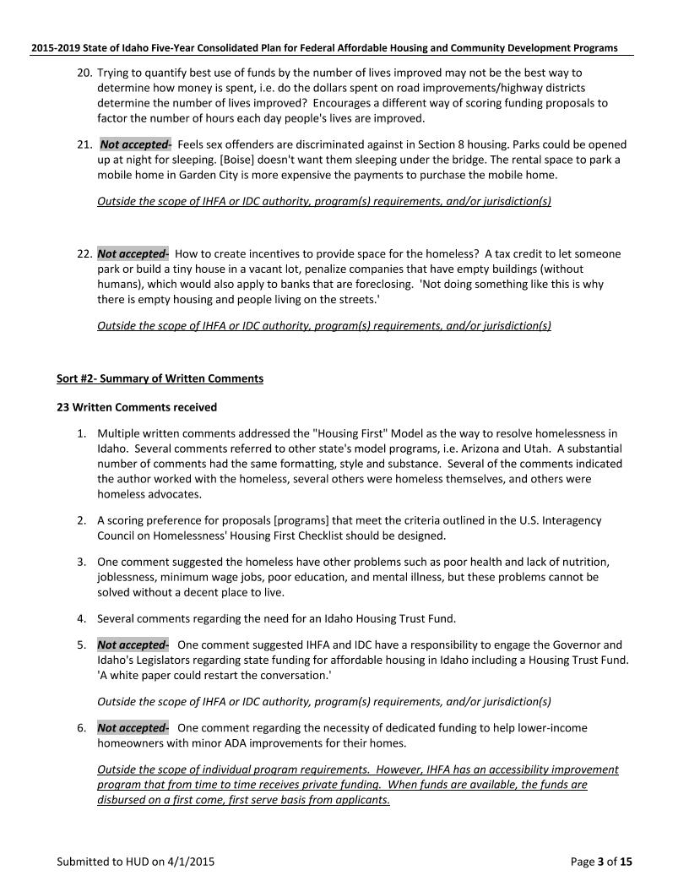

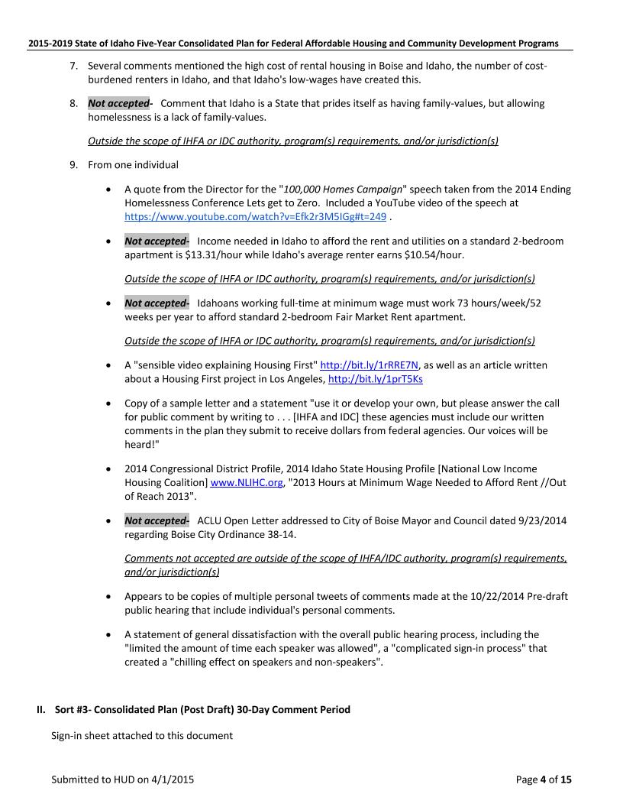

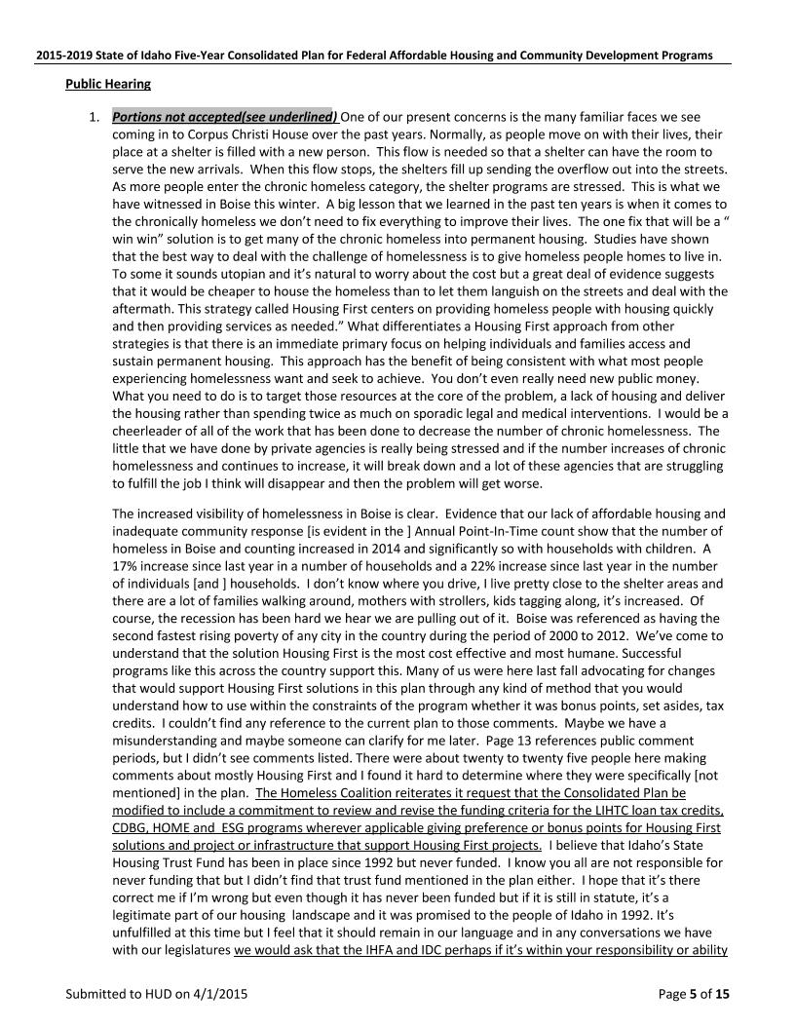

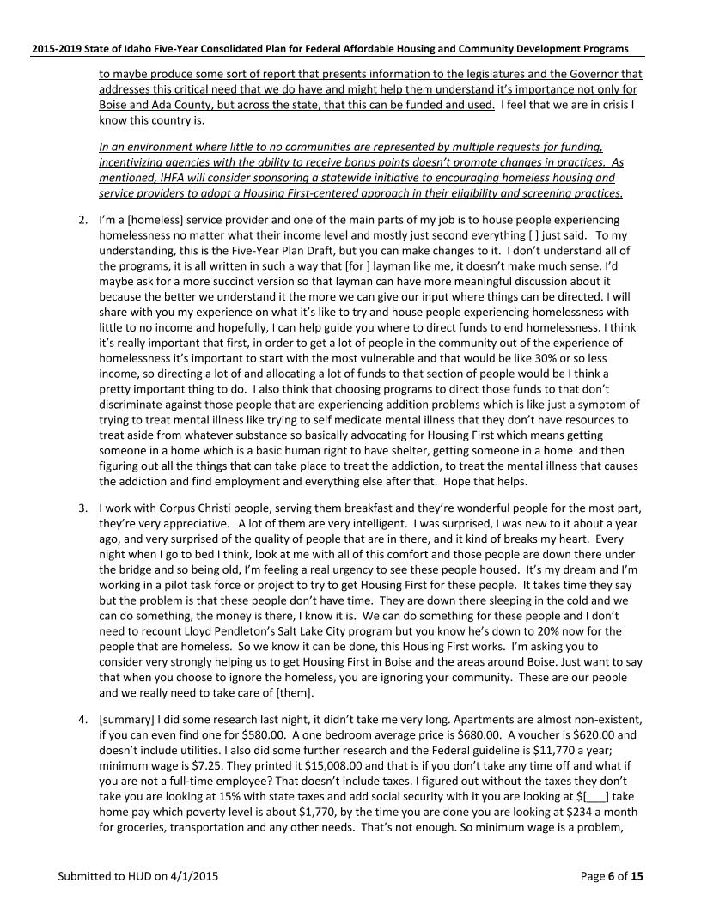

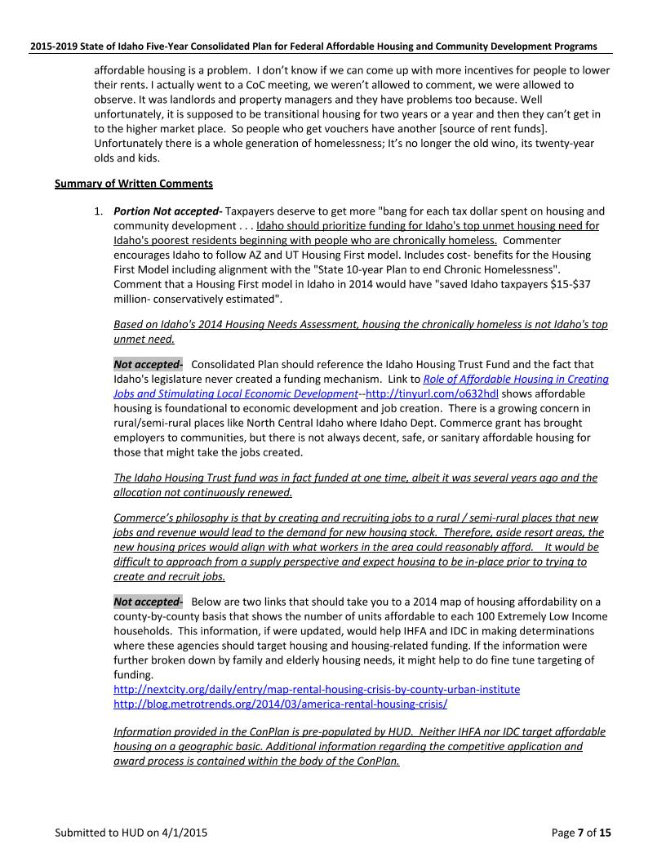

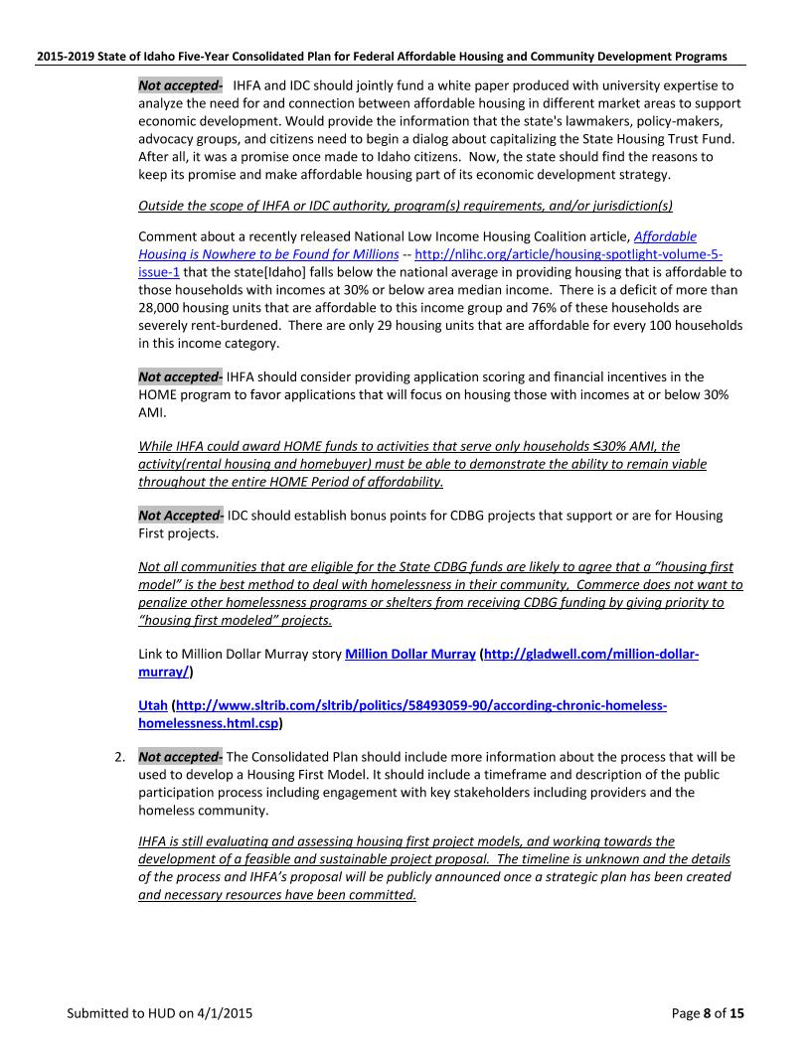

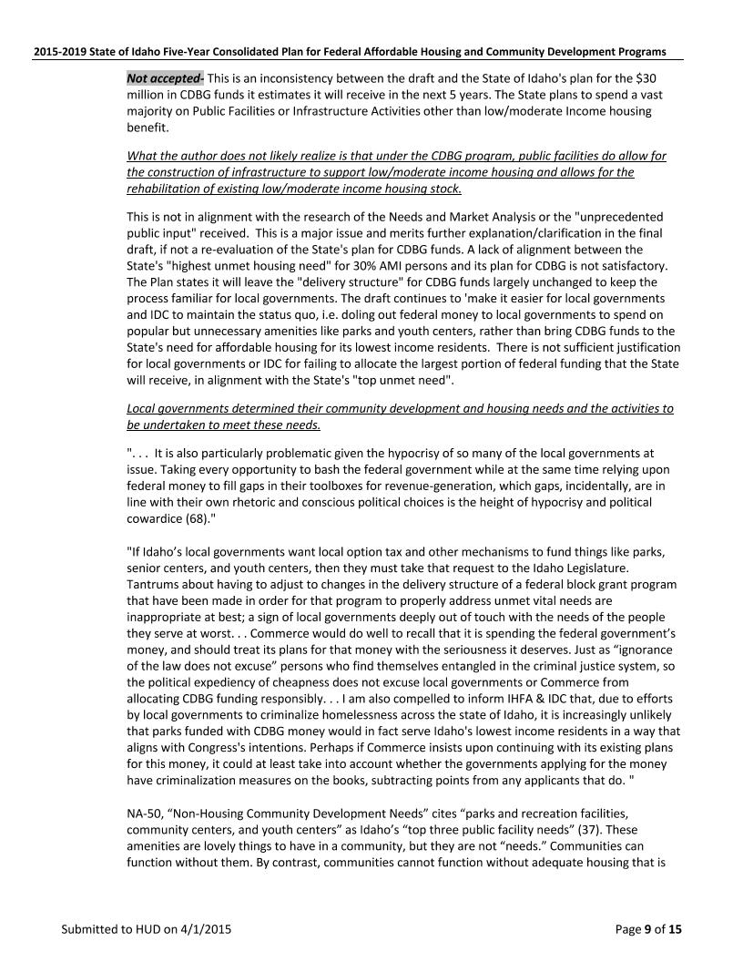

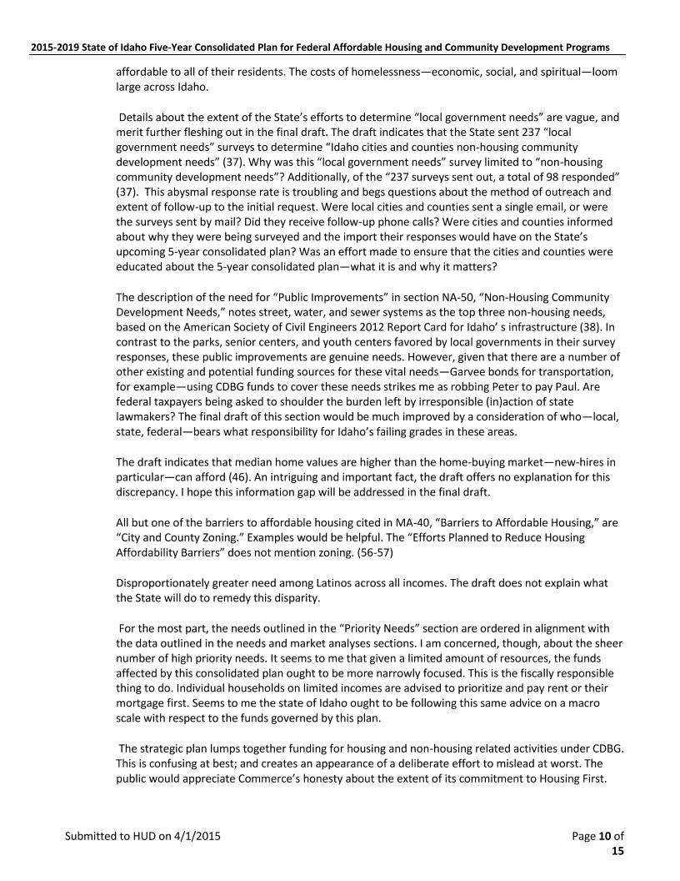

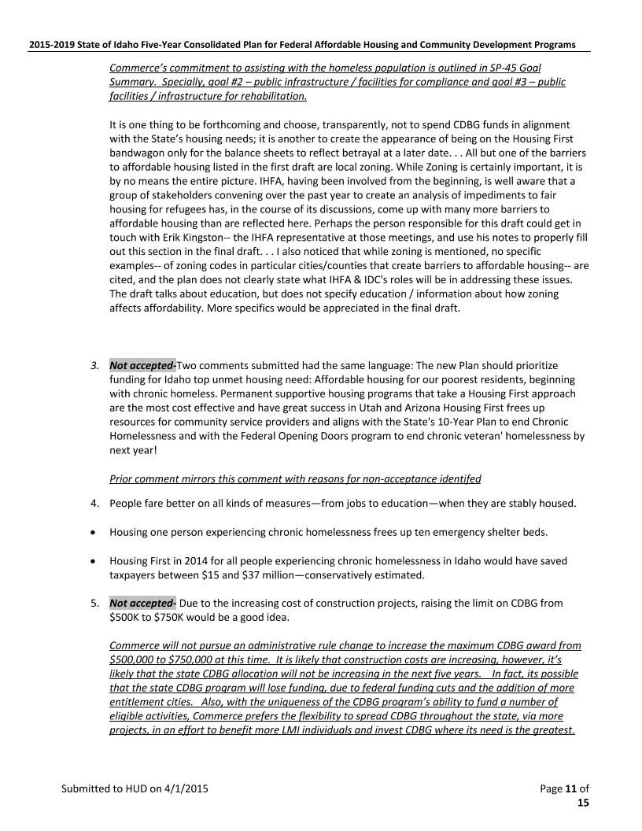

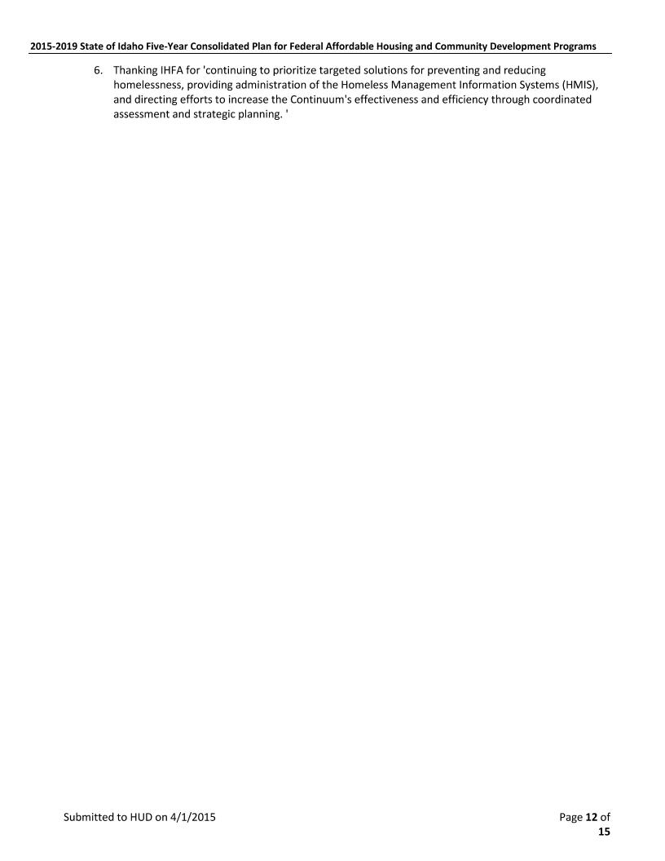

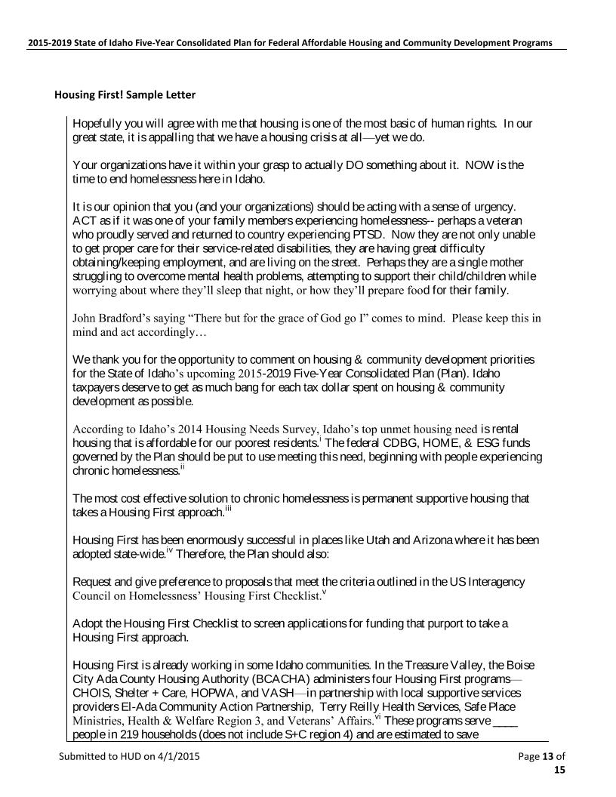

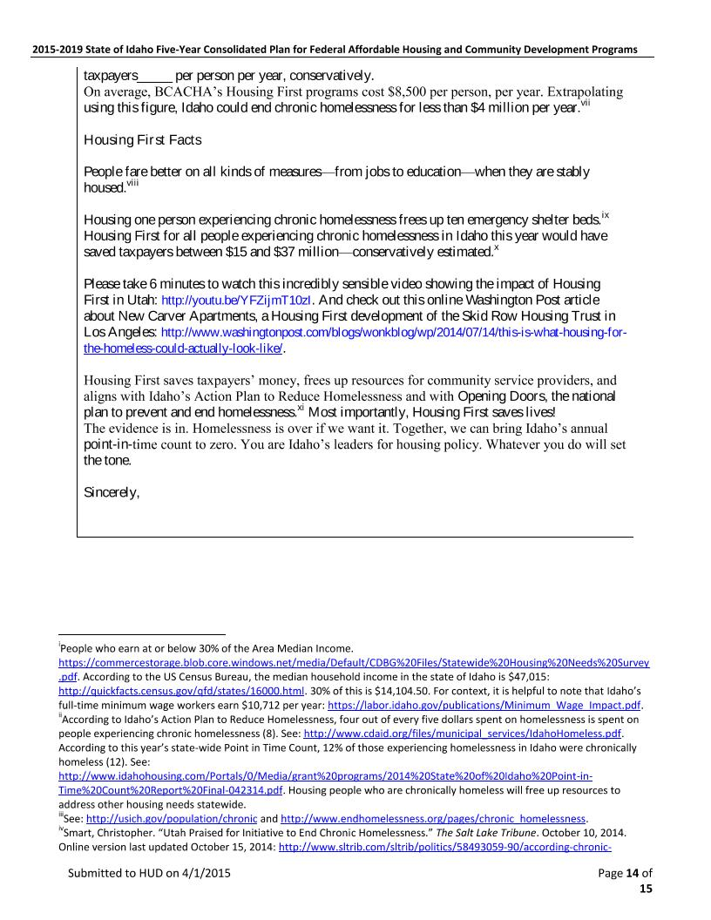

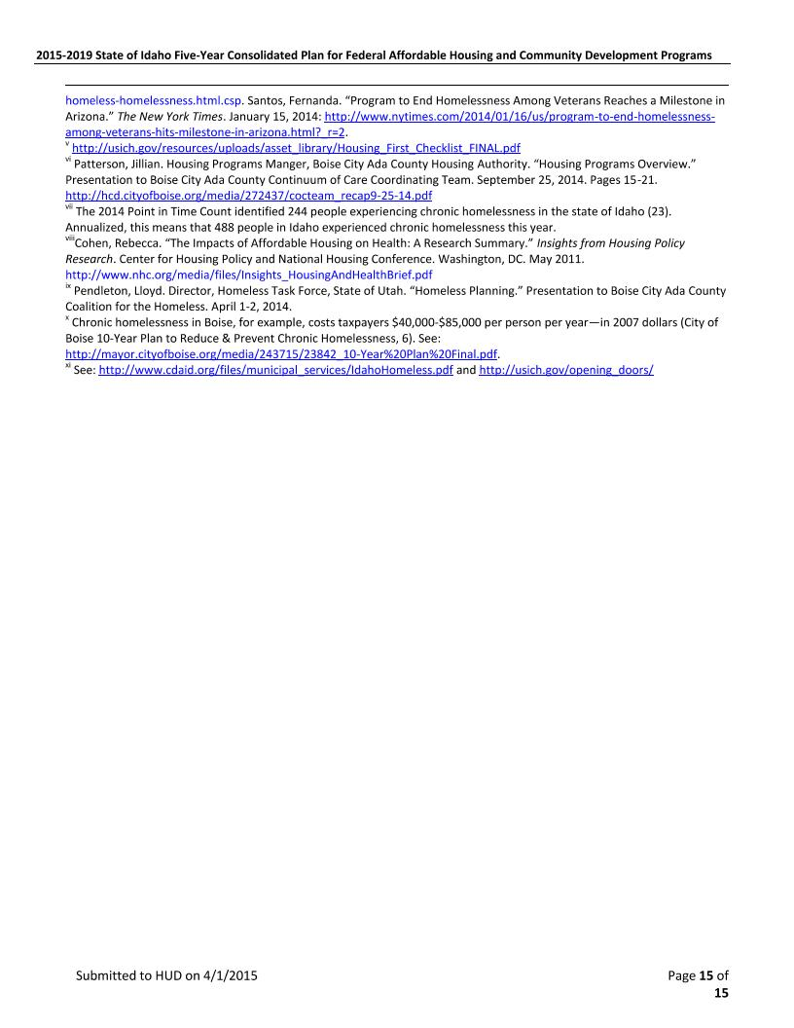

## 

# UNIQUE APPENDICES

## ES-05- Executive Summary- Summary of Objectives and Outcomes

### Idaho Department of Commerce

### CDBG Program

Over the next five years, the goals and indicators for the CDBG program are as follows:

**Public Facilities / Infrastructure - Compliance:** Obligate/Expend 25% of the five year allocation on activities that brings public facilities systems (infrastructure, community facilities, public utilities) into compliance with environmental laws, federal and state standards, industry standards, building codes, and best management practices.  These activities over a five year period should benefit approximately 108,225 individuals.

**Public Facilities / Infrastructure - Rehabilitation**: Obligate/Expend 30% of the five year allocation on activities that include the rehabilitation, replacement, and/or remodeling of public facilities (infrastructure, community facilities, public utilities an affordable housing) systems.  These activities should benefit approximately 108,225 individuals.

**Public Facilities / Infrastructure – New Construction:** Obligate/Expend 25% of the five year allocation on the new construction of a public facility (infrastructure, community facilities, and public utilities) or extension of public facilities to an eligible service area.   This includes new infrastructure to support affordable housing and housing related activities.  These activities should benefit approximately 108,225 individuals.

**Economic Development – Job Creation:** Obligate/Expend 10% of the five year allocation on public infrastructure improvements for business expansion and subsequent job creation for low-to-moderate income persons. These activities should create 300 jobs.

**Economic Development – Downtown Revitalization:** Obligate/Expand 10% of the five year allocation on public infrastructure improvements to prevent blighted downtown areas.   These activities should improve eight (8) downtowns.

**Technical Assistance-** These activities will include furthering fair housing, and other training and technical assistance.

### 

### Idaho Housing and Finance Association

### Affordable Housing Trust Fund

A Housing Trust Fund is one way a state, city, or county can help fund affordable housing activities. Examples of how some state generate revenue for their housing trust fund include real estate or transfer taxes, interest on broker, title and real estate escrow accounts, document recording fees, eviction court fees, unclaimed property or lottery funds, etc. Currently 47 states, including the District of Columbia, have created at least one housing trust fund. Idaho is one of five states that created a housing trust fund but failed to create the funding mechanism. Because there is no funding mechanism, this effectively eliminates state funding to help address Idaho's affordable housing needs. Accordingly, Idaho is dependent on Federal housing programs, such as the U.S. Department of Housing and Urban Development, the U.S. Department of Agriculture-Rural Development), the U.S. Department of Treasury (Low-Income Housing Tax Credit Program) and the private sector to meet its affordable housing needs.

### 

### HOME Program

Over the next five years, the HOME program will:

**Goal: Provide Decent Affordable Housing to Low-income Households and Individuals**

**Objective: Create and Preserve Housing Affordability For Low-Income Households**

**Outcomes**

* Construct existing affordable rental housing throughout Idaho- 1042 Units(includes Low-Income Housing Tax Credit Program)
* Preserve existing rental housing through rehabilitation- 400 Units(Includes Low-Income Housing Tax Credit Program)
* Construct and rehabilitate existing affordable single-family homebuyer units then assist low-income families and individuals to become homeowners to encourage stability in local communities throughout Idaho- 500 Units
* Provide Downpayment/closing cost assistance to assist low-income households purchase a home to encourage stability in local communities throughout Idaho- 175 Units

**Objective: Provide Decent Affordable Housing**

**Objective: Provide Suitable Living Environment**

**Outcome**

* Develop a HOME-TBRA Program during PY2015 that will provide rental assistance for approximately 80 families/individuals during the remainder of the Consolidated Plan.

The 2015-2019 Five-Year Consolidated Plan as submitted to HUD on or before April 1, 2015 will not contain a HOME TBRA program requirements. IHFA will develop the TBRA program during PY2015. When the program requirements have been defined, IHFA will follow the Substantial Amendment requirements as outlined in the most current Citizen Participation Plan. Following the completion of this process, IHFA will then submit an amendment to HUD-CPD. Once the amendment has been approved by HUD-CPD, IHFA will be able to implement a HOME TBRA program. The most recent Public Participation Plan for Idaho's Federal Affordable Housing and Community Development Programs can be found at <http://www.idahohousing.com/Portals/0/Media/grant%20programs/2014%20Adopted%20Citizen%20Participation%20Plan-021715.pdf>

**Objective**

Help support community-based housing development organizations (CHDOs) by providing financial assistance for day-to-day operating expenses and training to increase development capacity for affordable housing opportunities in the communities they serve.

**Outcomes**

* Provide Operating assistance grants to Certified CHDOs to help with day-to-day operating and training expenses- Up to 5% of each annual allocation
* Provide Pre-development loans to Certified CHDOs to explore the feasibility of potential CHDO-eligible project activities. Will not to exceed 10% of the total amount of CHDO Set-Aside for CHDO-eligible project activities.

### ESG Program

Over the next five years, the ESG program will continue to provide emergency shelter and service solutions to homeless families and individuals.  ESG subrecipients will be actively engaged in homeless initiatives backed by the Balance of State Continuum of Care and IHFA.  Homelessness efforts in Idaho will soon include an improved coordinated assessment system and the development of Housing First projects.  ESG activities will promote, endorse, and participate in these activities

Evaluation of Past Performance

The grantees prepare and submit a Consolidated Annual Performance Evaluation Report (CAPER) to HUD 90 days after the start of the next program year. Because of these submission requirements, the evaluation of past performance in this Consolidated Plan will include 4 of the 5 years in the current 2010-2014 Consolidated Plan at the time of submission to HUD.

CDBG program years (2010-13)

Goal: 45% to 60% of CDBG obligated / expended on activities that met the Suitable Living Environments goal.  After four years CDBG equates to 50% = Goal Met.

Goal: 20% to 40% of CDBG obligated / expended on activities that met the Expand Economic Opportunities goal.  After four years CDBG equates to 18% - Goal not Met.

HOME Investment Partnerships Program (2010-2013)

**Rental Housing:** Goal- 100 units/1128 completed (Includes HOME, NSP, and LIHTC units). Goal Met

**Homeownership Housing**: Goal-2000 units/434 completed. Goal Not Met  

**Non-Homeless Special Needs**

**Elderly (62+): Goal-**75 units/ 64 units completed.   Goal Not Met

**Handicap Accessible Units:** Goal-25 units/ 38 units completed. Goal Met

**Developmental Disability:** Goal-25 units/ 0 completed. Goal Not Met

**HIV/AIDS:** Goal-225 rental vouchers/ 245 households assisted. Goal Met

**Victims of Domestic Violence:** Goal 20 units. Goal Not Met

ESG Program

Over the next five years, the ESG program will continue to provide emergency shelter and service solutions to homeless families and individuals.  ESG subrecipients will be actively engaged in homeless initiatives backed by the Balance of State Continuum of Care and IHFA.  Homelessness efforts in Idaho will soon include an improved coordinated assessment system and the development of Housing First projects.  ESG activities will promote, endorse, and participate in these activities.

## PR-15 Citizen Participation

In preparing for the consolidated planning requirements, the *2014 Public Participation Plan for Idaho's HUD-CPD Affordable Housing and Community Development Programs* was adopted.

Below is the summary of the public participation process for the Consolidated Plan. It included two (2) 30-day  comment periods as well as two (2) public hearings. In addition, IHFA commissioned a 2014 Statewide Housing Need Survey and Housing, Demographic, and Transportation Report. IDC conducted a Community Development Needs Survey.

### Pre-Draft

* IHFA commissioned a Statewide Housing Needs Survey in June of 2014. Invitations to participate in the survey were mass emailed to more than 3,700 stakeholders, including units of local government, residential housing lenders, public housing authorities/owners, HOME/LIHTC/USDA-RD/Section 8 rental housing owners, developers and management companies, federal housing program administrators, and service providers. In addition to the mass email distribution, legal notices were published in Idaho's major newspapers, including the all-Spanish newspaper, inviting the public to participate in an anonymous online survey. Respondents were asked to respond to a series of questions regarding their community's current housing and homeless needs and priorities.  The survey and results are found online at [**http://www.idahohousing.com/ihfa/grant-programs/plans-and-reports.aspx**](http://www.idahohousing.com/ihfa/grant-programs/plans-and-reports.aspx)
* IHFA commissioned an *Idaho County by County Housing, Demographic, and Transportation  Report.* This report is available online [**http://www.idahohousing.com/ihfa/grant-programs/plans-and-reports.aspx**](http://www.idahohousing.com/ihfa/grant-programs/plans-and-reports.aspx)
* IHFA and IDC sought input from agencies and units of local government regarding affordable housing and community development needs.
* The Pre-draft 30-day comment period was October 1-October 30, 2014.  One public hearing to receive oral and written comments was held at IHFA's offices in Boise, Idaho on October 22, 2014. A Summary of Public Comments is attached to this Consolidated Plan.
* Legal notices for the *pre-draft* 30-day comment period and one public hearing were published in Idaho's major newspapers, including the *El Hispano.* IHFA also reached out to the mayors of Twin Falls, Pocatello, Moscow, Meridian, Lewiston, Idaho Falls, Coeur d’ Alene, and Blackfoot, the City of Boise, Idaho Continuums of Care, the Fair Housing Forum, the Director of Idaho Health and Welfare, Regional Housing Coordination Round Tables participants, and the Idaho Rural Partnership Foundation, and asked for input regarding their community's affordable housing and community development needs and priorities. The State of Idaho Division of Health and Welfare was consulted regarding Lead-based paint programs and anti-poverty strategies.

### Post Draft 30- Day Comment Period

* A summary of written and oral comments received during the second comment period are attached to this Consolidated Plan.
* Proof of publication(legal notices) are attached to the Consolidated Plan
* Emails to Idaho's Major libraries and IHFA branch offices are attached to the Consolidated Plan
* The Post Draft (second and final) 30-day comment period was held February 23-March 24, 2015
* One public hearing- IHFA Main Office, Boise Idaho on March 5, 2015.

|  |  |  |
| --- | --- | --- |
| MA-35-Idaho Facilities And Services For Non-Homeless Persons Requiring Supportive Housing ***The State Of Idaho Does Not Own Or Administer Any State Housing Programs*** | | |
| **Disabilities** | | |
| **Facilities** | | Idaho State School and Hospital – Specialized services for the most severely impaired persons with developmental disabilities. Provides safety net for those who have no other placement options and pursues the most appropriate opportunities for clients who are ready to leave the facility. Discharges are to available community-based services such as supported living with the goal of increasing the ability to return clients to their homes. |
| Intermediate Care Facilities – Group living for adults and children with developmental disabilities and intense needs to support. | | |
| Licensed Residential and Assisted Living Facilities – Group living arrangements for adults who have varying needs for support. | | |
| Certified Family Homes – Available to adults with developmental disabilities and are generally limited to two or three non-family members in each home. | | |
| **Supportive Services** | | State of Idaho Department of Health and Welfare  Family Support Program- Designed to enhance family’s capacity to care for a family member in the home. Services include respite care, specialized evaluations, adaptive equipment, therapies, transportation, specialized clothing, and housing modifications. |
| Council on the Deaf and Hard of Hearing – Provides Educational Interpreter Quality Assurance, Educational Interpreter Guidelines, support for assistive technology centers | | |
| Advocacy/Protection/Legislative –Numerous coalitions, groups, and non-profits work around the State work to promote advocacy and equitable treatment of persons with disabilities. | | |
| Centers for Independent Living - CILs are nonresidential, community based, cross-disability, private, nonprofit organizations that are designed and operated by individuals with disabilities. Services include Information and Referral Services, Independent Living Skills Training. Other services offered at Idaho CILs include assistance obtaining legal services, housing, assistive devices, and communication services. Individual and Systems Advocacy | | |
| Disability Specific Organizations – Supportive services are offered through a variety of foundations, non-for –profit and private organizations for Attention Deficit Disorder, Autism, Brain Injury, Blind and Visual Impairments, Cerebral Palsy, Epilepsy, Mental Health and Learning Disabilities. | | |
| Vocational Rehabilitation – State program to assists persons with disabilities to prepare for, secure, retain, or regain employment. | | |
| **Each of Idaho’s Health Districts provides supportive services for persons with HIV/AIDS via the Ryan While Titles II and I funding** | | |
| Idaho Housing Opportunities for Persons with AIDS/HIV (HOPWA):  Includes supportive permanent housing and supportive services through the following contracted providers:  North Idaho AIDS Coalition (NIAC) represents 5 counties in Idaho  North Central District Health Department (NCDHD) Represents 5 counties in North-Central Regions  Boise City/Ada County Housing Authority (BCACHA)  South Central District Health Department (SCDHD)  Southeastern Idaho District Health Department (SIDHD)  District Seven Health Department  North Idaho AIDS Coalition  Family Practice Residency | | |
| Intensive Case Management Services – Available through numerous non-for profit, state-funded and private agencies throughout the State including but not limited to Living Independence Network Corp (LINC), Co-Ad, Inc., Mountain States Group, Community Partnerships of Idaho, Development Workshop, Inc, Joshua Smith Inc., LIFE Inc. | | |
| **Idaho Housing and Finance Association** | | |
| HOUSING SERVICES |  | |
| EMERGENCY SOLUTIONS GRANTS (ESG)- Authorized by Title IV of the Stewart B. McKinney-Vento Homeless Assistance Act (42 U.S.C. 11371-11378). The grant is available to units of general local government or private non-profit organizations. The purpose of the program is to accommodate the beginning steps in Idaho's Continuum of Care process by preventing homelessness, rapidly re-housing the homeless, and providing emergency shelter that meets immediate needs and enables persons experiencing homelessness to move toward independent living. Administered by Idaho Housing and Finance Association | | |
| CONTINUUM OF CARE (COC) PROGRAM- The [**HEARTH Act**](https://www.hudexchange.info/homelessness-assistance/hearth-act) consolidates the three separate McKinney-Vento homeless assistance programs, including the Supportive Housing Program, Shelter Plus Care Program, and Section 8 Moderate Rehabilitation SRO Program into a single grant program known as the Continuum of Care (CoC) Program. The former Supportive Housing Program (SHP) helps develop and provide housing and related supportive services for people moving from homelessness to independent, supportive living. Program funds help homeless people live in a stable place, increase their skills and their income, and gain more control over the decisions that affect their lives. Administered by Idaho Housing and Finance Association | | |
| IHFA SECTION 8 HOUSING CHOICE VOUCHER PROGRAM Under contract with HUD, Idaho Housing administers federal rental assistance programs that help low-income families and elderly or disabled individuals obtain decent, affordable rental housing. To be eligible for rental assistance, tenants must qualify under HUD income limits and other eligibility criteria. Tenant incomes, allowances and family compositions are all verified and recertified annually by Idaho Housing staff. Tenants under these programs pay 30 percent of their adjusted gross monthly income for rent and utilities. Or, if they can afford it, a family may choose a unit where their portion of rent and utilities may not exceed 40 percent of their monthly adjusted income. As a tenant’s income changes, the tenant’s rent share changes proportionately. The demand for rental assistance far exceeds the supply. Applicants are usually placed on waiting lists from two to 24 months, depending on their current housing status and the area of the state. Persons requiring rental assistance can apply at the Idaho Housing Branch Office that serves their region. Idaho Housing branch offices are located in Coeur d’Alene, Lewiston, Twin Falls and Idaho Falls  Preferences:   * Household member has a terminal illness that is considered by a physician to be in the final stages (must be verified by a medical physician when we reach your name on the waiting list.). * Household that includes one or more children; under age 18 or disabled) A household where the head or co-head of household or the sole member is: U.S.C. 423) or Section 102(7)(b) of the Developmental Disabilities Assistance and Bill of Rights Act (42 U.S.C. 6001(7)) or has been determined to have a physical, mental, or emotional impairment that is expected to be of long-continued and indefinite duration; substantially impedes the ability to live independently and is of such a nature that the ability to live independently could be improved by more suitable housing conditions | | |
| **FAMILY SELF-SUFFICIENCY PROGRAM** Families who participate in the federal Section 8 Housing Choice Voucher program are eligible to be part of Idaho Housing's Family Self-Sufficiency (FSS) Program. FSS is a voluntary program that helps families become economically independent. Through this program households learn to set goals that always include employment and often include home ownership. FSS Program participants agree, via a five-year contract, to establish and attain specific goals. The program's goals include assisting families to become free of all forms of state and federal welfare through employment. FSS Specialists in each branch office meet with household members to establish goals that might include: employment, job training, education, job search, money management, credit repair, and home ownership. Working as a team, the family, local service providers and the FSS Specialists help families identify and eliminate obstacles to self-sufficiency. Participants may receive an interest-bearing escrow (savings) account that accrues as their household's portion of the rent increases because of an increase in earned-income. The tax-free account is given to the family when they complete their FSS Contract of Participation and are free of welfare for 12 consecutive months. | | |

## MA-40 Barriers to Affordable Housing 91.310(d)

*IHFA and IDC supports accredited training for Idaho planning professionals, policy makers and government staff to improve compliance in land-use, zoning and building codes, and other housing policies. Letters of support for such training [were] provided by the Association of Idaho Cities, The Community Planning Association of Southwest Idaho (COMPASS), The Idaho Chapter of the American Planning Association, and the University of Idaho Urban Research and Design Center.*

1. City and county zoning that does not allow small lots for single-family detached housing in at least one district. Minimum lot size requirements are a type of restriction that can increase housing costs (since land costs are a significant portion of total development costs).
2. City and County Zoning that does not allow construction of multifamily housing and mapping enough land into the district to allow a reasonable chance that some multifamily housing will be developed.  Local planning and zoning policies continue to represent a cause of increased housing costs in some areas.
3. City and county zoning that does not allow manufactured homes in at least one residential zone.
4. City and county zoning that limit house or dwelling unit sizes.  Minimum house size requirements have been identified as significant cause of increased housing prices.
5. Lack of inclusionary group home zoning policies—including congregate care, nursing home and assisted living facilities at the city and county level—could subject the city or county to a developer’s request for “reasonable accommodation.” Failure to provide “reasonable accommodation” could be a violation of federal law.
6. City and county zoning that does not allow accessory dwelling units in at least one zone district.
7. City and county zoning that does not allow mixed use (residential units) in at least one commercial zone district.
8. City and county zoning that does not allow for lower parking standards.  A lower standard can and generally should be used for affordable housing, multifamily housing, group housing and special needs housing.
9. City and county zoning that does not allow nonconforming structures to be rebuilt with the same number of units as before following a disaster.  Affordable units may be lost and allowing rebuilding with the same number of units will preserve these units in the housing stock.
10. City and county zoning that does not provide common incentives to encourage affordable housing.  Incentives alone are often not enough to make development of affordable housing feasible; they can be part of a broader package of incentives.
11. State-level property tax waiver policy restricts opportunities for many affordable housing developers and managers to create a range of housing affordable to local residents.

As previously noted, neither IHFA nor IDC (grantees) are part of the legislative branch; therefore, it is beyond our ability to make or alter legislation or policy. However, grantees perceive a role in influencing policy makers and practitioners through education and outreach, the theory being that increased general awareness of the benefits of housing affordability creates a more receptive environment at all levels of government.

In the IHFA's long experience working in Idaho, this type of outreach is essential to preserve or construct a range of housing that is affordable to households throughout the state. To this end, one of the considerations IHFA makes available is a brief summary entitled: [*Fair housing compliance: local government considerations*](http://fairhousingforum.org/wp-content/uploads/Fair-housing-compliance_local-government-considerations3.pdf)*.*

**Please note.** Information and findings regarding Barriers to Affordable Housing contained in the [*2011 Analysis of Impediments*](http://fairhousingforum.org/uncategorized/2011-analysis-of-impediments/)represent only a point-in-time survey and analysis. Individual counties may have subsequently modified their policies and procedures; individual cities and communities may have policies and procedures that differ substantially from their surrounding county. Information collected indicated *some* Idaho counties’ land use regulations and zoning policies *may* create barriers to affordability. This should not be interpreted to mean *all* county land-use policies (or the cities within those counties) were or are problematic.

[*Section VI. Land-Use Regulations as Barriers to Affordable Housing*](http://fairhousingforum.org/wp-content/uploads/Excerpt-from-2011-AI_Land-use-Regulations-and-County-Summaries.pdf) contains a county-by-county assessment of policies and recommendations. This provides the context that clarifies the linkage between local policy(s) and housing diversity and affordability

*State-level* barriers to affordability (as referenced in the 2011 Analysis of Impediments):

No state funding or resources devoted to Idaho's [Housing Trust Fund structure subsequent to its creation in 1992](http://www.legislature.idaho.gov/idstat/Title67/T67CH81SECT67-8101.htm);

* Continuous [legislative opposition to local control](http://www.idahopress.com/members/local-option-tax-talking-in-circles/article_789f6620-75ba-11e4-8c6f-e73e78d73763.html) over raising revenue. This effectively limits the ability of cities and counties to support housing affordability;
* Efforts to enact inclusionary zoning ordinances or ‘in-lieu fees’ to support local housing affordability have been eliminated or withdrawn because of [lawsuits—and the threat of lawsuits. These have come from individuals and the Mountain Central Board of Realtors supported by the Idaho Association of Realtors;](http://www.wrjournal.com/articles/2008/08/01/news/local_news/fstory.txt) in the case of [McCall, ID, the Fourth Circuit Court sided with Realtors](http://activerain.trulia.com/blogsview/399507/workforce-housing-ordinance-struck-down-by-idaho-district-court) (see p. 14)

## Affirmatively Furthering Fair Housing

*Grantees acknowledge Idaho's next Analysis of Impediments is due in PY 2016. Grantees also acknowledge HUD re-opened the comment period for the proposed new rule regarding AFFH on January 15, 2015 because of the concerns expressed regarding State Jurisdiction's ability to use and complete the new AFH assessment tool designed for Entitlement Communities. In re-opening the comment period, HUD indicated it was allowing entities (States) to submit the new AFH format at a later date so it could address these concerns. Idaho State Grantees look forward to receiving clear guidance from HUD regarding this matter as soon as possible.*

The research conducted for the 2011 State of Idaho Analysis of Impediments identified three impediments. An “impediment” may have the effect of restricting housing choices or the availability of housing choices on the basis of race, color, religion, sex, disability, familial status, or national origin.

**Impediments**

**Fair Housing Impediment No. 1-** Idaho counties’ land use regulations and zoning policies ***may*** create barriers to fair housing.

**Fair Housing Impediment No. 2-** Idaho’s state fair housing law does not provide protection based on familial status.

**Fair Housing Impediment No. 3**-State policies that limit local government ability to raise revenues for housing activities may restrict the ability of counties to address impediments.

## MA- 50- Non-Housing Community Development Assets

Describe any major changes that may have an economic impact, such as planned public or private sector investments or initiatives that have affected or may affect job and business growth opportunities during the planning period. Describe any needs for workforce development, business support or infrastructure these changes may create.

Private Investment:

With the geographical size and somewhat three distinct regions within the State of Idaho (north, central, eastern) there is no one private sector investment(s) that is likely to have a significant effect on job and business growth opportunities statewide. However, significant private investment that may create job growth within a region include: Areva’s investment in an uranium enrichment facility; Union Pacific’s investment in an intermodal rail shuttle service, cheese and yogurt producer’s continued expansion in central Idaho, and increased exporting of Idaho manufactured agriculture equipment, and demand for Idaho’s high tech sector knowledge and products. One private investment activity that is affecting statewide job growth is the continuing trend of older individuals moving to Idaho to retire or semi-retire. This is leading to an above average increase in residential real estate development.

Public Investment and Initiatives:

With a likely decline of federal funding investment into Idaho over the next five years this will decrease and delay some economic development growth opportunities. Also, whereas, state government has been somewhat reluctant to cover federal funding gaps for education and transportation and is unlikely to develop new public financing tools, funding pressures will fall onto local governments. Many of these local governments are rural cities and counties, therefore, have limiting revenue resources.

Over the past five years there has not been an overabundance of investment into economic development activities with exception to a new statewide tax abatement program and small business collateral loan program. The projected need over the next five years for economic development activities (identified below) are as follows:

* Job training will be high
* Business assistance programs (tax abatements, low interest or loan guarantees, or public absorption of site development) will be moderate

Workforce Needs

To understand the labor needs it needs to be understood what are likely to be Idaho highest job growth sectors. Having this data should transcend into those sectors that will have a higher than average need for educated and trained individuals. The list below identifies the top ten job growth sectors for the next ten years.

* Healthcare/Social services, to add 21,800 jobs
* Retail Trade to add 16,800 jobs
* Leisure/Hospitality to add 14,700 jobs
* Professional/business services to add 11,800 jobs
* Construction to add 11,600 jobs
* Manufacturing to add 6,000 jobs
* Education to add 5,700 jobs
* Financial to add 4,500 jobs
* Wholesale to add 3,600 jobs
* Agriculture to add 3,400 jobs

This list, however, does not breakdown the specific skill sets needed within a sector.

Infrastructure Needs In Idaho

Dams – (Grade = C) - The average date of construction completion for Idaho dams is 1952. As a result, funding needed to service, maintain, repair, or replace dams will continue to increase at an accelerated pace.

Drinking Water – (Grade C+) - Repair and replacement of distribution lines is well below ideal rates. Some municipalities do not have significant and active source protection programs. Recent growth in the state has contributed to somewhat new facilities resulting in better grades than likely seen in other areas of the United States. Idaho’s challenge will be to maintain existing systems and improve conditions for older systems.

Wastewater- (Grade B-) Replacement and repair of collection pipelines is not keeping pace with the ageing infrastructure. Many wastewater systems have not been video inspected in the last 10 years. Recent growth in the state has contributed to somewhat new facilities resulting in better grades than likely seen in other areas of the United States. Idaho’s challenge will be to maintain existing systems and improve conditions for older systems.

Aviation – (Grade = C) Idaho has more aviation services per capita than most Americans, however, incompatible land uses around airports reduce their function and value.

During the next 10 years, Idaho is predicted to experience a shortfall of its share of airport funding.

Energy – (Grade = C+) Energy prices remain low in Idaho, but as Idaho continues to grow, so does the demand for energy. Transmission is increasingly vital.

State Highways – (Grade = D+) The existing budget for the state highway system is well below the need and Idaho’s reliance on federal funding will limit our ability to meet future needs.

Local Highways - (Grade = C-) Most of the local highways across Idaho meet their capacity needs, but funding shortfalls and limitation will hamper improvements.

Rail – (Grade = C+ / Grade = D passenger) – Private companies continue to invest in rail improvements for Idaho’s critical freight rail system. Passenger rail options are limited across the state.

School Facilities – (Grade = C-) School facilities continue to age and overcrowding will continue to challenge school districts. The lack of recent assessments prevents a complete understanding of the growing needs.

Bridges – (Grade = D) Many bridges are reaching the limits of their life expectancy. Current funding levels are far outpaced by the replacement need, particularly for critical bridges.

Transit – (Grade = D) Transit in Idaho is safe and relatively efficient, but lacks the accessibility and funding to meet the needs. *Source: ASCE 2012 Report Card

## NA-10 Housing Needs Assessment

Summary of Housing Needs

Idaho's trends for the most part, reflect national trends. Idaho affordable housing and affordable housing needs are no exception. 

While Idaho's official unemployment rate continues to drop, an indication Idaho's job market is back, it is important to note these numbers do not reflect the underemployed or those who have stopped looking for work. In addition, many of the pre-recession high paying tech jobs are gone. Driver's license data indicates many Idahoans moved to places like Washington, Utah, Oregon, Wyoming, Montana and North Dakota and Texas (30,000  Idahoans in 2012). In 2012, Idahoans earned less than residents in all other states except Mississippi.

And in 2013,  Idaho had the largest percentage of minimum wage workers in the county with the number of workers earning the legal minimum wage ($7.25) increasing by 60%[State Impact Idaho: "The minimum wage in Idaho, 75 years later": June 25, 2013; Emilie Ritter Saunders]. The 2014 Idaho Housing, Demographics, and Transportation Report commissioned by Idaho Housing and Finance Association(see appendices) indicates that the lowest income earners in every county in Idaho have housing and transportation costs that exceed 100% of their income.  This usually means they are working more than 1 job to make ends meet.

Basic housing trends for the next 5 years: Low inventory and high demand for both rental and homebuyer housing will keep prices highly competitive; lower homeownership and higher rental rates; and an increasing need for housing options for families and individuals who are homeless.  Using historical data as the predictor, Idaho's overall population will increase an average of 2% each year. One could use this and predict Idaho's housing needs will increase 2% a year for the next 5 years or 10% by the end of Program Year 2019. However, the factors mentioned above will create an even greater challenge for Idaho's increasing low-income populations and their affordable housing needs for the next 5 years. (Idaho County-by-county data regarding cost burdened renters and homeowners, percentage of residents, children, and seniors living in poverty is available online at http://www.idahohousing.com/ihfa/grant-programs/plans-and-reports.aspx *2014 Idaho Housing Needs Survey* and the *2014 Idaho County, Demographic, Housing and Transportation Data Report*

To project housing needs of special populations and by family type, a compound annual growth rate of 1.65 percent was applied to the current level of housing needs by population type. This growth rate is based on the population growth that occurred in Idaho during the past decade. The current level of housing needs was based on available data from HUD (CHAS data), the U.S. Census and other state and national sources. In some cases, housing need is measured by cost burden. In others, poverty is used as a proxy. In other cases, data on housing needs by population type captured in national surveys are extrapolated to Idaho’s population.

The resulting projected five-year housing needs by family type and special need follow.

Extremely low income households: HUD CHAS data estimate that 35,000 extremely low income (< 30% HAMFI) households have one or more housing needs. In five years, this number is estimated to be 38,500.

Low income households: HUD CHAS data estimate that 23,000 low income (30-50% HAMFI) households have one or more housing needs. In five years, this number is estimated to be 25,000.

Moderate income households: HUD CHAS data estimate that 17,500 extremely low income (50-80% HAMFI) households have one or more housing needs. In five years, this number is estimated to be 19,000.

Middle income households: HUD CHAS data estimate that 6,250 extremely low income (80-100% HAMFI) households have one or more housing needs. In five years, this number is estimated to be 6,700.

Renters: Currently, according to HUD CHAS data, 40,500 renter households in Idaho have one or more housing problems, most of which is cost burden. If the level of cost burden stays the same among renters, in five years, the number of renters with housing needs could reach 44,000.

Owners: Similarly, 41,600 owners experience housing problems, mostly cost burden. In 2020, as many as 45,000 Idaho owners could have housing problems.

Elderly: 34,500 seniors (age 62 and older) currently face cost burden; by 2020, this could increase to 37,500.

Single persons: Of the 138,600 single person households in Idaho, 17,500 live in poverty and, therefore, are likely to have housing needs. In five years, the numbers of single person households with housing needs is expected to reach 19,000.

Large families: Almost 14,000 large families in Idaho are cost burdened. By 2020, more than 15,000 large families could be cost burdened.

Persons with disabilities: HUD provides detailed CHAS data on housing needs by type of disability on its [www.huduser.org](http://www.huduser.org) website (Table 6). Using the data that estimate disability sub-populations with 1 or more housing needs and applying the five year growth rate, in 2020:

10,200 Idahoans with vision and hearing impairments could have housing needs;

14,000 Idahoans with ambulatory limitations could have housing needs;

Another 14,000 Idahoans with cognitive limitations could have housing needs; and

12,000 Idahoans with self-care or independent living limitations could have housing needs.

Victims of domestic violence: Based on estimates from the CDC, (3.6% of women and 1% of men who have experienced domestic violence have some type of housing need), by 2010, as many as 1,650 Idahoans experiencing domestic violence could have new housing needs annually. This would bring the number of victims of domestic violence who have experienced violence anytime in their life and who have had or still have housing needs to nearly 29.000.

| Formerly homeless receiving rapid re-housing assistance: **Demographics** | **Base Year: 2000** | **Most Recent Year: 2011** | **% Change** |
| --- | --- | --- | --- |
| Population | 1,293,953 | 1,549,987 | 20% |
| Households | 470,133 | 575,497 | 22% |
| Median Income | $37,572.00 | $46,890.00 | 25% |

Table 59 - Housing Needs Assessment Demographics

|  |  |
| --- | --- |
| **Data Source:** | 2000 Census (Base Year), 2007-2011 ACS (Most Recent Year) |



## Projected Rental and Homeowner Occupied Units

### Number of Households Table

|  | **0-30% HAMFI** | **>30-50% HAMFI** | **>50-80% HAMFI** | **>80-100% HAMFI** | **>100% HAMFI** |
| --- | --- | --- | --- | --- | --- |
| Total Households * | 52,545 | 64,795 | 100,665 | 62,410 | 295,080 |
| Small Family Households * | 17,265 | 19,340 | 37,305 | 25,565 | 158,345 |
| Large Family Households * | 4,265 | 6,325 | 12,095 | 8,555 | 32,235 |
| Household contains at least one person 62-74 years of age | 7,000 | 11,555 | 18,425 | 11,330 | 54,570 |
| Household contains at least one person age 75 or older | 6,060 | 12,955 | 13,855 | 6,505 | 18,895 |
| Households with one or more children 6 years old or younger * | 11,150 | 13,395 | 23,325 | 13,900 | 38,895 |

Table 60 - Total Households Table

|  |  |
| --- | --- |
| **Data Source:** | 2007-2011 CHAS |

### Housing Needs Summary Tables

1. Housing Problems (Households with one of the listed needs)

|  | **Renter** | | | | | **Owner** | | | | |
| --- | --- | --- | --- | --- | --- | --- | --- | --- | --- | --- |
| **0-30% AMI** | **>30-50% AMI** | **>50-80% AMI** | **>80-100% AMI** | **Total** | **0-30% AMI** | **>30-50% AMI** | **>50-80% AMI** | **>80-100% AMI** | **Total** |
| NUMBER OF HOUSEHOLDS | | | | | | | | | | |
| Substandard Housing - Lacking complete plumbing or kitchen facilities | 930 | 860 | 565 | 350 | 2,705 | 610 | 420 | 465 | 310 | 1,805 |
| Severely Overcrowded - With >1.51 people per room (and complete kitchen and plumbing) | 375 | 490 | 680 | 125 | 1,670 | 195 | 185 | 190 | 105 | 675 |
| Overcrowded - With 1.01-1.5 people per room (and none of the above problems) | 1,515 | 1,285 | 1,860 | 840 | 5,500 | 575 | 560 | 1,690 | 1,170 | 3,995 |
| Housing cost burden greater than 50% of income (and none of the above problems) | 19,895 | 9,070 | 1,530 | 110 | 30,605 | 11,375 | 10,025 | 10,550 | 3,215 | 35,165 |
| Housing cost burden greater than 30% of income (and none of the above problems) | 3,085 | 13,320 | 15,045 | 2,525 | 33,975 | 2,645 | 6,995 | 16,725 | 12,035 | 38,400 |
| Zero/negative Income (and none of the above problems) | 2,190 | 0 | 0 | 0 | 2,190 | 2,370 | 0 | 0 | 0 | 2,370 |

Table 61 – Housing Problems Table

|  |  |
| --- | --- |
| **Data Source:** | 2007-2011 CHAS |

2. Housing Problems 2 (Households with one or more Severe Housing Problems: Lacks kitchen or complete plumbing, severe overcrowding, severe cost burden)

|  | **Renter** | | | | | **Owner** | | | | |
| --- | --- | --- | --- | --- | --- | --- | --- | --- | --- | --- |
| **0-30% AMI** | **>30-50% AMI** | **>50-80% AMI** | **>80-100% AMI** | **Total** | **0-30% AMI** | **>30-50% AMI** | **>50-80% AMI** | **>80-100% AMI** | **Total** |
| NUMBER OF HOUSEHOLDS | | | | | | | | | | |
| Having 1 or more of four housing problems | 45,430 | 23,400 | 9,270 | 2,850 | 80,950 | 25,520 | 22,380 | 25,790 | 9,600 | 83,290 |
| Having none of four housing problems | 14,630 | 41,820 | 70,470 | 34,170 | 161,090 | 10,400 | 41,990 | 95,800 | 78,210 | 226,400 |
| Household has negative income, but none of the other housing problems | 4,380 | 0 | 0 | 0 | 4,380 | 4,740 | 0 | 0 | 0 | 4,740 |

Table 62 – Housing Problems 2

|  |  |
| --- | --- |
| **Alternate Data Source Name:** |  |
| Renter and homeowner data past, present and future |  |

3. Cost Burden > 30%

|  | **Renter** | | | | **Owner** | | | |
| --- | --- | --- | --- | --- | --- | --- | --- | --- |
| **0-30% AMI** | **>30-50% AMI** | **>50-80% AMI** | **Total** | **0-30% AMI** | **>30-50% AMI** | **>50-80% AMI** | **Total** |
| NUMBER OF HOUSEHOLDS | | | | | | | | |
| Small Related | 9,670 | 9,020 | 7,265 | 25,955 | 4,105 | 5,655 | 12,030 | 21,790 |
| Large Related | 2,095 | 2,355 | 1,675 | 6,125 | 1,590 | 2,035 | 4,215 | 7,840 |
| Elderly | 2,920 | 4,140 | 2,585 | 9,645 | 5,340 | 6,715 | 6,760 | 18,815 |
| Other | 10,495 | 8,515 | 5,850 | 24,860 | 3,910 | 3,050 | 5,045 | 12,005 |
| Total need by income | 25,180 | 24,030 | 17,375 | 66,585 | 14,945 | 17,455 | 28,050 | 60,450 |

Table 63 – Cost Burden > 30%

|  |  |
| --- | --- |
| **Data Source:** | 2007-2011 CHAS |

4. Cost Burden > 50%

|  | **Renter** | | | | **Owner** | | | |
| --- | --- | --- | --- | --- | --- | --- | --- | --- |
| **0-30% AMI** | **>30-50% AMI** | **>50-80% AMI** | **Total** | **0-30% AMI** | **>30-50% AMI** | **>50-80% AMI** | **Total** |
| NUMBER OF HOUSEHOLDS | | | | | | | | |
| Small Related | 8,505 | 3,505 | 660 | 12,670 | 3,755 | 3,540 | 4,460 | 11,755 |
| Large Related | 1,880 | 620 | 40 | 2,540 | 1,460 | 1,125 | 1,165 | 3,750 |
| Elderly | 2,170 | 1,880 | 670 | 4,720 | 3,750 | 3,385 | 2,815 | 9,950 |
| Other | 9,135 | 3,585 | 475 | 13,195 | 3,160 | 2,150 | 2,270 | 7,580 |
| Total need by income | 21,690 | 9,590 | 1,845 | 33,125 | 12,125 | 10,200 | 10,710 | 33,035 |

Table 64 – Cost Burden > 50%

|  |  |
| --- | --- |
| **Data Source:** | 2007-2011 CHAS |

5. Crowding (More than one person per room)

|  | **Renter** | | | | | **Owner** | | | | |
| --- | --- | --- | --- | --- | --- | --- | --- | --- | --- | --- |
| **0-30% AMI** | **>30-50% AMI** | **>50-80% AMI** | **>80-100% AMI** | **Total** | **0-30% AMI** | **>30-50% AMI** | **>50-80% AMI** | **>80-100% AMI** | **Total** |
| NUMBER OF HOUSEHOLDS | | | | | | | | | | |
| Single family households | 1,715 | 1,485 | 1,895 | 775 | 5,870 | 635 | 665 | 1,630 | 1,020 | 3,950 |
| Multiple, unrelated family households | 119 | 165 | 225 | 160 | 669 | 135 | 80 | 250 | 270 | 735 |
| Other, non-family households | 135 | 210 | 440 | 130 | 915 | 15 | 0 | 20 | 10 | 45 |
| Total need by income | 1,969 | 1,860 | 2,560 | 1,065 | 7,454 | 785 | 745 | 1,900 | 1,300 | 4,730 |

Table 65 – Crowding Information – 1/2

|  |  |
| --- | --- |
| **Data Source:** | 2007-2011 CHAS |

|  | **Renter** | | | | **Owner** | | | |
| --- | --- | --- | --- | --- | --- | --- | --- | --- |
| **0-30% AMI** | **>30-50% AMI** | **>50-80% AMI** | **Total** | **0-30% AMI** | **>30-50% AMI** | **>50-80% AMI** | **Total** |
| Households with Children Present | 0 | 0 | 0 | 0 | 0 | 0 | 0 | 0 |

Table 66 – Crowding Information – 2/2

## NA-35 Public Housing

IHFA's branch offices maintain data on wait lists by family type, race, ethnicity and disability. The table below shows the numbers and types of families on the wait lists for tenant based Rental assistance. HFA Wait List Table Revised 7/17/2015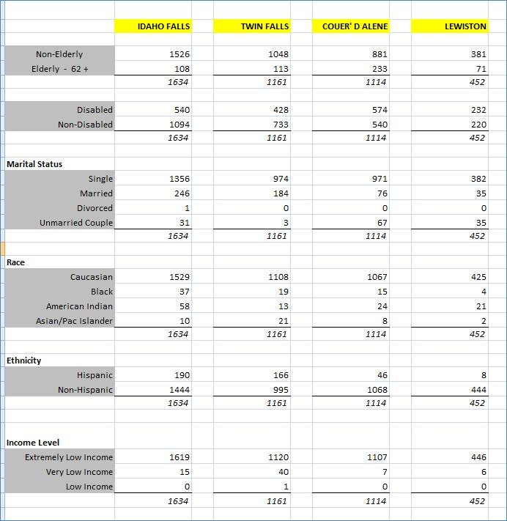

Based on the wait list tables, the most immediate need is affordable rental housing with accessibility accommodations.

PHA Plans of local jurisdictions with their own PHA were consulted for additional wait list information. These Plans were largely dedicated to capital improvement needs and did not contain data on wait lists.

Discussion: Please see above

## NA-50 Non-Housing Community Development Needs

Local Governments Community Development Needs Survey

In October 2014, the State of Idaho Department of Commerce sent out a survey to 44 counties and 193 cities to facilitate the planning and guidance of the 2015-2019 Consolidated Plan and prioritize how CDBG funds are allocated among program set a sides and activities within each set a sides. Of the 237 surveys sent out, 98 responses were received.

Comments received from cities and counties are presented in the following list:

* Give city government free administration course, and assistance on acquiring these funds. It is very much needed in my city. I would love to attend the Idaho funds administration course in September
* Please keep our city in mind when this grant opportunity comes available. Our city is a railroad town with a lot of elderly people and low income. We are struggling severely with no businesses and low job opportunities. Our streets and roads need repaired and our citizens need jobs
* We need more help with aging infrastructure
* Increase for public services and housing, decrease economic development and increase public infrastructure
* Roads
* I have found CDBG funding very important for our community. Thank you for all you do!
* I am new and am requesting information on how to access these funds for the city of Chubbuck
* It is a good program
* Great program
* Need to pave many dirt roads. This is very expensive and our street revenue will not go far enough
* We have two requests: 1. We would like to see downtown revitalization become its own category – at 20-25%. We have found that such projects provide much great benefit, as private investment increases dramatically in areas adjacent to public improvement projects. Similarly business activity increases in these areas. This leverage effect stimulates significant secondary economic growth far beyond the public funds expended. 2. We would like you to revise the job creation grant so that it is more accessible to smaller communities like ours. Perhaps partitioning the funds allocating a portion for smaller projects specifically would be helpful.
* Increase senior center grants to $250,000
* Move more funds into economic development projects. Economic growth is a better long term infrastructure funding mechanism
* Harrison needs economic development projects-job creation, downtown revitalization, sewer system, water system upgrades
* Our city needs a new library. Ours is in very poor condition. Please let us know how to apply for a grant to build this. Thank you. Also we have needs for sidewalks
* Thank you for the help we have received in the past
* More money for drug, alcohol and behavioral health issues
* We prefer to not invest in infrastructure we may not be able to maintain
* I say yes and no because I support all of the above as critically important to McCall however low income housing is a looming problem for our town. We had difficulty hiring seasonal staff due to a shortage of rental [housing] and more important[ly], affordable rentals. Our infrastructure needs are of the highest priority for both public safety and economic development. The grant received for our office a couple of years ago made a substantial difference in our town
* Up the percentage from infrastructure 55%. Drop economic development to 35%. Grants or money collected is still taxpayer based. The pressing need for most cities is repair of infrastructure
* We should spending less on economic development. More on infrastructure. Although I strongly believe in economic development I also believe this should be a business driven not government driven
* There is always a need for more funding to complete large projects but we understand the limitations of any funding source. The need to increase funding is because as old infrastructure continues to deteriorate and no maintenance/repairs are completed the project magnitude increases as well as the funds needed to address the problems. Early problem detection and repair equate to less funding needs
* Ours is a very small community in the mountains with no additional public/city property so expansions such as sewer/water could not happened
* When matching funds are required, at times it is hard for a small community to find the funds.
* More funds available for storm water projects
* Rockland appreciates all that the ICDBG program provided for the city
* Great program. For public infrastructure and economic development projects, the $500,000 limits the effectiveness of the program. Limit amounts should be raised. Rupert has concerns on eligibility requirements and validity of the ACS results regarding our citizen’s income levels.
* Our sewer systems are in dire need of repair and our community has many retired individuals who live at or below the poverty level. At least $5,000,000 for public infrastructure. Our rural county is severely impacted by federal agencies especially with new rule promulgation and many times state agencies add to this over regulation. Ex. EPA and IDEA. We local governments need more support from all state agencies in this regard or more formally stated, State of Idaho Agencies should stand up for citizens of Idaho first and figure ways to guide the federal over regulations to be less of a burden on citizens.
* The CDBG program has been a very effective tool for our community
* I feel a bit more should be allocated for sewer/water systems to promote more commerce the sewer and water systems need to be upgraded to support it.
* Economic hardship due to low-income residents and infrastructure needs that require immediate attention. Thank you.
* Senior services have been decreased in our area and need to be reevaluated based on low- income population
* City is in need of projects for youth
* Increase or remain the same but allowing 2 or 3 years of grant dollars for 2 or 3 phase projects

## SP 40 – Institutional Delivery Structure

## Assess of Strengths and Gaps in the Institutional Delivery System

### State Of Idaho-CDBG Program

With the number of rules and regulations that are conditioned for receiving and implementing a CDBG grant funded project the ability to comply with applicable requirements is challenging for cities and counties, especially considering they only receive a CDBG grant periodically.

In order to help ensure the capacity is available, Commerce has created and maintains a certified grant administrator program. Any CDBG grantee (city, county, or sub-recipient) is required to utilize a grant administrator to implement the project. Local government personnel, planning districts, and individual consultants have the ability to become certified. The utilization of certified grant administrators would be considered a strength, as it reduces the burden on Commerce staff and maintains a consist pool of consultant, who understand the CDBG rules, for a potential grantee to select from to help implement a CDBG funded project.

Commerce’s development and updating of a Grant Administration Manual, Application Handbook, and CDBG webpage is also an additional strength to the institutional delivery system.

The consistency of an established delivery structure for the CDBG program is defined and accessible by potential grantees and their sub-recipients.

Gaps to the system include grant administrator turnover or attrition, local government turnover, loss of planning districts, and the large geographical distances and rural makeup of the State. The ability to meet with grantees and assess projects can require a lot of travel time and stretch resources.

Commerce attempts to mitigate the delivery gaps by providing on-going technical assistance, application workshops, grant trainings, and presentations to potential grantees.

### ****IHFA- HOME**** Program

**Strength**-As the Lead Agency and Participating Jurisdiction for Idaho's HOME Program, IHFA has created an institutional structure that works well with private industry, local units of government, non-profit service providers, and affordable housing developers to create and preserve affordable housing throughout the State of Idaho. IHFA's current HOME program delivery system is a mature and well-developed system.

**Strength**- IHFA awards HOME funds to owners and developers who can demonstrate capacity to construct and/or rehabilitate affordable single-family properties and acquire and/or rehabilitate, and construct affordable rental housing. IHFA also awards funds to eligible, qualified low-income homebuyers for down payment/closing cost or other gap financing who have qualified for a primary mortgage loan. Using legal instruments, IHFA ensures development and long-term compliance adhere to HOME, other federal regulations, applicable state and local codes/zoning/ordinances, applicable HOME/local property standards, IHFA rehabilitation standards, and other criteria as submitted as part of the application process. To ensure the development process is progressing, IHFA conducts periodic inspections during the development phase and when completed. ensure the activity is progressing according to an approved time schedule and HOME limits. IHFA conducts on-site physical inspections and conducts compliance monitoring during the HOME period of affordability.

IHFA will award funds to experienced non-profits, CHDOs, and local units of government to own, develop, then sell, homebuyer properties to eligible and qualified low-income homebuyers. HOME and cross-cutting federal, state, and local codes, standards, ordinances and zoning are enforced through legal instruments with the developer as well as the homebuyer.

IHFA conducts annual monitoring to ensure the HOME-assisted homebuyer continues to reside in the HOME-assisted unit as principle residence. If this is no longer the case during the period of affordability, and there isn’t a military or full-time student approved exception, IHFA-HOME attempts to persuade the homebuyer to return to the unit. If this fails, IHFA will default on the HOME loan and require the HOME funds to be repaid or the unit be sold. All Idaho CHDOs currently participate in HOME homebuyer properties activity. All developers, including CHDOs, must demonstrate organizational and development capacity for the activity they plan to undertake. IHFA-HOME is responsible for qualifying low-income homebuyers for down payment/closing cost assistance and assistance under the homebuyer properties activity.

**Weakness**- CHDO set-aside funds are not currently used to fund HOME-assisted rental housing activities. Unfortunately, the HOME program's long-term CHDO (only) requirements put CHDOs at a real disadvantage when competing for loans and LIHTC syndicators. The industry and IHFA are reluctant to invest funds into a CHDO project because of the repayment or resale requirements if the entity fails to meet the CHDO-specific requirements at anytime during the 15- 20 years (period of affordability).

**Weakness**- Historically, Idaho's CHDO developers specialized in rental housing for Idaho's most vulnerable/special needs populations. Under the 2013 HOME rule, these same organizations could not demonstrate the development capacity needed (now) to do what their already successfully doing. Other organizations indicate that without additional operating subsidy such as HUD-811, 202, SHP, etc. they no longer have the financial desire capacity own, develop, or manage rental housing that serves special needs populations. Others simply cannot compete with Idaho's for-profit developers for the limited resources.

**Weakness**- The 2013 HOME Rule's additional legal, organizational, development, and financial requirements on CHDOs have reached the point where many CHDOs have determined becoming and maintaining CHDO status no longer beneficial to the organization or the community they serve.

**Weakness**-The increasingly onerous and complex HOME regulations combined with increasingly complex cross-cutting federal regulations/laws, and decreasing allocations, combine with a lack of state and local level resources all work to create a general weakness in the service delivery system in Idaho.

**Weakness**- The HOME program is under increasing scrutiny and HUD's response is to centralize control and decision-making at Headquarters rather than the HUD regions. From our perspective, this has only to increase the level of bureaucracy and created a lack of timely decision-making, to and already complex regulatory and administrative overburdened program.

### ****ESG**** Program

While Idaho is the 14th largest state in terms of total square miles, it ranks 39th in total population.  The 2013 US Census presents the Ada County- home of the state capital- population at just over 415,000.  Of the other 43 counties in Idaho, only three have a population exceeding 100,000.  This convincingly demonstrates Idaho’s rural makeup.  The resulting gaps are a reduced public awareness of the existence of homelessness and individuals living with HIV/AIDS; the decreased availability of resources to pair with federally funded programs; below adequate existence of affordable housing for low to moderate income individuals and families; the absence of available state and local resources to combat homelessness and HIV/AIDS; and an aged housing stock which does not include a sufficient amount of safe, decent, and sanitary rental units.

Fortunately, despite these challenges, the current service delivery system for federally funded programs is quite impactful.  IHFA is the main recipient of ESG funds for the state of Idaho. IHFA sub-grants funds to subrecipients across the state each year. The fund allocations are determined by methods which have been reviewed and commented on by the BOS COC participating agencies and organizations. The BOS COC homelessness service network consists of long tenured individuals with expansive knowledge and experience with HUD-funded programs and the homeless population.  The organizational structure established by the BOS COC ensures statewide collaboration and coordination of most homeless targeted housing and services programs, and funnels regional occurrences and happenings to the BOS COC board to ensure statewide awareness.

## SP-55 Barriers to Affordable Housing

IHFA and IDC supports accredited training for Idaho planning professionals, policy makers and government staff to improve compliance in land-use, zoning and building codes, and other housing policies. Letters of support for such training [were] provided by the Association of Idaho Cities, The Community Planning Association of Southwest Idaho (COMPASS), The Idaho Chapter of the American Planning Association, and the University of Idaho Urban Research and Design Center.

City and county zoning that does not allow small lots for single-family detached housing in at least one district. Minimum lot size requirements are a type of restriction that can increase housing costs (since land costs are a significant portion of total development costs).

City and County Zoning that does not allow construction of multifamily housing and mapping enough land into the district to allow a reasonable chance that some multifamily housing will be developed.  Local planning and zoning policies continue to represent a cause of increased housing costs in some areas.

City and county zoning that does not allow manufactured homes in at least one residential zone.

City and county zoning that limit house or dwelling unit sizes.  Minimum house size requirements have been identified as significant cause of increased housing prices.

Lack of inclusionary group home zoning policies—including congregate care, nursing home and assisted living facilities at the city and county level—could subject the city or county to a developer’s request for “reasonable accommodation.” Failure to provide “reasonable accommodation” could be a violation of federal law.

City and county zoning that does not allow accessory dwelling units in at least one zone district.

City and county zoning that does not allow mixed use (residential units) in at least one commercial zone district.

City and county zoning that does not allow for lower parking standards.  A lower standard can and generally should be used for affordable housing, multifamily housing, group housing and special needs housing.

City and county zoning that does not allow nonconforming structures to be rebuilt with the same number of units as before following a disaster.  Affordable units may be lost and allowing rebuilding with the same number of units will preserve these units in the housing stock.

City and county zoning that does not provide common incentives to encourage affordable housing.  Incentives alone are often not enough to make development of affordable housing feasible; they can be part of a broader package of incentives.

State-level property tax waiver policy restricts opportunities for many affordable housing developers and managers to create a range of housing affordable to local residents.

As previously noted, neither IHFA nor IDC (grantees) are part of the legislative branch; therefore, it is beyond our ability to make or alter legislation or policy. However, grantees perceive a role in influencing policy makers and practitioners through education and outreach, the theory being that increased general awareness of the benefits of housing affordability creates a more receptive environment at all levels of government.

In the IHFA's long experience working in Idaho, this type of outreach is essential to preserve or construct a range of housing that is affordable to households throughout the state. To this end, one of the considerations IHFA makes available is a brief summary entitled: [*Fair housing compliance: local government considerations*](http://fairhousingforum.org/wp-content/uploads/Fair-housing-compliance_local-government-considerations3.pdf)*.*

**Please note.** Information and findings regarding Barriers to Affordable Housing contained in the [*2011 Analysis of Impediments*](http://fairhousingforum.org/uncategorized/2011-analysis-of-impediments/)represent only a point-in-time survey and analysis. Individual counties may have subsequently modified their policies and procedures; individual cities and communities may have policies and procedures that differ substantially from their surrounding county. Information collected indicated *some* Idaho counties’ land use regulations and zoning policies *may* create barriers to affordability. This should not be interpreted to mean *all* county land-use policies (or the cities within those counties) were or are problematic.

[*Section VI. Land-Use Regulations as Barriers to Affordable Housing*](http://fairhousingforum.org/wp-content/uploads/Excerpt-from-2011-AI_Land-use-Regulations-and-County-Summaries.pdf) contains a county-by-county assessment of policies and recommendations. This provides the context that clarifies the linkage between local policy(s) and housing diversity and affordability.

*State-level* barriers to affordability (as referenced in the 2011 Analysis of Impediments):

* No state funding or resources devoted to Idaho's [Housing Trust Fund structure subsequent to its creation in 1992](http://www.legislature.idaho.gov/idstat/Title67/T67CH81SECT67-8101.htm);
* Continuous [legislative opposition to local control](http://www.idahopress.com/members/local-option-tax-talking-in-circles/article_789f6620-75ba-11e4-8c6f-e73e78d73763.html) over raising revenue. This effectively limits the ability of cities and counties to support housing affordability;
* Efforts to enact inclusionary zoning ordinances or ‘in-lieu fees’ to support local housing affordability have been eliminated or withdrawn because of [lawsuits—and the threat of lawsuits. These have come from individuals and the Mountain Central Board of Realtors supported by the Idaho Association of Realtors;](http://www.wrjournal.com/articles/2008/08/01/news/local_news/fstory.txt) in the case of [McCall, ID, the Fourth Circuit Court sided with Realtors](http://activerain.trulia.com/blogsview/399507/workforce-housing-ordinance-struck-down-by-idaho-district-court) (see p. 14)

## SP-80 Monitoring

IHFA and IDC utilize written policies and procedures to help ensure activities comply with program requirements, cross-cutting federal regulations, including minority business outreach; state, and local laws, regulations, ordinances, and standards; and local comprehensive planning requirements.

State of Idaho

CDBG

IDC (Idaho Department of Commerce) monitors all CDBG funded projects to ensure compliance with applicable program rules and regulations.  The IDC monitoring process starts before the actual funding of an application and continues until project closeout.  This dynamic process helps to ensure projects meets program requirements and improves the chances that any violations or potential violations are identified and corrected.

Pre-Development Monitoring:

Local governments who anticipate applying for CDBG funds are encouraged to contact IDC.  IDC provides recommendations and technical assistance to local governments to help them understand the CDBG program requirements.  Pre-development reviews also provide IDC an understanding of the potential projects and an early assessment to determine if it will meet the CDBG goals and regulations.

Application Monitoring:

During the review of the applications, IDC staff first determines if the application meets the required eight threshold factors, which includes national objectives and eligible activities.   If the application meets the eight threshold factors, further review of the application continues to determine if the project will meet program goals and strategies, procurement rules, acquisition and relocation requirements, citizen participation, and an assessment of the environmental review requirements.   Local governments’ accomplishments towards furthering fair housing and accessibility (504) standards are also reviewed.

Generally, IDC conducts a monitoring of the environmental review conduct by the local government prior to execution of the IDC contract.   If the environmental review is not completed before contract execution, it is monitored prior to the release of funds.

Project Monitoring:

IDC conducts a risk assessment of each project, utilizing the department’s Determination of On-site Monitoring criteria to establish if the project will require on-site monitoring or if the desk monitoring process will be sufficient.   IDC monitors all CDBG funded projects and reviews the local government’s financial audits.  During the course of a project IDC staff is continually monitoring the following applicable project components:

|  |  |  |
| --- | --- | --- |
| Financial Management | Procurement | Labor Standards |
| Acquisition & Relocation | Civil Rights | Fair Housing Activities |
| Citizen Participation | Section 504 ADA Standards | Performance |

Following project award IDC will take steps to ensure Minority/Women-owned business enterprises, HUD Zone businesses, disabled veteran-owned businesses and SBA Section 8(a) businesses in Idaho are notified of opportunities to provide goods and services through Professional Technical Assistance Center (PTAC). In addition to PTAC all newly awarded CDBG projects are published in Idaho Department of Transportation newsletter.

Monitoring of this procedure is limited because IDC has chosen to implement the CDBG funded projects notification to PTAC directly, rather than rely on the CDBG grantee to submit their invitation to bid to the PTAC. IDS’s process provides for an earlier notification. Early notification helps to ensure that potential contractors know well in advance of upcoming projects, rather than a two week bid solicitation period. This provides disadvantage businesses, with limited resources and time, a better opportunity for submitting and possibly obligating themselves to a bid.

The IDC process does require, however, the CDBG grantee submit a request for proposals (RFP) for design professional and grant administration services directly to the PTAC. The PTAC sends the summary RFP out to its clients via email.

The number of minority owned businesses that are PTAC clients, whom receive the project funding notification and summary RFPs, is currently 108.

IDC utilizes its in-house monitoring guide that is required to be completed by staff Specialist prior to project closeout.  IDC Specialists review and approve every CDBG request for payment.  This requires the Specialist to ensure request CDBG expenditures are allowable and appropriate.  Requests for payment are required to be supported by an invoice and executed contract.  IDC has an established process of receiving and reviewing a local government’s independent financial audit for any open project or project closed out within one year.  The audit is reviewed by IDC to determine if there are any findings and if so do they affect the CDBG funds.

On-Site Monitoring:

IDC plans to conduct an on-site monitoring of at least 25% of open CDBG grants during each program year, regardless of the program year in which the CDBG was funded.  (This would take effect starting for program year 2015).   On-site monitoring consists of review of the local government’s (grantee) project files, interviewing grantee staff, site observation, and exit conference.

Before closeout of a CDBG funded project, the local government chief official is required to submit a final financial and performance report.  The report is review by an IDC Specialist for accuracy and comparable with IDC monitoring documentation.

### Idaho Housing and Finance Association

HOME Program

IHFA-HOME Department is responsible for ensuring HOME activities are monitored for compliance. Using legal instruments that include the HOME, federal, state, local, IHFA requirements, and remedies for breach of contract or failure to follow requirements. The written agreement with the owner is executed prior to the disbursement of HOME funds, as described at §92.254 for homebuyer activities and §92.504 for rental activities. For HOME activities that involve development (rehabilitation, construction), IHFA-HOME Department is responsible for ensuring inspections are conducted during the development phase and prior to completion in IDIS. This includes an initial, progress, and final inspection to ensure the development activity is complete prior to sale or completion in IDIS.

Homebuyer Properties Activities

For homebuyer properties activities, when the development phase is longer than 60 days from the initial inspection to the completion inspection, IHFA will also conduct a progress inspection.

IHFA-HOME conducts a compliance monitor on all HOME-assisted homeowner units annually to determine the homebuyer continues to meet the HOME program's Principle Residence requirement during the period of affordability. This requirement is described in the homebuyer Occupancy Certification and the Deed of Trust.  If IHFA's monitoring determines the HOME-assisted homebuyer no longer resides in the HOME-assisted unit during the period of affordability and hasn't received a military or full-time student exception from IHFA-HOME, IHFA will take steps to attempt to get the homeowner to return to the HOME-assisted unit. However, if the HOME-assisted unit is not occupied as the homebuyer's Principle Residence, IHFA will take appropriate action to recover the HOME funds invested in the unit as identified in the Occupancy Certification and Deed of Trust Note.

Rental Activities

IHFA-HOME department conduct periodic progress inspections and a final inspection during the development phase of the activity. Within 12 months of project completion and every 3 years thereafter, IHFA- Compliance staff will conduct physical inspections of the property to ensure continuing compliance with state and local housing code and HOME's property standard. In addition, IHFA Compliance staff will review and approve each owner's annual certification of continuing compliance with HOME rent restrictions, HOME unit's tenant income, and continuing suitability for occupancy according to local health, safe, and building code, and HOME property standards, owner's reasonable attempts to rent all vacant low-income units before units of comparable size to tenants who did not have qualifying income, adherence to HOME floating or fixed units rule and application, and cross-cutting laws and regulations. HOME rental housing compliance monitoring policies and procedures are identified in the *IHFA Compliance Monitoring Manual. See* [*http://www.rentalcompliance.org/housing-compliance-services/tax-credit-home.aspx*](http://www.rentalcompliance.org/housing-compliance-services/tax-credit-home.aspx)

Rental Housing Risk-based Financial Assessment

IHFA-HOME staff will annually assess the financial viability of HOME-assisted rental projects following a written procedure. The assessment includes input from the IHFA Compliance Staff based on their physical inspections, tenant file reviews, and owners' certification of continuing compliance. The following projects have been determined to have a greater than average risk:

* Projects within 5 years of the end of the HOME affordability period
* Projects with HOME loan terms of Due-on-Sale or Net Operating Income (NOI)
* Projects on the ‘watch’ list, as determined by IHFA Compliance Staff
* Projects with inconsistent or nonpayment history
* Projects with 10 or more HOME units, which require a HUD mandated financial assessment

The most current financial statements are reviewed using a Tier 1 Easy Risk Assessment Tool (Easy RAT). The quick financial calculation helps determine two aspects: Is the project generating a positive cash flow; is there available cash sufficient to pay accounts payable. Consideration is given for other issues such as whether the auditor/accountant has concerns or required replacement reserve deposits are adequate.

The result of the Easy RAT is a ‘Pass’ or ‘Fail’, which determines the next step:

Projects that Pass the Easy RAT and have no other significant areas of concern are determined to be in a stable financial position. Additional review may be conducted because of other specific triggers.

Projects that Fail the Easy RAT are further assessed, beginning with Tier 2 Assessment. This phase looks at factors beyond simply operating cash and short-term debt. Aspects such as vacancy rate, HOME unit mix, location, and geographic factors, are reviewed for their impact on rental demand.

In some cases, based on the Tier 2 Assessment outcome, a historical spreadsheet may be created. The purpose of this additional assessment is to provide a comprehensive review from the perspective of the project. It may provide options and recommendations for IHFA and/or the project Owner/Manager.

The IHFA- HOME Department is ultimately responsible for ensuring the compliance of all HOME-assisted activities. The monitoring procedures are identified in the HOME Administrative Plan, the IHFA Compliance Monitoring Manual(rental housing activities), and the HOME Written Procedures Manual.

CHDOs

IHFA conducts annual certification of all CHDOs to ensure they continue to meet all CHDO requirements. The timing of the annual certification is at the same time of the annual Operating Assistance Grant NOFA. While organizations are allowed to certify at anytime throughout the year, they must be certified (again) prior to each commitment of CHDO Set-aside funds. The certification process includes the submission of individual board member certifications (to determine low-income/public sector status), current By-laws, Articles of Incorporation, evidence of legal status, current formal process to include low-income beneficiaries in the siting, development and management of affordable housing, resumes of all CHDO staff(including development staff for capacity), the most current financial statement, and evidence of adherence to HOME's Financial Management Standards. Over the next 12 months, prior to the commitment of CHDO set-aside funds, the CHDO is re-certified. In addition, IHFA-HOME is responsible for the inspection (see inspection procedure above) of each HOME-assisted activity, including CHDO set-aside activities, are progressing to completion according to the approved development time table and that the unit(s), meet the HOME and cross-cutting federal, state, and local codes, property/housing quality standards, zoning/ordinances prior to project completion, including sale to a homebuyer. Compliance monitoring and inspections for CHDO Set-aside activities follow the same procedures as all other HOME-assisted activities, both during acquisition and rehabilitation/construction, and during the HOME Period of Affordability.

**ESG Program**

IHFA has implemented ESG monitoring protocols to ensure all program funds are used in accordance with program regulation, corresponding NOFA guidance, and CPD preferences. All ESG subrecipients experience either an on-site, remote, or desk monitoring at least annually. The level and frequency of the monitoring is determined by IHFA’s risk assessment process. Each agency is rated in four main categories based on the risk they pose. The scoring categories include financial, physical management, participation, and services. Assessment outcomes will be grouped into three categories; high (top 35% of scores), medium (next 35% of scores), and low (bottom 30% of scores). Agencies that are identified as high risk will undergo on-site monitoring. If an agency has not experienced an on-site monitoring within the previous two years, they will automatically be categorized as high risk, regardless of their assessment scoring. Those agencies that are determined to be of medium risk will be monitored remotely. Agencies who pose a low risk according to the risk assessment will be subject to a desk monitor.

Monitoring may include, but are not limited to, review of the following items or activities:

* Agency policies, including but not limited to:
  + Non-discriminatory
  + Drug-free workplace
  + Conflict of interest
  + Participant eligibility
  + Resident termination
  + Grievance
* Financial and accounting practices, including:
  + Reconciliation policy
  + Internal control of funds
  + Accounts payable and receivable
  + General ledgers
  + Procurement policy
  + A-133 audit or audited financial statements
* Participant files
* Supporting documentation for fund reimbursement requests
* Organizational chart
* Board of Directors
* Records retention
* Verification of insurance
* Affirmative Marketing Plan

On-site monitoring also includes at least a 20% sampling of participant files and 10% sampling of units to they meet HUD’s Housing Quality Standards (HQS). Remote monitoring will include all elements listed above, but will only include a 10% sampling of participant files. Desk monitoring will include agency and project reviews but will not include the review of participant files.

Upon the conclusion of the monitoring efforts, an exit interview is conducted to discuss findings, comments, concerns, technical assistance, and recommendations with key program and agency staff. The agency will later receive formal notice of the monitoring results, requesting that all findings be addressed within 30 days.

As outlined in each agencies grant agreement, corrective action may be taken for failing to comply with monitoring findings and administering program funds in a manner unreflective of HUD regulations.

All reimbursement request submitted to IHFA are reviewed for accuracy and inclusion of eligible activities only prior to fulfilling the reimbursement request and IDIS drawdown.

## AP-30 Method of Distribution

### State of Idaho CDBG

**Describe the state program addressed by the Method of Distribution**

State of Idaho Department of Commerce distributes CDBG funds on a competitive statewide basis where applications are ranked against each other for funding.

**Describe all the criteria that will be used to select applications and the relative importance of these criteria.**

There are five variables that define how Idaho prioritizes its projects and activities that will be eligible to receive CDBG funds.

First variable to prioritizing CDBG funds is to ensure the project will meet at least one required national objective.

* Activities benefiting low to moderate-income (LMI) persons.
* Prevention/Elimination of Slums and Blight
* Urgent Needs (Imminent Threat)

Second variable to prioritizing CDBG funds is ensuring the proposed project meets Idaho CDBG threshold factors. Applications must meet the following:

* Submission of an application
* Eligible applicant
* Eligible activities
* Executed citizen participation plan and hold public hearing
* Meet (one) statewide goal:
* Preserve and enhance suitable living environments
* Expanding economic opportunities
* Applicant has administrative capacity
* Adopted fair housing plan
* Adopted Anti-displacement plan

Third variable to prioritizing CDBG funds is to score, rank, and fund projects that meet the following conditions:

* Have a compelling need for CDBG funds
* A measureable impact and positive impact for lower income households
* Project is well planned and feasible
* Timely use of CDBG funds
* Grantee’s ability to properly administer applicable CDBG requirements
* Grantee’s or sub-recipients ability to maintain and operate system or facility

Fourth variable: Idaho’s Economic Advisory Council review, interruption, and recommendation of the project. Determining if the project can demonstrate:

* local ability to finance,
* local effort and commitment, and
* local and regional economic impact.
* The Governor of Idaho decides to fund or not to fund.

Fifth variable:

* 70% of Idaho’s CDBG funds, aggregated over a three-year period, will fund projects that will principally benefit low to-moderate income persons.
* 100% of annual CDBG awarded will be obligated within 15 months of funding agreement date. These five variables cover public facilities, infrastructure for jobs, downtown revitalization, community centers, and imminent threat applications.

If only summary criteria were described, how can potential applicants access application manuals or other state publications describing the application criteria? (CDBG only)

Idaho CDBG application handbook with specific scoring criteria is located on website [www.commerce.idaho.gov](http://www.commerce.idaho.gov)

Describe how resources will be allocated among funding categories.

Idaho Department of Commerce distributes CDBG funds on a competitive statewide basis where applications are ranked against each other for funding.  The ICDBG Application A handbook that details the application review procedures is available online at [www.community.idaho.gov](http://www.community.idaho.gov) .  IDC does set-aside the CDBG funds as follows:

* + Two percent (2%) plus $100,000 of the total allocation is reserved for the department's administrative costs;
  + One percent (1%) of the total is reserved for technical assistance;
  + Five percent (5%) or $300,000, whichever is less, of the total allocation is set aside for imminent threat grants with a maximum grant amount of $100,000.  Applications are received quarterly.
  + Six percent (6%) or $600,000, whichever is less, of the total allocation is set aside for senior citizen center and community center grants with a maximum grant amount of $150,000; Applications are received annually.
  + Fifty percent (50%) of the remaining allocation, plus 50% of the program income, recaptured funds, and carryover funds from previous program year is reserved for public facility and housing grants.  Maximum grant amount available is $500,000.  Applications are received annually.
  + Fifty percent (50%) of the remaining allocation, plus 50% of program income, recaptured funds, and carryover funds from the previous year is reserved for economic development grant for both job creation and downtown revitalization projects. Maximum grant amount available is $500,000.  Job creation applications are received quarterly and downtown revitalization applications are received annually.

Idaho State CDBG program rules allow for flexibility between these funding set-asides based upon public need in the various categories(i.e. if the State receives fewer requests for public facilities, and a larger than normal number of senior center funding requests, we may choose to increase the senior center funding above the projected set-aside). Historically Idaho Department of Commerce has moved more funds due to demand into the Public Facilities set aside.  This percentage has been above the 50% requirement.

Describe threshold factors and grant size limits

Idaho Department of Commerce distributes CDBG funds on a competitive statewide basis where applications are ranked against each other for funding. The ICDBG Application A handbook that details the application review procedures is available online at [www.community.idaho.gov](http://www.community.idaho.gov) IDC does set-aside the CDBG funds as follows:

Two percent (2%) plus $100,000 of the total allocation is reserved for the department's administrative costs;

One percent (1%) of the total is reserved for technical assistance;

Five percent (5%) or $300,000, whichever is less, of the total allocation is set aside for imminent threat grants with a maximum grant amount of $100,000. Applications are received quarterly.

Six percent (6%) or $600,000, whichever is less, of the total allocation is set aside for senior citizen center and community center grants with a maximum grant amount of $150,000; Applications are received annually.

Fifty percent (50%) of the remaining allocation, plus 50% of the program income, recaptured funds, and carryover funds from previous program year is reserved for public facility and housing grants. Maximum grant amount available is $500,000. Applications are received annually.

Fifty percent (50%) of the remaining allocation, plus 50% of program income, recaptured funds, and carryover funds from the previous year is reserved for economic development grant for both job creation and downtown revitalization projects. Maximum grant amount available is $500,000. Job creation applications are received quarterly and downtown revitalization applications are received annually.

Idaho State CDBG program rules allow for flexibility between these funding set-asides based upon public need in the various categories(i.e. if the State receives fewer requests for public facilities, and a larger than normal number of senior center funding requests, we may choose to increase the senior center funding above the projected set-aside).

What are the outcome measures expected as a result of the method of distribution?

Create suitable living environments and Expand Economic Development Opportunities in the following outcomes:

Availability/accessibility:

Activities under this strategy will include a variety of projects such as: Bringing public facilities systems (infrastructure, community facilities, public utilities) into compliance with environmental laws, federal standards, Idaho Standards for Public Works Construction, or best management practices.  New construction of public infrastructure to support businesses creating new low to moderate income jobs.

Sustainability:

Activities under this strategy will include a variety of projects such as installing new public facility (infrastructure, community facilities, and public utilities) system or extending a system to a new service area. This includes infrastructure to support affordable housing.

Affordability:

Activities under this strategy will include rehabilitation, replacement, or remodeling of a public facility (infrastructure, community facilities, public utilities, and housing) system. And elimination of slum and blighted conditions

## AP-65 Homeless and Other Special Needs Activities – 91.320(h)

**Introduction**

IHFA’s administration of the COC, ESG, and HOPWA programs; Idaho’s Homeless Management Information System; the BOS COC; HOME and Low Income Housing Tax Credit programs; and a large portion of the Section 8 Housing Choice Vouchers available in the state, places the association in a unique position to pair resources and form partnerships with others to impose a positive impact upon the living situation of homeless persons in Idaho.

Describe the jurisdictions one-year goals and actions for reducing and ending homelessness including

In the ever so common occurrence of reducing HUD-funding for federal housing programs, IHFA seeks to maintain support to the current number of households served with ESG funds. The previous fully completed program year served just over 3,200 persons. IHFA hopes to continue the level of impact seen across Idaho by serving at least 3,200 persons in the next program year. This goal can be reached by reviewing geographical distribution, fund allocation, and prioritization preference policies to ensure funding is targeting those most in need. Creating linkages between healthcare, housing, and supportive services; creating access to permanent and affordable housing; and forming partnerships between all agencies that have an impact on the homeless population, will help to reduce recidivism rates and increase program success rates. This, in turn, will increase shelter bed availability and allow the shelter resource to be used as intended; a resource to exit homelessness and find reprieve until a stable living situation is possible.

Reaching out to homeless persons (especially unsheltered persons) and assessing their individual needs

The Idaho Balance of State Continuum of Care has invited the Boise City/Ada County Continuum of Care to collectively participate in the annual Point In Time count.  This allows Idaho to conduct and report a statewide count, which takes place on the last Wednesday of each January.  The next count will take place on January 27, 2016.  Multiple planning sessions and discussions will begin in the fall of 2015 and occur regularly leading up to the count to ensure that all questions asked are beneficial in determining housing and service needs of homeless individuals as well as causes of homelessness.  Questions, which have not previously yielded desired or anticipated results, will be removed and new questions with quantitative and qualitative purpose will be developed.  Currently, questions focus on the extent of homelessness (including length and environment), factors contributing to homelessness, factors limiting one’s ability to exit homelessness, and basic demographics.  The data collected will offer Idaho unique insight into the efforts that should be made in combating and ending homelessness.  Homeless-specific programs can gain an understanding of service and housing needs based on the past and current barriers which contribute to each individual’s or family’s situation. This data aids the BOS COC network in ensuring services associated with the most commonly reported causes of homelessness are made available.

Additionally, the Continuum of Care board includes representation from a formerly homeless individual and will strive to continually include representation from a currently or formerly homeless individual.  The inclusion of individuals with firsthand experience of homelessness is extremely valuable in adding insight on the needs of those misfortuned with homelessness during policy decision making.  Although the BOS COC spans across 43 of Idaho’s 44 counties and ESG serves all of Idaho, the organizational structure successfully pools the knowledge, experience, and encounters of all those participating.  This collection of individuals closely connected to the issue of homelessness provides invaluable conclusions into the housing and service needs of the homeless persons served.

Each shelter and homeless provider will be encouraged to continually implement their own marketing strategies to ensure outreach efforts are targeted to those in need of the services offered, and are easily accessible.  This effort is reviewed during project monitoring.

Addressing the emergency shelter and transitional housing needs of homeless persons

IHFA has begun investigating Coordinate Entry System models and assessment tools to begin planning for implementation within Idaho. This system will assess the vulnerability, needs, and extent of barriers of those experiencing homelessness. The collection of this data will allow homeless provider networks, such as the BOS COC, understand the homeless population’s needs better. Using an objective assessment of each individual or family, will allow IHFA to assess which housing component and service types that Idaho is in most need of. “Right sizing,” or re-aligning resources with the population need, can then occur. This process will ensure homeless persons are directed towards the resources that have the highest likelihood of reducing their extent of homelessness, or removing them from homelessness altogether. As this shift in resource priority is made, emergency shelters and transitional housing projects can be utilized as intended; to reduce length of homelessness and re-introduce households to stable living environments.

Helping homeless persons (especially chronically homeless individuals and families, families with children, veterans and their families, and unaccompanied youth) make the transition to permanent housing and independent living, including shortening the period of time that individuals and families experience homelessness, facilitating access for homeless individuals and families to affordable housing units, and preventing individuals and families who were recently homeless from becoming homeless again

In the absence of appropriate and effective intervention efforts and resources, many families and individuals will become homeless as life changes such as loss of employment, lack of affordable housing, loss of support networks, exit from an institution or facility, and other severe circumstances present themselves.  For those that experience these misfortunes, recovery can be extremely difficult when disability, controlled substance or alcohol dependency, or other extreme conditions exist.  In some cases long-term and ongoing permanent housing is the most appropriate housing solution.  However, IHFA, the BOS COC, and regional housing coalitions identify the need for services that focus on reducing shelter stays and diverting individuals and families away from homelessness altogether.  Of the 30 BOS COC housing projects currently operating, 13 are offering transitional housing options to homeless families and individuals.  The support necessary to renew these transitional housing projects has been given.  The BOS COC has recently been approved to reallocate program funds to rapid re-housing projects that will contribute to Idaho’s effort in reducing the extent of homelessness for many.  Agencies will begin operating these new projects over the upcoming year.  ESG funds also place an emphasis on rapid re-housing by placing a high priority of these funds over homelessness prevention funds.

IHFA and the BOS COC acknowledge and supports the commitment to preventing and ending homelessness displayed by HUD through *Opening Doors.*  Whether a participant receives housing and service support through transitional or permanent housing, each agency strives to individualize goal-based service planning to increase the likelihood for long-term success and self-sufficiency; ensure access to more stable housing situations; and establish support networks and habits that reduce the likelihood of recidivism.

Helping low-income individuals and families avoid becoming homeless, especially extremely low-income individuals and families and those who are: being discharged from publicly funded institutions and systems of care (such as health care facilities, mental health facilities, foster care and other youth facilities, and corrections programs and institutions); or, receiving assistance from public or private agencies that address housing, health, social services, employment, education, or youth needs

Of the ESG funding not associated with shelter activities, approximately forty (40%) is used towards homelessness prevention efforts.  These funds can be leveraged with services which assist families or individuals in evaluating their primary cause(s) of becoming or being at risk of homelessness.  Doing so increases the probability that those receiving assistance will learn to adapt and improve habits or situations in an effort to avoid homelessness or the risk thereof.  All agencies operating COC, ESG, HOPWA, and other homeless-targeted programs will be strongly encouraged to offer services that educate and counsel individuals and families on skills that promote self sufficiency.

The BOS COC is working with a HUD contractor to identify points of entry into homelessness, which may increase the Continuum’s understanding of how to redirect individuals and families away from becoming homeless.  The effort will include a collaboration of state agencies, homeless network providers, both continuums of care in Idaho, and all others who may meet, treat, serve, or interact with the homeless on a regular basis.  The coordination will attempt to bring health, housing, social service, employment, education, and youth service providers together to discuss the important issue of homelessness, and, while linking and pairing the services of those involved, develop a plan that addresses the need to prevent and reduce homelessness.

## 

## AP-75-Barriers to Affordable Housing

**Administrative Burden for Non-Entitlement Areas**

Neither IHFA nor IDC are part of the legislative branch of government and are therefore, unable to make or alter legislation or set policy for the State of Idaho. We also acknowledge that many rural Idaho communities have limited administrative capacity, often relying on part-time leadership and staff positions serving communities with populations as small as a few hundred individuals.

**Note.** Idaho has 128 cities (and one county) with populations under 1,000. Of these, 86 have fewer than 500 residents, and 51 fewer than 250 residents. Much of the existing housing stock in these areas was constructed prior to 1970 and is in poor condition. In addition to the practical limits of administrative staff and small tax bases, unfunded mandates typically meet with strong resistance in Idaho, both among leadership and the electorate. This can also limit program effectiveness and efficiency.

Federal initiatives and complex regulations create demands on local communities and organizations with already limited capacity; this can undermine the ability to effectively administer the programs. IHFA and IDC continue to work closely with local and regional entities to help them maximize limited resources, and remain committed to pursuing resources and strategies that may help ease this burden.

IHFA and IDC can and will play a role in distributing tools and information to these non-entitlement areas and lawmakers, and in supporting policy improvements through education and outreach. Since increased general awareness of the benefits of housing affordability may create a more receptive environment at all levels of government, IHFA and IDC will pursue three key objectives and corresponding actions:

1. Research and develop materials that describe the economic development, community development, cost benefit and other implications of housing affordability. Materials to include available datasets, information on conducting a housing needs assessment and conducting a self-evaluation using HUD Form 27300 - America's Affordable Communities Initiative.
2. Create key messaging that is simple and non-threatening to help engage a broader audience for the above materials.
3. Distribute these materials to the following key stakeholder groups including:
   * State elected officials, agencies and policy makers
   * Units of local government
   * Housing stakeholders, including Continuum of Care, developers and advocacy groups
   * Land-use and transportation planners, economic and community developers, etc.

**Action:** To support Objective #1 above, IHFA has created a new [Housing Toolbox for Idaho Policymakers](http://fairhousingforum.org/?p=1360), at [fairhousingforum.org/?p=1360](http://fairhousingforum.org/?p=1360). This page will serve as a gateway to information relevant to our target audience.

**Action:**  To support Objective #2, IHFA has created a [simple handout](http://fairhousingforum.org/wp-content/uploads/Needs-Assessment_Housing-Plan-6_15.doc) based on our work with diverse populations and leadership in unincorporated Idaho. The aim of this overview is to reach lawmakers and staff unfamiliar with the role of housing in community stability. We will continue to sponsor and participate in trainings regarding specific program areas. In addition, IHFA hosts the biannual Regional Housing Coordination Roundtables and the Idaho Housing and Economic Development Conference every three years. These venues allow us to assess regional barriers, evaluate social, political and resource factors, and pursue solutions with other stakeholders in an open and collaborative way.

**Action:**  To support Objective #3 above, IHFA provides technical assistance to project sponsors of affordable housing projects in non-entitlement communities.

**Action:**  To support Objective #3 above, IHFA will continue to educate and engage state and local policy makers on housing issues. IHFA’s Housing Resources Coordinator serves on the faculty of the North West Community Development Institute (CDI), presenting a course entitled *‘Housing as a Second Language’* for participants who include elected officials, policy makers, government staff, and community and economic development professionals.

**Action:** To support Objective #3 above, IHFA will continue to present information on housing affordability at the following annual conferences and event: Idaho Chapter of the American Planning Association Chapter Conference; Association of Idaho Cities; Idaho Rural Partnership events; and others as the opportunity arises.

**Action:** To support Objective #3 above, IHFA and IDC will continue to support the Idaho Community Review and its sponsoring organization, the Idaho Rural Partnership ([irp.idaho.gov](http://www.irp.idaho.gov)). Each year this program helps two to four small communities evaluate challenges and opportunities—including housing—with an emphasis on economic growth and community resilience. At the community’s request, IHFA will provide technical guidance to communities struggling to accommodate the housing needs of their residents. Resources include links to relevant data sets, information on the design, use and essential components of a housing needs assessment, and information on housing terminology and messaging to assist in promoting acceptance of housing that is affordable to a range of household types and incomes.

IHFA will continue to seek additional funding through private and public grants, match and donations to help offset costs for those individuals and families moving through Idaho’s Continuum of Care.

**Action:** To support Objective #3 above, IHFA will continue to support a free, bilingual, ADA-compliant housing locator tool at [www.housingidaho.com](https://mailout.ihfa.org/owa/redir.aspx?C=PhsABWaO50miExdMUZdBvaSCxzlOQtEIj8a43YUDLC72Vl_j_f0XrL_m1qUa99_9ulrBAASl7fE.&URL=http%3a%2f%2fwww.housingidaho.com) to provide an efficient, accessible link between tenants and housing providers. All marketing materials are in English and Spanish, and both the site and a full-service call center provide information in English and Spanish. The site also offers a Google Translate feature to accommodate additional language groups.

During the most recent program year ending 3/31/15, IHFA sponsored costs for basic site hosting and maintenance (approx. $19,000/yr) and periodic updates. In addition, IHFA Housing Resources Coordinator serves as a liaison between the web developer ([www.Socialserve.com](http://www.Socialserve.com)), IHFA, and users throughout the state (over 1,200 housing providers) to develop site awareness among tenants, landlords, and case managers, and to provide feedback on site functionality and content. We anticipate these costs to be relatively stable in the coming years.

# Affirmatively Furthering Fair Housing

The research conducted for the 2011 State of Idaho Analysis of Impediments identified three impediments. An “impediment” *may* have the effect of restricting housing choices or the availability of housing choices based on race, color, religion, sex, disability, familial status, or national origin.

Below see the strategies IHFA and IDC propose to address each impediment, where possible.

**Note.** Many education and outreach actions are ongoing

## Impediments

**Fair Housing Impediment No. 1-** Idaho counties’ land use regulations and zoning policies *may* create barriers to fair housing.

|  |  |  |  |  |  |  |
| --- | --- | --- | --- | --- | --- | --- |
| **Strategy** | | **Target date**  **Q1 / Q2**  **Q3 / Q4** | | **Quantitative estimate (#/units)** | | **Cost estimate** |
| 1a | | Ongoing | | Distribute 1,000 guides/year  Two outreach events/ quarter | |  |
| **Strategy Description**  During the ranking and review process for ICDBG public facilities and housing projects, IDC will continue to award additional points to projects in communities that have adopted the 2006 International Building Code, which incorporates fair housing and accessibility standards. IDC has also updated its ICDBG application to include information about residential zoning of group homes and encourages cities and counties to amend building codes as necessary to include accessibility standards for new residential construction. | | | | | | |
| **Strategy** | | | **Target date**  **Q1 / Q2**  **Q3 / Q4** | | **Quantitative estimate (#/units)** | | **Cost estimate** | | |
| 1a | | Ongoing | | 15 HOME rental project applications | | No cost | | |

|  |  |  |  |  |
| --- | --- | --- | --- | --- |
| **Strategy Description**  New Construction rental projects are reviewed for compliance of Site and Neighborhood Standards (24 CFR Part 92.202). HOME-Assisted rental projects must comply with federal laws, regulations and Executive Orders. HOME rental housing applications require an **Affirmatively Furthering Fair Housing Resolution adopted by** the potential project’s unit of local government. | | | | |
| **Strategy** | | **Target date**  **Q1 / Q2**  **Q3 / Q4** | **Quantitative estimate (#/units)** | **Cost estimate** |
| 1b | | Ongoing | 15 multi-family project applications per year/ 300 units | $90,000 |
| **Strategy Description**  HOME multifamily rental housing applications require a market study that includes demographic mapping of the project's primary market area and analyzes the ratio of low-income residents to overall resident population, ratio of number of affordable housing units to total units, location of essential services, economic opportunities, overall community/economic profile and outlook, unemployment rate, housing supply, and other affordable housing project/units in the area. | | | | |

|  |  |  |  |
| --- | --- | --- | --- |
| **Strategy** | **Target date**  **Q1 / Q2**  **Q3 / Q4** | **Quantitative estimate**  **(#/units)** | **Cost estimate** |
| 1c | Ongoing | Distribute 1,000 guides/year  Two outreach events/ quarter | $100/yr. |
| **Strategy Description**  Information and findings contained in the [*2011 Analysis of Impediments*](http://fairhousingforum.org/uncategorized/2011-analysis-of-impediments/)represent a point-in-time survey and analysis; individual counties may have subsequently modified policies and procedures, and individual cities or communities may have policies and procedures that differ substantially from their surrounding county.  The specific language in the 2011 AI states: “Idaho counties' land use regulations and zoning policies *may* create barriers to fair housing,” After thorough research and analysis, the AI did not identify an instance of actual impediment caused by land use or zoning policies. To our knowledge, to date, no city/county has been cited in any legal complaints filed with HUD or with the Intermountain Fair Housing Council (IFHC).  IHFA did not provide action items because taking direct actions to influence local city or county zoning ordinances is outside the scope of IHFA’s powers as contained in our enabling legislation. *IHFA is a quasi-public, not-for-profit corporation, established by legislation, empowered to act as a financial intermediary and administer federal funds as directed by the State of Idaho. IHFA uses no State revenues in its operations, and is not a part of state government*. IHFA Board of Commissioners is appointed by the Governor, to direct the operations of the organization as a fully self-sustaining entity. IHFA's mission is to sustain and increase the supply of affordable housing in Idaho.  No Idaho city or county currently allows inclusionary zoning. This issue was tried in 4th District Court and found to be illegal under Idaho law. However, should the opportunity arise for re-consideration of the legality of inclusionary zoning, IHFA would support and encourage that change.  IHFA produced a subset of information from the 2011 AI entitled [*What Every County and City Needs to Know*](http://fairhousingforum.org/uncategorized/what-every-county-and-city-needs-to-know/). It is available online and is distributed on a regular basis at stakeholder events.  IHFA and IDC will continue to work with diverse stakeholders to promote awareness of issues raised in the 2011 Analysis of Impediments (AI). Planned activities include regular presentation and training events to P&Z officials, policy makers and others through workshops and events sponsored by the Association of Idaho Cities, the Idaho Chapter of the American Planning Association, the NW Community Development Institute, the Idaho Rural Partnership and the Idaho Community Review. IHFA also offers to present this information to local governments on request. | | | |

Fair Housing Impediment No. 2- Idaho’s state fair housing law does not provide protection based on familial status.

|  |  |  |  |
| --- | --- | --- | --- |
| **Strategy** | **Target date**  **Q1 / Q2**  **Q3 / Q4** | **Quantitative estimate (#/units)** | **Cost estimate** |
| 2a | Ongoing | N/A | $0 |
| **Description**  Idaho fair housing law lacks ‘substantial equivalency’ with the federal fair housing law for two reasons: state law does not recognize ‘familial status’ as a protected class, and the state has not granted subpoena authority to the Idaho Human Rights Commission (IHRC). IHRC would be the state agency responsible to apply for FHAP funds that allow the agency to receive, investigate, and take enforcement actions in relation to complaints of federal fair housing violation. Absent IHRC subpoena authority, those actions default to the Intermountain Fair Housing Council (IFHC) funded under a FHIP-PEI grant. In the view of the AI and of IHFA, there is no impediment to fair housing choice resulting from the current process.  IHFA has provided information on ‘substantial equivalency’ to lawmakers upon request at various times over the past decade. If legislation were sponsored that supported adding familial status to Idaho’s fair housing law, IHFA would fully support it. Legislative history clearly indicates an unwillingness to grant subpoena power to the IHRC. If however, that debate arose again IHFA would support changes that would allow Idaho to achieve Fair Housing ‘substantial equivalency.’ | | | |

|  |  |  |  |
| --- | --- | --- | --- |
| **Strategy** | **Target date**  **Q1 / Q2**  **Q3 / Q4** | **Quantitative estimate (#/units)** | **Cost estimate** |
| 2b | July 2016 | 21 CDBG applicants | $3,000 / yr. |
| **Strategy Description**  IDC will pursue a change to the Idaho Administrative Code (IDAPA 28.02.01), which will allow IDC to provide additional points to CDBG applicants that have adopted familial status protection. | | | |

**Fair Housing Impediment No. 3**-State policies that limit local government ability to raise revenues for housing activities may restrict the ability of counties to address impediments.

|  |  |  |  |
| --- | --- | --- | --- |
| **Strategy** | **Target date**  **Q1 / Q2**  **Q3 / Q4** | **Quantitative estimate (#/units)** | **Cost estimate** |
| 3a | Ongoing | N/A | $0/yr. |
| **Description**  Idaho’s local governments do not have the authority to adopt local option taxation.  While local option taxation might provide a direct tool for accumulating and funding affordable housing in high-cost areas, [tax increases are historically unsuccessful at the state legislative](http://www.idahopress.com/members/local-option-tax-talking-in-circles/article_789f6620-75ba-11e4-8c6f-e73e78d73763.html) level. There are other tools for creating resources for affordable housing financing. To that end, some areas use Urban Renewal Agencies. IHFA’s organizational structure supports and encourages tools for resource development as necessary to increase the supply of affordable housing in Idaho. With no clear illustration of fair housing impediments or barriers resulting from the current tax policy, the only realistic action step for IHFA to undertake is to support and educate local officials about the tools available to help increase community viability and workforce diversity.  Because IHFA is neither a governmental entity nor an enforcement entity and functions as a non-profit financial intermediary, the actions IHFA employs must be realistic to Idaho's business environment. These actions currently focus on fostering cross-sector community partnerships, which will increase awareness of fair housing law and issues, and encourage financial collaborations that support the costs associated with preserving and expanding Idaho’s inventory of affordable housing. Until or unless federal laws or HUD regulations specifically require HOME Grantees to propose legislation and/or restricts federal resources from being utilized in communities that will not change or create zoning ordinances that meet HUD’s satisfaction, IHFA is not empowered to engage more aggressively. IHFA can only educate and support expansions of current local and state policy where practical and realistic. | | | |

## AP-90- Program Specific Requirements

Emergency Solutions Grant- 24 CFR 91.320(k)(3)

Although HUD regulations allow ESG program funds to be used for additional purposes, in an effort to ensure maximum impact and to address priority needs, IHFA has identified the following activities as allowable:

* Emergency Shelter- Intended to provide temporary shelter for persons experiencing homelessness in general or for specific populations of homeless persons:
  + Funds may be used in two manners:
    - Essential Services- Case management, childcare, education services, employment assistance and job training, outpatient health services, life skills, training, mental health services, substance abuse treatment services, transportation, services for special populations.
    - Shelter Operations- Maintenance, rent, security, fuel, equipment, insurance, utilities, food, furnishings, and supplies for operations.  Where no appropriate emergency shelter is available for a homeless family or individual, eligible costs may also include a hotel or motel voucher.
* Rapid Re-Housing- intended to assist homeless individuals and families living on the streets or in an emergency shelter transition as quickly as possible into permanent housing and achieve stability in that housing:
  + Rapid re-housing funds may be used in two manners:
    - Housing Relocation and Stabilization Services- Financial assistance, housing search and placement, and housing stability case management.  The total period for which any program participant may receive services must not exceed 15 months during any two (2) year period, include any arrears.
    - Short and Medium Term Tenant Based Rental Assistance- Program participants select a housing unit in which to live (may be within a specified service area) and receive rental assistance.  The total period for which any program participant may receive the services must not exceed 23 months during any two (2) year period, including any arrears.

* Homelessness Prevention*-* intended to keep individuals and families from becoming homeless through the provision of rent assistance and limited services*:*
  + Homelessness prevention may be used in two manners:
    - Housing Relocation and Stabilization Services- Financial assistance, housing search and placement, and housing stability case management.  The total period for which any program participant may receive services must not exceed 15 months during any two (2) year period, including any arrears.
    - Short and Medium Term Tenant Based Rental Assistance- Program participants select a housing unit in which to live (may be within a specified service area) and receive rental assistance.  The total period for which any program participant may receive the services must not exceed 12 months during any two (2) year period, including any arrears or late fees.

IHFA limits the length of assistance for Homelessness Prevention and Rapid Re-Housing; however, sub-recipients may choose to further limit participant timeframes.  Homelessness Prevention and Rapid Re-Housing participants’ income eligibility will be assessed every three (3) months.

Potential applicants for ESG funding will be scored in part on the criteria listed below. Evidence of performance will be required for successful applicants. All sub-recipients will be required to enter data into Idaho’s Homeless Management Information System (HMIS) to determine accomplishments for the proposed program activities.

 Goal achievement will factor into future funding applications. Organizations who do not meet the following performance standards may not be funded:

* Targeting Applicants In Most Need of Assistance
  + Seventy five percent (75%) of participants presenting with two or more barriers to housing stability at assessment are able to obtain stable housing within 60 days.
    - Achievement of this goal will be verified using HMIS data.
* Reducing Number of Those Living On Streets or In Shelters
  + Fifty percent (50%) of participants who are literally homeless upon assessment will be diverted from shelter and rapidly re-housed; or
  + Seventy five percent (75%) of clients receiving homelessness prevention will not enter a HUD-funded shelter or rapid re-housing program within twelve (12) months of receiving assistance
    - Achievement of the applicable goal will be verified using HMIS data.
* Shortening Length of Homelessness
  + Fifty percent (50%) of participants living in shelter will exit to permanent housing within sixty (60) days of shelter entry
    - Achievement of this goal will be verified using HMIS data.
* Reducing Housing Barriers or Risk of Housing Stability
  + Fifty percent (50%) of participants will exit the program receiving at least on mainstream resource in addition to housing.
    - Achievement of this goal will be verified using HMIS data.

## Written standards for providing ESG assistance

The ESG Policy Manual is available online at:

<http://www.idahohousing.com/Portals/0/Media/grant%20programs/2013%20ESG%20Policy%20Manual-061714.pdf>

Idaho Housing and Finance Association, as the ESG administrator in Idaho, has instituted a policy manual to identify, highlight, and/or clarify both federal regulations of Title 24 Code of Federal Regulations Part 576 that govern ESG and the procedures used by IHFA, as directed by the U.S. Department of Housing and Urban Development (HUD).  Also included are standards for financial management and internal controls which exist within 24 CFR 84 and 85, and OMB Circulars A-110, A-122, and A-133.  The manual also states IHFA’s responsibilities related to environmental regulations found within 24 CFR Part 58.

To promote and ensure consistency within the administration of ESG, and across the statewide program, the policy manual states the purpose of the program, the fundamental components of a COC system, grant application process, the funding methodology instituted by IHFA, and the policies imposed through the governance of the program.  General policy determinations include, but are not limited to, record retention, data collection and evaluation, coordinated entry, financial managements, conflict of interest, project monitoring, confidentiality, physical condition of the unit/facility, HMIS participation, matching grant funds, the cost reimbursement process, fair housing, HUD’s homeless definitions, and eligible activities.  The eligible activities are further defined by project type (shelter, homelessness prevention, and rapid re-housing).

Clear and concise guidance and policy is essential to an effective and consistent statewide implementation of the ESG program.

## Housing First! Sample Letter

This letter submitted by several individuals during the Pre-draft 30-day Comment Period. It is provided here in its entirety.

|  |
| --- |
| Hopefully you will agree with me that housing is one of the most basic of human rights. In our great state, it is appalling that we have a housing crisis at all—yet we do.  Your organizations have it within your grasp to actually DO something about it. NOW is the time to end homelessness here in Idaho.  It is our opinion that you (and your organizations) should be acting with a sense of urgency. ACT as if it was one of your family members experiencing homelessness-- perhaps a veteran who proudly served and returned to country experiencing PTSD. Now they are not only unable to get proper care for their service-related disabilities, they are having great difficulty obtaining/keeping employment, and are living on the street. Perhaps they are a single mother struggling to overcome mental health problems, attempting to support their child/children while worrying about where they’ll sleep that night, or how they’ll prepare food for their family.  John Bradford’s saying “There but for the grace of God go I” comes to mind. Please keep this in mind and act accordingly…  We thank you for the opportunity to comment on housing & community development priorities for the State of Idaho’s upcoming 2015-2019 Five-Year Consolidated Plan (Plan). Idaho taxpayers deserve to get as much bang for each tax dollar spent on housing & community development as possible.  According to Idaho’s 2014 Housing Needs Survey, Idaho’s top unmet housing need is rental housing that is affordable for our poorest residents.[1] The federal CDBG, HOME, & ESG funds governed by the Plan should be put to use meeting this need, beginning with people experiencing chronic homelessness.[2]  The most cost effective solution to chronic homelessness is permanent supportive housing that takes a Housing First approach.[3]  Housing First has been enormously successful in places like Utah and Arizona where it has been adopted state-wide.[4] Therefore, the Plan should also:  Request and give preference to proposals that meet the criteria outlined in the US Interagency Council on Homelessness’ Housing First Checklist.[5]  Adopt the Housing First Checklist to screen applications for funding that purport to take a Housing First approach.  Housing First is already working in some Idaho communities. In the Treasure Valley, the Boise City Ada County Housing Authority (BCACHA) administers four Housing First programs—CHOIS, Shelter + Care, HOPWA, and VASH—in partnership with local supportive services providers El-Ada Community Action Partnership, Terry Reilly Health Services, Safe Place Ministries, Health & Welfare Region 3, and Veterans’ Affairs.[6] These programs serve ____ people in 219 households (does not include S+C region 4) and are estimated to save taxpayers_____ per person per year, conservatively.  On average, BCACHA’s Housing First programs cost $8,500 per person, per year. Extrapolating using this figure, Idaho could end chronic homelessness for less than $4 million per year.[7]    **Housing First Facts**  People fare better on all kinds of measures—from jobs to education—when they are stably housed.[8]  Housing one person experiencing chronic homelessness frees up ten emergency shelter beds.[9]  Housing First for all people experiencing chronic homelessness in Idaho this year would have saved taxpayers between $15 and $37 million—conservatively estimated.[10]  Please take 6 minutes to watch this incredibly sensible video showing the impact of Housing First in Utah: <http://youtu.be/YFZijmT10zI>. And check out this online *Washington Post* article about New Carver Apartments, a Housing First development of the Skid Row Housing Trust in Los Angeles: <http://www.washingtonpost.com/blogs/wonkblog/wp/2014/07/14/this-is-what-housing-for-the-homeless-could-actually-look-like/>.  Housing First saves taxpayers’ money, frees up resources for community service providers, and aligns with Idaho’s Action Plan to Reduce Homelessness and with *Opening Doors*, the national plan to prevent and end homelessness.[11] Most importantly, Housing First saves lives!  The evidence is in. Homelessness is over if we want it. Together, we can bring Idaho’s annual point-in-time count to zero. You are Idaho’s leaders for housing policy. Whatever you do will set the tone. |

# Grantee SF-424s and Certification(s)- 2015 Action Plan

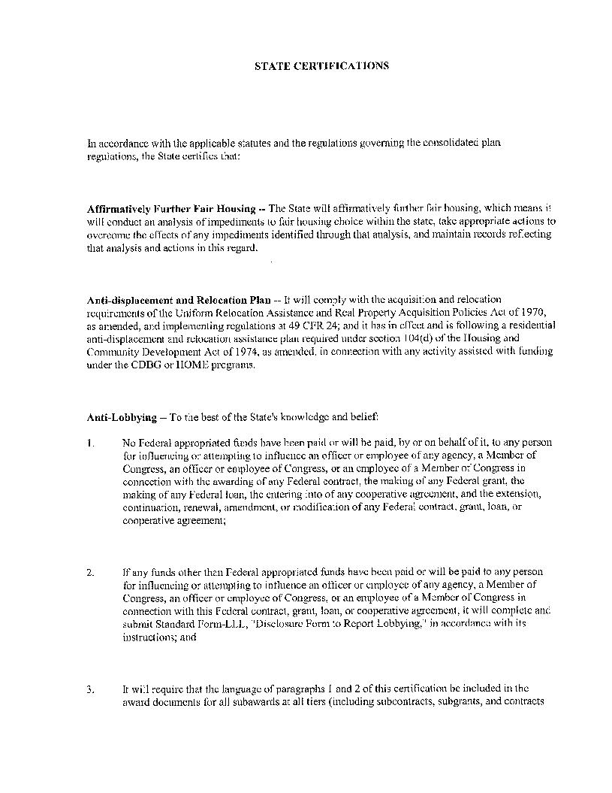

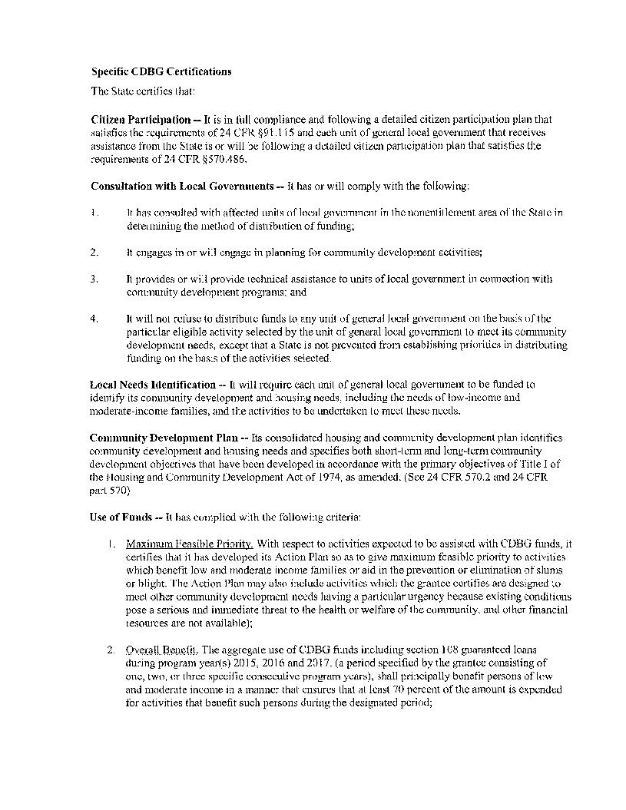

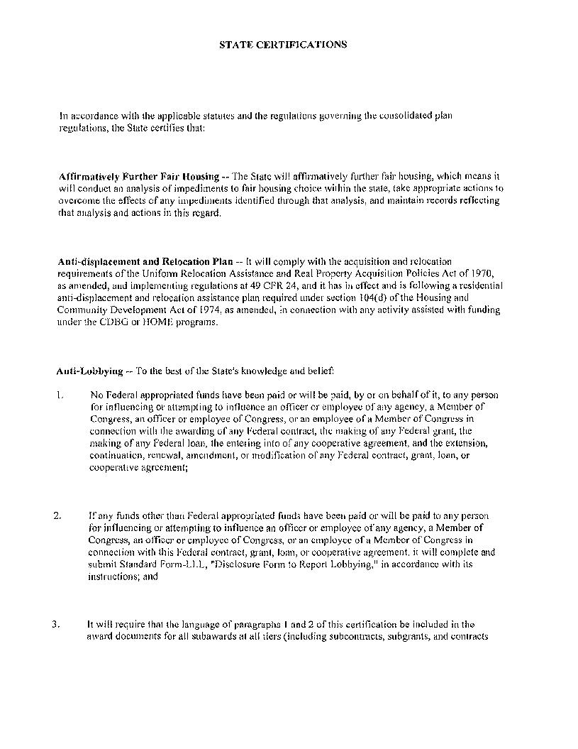

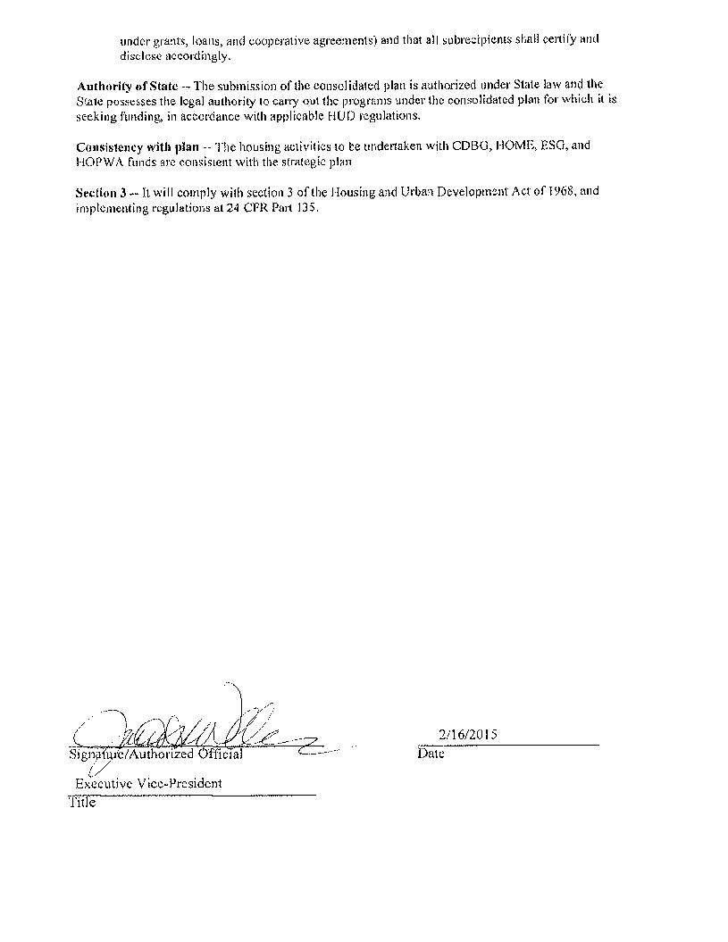

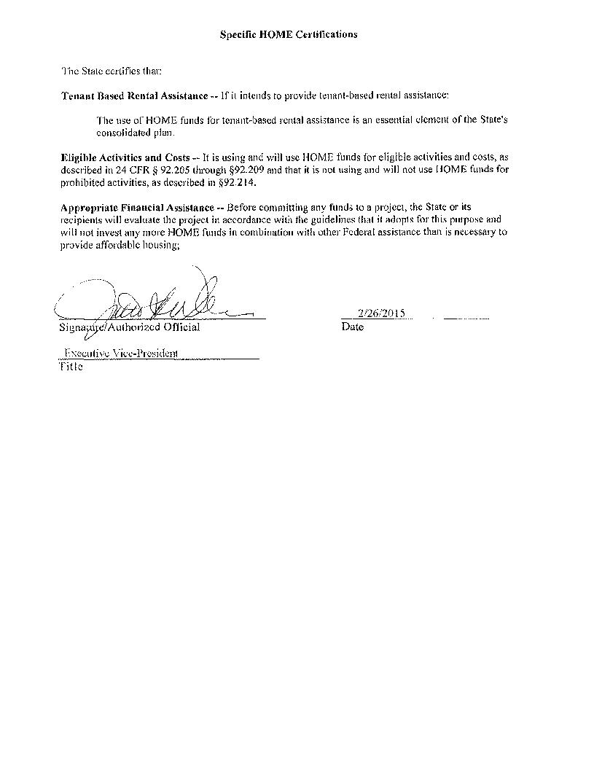

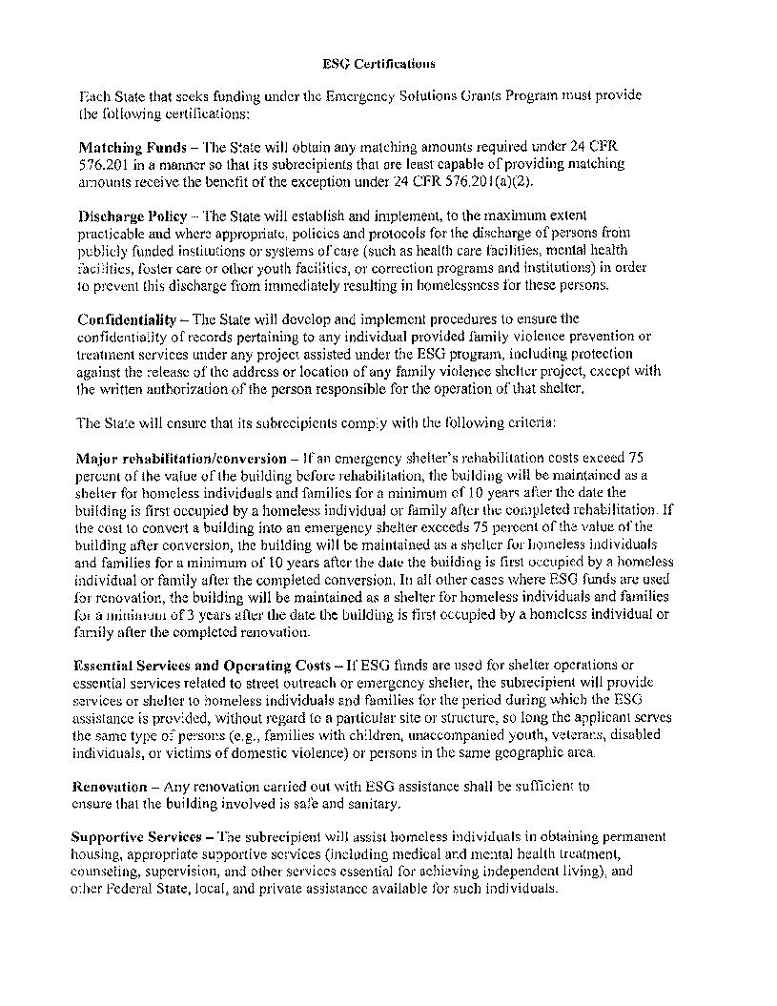

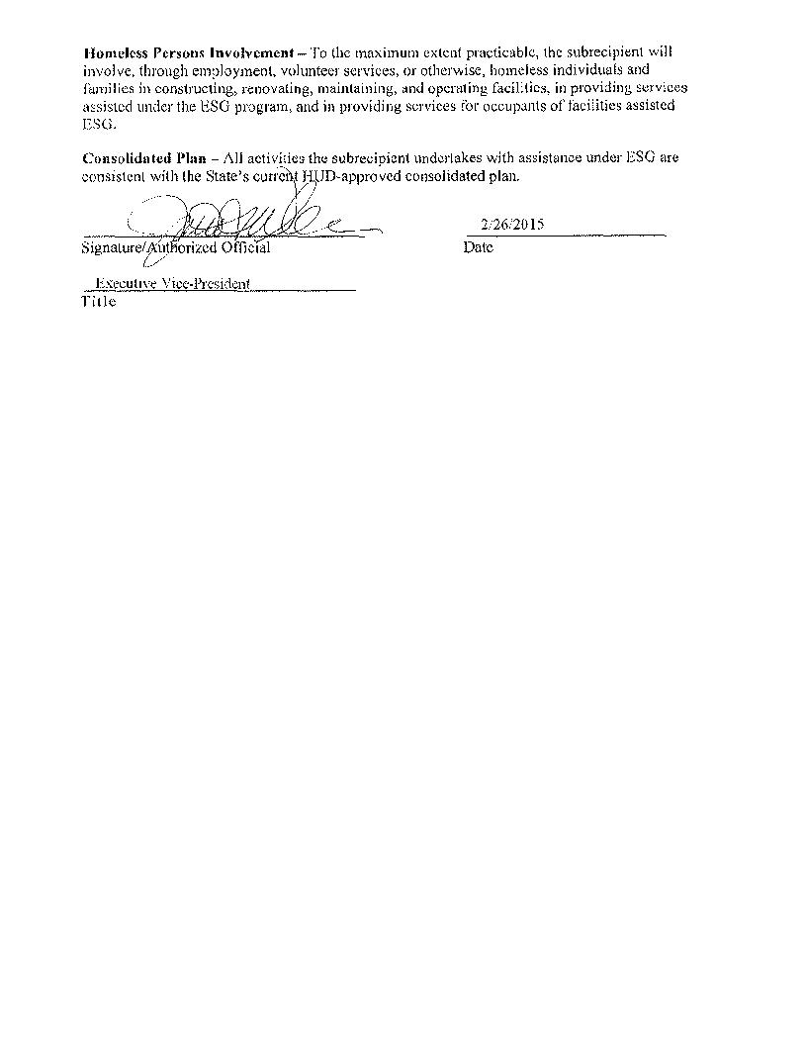

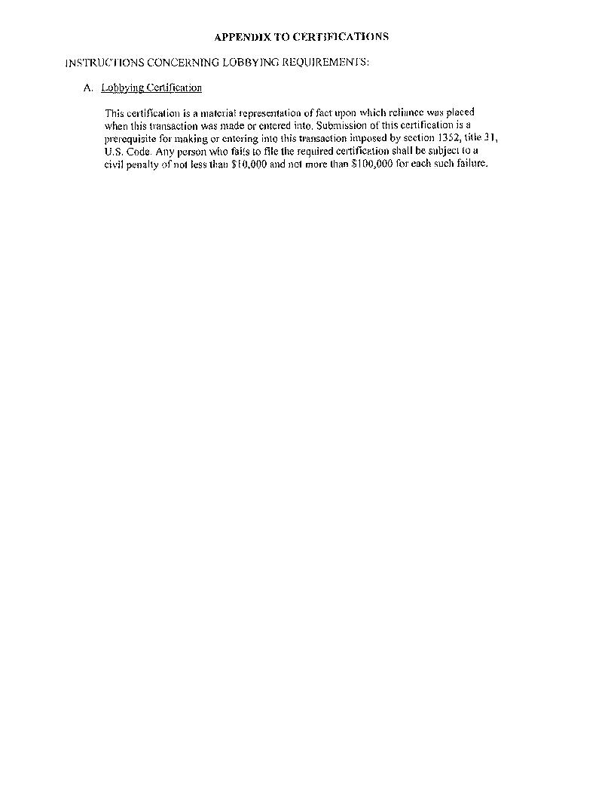

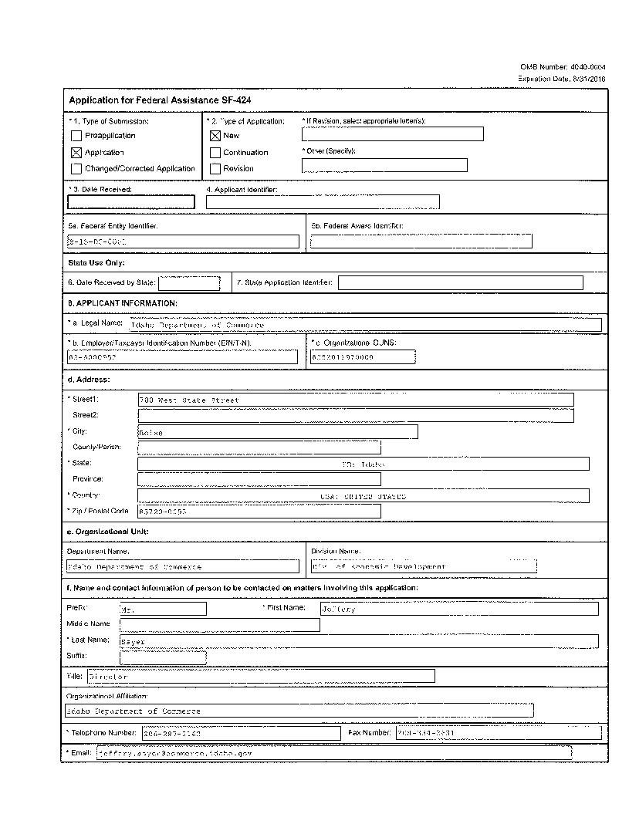

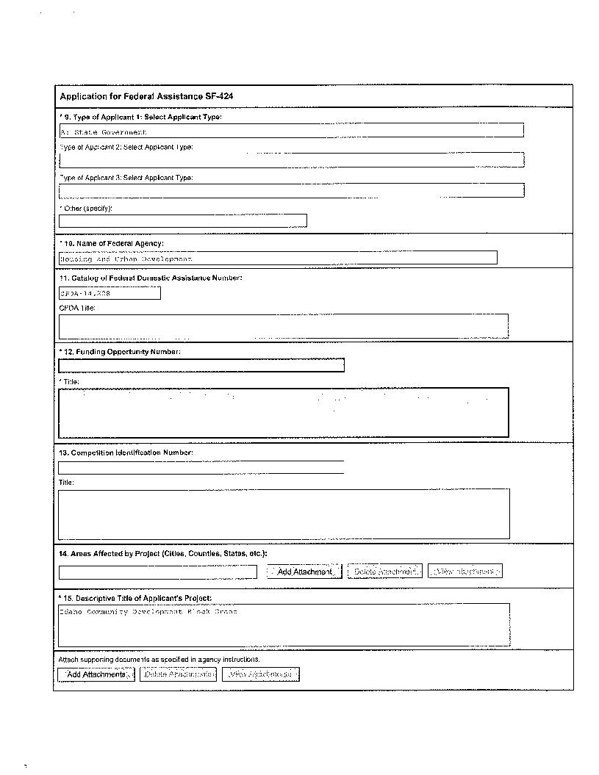

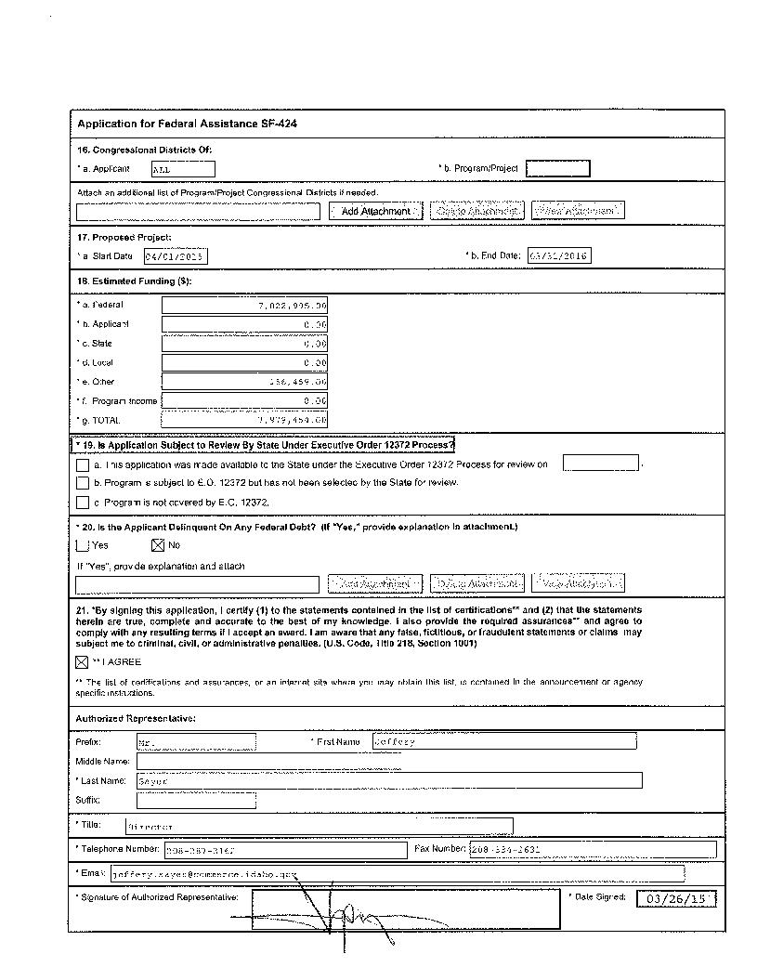

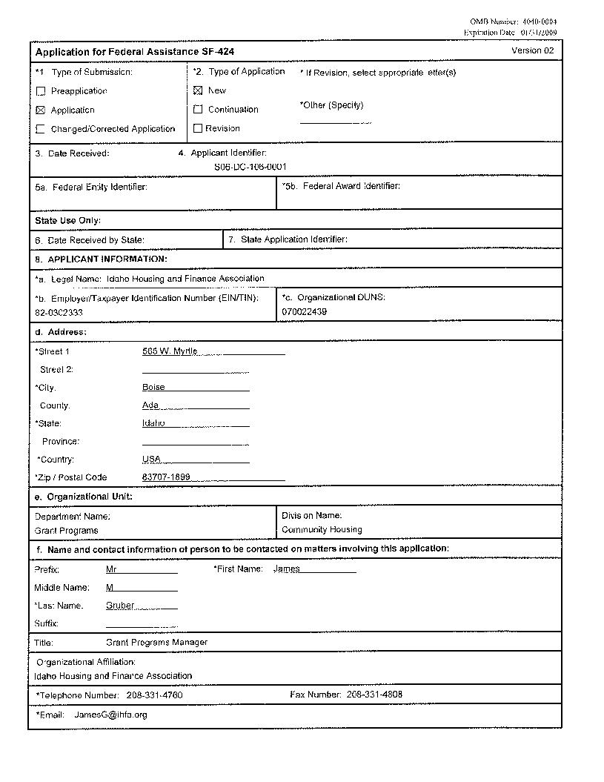

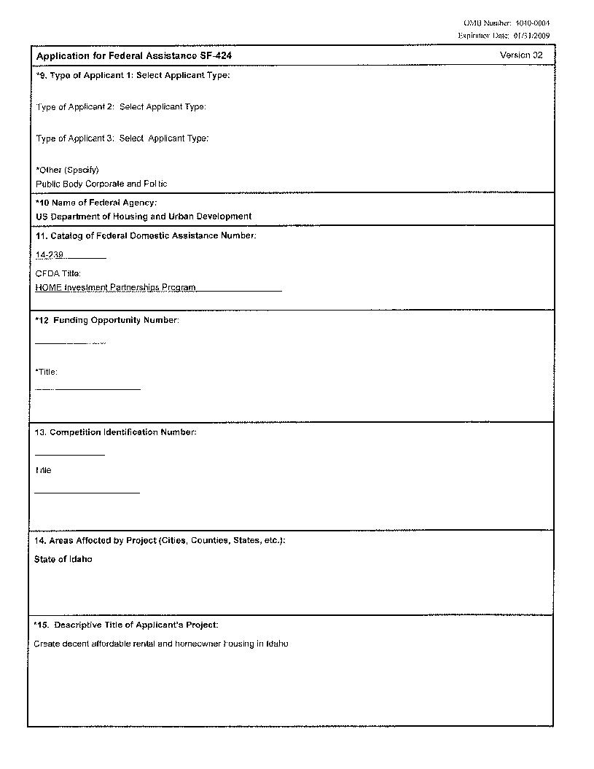

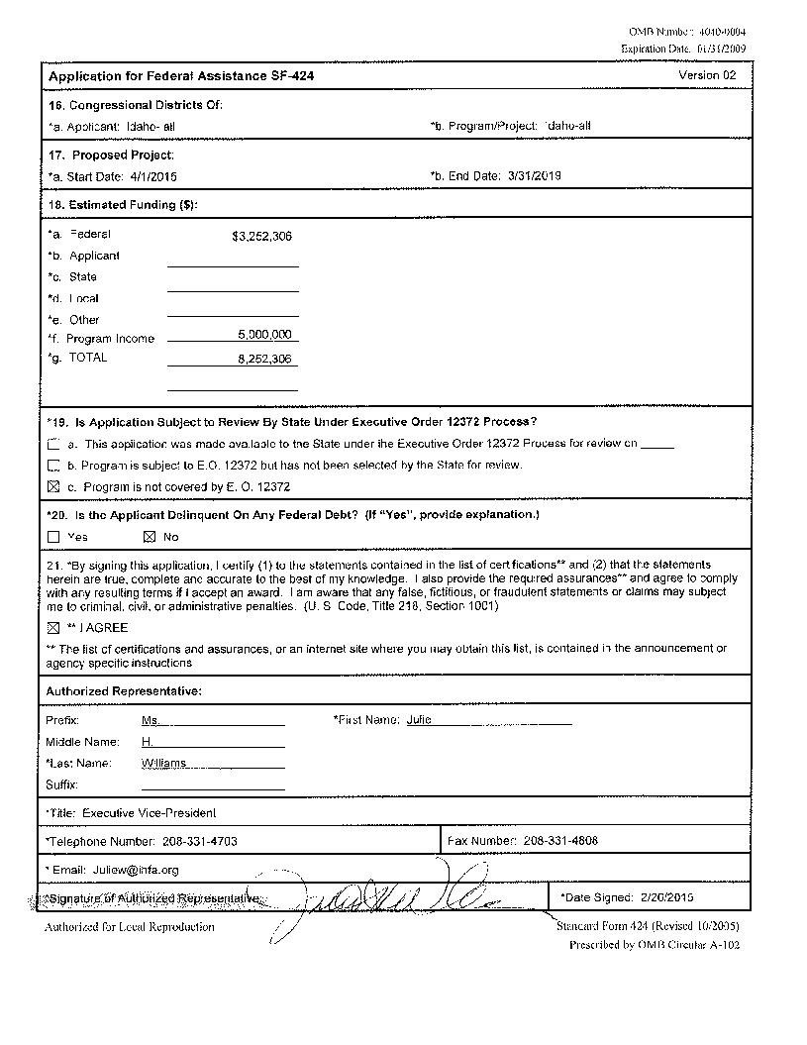



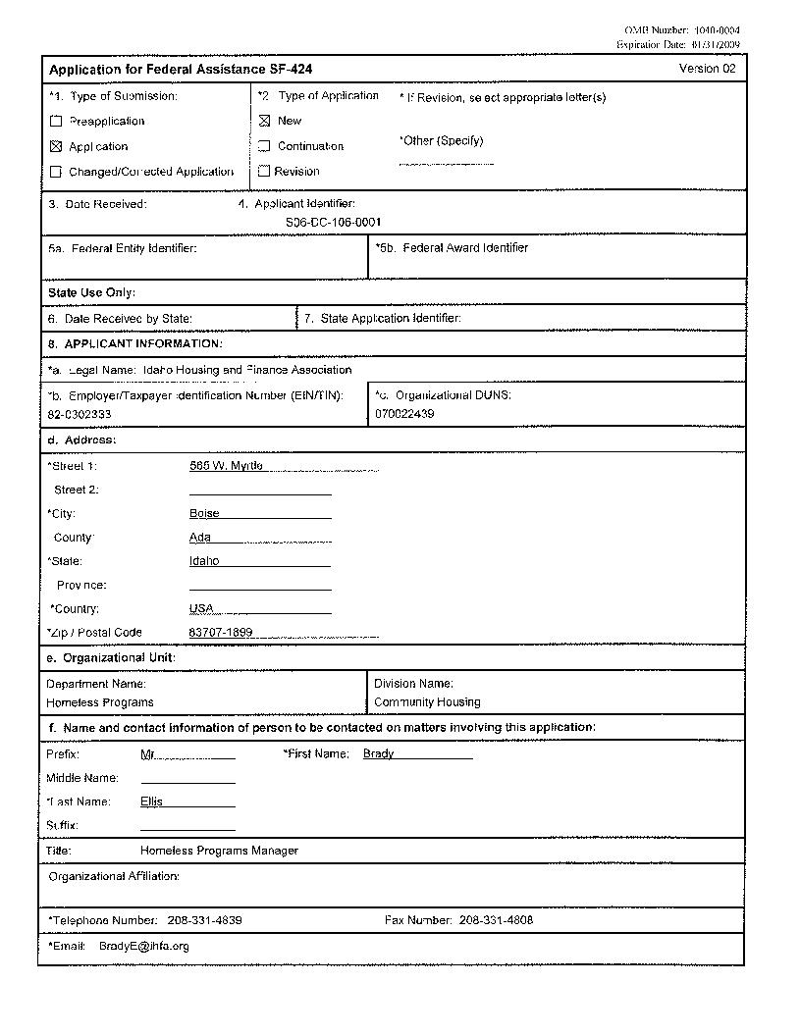

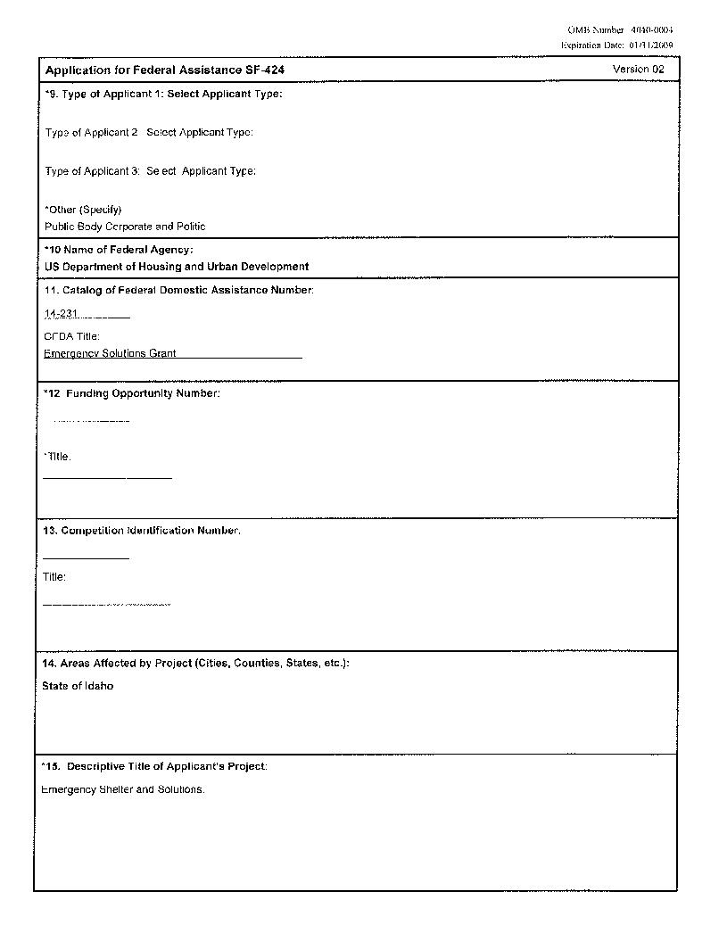

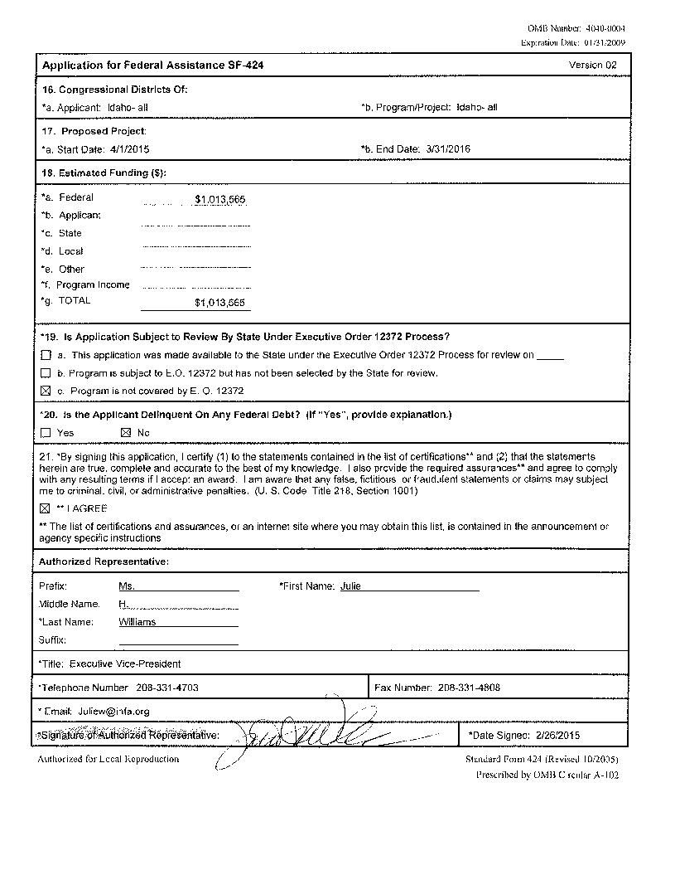

# Appendix - Alternate/Local Data Sources

|  |  |
| --- | --- |
| 1 | Data Source Name  Idaho Statewide Housing Needs Survey |
| List the name of the organization or individual who originated the data set.  BBC Research and Consulting |
| Provide a brief summary of the data set.  2015-2019 State of Idaho Housing and Stakeholder Survey |
| What was the purpose for developing this data set?  To assess Idaho's housing needs at a community and stakeholder level to support the State of Idaho's 2015-2019 Five- Year Consolidated Plan. |
| Provide the year (and optionally month, or month and day) for when the data was collected.  June 2014 |
| Briefly describe the methodology for the data collection.  The survey invitation was sent to a wide variety of stakeholders in three separate email blasts.  More than 3,700 stakeholders were invited by email to take the online anonymous survey.  In addition to the email blasts, legal notices were published in major Idaho newspapers inviting the public to participate in the online survey. |
| Describe the total population from which the sample was taken.  3,700 stakeholders were invited to take the survey in addition to the public. |
| Describe the demographics of the respondents or characteristics of the unit of measure, and the number of respondents or units surveyed.  A total of 487 stakeholders participated in the online stakeholder survey.  Participants represented a variety of industries and organizations offering services at the jurisdictional, regional, and statewide level. |
| 2 | Data Source Name  Idaho Housing, Demographic and Transportation Repo |
| List the name of the organization or individual who originated the data set.  BBC Consulting |
| Provide a brief summary of the data set.  2014 Idaho County-By-County Demographic, Housing, and Transportation Report |
| What was the purpose for developing this data set?  Develop current information regarding Idaho's housing, demographics is a concise summary |
| How comprehensive is the coverage of this administrative data? Is data collection concentrated in one geographic area or among a certain population?  Data is consistent on a county-by county level as well as the entire state of Idaho. The information is more current data than many of the eCon pre-populated tables. |
| What time period (provide the year, and optionally month, or month and day) is covered by this data set?  2008-2012 American Community Survey 5-Year Estimates; US Census 2000; 2010; 2013 Population Estimates |
| What is the status of the data set (complete, in progress, or planned)?  Complete |
| 3 | Data Source Name  2013 American Community Survey-Comparative Housing |
| List the name of the organization or individual who originated the data set.  U.S. Census |
| Provide a brief summary of the data set.  Comparative Housing characteristics for Idaho |
| What was the purpose for developing this data set?  To provide recent data. |
| How comprehensive is the coverage of this administrative data? Is data collection concentrated in one geographic area or among a certain population?  Data is for the entire state of Idaho. |
| What time period (provide the year, and optionally month, or month and day) is covered by this data set?  2013 one-year estimates. |
| What is the status of the data set (complete, in progress, or planned)?  Complete |
| 4 | Data Source Name  2012 Guidelines for LPB Title 24 Part 35 |
| List the name of the organization or individual who originated the data set.  Office of Healthy Homes and Lead Hazard Control, Second Edition, July 2012 |
| Provide a brief summary of the data set.  2012 Update to HUD's Lead-based Paint Poisoning Prevention in Certain Residential Structures Rule. |
| What was the purpose for developing this data set?  See above |
| How comprehensive is the coverage of this administrative data? Is data collection concentrated in one geographic area or among a certain population?  Nationally for all HUD programs |
| What time period (provide the year, and optionally month, or month and day) is covered by this data set?  Updated in 2012 |
| What is the status of the data set (complete, in progress, or planned)?  Complete |
| 5 | Data Source Name  Local Government Survey |
| List the name of the organization or individual who originated the data set.  State of Idaho Department of Commerce |
| Provide a brief summary of the data set.  The survey asked the recipients to prioritize the needs in their community, identify their assessment of the current CDBG method of distribution, and inquired if there should be changes made to method of distribution. |
| What was the purpose for developing this data set?  Cities and counties in the State of Idaho were surveyed to determine their priority needs within the eligible activities of the CDBG program. |
| Provide the year (and optionally month, or month and day) for when the data was collected.  The local government survey was conducted in August 2014. |
| Briefly describe the methodology for the data collection.  All cities and counties within the State of Idaho, excluding the seven entitlements: Coeur D Alene, Lewiston, Nampa, Meridian, Boise, Pocatello and Idaho Falls, were mailed a hard copy of the survey and asked to return it to the Department of Commerce within two weeks.  A self-addressed stamped envelope was included with the survey. |
| Describe the total population from which the sample was taken.  The survey was sent to 44 counties and 193 cities in the State of Idaho. |
| Describe the demographics of the respondents or characteristics of the unit of measure, and the number of respondents or units surveyed.  The surveys were addressed to the city and county officials of the 44 counties and 193 cities. |
| 6 | Data Source Name  2012 Report Card for Idaho Infrastructure |
| List the name of the organization or individual who originated the data set.  American Society of Civil Engineers |
| Provide a brief summary of the data set.  An assessment of 11 infrastructure systems throughout the State of Idaho.   These systems included energy, water, wastewater, dams, bridges, rail, aviation, school facilities, and public transit. |
| What was the purpose for developing this data set?  To assess and grade the infrastructure systems based on their current conditions.  Then to evaluate the cost to improve any deficiencies and measure projected demand. |
| How comprehensive is the coverage of this administrative data? Is data collection concentrated in one geographic area or among a certain population?  State-wide |
| What time period (provide the year, and optionally month, or month and day) is covered by this data set?  2012 |
| What is the status of the data set (complete, in progress, or planned)?  The report was complete. |
| 7 | Data Source Name  Idaho Workforce Development Council |
| List the name of the organization or individual who originated the data set.  Idaho Department of Labor – Workforce Development Council |
| Provide a brief summary of the data set.  Data set include state unemployment rate, wage rates, and percentage of Idaho students who pursue post-secondary education opportunities. |
| What was the purpose for developing this data set?  Understanding the unique needs of business, workers and students, will make policy recommendations to the Governor and the Board of Education, and will facilitate coordination of an integrated Idaho workforce development systems. |
| How comprehensive is the coverage of this administrative data? Is data collection concentrated in one geographic area or among a certain population?  State-wide |
| What time period (provide the year, and optionally month, or month and day) is covered by this data set?  2011-2012 |
| What is the status of the data set (complete, in progress, or planned)?  The report is complete. |
| 8 | Data Source Name  Idaho Business and Opportunity |
| List the name of the organization or individual who originated the data set.  Idaho Department of Commerce |
| Provide a brief summary of the data set.  Data set include tax exemptions, new job tax credits, and other incentive resources available for business creating jobs in Idaho. |
| What was the purpose for developing this data set?  To educate business about the resources and incentives of creating jobs in Idaho. |
| How comprehensive is the coverage of this administrative data? Is data collection concentrated in one geographic area or among a certain population?  State-wide |
| What time period (provide the year, and optionally month, or month and day) is covered by this data set?  2014 |
| What is the status of the data set (complete, in progress, or planned)?  The report is complete. |
| 9 | Data Source Name  Entire state including entitlement communities |
| List the name of the organization or individual who originated the data set.  BBC Consulting |
| Provide a brief summary of the data set.  HUD's data excluded local entitlement areas for the year 2000. |
| What was the purpose for developing this data set?  Table adjusted to include total households for the entire state of Idaho in the year 2000, which now include local entitlement areas(HOME and CDBG) |
| How comprehensive is the coverage of this administrative data? Is data collection concentrated in one geographic area or among a certain population?  2000 Census (Base Year), 2010-2013 ACS(most recent year) |
| What time period (provide the year, and optionally month, or month and day) is covered by this data set?  2000 Census through 2013 American Community Survey estimates |
| What is the status of the data set (complete, in progress, or planned)?  complete |
| 10 | Data Source Name  Renter and homeowner data past, present and future |
| List the name of the organization or individual who originated the data set.  Idaho Housing and Finance Association |
| Provide a brief summary of the data set.  Using the 2013 American Community Survey 1-Year Estimates |
| What was the purpose for developing this data set?  Using historical data as the predictor for the number of renters and homeowners, rents, and number of available and affordable units over the next 5 years. |
| How comprehensive is the coverage of this administrative data? Is data collection concentrated in one geographic area or among a certain population?  Because IHFA is a state PJ, the data is required for the entire state. However, because like many states, Idaho's character varies by county by county and community by community based on factors that are too numerous to mention in this report. IHFA will use historical data from the 2013 ACS to make general predictions for the next 5 years in each category. |
| What time period (provide the year, and optionally month, or month and day) is covered by this data set?  PY 2015-2019 |
| What is the status of the data set (complete, in progress, or planned)?  N/A |
| 11 | Data Source Name  Estimated number of families and family types |
| List the name of the organization or individual who originated the data set.  BBC Consulting |
| Provide a brief summary of the data set.  Estimates of current housing assistance needs for family types as required by §91.305 (b)(1) and projected housing needs for these family types of ensuing five-year period. |
| What was the purpose for developing this data set?  To meet Con Plan requirements |
| How comprehensive is the coverage of this administrative data? Is data collection concentrated in one geographic area or among a certain population?  Projections and estimates are statewide |
| What time period (provide the year, and optionally month, or month and day) is covered by this data set?  PY 2015-PY 2019 |
| What is the status of the data set (complete, in progress, or planned)? |
| 12 | Data Source Name  Number of Housing Units including entitlement area |
| List the name of the organization or individual who originated the data set.  2010-2013 3-Year ACS |
| Provide a brief summary of the data set.  Provided because this includes the entire state of Idaho, not just the non-entitlement areas, which is what HUD's pre-populated data provides. |
| What was the purpose for developing this data set?  More complete picture of the state's housing units. |
| How comprehensive is the coverage of this administrative data? Is data collection concentrated in one geographic area or among a certain population?  See above |
| What time period (provide the year, and optionally month, or month and day) is covered by this data set?  See above |
| What is the status of the data set (complete, in progress, or planned)?  It is the 3-year American Community Survey |
| 13 | Data Source Name  Unit Size by Tenure |
| List the name of the organization or individual who originated the data set.  2010-2012 3-Year ACS |
| Provide a brief summary of the data set.  See above |
| What was the purpose for developing this data set?  Provide more inclusive numbers for the entire state |
| How comprehensive is the coverage of this administrative data? Is data collection concentrated in one geographic area or among a certain population?  See above |
| What time period (provide the year, and optionally month, or month and day) is covered by this data set?  2010-2012 3-Year ACS |
| What is the status of the data set (complete, in progress, or planned)?  See above |
| 14 | Data Source Name  Cost of Housing |
| List the name of the organization or individual who originated the data set.  2012 1-Year ACS |
| Provide a brief summary of the data set.  Cost of Housing 2012 1-Year ACS |
| What was the purpose for developing this data set?  To replaces HUD's pre-populated data with more current estimates |
| How comprehensive is the coverage of this administrative data? Is data collection concentrated in one geographic area or among a certain population?  See above- |
| What time period (provide the year, and optionally month, or month and day) is covered by this data set?  See above |
| What is the status of the data set (complete, in progress, or planned)?  See above |
| 15 | Data Source Name  County HOME rents/FMR/Median Rent |
| List the name of the organization or individual who originated the data set.  Idaho Housing and Finance Association |
| Provide a brief summary of the data set.  County by County comparison of HOME rents to FMR and gross median rent |
| What was the purpose for developing this data set?  to respond to a required econ plan discussion question regarding how do these rent figures impact the statewide strategy to provide or preserve affordable housing. |
| How comprehensive is the coverage of this administrative data? Is data collection concentrated in one geographic area or among a certain population?  County by County for entire state |
| What time period (provide the year, and optionally month, or month and day) is covered by this data set?  Current as of 2015( 2015 HOME rents, U.S. Census Bureau 2008-2012 American Community Survey Five-Year estimates, 2013 |
| What is the status of the data set (complete, in progress, or planned)?  complete |

1. People who earn at or below 30% of the Area Median Income. <https://commercestorage.blob.core.windows.net/media/Default/CDBG%20Files/Statewide%20Housing%20Needs%20Survey.pdf>. According to the US Census Bureau, the median household income in the state of Idaho is $47,015: <http://quickfacts.census.gov/qfd/states/16000.html>. 30% of this is $14,104.50. For context, it is helpful to note that Idaho’s full-time minimum wage workers earn $10,712 per year: <https://labor.idaho.gov/publications/Minimum_Wage_Impact.pdf>.
2. According to Idaho’s Action Plan to Reduce Homelessness, four out of every five dollars spent on homelessness is spent on people experiencing chronic homelessness (8). See: <http://www.cdaid.org/files/municipal_services/IdahoHomeless.pdf>. According to this year’s state-wide Point in Time Count, 12% of those experiencing homelessness in Idaho were chronically homeless (12). See: <http://www.idahohousing.com/Portals/0/Media/grant%20programs/2014%20State%20of%20Idaho%20Point-in-Time%20Count%20Report%20Final-042314.pdf>. Housing people who are chronically homeless will free up resources to address other housing needs statewide.
3. See: <http://usich.gov/population/chronic> and <http://www.endhomelessness.org/pages/chronic_homelessness>.
4. Smart, Christopher. “Utah Praised for Initiative to End Chronic Homelessness.” *The Salt Lake Tribune*. October 10, 2014. Online version last updated October 15, 2014: <http://www.sltrib.com/sltrib/politics/58493059-90/according-chronic-homeless-homelessness.html.csp>. Santos, Fernanda. “Program to End Homelessness Among Veterans Reaches a Milestone in Arizona.” *The New York Times*. January 15, 2014: <http://www.nytimes.com/2014/01/16/us/program-to-end-homelessness-among-veterans-hits-milestone-in-arizona.html?_r=2>.
5. <http://usich.gov/resources/uploads/asset_library/Housing_First_Checklist_FINAL.pdf>
6. Patterson, Jillian. Housing Programs Manger, Boise City Ada County Housing Authority. “Housing Programs Overview.” Presentation to Boise City Ada County Continuum of Care Coordinating Team. September 25, 2014. Pages 15-21. <http://hcd.cityofboise.org/media/272437/cocteam_recap9-25-14.pdf>
7. The 2014 Point in Time Count identified 244 people experiencing chronic homelessness in the state of Idaho (23). Annualized, this means that 488 people in Idaho experienced chronic homelessness this year.
8. Cohen, Rebecca. “The Impacts of Affordable Housing on Health: A Research Summary.” *Insights from Housing Policy Research*. Center for Housing Policy and National Housing Conference. Washington, DC. May 2011. <http://www.nhc.org/media/files/Insights_HousingAndHealthBrief.pdf>
9. Pendleton, Lloyd. Director, Homeless Task Force, State of Utah. “Homeless Planning.” Presentation to Boise City Ada County Coalition for the Homeless. April 1-2, 2014.
10. Chronic homelessness in Boise, for example, costs taxpayers $40,000-$85,000 per person per year—in 2007 dollars (City of Boise 10-Year Plan to Reduce & Prevent Chronic Homelessness, 6). See: <http://mayor.cityofboise.org/media/243715/23842_10-Year%20Plan%20Final.pdf>.
11. See: <http://www.cdaid.org/files/municipal_services/IdahoHomeless.pdf> and <http://usich.gov/opening_doors/>