Contents
ES-05- Executive Summary- Summary of Objectives and Outcomes 4
Idaho Department of Commerce 4
CDBG 4
Idaho Housing and Finance Association 5
National Affordable Housing Trust Fund Program 5
Evaluation of Past Performance 6
CDBG Program 6
HOME Investment Partnerships Program 7
Housing Trust Fund Program 7
ESG Program 7
PR-15 Citizen Participation 8
Pre-Draft 8
Post Draft 30- Day Comment Period 9
Post Draft 5- Day Comment Period for CDBG-CV 9
NA-10 Housing Needs Assessment 9
Introduction to Data and Related Definitions 9
NA-15 Disproportionately Greater Need: Housing Problems - 91.305 (b)(2) 14
NA-20 Disproportionately Greater Need: Severe Housing Problems – 91.305(b)(2) 15
Introduction 15
NA-25 Disproportionately Greater Need: Housing Cost Burdens – 91.305 (b)(2) 17
NA-35 Public Housing – (Optional) 19
NA-45 Non-Homeless Special Needs Assessment – 91.305 (b,d) 19
Housing Market Analysis 20
MA-10 Number of Housing Units – 91.310(a) 20
MA-15 Housing Market Analysis: Cost of Housing – 91.310(a) 24
MA-30 Homeless Facilities – 91.310(b) 25
MA-35 Special Needs Facilities and Services – 91.310(c) 27
MA-40 Barriers to Affordable Housing – 91.310(d) 29
MA-45 Infrastructure Needs in Idaho 31
MA-50 Needs and Market Analysis Discussion 33
MA-60 Broadband Needs of Housing occupied by Low- and Moderate-Income Households – 92.210(a)(4), 91.310(a)(2) 34
SP 40 – Institutional Delivery Structure 37
State of Idaho (Commerce) -CDBG Program 37
IHFA- HOME Program 38
IHFA- ESG Program 38
SP-55 Barriers to Affordable Housing 39
SP-65 Lead Based Paint Hazards 42
SP-80 Monitoring 45
2020 Action Plan 50
AP-30 Method of Distribution 50
State of Idaho HOME/HTF 50
State of Idaho CDBG 58
CDBG-CV CARES FUNDS 60
Broadband: 63
Resiliency: 63
Opportunity Zones: 64
AP-50 – GEOGRAPHIC DISTRIBUTION 64
AP-65 Homeless and Other Special Needs Activities – 91.320(h) 65
AP-75-Barriers to Affordable Housing 69
AP-85- Other Actions- 74
AP-90- Program Specific Requirements 75
Written standards for providing ESG assistance 77

ES-05- Executive Summary- Summary of Objectives and Outcomes

Idaho Department of Commerce

CDBG
Over the next five years, the goals and indicators for the CDBG program are as follows:
Public Facilities / Infrastructure - Compliance: Obligate/Expend 25% of the five-year allocation on activities that brings public facilities systems (infrastructure, community facilities, public utilities) into compliance with environmental laws, federal and state standards, industry standards, building codes, and best management practices. This includes helping qualified communities develop facility plans for water and sewer systems, conduct broadband feasibility studies, or develop a facilities energy audit. These activities over a five-year period should benefit approximately 60,000 individuals.

Public Facilities / Infrastructure - Rehabilitation: Obligate/Expend 30% of the five-year allocation on activities that include the rehabilitation, replacement, and/or remodeling of public facilities (infrastructure, community facilities, public utilities, and affordable housing) systems. This includes helping qualified communities develop facility plans for water and sewer systems, conduct broadband feasibility studies, or develop a facilities energy audit. These activities should benefit approximately 85,000 individuals. This would include helping qualified cities or counties acquire testing and/or rehabilitate a building to establish an infectious disease treatment clinic and/or accommodate isolation of patients during recovery.

Public Facilities / Infrastructure – New Construction: Obligate/Expend 25% of the five-year allocation on the new construction of a public facility (infrastructure, community facilities, and public utilities) or extension of public facilities to an eligible service area. This includes new infrastructure to support affordable housing and housing related activities. These activities should benefit approximately 60,000 individuals.

Economic Development – Job Creation: Obligate/Expend 10% of the five-year allocation on public infrastructure improvements for business expansion and subsequent job creation for low-to-moderate income persons. These activities should create 250 jobs.

Economic Development – Downtown Revitalization: Obligate/Expand 10% of the five-year allocation on public infrastructure improvements to prevent blighted downtown areas. These activities should improve eight (8) downtowns.

Public Service – Obligate CDBG-CV-CARES funds to public service projects that help to prevent, prepare for and respond to Coronavirus COVID-19 and other infectious diseases.

Technical Assistance- These activities will include furthering fair housing education and outreach and CDBG technical assistance and training.
CDBG new highlights:
- Created a new funding set-aside to help LMI communities develop facility plans for their water or sewer system, conduct broadband feasibility studies, or develop a facilities energy audit.
- Increased funding levels from $150,000 to $225,000 for senior centers, community centers, and public park projects.
- Increased funding level from $100,000 to $150,000 for post-disaster projects.

Idaho Housing and Finance Association

National Affordable Housing Trust Fund Program
Over the next five years, the HTF program will
Goal: Provide Decent Affordable Housing to Extremely Low-income Households and Individuals
Objective: Create and Preserve Housing Affordability For Extremely Low-Income Households
Outcomes:
- Help construct or rehabilitate affordable rental housing throughout Idaho- 45 Units (9 units per year).

HOME Program
Over the next five years, the HOME program will:
Goal: Provide Decent Affordable Housing to Low-income Households and Individuals
Objective: Create and Preserve Housing Affordability For Low-Income Households
Outcomes
- Help Construct new affordable rental housing throughout Idaho- 180 Units
- Preserve existing rental housing through rehabilitation- 30 Units
- Construct and rehabilitate existing affordable single-family homebuyer units then assist low-income families and individuals to become homeowners to encourage stability in local communities throughout Idaho- 75 Units
Objective: Help support community-based housing development organizations (CHDOs) by providing financial assistance for day-to-day operating expenses and training to increase development capacity for affordable housing opportunities in the communities they serve.
Outcomes
- Provide Operating assistance grants to Certified CHDOs to help with day-to-day operating and training expenses- Up to 5% of each annual allocation
- Provide Pre-development loans to Certified CHDOs to explore the feasibility of potential CHDO-eligible project activities. Will not to exceed 10% of the total amount of CHDO Set-Aside for CHDO-eligible project activities.

ESG Program
Objective: Use Rapid Re-Housing, Homelessness Prevention and Shelter services to ensure that homeless is rare, brief, and non-reoccurring as defined by the BoS CoC Board with input from the Regional Coalitions and other stakeholders.
Outcomes:
- Provide emergency shelter and service solutions to families and individuals experiencing homelessness. Strategically use Homelessness Prevention funds to prevent individuals and families from experiencing Homelessness. Use Rapid Re-housing funding to provide temporary assistance that quickly moves individuals and families who experience literal homelessness into permanent housing while providing appropriate time-limited supports to help them stabilize there. Combine affordable housing assistance with voluntary support services to address the needs of chronically homeless people. The services are designed to build independent living and tenancy skills and connect people with community-based health care, treatment and employment services.

Evaluation of Past Performance
The grantees prepare and submit a Consolidated Annual Performance Evaluation Report (CAPER) to HUD 90 days after the start of the next program year. Because of these submission requirements, the evaluation of past performance in this Consolidated Plan will include 4 of the 5 years in the current 2015-2019 Consolidated Plan at the time of submission to HUD.

CDBG Program
Over the last five years (2015-19) Commerce received $39,215,514 in CDBG funding. Of this total amount, minus state administration and technical assistance, here is the breakdown of the five goals and indicators:
Public Facilities / Infrastructure – Compliance:
Total amount of CDBG obligated = $10,593173
Number of projects = 30
Number of people who benefit = 58,790
Number of LMI individuals who benefit = 42,295

Public Facilities / Infrastructure – Rehabilitation:
Total amount of CDBG obligated = $13,176,906
Number of projects = 40
Number of people who benefit = 85,759
Number of LMI individuals who benefit = 59,573

Public Facilities / Infrastructure – New Construction:
Total amount of CDBG obligated = $11,820,721
Number of projects = 31
Number of people who benefit = 129,485
Number of LMI individuals who benefit = 71,055
Economic Development – Job Creation:
Total amount of CDBG obligated = $1,143,000
Number of projects = 1
Number of people who benefit = 94
Number of LMI individuals who benefit = 61
Economic Development – Downtown Revitalization
Total amount of CDBG obligated = $3,818,950
Number of projects = 8
Number of people who benefit = 69,202

HOME Investment Partnerships Program
Rental Housing Constructed: Goal- 1042 units/ 1,323 completed (Includes HOME, HTF, and LIHTC units). Goal Met
Rental Housing rehabilitated Goal- 400 units/667 completed. (Includes HOME, HTF, and LIHTC units) Goal Met.
Homeowner Housing Added: Goal- 225 units/119 Completed Goal not Met
Direct Financial Assistance to Homebuyers: Goal- 175 units/26 Completed. Goal not Met
Tenant- Based Rental Assistance/Rapid Rehousing: Goal 80 units/ 0 completed. Goal not Met.

Housing Trust Fund Program
Rental Housing: Goal- 55 units/ 13 completed. Goal Not Met

ESG Program
ESG program funds were to be used for the following eligible activities: shelter, homelessness prevention, and rapid re-housing. IHFA’s goal was to, through collaboration with and participation in the Balance of State and Boise City/Ada County CoC’s, continually impress a positive impact upon the homeless families and individuals in Idaho. As data collection evolved through HMIS and CoC innovations, ESG funds were to be used in a manner that best fits the needs of those seeking the refuge it can offer.

Goal Outcome Indicator

GOAL OUTCOME INDICATOR

Tenant Based Rental Assistance/Rapid Rehousing Goal 375 Outcome 1131 UoM: HH Assisted
Homeless Person Overnight Shelter Assisted Goal 3113 Outcome 9936 UoM: Persons
Homelessness Prevention Assisted Goal 223 Outcome 2909: UoM Persons

Other Goal 335 Outcome 2345: UoM

PR-15 Citizen Participation
In preparing for the consolidated planning requirements, the 2017 Public Participation Plan for HUD-Funded Affordable Housing and Community Development Programs was followed.
Below is a summary of the public participation process for the Plan that included two (2) 30-day comment periods and two public hearings. In addition, IHFA commissioned a 2019 Statewide Housing Need Survey and a 2019 Idaho County-Level Housing Demographic, and Transportation Report.

Pre-Draft
- IHFA commissioned a Statewide Housing Needs Survey in January of 2019. Invitations to participate in the survey were mass emailed to stakeholders on a statewide basis, including units of local government, residential housing lenders, public housing authorities/owners, HOME/LIHTC/USDA-RD/Section 8 rental housing owners, developers and management companies, federal housing program administrators, and service providers. In person and online consultations were held with attendees as part of the Pre-Draft in process. Results of the stakeholder consultations are available upon request.
The 2019 Statewide Housing Needs Survey is found online at:
https://www.idahohousing.com/documents/statewide-housing-needs-survey-2.pdf

IHFA commissioned the 2019 Idaho County-Level Demographic & Housing Data.
This report is available online:
https://www.idahohousing.com/documents/2019-idaho-county-level-housing-demographic-data.pdf
- IHFA and IDC sought input from agencies and units of local government regarding affordable housing and community development needs.
- The Pre-draft 30-day comment period was October 1-October 30, 2019. One public hearing to receive oral and written comments was held at IHFA's offices in Boise, Idaho on October 23, 2019. No Comments were received.
- Legal notices for the pre-draft 30-day comment period and one public hearing were published in Idaho's major newspapers. IHFA also reached out to the mayors of Twin Falls, Pocatello, Moscow, Meridian, Lewiston, Idaho Falls, Coeur d’ Alene, and Blackfoot, the City of Boise, Idaho Continuums of Care, the Fair Housing Forum, the Director of Idaho Health and Welfare, Regional Housing Coordination Round Tables participants, and the Idaho Rural Partnership Foundation, and asked for input regarding their community's affordable housing and community development needs and priorities. The State of Idaho Division of Health and Welfare was consulted regarding Lead-based paint programs and anti-poverty strategies.

Post Draft 30- Day Comment Period
- A summary of written and oral comments that were received during this second comment period are attached to this Consolidated Plan.
- Proof of publication
- Public Notices sent to Idaho's Major libraries and IHFA branch offices
- The Post Draft (second and final) 30-day comment period was held March 3, 2020-April 2, 2020
- One public hearing- IHFA Main Office, Boise Idaho on March 25, 2020.

Post Draft 5- Day Comment Period for CDBG-CV
- A summary of comments received during this second comment period are attached to this Consolidated Plan.
- Proof of publication
- The Post Draft 5 day comment period was held May 4th,2020- May 8th,2020
- One public hearing held virtually on May 7th, 2020

NA-10 Housing Needs Assessment
Introduction to Data and Related Definitions
The data throughout this document is generated from the United States Census Bureau and the Department of Housing and Urban Development (HUD). The Comprehensive Housing Affordability Strategy (CHAS) dataset is a custom tabulation developed by the Census Bureau, derived from American Community Survey (ACS) data. The most recent CHAS data used in this document -- the 2011-2015 5-year estimate -- are determined for each jurisdiction that receives HUD funding. Because 2015 is the latest available CHAS dataset, this document will utilize 2015 data throughout. Utilizing 2015 throughout the document will make for clearer comparisons and make for a consistent narrative across all sections of the Consolidated Plan.
Because CHAS data is derived from ACS data, Census definitions dictate the definitions of the variables discussed in these tables:
Small Family Household: A household with two-four members
Large Family Household: A household with five or more members
Elderly: Ages 62-74
Frail Elderly or Extra Elderly: Ages 75+
Household: All people living in a housing unit. Members of a household can be related or unrelated.
Family: Related individuals living in the same household
Nonfamily: Unrelated individuals living in the same household
The term Area Median Income (AMI) and HUD Area Median Family Income (HAMFI) are interchangeable when the terms are being used to explain CHAS data derived from ACS data. For consistency throughout this document, only the term AMI will be used. It is important to note that within this document, AMI refers to the entire state of Idaho. Throughout this document data tables compare populations based on income ranges. These income ranges are categorized based on AMI and are used by HUD to determine eligibility to certain programs.
HUD defines the following income brackets as low-moderate income.
Extremely Low Income = >30% AMI
Low Income = 30-50% AMI
Moderate Income 50-80% AMI
The income brackets used throughout this document are an aggregate of the state. Based on the 2015 American Community Survey the median incomes in 2015 for the State of Idaho are as follows:

Household Size | 0-30% Median Income | 30-50% Median Income | 50-80% Median income | 100% Median Income
1-person | $ 7,250 | $ 12,083 | $ 19,333 | $ 24,166
2 people | $ 15,850 | $ 26,417 | $ 42,267 | $ 52,834
3 people | $ 16,967 | $ 28,279 | $ 45,246 | $ 56,558
4 people | $ 19,490 | $ 32,484 | $ 51,974 | $ 64,967
5 people | $ 18,751 | $ 31,252 | $ 50,003 | $ 62,504
6 people | $ 19,361 | $ 32,268 | $ 51,628 | $ 64,535
Source: 2011-2015 ACS
Housing Problems and Severe Housing Problems
The four housing problems outlined in the data and narrative below are defined in narrow terms as follows:
Substandard Housing – Lacking complete kitchen facilities
A complete kitchen consists of a sink with a faucet, a stove or range, and a refrigerator
Substandard Housing – Lacking complete plumbing facilities
Complete plumbing consists of hot and cold running water, a flush toilet, and a bathtub or shower
Cost Burden – Cost burden greater than 30% of income
Overcrowding – More than one person per room
The four severe housing problems are similar, but have two distinct differences in the definitions for cost burden and overcrowding:
Substandard Housing – Lacking complete kitchen facilities
A complete kitchen consists of a sink with a faucet, a stove or range, and a refrigerator
Substandard Housing – Lacking complete plumbing facilities
Complete plumbing consists of hot and cold running water, a flush toilet, and a bathtub or shower
Cost Burden – Cost burden greater than 50% of income
Overcrowding – More than 1.5 persons per room
Defining Rural Idaho
Idaho is a state with vast differences across its counties. From urban counties to open rural counties, Idaho’s residents reside in a variety of settings that often dictate the housing needs. Matching the national trend, Idaho has become increasingly urbanized. In 2010, 70.6% of Idaho residents lived within an urban area. This percentage is far above the 57.4% in 1990. While most counties in Idaho are still growing, the urban counties account for the majority of the state’s population growth. Urban counties are counties that contain a city with at least 20,000 people. Between 2000 and 2015, urban counties have seen a net growth of over 40%, while commuting counties, rural center counties, and open rural counties have each seen about a 12% net growth over the same period.
As noted in the 2018 Idaho Department of Labor Report titled Idaho’s Urban-Rural Divide, urban Idaho is booming while rural Idaho is economically challenged as stated in the report. Wages are a key element when discussing housing needs, and although wages are important to all individuals and families seeking affordable housing, rural workers are often more vulnerable to dramatic shifts in wage because housing stock is less, and rural workers often face higher costs of living. To view the report’s maps and figures outlining the urban-rural divide of Idaho please visit: https://labor.idaho.gov/wioa1/meetings/040518/wdc-Idaho-Urban-Rural-Divide.pdf
As needs are identified within this Consolidated Plan, it is important to note that Idaho’s housing needs are not uniform , but dynamic in nature, changing from county to county and within counties that have both urban and rural areas.

As is the case for most jurisdictions, a majority of Idaho households own their homes. However, this fact is met with an opposing trend. In 2010, 72.3% of the state’s households owned their home. This steady shift towards more households renting is indicative of a shift towards populations moving to urban areas that support a wider variety of income opportunities. Because Idaho is a state with a large population of rural households however, there remains a high need for housing support both for renter households as well as owner households.
Source: 2011-2015 CHAS

Source: 2011-2015 CHAS
While 46.1% of all Idaho households earn more than 100% of the median income, 42.8% (252,325) of Idaho households earn 80% AMI or less; these households are all considered low- moderate-income households using HUD standards. Of these low- moderate-income households:
33% are small family households (2-4 family members)
35% are households that contain one person age 62 or older
19% are households with one or more children 6 years or younger

Source: 2011-2015 CHAS

Comparing the above to graphs, 68% of owner households earn 80% AMI or more while just 34% of renter households earn 80% AMI or more. Of all owner households 32% are considered low- moderate-income while 66% of renter households are considered to be low- moderate- income households.

Source: 2011-2015 CHAS

Above is another way to visualize the income brackets that makeup renter and owner households. Of all those households earning 80% AMI or more, only 18.5% are renter households. Of all low- moderate-income households (0-80% AMI), 52.5% are renter households.

NA-15 Disproportionately Greater Need: Housing Problems - 91.305 (b)(2)
Assess the need of any racial or ethnic group that has disproportionately greater need in comparison to the needs of that category of need as a whole.
Introduction
According to HUD, disproportionate need refers to any need for a certain race/ethnicity that is more than ten (10) percentage points above the demonstrated need for the total households within the jurisdiction at a particular income level. The tables and analyses below identify the share of households by race/ethnicity and income level experiencing one or more of the four housing problems outlined by HUD guidelines. When the ten-percentage point threshold is reached, that number is highlighted in yellow. The four housing problems are:
- Housing unit lacks complete kitchen facilities
  - A complete kitchen consists of a sink with a faucet, a stove or range, and a refrigerator
- Housing unit complete plumbing facilities
  - Complete plumbing consists of hot and cold running water, a flush toilet, and a bathtub or shower
- More than one person per room (overcrowded)
- Household is cost burdened
  - Between 30-50% of income is devoted to housing costs
Income classifications are as follows: 0%-30% AMI is considered extremely low-income, 30%-50% AMI is low-income, 50%-80% AMI is moderate-income, and 80%-100% is middle-income.
The table below outlines the percentage of households experiencing a housing problem. First by the jurisdiction as a whole and then by each racial/ethnic group as reported within the CHAS dataset.
Housing Problems Experienced by Race/Ethnicity and Income Bracket
Race/Ethnicity | 0-30% AMI | 30-50% AMI | 50-80% AMI | 80-100% AMI
Jurisdiction as a whole | 75.6% | 68.1% | 42.0% | 23.0%
White | 75.4% | 67.1% | 41.7% | 23.0%
Black / African American | 88.7% | 66.1% | 74.7% | 16.3%
Asian | 59.2% | 55.2% | 40.4% | 37.1%
American Indian, Alaska Native | 73.2% | 59.4% | 39.5% | 22.1%
Pacific Islander | 28.6% | 100.0% | 78.0% | 0.0%
Hispanic | 78.7% | 75.5% | 41.6% | 20.2%
Source: 2011-2015 CHAS

Discussion
As noted from the tables above, the following racial/ethnic household experienced one or more housing problem disproportionately for renters and owners combined:
- Black / African American: 0-30% AMI and 50-80% AMI
- Pacific Islander: 30-50% AMI and 50-80% AMI
- Asian: 80-100% AMI
Source: 2011-2015 CHAS

NA-20 Disproportionately Greater Need: Severe Housing Problems – 91.305(b)(2)
Assess the need of any racial or ethnic group that has disproportionately greater need in comparison to the needs of that category of need as a whole.
Introduction
According to HUD, disproportionate need refers to any need for a certain race/ethnicity that is more than ten (10) percentage points above the demonstrated need for the total households within the jurisdiction at a particular income level. The tables and analyses below identify the share of households by race/ethnicity and income level experiencing one or more of the four housing problems outlined by HUD guidelines. When the ten-percentage point threshold is reached, that number is highlighted in yellow.

Severe Housing Problems are defined as:
- Housing unit lacks complete kitchen facilities
  - A complete kitchen consists of a sink with a faucet, a stove or range, and a refrigerator
- Housing unit lacks complete plumbing facilities
  - Complete plumbing consists of hot and cold running water, a flush toilet, and a bathtub or shower
- Severe Cost Burden (cost burden over 50 percent)
- Severe overcrowding (more than 1.5 persons per room)
For the tables below, the column labeled “Share” is the share of the population within the jurisdiction that has one or more of the four housing problems. When a race/ethnicity’s share of housing problems is more than ten percentage points above the jurisdiction ratio, that race/ethnicity is found to have a disproportionate housing need.
The table below outlines the percentage of households experiencing a housing problem. First by the jurisdiction as a whole and then by each racial/ethnic group as reported within the CHAS dataset.
Severe Housing Problems Experienced by Race/Ethnicity and Income Bracket
Race/Ethnicity | 0-30% AMI | 30-50% AMI | 50-80% AMI | 80-100% AMI
Jurisdiction as a whole | 63.5% | 33.7% | 13.2% | 7.0%
White | 63.5% | 32.9% | 12.7% | 6.5%
Black / African American | 70.5% | 23.8% | 29.2% | 11.6%
Asian | 42.7% | 45.6% | 12.8% | 15.9%
American Indian, Alaska Native | 58.2% | 25.9% | 18.7% | 16.3%
Pacific Islander | 28.6% | 100.0% | 24.0% | 0.0%
Hispanic | 66.3% | 40.5% | 16.2% | 11.3%
Source: 2011-2015 CHAS

The following tables identify housing problems among the jurisdiction as a whole, then identify housing problems among each racial/ethnic category as collected in the CHAS. The tables below are HUD-generated tables with the addition of the “Share” column. The “Share” column identifies what percentage of the population in that row is experiencing a housing problem. A group experiencing housing problems ten percentage points above Jurisdiction as a whole is considered to be experiencing a disproportionate need.

Source: 2011-2015 CHAS

NA-25 Disproportionately Greater Need: Housing Cost Burdens – 91.305 (b)(2)
Assess the need of any racial or ethnic group that has disproportionately greater need in comparison to the needs of that category of need as a whole.
Introduction
According to HUD, disproportionate need refers to any need for a certain race/ethnicity that is more than ten (10) percentage points above the need demonstrated for the total households within the jurisdiction at a specific income level. The tables and analyses below identify the share of households by race/ethnicity and income level experiencing housing cost burdens as outlined by HUD guidelines. When the ten-percentage point threshold is reached, that number is highlighted in yellow. The table below indicates the share of households by race/ethnicity experiencing cost burden (paying 30%-50% of household income towards housing costs) and severe cost burden (paying more than 50% of household income towards housing costs).
Disproportionate need for each race/ethnicity is determined by calculating the share of the total number of cost burdened and severely cost burdened households from each race/ethnicity and comparing that figure to the share of all Idaho households. (Share of Race/Ethnicity = # of households for that race/ethnicity with cost burden / total # of households for that race/ethnicity.)
Housing Cost Burden
Housing Cost Burden | <=30% | 30-50% | >50% | No / negative income (not computed)
Jurisdiction as a whole | 413,955 | 94,505 | 72,965 | 7,890
White | 368,340 | 81,015 | 62,990 | 6,605
Black / African American | 1,570 | 705 | 520 | 10
Asian | 4,395 | 920 | 715 | 220
American Indian, Alaska Native | 3,775 | 950 | 930 | 110
Pacific Islander | 240 | 115 | 105 | 0
Hispanic | 31,100 | 9,045 | 6,480 | 770
Source: 2011-2015 CHAS

Housing Cost Burden by Race/Ethnicity: Disproportionately Greater Need
Race/Ethnicity | > 30% of Income to Housing Costs | 30%-50% of Income to Housing Costs | > 50% of Income to Housing Costs
Jurisdiction as a whole | 28.8% | 16.3% | 12.5%
White | 28.1% | 15.8% | 12.3%
Black/African American | 43.8% | 25.2% | 18.6%
Asian | 27.1% | 15.3% | 11.9%
American Indian/Alaska Native | 33.2% | 16.8% | 16.4%
Pacific Islander | 47.8% | 25.0% | 22.8%
Hispanic | 33.3% | 19.4% | 13.9%
Source: 2011-2015 CHAS

Discussion
As noted from the tables above, the following racial/ethnic households experience cost burden or severe cost burden more than ten (10) percentage points above the rate of the state as a whole:
- Black / African American
- Pacific Islander

NA-35 Public Housing – (Optional)

What are the number and type of families on the waiting lists for public housing and section 8 tenant-based rental assistance? Based on the information above, and any other information available to the jurisdiction, what are the most immediate needs of residents of public housing and Housing Choice voucher holders?
Idaho Housing and Finance Association (IHFA) branch offices maintain data on waitlists by family type, race, ethnicity and disability.
Tenant-Based Housing Choice Vouchers
Households on Waiting List |  | Anticipated Wait Time by Branch
Total = 4,067
By Branch |  | Idaho Falls – 24-30 months  Twin Falls – 24-30 months  Lewiston – 18-24 months  Coeur d’Alene – 27-36 months
Idaho Falls – 1,297  Twin Falls – 957 | Lewiston – 510  Coeur d’Alene – 1,303

Public Housing Authority (PHA) Plans for local units of government with their own PHAs were consulted for additional waitlist information. These Plans were dedicated in large part to capital improvement needs and did not contain data on wait lists, see below for the Ada County response.
Ada County Housing Authority reported a waiting list of 2,142 for the Housing Choice Voucher program, 335 waiting for public Housing, and 209 on the waiting list for Section 8 as of April 24th, 2020

NA-45 Non-Homeless Special Needs Assessment – 91.305 (b,d)

Special Needs Group | # | %
Disability
Ambulatory | 97,608 | 6.6%
Cognitive | 80,275 | 5.4%
Vision | 36,677 | 2.3%
Hearing | 70,056 | 4.4%
Persons with Illicit Drug Use Disorder | 33,000 | 2.73%
Persons with Alcohol Use Disorder | 72,000 | 5.9%
Persons with Substance Use Disorder | 96,000 | 7.9%
Source: 2011-2015 ACS & 2015-2016 National Survey on Drug Use and Health

Housing Market Analysis

MA-10 Number of Housing Units – 91.310(a)

Describe the number and targeting (income level/type of family served) of units assisted with federal, state, and local programs.

 | Race/Ethnicity
Idaho (State) | White |  | Black |  | Hispanic |  | Asian or Pacific Islander
Housing Category | # | % | # | % | # | % | # | %
Public Housing | 569 | 79.92% | 18 | 2.53% | 113 | 15.87% | 6 | 0.84%
Project-Based Section 8 | 3,095 | 88.38% | 81 | 2.31% | 213 | 6.08% | 52 | 1.48%
Other Multifamily | 409 | 92.95% | 1 | 0.23% | 23 | 5.23% | 2 | 0.45%
HCV Program | 5,668 | 84.82% | 194 | 2.90% | 639 | 9.56% | 52 | 0.78%
Total Households | 512,095 | 88.32% | 2,520 | 0.43% | 45,200 | 7.80% | 6,617 | 1.14%
0-30% of AMI | 47,690 | 81.26% | 475 | 0.81% | 7,465 | 12.72% | 725 | 1.24%
0-50% of AMI | 87,660 | 69.68% | 805 | 0.64% | 14,860 | 11.81% | 1,414 | 1.12%
0-80% of AMI | 178,250 | 76.83% | 1,435 | 0.62% | 26,405 | 11.38% | 2,418 | 1.04%
Note 1: Data Sources: Decennial Census; APSH; CHAS
Note 2: Numbers presented are numbers of households not individuals.
Note 3: Refer to the Data Documentation for details (www.hudexchange.info/resource/4848/affh-data-documentation).

Within the State of Idaho, Housing Choice Vouchers represent the majority of units and households assisted by federal, state, and local programs. The vast majority of those households, 85%, are White households. The majority of those families, about 57%, fall within the 0-80% AMI range, while about 15% fall within the 0-30% AMI range.
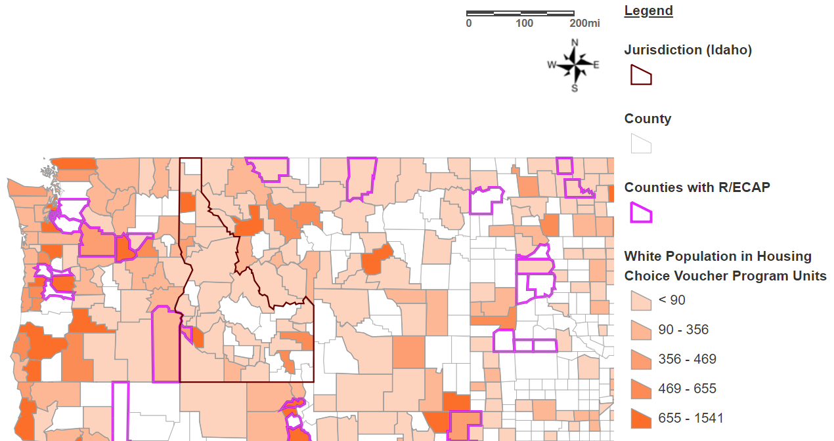
Besides White Households, Hispanic households are the second most represented demographic group represented in assisted housing. Hispanic families make up nearly 16% of public housing units in the state, which is slightly higher than the community’s representation in the state of about 12%.
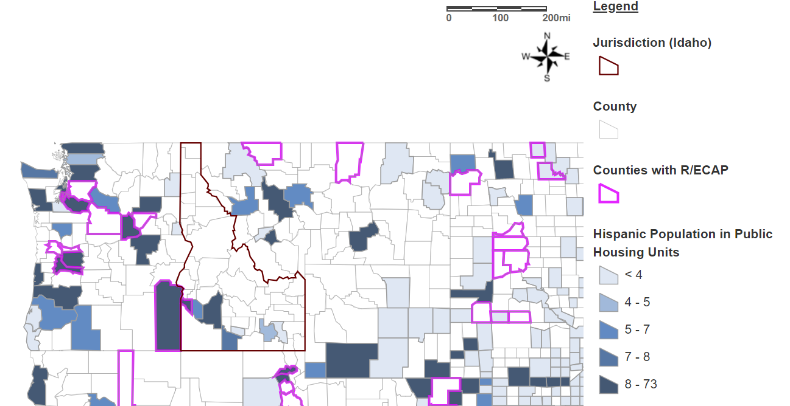
Public housing units with Hispanic households are geographically located in the Southwest region of the state.
Does the availability of housing units meet the needs of the population?
Total Vacant Housing Units
Total Housing Units | 680,302
Occupied Housing Units | 589,320
Vacant Housing Units | 90,982
Homeowner vacancy rate | 2
Rental vacancy rate | 6
Data Source: 2011-2015 ACS
Vacant Unit Status
 | Estimate | %
For Rent | 10,732 | 12%
Rented, not occupied | 2,560 | 3%
For sale only | 8,403 | 9%
Sold, not occupied | 4,045 | 4%
For seasonal recreational or occasional use | 46,721 | 51%
For migrant workers | 737 | 1%
Other vacant | 17,784 | 20%
Total | 90,982
Data Source: 2011-2015 ACS
According to ACS 2011-2015 estimates, the vacancy rate for owner-occupied units was 2%, thus highlighting the tight market for homeownership opportunities in the state. Meanwhile, the vacancy rate for rental units is more than double the rate of owner-occupied units at 5.5%. Such rate, and 2018 data from HousingIdaho.com and showcasing a vacancy rate of less than 2% for their listings, underscores the conditions of a tight rental market in the state and the lack of affordable housing units, particular for households in the most need.
Based on Idaho County-by County Housing, Demographic Assessment of 2018, 52.6% of the housing units in the state are affordable to renters earning the Area’s Median Income. Meanwhile, about 78.6% of housing units are affordable to owners earning the Area’s Median Income. Moreover, the gap of affordability is particularly large for families earning less than 50% of the Area Median Income.
Describe the need for specific types of housing:
Larger units to accommodate families are still in short supply in the state. Moreover, properties that are accessible for people with ambulatory disabilities and the elderly are also needed. Lastly, as national trends have shown, greater diversity in the housing typology to accommodate not only larger families, but also multi-generational and an array of other family unit structures should also be considered for the long-term viability of the affordable housing stock of the state. In 2018, for example, the City of Boise proposed changes related to Accessory Dwelling Units (ADU). The proposal would increase the size limit of an ADU to 700 square feet (but still limited to one bedroom), thus allowing the city to address the needs of a growing population in the city.
In addition to the need to address particular types of housing, the location and sizes of adequate parcels for housing development continued to be an issue. Such elements are particularly important in addressing the need for better access to housing for workers in urbanized areas of the state and the elderly disabled population still residing in rural areas.
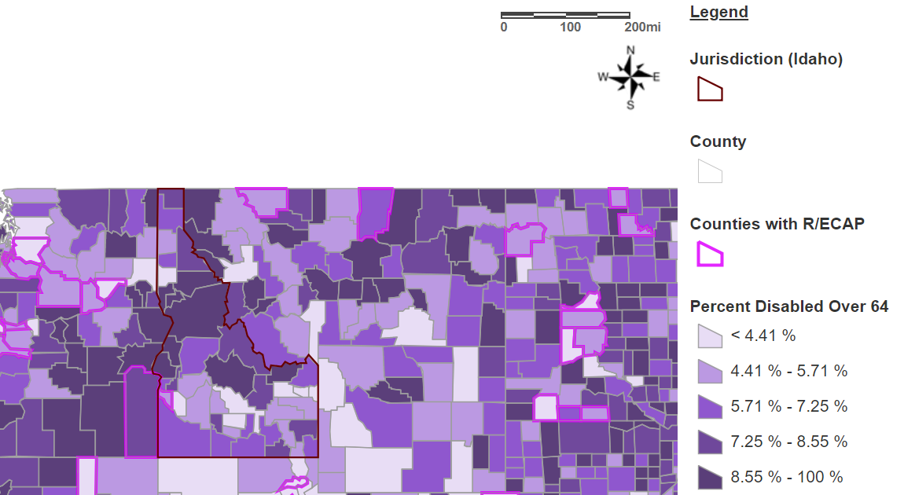

MA-15 Housing Market Analysis: Cost of Housing – 91.310(a)

Is there sufficient housing for households at all income levels?
With over 75% of the rental housing units with rents less than $1,000, overall access to affordable housing for households at all income levels is sufficient, though misleading in geographical terms. Counties experiencing population growth, such as Canyon County, have a lower percentage of affordable units accessible to renters and homeowners, while counties experiencing population drops have a higher portion of affordable units. Overall, urban counties continue to experience higher gaps in affordability for all income levels, while rural counties with higher transportation and maintenance costs face an array of other affordability barriers.
Based on 2011-2015 CHAS data, there are 167,485 households experiencing housing cost burden of over 30% in the state of Idaho. With only about 138,980 units affordable to households with an HAMFI of 50% or less, the gap between housing supply and demand will continue to make such gap and burden larger over time.
The Needs Assessment identified the following number of households in Idaho in each income bracket.
Income Bracket | Renter Households | Owner Households
0-30% AMI | 41,610 | 25,295
30-50% AMI | 36,230 | 35,845
50-80% AMI | 43,165 | 70,180
80-100% AMI | 19,250 | 46,230
>100% AMI | 43,205 | 228,310

Renter Households
The Housing Affordability table shows that there are 11,575 housing units affordable to those renter households earning 30% AMI while there are 41,610 renter households in Idaho earning 30% AMI or less. This shows a lack of approximately 30,035 homes for Idaho renter households earning 30% AMI or less. This gap experienced by those renter households earning 30% AMI or less is the greatest among all income brackets, identifying that there is largely insufficient housing available for those renter households earning 30% AMI or less.
For renter households earning 30% AMI or greater, comparing the Housing Affordability to the number of renter households, there appears to be a sufficient number of affordable homes. It is important to recognize these are statewide numbers and some areas of the state have higher housing costs generally, which in turn may limit the number of homes available to those lower income brackets. This is especially the case in metro areas where the HOME Rent Limits are nearing the $800 range, such as Boise Metro Area.
Owner Households
The Housing Affordability table shows that there are 28,050 housing units affordable to those owner households earning 50% AMI while there are 38,845 owner households in Idaho earning 30-50% AMI. This shows a lack of approximately 10,795 homes for Idaho owner households earning 30-50% AMI. The Housing Affordability table does not present data on the number of homes affordable to those owner households earning 30% AMI or less. The Housing Affordability table suggests there are enough homes affordable to those owner households earning 50% or greater. However, like renter households across the state, there are areas where housing costs are greater and therefore a greater number of households are cost burdened.

MA-30 Homeless Facilities – 91.310(b)
Introduction
As of 2018, the statewide homeless Point In Time (PIT) count for Idaho was 1,256, which represented a slight increase from the 1,204 recorded in 2017, but a 9% decrease from the highest shelter and unsheltered homeless population recorded in 2016.

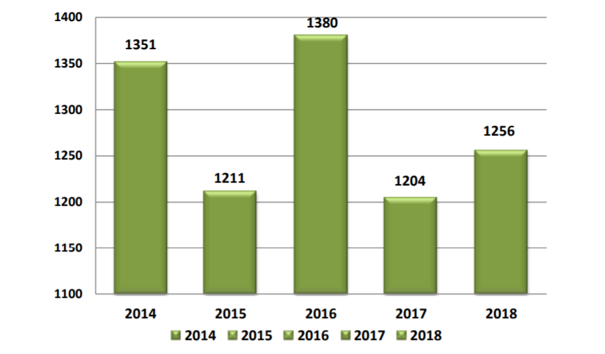
Data Source: | Idaho State CoC PIT Count Report 1/31/2018

While Region 7 and Ada County account for the bulk of the state’s homeless population, 764 as of 2018, those numbers have dropped 9% from the previous year, based on the PIT count report of 1/31/2018 by the Idaho Housing and Finance Association. Meanwhile other regions, such as Region 2 and Region 3, have slight increases in their homeless populations in the last year. In Region 2, which includes the counties of Idaho, Latah, Clearwater, Nez, and Perce, the homeless population has increased by 66% from the previous year.
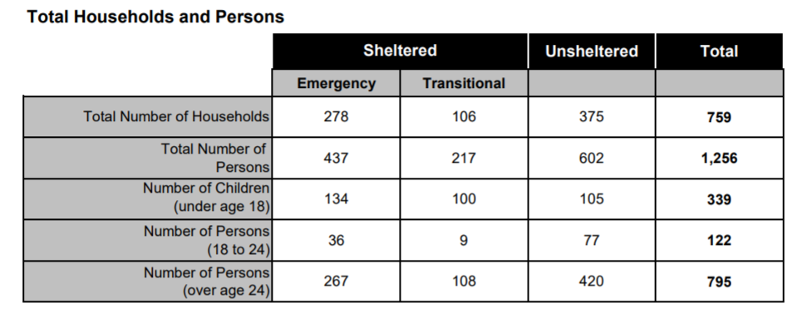
Data Source: | Idaho State CoC PIT Count Report 1/31/2018

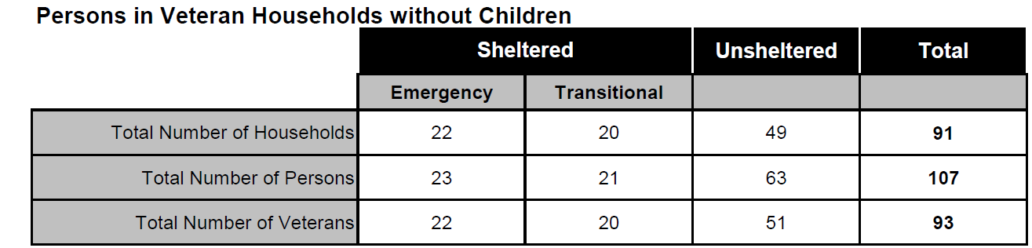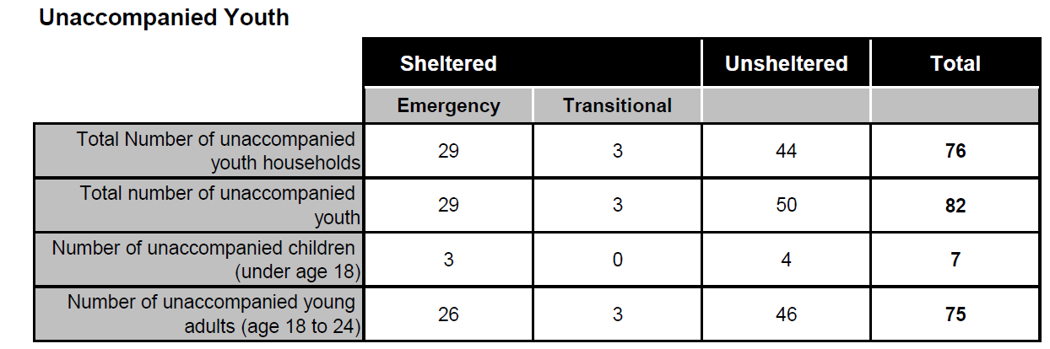
Data Source: | Idaho State CoC PIT Count Report 1/31/2018

MA-35 Special Needs Facilities and Services – 91.310(c)
Introduction
Many Idahoans face homelessness, or the risk of becoming homeless, each year. As the main recipient of homelessness assistance funding, Idaho Housing and Finance Association is the recipient of the majority of homelessness assistance funds. IHFA administers the CoC, ESG, and HOPWA programs to meet the special needs and services for communities in the state. While also maintaining Idaho’s Homeless Management Information System, HOME and Low Income Housing Tax Credit allocations, and a large portion of the total Section 8 Housing Choice Vouchers available in the state, IHFA is unique position to pair resources and form partnerships with others to promote a positive impact upon the living situation of homeless persons in Idaho and meet the needs of different communities in the state.
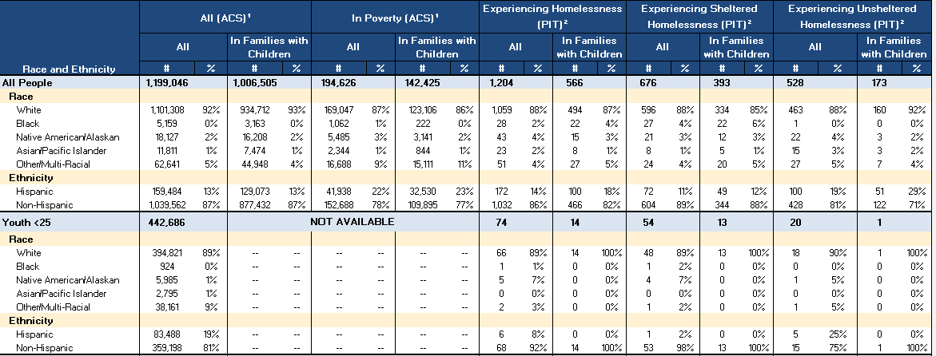
Data Source: | HUD CoC Racial Equity Analysis Tool, data based on ACS 2011-2015 and 2017 PIT Count

Based on the snapshot provided by HUD’s CoC Racial Equity Analysis for Idaho, addressing the special needs of youth experiencing homelessness and unsheltered Hispanic households with children remain special needs areas the State of Idaho and IHFA should remain mindful of moving forward.

Number of HUD Subsidized Housing Units in Idaho
HUD Program | Number of Units
Public Housing | 752
Housing Choice Vouchers | 7465
Project Based Section 8 | 3768
202 Housing for seniors and people with disabilities | 386
811 Housing for people with disabilities | 104
Note: Excludes HOME and CDBG
Source: HUD Picture of Subsidized Households 2019
Average Waitlist Time for Public Housing and Housing Choice Vouchers in Idaho
HUD Program | Average Number of Months on Waiting List
Public Housing | 12
Housing Choice Vouchers | 21
Source: HUD Picture of Subsidized Households 2019
Household Income in HUD Subsidized Housing Units in Idaho
HUD Program | Average Annual Household Income | % Households with Income Below 50% AMI | % Households with Income Below 30% AMI
Public Housing | $16,583 | 87 | 61
Housing Choice Vouchers | $14,064 | 96 | 70
Project Based Section 8 | $12,963 | 95 | 68
202 Housing for seniors and people with disabilities | $13,145 | 98 | 65
811 Housing for people with disabilities | $11,519 | 98 | 82
Source: HUD Picture of Subsidized Households 2019

MA-40 Barriers to Affordable Housing – 91.310(d)
Negative Effects of Public Policies on Affordable Housing and Residential Investment
Based on Idaho’s 2017 Analysis of Impediments to Fair Housing Choice, This section identified housing needs of residents in Idaho, whether housing challenges disproportionately affect certain protected classes, and whether potential barriers exist in the public and private provision of housing.
Parcel Sizes: City and county zoning may not allow for small lots for single-family detached housing or other forms of housing typology, such as Accessory Dwelling Units. Parcel sizes are a type of restriction that may increase housing and development costs of affordable housing units.
Health and safety codes: The Idaho Division of Building Safety sets the regulations for building codes; installation of electrical, plumbing and HVAC work; manufactured housing standards; and logging safety. The division also oversees licensing of electrical, HVAC, manufactured housing, plumbing, and public works contractors.
Building construction codes ensure the health and safety of occupants. However, codes with extensive requirements may increase housing costs and reduce the supply of affordable housing. In addition, if they contain provisions that discourage or prohibit the types of reasonable modifications needed to meet the needs of certain protected classes, they may create barriers to fair housing choice for these groups.
State and local regulations: A variety of regulations can affect provision of housing and housing choice of protected classes. The following list provides examples of regulations where the code may create challenges in housing provision.
- Idaho Statutes, Title 67. State Government and State Affairs. Chapter 65.
Local Land Use and Planning confers zoning powers on cities and counties. Such bodies are required to prepare a Comprehensive Plan that addresses, among other land use factors, an analysis of housing conditions and needs, including the need for “low‐cost” housing. The plans must also address the needs for community facilities (schools, recreation facilities, transportation). Plans are reviewed and adopted by local planning commissions. It is important to include rehabilitation as part of building standards because much of the nation’s affordable housing stock is in older structures. This tends to help preserve the supply of affordable housing. The state statute does not prescribe how often Comprehensive Plans are updated.

- Title 26. Banks and Banking, Chapter 31. Idaho Residential Mortgage Practices Act.
Regulates the activities of mortgage brokers and lenders to protect borrowers against unknown and unreasonable fees and other practices that could adversely affect mortgage loan terms.
Other types of regulations than can affect housing provision are not regulated at the state level. These include occupancy codes and restrictions (beyond the IBC), certain types of group homes (e.g., homes for recovering alcoholics and/or substance abusers), ability to enact code enforcement, and displacement of low income residents (other than what is included in the manufactured home regulations discussed above).
Limits on local revenue generation: It is common for states in the western U.S. to limit taxation. Idaho does this by limiting annual increases in property taxes and, except for resort areas with voter approval, not allowing cities to collect local sales taxes. If allowed, such revenue could be used to support affordable housing in communities where housing is determined to be a priority need. It is important to note, however, that the additional revenue would compete with other local needs; as such, the actual effects of limits on local revenue generation on housing availability are unclear.
Limit on inclusionary zoning: Also similar to many western states is Idaho’s ban on rent control, which affects the use of inclusionary zoning programs. Inclusionary zoning is a program commonly used in high cost areas to produce affordable housing. In general, inclusionary zoning programs require that residential developments of a certain size incorporate a proportion of units that meet affordable price points. Inclusionary zoning can be applied to rental or homeownership housing or both. Some high cost urban areas in the West (Austin and Denver) have implemented voluntary inclusionary zoning in exchange for development benefits including density bonuses. Several Idaho resort areas that have attempted to enact inclusionary zoning programs have been challenged in court, resulting in the programs being overturned. The courts have determined that such programs exceed local jurisdiction’s authority.
Public transportation Access: The Idaho Department of Transportation estimates that 56% of Idahoans have access to public transit, as such public transportation access is often limited or not existent, particularly in remote, rural areas of the state. Such lack of public transportation limits the location and placement of affordable housing units, particular those aimed at serving the needs of the elder and persons with disabilities.
Infrastructure Investment: Along with investments in public transportation, investments in general infrastructure, such as roads and sidewalks, also have an impact on the location of affordable housing units in the state. Infrastructure, particularly in rural areas, determines not only access to housing, but also employment opportunities.
Proficient Schools: Access to adequate schools often determines the preferred location of families and the potential investment developers are willing to make in a particular area. Ensuring that proficient schools are accessible to everyone in the state, particularly those in rural areas and for students with disabilities, remains a challenge for the state and a barrier for potential housing development.
Jobs: The location of workforce hubs often determines where and when households are willing to live or relocate to a certain areas. Economic development strategies in the state must take into account housing and the location of potential jobs in order to ensure affordability for new workers moving in and the existing community.
As previously noted, neither IHFA nor IDC (grantees) are part of the legislative branch; therefore, it is beyond our ability to make or alter legislation or policy. However, grantees perceive a role in influencing policy makers and practitioners through education and outreach, the theory being that increased general awareness of the benefits of housing affordability creates a more receptive environment at all levels of government.
Please note. Information and findings regarding Barriers to Affordable Housing contained in the 2017 Analysis of Impediments represent only a point-in-time survey and analysis. Individual counties may have subsequently modified their policies and procedures; individual cities and communities may have policies and procedures that differ substantially from their surrounding county. Information collected indicated some Idaho counties’ land use regulations and zoning policies may create barriers to affordability. This should not be interpreted to mean all county land-use policies (or the cities within those counties) were or are problematic.
Section V. Land-Use and Zoning Regulations contains a county-by-county assessment of policies and recommendations. This provides the context that clarifies the linkage between local policy(s) and housing diversity and affordability

MA-45 Infrastructure Needs in Idaho

CDBG
Dams – (Grade = C) The state average age for Idaho’s dams is approaching 60 years. Remarkable, few new water storage projects are currently being considered, and none are being designed or constructed to replace those whose service life is, or soon will exceed 75 years. The cost for repair has increased steadily, while replacement costs for existing structures have increased exponentially since the last large dam was built in Idaho in the 1970’s. Current estimates of construction costs for repair of that facility are estimated to exceed $500 million, on top of $140 to $160 million in emergency response costs.

Drinking Water – (Grade C) – Idaho’s drinking water infrastructure needs will grow in future years; especially as existing infrastructure ages and the state’s population grows. The EPA estimated in its 2011 Drinking Water Infrastructure Needs Survey Idaho needs $961.8 million in funding over the next 20 years. Small clean water systems which are defined by the EPA as serving 3,300 persons or fewer, are grappling with a significant portion of the total overall bill.

Idaho needs to prepare for current and future population growth by building new facilities, expanding pipelines, and investing in existing drinking water assets.

Wastewater- (Grade B-) The EPA reports that over the next 20 years, Idaho will require $1.38 billion in wastewater infrastructure needs. Population growth is already demanding sewer system capacity expansion in Idaho. Additionally, there is tension between existing, current-day jurisdictional boundaries and the need to plan for tomorrow. Future communities will exist outside current-day city limits, and coordination to float bonds and plan comprehensively is needed.

Responses to the ASCE survey on wastewater infrastructure demonstrate that the ability of Idaho’s systems to meet various levels of anticipated growth is a cause for concern. 50% of respondents reported their jurisdiction was capable of meeting only 70% to 90% of anticipated growth.

Energy – (Grade = B-) While the State’s total energy consumption is increasing, the per capita consumption in the state is decreasing. The decrease in per capita consumption is a result of technological advances in energy generation and consumption along with consumer education. The future needs for energy in Idaho will be met by repairing or replacing aging infrastructure and constructing new infrastructure to adjust for the state’s increasing population, as well as to increase resilience of energy generation and distribution.

State Highways – (Grade = C-) For the first time in ten years, Congress passed a long-term bill that was signed into law in December 2015 and covers a five-year period. While the new bill does provide some certainty in the amount of Federal funds that will be available over the next few years, the certainty is temporary. The chronic insolvency of the Highway Trust Fund and the national debt situation, combined with the high level of dependency of state highway system funding on Federal sources, continues to cause concern. The Federal gas tax has not increased since 1993, resulting in a $15 billion annual federal shortfall. To bridge the gap, funds would be transferred from a number of uncertain sources.

Additional state funding provided in FY 2015 and FY 2016 from the fuel tax increase and budget surplus transfer has helped address the backlog in infrastructure funding. Also, Idaho legislators approved a one-time boost of $300 million in additional GARVEE bonds in 2017. However, the remaining annual shortfall of nearly $450 million will result in a continuing struggle to meet future needs.

Local Highways - (Grade = C-) As the 2015 gas tax was further phased in, local jurisdictions, received an additional 27% of funds over the previous year. However, they still reported a $299.9 million shortfall in delayed transportation funding.

If sustainable new revenues are not identified and provided on the system, the local highways will rapidly deteriorate to the point that they are unusable and unsafe.

School Facilities – (Grade = C-) Idaho is one of the only 12 states that provide no state funding support for K-12 construction. Less than 5% of survey respondents indicated affirmatively that the current level of funding meets the needs of their schools. Only 28% agreed that future funding prospects will meet the future needs of their schools.

While Idaho continues to recover from the 2008 recession, we still can make additional progress when it comes to investment in Idaho public schools. The National Council on School Facilities estimates that Idaho has a projected annual gap of $561 million for K-12 facilities responsibilities.

Bridges – (Grade = D) Idaho has identified needed repairs on 1,515 bridges, and the state estimates the cost of repair to these bridges will total $2.2 billion. Over the last 10 years, the Idaho Transportation Department has been able to construct approximately 36 bridges per year and do major rehabilitation work on approximately 8 bridges per year, but funding for a quicker rate of rehabilitation and replacement is needed to lower the number of structurally deficient bridges in the state.

*Source: ASCE 2018 Report Card

MA-50 Needs and Market Analysis Discussion
Are there areas where households with multiple housing problems are concentrated? (include a definition of "concentration")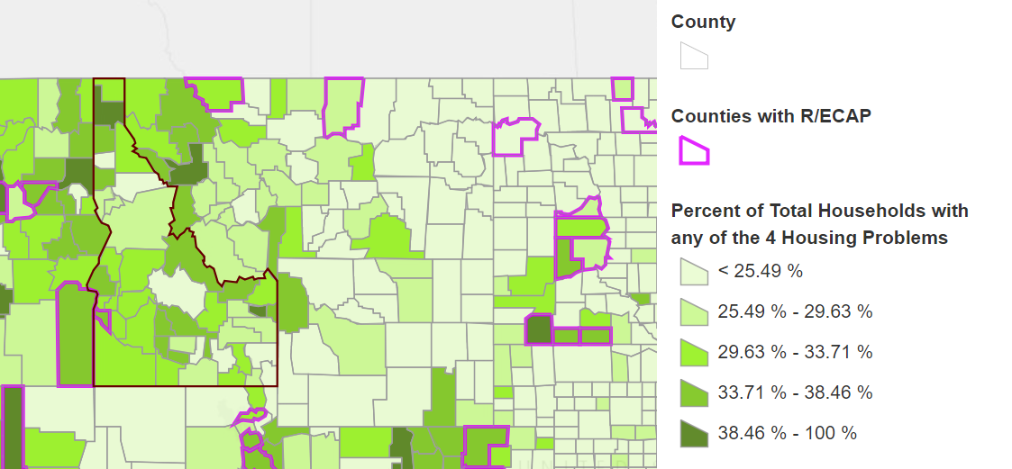
Counties such as Bonner and Madison are areas where households with multiple housing problems are the most concentrated. Concentration, in this case, refers to counties with 10%of total households with any of the four housing problems over 39%.
Bonner County, for example, has nearly 17,390 households with any of 4 Housing Problems or nearly 40% of the total households in the county. Meanwhile, Madison County has over 10,300 households with any of the four major housing problems. Such number presents nearly 47% of all households in the county. Neighboring counties, such as Clark and Teton are also experiencing a high proportion of households with housing problems, with over 35% of the households in both counties experiencing one of the four housing problems.
Are there any areas in the jurisdiction where racial or ethnic minorities or low-income families are concentrated? (include a definition of "concentration")
Overall, the southern portion of the state of Idaho represents the highest concentration of minority and low-income households. Counties such as Canyon, for example, have been designated as R/ECAP zones where the concentration of minority and low-income is highest in the state. Other counties, such as Clark, Power, Lincoln, Minidoka, and Jerome have a high percentage of Hispanic families. In this case, concentration refers to counties with 28% or more of Hispanic families.
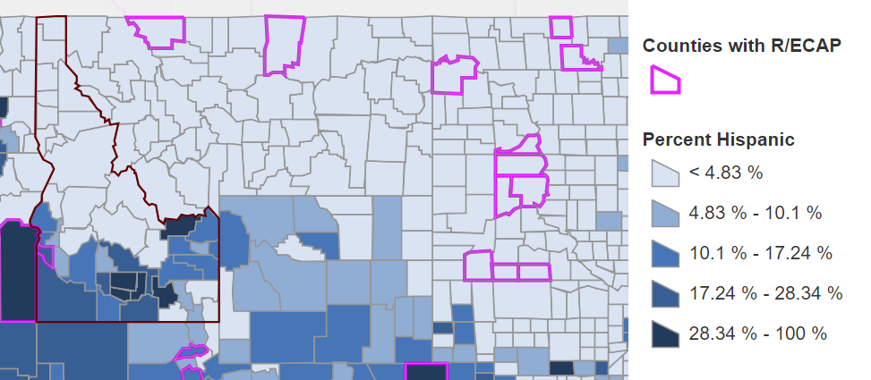
In terms of low-income families in particular, counties such as Ada, Valley, Blaine, Latah, and Nez represent areas with highest concentration of low poverty. In this case, concentration refers to counties with a total population average low poverty index of 53 or higher.
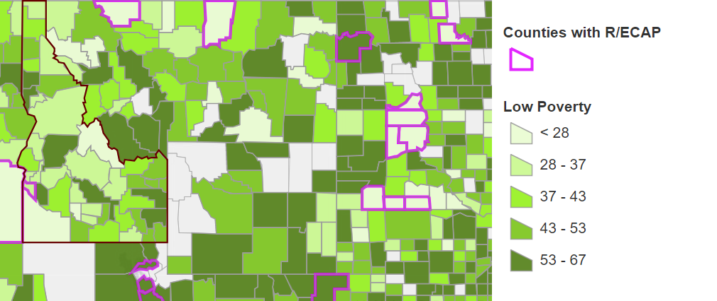

MA-60 Broadband Needs of Housing occupied by Low- and Moderate-Income Households – 92.210(a)(4), 91.310(a)(2)
Describe the need for broadband wiring and connections for households, including low- and moderate-income households and neighborhoods.
Reliable broadband infrastructure attracts businesses, connects people to educational opportunities, and enhances social life among a host of other contributions to quality of life. According to broadbandnow.com/Idaho an estimated 21% of Idaho residents are underserved by broadband service providers, meaning they are either receiving unstable options, or minimal to no options at all. Those Counties that are most underserved are in the North part of the State: Shoshone, Clearwater, Idaho, and Camas Counties are notably underserved.
In November 2019, Idaho Department of Commerce approved the Broadband Access is Imperative to Idaho report. The report identifies plans, gaps, and strategies moving forward to increase the broadband access across the state. The Task Force identified five (5) recommendations and calls-to action:
- Update Broadband Plan
  - The State will identify places for public-private partnerships and will work to support maximum funding opportunities and coordination to expand broadband service across Idaho.
- Establish a State Broadband Office
  - The Task Force is initially recommending one full time staff person in the office that may provide consumer education, facilitating opportunities and funding sources, and coordinate where Idaho can leverage existing infrastructure in efforts to expand broadband.
- Consider State Funding Options
  - The Task Force recommends looking into ways to maximize existing funding and leverage new sources where possible and complement “one dig” or “one hang” projects where the most impact could be done with the fewest resources.
- Improve deployment efficiency by formalizing “Dig Once” and “Hang Once” policies
  - Establish a state construction registry maintained by the State of Idaho for all upcoming transportation infrastructure projects and of existing available conduit in the public right of way and promote joint projects.
- Engage on near term projects
  - Near term projects could have an immediate impact on unserved areas, those projects are:
    - North Central Idaho “open access” fiber network across five counties
    - North-South pathway between Grangeville and Riggins
    - I-90 corridor between town of Cataldo and the Idaho and Montana border
    - Melba
Describe the need for increased competition by having more than one broadband Internet service provider serve the jurisdiction.
Competition among service providers keeps prices lower for consumers and presents options for a consumer so they may make choices that best suit their needs. Below is a map outlining Idaho access to providers offering broadband services. The speeds identified are 25Mbps download and 3Mbps upload – the minimum speeds to be considered broadband.

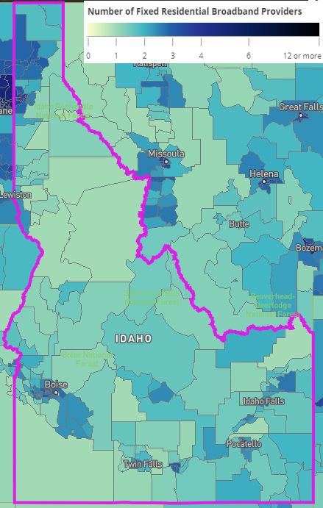
Source: FCC Broadband Mapping – broadbandmap.fcc.gov

Below is a table that identifies what percentage of the jurisdiction has access to broadband providers.

Percent Coverage to Broadband Providers
Jurisdiction | No providers | 1 or more providers | 2 or more providers | 3 or more providers
Nationwide | 0.10 | 99.9 | 94.1 | 72.6
Idaho | 0.0 | 100 | 83.2 | 60.0
Wyoming | 0.0 | 100 | 81.4 | 47.8
Montana | 0.0 | 100 | 81.0 | 52.6
Source: FCC Broadband Mapping – broadbandmap.fcc.gov

Idaho compares above its immediate neighbors in access to broadband. However, much like other states with largely rural areas, the access to broadband in rural areas is limited, usually having only a single provider to broadband access. This limited competition can often lead to increased prices, creating barriers to broadband access in rural areas.

SP 40 – Institutional Delivery Structure

State of Idaho (Commerce) -CDBG Program

Commerce’s 2019 reduction of its state codified rules for the Idaho CDBG program will be a strength, as it will allow Commerce to make CDBG delivery changes with fewer procedural requirements. In the past, changes to the state codified rules required approval by the Idaho legislature, which slowed down the efficiencies and effectiveness of the program.
The consistency of Commerce’s competitive grant application forms, process, and timeline of the delivery structure for the CDBG program is considered a strength in delivery.
With the number of rules and regulations that are conditioned for receiving and implementing a CDBG grant funded project the ability to comply with applicable requirements is challenging for cities and counties, especially considering they only receive a CDBG grant periodically. Also, many of the cities and counties have limited staff available to implement a CDBG project. In order to help ensure the capacity is available, Commerce has created and maintains a certified grant administrator program. Any CDBG grantee (city, county, or sub-recipient) is required to utilize a grant administrator to implement the project. Local government personnel, planning districts, and individual consultants have the ability to become certified. The utilization of certified grant administrators would be considered a strength, as it reduces the burden on Commerce staff and maintains a consist pool of consultant, who understand the CDBG rules, for a potential grantee to select from to help implement a CDBG funded project.
Commerce’s development and updating of a Grant Administration Manual, Application Handbook, CDBG Procedures Guide, and CDBG webpage is an additional strength to the institutional delivery system.
Gaps to the system include grant administrator turnover, local government turnover, loss of a planning district, and the large geographical distances and rural makeup of the State. The ability to meet with grantees and assess projects can require a lot of travel time and stretch resources. Commerce’s attempts to mitigate the delivery gaps by providing on-going technical assistance, application workshops, grant trainings, and presentations to potential grantees.
The grant administration manual does need to be re-configured on Commerce’s website by breaking out certain fillable sections within a chapter. This would hopefully reduce some confusion of what forms are required.

IHFA- HOME Program
As the Lead Agency and Participating Jurisdiction for Idaho's HOME Program, IHFA has created an institutional structure that works well with private industry, local units of government, non-profit service providers, and affordable housing developers to create and preserve affordable housing throughout the State of Idaho. IHFA's current HOME program delivery system is a mature and well-developed system.
IHFA awards HOME funds to owners and developers who can demonstrate capacity to construct and/or rehabilitate affordable single-family properties and acquire and/or rehabilitate, and construct affordable rental housing. IHFA also awards funds to eligible, qualified low-income homebuyers for down payment/closing cost or other gap financing who have qualified for a primary mortgage loan. Using legal instruments, IHFA ensures development and long-term compliance adhere to HOME, other federal regulations, applicable state and local codes/zoning/ordinances, applicable HOME/local property standards, IHFA rehabilitation standards, and other criteria as submitted as part of the application process. To ensure the development process is progressing, IHFA conducts periodic inspections during the development phase and when completed. ensure the activity is progressing according to an approved time schedule and HOME limits. IHFA conducts on-site physical inspections and conducts compliance monitoring during the HOME period of affordability.
IHFA will award funds to experienced non-profits, CHDOs, and local units of government to own, develop, then sell, homebuyer properties to eligible and qualified low-income homebuyers. HOME and cross-cutting federal, state, and local codes, standards, ordinances and zoning are enforced through legal instruments with the developer as well as the homebuyer.
IHFA conducts annual monitoring to ensure the HOME-assisted homebuyer continues to reside in the HOME-assisted unit as principle residence. If this is no longer the case during the period of affordability, and there isn’t a military or full-time student approved exception, IHFA-HOME attempts to persuade the homebuyer to return to the unit. If this fails, IHFA will default on the HOME loan and require the HOME funds to be repaid or the unit be sold. All Idaho CHDOs currently participate in HOME homebuyer properties activity. All developers, including CHDOs, must demonstrate organizational and development capacity for the activity they plan to undertake. IHFA-HOME is responsible for qualifying low-income homebuyers for down payment/closing cost assistance and assistance under the homebuyer properties activity.

IHFA- ESG Program
While Idaho is the 14th largest state in terms of total square miles, it ranks 39th in total population. The 2013 US Census presents the Ada County- home of the state capital- population at just over 415,000.
Of the other 43 counties in Idaho, only three have a population exceeding 100,000. This convincingly demonstrates Idaho’s rural makeup. The resulting gaps are a reduced public awareness of the existence of homelessness and individuals living with HIV/AIDS; the decreased availability of resources to pair with federally funded programs; below adequate existence of affordable housing for low to moderate income individuals and families; the absence of available state and local resources to combat homelessness and HIV/AIDS; and an aged housing stock which does not include a sufficient amount of safe, decent, and sanitary rental units.
Fortunately, despite these challenges, the current service delivery system for federally funded programs is quite impactful. IHFA is the main recipient of ESG funds for the state of Idaho. IHFA sub-grants funds to subrecipients across the state each year. The fund allocations are determined by methods which have been reviewed and commented on by the BoS CoC participating agencies and organizations. The BoS CoC homelessness service network consists of long tenured individuals with expansive knowledge and experience with HUD-funded programs and the homeless population. The organizational structure established by the BoS CoC ensures statewide collaboration and coordination of most homeless targeted housing and services programs, and funnels regional occurrences and happenings to the BoS CoC board to ensure statewide awareness.

SP-55 Barriers to Affordable Housing
Negative Effects of Public Policies on Affordable Housing and Residential Investment
Based on Idaho’s 2017 Analysis of Impediments to Fair Housing Choice, This section identified housing needs of residents in Idaho, whether housing challenges disproportionately affect certain protected classes, and whether potential barriers exist in the public and private provision of housing.
Parcel Sizes: City and county zoning may not allow for small lots for single-family detached housing or other forms of housing typology, such as Accessory Dwelling Units. Parcel sizes are a type of restriction that may increase housing and development costs of affordable housing units.
Health and safety codes: The Idaho Division of Building Safety sets the regulations for building codes; installation of electrical, plumbing and HVAC work; manufactured housing standards; and logging safety. The division also oversees licensing of electrical, HVAC, manufactured housing, plumbing, and public works contractors.
Building construction codes ensure the health and safety of occupants. However, codes with extensive requirements may increase housing costs and reduce the supply of affordable housing. In addition, if they contain provisions that discourage or prohibit the types of reasonable modifications needed to meet the needs of certain protected classes, they may create barriers to fair housing choice for these groups.
State and local regulations: A variety of regulations can affect provision of housing and housing choice of protected classes. The following list provides examples of regulations where the code may create challenges in housing provision.
- Idaho Statutes, Title 67. State Government and State Affairs. Chapter 65.
Local Land Use and Planning confers zoning powers on cities and counties. Such bodies are required to prepare a Comprehensive Plan that addresses, among other land use factors, an analysis of housing conditions and needs, including the need for “low‐cost” housing. The plans must also address the needs for community facilities (schools, recreation facilities, transportation). Plans are reviewed and adopted by local planning commissions. It is important to include rehabilitation as part of building standards because much of the nation’s affordable housing stock is in older structures. This tends to help preserve the supply of affordable housing. The state statute does not prescribe how often Comprehensive Plans are updated.

- Title 26. Banks and Banking, Chapter 31. Idaho Residential Mortgage Practices Act.
Regulates the activities of mortgage brokers and lenders to protect borrowers against unknown and unreasonable fees and other practices that could adversely affect mortgage loan terms.
Other types of regulations than can affect housing provision are not regulated at the state level. These include occupancy codes and restrictions (beyond the IBC), certain types of group homes (e.g., homes for recovering alcoholics and/or substance abusers), ability to enact code enforcement, and displacement of low income residents (other than what is included in the manufactured home regulations discussed above).
Limits on local revenue generation: It is common for states in the western U.S. to limit taxation. Idaho does this by limiting annual increases in property taxes and, except for resort areas with voter approval, not allowing cities to collect local sales taxes. If allowed, such revenue could be used to support affordable housing in communities where housing is determined to be a priority need. It is important to note, however, that the additional revenue would compete with other local needs; as such, the actual effects of limits on local revenue generation on housing availability are unclear.
Limit on inclusionary zoning: Also similar to many western states is Idaho’s ban on rent control, which affects the use of inclusionary zoning programs. Inclusionary zoning is a program commonly used in high cost areas to produce affordable housing. In general, inclusionary zoning programs require that residential developments of a certain size incorporate a proportion of units that meet affordable price points. Inclusionary zoning can be applied to rental or homeownership housing or both. Some high cost urban areas in the West (Austin and Denver) have implemented voluntary inclusionary zoning in exchange for development benefits including density bonuses. Several Idaho resort areas that have attempted to enact inclusionary zoning programs have been challenged in court, resulting in the programs being overturned. The courts have determined that such programs exceed local jurisdiction’s authority.
Public transportation Access: The Idaho Department of Transportation estimates that 56% of Idahoans have access to public transit, as such public transportation access is often limited or not existent, particularly in remote, rural areas of the state. Such lack of public transportation limits the location and placement of affordable housing units, particular those aimed at serving the needs of the elder and persons with disabilities.
Infrastructure Investment: Along with investments in public transportation, investments in general infrastructure, such as roads and sidewalks, also have an impact on the location of affordable housing units in the state. Infrastructure, particularly in rural areas, determines not only access to housing, but also employment opportunities.
Proficient Schools: Access to adequate schools often determines the preferred location of families and the potential investment developers are willing to make in a particular area. Ensuring that proficient schools are accessible to everyone in the state, particularly those in rural areas and for students with disabilities, remains a challenge for the state and a barrier for potential housing development.
Jobs: The location of workforce hubs often determines where and when households are willing to live or relocate to a certain areas. Economic development strategies in the state must take into account housing and the location of potential jobs in order to ensure affordability for new workers moving in and the existing community.
As previously noted, neither IHFA nor IDC (grantees) are part of the legislative branch; therefore, it is beyond our ability to make or alter legislation or policy. However, grantees perceive a role in influencing policy makers and practitioners through education and outreach, the theory being that increased general awareness of the benefits of housing affordability creates a more receptive environment at all levels of government.
Please note. Information and findings regarding Barriers to Affordable Housing contained in the 2017 Analysis of Impediments represent only a point-in-time survey and analysis. Individual counties may have subsequently modified their policies and procedures; individual cities and communities may have policies and procedures that differ substantially from their surrounding county. Information collected indicated some Idaho counties’ land use regulations and zoning policies may create barriers to affordability. This should not be interpreted to mean all county land-use policies (or the cities within those counties) were or are problematic.
Section V. Land-Use and Zoning Regulations contains a county-by-county assessment of policies and recommendations. This provides the context that clarifies the linkage between local policy(s) and housing diversity and affordability.

SP-65 Lead Based Paint Hazards
Year Unit Built
Year Unit Built | Owner-Occupied |  | Renter-Occupied
 | Number | % | Number | %
2000 or later | 107,554 | 27% | 39,443 | 22%
1980-1999 | 118,513 | 29.2% | 54,853 | 29.9%
1940-1979 | 145,706 | 36% | 73,199 | 40%
Before 1939 | 34,093 | 8.4% | 15,961 | 8.7%
Total | 405,865 |  | 183,455
Data Source: ACS 2011-2015

Risk of Lead-Based Paint Hazard
Risk of Lead-Based Paint Hazard | Owner-Occupied |  | Renter-Occupied
 | Number | % | Number | %
Total Number of Units Built Before 1980. | 179,798 | 44% | 89,159 | 49%

Housing units built before 1980 with children under the age of 6 present | 23,450 | 6% |  | 16,345 |  | 9%
Data Source: | 2011-2015 ACS (Total Units) 2011-2015 5CHAS (Units with Children present)

Housing that will be assisted with Federal funds in Idaho is required to have an EPA Risk Assessment/Paint Testing to determine the presence of Lead-based Paint prior to a commitment of funds for rehabilitation if constructed on or before January 1, 1978.
Estimated Number of Housing Units Occupied by Low or Moderate-Income Families with LBP Hazards
Based on 2011-2015 ACS figures, about 47% of Idaho's housing stock was built prior to 1980. Based on the age of this housing, one could assume that some of those units will have Lead-based paint (LBP). While not all homes built before 1980 have Lead-based paint, homes built between 1940 and 1959 (76,635 units) have a higher risk for having LBP.
With 9% of the rental homes and 6% of owned units built before 1980 having a presence of children under the age of 6, it is important to assume any exposure to Lead-based paint would be detrimental to those families. The higher rate for rental units is particularly worrisome, for in many cases families renting a pre-1980 housing unit may not have the financial means to easily move or the resources to reach out to test for LBP.
Actions to address LBP hazards and increase access to housing without LBP hazards
The Lead-Based Paint Poisoning Prevention Act prohibits the use of Lead-Based paint in all residential structures constructed on or after January 1, 1978(exemptions apply). HUD estimates 11% of U.S. housing built between 1960 and 1977 has significant lead-based paint hazards, with 39% of housing built between 1940-1959, and 67% of housing built prior to 1939 (Guidelines for Evaluation of Control of LBP hazards in HUD Housing, 2012 Update: Chapter 5, pg. 12)]. Idaho has a total of 680,302 housing units; 40% of these units were built before 1980. While not all homes built before 1980 have Lead-based paint, homes built between 1940 and 1959 (76,635 units) have a higher risk for having LBP. It is noted that these estimates do not account for the number of housing units that have had lead hazard reduction or elimination activities. Accordingly, the number of residential units in Idaho with significant LBP hazards is likely to be significantly lower. Additional information available below.
How are the actions listed above integrated into housing policies and procedures?
The State of Idaho has not adopted a state level Lead-based paint/hazard reduction program. Therefore, residential acquisition and/or rehabilitation activities are required to follow the EPA Lead-Based Paint Renovation, Repair, and Paint Rule (RRP). This rule applies to all permanent residential housing built before January 1, 1978. Because there is no state level program, EPA must approve and certify all Idaho's LBP trainers, risk assessors/paint testers and renovation firms/workers in Idaho; it does not recognize other state level programs or certifications, i.e. Oregon. When HUD funds are used residential acquisition and/or rehabilitation activities, HUD's Lead-Safe Housing Rule (LSHR) also applies to the activity. In cases where either the RRP Rule or HUD’s LSHR is more restrictive, the most restrictive rule will apply.
There are certain LBP rule exemptions under EPA's RRP rule, however to be defined as an acceptable exemption under the HOME/HTF Program, HUD LSHR must also identify it as an exemption. The most restrictive rule will apply.
LBP policies and procedures are outlined Annual Administrative Plan and enforced through a written agreement with the owner. LBP tenant disclosure requirements and LBP hazard identification and reduction activities requirements are monitored for compliance during the period of affordability.
IHFA supports the position that education and training will reduce lead-based paint hazards in Idaho's residential housing. While Idaho does not define IHFA as a State agency, HUD does for program administration purposes. Therefore, IHFA is ineligible to apply for HUD Lead-based Paint training program funds.
Discussion:
Overall, Idaho has been fairly successful reducing the exposure to LBP to families with children under the age of 6 and overall in the state. In 2011, for example, only 13% of rental units built prior to 1980 had a child under the age of 6 present; moreover, 52% of all rental units had been built prior to 1980. By 2015, that percentage of rental units built prior to 1980 with children under the age of 6 dropped to 9%, while the overall number of rental units built prior to 1980 dropped to 49%.
At the local level, some cities have taken proactive steps to lower those numbers further. For example, the city of Pocatello’s Planning and Development Services Department received a $1.5 million Lead-Based Paint Hazard Control Grant from HUD’s Office of Lead Hazard Control and Healthy Homes in 2018. Since then, the city has used the funding to launch a Lead Safe and Healthy Homes initiative. The initiative aims to provide lead-based paint hazard control through licensed and certified contractors at no cost to homeowners and renters in the area. Similar local efforts across the state will help reduce exposure to lead-based paint hazard even further in the state.
How are the actions listed above integrated into housing policies and procedures?
The State of Idaho does not have a state level Lead-based paint/hazard reduction program. Because of this, residential housing acquisition and/or rehabilitation activities are required to follow the EPA’s Lead-Based Paint Renovation, Repair, and Paint Rule (RRP). This rule applies to all permanent residential housing built before January 1, 1978. The EPA must approve and certify all LBP trainers, risk assessors/paint testers and renovation firms/workers who work or train in Idaho. The EPA does not recognize other state level programs or certifications, i.e. Oregon in Idaho.
Whenever HUD funds are used residential acquisition and/or rehabilitation activities, HUD's Lead-Safe Housing Rule (LSHR) also applies to the activity. In cases where either the RRP Rule or HUD’s LSHR is more restrictive, the most restrictive rule applies. Both developer and contractor(s) are required to be an EPA-certified renovation firm, and follow the EPA Renovation, Repair, and Paint Rule and HUD’s Lead-Safe Housing Rule if LBP if LBP exceeds HUD’s de minimis levels.
There are certain LBP rule exemptions under EPA's RRP rule, however, to be defined as an acceptable exemption under the HOME/HTF Program, HUD LSHR must also identify it as an exemption. The most restrictive rule will apply.
HOME LBP policies and procedures are outlined Annual Administrative Plan and enforced through a written agreement with the owner. LBP tenant disclosure requirements and LBP hazard identification and reduction activities requirements are monitored for compliance during the period of affordability. The majority of developer proposed affordable housing development activities involve new construction.
IHFA supports a position that education and training will reduce lead-based paint hazards in Idaho's residential housing. IHFA is ineligible to apply for HUD Lead-based Paint training program funds.

SP-80 Monitoring

IHFA and Idaho Department of Commerce utilize written policies, procedures, and monitoring guides to help ensure activities comply with program requirements, cross-cutting federal regulations, including minority business outreach; state, and local laws, regulations, ordinances, and standards; and local comprehensive planning requirements.

State of Idaho
CDBG

Commerce monitors all CDBG funded projects to ensure compliance with applicable program rules and regulations. The Commerce monitoring process starts before the actual funding of an application and continues until project closeout. This dynamic process helps to ensure projects meets program requirements and improves the chances that any violations or potential violations are identified and corrected.
Pre-Development Monitoring:
Local governments who anticipate applying for CDBG funds are encouraged to contact Commerce. Commerce provides recommendations and technical assistance to local governments to help them understand the CDBG program requirements. Pre-development reviews also provide Commerce an understanding of the potential projects and an early assessment to determine if it will meet the CDBG goals and regulations.
Application Monitoring:
During the review of the applications, Commerce staff first determines if the application meets the required eight threshold factors, which includes national objectives and eligible activities. If the application meets the eight threshold factors, further review of the application continues to determine if the project will meet program goals and strategies, procurement rules, acquisition and relocation requirements, citizen participation, and an assessment of the environmental review requirements. Local governments’ accomplishments towards furthering fair housing and accessibility (504) standards are also reviewed.
Generally, Commerce conducts a monitoring of the environmental review conduct by the local government prior to execution of the Commerce contract. If the environmental review is not completed before contract execution, it is monitored prior to the release of funds.
Project Monitoring:
Commerce conducts a risk assessment of each project, utilizing the department’s Determination of On-site Monitoring criteria to establish if the project will require on-site monitoring or if the desk monitoring process will be sufficient. Commerce monitors all CDBG funded projects and reviews the local government’s financial audits. During the course of a project Commerce staff is continually monitoring the following applicable project components:
Financial Management | Procurement | Labor Standards
Acquisition & Relocation | Civil Rights | Fair Housing Activities
Citizen Participation | Section 504 ADA Standards | Performance
Following project award Commerce will take steps to ensure Minority/Women-owned business enterprises, HUD Zone businesses, disabled veteran-owned businesses and SBA Section 8(a) businesses in Idaho are notified of opportunities to provide goods and services through Professional Technical Assistance Center (PTAC).
Commerce has chosen to implement the CDBG funded projects notification to PTAC directly, rather than rely on the CDBG grantee to submit their invitation to bid to the PTAC. This provides for an earlier notification to potential contractors. Early notification helps to ensure that potential contractors know well in advance of upcoming projects, rather than a two-week bid solicitation period. This provides disadvantage businesses, with limited resources and time, a better opportunity for submitting and possibly obligating themselves to a bid. Commerce does request and receive a list from PTAC of the business that received the notification and their applicable preference.
Commerce does require, however, the CDBG grantee submit a request for proposals (RFP) for design professional and grant administration services directly to the PTAC. The PTAC sends the summary RFP out to its clients via email.
The number of minority owned businesses that are PTAC clients, whom receive the project funding notification and summary RFPs, is currently 67.
Commerce utilizes its in-house monitoring guide that is required to be completed by staff Specialist prior to project closeout. Commerce Specialists review and approve every CDBG request for payment. This requires the Specialist to ensure request CDBG expenditures are allowable and appropriate. Requests for payment are required to be supported by an invoice and executed contract. Commerce has an established process of receiving and reviewing a local government’s independent financial audit for any open project or project closed out within one year. The audit is reviewed by Commerce to determine if there are any findings and if so, do they affect the CDBG funds.
On-Site Monitoring:
Commerce plans to conduct an on-site monitoring of at least 25% of open CDBG grants during each program year, regardless of the program year in which the CDBG was funded. On-site monitoring consists of review of the local government’s (grantee) project files, interviewing grantee staff, and site observation.
Before closeout of a CDBG funded project, the local government chief official is required to submit a final financial and performance report. The report is review by a Commerce Specialist for accuracy and comparable with Commerce monitoring documentation.

Idaho Housing and Finance Association
HOME Program
IHFA-HOME Department is responsible for ensuring HOME activities are monitored for compliance. Using legal instruments that include the HOME, federal, state, local, IHFA requirements, and remedies for breach of contract or failure to follow requirements. The written agreement with the owner is executed prior to the disbursement of HOME funds, as described at §92.254 for homebuyer activities and §92.504 for rental activities. For HOME activities that involve development (rehabilitation, construction), IHFA-HOME Department is responsible for ensuring inspections are conducted during the development phase and prior to completion in IDIS. This includes an initial, progress, and final inspection to ensure the development activity is complete prior to sale or completion in IDIS.
When HUD funds are used to create multifamily affordable housing, HUD's Section 3 and Minority and Women-Owned Business Entities (MBE/WBE) requirements help target local economic development to low-income residents and business entities, as well as MBE/WBE. Section 3 outreach requirements are determined on the basis of the entire project's aggregate federal funding. Examples of local outreach can include advertising potential employment opportunities in the area the project will be located, and submitting the project information Idaho's and HUD's Section 3 Business Entity Registration. Section 3 and MBE/WBE requirements are identified in the HOME Administrative Plan and are included in HOME written agreements and Loan and Regulatory agreement as they apply to the project. Each developer for each project self certifies they are meeting the HUD Section 3 and MBE/WBE requirements.
Homebuyer Properties Activities
For homebuyer properties activities, when the development phase is longer than 60 days from the initial inspection to the completion inspection, IHFA will also conduct a progress inspection.
IHFA-HOME conducts a compliance monitor on all HOME-assisted homeowner units annually to determine the homebuyer continues to meet the HOME program's Principle Residence requirement during the period of affordability. This requirement is described in the homebuyer Occupancy Certification and the Deed of Trust. If IHFA's monitoring determines the HOME-assisted homebuyer no longer resides in the HOME-assisted unit during the period of affordability and hasn't received a military or full-time student exception from IHFA-HOME, IHFA will take steps to attempt to get the homeowner to return to the HOME-assisted unit. However, if the HOME-assisted unit is not occupied as the homebuyer's Principle Residence, IHFA will take appropriate action to recover the HOME funds invested in the unit as identified in the Occupancy Certification and Deed of Trust Note.
Rental Activities
IHFA-HOME department conduct periodic progress inspections and a final inspection during the development phase of the activity. Within 12 months of project completion and every 3 years thereafter, IHFA- Compliance staff will conduct physical inspections of the property to ensure continuing compliance with state and local housing code and HOME's property standard. In addition, IHFA Compliance staff will review and approve each owner's annual certification of continuing compliance with HOME rent restrictions, HOME unit's tenant income, and continuing suitability for occupancy according to local health, safe, and building code, and HOME property standards, owner's reasonable attempts to rent all vacant low-income units before units of comparable size to tenants who did not have qualifying income, adherence to HOME floating or fixed units rule and application, and cross-cutting laws and regulations. HOME rental housing compliance monitoring policies and procedures are identified in the IHFA Compliance Monitoring Manual. See http://www.rentalcompliance.org/housing-compliance-services/tax-credit-home.aspx
Rental Housing Risk-based Financial Assessment
IHFA-HOME staff will annually assess the financial viability of HOME-assisted rental projects following a written procedure. The assessment includes input from the IHFA Compliance Staff based on their physical inspections, tenant file reviews, and owners' certification of continuing compliance. The following projects have been determined to have a greater than average risk:
- Projects within 5 years of the end of the HOME affordability period
- Projects with HOME loan terms of Due-on-Sale or Net Operating Income( NOI)
- Projects on the ‘watch’ list, as determined by IHFA Compliance Staff
- Projects with inconsistent or nonpayment history
- Projects with 10 or more HOME units, which require a HUD mandated financial assessment

The most current financial statements are reviewed using a Tier 1 Easy Risk Assessment Tool (Easy RAT). The quick financial calculation helps determine two aspects: Is the project generating a positive cash flow; is there available cash sufficient to pay accounts payable. Consideration is given for other issues such as whether the auditor/accountant has concerns or required replacement reserve deposits are adequate.
The result of the Easy RAT is a ‘Pass’ or ‘Fail’, which determines the next step:
Projects that Pass the Easy RAT and have no other significant areas of concern are determined to be in a stable financial position. Additional review may be conducted because of other specific triggers.
Projects that Fail the Easy RAT are further assessed, beginning with Tier 2 Assessment. This phase looks at factors beyond simply operating cash and short-term debt. Aspects such as vacancy rate, HOME unit mix, location, and geographic factors, are reviewed for their impact on rental demand.
In some cases, based on the Tier 2 Assessment outcome, a historical spreadsheet may be created. The purpose of this additional assessment is to provide a comprehensive review from the perspective of the project. It may provide options and recommendations for IHFA and/or the project Owner/Manager.
The IHFA- HOME Department is ultimately responsible for ensuring the compliance of all HOME-assisted activities. The monitoring procedures are identified in the HOME Administrative Plan, the IHFA Compliance Monitoring Manual(rental housing activities), and the HOME Written Procedures Manual.
CHDOs
IHFA conducts annual certification of all CHDOs to ensure they continue to meet all CHDO requirements. The timing of the annual certification is at the same time of the annual Operating Assistance Grant NOFA. While organizations are allowed to certify at anytime throughout the year, they must be certified (again) prior to each commitment of CHDO Set-aside funds. The certification process includes the submission of individual board member certifications (to determine low-income/public sector status), current By-laws, Articles of Incorporation, evidence of legal status, current formal process to include low-income beneficiaries in the siting, development and management of affordable housing, resumes of all CHDO staff(including development staff for capacity), the most current financial statement, and evidence of adherence to HOME's Financial Management Standards. Over the next 12 months, prior to the commitment of CHDO set-aside funds, the CHDO is re-certified. In addition, IHFA-HOME is responsible for the inspection (see inspection procedure above) of each HOME-assisted activity, including CHDO set-aside activities, are progressing to completion according to the approved development time table and that the unit(s), meet the HOME and cross-cutting federal, state, and local codes, property/housing quality standards, zoning/ordinances prior to project completion, including sale to a homebuyer. Compliance monitoring and inspections for CHDO Set-aside activities follow the same procedures as all other HOME-assisted activities, both during acquisition and rehabilitation/construction, and during the HOME Period of Affordability.
ESG Program Monitoring
Multiple forms of monitoring exist: project, performance, and HMIS/CMIS. Project compliance will be carried out by the Collaborative Applicant. Performance compliance will be enforced by CoC committees and the Collaborative Applicant. HMIS/CMIS compliance will be conducted and enforced by the HMIS Lead Agency.

In executing project compliance, the Collaborative Applicant will establish and maintain standard procedures for ensuring that CoC and ESG Program funds are used in accordance with federal requirements, and will establish and maintain sufficient records to enable the U.S. Department of Housing and Urban Development (HUD) to determine whether subrecipients are meeting the requirements of 2 CFR 200.
CoC and ESG Program monitoring activities will include financial and project compliance outlined in 2 CFR 200 and identified in this policy and the supporting CoC and ESG Project Monitoring Checklists.
HUD maintains responsibility for monitoring all CoC and ESG recipients, including monitoring a sample of subrecipients when a recipient is selected for HUD program monitoring. Noncompliance with HUD and local regulation and policy may result in the full or partial defunding of a grant, required technical assistance and/or training, required transfer of the grant to a new subrecipient, or a variation of the remedies herein.
Performance compliance will be carried out by the Strategic Planning Committee, with support from the HMIS Lead Agency and Data Collection, Reporting, and Evaluation Committee. Performance includes adherence to system performance, data quality, and data completeness measures or standards. Any defunding or reassigning of grant activities must be approved by the CoC Board. Additional detail regarding this process is included in Section 4: Systemwide Performance Measures.
The execution of HMIS/CMIS monitoring will be completed by the HMIS Lead Agency. All HMIS/CMIS users and HMIS/CMIS-participating agencies will be monitored at least annually. All agencies required to participate in HMIS or CMIS through CoC or ESG awards may experience delays in reimbursement payments from the Collaborative Applicant for failure to comply with HMIS or CMIS collection and reporting standards until such time that the agency is in compliance.

2020 Action Plan

AP-30 Method of Distribution

State of Idaho HOME/HTF
Homebuyer Properties Program
General Requirements
Funding proposals are accepted from qualified units of local government and community-based non-profit developers following a published Request for Proposals. Eligible activities under this program include acquisition and/or rehabilitation of Substandard (condition) single-family units, and acquisition and/or new construction of single-family units. When development phase is complete, the units are sold to qualified HOME-eligible, IHFA-qualified homebuyers within 9 months. If the unit is not sold within 9 months, it must be converted to a permanent HOME rental unit or the owner-developer must repay the entire amount (including IHFA project costs) of HOME funds expended on the activity.
The sales price to a low-income homebuyer cannot exceed the annual HOME Homeownership Value Limits for the area, published by HUD-CPD. The homebuyer(s) must provide evidence they have completed a homebuyer-counseling course that meets the HOME program's homebuyer education requirements, and submit a monthly budget that identifies recurring expenses, as part of an application for funding. This is in addition to the other IHFA requirements such as homebuyer household asset limitation, credit score, and minimum homebuyer investment. These and other requirements, including maximum subsidy amounts are identified in the Annual Administrative Plan @ Chapter 2. IHFA reviews and updates its Administrative Plan annually to address the market and program changes.
HOME-eligible homebuyers must have an annual household income ≤ 80% AMI, as defined by 24 CFR 5.609 (Annual Gross Income). HOME assistance is provided to the homebuyer as a direct subsidy and is a 0% interest, due-on-sale or default loan. The homebuyer must reside in assisted unit as a primary residence during the HOME period of affordability. IHFA does allow two exceptions to the primary residency rule: Military transfer or deployment and full-time student status at a post-secondary education institution located more than 50 miles from the assisted unit. The homebuyer must have a plan in place to return to the unit at a specified time to be considered for an exception. The residency requirements and loan terms are provided to the homebuyer at the time of application for funding, and again prior to loan closing in the homebuyer's Deed of Trust Note.
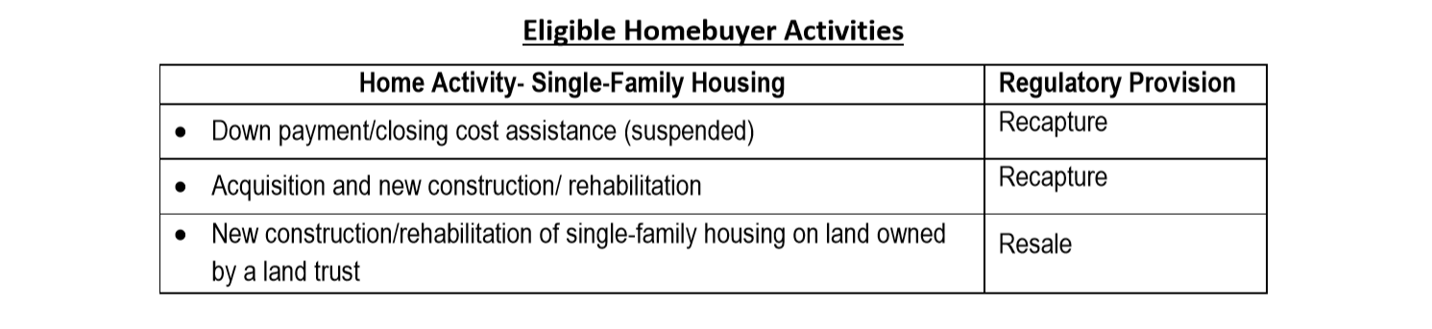
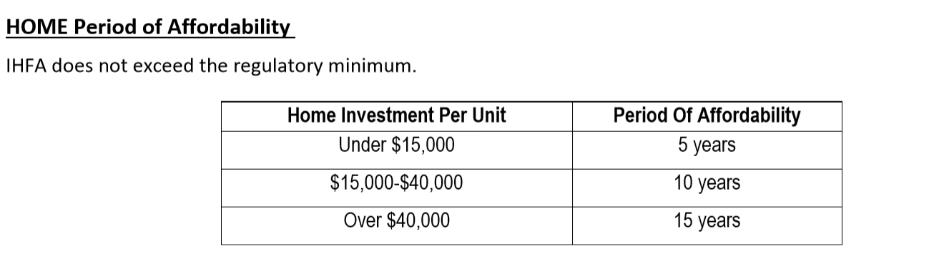
Methods used to Recapture HOME Funds
1. Recapture Option
Under the Recapture Option, a homebuyer can sell their HOME-assisted unit at any time, to any willing buyer, for whatever the market will bear, with no restrictions. However, when the title to the unit is transferred, IHFA will attempt to recapture the full amount of the homebuyer’s HOME loan as available from the net proceeds of the sale as defined under the HOME Program's Recapture Option §92.254 (a)(ii)(A).
IHFA will also attempt to recapture the total amount of HOME direct subsidy provided to the homebuyer if the homebuyer fails to comply with the HOME program’s primary residency requirements during the period of affordability. These requirements and conditions are described in the homebuyer’s Deed of Trust Note.
When the period of affordability expires, the homebuyer is no longer required to comply with the primary residency requirements, however, the HOME loan remains in place as 0% interest, due on sale.
2. Resale Option
IHFA will use the HOME Program’s Resale Provision when a nonprofit owner-developer rehabilitates or constructs a homebuyer unit on land held in trust for at least 50 years. Under the IHFA’s Resale Option, the land trust will repay the development subsidy only if the unit is rented without an IHFA-approved exception, or a low-income homebuyer no longer owns the unit, or the land on which the unit sits is no longer held in trust, or the title to the land under the unit is transferred.
Through the land-lease with the homebuyer and the Deed of Trust and MORC with IHFA, the land trust is required to use “first right of refusal” and other resale restrictions in order to keep the unit affordable in perpetuity.
General Homebuyer Requirements
IHFA follows the HOME program's Resale Provisions for approved homebuyer properties activities designed to allow the homeowner to hold title to the HOME-assisted unit, and the land under the unit is owned by a land trust for at least 50 years. The HOME program's primary residency requirements will apply. During the period of affordability, these requirements are enforced through a land-lease between the land trust and the homeowner, and a Memorandum of Restrictive Covenants and Deed of Trust between IHFA and the land trust. Under the Resale Option, the period of affordability is determined by the total amount of HOME funds expended on the unit (will always be 15 years), which includes rehabilitation/ construction costs, developer fee, and IHFA’s project costs (salaries, inspections, title, etc.). The period of affordability and the primary residency requirements will never exceed the HOME Program’s regulatory minimum.
Homebuyer Provisions
There is no presumption of affordability as defined at 24 CFR 92.254(a)(5)(i)(B).
The HOME program's Resale Provisions are enforced through restrictive covenants and a deed restriction between IHFA and the land trust, and a land-lease between the land trust and the homeowner.
The HOME Note and Deed of Trust with the land trust will require all homebuyers in the unit be ≤ 80% AMI at the time the purchase contract is signed. The sales price of the unit will include a price reduction equal to the HOME development subsidy and the estimated value of the land under the unit. During the period of affordability, to ensure each homebuyer during the period of affordability is ≤ 80% AMI, IHFA will require the land trust to submit an Income Verification and Certification Form for IHFA’s review prior to transfer of title.
The long-term ground lease with the homeowner will enforce the HOME income limit, primary occupancy and sales price restrictions, and include corrective actions the land trust will take if the homeowner violates these restrictions on the unit. The land trust will also include additional restrictions, including the use of a purchase option, right of first refusal, and other legal means to intervene and preserve the affordability of a HOME-assisted unit.
During the period of affordability, the land trust will repay the HOME development subsidy when: • The Unit is rented or leased or otherwise vacated by the homebuyer who has not received an IHFA-approved Primary Residency Exemption (click here Primary Residency Requirement) and refuses to return to the unit to occupy it as a primary residence; • Title is transferred to a homebuyer who is not low-income (≤80% AMI); • Foreclosure, transfer in lieu of foreclosure, or assignment of an FHA insured mortgage to HUD
After the period of affordability has expired, the land trust will repay the HOME development subsidy only when the land, on which the assisted unit is located, is taken out of the affordable housing land trust, or title to the land under the unit is transferred.

Definitions
Capital Improvements
(a) A major structure or system when (1) the cost of the specific improvement exceeds $3000.00 and (2) work is completed within 5 years of the sale, and (3) approved by the land trust, and (4) the unit is sold to a qualified low-income homebuyer.
i. Major structure improvement- The addition of a bedroom, bathroom, or additional square footage, as approved by the land trust.
ii. Major system improvement- A new or replaced system, i.e. roof, shingles, HVAC, electrical, energy efficient windows, doors, and insulation, as approved by the land trust.
(b) The cost must be incurred directly by a homeowner with no other reimbursement opportunity, i.e. insurance, gift, etc.
(c) A receipt or other third-party proof of expenditure is required, i.e. cancelled check, credit card statement. The work must be properly permitted (as required), with workmanship conducted by a professional contractor experienced in the area of work. Workmanship and materials must comply with the current State of Idaho Residential code. The land trust or its designated representative must approve and inspect the workmanship, materials, and the finished product.
i. If the homeowner is a professional contractor with direct experience related to the type of work to be performed (i.e. can document direct experience installing the major system or structure in question), performs the work him/herself, and all other conditions are satisfied, than the cost of materials can be included in the Capital Improvement calculation.
(d) For the purposes of determining a low-income seller’s “investment” in the unit, general repairs, updates, and other improvements under $3000, are not defined as a Capital Improvement.
Development Subsidy
Up to $40,000/unit provided to the land trust as development subsidy at time the rehabilitated or constructed unit is sold to the first low-income homebuyer. This subsidy will remain with the land trust as long as a low-income homeowner owns the unit during the period of affordability. After the period of affordability end, the subsidy will remain with the unit as long as the land remains in the affordable housing land trust.

HOME Subsidy during the Period of Affordability
No additional HOME subsidy provided to the land trust for the assisted unit • No direct HOME subsidy provided to any homebuyer for the assisted unit.
Deed of Trust and Restrictive Covenants
During the period of affordability, IHFA will enforce the primary residency requirement and the 80% AMI homebuyer requirement through a restrictive covenant with the homeowner and the land trust.
A deed of trust with the land trust is used to secure IHFA’s right to recover the HOME development subsidy from the land trust in the event the land trust does not utilize its purchase option, right of first refusal, or other means at its disposal to intervene and preserve the affordability of the unit. The deed of trust will remain in place after the period of affordability expires.
IHFA will allow the use of other notes and mortgages in addition to, but never in lieu the HOME MORC and Deed of Trust. The HOME MORC is always be filed in the most senior position.
Fair Return on Investment ("FRI")
When the assisted unit is sold to another low-income (≤ 80% AMI) homebuyer during the period of affordability, a low-income seller is entitled to a fair return on their investment, only as available from the Net Proceeds of the sale (repayment of all senior liens and seller’s closing costs).
Seller’s Investment-Defined
If the seller is ≤ 80% AMI, then the following items are defined as an “investment” for determining a Fair Return on Investment
  - Seller’s Mortgage Equity (mortgage pay down amount); plus
  - 50% of Capital Improvement(s) costs for individual improvement was completed within 5 years of the sale (see Capital Improvement); plus
3) Up to a maximum of 1.5% CPI inflation rate (as determined by the Consumer Price Index calculator times (×) Seller’s purchase price of the unit, times (×) the number of years Seller owned the unit. Consumer Price Index1 Inflation Calculator at https://www.bls.gov/data/inflation_calculator.htm
Foreclosure, Transfer In Lieu Of Foreclosure, Or Assignment of an FHA Mortgage
As described at 92.254(a)(5)(i)(A), the HOME resale option’s restrictions may be extinguished by a senior lender in the event of foreclosure, transfer in lieu of foreclosure, or the assignment of an FHA mortgage in order to clear title. The land trust shall use a purchase option, right of first refusal, and other approved means to intervene and preserve the affordability of the unit.
Homebuyer Preference Populations
A homebuyer preference may be allowed when the population is deemed essential to the local community and does not violate Federal Fair Housing and Equal Opportunity laws, executive orders, or program regulations. Examples of an essential population would be education providers, firefighters, law enforcement, and medical/care providers. A homebuyer preference is allowed only if identified in the land trust's HOME written agreement and the memorandum of restrictive covenants.
Seller’s Initial Investment
Earnest money and down-payment/closing costs when paid directly by the homebuyer when they purchased the HOME-assisted unit.
HOME Income Limit
At the time the purchase and sales contract is executed, the homebuyer’s annual household income must be ≤ 80% AMI as defined at 24 CFR 5.609. IHFA annually publishes the household asset limitation, maximum PITI and other homebuyer requirements. These requirements are reviewed along with the homebuyer’s monthly budget or recurring expenses, prior to funding approval or denial.
Current limits and other requirements are available on the IHFA website, in the Annual Administrative Plan and under the Resources menu at https://Www.Idahohousing.Com/Federal-Programs/HomeProgram/
Reasonable Range of Low-Income Homebuyers
An assisted unit must remain affordable to a reasonable range of low-income homebuyers during the period of affordability. IHFA defines “reasonable” as a household income of 50%-80% AMI. In some cases, IHFA may allow a lower AMI homebuyer if (1) additional subsidy is provided by other private or public sources, (2) has good credit and (3) a stable work history.
Maximum PITI (Principal, Interest, Taxes, Insurance)
During the period of affordability, a typical PITI is 35% of household's gross monthly income. However, under certain circumstances, IHFA may allow a higher PITI when the homebuyer has good-exceptional credit/history, a stable work history, approval from an IHFA-approved lender and the land trust.
Net Proceeds
The amount after repayment of all senior liens and the seller's closing costs.
Sales Price Determination during the HOME Period of Affordability
To determine the maximum sales price during the HOME Period of Affordability:
Initial Sale Price Determination
Step #1 Determine the estimated value of property (land and unit combined) use one of two approved methods:
- Comparative Market Analysis or Broker’s Price Opinion completed by a licensed real estate professional who is familiar with the local neighborhood market conditions
- Appraisal
Step #2 Deduct the following from the estimated value of the property
- Estimated value of the land
- IHFA Development Subsidy
Step #3 IHFA defines the Fair Market Value of an assisted unit as the negotiated sales price between the willing buyer and willing seller.
Subsequent Sale Price & Limit- Determination
Maximum Sales Price Limit is a total of the following:
- Amount of senior lien(s) repayment;
- Seller’s closing costs
- Seller’s Fair return on Investment
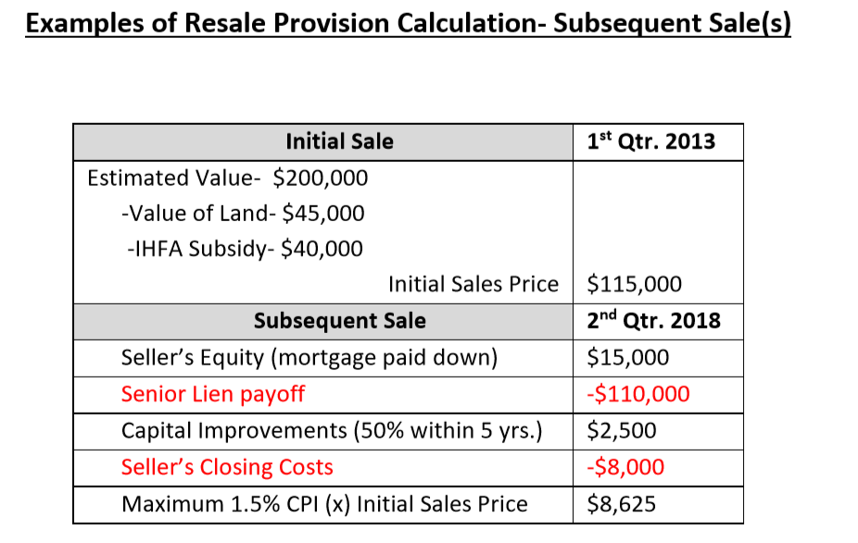

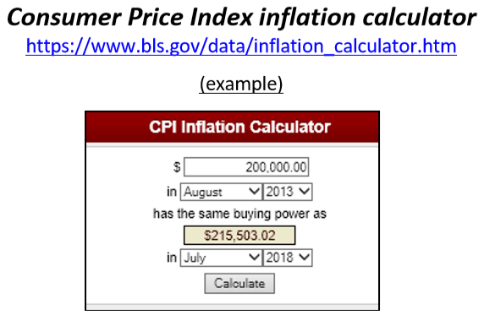
State Program No. 4- HOME & HTF Rental Housing Production
Describe threshold factors and grant size limits
At application, submission of the following is required in order for the application to receive additional review and scoring:
- Most recent third-party financial statements from applicant, owner, and developer. Statement from owner is not required if a newly formed entity.
- A Physical Needs Assessment is required for acquisition and/or rehabilitation projects. The PNA determines the scope of rehabilitation. See Chapter 2, Annual Administrative Plan for additional information regarding a PNA https://www.idahohousing.com/federal-programs/home-program/
- A Capital Needs Assessment for all projects is required, with sufficient detail to determine the amount of funds needed for replacement reserve and major repairs during the life of the project. See Chapter 2, Annual Administrative Plan to additional information regarding CNA https://www.idahohousing.com/federal-programs/home-program/
- Annual operating costs and revenues, described in sufficient detail to compare line items against properties of similar type and size to allow IHFA to determine whether the planned expenditures are sufficient and reasonable. The budget should include general management expenses, maintenance and operating costs, any project paid utilities, taxes, insurance premiums, and adequate deposits to replacement reserves. In most cases, evaluation of total operating costs should be summarized in “per unit per year” amounts rather than as a percentage of projected revenue.
- Market study that meets the requirements described in Exhibit M-Annual Administrative Plan https://www.idahohousing.com/federal-programs/home-program/
- Fair Housing
1. An Affirmatively Furthering Fair Housing Choice (AFFH) Resolution adopted by the proposed project’s unit of local government (City or County). If the local unit of government has not/will not adopt the AFFH resolution, the application/proposal will not meet minimum threshold.
2. One of the following:
- If the proposed activity is located in a CDBG Non-Entitlement area, then submit the local jurisdiction's most recent Fair Housing Assessment Plan reviewed by the State of Idaho's CDBG Program (Idaho Department of Commerce);
Or
- If the proposed activity is located in a CDBG Entitlement Area (Boise, Nampa, Meridian, Lewiston, Coeur d' Alene, Idaho Falls, Caldwell, and Pocatello), then submit that city's most recent Analysis of Impediments To Affirmatively Further Fair Housing If the city's Analysis of Impediments or Affirmative Housing Assessment document is available online, then applicant need only provide IHFA with the link to the online document (hard copy would not be required); Or
- If the local jurisdiction in which the property will be located has never received State CDBG funds (and hasn't completed a Fair Housing Assessment Plan on their own), or the project will not be located in a CDBG Entitlement area, then applicant must request a Fair Housing Assessment Plan be completed by the local jurisdiction. The plan must contain the same components as the State of Idaho's CDBG Program.
- Evidence applicant and developer have experience and capacity to begin construction within 12 months of the award, and complete the project within the specified timeframe.
- Evidence of site control that complies with the Uniform Relocation Assistance and Real Property Acquisition Policies Act of 1970 and Environmental Review Procedure 24 CFR 58.22 (See Chapter 6, 9 and Exhibit O)
- Owner/Developer/Management Capacity Self-Certification Form (See Exhibit W)
- Pro forma that incorporates the following assumptions:
1. 7% vacancy factor
2. 2% annual increase in income
3. 3% annual increase in expenses including replacement reserves
- Release of Information- See Exhibit X- Administrative Plan

State of Idaho CDBG
Describe the state program addressed by the Method of Distribution
Commerce distributes CDBG funds on a competitive statewide basis where applications are ranked against each other within their applicable set-aside for funding. The five set-aside are public facilities, infrastructure to jobs, downtown revitalization, senior / community centers, and public parks. Also, Commerce is planning to add a new set-aside – planning / studies grants. Post-disaster applications are not reviewed and funded under a competitive basis.
Describe all the criteria that will be used to select applications and the relative importance of these criteria.
There are five variables that define how Idaho prioritizes its projects and activities that will be eligible to receive CDBG funds.
First variable to prioritizing CDBG funds is to ensure the project will meet at least one required national objective.
- Activities benefiting low to moderate-income (LMI) persons.
- Prevention/Elimination of Slums and Blight
- Urgent Needs (Imminent Threat)
Second variable to prioritizing CDBG funds is ensuring the proposed project meets Idaho CDBG threshold factors. Applications must meet the following:
- Submission of an application
- Eligible applicant
- Eligible activities
- Executed citizen participation plan and hold public hearing
- Applicant has the administrative capacity to properly administer a CDBG
- Adopted fair housing resolution
- Grantee’s execution of the ICDBG certifications
Third variable to prioritizing CDBG funds is to score, rank, and fund projects that meet the following conditions:
- Have a need for CDBG funds
- A measurable and positive impact for lower income households
- Project is well planned and feasible
- Local commitment and match
- Project has a high degree of readiness to proceed
- Grantee’s or sub-recipient’s ability to maintain and operate the system or facility
Fourth variable: Idaho’s Economic Advisory Council review, evaluation, and recommendation of the project. Determining if the project can demonstrate:
- local ability to finance,
- local effort and commitment, and
- local and regional economic impact.
- The Governor of Idaho decides to fund or not to fund.
Fifth variable:
- 70% of Idaho’s CDBG funds, aggregated over a three-year or two-year period, will fund projects that will principally benefit low to-moderate income persons.
- 100% of annual CDBG awarded will be obligated within 15 months of funding agreement date.
These five variables cover public facilities, infrastructure for jobs, downtown revitalization, senior / community centers, public parks and post-disaster applications.
If only summary criteria were described, how can potential applicants access application manuals or other state publications describing the application criteria? (CDBG only)
Idaho CDBG application handbook with specific scoring criteria is located on website www.commerce.idaho.gov
Describe how resources will be allocated among funding categories.
Commerce distributes CDBG funds on a competitive statewide basis where applications are ranked against each other for funding. The ICDBG Application Handbook details the application review procedures and is available online at www.community.idaho.gov . Commerce does set-aside the CDBG funds as follows:
- Two percent (2%) plus $100,000 of the total allocation is reserved for the department's administrative costs;
- One percent (1%) of the total is reserved for technical assistance;
- $300,000 is set aside for post-disaster grants with a maximum grant amount of $150,000. Applications are received quarterly.
- Ten percent (10%) of the total allocation is set aside for senior citizen center, community center, and public park grants with a maximum grant amount of $225,000. Applications are received annually.
- $150,000 is set-aside for planning / study grants. Application are received annually.
- Fifty percent (50%) of the remaining allocation, plus 50% of the program income, recaptured funds, and carryover funds from previous program year is reserved for public facility grants. Maximum grant amount available is $500,000. Applications are received annually.
- Fifty percent (50%) of the remaining allocation, plus 50% of program income, recaptured funds, and carryover funds from the previous year is reserved for economic development grant for both job creation and downtown revitalization projects. Maximum grant amount available is $500,000. Job creation applications are received quarterly and downtown revitalization applications are received annually.
Commerce CDBG procedures allow for flexibility between these funding set-asides based upon public need in the various categories (i.e. if Commerce receives fewer requests for job creation and a larger than normal number of public facilities funding requests, we may choose to increase the public facilities funding above the projected set-aside). Historically, Commerce has moved more funds due to demand into the Public Facilities set aside.

Describe threshold factors and grant size limits
Commerce distributes CDBG funds on a competitive statewide basis where applications are ranked against each other for funding. The ICDBG Application Handbook details the application review procedures and is available online at www.community.idaho.gov . Commerce does set-aside the CDBG funds as follows:
- Two percent (2%) plus $100,000 of the total allocation is reserved for the department's administrative costs;
- One percent (1%) of the total is reserved for technical assistance;
- $300,000 is set aside for post-disaster grants with a maximum grant amount of $150,000. Applications are received quarterly.
- Ten percent (10%) of the total allocation is set aside for senior citizen center, community center, and public park grants with a maximum grant amount of $225,000. Applications are received annually.
- $150,000 is set-aside for planning / study grants. Application are received annually.
- Fifty percent (50%) of the remaining allocation, plus 50% of the program income, recaptured funds, and carryover funds from previous program year is reserved for public facility grants. Maximum grant amount available is $500,000. Applications are received annually.
- Fifty percent (50%) of the remaining allocation, plus 50% of program income, recaptured funds, and carryover funds from the previous year is reserved for economic development grant for both job creation and downtown revitalization projects. Maximum grant amount available is $500,000. Job creation applications are received quarterly and downtown revitalization applications are received annually.
Commerce CDBG procedures allow for flexibility between these funding set-asides based upon public need in the various categories (i.e. if Commerce receives fewer requests for job creation and a larger than normal number of public facilities funding requests, we may choose to increase the public facilities funding above the projected set-aside). Historically, Commerce has moved more funds due to demand into the Public Facilities set aside.
What are the outcome measures expected as a result of the method of distribution?
Create Suitable Living Environments and Expand Economic Development Opportunities in the following:
- Public Facilities Infrastructure – Compliance - Availability: Activities that bring public facilities systems (infrastructure, community facilities, public utilities) into compliance with environmental laws, federal and state standards, and best management practices.
- Public Facilities Infrastructure – Rehabilitation - Affordability: Activities that include rehabilitation, replacement, or remodeling of a public facility (infrastructure, community facilities, public utilities, and housing) systems.
- Public Facilities Infrastructure - New Construction - Sustainability: Activities that construct new public facilities (infrastructure, community facilities, and public utilities) system or extending a system to a new service area. This includes infrastructure to support affordable housing and related activities.
- Economic Development - Job Creation - Availability: Activities that expand or construct new public infrastructure to support businesses creating new low to moderate-income jobs.
- Economic Development - Downtown Revitalization - Affordability: Activities that improve public infrastructure and remove slum and blight in redevelopment areas.

CDBG-CV CARES FUNDS

Describe the state program addressed by the Method of Distribution
The State of Idaho (Commerce and IHFA) plans to distribute the CDBG-CV CARES funds via a combination of approaches. Why, because the ability to prepare, prevent, and respond to the COVID-19 coronavirus is dynamic. Essentially, the State of Idaho (Idaho) needs flexible funding distribution options at its disposal as one approach might not be adequate in combating coronavirus. This includes, possibly granting CDBG-CV CARES to entitlement cities and other entities than just general local governments (UGLGs).

Idaho plans to expend the CARES statewide, as the entire state is impacted by COVID-19. The method-of-distribution (MOD) will resemble a statewide fair share approach. The set-asides are established to meet the eligible activities as established in Federal Register FR-6218-N-01 are as follows:

Set-asides:
- Public Service
- Planning
- Public Facilities
- Special Economic Development Assistance

Describe all the criteria that will be used to select applications and the relative importance of these criteria.

There are five variables that will define how Idaho prioritizes its activities, services, and projects that will be eligible to receive CDBG-CV CARES funds.

First variable to prioritizing CDBG-CV CARES funds is to ensure the activity, service, or project will meet at least one required national objective.
- Activities benefiting low to moderate-income (LMI) persons. *
- Urgent Needs (Imminent Threat)

Second variable to prioritizing CDBG-CV CARES funds is ensuring the proposed activity, service, or project meets threshold factors. Applications must meet the following:
- Submission of an application or proposal
- Eligible applicant
- Eligible activities as identified under CDBG-CV CARES funding
- Certifying that the activity will not be a Duplication of Benefits
- Applicant has the administrative capacity to properly administer a CDBG-CV CARES
- Executed citizen participation plan and hold public hearing
- Grantee’s execution of the ICDBG-CV CARES certifications

Third variable to prioritizing CDBG funds is to score, rank, and fund projects that meet the following conditions:
- Have a need for CDBG-CV CARES funds
- A measurable impact for preventing, preparing for, and responding to coronavirus or addressing public health or alleviating economic hardships
- Activity, service, or project is well planned and feasible
- Activity, service, or project has a calculated degree of readiness to proceed
- Grantee’s or sub-recipient’s ability to maintain and operate the service, system, or facility. This would include having the financial structure to handle CDBG CARES funds.

Fourth variable: Idaho’s funding review committee(s) review and recommendation to fund the activity, service, or project for meeting the CARES funding goals and objectives.

Fifth variable:
- At least 70% of Idaho’s CDBG-CV CARES funds will fund projects that will principally benefit low to-moderate income persons.
- CDBG-CV CARES will be obligated based on need up to June 22, 2025, one-year before all funds must be expended.

If only summary criteria were described, how can potential applicants access application manuals or other state publications describing the application criteria? (CDBG only)

CDBG-CV CARES information and application handbooks will be located at the following website(s) www.commerce.idaho.gov and/or https://www.idahohousing.com/

Describe how resources will be allocated among funding categories.
CDBG-CV CARES funds will be set-side as follows:

CARES I = $4,564,590
- $228,230 or five Percent (5%) of the total allocation is reserved for the Idaho's administrative costs;
- $91,292 or two percent (2%) of the total is reserved for technical assistance;
- $3,245,069 is set-aside for public services;
- $0 is set aside for planning;
- $1,000,000 is set aside for public facilities; and
- $0 is set aside for special economic development assistance.

CARES II = $4,361,030
- $218,051 or five Percent (5%) of the total allocation is reserved for Idaho’s administrative costs;
- $87,221 or two percent (2%) of the total is reserved for technical assistance; and
- $4,055,758 is set aside for public service and public facilities to deal with housing disruptions and stresses. This could include funding for Idaho’s entitlement cities.

CARES III = $3,309,587
- $165,479 or five Percent (5%) of the total allocation is reserved for Idaho’s administrative costs;
- $66,192 or two percent (2%) of the total is reserved for technical assistance;
- $1,200,000 is set-aside for public services;
- $300,000 is set-aside for planning;
- $1,200,000 is set-aside for public facilities; and
- $377,916 for special economic development assistance.

Idaho’s CDBG CARES procedures allow for moving funds between the different funding set-asides based upon need.

Describe threshold factors and grant size limits

Threshold Factors:
- Submission of an application or proposal
- Eligible applicant
- Eligible activities as identified under CDBG-CV CARES funding
- Activity will not be a Duplication of Benefits
- Applicant has the administrative capacity to properly administer a CDBG-CV CARES
- Executed citizen participation plan and hold public hearing
- Grantee’s execution of the ICDBG-CV CARES certifications

Grant Size Limits:
- Maximum grant size will be limited to the amount of the set aside with exception to the entitlement grants and rural broadband planning grants. Maximum amount awarded will be based on population or regional fair share approach.

What are the outcome measures expected as a result of the method of distribution?

- CDBG-CV-CARES – Public services, public facilities, planning, and special economic development assistance to prevent, prepared and respond to COVID-19 and other infectious diseases.

Broadband:
In May 2019, Idaho Governor Brad Little established, via Executive Order # 2019-05, the Idaho Broadband Task Force. The objectives of the task force was to assess:
- If urban and rural Idaho communities were connected and well-positioned to attract business and create maximum success;
- Ensure adequate mapping of broadband infrastructure;
- Analyze existing resources and gaps related to internet connectivity, high speeds, expansion plans, and capacity.
The task force completed their report and made it available for review on November 22, 2019.
The full report can be found at https://gov.idaho.gov/pressrelease/governor-little-accepts-idaho-broadband-task-force-recommendations/

In the upcoming months a number of the recommended “Call for Action” will likely be advanced if not implemented. Commerce will evaluate the possibility of using CDBG to help qualified low-to-moderate income (LMI) cities or counties develop a feasibility study conducted by a qualified firm. The study would include a broadband needs and market assessment, community engagement, current broadband networking capabilities, GIS-based analysis, gap analysis of current broadband environment, assessment of regulatory environment, financial feasibility, and recommendation. The study should then provide the information necessary for the city or county to determine the next steps they want to implement to improve their broadband capabilities.

Resiliency:
The State of Idaho, in accordance with Title 46, Chapter 10, “State Disaster Preparedness Act of 1975, as amended by the Idaho Homeland Security Act of 2004.” Is required to plan and prepare for disasters and emergencies resulting from natural or man- caused events, enemy attack, terrorism, sabotage, or other hostile action.
This Idaho emergency Operations Plan is an all-discipline, all-hazards plan that establishes a single, comprehensive framework for the management of domestic incidents and provides the structure and mechanism for the coordination of state support to state, local, and tribal incident managers and for exercising direct state authorities and responsibilities. This plan has been revised to better align with the National Response Framework, incorporates National Incident Management System principles, and provides a comprehensive framework for statewide emergency management. It addresses the role and responsibilities of state government organizations and provides a link to federal, local, and private organizations and resources that may be activated to address disasters and emergencies in Idaho. State government departments cooperate with the Idaho Office of Emergency Management in an ongoing planning process that produces an effective framework for coordinating the delivery of state assistance to local governments. When directed, state agencies will take the appropriate actions to mobilize and deploy resources to assist in life, safety, and property protection efforts in accordance with this revised Idaho Emergency Operations Plan. Pursuant to the authority contained in the Idaho Disaster Preparedness Act of 1975, amended by the Idaho Homeland Security Act of 2004 and Governor’s Executive Order 2014-07, the head of each designated department and agency shall take the necessary actions to implement this plan by developing written internal procedures that detail support required by the plan and shall be prepared to put their plan into action.
Commerce takes two approaches to help communities build resiliency. First, no CDBG project will be constructed until after the completion of an environmental review, in accordance 24 CFR Part 58. Projects that comply with 24 CFR Part 58, should be less likely to be impacted by a natural or man – caused event. Second, Commerce provides a set-aside of CDBG funding to help communities recovery from a natural disaster, should it be necessary. Helping a community getting its infrastructure back into operation and hopefully designed to not likely experience another natural caused event should improve the communities’ resiliency.

Opportunity Zones:
In 2018, Idaho designated 28 census tracts as opportunity zones. Opportunity Zones is a program of the Tax Cuts and Jobs Act of 2017 to encourage long-term investment in low-income urban and rural communities. Private investment vehicles that place 90% of more of their funds into an Opportunity Zone can earn tax relief on the capital gains generated through those investments. Tax benefits increase the longer the investments are in place. Commerce continues to market the established zones at its website and offer information.
In other efforts to help spur job creation projects within Idaho’s Opportunity Zones, Commerce has amended its scoring on CDBG job creation projects to include additional point for projects located within an opportunity zone. It should also be noted, that Commerce has already funded a number of projects with CDBG in the state’s opportunity zones.

AP-50 – GEOGRAPHIC DISTRIBUTION
HOME & HTF
Rental Activities- Because HOME/HTF funds are awarded as gap financing; IHFA does not follow a geographic distribution model. For development activities, IHFA follows a published NOFA/RFP application process. Activities are selected following an application review and scoring process. This process allows IHFA to fund activities that best demonstrate long-term feasibility, owner, developer and management capacity, as well as market need, among other IHFA criteria.
- Multifamily Rental activity applications are submitted once each year. The application must meet minimum threshold requirements prior to scoring. Threshold requirement include: Market analysis including the current number and type of affordable and market rate housing units, age of current housing stock, rental vacancy rates, employment opportunity, percentage of low-income households to overall population, and proximity of the project to essential services (schools, medical, food), prior to scoring. Other threshold requirements include an alternative site analysis, a pro forma that includes the industry standard vacancy rates and an annual increase in expenses and income, site control that adheres to Uniform Relocation Act, Voluntary Sales Disclosure, and Environmental Review requirements. Owner must also submit evidence the local community in which the project will be located, is committed to affirmatively furthering fair housing choice.
- Additional multifamily scoring categories: Geographic diversity (HTF Only), applicant/developer capacity, leverage, tenant preference for a priority housing needs population, IHFA green building design components, and site/unit amenities, match, and site suitability.
- Single-Family Activities- Non-profit owner-developers apply for funds to acquire and/or construct or rehabilitate single-family (homebuyer or rental) housing units once each year. Homebuyer properties must be sold to HOME-eligible homebuyers within 9 months of development completion. The nonprofit’s proposal must include an analysis of the local market, evidence of developer experience and capacity, including previously funded activities, the local community’s commitment to fair housing choice, and the number, type, and scope of the proposed activity, and if a homebuyer activity, a sales plan, etc.
- Housing Trust Fund-Specific
The Federal Housing Enterprises Financial Safety and Soundness Act of 1992 (The Act) as revised by HERA, provides for the distribution of funds to states based on four (4) Need factors [24 CFR 93.51(a)(d) and a local construction cost adjustment factor [§93.51(e)]. Need factors include
- Relative shortage of rental housing available to Extremely low-income individuals and families
- Relative shortage of rental housing available to very low-income individuals and families
- Relative number of extremely low-income (ELI) renters living in substandard, overcrowded and/or unaffordable housing in Idaho
- Relative number of very low-income renters living in substandard, overcrowded, and/or unaffordable housing.

See AP-90 for a detailed response regarding geographic diversity

AP-65 Homeless and Other Special Needs Activities – 91.320(h)
Reaching out to homeless persons (especially unsheltered persons) and assessing their individual needs
Due to the geographic diversity of being a balance of state continuum of care, and the rural nature and uniqueness of the many communities within the Idaho BoS CoC, a “one size fits all” approach to conducting outreach to those experiencing homelessness to assess their individual needs is not efficient, practical or effective. Because of these considerations, the Idaho BoS CoC is divided into six regions, with each region having an active Regional Coalition and a Coordinated Entry Access Point.
      - IHFA works with the six Regional Coalitions to help identify effective tools, methods and strategies to effectively conduct outreach to those experiencing homelessness. Additionally, each region works together with their own community partners to help identify the most effective outreach strategies for their unique location and to identify and address barriers within their geographic region. This approach allows flexibility within each geographic region to ensure the outreach is effective given the unique circumstances of each region, while also having the Idaho BoS CoC provide comprehensive coordination and oversight.
      - To help with outreach, the Idaho BoS CoC produces informational brochures, cards and posters which are displayed in Access Point locations and delivered to community stakeholders who may come in contact with those experiencing a housing crisis. Additionally, IHFA, in coordination with the Idaho BoS CoC, maintains and updates a dedicated landing page on its website to make information about housing programs and resources for those who may be experiencing a housing crisis, readily available.
      - The Idaho BoC CoC ensures a broad representation of community stakeholders are participating on the IHCC Board and in Regional Coalitions. This enables the CoC to share up to date information about COC, ESG and HOPWA programs which can then be disseminated throughout the state through a wide variety of resource providers. The IHCC board includes representatives from the Idaho Departments of Education, Labor, Commerce, Corrections, Health and Welfare, as well as representation from DV agencies and HIV/AIDs organizations. Regional Coalitions include representatives from local law enforcement, early childhood education, elected officials, food banks, social workers, and other non-profit organizations who serve those who are or who may become at risk of homelessness.
      - IHFA, in coordination with the Idaho BoS CoC, produces an annual Report to the Community on the state of homelessness in Idaho. This professionally designed booklet provides statistics and shows trends and needs throughout the state. The booklet is widely disseminated to hundreds of stakeholders, including state and local elected officials, news media, and representatives from hospitals, education, justice, law enforcement, nonprofits and others to increase awareness of the programs available and the needs throughout the state. This helps educate those working with marginalized Idahoans, and increases the distribution of information to them about out programs through this wide array of stakeholders.
Addressing the emergency shelter and transitional housing needs of homeless persons
The Coordinated Entry system went into effect in the BOS COC on January 22, 2018. Coordinated Entry streamlines and facilitates access to appropriate housing and services. The process centers on streamlining access to housing assistance and screens applicants for eligibility for these and other programs using a consistent and well-coordinated approach, and assessing their needs to determine which interventions are most appropriate. This has proved to be an invaluable tool in l assessing the vulnerability, needs, and extent of barriers of those experiencing homelessness.
      - We will continue to collect data, which allows homeless provider networks, such as the BoS CoC, understand the homeless population’s needs better. Using an objective assessment of each individual or family, allows IHFA to assess which housing component and service types that Idaho is in most need of. “Right sizing,” or re-aligning resources with the population need, can then occur. This process will ensure homeless persons are directed towards the resources that have the highest likelihood of reducing their extent of homelessness, or removing them from homelessness altogether. As this shift in resource priority is made, emergency shelters, and rapid rehousing can be utilized as intended; to reduce length of homelessness and re-introduce households to stable living environments.
      - We will continue to support the need for Emergency Shelters throughout the state of Idaho through funding allocations and in all decision-making processes, including outreach to shelters for target populations of domestic violence survivors and youth.
      - IHFA, in coordination with the Idaho BoS CoC, is spearheading the renovation of a former city owned building to repurpose it for a much needed shelter in Pocatello Idaho. Aid for Friends is the only shelter for men, women and families in the area. For the past 30 years, the non-profit operated out of a single family three story home built in the 1930’s, making it very difficult to serve those struggling in their community. Many times, the shelter has operated at 114% capacity. Thanks to a community wide fundraising effort, Aid for Friends has started the renovation process on a new and much larger homeless shelter. The new shelter will provide appropriate living quarters for men, women and families. It will include a dining area, laundry facilities and space for education and workforce development opportunities. Aid for Friends anticipates the new shelter will serve almost 1,000 Southeast Idaho residents each year who may be facing or experiencing homelessness. This is an example that IHFA is looking to replicate in other communities in Idaho.
      - The Idaho BoS CoC provides grant funding and support to many agencies who are helping survivors of domestic violence. By providing the survivors with transitional housing, it enables them to find a safe refuge to be able to rebuild their lives and move on to more permanent housing opportunities. Through education, support, and counseling, these agencies help many families heal and become stably housed.

Helping homeless persons (especially chronically homeless individuals and families, families with children, veterans and their families, and unaccompanied youth) make the transition to permanent housing and independent living, including shortening the period of time that individuals and families experience homelessness, facilitating access for homeless individuals and families to affordable housing units, and preventing individuals and families who were recently homeless from becoming homeless again
In the absence of appropriate and effective intervention efforts and resources, many families and individuals will become homeless as life changes such as loss of employment, lack of affordable housing, loss of support networks, exit from an institution or facility, and other severe circumstances present themselves. For those that experience these misfortunes, recovery can be extremely difficult when disability, controlled substance or alcohol dependency, or other extreme conditions exist. In some cases long-term and ongoing permanent housing is the most appropriate housing solution. However, IHFA, the BOS CoC, and regional housing coalitions identify the need for services that focus on reducing shelter stays and diverting individuals and families away from homelessness altogether.
IHFA and the BoS CoC acknowledges and supports the commitment to preventing and ending homelessness displayed by HUD through Home Together and Opening Doors. Whether a participant receives housing and service support through transitional or permanent housing, each agency strives to provide individualized goal-based service planning to increase the likelihood for long-term success and self-sufficiency; ensure access to more stable housing situations; and establish support networks and habits that reduce the likelihood of recidivism.
The Idaho BoS CoC provides grants and support to many Permanent Supportive Housing programs throughout the state of Idaho. Additionally, IHFA, who is also the tax credit recipient for the state of Idaho, has added in its QAP, incentive points for developers to add dedicated PSH units in their tax credit properties. Developers are required to partner with agencies who work with those experiencing homelessness to provide supportive services and enter data into HMIS. These additional PSH units are in great need and IHFA is proud of the success this has had in adding PSH units to current and future tax credit projects throughout Idaho.
IHFA has also been instrumental in the development of New Path, which has 40 PSH units serving chronically homeless individuals, providing housing and partnering with health care and service providers to meet the needs of its residents. IHFA also celebrated the opening of Valor Point, a project with 27 PSH units, providing housing and services to housing veterans experiencing homelessness. IHFA is looking for other opportunities to develop similar properties that will provide more PSH units to vulnerable populations throughout Idaho.
Helping low-income individuals and families avoid becoming homeless, especially extremely low-income individuals and families and those who are: being discharged from publicly funded institutions and systems of care (such as health care facilities, mental health facilities, foster care and other youth facilities, and corrections programs and institutions); or, receiving assistance from public or private agencies that address housing, health, social services, employment, education, or youth needs
Over the next year, the Balance of State CoC will continue to work to help low-income individuals and families avoid becoming homeless, especially extremely low-income individuals and families and (1) those who are being discharged from publicly funded institutions and systems of care (such as health care facilities, mental health facilities, foster care and other youth facilities, and corrections programs and institutions); and (2) those who are receiving assistance from public or private agencies that address housing, health, social services, employment, education, or youth needs. The following goals and strategies will guide this work:
- We will, over the next year, leverage the work IHFA does in administering the HUD Housing Choice Voucher (HCV) rental assistance program in 34 of the 44 counties in Idaho. The program helps low-income families, the elderly, and disabled individuals obtain decent, safe, and affordable rental housing. IHFA was recently awarded Mainstream Vouchers which target non-elderly disabled individuals who are either chronically homeless or are exiting institutions. Mainstream vouchers have been allocated throughout the CoC’s six regions, with clients identified and prioritized in collaboration with the CoC’s Coordinated Entry system. This ensures all housing options are made available to clients within this population and facilitates the goal of filling all the mainstream voucher slots to house as many clients as possible within this population.
- We will continue, over the coming year, to strengthen our relationships with the school systems and the foster care system in Idaho to prevent homelessness among youth aging out of foster care.
- We will continue, over the coming year, to include key stakeholders at the table to provide input regarding these vulnerable populations. For example, we have representatives from the Idaho Department of Education and the Department of Corrections on our IHCC Board and have many representatives from key stakeholders serving these populations participating in our Regional Coalitions who provide input and direction to our CoC.
- Over the next year, we will ensure that all agencies receiving ESG funds in Idaho offer services that educate and counsel individuals and families to develop skills that promote self-sufficiency, including connecting to SOAR resources when appropriate.
- Approximately 40% of the ESG funding not associated with shelter activities is used to fund Homelessness Prevention efforts. This funding allocation will remain consistent over the coming year. These funds are leveraged with services to assist families or individuals in evaluating their primary cause(s) of becoming or being at risk of homelessness.
- Over the coming year, we will continue to work with public and private agencies that address housing, health, social services, employment, education, or youth needs in making them aware of the Coordinated Entry system so that those needing housing assistance can be referred and assessed and have access appropriate programs as they are available.
Putting these goals and strategies into action will increase the probability that those needing assistance will improve their housing stability and reduce their risk of experiencing future episodes of homelessness.
IHFA also supplements the homelessness prevention dollars provided through the ESG program with private funds raised though the Home Partnership Foundation, providing another resource to help prevent individuals and families from entering the homelessness services system.

AP-75-Barriers to Affordable Housing
Goals and milestones- 2020 Program Year

ISSUES AND CONTRIBUTING FACTORS | GOAL | MILESTONES | RESPONSIBLE ENTITY
Higher housing needs of disabled, elderly and extremely low income households and limits on local revenue generation | A. Support residents with disproportionate housing needs living in non- entitlement areas:  - Continue preferences for deeply subsidized rental housing.  - Support tenant preferences that target priority housing needs populations as identified in the 5-Year Consolidated Plan.  - Support partner efforts to develop a recurring source of state funding for the Idaho Housing Trust Fund, emphasizing the unique needs of non- entitlement communities.  - Require affordable rental housing projects to be located in communities that are committed to Affirmatively Furthering Fair Housing Choice. | - Complete 10 units of rental housing annually that target priority housing needs populations (Disabled, Elderly,  ≤30% AMI).  - Retain current preferences in LIHTC QAP; evaluate effectiveness of income targeting during subsequent years based on applications received in 2018 and 2019.  - Encourage efforts to provide state support for housing trust fund.  - The Annual Administrative Plan to require proof that communities in which the HOME, HTF projects are located are committed to Affirmatively Furthering Fair Housing. Evidenced by the submission of an adopted Fair Housing Resolution, a Fair Housing Plan, or a current Analysis of Impediments to Affirmatively Furthering Fair Housing (CDBG Entitlement Communities) at the time the application is submitted for funding. | IHFA
Disproportionately lower homeownership rates among Hispanic, Native American and African American households | B. Help qualified renters attain homeownership: Support credit counseling and homeownership readiness though affirmative marketing. | 1. Continue Finally Home! Homebuyer Education classes in Moscow, Sandpoint, Coeur d Alene, Idaho Falls, Twin Falls, Nampa, and Boise, and online to reach 5,000 or more potential homebuyers. Continue bilingual outreach, training, and customer  service efforts. | IHFA
Landlord lack of fair housing awareness resulting in fair housing complaints and higher use of publicly subsidized housing by minority residents | C. Increase fair housing knowledge:  - Continue current fair housing capacity building and educational outreach activities, particularly among property owners and persons with disabilities.  2. Continue to provide information about and support expansion of state fair housing protections to include familial status.  3. Continue to award preferences points to CDBG applicants with fair housing protections that include familial status.  4. Require affordable  rental housing projects to be located in communities that are committed to Affirmatively Furthering Fair Housing Choice or have adopted a Fair Housing Plan (CDBG non- entitlement areas). | - With Idaho Fair Housing Forum partners, support 2 to 10 fair housing training events annually with landlord groups  - Support efforts to add familial status to state protections.  - During program years 2017- 2020, Commerce will continue to award preference points to CDBG applicants that include fair housing protections for familial status.  4. HOME and HTF written agreements specify Federal fair housing and nondiscrimination laws, including familial status as a protected class in accordance with Title VIII of the Civil Rights Act of 1968. | IHFA-1,2, & 4  Commerce -3

Housing developed with limited Visitable or Accessible features; Access or proximity to public infrastructure; Local policies associated with land use and zoning, including those that limit group homes. | D. Increase accessible, affordable housing options:  - Continue with HOME, HTF application preference points for rental housing that benefits elderly, disabled, ≤30% AMI.  - Explore ways to incent Visitable housing.  3. Continue to support educational efforts to inform local jurisdictions of best practices and legal risks associated with land use and zoning laws, including requiring conditional use permits for group homes.  - Provide funding preference for needed accessibility improvements.  - Explore creation of a more coordinated and comprehensive effort to address the access needs of persons with disabilities. | - Retain current preferences in Administrative Plan.  - Provide funding preferences for Visitable single-family rental housing.  - Coordinate annual training on best practices in land use and zoning, focusing on group homes.  - Five percent of all new multifamily rental housing will be wheelchair accessible; two percent will accommodate persons living with sensory impairments.  5. Continue to market ADA improvements as eligible activities for CDBG  - Complete 15 projects that improve ADA accessibility during 2017-2021 assuming national objectives are met.  b. Ensure all CDBG grantees (cities and counties) have updated their ADA Transition Plans prior to project closeout.  c. Increase CDBG application priority ranking points for projects that focus on the removal of architectural barriers or improve ADA accessibility. | IHFA 1,2,3,4  Commerce-5

Gaps in educational achievement for students with disabilities; African American, Native American and Hispanic students; LEP students; and students in transition and at- risk and economically disadvantaged students | E. Help address education proficiency gaps:  - Consider Utah's best practice of adding preferences for LIHTC location in areas with high proficiency schools* | Explore effectiveness of Utah's LIHTC program in 2019 and 2020 (after it has been utilized for three years) | IHFA
Low wages in economically disadvantaged rural areas due to limited economic growth and growth in low wage industries (e.g., service jobs) | F. Increase employment in economically disadvantaged communities:  - Continue to allocate CDBG to job creation activities in rural communities. | 1. Use CDBG funds to leverage the creation of 30 moderate to high paying jobs created or retained annually, 2017 through 2020 | Commerce
Inaccessible (pre-ADA) public buildings, commercial establishments, and infrastructure. Lack of funding for—and high cost of—accessibility improvements to streets, sidewalks, and other public infrastructure. | G. Dedicate additional federal support to increasing employment and accessibility in non- entitlement areas:  - Support federal efforts to expand infrastructure redevelopment in rural areas and ensure that these include creating environments that are more accessible. | - Activities to be determined in future action plans depending upon federal activities to improve infrastructure.  - Promote community accessibility practices to increase awareness of access and opportunity. | Commerce-1 IHFA-2

Insufficient transportation services to support independent, integrated community living for seniors and persons with disabilities. Lack of public transportation in rural areas. | H. Dedicate additional federal support to increasing employment and accessibility in non- entitlement areas— contingent on participation of Idaho Transportation Department and Federal Highway Administration):  - Encourage local government grantee's ability to play a role in transportation planning at the state and regional levels.  - Through roundtable discussions, public-private partnerships, explore the demand to expand and create formal rideshare programs in rural communities with need. | - Ensure CDBG grantees (cities and counties) located in resort communities or college towns have completed the transportation component of their comprehensive plan (as per Idaho's Local Land Use Planning Act). At a minimum, the transportation component should assess bicycle and pedestrian circulation and the existing (or feasibility of) public transportation - bus or van. Further, the city or county should address the transportation factors that are contributing to limiting opportunities for its residents in their fair housing assessment.  - Convey the importance of transportation alternatives in an integrated community living to the Idaho Transportation Department's Public Transportation Interagency Working Group. | Commerce-1 IHFA-2
Challenges to housing for persons with criminal backgrounds who cannot qualify for publicly supported housing and for whom private sector may be reluctant to provide housing. | - Explore programs to provide housing options for persons with criminal backgrounds, particularly those who are disproportionately represented by certain protected classes:  1. Explore best practices (e.g., Sponsors, Inc. in Oregon) to assist men and women in corrections re- integrating into communities.  2. Educate housing partners statewide on appropriate language on criminal backgrounds in rental agreements. | Annual outreach via stakeholder networks and conferences; include best practice information in correspondence to affordable housing providers. | IHFA

AP-85- Other Actions-
Actions planned to foster and maintain affordable housing
Idaho Housing and Finance Association
1) As the State of Idaho’s legislated housing agency, IHFA maintains a highly visible presence in Idaho. This is accomplished through ongoing public affairs and media events, including the annual Regional Housing Roundtable (Lewiston, Coeur d’ Alene, Boise/Nampa, Twin Falls and Pocatello) bi-annual Conference on Housing and Economic Development.
2) IHFA is the HUD grantee for the State of Idaho’s federal affordable housing programs, including the Section 8 Housing Choice Voucher Program, the HOME Investment Partnerships Program, the National Housing Trust Program, the Neighborhood Stabilization Program, and the Low-Income Housing Tax Credit Program.
3) During the period of affordability, IHFA’s Compliance Department conducts compliance monitoring on all rental housing projects as required at §92.504 (HOME) and §93.404 (HTF). Monitoring includes the following: Tenant files, annual owner certifications, unit mix (fixed/floating units), household income prior to occupancy and at recertification, rent and utility allowance calculations, tenant disclosure notices (lead-based paint and Section 504), tenant rights and protections are included in the lease agreement, marketing and outreach. At least once every 3 years, there is a physical inspection of the units, based on the appropriate unit sample, to ensure property standards at §92.251 (HOME) and §93.301 (HTF) are maintained.
4) Households who participate in the Section 8 Housing Choice Voucher program are eligible to be part of Idaho Housing's Family Self-Sufficiency (FSS) Program, a voluntary program that helps families become economically independent. The goals include assisting families to become free of all forms of state and federal welfare through employment. Participants may receive an interest-bearing escrow (savings) account that accrues as their household's portion of the rent increases because of an increase in earned-income. A tax-free account is provided to the family when they complete their FSS Contract of Participation and are free of welfare for 12 consecutive months. The program matches an individual's savings, up to $2,000, dollar-for-dollar towards the down payment on a home. 5) When HUD funds create or preserve affordable housing, HUD's Section 3, and Minority and Women Owned Business Entities (MBE/WBE) requirements help local economic development opportunities for low-income residents, business entities, Minority, and Women-Owned Business Entities (MBE/WBE). Section 3 outreach requirements are determined by the project's aggregate federal funding. Some examples of Section 3 and MBE/WBE outreach includes advertising potential employment in the area in which the project is located, and submitting the project information to Idaho's Section 3 Business Entity Registration. Section 3 and MBE/WBE requirements are included in the written agreement. 6) Financial Risk Assessment- To help ensure multifamily projects remain financially viable during their period of affordability, IHFA conducts an annual financial risk assessment on HOME/HTF properties with 10 or more assisted units. Additional financial oversight and corrective actions can be implemented, as required by the program regulation and included in the written agreement.
7) LIHTC Program- Twenty percent of the annual per capita tax credit will be set-aside for the rehabilitation of existing federally assisted rent-restricted developments and/or for the new construction of developments financed or guaranteed by USDA-Rural Development. For rehabilitation developments, the scope of the rehabilitation must meet the per unit hard cost requirements identified in Section 4.17 of IHFA’s annual LIHTC Qualified Action Plan. The set-aside is available on a statewide basis during the August Application Round if sufficient applications are received. Otherwise, it will be available for all other qualified non-targeted applications.
8) ESG- The Idaho Balance of State Continuum of Care has utilized a non-renewable planning grant to help expand current activities and establish governing structures and systems, which ensure proper oversight and coordination of HUD-funded homeless programs. The activities identified by the BoS CoC are coordination activities, project evaluation, participation in the consolidated plan, CoC application activities, and developing a CoC system. Several of these activities include efforts that enhance coordination between public and private housing and service agencies. The CoC has made itself more visible in regional planning and advocacy bodies to ensure all agencies and individuals connected to homelessness issues are familiar with resources available. This promotes and fosters relationships between housing and service providers. ESG and HOPWA providers are included in the CoC’s efforts.

AP-90- Program Specific Requirements
Refinancing of Existing Debt. Enter or attach the grantee’s refinancing guidelines below. The guidelines describe the conditions under which the grantee will refinance existing debt. The grantee’s refinancing guidelines must, at a minimum demonstrate that rehabilitation is the primary eligible activity and ensure that this requirement is met by establishing a minimum level of rehabilitation per unit or a required ratio between rehabilitation and refinancing.
HOME & HTF Programs
IHFA may consider refinancing of existing debt if the debt was not made or insured by any Federal Program (CDBG, USDA-RD, VA, HUD-202 or 811 or 221(d(4), PHA Capitol Fund, FHA), and substantial rehabilitation will be the primary activity. Activity is eligible within Idaho, except the City of Boise.
Requirements:
1) Refinancing is necessary to permit the continued affordability of the project;
2) Affordability period is no less than 15 Years;
3) A review of the owner’s financial and property management practices clearly demonstrates there was no disinvestment in the property;
4) Feasibility of serving the current target population over an extended period is demonstrated by pro forma;
5) Substantial Rehabilitation of all units and tenant common areas is necessary as demonstrated by a Physical Needs Assessment.
a) “Substantial Rehabilitation” defined as ≥$25,000 per unit in hard rehabilitation costs. “Hard” rehabilitation costs for this activity is defined as site work, physical improvements, and construction contingency.
6) PNA must meet the following requirements:
a) Assessment must be conducted or updated within the previous 6 months;
b) Assess the physical condition of all major systems, structures, units, and tenant common areas;
1. Identify any major system with a useful remaining life of less than 15 years. Any system with less than a 15-year useful remaining life must be replaced as part of the rehabilitation project.
c) Prepared by an independent architect/engineer who is licensed and certified by the State of Idaho;
d) Architect or Engineer must certify the PNA is an accurate assessment of the entire property and includes an assessment of the items needed to comply with the Property Standards:
Property Standards- State of Idaho's building codes, applicable local property standards and ordinances, Uniform Physical Condition Standards (UPCS), applicable federal crosscutting regulations (Fair Housing Act, Section 504, ADA, UFAS, HUD Lead Safe Housing Rule) and ASHRAE 90.1 for Multifamily buildings.
PNA Inspectable Components
1. Site- Topography, drainage, pavement, curbing, sidewalks, parking, landscaping, amenities, water, storm drainage, gas and electric utilities, playground, site furniture, irrigation system;
2. Assess potential impact of natural disasters, (e.g. earthquake, flooding, wildfires, drought) in accordance with state and local code;
3. Estimate the useful remaining life of all Major Systems and components based on current age and condition. Major Systems defined as structural support, roofing, cladding and weatherproofing, plumbing, electrical, heating, and air conditioning.
4. Exterior walls, balconies, exterior doors and windows, roofing system and drainage;
5. Interior finishes of all units and tenant common areas (carpeting, vinyl tile, plaster walls, paint condition, etc.), unit kitchen finishes and appliances, unit bathroom finishes and fixtures;
6. Lobbies and corridors
PNA Must Also Address The Following
- Critical Repair Items- Any health and safety deficiencies/violations of building code and local property standards/code that require immediate remediation.
- On-site inspection- All units and tenant common areas
1. Identify all physical deficiencies based on (i) visual inspection and survey, (ii) review of pertinent documentation, and (iii) interviews with the property owner, management staff, tenants, community groups, and government officials;
2. Explain how the Project will meet handicap accessibility requirements;
3. Identify physical obstacles and describe methods that can be taken to make the project accessible;
4. Prepare a Scope of Work that follows the HOME Rehabilitation Standards See Admin Plan Exhibit C;
5. Determine the cost/benefit of each significant work item in the rehabilitation plan (items greater than $5,000) that will reduce operating expenses and/or tenant expenses (e.g., individual utility metering, extra insulation, thermopane windows, and setback thermostats.
Emergency Solutions Grant- 24 CFR 91.320(k)(3)

Written standards for providing ESG assistance
The ESG Policy Manual is available online at:
https://www.idahohousing.com/documents/written-standards-2020.pdf
Idaho Housing and Finance Association, as the ESG administrator in Idaho, has instituted a policy manual to identify, highlight, and/or clarify both federal regulations of Title 24 Code of Federal Regulations Part 576 that govern ESG and the procedures used by IHFA, as directed by the U.S. Department of Housing and Urban Development (HUD). Also included are standards for financial management and internal controls which exist within 2 CFR 200. The manual also states IHFA’s responsibilities related to environmental regulations found within 24 CFR Part 58.
To promote and ensure consistency within the administration of ESG, and across the statewide program, the policy manual states the purpose of the program, the fundamental components of a CoC system, grant application process, the funding methodology instituted by IHFA, and the policies imposed through the governance of the program. General policy determinations include, but are not limited to, record retention, data collection and evaluation, coordinated entry, financial managements, conflict of interest, project monitoring, confidentiality, physical condition of the unit/facility, HMIS participation, matching grant funds, the cost reimbursement process, fair housing, HUD’s homeless definitions, and eligible activities. The eligible activities are further defined by project type (shelter, homelessness prevention, and rapid re-housing).
Clear and concise guidance and policy is essential to an effective and consistent statewide implementation of the ESG program.
Although HUD regulations allow ESG program funds to be used for additional purposes, in an effort to ensure maximum impact and to address priority needs, IHFA has identified the following activities as allowable:
- Emergency Shelter- Intended to provide temporary shelter for persons experiencing homelessness in general or for specific populations of homeless persons:
  - Funds may be used in two manners:
    - Essential Services- Case management, childcare, education services, employment assistance and job training, outpatient health services, life skills, training, mental health services, substance abuse treatment services, transportation, services for special populations.
    - Shelter Operations- Maintenance, rent, security, fuel, equipment, insurance, utilities, food, furnishings, and supplies for operations. Where no appropriate emergency shelter is available for a homeless family or individual, eligible costs may also include a hotel or motel voucher.
- Rapid Re-Housing- intended to assist homeless individuals and families living on the streets or in an emergency shelter transition as quickly as possible into permanent housing and achieve stability in that housing:
  - Rapid re-housing funds may be used in two manners:
    - Housing Relocation and Stabilization Services- Financial assistance, housing search and placement, and housing stability case management. The total period for which any program participant may receive services must not exceed 15 months during any two (2) year period, include any arrears.
    - Short and Medium Term Tenant Based Rental Assistance- Program participants select a housing unit in which to live (may be within a specified service area) and receive rental assistance. The total period for which any program participant may receive the services must not exceed 23 months during any two (2) year period, including any arrears.

- Homelessness Prevention- intended to keep individuals and families from becoming homeless through the provision of rent assistance and limited services:
  - Homelessness prevention may be used in two manners:
    - Housing Relocation and Stabilization Services- Financial assistance, housing search and placement, and housing stability case management. The total period for which any program participant may receive services must not exceed 15 months during any two (2) year period, including any arrears.
    - Short and Medium Term Tenant Based Rental Assistance- Program participants select a housing unit in which to live (may be within a specified service area) and receive rental assistance. The total period for which any program participant may receive the services must not exceed 12 months during any two (2) year period, including any arrears or late fees.
IHFA limits the length of assistance for Homelessness Prevention and Rapid Re-Housing; however, sub-recipients may choose to further limit participant timeframes. Homelessness Prevention and Rapid Re-Housing participants’ income eligibility will be assessed every three (3) months.
Potential applicants for ESG funding will be scored in part on the criteria listed below. Evidence of performance will be required for successful applicants. All sub-recipients will be required to enter data into Idaho’s Homeless Management Information System (HMIS) to determine accomplishments for the proposed program activities.

https://broadbandnow.com/Idaho
https://commerce.idaho.gov/content/uploads/2019/11/Broadband-Taskforce-Final_v3.pdf
A consumer price index (CPI) measures changes in the price level of a market basket of consumer goods and services purchased by households. The CPI is a statistical estimate constructed using the prices of a sample of representative items whose prices are collected periodically.

