Governor’s Trade Mission to Canada
Program Participation Guidelines and Application Instructions

- Introduction

The Idaho Department of Commerce (IDC) and the Idaho State Department of Agriculture (ISDA) are pleased to announce the competitive solicitation process to award assistance to participate in IDC/ISDA led Trade Mission to support export efforts by small businesses in Idaho.
The U.S. Small Business Administration’s (SBA) Office of International Trade (OIT) has allocated funds to Idaho through the State Trade Expansion Program (STEP) Grant program. IDC and ISDA will be awarding export promotion awards to Idaho companies on a competitive basis. If an applicant has limited English proficiency and needs access to resources for assistance, the IDC maintains services standards to help.
Program Purpose

These initiatives are aimed at achieving two goals: 1) increase the number of small businesses exporting in Idaho and 2) increase the value of exports for small businesses that currently export. Awards can offset a portion of eligible expenses associated with international marketing initiatives. IDC and ISDA have chosen to lead a Governor’s Trade Mission to Canada. Companies will submit competitive applications to be selected for participation in the mission.

IDC and ISDA will provide the following:
- Organize logistics, payments, and terms and conditions with contractors
- Logistical arrangements including air travel, hotels, and ground transportation
- Coordinate with U.S. Commercial service & contractors
- Organize pre-mission meetings/conference calls
- Help facilitate follow up action items with each company

You agree to:
- Participate in full mission itinerary times and dates with the IDC/ISDA and other recipients
- Provide company literature, summaries, and logos for marketing brochure upon request and in a timely manner
- Attend all conference calls and meetings that pertain to the trade mission
- Clearly communicate product/service intricacies to IDC/ISDA & USCS
- Facilitate flight and hotel reservations and provide IDC/ISDA with copies
- Responsible for costs outside of the project including, but not limited to: food, ground transportation, traveler costs, change fees, additional shipping costs, and any change/cancellations fees
- Program Uses

The program was designed with flexibility to meet the specific international marketing needs of Idaho companies. Approved IDC/ISDA Trade Missions for 2018 include the following:
- Governor Led Trade Mission to Canada – October 1-4, 2018
- Qualification

The Trade Facilitation and Trade Enforcement Act of 2015, which authorized the State Trade Expansion Program, limits provision of services to ‘eligible small business concerns’. For purposes of implementing the STEP Program, the U.S. Small Business Administration (SBA) operationally defines the term ‘eligible small business concern’ as an entity that meets the specifications below and completes the subsequent certification.

Complies with SBA requirements for self-representation as an eligible small business concern:
- Is organized or incorporated in the United States;
- Is operating in the United States;
- Meets
  - The applicable industry-based small business size standard established under section 3 of the Small Business Act; or
  - The alternate size standard applicable to the program under section 7(a) of the Small Business Act and the loan programs under title V of the Small Business Investment Act of 1958 (15 U.S.C. 695 et seq.);
The U.S. Small Business Administration (SBA) size standards are found at 13 C.F.R. Part 121. Use the following sba.gov link for information on size standards for your business (https://www.sba.gov/category/navigation-structure/contracting/contracting-officials//small-business-size-standards ) Click HERE to link directly to the complete list of SBA size standards used to define small business concerns based on NAICS codes.;
- Has been in business for not less than 1 year, as of the date on which assistance using a grant under this subsection commences; and
- Has access to sufficient resources to bear the costs associated with trade, including the costs of packing, shipping, freight forwarding, and customs brokers.

Eligible small business must meet the following additional criteria to be considered for this program:
- Operates a business in Idaho to process, assemble, and/or distribute a product or provide an exportable service. The company does not need to be headquartered in Idaho, but must have operations located within the state to qualify.
- Must not be debarred, suspended, proposed for disbarment, declared ineligible, or voluntarily excluded from participation in this transaction by any Federal department or agency.
- Company is for-profit
- Recipients must adhere to the Civil Rights Act of 1964, click HERE for information.

The following small businesses are not eligible for STEP funding:
- Consulting agencies
- Companies, organizations or individuals recruiting foreign direct investment
- Companies engaged in any activity that is illegal under Federal or state law
- Derives more than one-third of its gross annual revenue from legal gambling activities
- Distributors representing clients
- Educational institutions or for-profit schools recruiting students
- Foreign based companies or more than 49% foreign owned
- Hospitality or tourism operators
- Law Firms
- Multi-level marketing (MLM), direct sales or network marketing companies
- Non-Profit organizations, unless a significant portion of activities are to assist entrepreneurs
- Presents live performances of a sexual nature or derives more than a minor amount of revenue from the sale of products or services of a sexual nature
- Real estate developers
- Retail businesses
- Companies assessed a risk rating from previous year(s) STEP awards may be deemed ineligible

- Application Process
Register & Apply:
All applications are accepted online at Idaho Commerce’s Grants Portal. To register for an account and apply for a STEP Trade Mission, contact Tina Salisbury at 208-287-3164 or by email: 33T33Ttina.salisbury@commerce.idaho.gov33T33T. Once registered you will receive instructions via email for using the portal.
Submission Procedures
- Registration form must be submitted to IDC/ISDA by the June 29th deadline.
- STEP application and documents must be completed and uploaded to IDC portal by July 13th at 3:00pm MTN. The department strives for a two-week turnaround from application deadline to award.

Selection and Scoring Criteria

Applications for funding are evaluated using the following criteria and process:
- Applicant’s export capabilities, product/service potential, commitment and resources
- Proposal completeness, reasoning and potential impact on the Idaho company and the greater state economy

Once applications have been received and evaluated, IDC and ISDA will set a competitive range for applications and set a threshold score, below which application will not be awarded. The ratings will be a tool used in the final determination of the awards.
Additionally, up to 15-point bonus will be given to companies that are Woman Owned; Veteran or Service-Disabled Veteran Owned; located in rural communities (defined as counties in which the largest town or city has a population of less than 20,000).
A Risk Assessment Rating will apply only to previous award recipients for a possible -15 points.
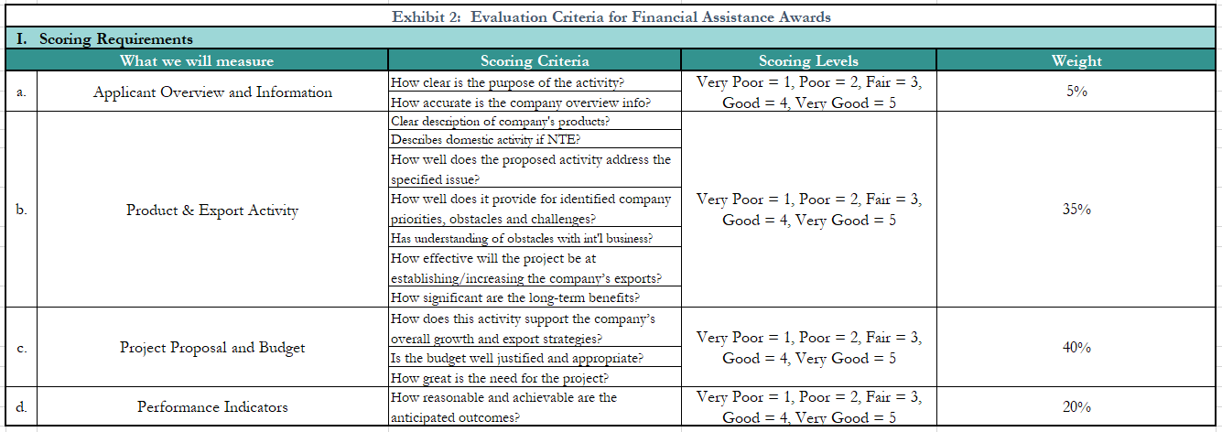
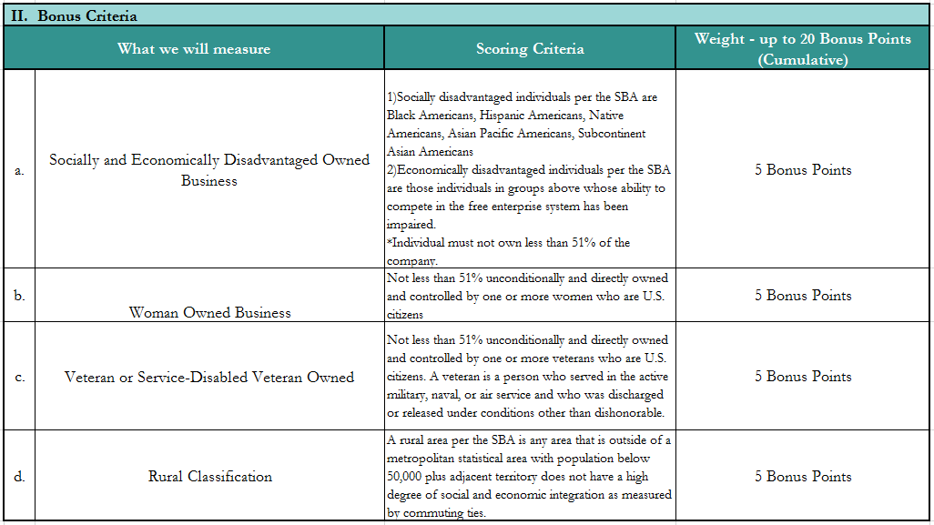
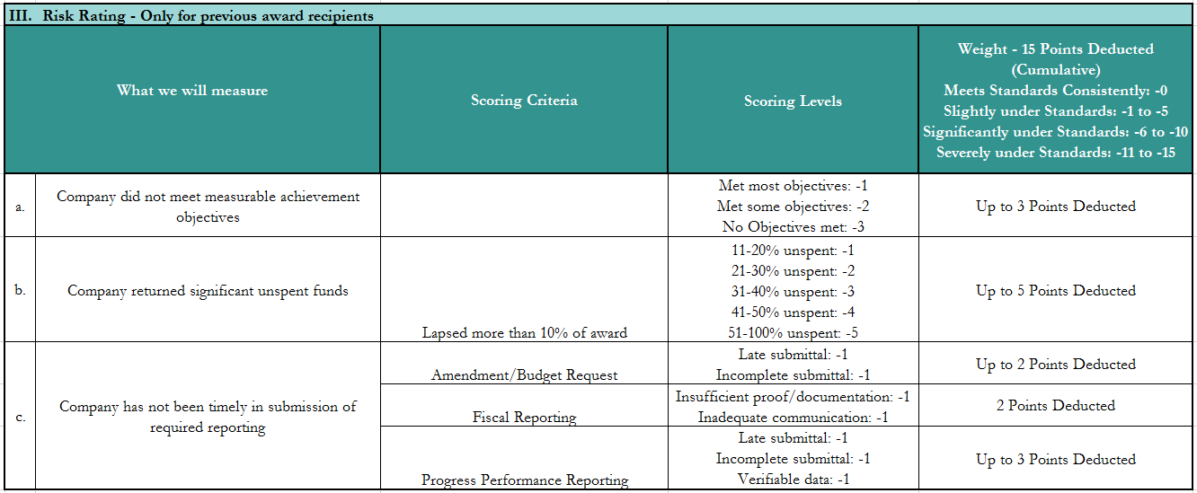

F. Financial Reporting

Awardees will not receive any reimbursements. The value of this award is the participation fee only which will be waived for awardees.
G. Quarterly Reporting Requirements

Progress Performance Reporting (PPR)
Companies will be required to complete progress performance reports indicating projected and actual sales, activities performed, including success stories and/or trade barriers. A reminder email will be sent to recipients with instructions and reporting template as deadlines approach.
Reporting Schedule:
- 30 days after project completion
- March 1, 2019
H. Contacts
For more information or questions, please contact:

Tina Salisbury, Idaho Department of Commerce
Phone: (208) 287-3164
Email: 33T33Ttina.salisbury@commerce.idaho.gov33T

Chelsea Conlon, Idaho State Department of Agriculture
Phone: (208) 332-8678
Email: 33T33TChelsea.Conlon@isda.idaho.gov33T33T

Funded in part through a grant with the U.S. Small Business Administration.

