Chapter 6: Financial and Closeout Forms

Introduction – This chapter contains the instructions and forms necessary to submit a request for payment and project closeout. The forms include:

- Request for Funds,
- Signature Authorization form,
- Progress report,
- Disbursement report and
- Closeout documents.

Rural Community Block Grant Request for Funds Form

Instructions – Request for Funds

Contract Number: Enter the RCBG number on the front page of the grant contract.

Billing Period: The two calendar dates for the beginning and the ending of the report period. The beginning date should match the ending date of the previous Request for Funds.

Date of Request: The date the report is prepared by the contact person.

Request Number: The Request for Funds should be numbered consecutively.

Column 1: Budget Categories: Enter the item name as shown on the most current RCBG contract budget.

Column 2: RCBG Budget: Enter the dollar amount for each line item as shown on the most current RCBG contract budget or approved contract amendment.

Column 3: Total RCBG Funds Disbursed to Date: Enter, by line item, the total of all RCBG funds disbursed to date.

Column 4: Current Request for Funds: This should be the amount of costs incurred and bills that the grantee has approved for payment this pay period.

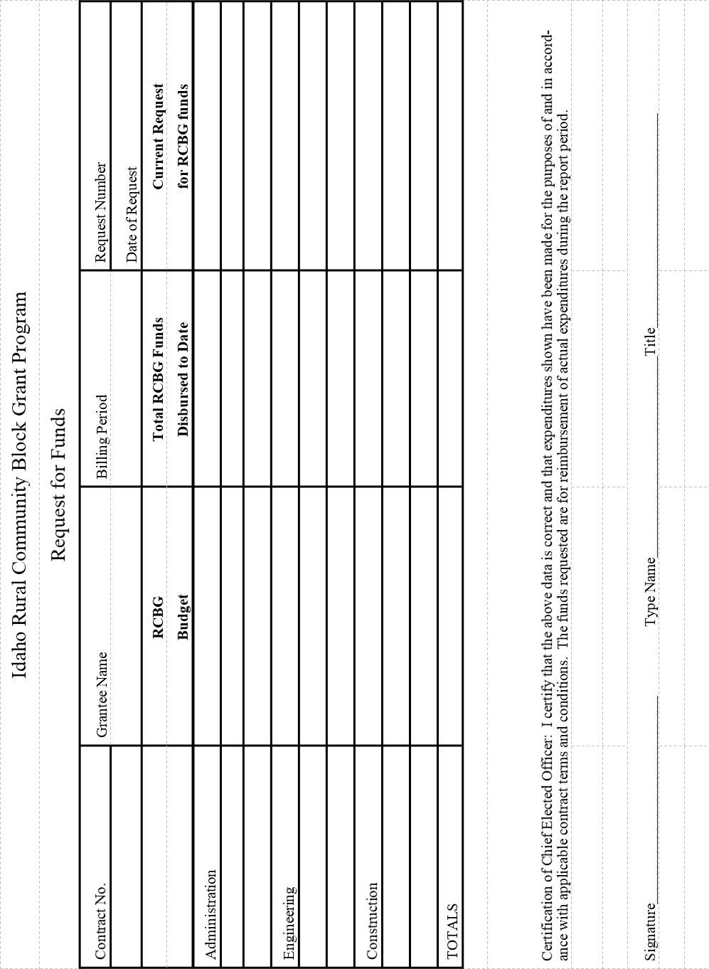
Request for Funds Authorized Signatures

Part I: Grant Number and Address

1. Address for Payment:

_________________________________________________
_________________________________________________

2. Grant Number:

_____________________________________

Part II: Authorized Signatures

3. Authorized Signature (1)

Signature Printed Name and Title

4. I certify the signature(s) above are of the individuals authorized to draw payments for the cited contracts.

___________________________ __________________________ __________________
Signature of Chief Elected Official Printed Name and Title Date

Return this form to:
Idaho Department of Commerce
700 West State Street
P. O. Box 83720
Boise, ID 83720-0093

Instructions

It is Commerce’s intent that the Request for Funds be signed by the Chief Elected Official. In the event it is necessary to authorize another individual to sign the request, the signature form must first be filled out and returned to Commerce. The approved signor should notify the Chief Elected Official each time a Request for Funds is submitted.
Rural Community Block Grant Progress Report

Grantee: |  | Sub-recipient: |  | Report No.:
Grant No. | Report Period:  From___________________  To_____________________ |  | Design Professional: Identify current phase  __ Design Phase  __ Bidding Phase  __ Construction Phase  __ Post Construction Phase
Construction Status: Narrative on construction activities (max 3 sentences). Attach photos if available.

Percentage of construction complete _____%

Instructions: Identify the date that the activity was completed and the date the documentation was sent to Commerce. If activity has not yet been completed leave blank. Checklist is to identify that specific steps are met, but it does not replace the directions in the RCBG manual.

GRANT ADMIN AND DESIGN PROFESSIONAL PROCUREMENT | Execution Date | Date submitted to Commerce
Grant Admin Contract (if applicable):
Design Professional Contract with RCBG attachment:

construction progress  All documents must be sent even if RCBG funds are not expended on construction. | Execution Date | Date submitted to Commerce
Construction bid document review certification:
Invitation to Bid (published) Notices:
Bid Tabulations:
Bid Form (from lowest responsive and responsible bidder)
Bid Bond (required if bid over $200,000)
Preconstruction Conference – minutes and checklist
Notice to Proceed:
Insurance Certification (commercial general liability, worker’s comp, and automobile liability)
Construction Contract:
Performance Bond and Payment Bond (required if bid over $200,000)
Certificate of Substantial Completion:

Certification:

I, the undersigned, do hereby certify that the above information contained in this report, including the attached disbursement report, is correct and accurately reflects the progress and status of the grant project.

________________________________________________ _________________________
Signature of Grant Administrator / Consultant Date

.

Disbursement report

Request for Funds this Period: $________________ Request for Funds #___________________

Date Received | Date Deposited | Date Disbursed | Check # | Amount | To Whom

Rural Community Block Grant Closeout Forms

Instructions and forms necessary to document the jobs created and or retained as well as the forms necessary to close out the grant with the Idaho Commerce. The forms included are company Job Creation information form, final performance report, final financial report, and closeout agreement.

For Closeout, the Grantee will need to provide two complete copies of the final performance, final financial, and closeout agreement with original signatures.

1. Two signed* originals of the Closeout Agreement

2. Two signed* originals of the Final Performance Report

3. Two signed* originals of the Final Financial Report
Includes the following attachments:
- current disbursement report,
- final progress report, and
- final RCBG Request for Funds.

*Note: All documents must be signed by the chief elected official. Upon Commerce approval of the Closeout Documents one original will be maintained by Commerce, one original will be returned to the Grantee, and copies will be electronically sent to the Grant Administrator.

Closeout Agreement

This Agreement made by and between Idaho Department of Commerce (IDC) and the
_______________sets forth for the final conditions associated with the closeout of the RCBG grant project RCBG-______________ that has been completed pursuant to the grant agreement dated __________________ and any applicable amendments.

The _________________ agrees as follows:

- All records and documents pertaining to this grant will be maintained for a period of four (4) years after execution of this closeout agreement.
- To submit to IDC their independent financial audit for fiscal year 20____

IDC maintains the right to conduct future monitoring of this grant, either on site or by review of information or copies of documents requested from the _______________. The _____________ acknowledges that a finding of noncompliance resulting from such a review and failure to take appropriate corrective actions may require the __________________ to repay IDC any disallowed costs based on the monitoring and/or audits.

Idaho Department of Commerce | ______________________________________
 | Grantee
______________________________________ | ______________________________________
Signature | Signature
______________________________________ | ______________________________________
Dennis J Porter | Printed Name
______________________________________ | ______________________________________
Title | Title
______________________________________ | ______________________________________
Date | Date

Final Performance Report

Grantee: Contract Number:

Prepared By: Date

Project Activities:
Provide a detailed narrative of completed activities. Provide a detailed narrative paragraph (at least 1/3 page) for the completed activities:

Grant Administration: (at a minimum identify the RFP process and timelines, proposals submitted, evaluation of proposals, highest rank proposal, when contract was executed).

Design Professional: (at a minimum identify the RFP process and timelines, proposals submitted, evaluation of proposals, highest rank proposal, when contract was executed).

Construction: (at a minimum identify the Invitation to Bid process and timelines, how many bids received, the selected bidder, dates of the award notice, contract, and notice to proceed. Identify number of change orders, total contract amount, and date of certificate of substantial completion).

Project Benefits:

Construction Scope of Work (Provide narrative of the scope of work completed.)

Job Benefits

Describe the benefits (paid vacation, sick leave, training, health insurance, etc.)

Identify () fringe benefits provided by the employer or business(es)

____ Sick Leave
____ Vacation Leave
____ Health Insurance
___ Medical
___ Dental
___ Vision
___ Prescription

____ Retirement Program (requires employer contribution)
___ Pension
___ IRA
___ 401(k)
___ Other (describe :________________________________)

Attach - Company Job Information form.

CERTIFICATION:

I, the undersigned, do hereby certify that the information contained in this report is true and correct and accurately reflects the accomplishments of the grant project.

_______________________________
Signature of Chief Elected Official Title Date

Financial Report

Grantee: Contract Number:

Prepared By: Date

I. Matching Funds

A. Match Expenditure – In the table below, please list those matching funds identified in the grantee’s RCBG contract or latest contract amendment.

Source of Funds | Amount Pledged | Actual Spent | Difference
EDA Grant
Federal Grant
ITD Grant
State Grant
Foundation Grant
Local Cash/Bond/Loans
Local In-Kind
Volunteer
Donations
Other
Total

B. Match Expenditure Differences – If applicable, list by item those matching sources not fully spent and explain why the funds were not fully expended.

C. Volunteer/In-Kind/Force Account – If applicable, describe the processes used to track and value the labor used.

II. Final Payment Request

Step One Fill out the standard RCBG Request for Funds form and in the request number box write FINAL and attach it to this report.

Step Two If the grantee plans to close the grant with unexpended grant funds, please type the amount to be returned in Section V of this report.

III. Certification of Grantee

It is hereby certified that all activities undertaken by the GRANTEE with funds provided under the contract agreement number have, to the best of my knowledge, been carried out in accordance with the contract; that proper provision has been made by the GRANTEE for the payment of all unpaid costs and any unsettled third-party claims; that the Idaho Department of Commerce is under no obligation to make any further payment to the GRANTEE under the contract in excess of the amount identified in “Final Request for Funds” dated , hereof; and that every statement and amount set forth in this document is true and correct as of this date.

Signature of Chief Elected Official Date

Printed Name and Title of Chief Elected Official

IV. Idaho Department of Commerce

The completion of the grant is hereby approved; therefore, I authorize de-obligation of the unutilized RCBG funds in the amount of $_________.

Signature of Commerce Authorized Official Date

Printed Name & Title

Company Job Information Form
Company Name: (Company Name)_______
RCBG Grant Number: RCBG-___________
 | Reporting Period
 | From: | (Date)
 | To: | (Date)
 | Name | Job Classification |  | Hire Date | Full-time or part-time
1
2
3
4
5
6
7
8
9
10
11
12
13
14
15
16
Certification of Accurate Information: I certify that the above information is accurate and correct, based upon the company's personnel and financial records.

Authorized Signature |  |  |  | Date

